Spectrometer Live Tool – User Guide
Author: Melih Karaoglan

1. What is this tool?
This application is a live spectrometer interface designed for laboratory measurements and teaching demonstrations. It allows users to visualize spectra in real time, apply reference-based corrections, and export measurement data without modifying the source code.

2. How to start
- Make sure Python is installed.
- Install required libraries:
  - numpy
  - matplotlib
  - seabreeze
- Run the script:
- python spectrometer_tool.py
- If no spectrometer is detected, the tool automatically switches to dummy mode.

3. Interface Overview
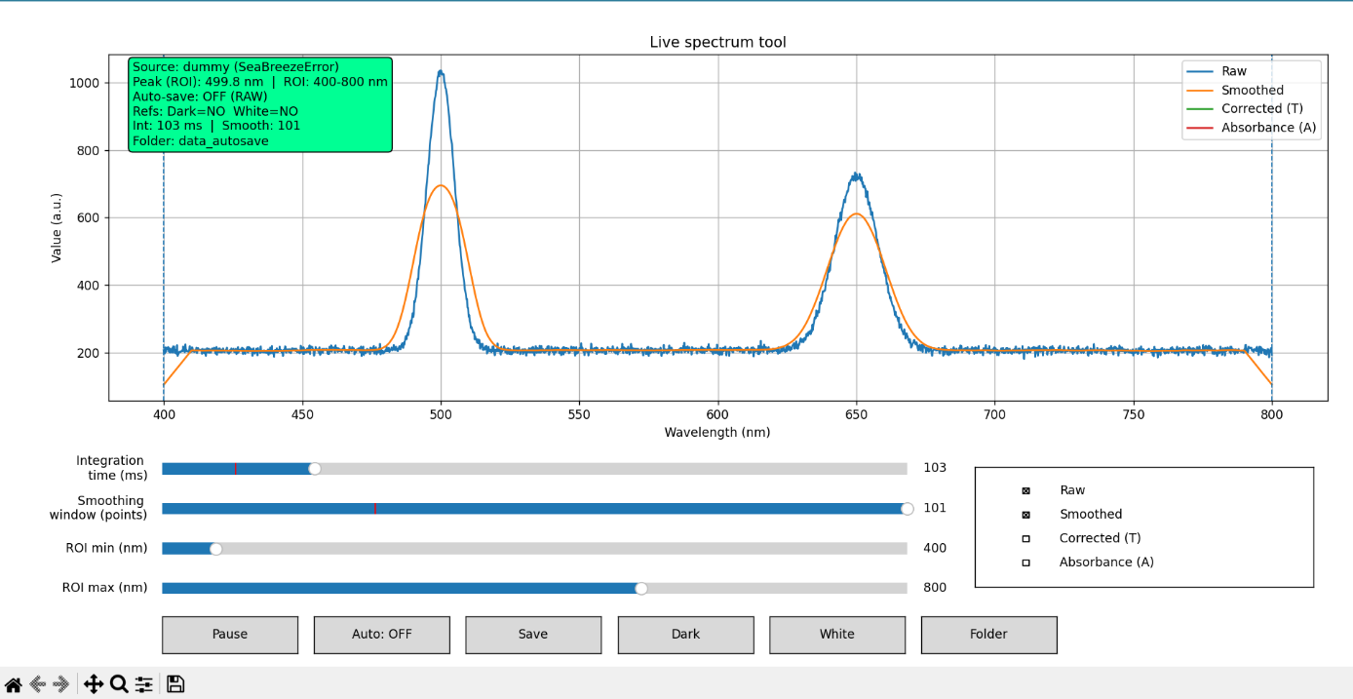The interface consists of:
- A live plot area showing spectra
- Sliders for integration time, smoothing, and ROI
- Checkboxes to show or hide curves
- Buttons for saving data and capturing references
- A status box displaying current settings

4. Typical Lab Workflow
- Start the tool.
- Block the light path and press Dark to record the dark reference.
- Apply the reference condition and press White.
- Adjust integration time and smoothing if needed.
- Observe corrected transmission or absorbance curves.
- Save data manually or enable auto-save.

5. Keyboard Shortcuts
Key | Action
d | Capture dark reference
w | Capture white reference
s | Save current spectrum
a | Toggle auto-save
p | Pause / resume acquisition
o | Choose output folder
q | Quit application

6. Output Data
Saved CSV files contain wavelength and intensity values.
Reference files and measurement data are stored in the selected output folder, allowing easy reuse and post-processing.

7. Notes for Students
- Always capture dark and white references before using corrected or absorbance views.
- Large spikes in corrected data usually indicate poor reference quality.
- Use smoothing and ROI to stabilize peak detection.

