**Python(VS Code):**

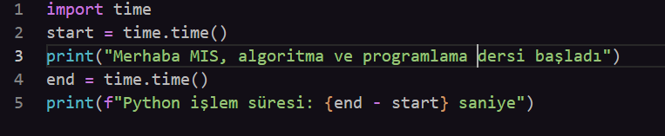



**C#(VS Code):**

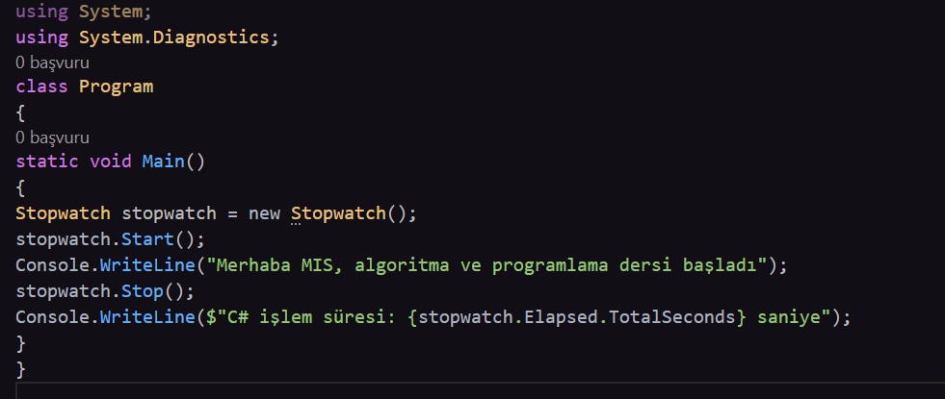



**C++(Visual Studio Communty 2022):**

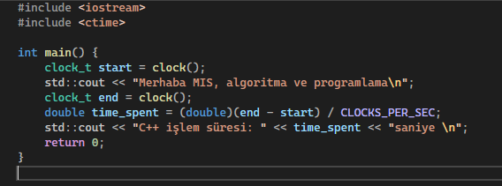



**C(**[**https://onecompiler.com/c/42vaxaudd**](https://onecompiler.com/c/42vaxaudd) **):**

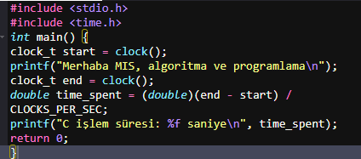



**Java(**[**https://www.tutorialspoint.com/online_java_compiler.php**](https://www.tutorialspoint.com/online_java_compiler.php)**):**

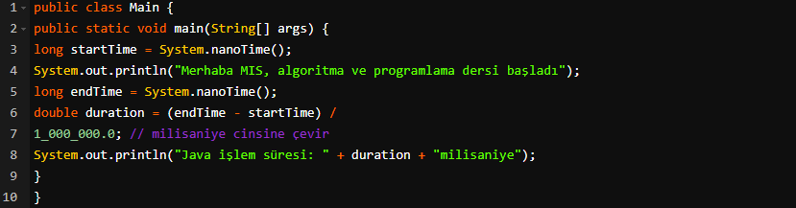



**Node.js(**[**https://www.tutorialspoint.com/execute_nodejs_online.php**](https://www.tutorialspoint.com/execute_nodejs_online.php) **):**

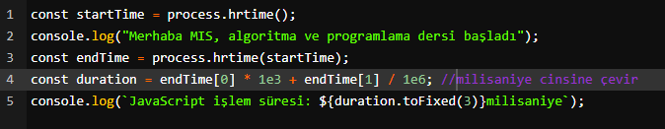



**GO(** [**https://go.dev/play/**](https://go.dev/play/) **):**

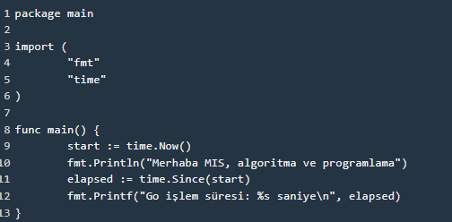



**RUST(**[**https://play.rust-lang.org/?version=stable&mode=debug&edition=2021**](https://play.rust-lang.org/?version=stable&mode=debug&edition=2021) **):**

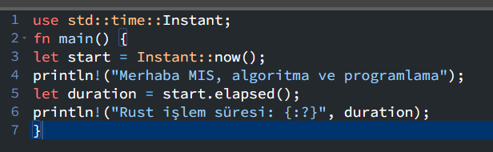

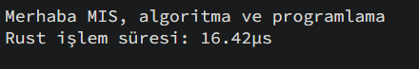

**RUBY(**[**https://onecompiler.com/ruby/42utg4a3p**](https://onecompiler.com/ruby/42utg4a3p) **):**

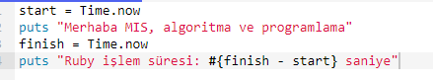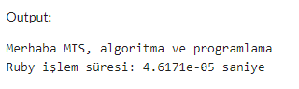

**PERL(**[**https://onecompiler.com/perl/42utgar3v**](https://onecompiler.com/perl/42utgar3v) **):**

