Data Understanding & Preparation Report
TEKNOFEST Healthcare AI — Missense Variant Classification

Executive Summary
- 4 datasets: MASTER (2931), CFTR (111), PAH (372), KANSER (388)
- Binary classification: Benign (0) vs Pathogenic (1)
- All datasets imbalanced (69-83% pathogenic)
- 57 constant columns must be dropped
- 54.9% mean row-level missingness in MASTER
- EK_4/EK_6 are HIGH leakage risk (possible ClinVar circularity)
- CFTR too small for independent model (n=111)
- Start with Pipeline B (Missingness-Aware LightGBM)

1. Dataset Inventory
Dataset | Rows | Columns | Schema Match
MASTER | 2931 | 353 | True
CFTR | 111 | 353 | True
PAH | 372 | 353 | True
KANSER | 388 | 353 | True

2. Class Distribution
Dataset | Total | Pathogenic | Benign | Ratio
MASTER | 2931 | 2149 | 782 | 2.75:1
CFTR | 111 | 90 | 21 | 4.29:1
PAH | 372 | 310 | 62 | 5.0:1
KANSER | 388 | 268 | 120 | 2.23:1

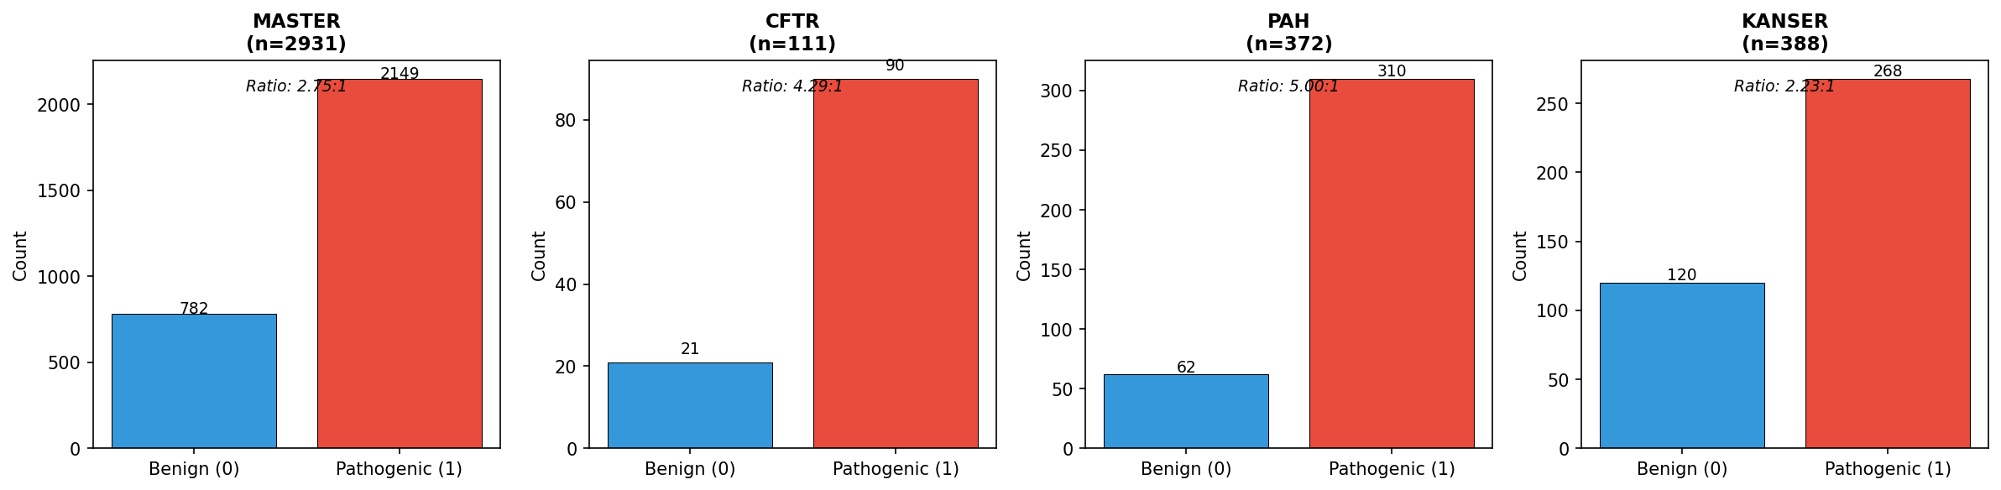

3. Missing Value Analysis
Missingness bands (MASTER features):
Band | Feature Count
0% | 0
0-5% | 0
5-20% | 12
20-50% | 174
50-80% | 146
80-95% | 18
>95% | 1

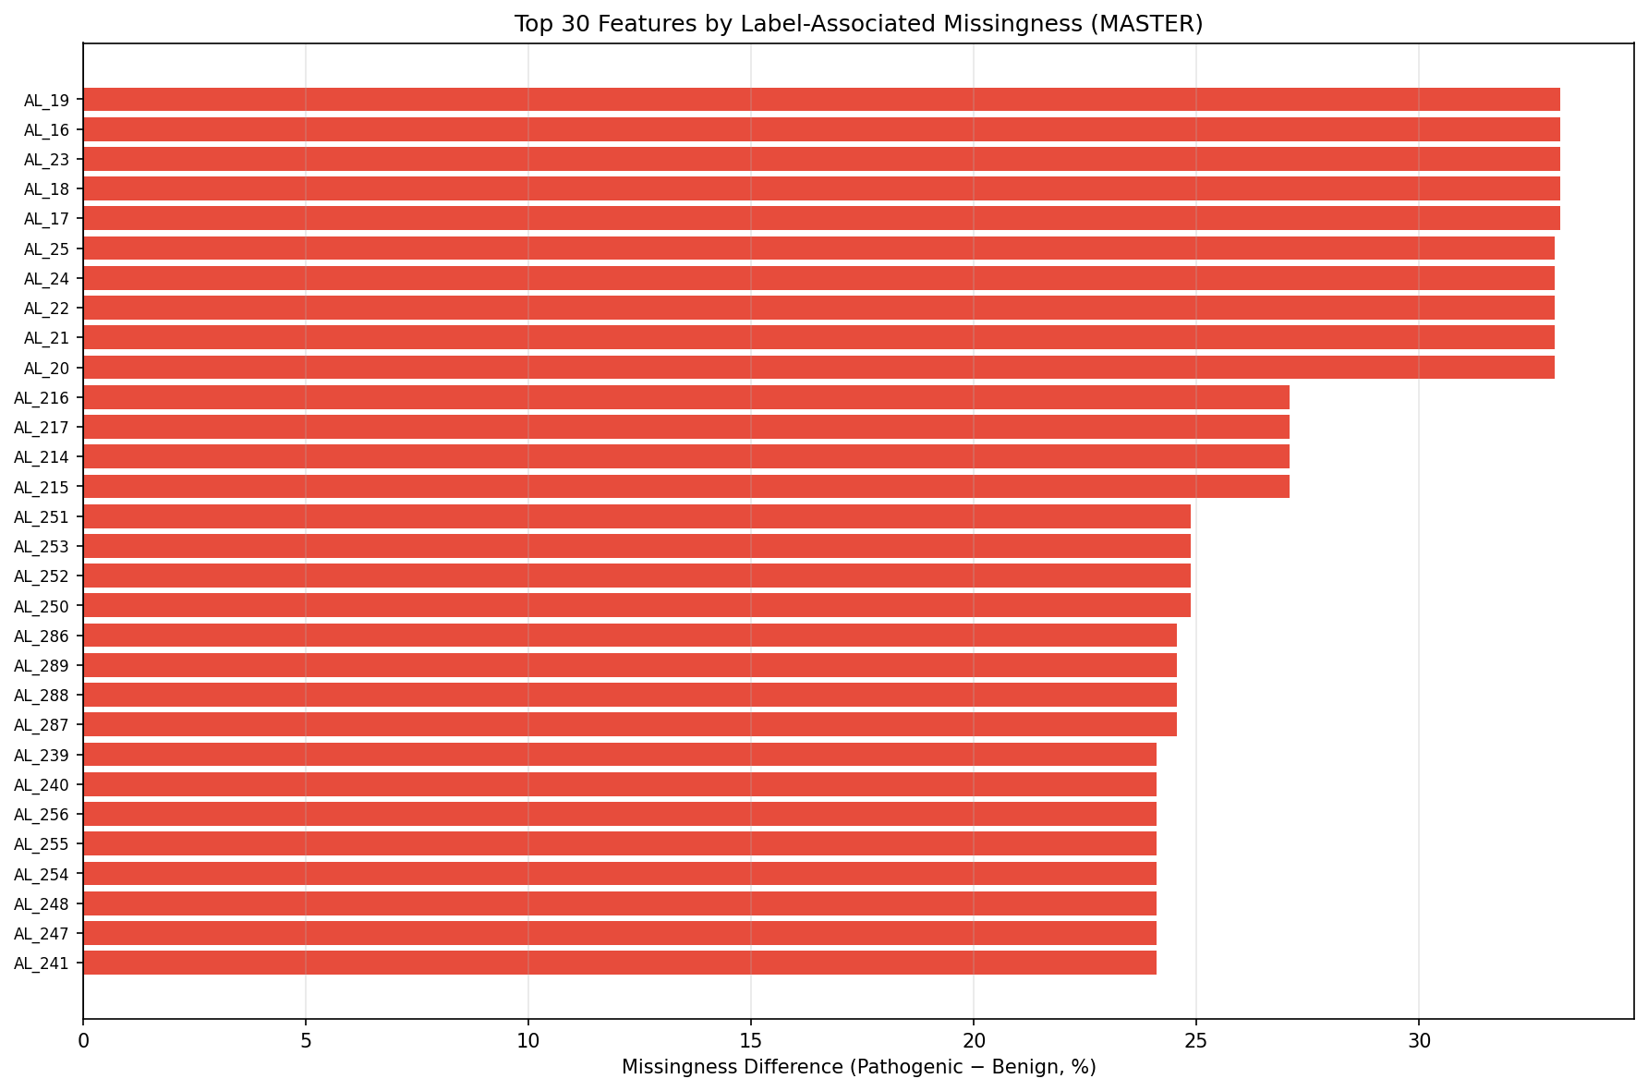

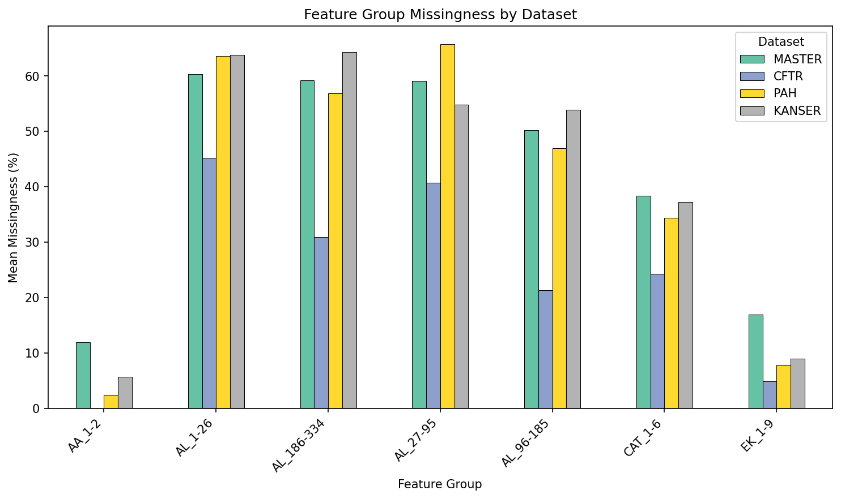

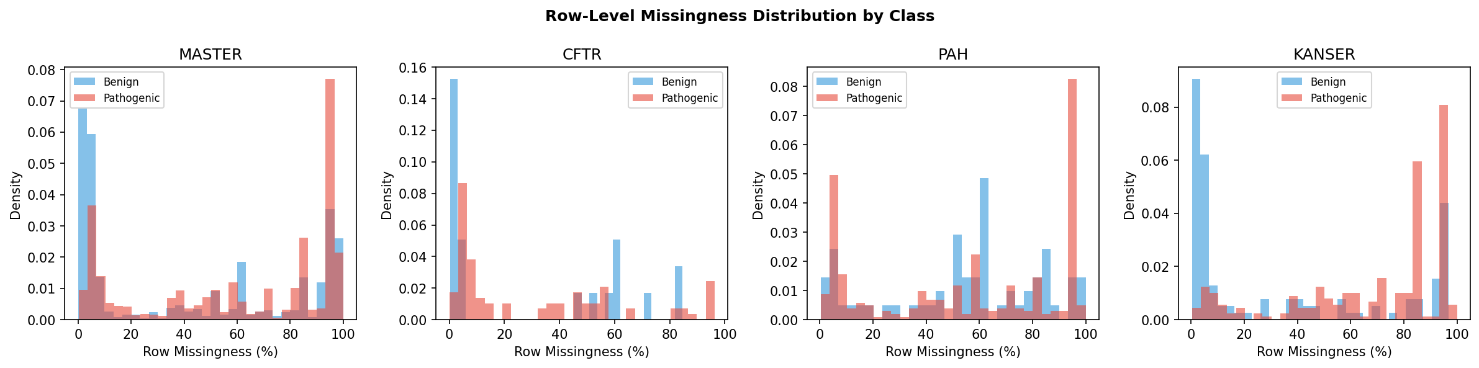

4. Duplicate and Overlap Analysis
Dataset | Exact Dups | Feature Dups | Conflicts | ID Dups
MASTER | 0 | 115 | 0 | 0
CFTR | 0 | 0 | 0 | 0
PAH | 0 | 4 | 0 | 0
KANSER | 0 | 2 | 0 | 0

Variant_ID overlap: MASTER-CFTR=77, MASTER-PAH=255, MASTER-KANSER=246
All shared variants have consistent labels.

5. Constant Features
Dataset | Constant Cols | Near-Constant Cols
MASTER | 57 | 66
CFTR | 70 | 70
PAH | 91 | 92
KANSER | 69 | 72

6. Feature Types
AL features: 334 (mostly [0,1] probability/scores)
CAT features: 6 (categorical — populations, genotypes, regions)
EK features: 9 (extra scores — mixed risk levels)
AA features: 2 (amino acid identity)

7. EK Feature Risk Analysis
Feature | Range | Corr w/ Label | Risk | Action
EK_1 | [0.856, 6.17] | 0.085 | LOW | KEEP
EK_2 | [-11.9, 6.17] | 0.316 | MEDIUM | MONITOR
EK_3 | [-11.369, 7.01] | 0.296 | LOW | KEEP
EK_4 | [0.0, 1.0] | 0.320 | HIGH | ABLATION
EK_5 | [0.0, 1.0] | 0.154 | MEDIUM | MONITOR
EK_6 | [0.0, 1.0] | 0.302 | HIGH | ABLATION
EK_7 | [-3.322, 10.003] | 0.380 | MEDIUM | MONITOR
EK_8 | [-5.716, 0.756] | 0.232 | LOW | KEEP
EK_9 | [-20.0, 11.934] | 0.322 | MEDIUM | MONITOR

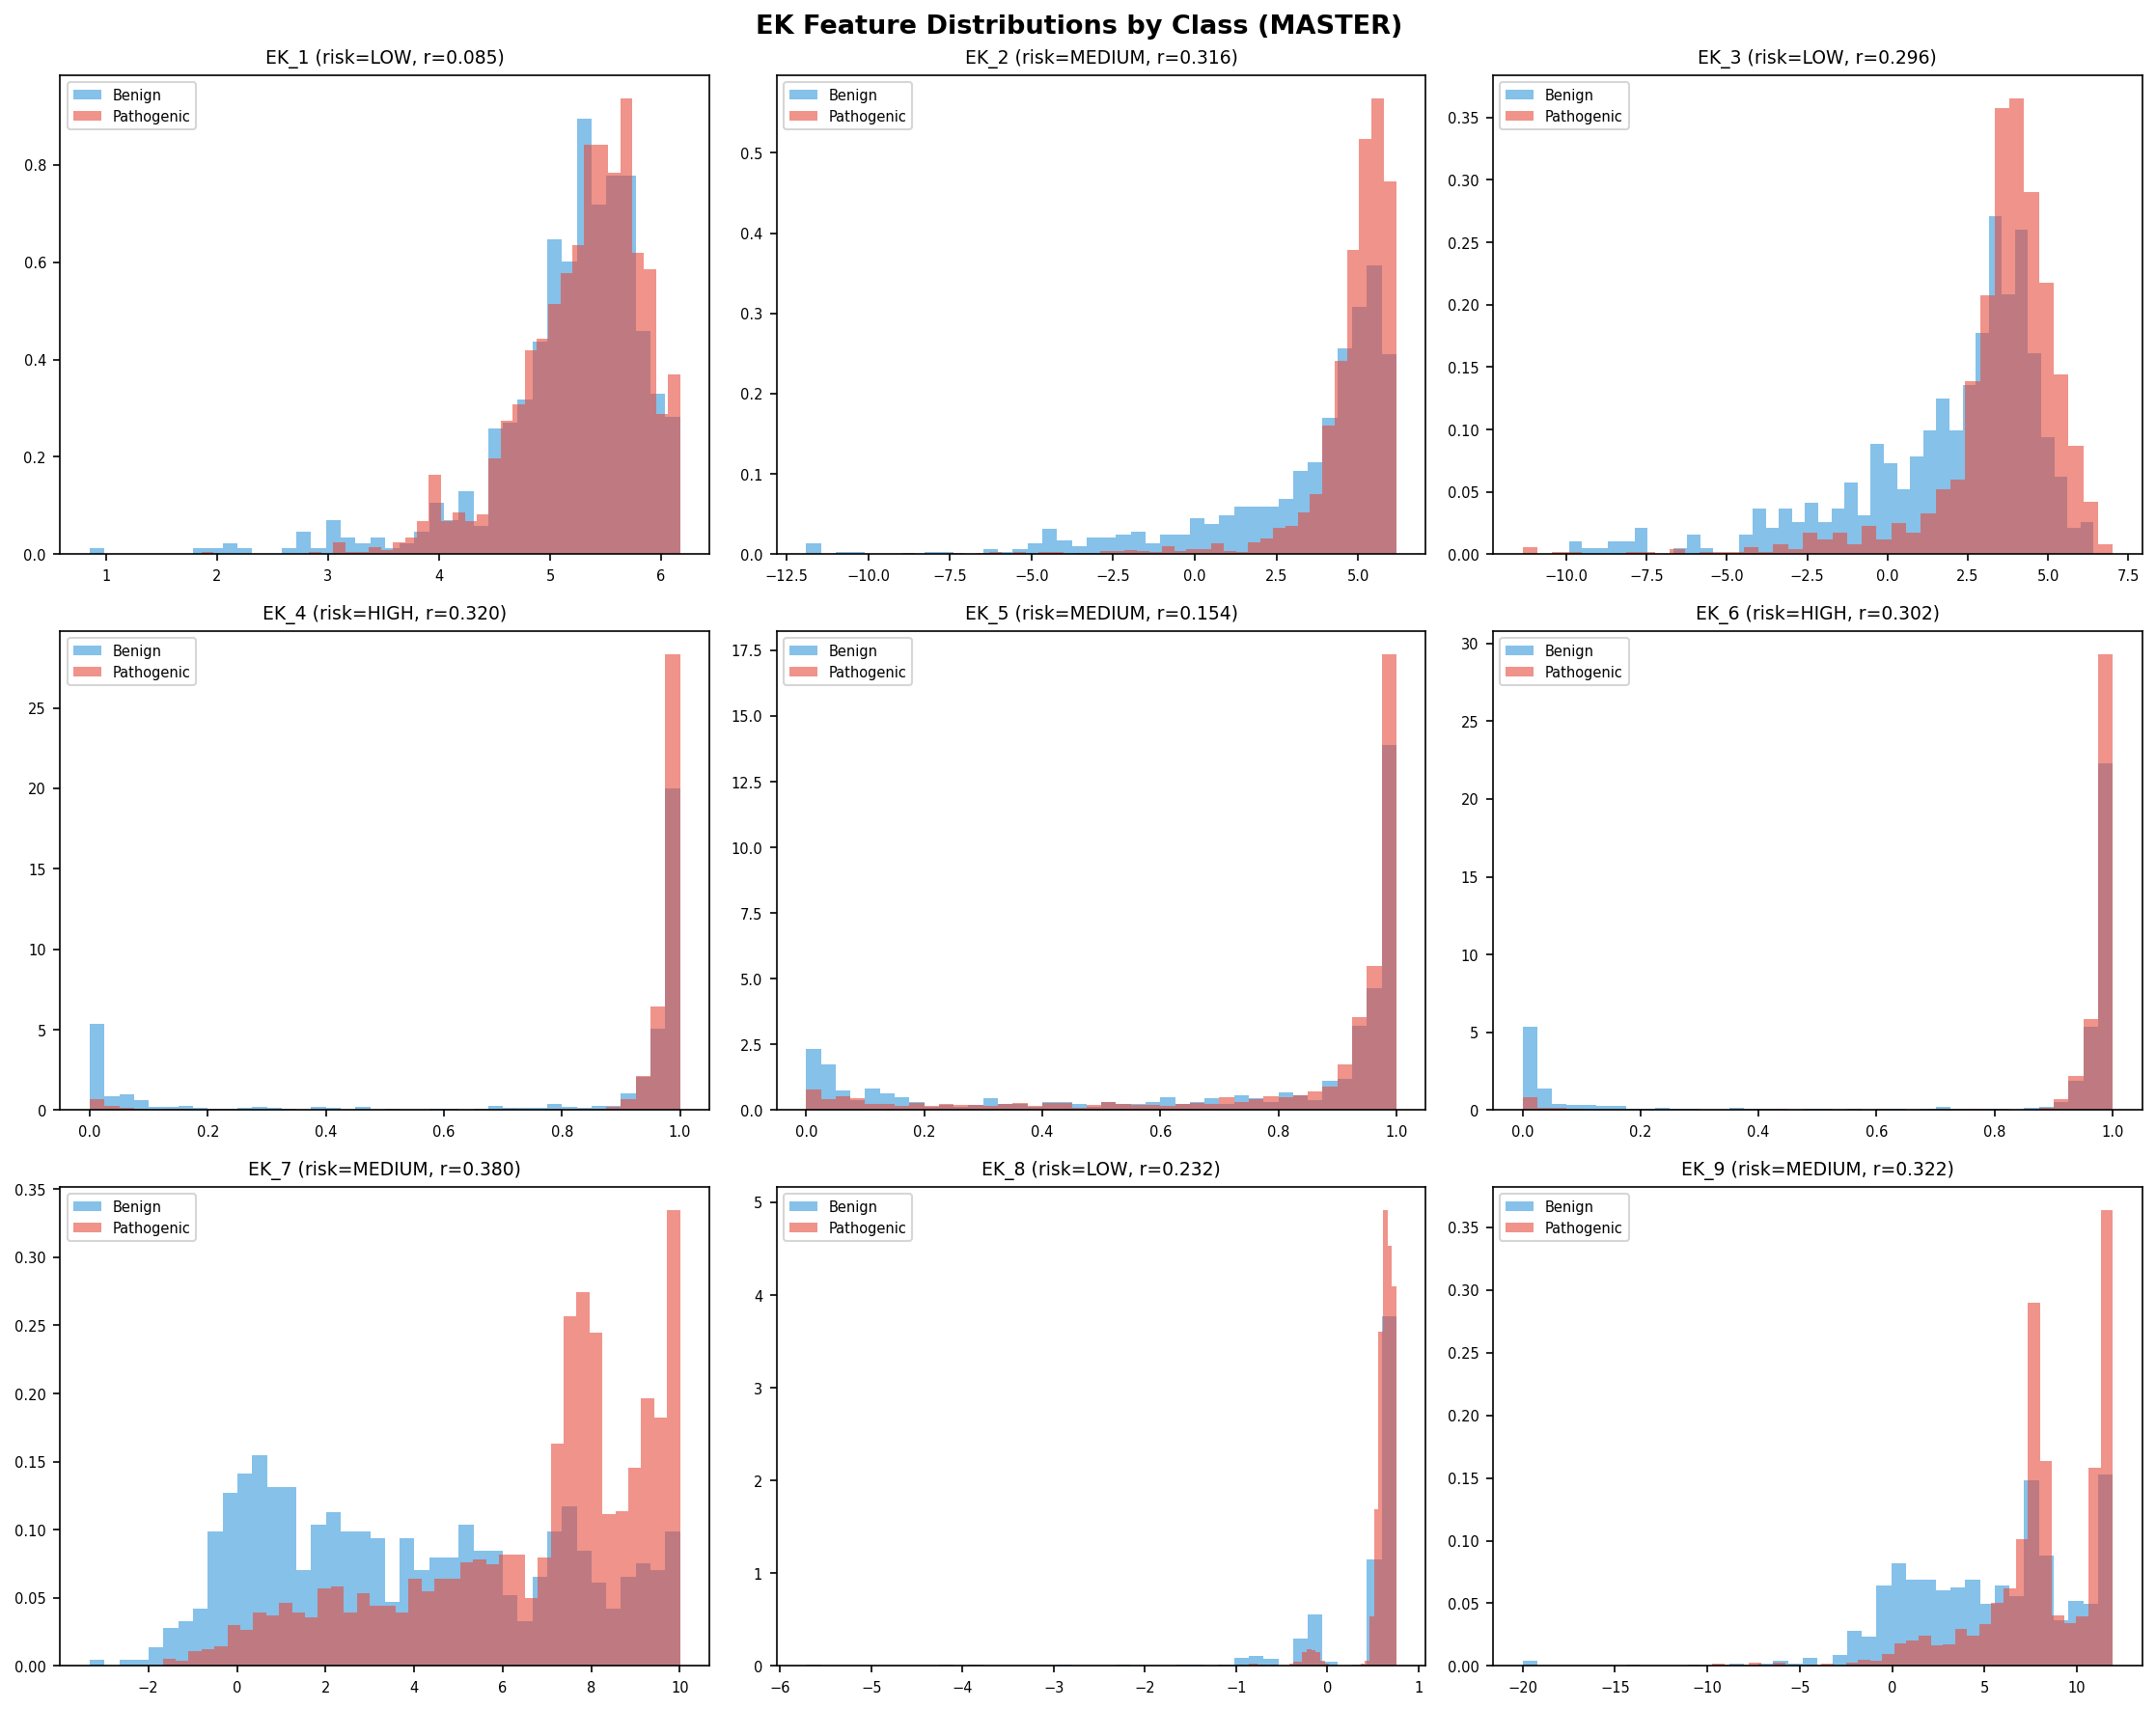

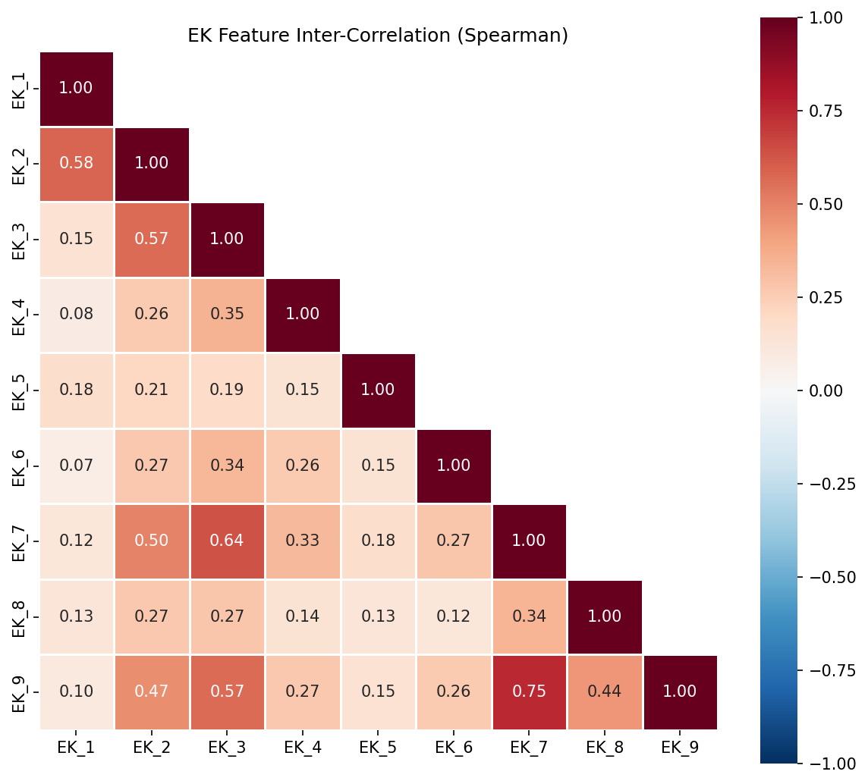

8. Panel Comparison
Panel | Tested | Shifted | Shift %
CFTR | 100 | 4 | 4.0%
PAH | 100 | 57 | 57.0%
KANSER | 100 | 0 | 0.0%

9. Preprocessing Recommendations
Step | Priority | Applies To
Drop Variant_ID from features | MANDATORY | All models
Drop constant columns (MASTER: 57) | MANDATORY | All models
Use class weights (is_unbalance / scale_pos_weight) | MANDATORY | All models
Stratified K-Fold CV | MANDATORY | All models
Variant_ID-aware splitting for panel evaluation | MANDATORY | Panel evaluation
Native missing handling (no imputation) | RECOMMENDED | GBDT models
Add missingness indicator features | RECOMMENDED | All models
One-hot encode CAT_3/4/5 | RECOMMENDED | All models
Label encode CAT_1/CAT_2 | RECOMMENDED | GBDT models
Binary flag for CAT_6 | RECOMMENDED | All models
One-hot encode AA_1/AA_2 | RECOMMENDED | All models
EK ablation (train with and without EK_4/5/6) | HIGH | All models
Median imputation + scaling | CONDITIONAL | Linear models only
Avoid SMOTE / oversampling | WARNING | All models
Avoid target encoding outside CV folds | WARNING | All models

10. Validation Strategy
- 5-fold Stratified K-Fold on MASTER
- Variant_ID-aware splitting (no overlap between train/val)
- Evaluate per-panel separately using OOF predictions
- Report ROC-AUC, PR-AUC, F1, sensitivity, specificity, MCC
- Report mean ± std across folds

11. Top Features by Label Association
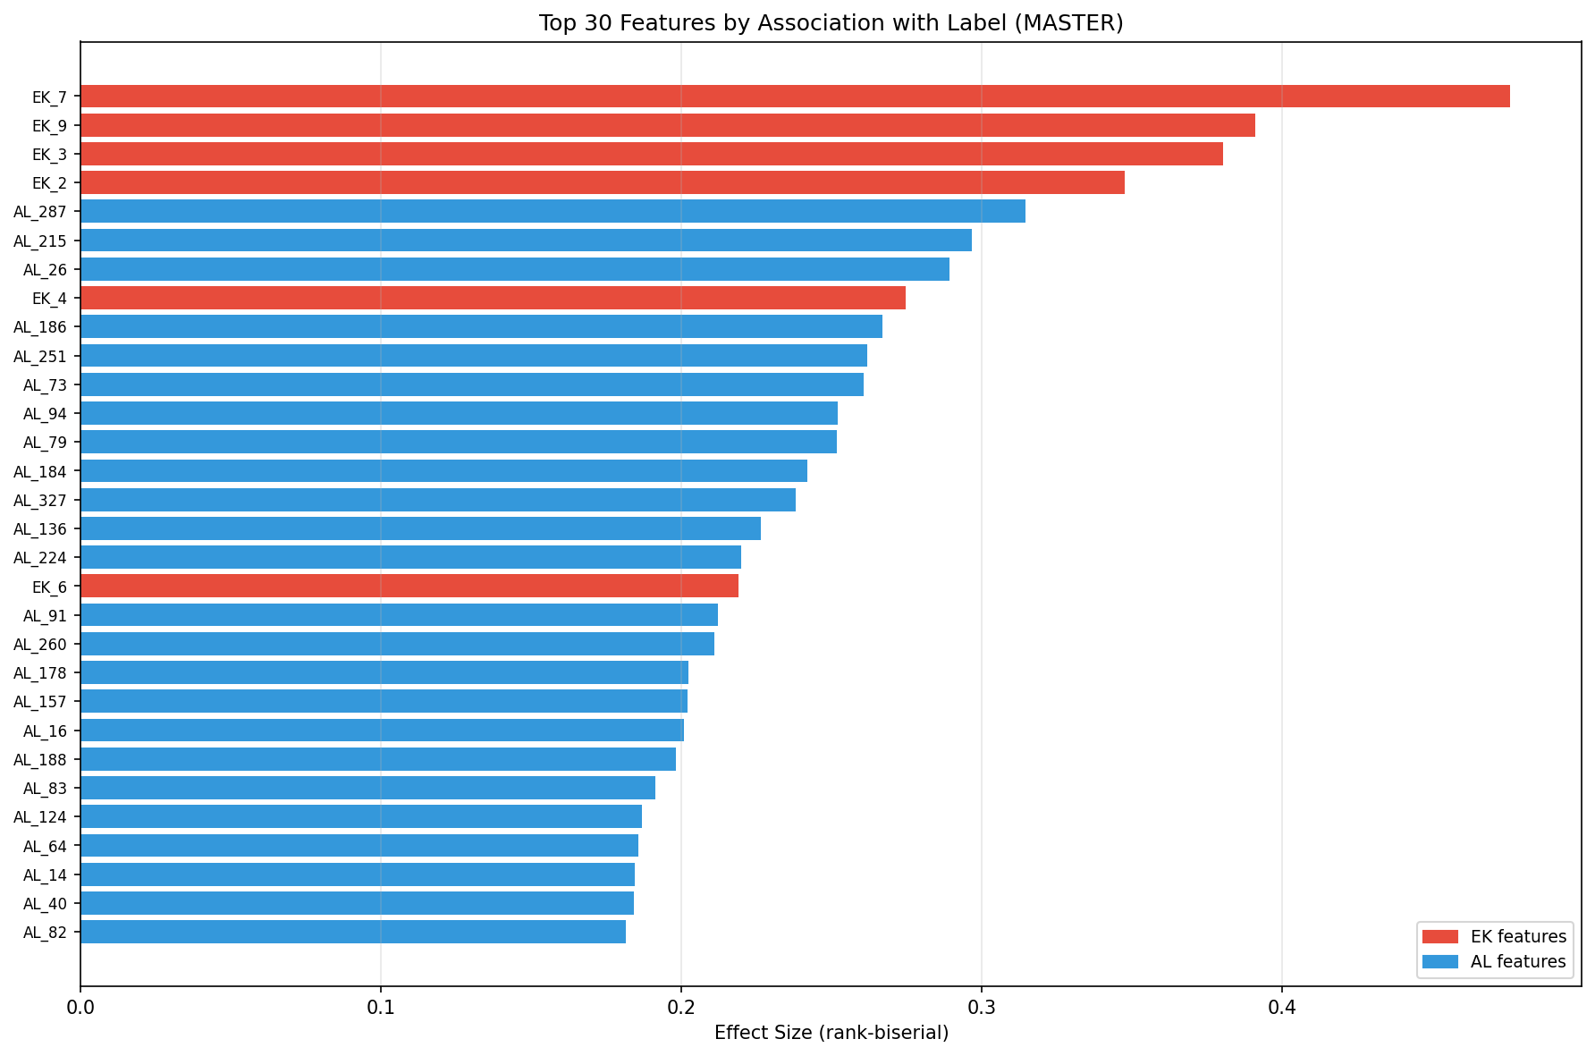

12. Risk Register
# | Risk | Severity | Mitigation
1 | EK_4/EK_6 circularity | HIGH | Ablation testing
2 | Variant_ID overlap leakage | HIGH | Group-aware splitting
3 | Label-associated missingness | HIGH | Missingness indicators
4 | Class imbalance | MEDIUM | Class weights + threshold tuning
5 | CFTR too small | HIGH | Global model only
6 | PAH distribution shift | MEDIUM | Panel calibration
7 | 57 constant columns | MEDIUM | Drop before modeling
8 | Feature anonymisation | LOW | Accept uncertainty
9 | Conflicting labels | LOW | Accept as noise
10 | EK_5 unknown origin | MEDIUM | Monitor

