TEKNOFEST Healthcare AI
Phase 01: Data Understanding Report
Generated: 2026-05-24
Missense Variant Pathogenicity Classification — Exploratory Data Analysis

Table of Contents
1. Dataset Inventory
2. Schema Summary
3. Class Distribution
4. Missing Value Analysis
5. Distribution and Outlier Analysis
6. Feature-Target Association
7. Correlation and Redundancy
8. Panel Comparison
9. Leakage Risk Register
10. Executive Summary and Recommendations

1. Dataset Inventory
The project contains 4 CSV datasets: 1 master training set and 3 gene-specific panel datasets.
File | Type | Size (MB) | Rows | Columns | Role
YARISMA_TRAIN_CFTR.csv | CSV | 0.28 | 111 | 353 | Panel dataset (CFTR)
YARISMA_TRAIN_KANSER.csv | CSV | 0.66 | 388 | 353 | Panel dataset (KANSER)
YARISMA_TRAIN_MASTER.csv | CSV | 5.14 | 2931 | 353 | General training set
YARISMA_TRAIN_PAH.csv | CSV | 0.8 | 372 | 353 | Panel dataset (PAH)

All datasets share the same column schema with 353 columns.
Feature names are ANONYMIZED (AL_1 to AL_334, CAT_1 to CAT_6, EK_1 to EK_9).

Column Groups
Group | Count | Description
AL_* | 334 | Anonymized numeric features
CAT_* | 6 | Categorical features
EK_* | 9 | Extra/additional features
AA_* | 2 | Amino acid features
Variant_ID | 1 | Variant identifier
Label | 1 | Target (0=Benign, 1=Pathogenic)

2. Schema Summary
Dataset | Shape | Numeric Cols | Object Cols | Constant Cols | Duplicate Rows
CFTR | 111x353 | 344 | 9 | 70 | 0
KANSER | 388x353 | 344 | 9 | 69 | 0
MASTER | 2931x353 | 344 | 9 | 57 | 0
PAH | 372x353 | 345 | 8 | 91 | 0

CAT_1: Population/ancestry (gnomAD, AllofUs labels)
CAT_2: AllofUs population annotations
CAT_3, CAT_4: Genotype strings (e.g., C/C, T/T)
AA_1, AA_2: Reference and alternate amino acids (single-letter codes)

3. Class Distribution
Dataset | Total N | Pathogenic (1) | Benign (0) | Other/Unknown | Positive Ratio | Imbalance Ratio
CFTR | 111 | 90 | 21 | 0 | 0.8108 | 4.29
KANSER | 388 | 268 | 120 | 0 | 0.6907 | 2.23
MASTER | 2931 | 2149 | 782 | 0 | 0.7332 | 2.75
PAH | 372 | 310 | 62 | 0 | 0.8333 | 5.0

Labels are binary (0=Benign, 1=Pathogenic). No VUS or uncertain labels.
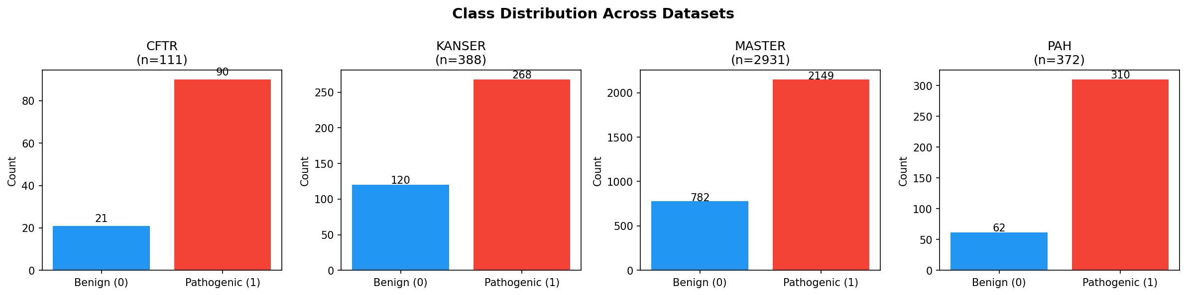

4. Missing Value Analysis
Band | Columns
0% | 2
0-5% | 0
5-20% | 12
20-50% | 174
50-80% | 146
80-95% | 18
>95% | 1

Differential Missingness by Target (Top 15)
Dataset | Column | Miss% Pathogenic | Miss% Benign | Abs Difference
KANSER | AL_25 | 86.19 | 29.17 | 57.03
KANSER | AL_17 | 86.19 | 29.17 | 57.03
KANSER | AL_24 | 86.19 | 29.17 | 57.03
KANSER | AL_23 | 86.19 | 29.17 | 57.03
KANSER | AL_22 | 86.19 | 29.17 | 57.03
KANSER | AL_21 | 86.19 | 29.17 | 57.03
KANSER | AL_20 | 86.19 | 29.17 | 57.03
KANSER | AL_19 | 86.19 | 29.17 | 57.03
KANSER | AL_18 | 86.19 | 29.17 | 57.03
KANSER | AL_16 | 86.19 | 29.17 | 57.03
KANSER | AL_15 | 60.45 | 9.17 | 51.28
KANSER | AL_14 | 60.45 | 9.17 | 51.28
KANSER | AL_13 | 60.45 | 9.17 | 51.28
KANSER | AL_12 | 60.45 | 9.17 | 51.28
KANSER | AL_11 | 60.45 | 9.17 | 51.28
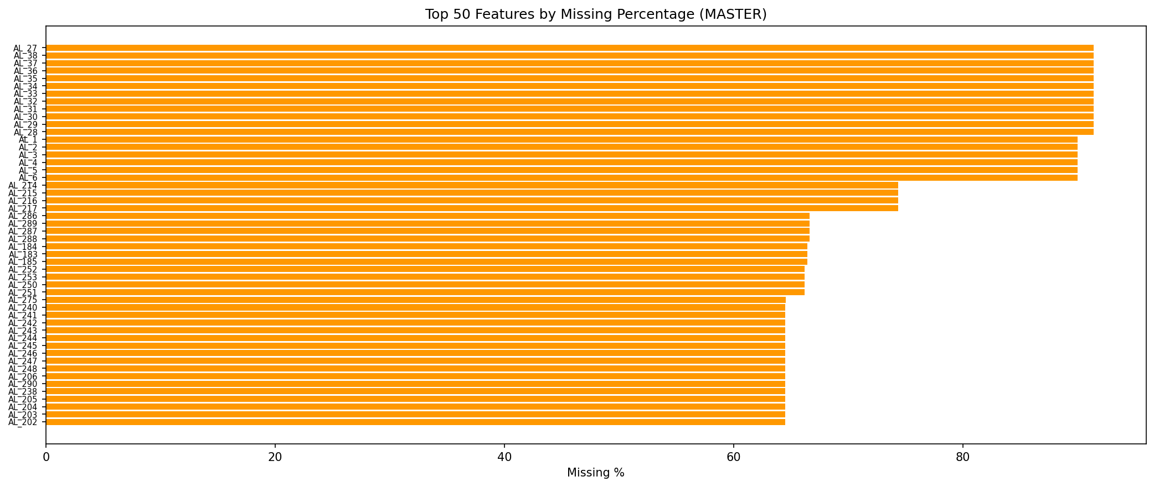
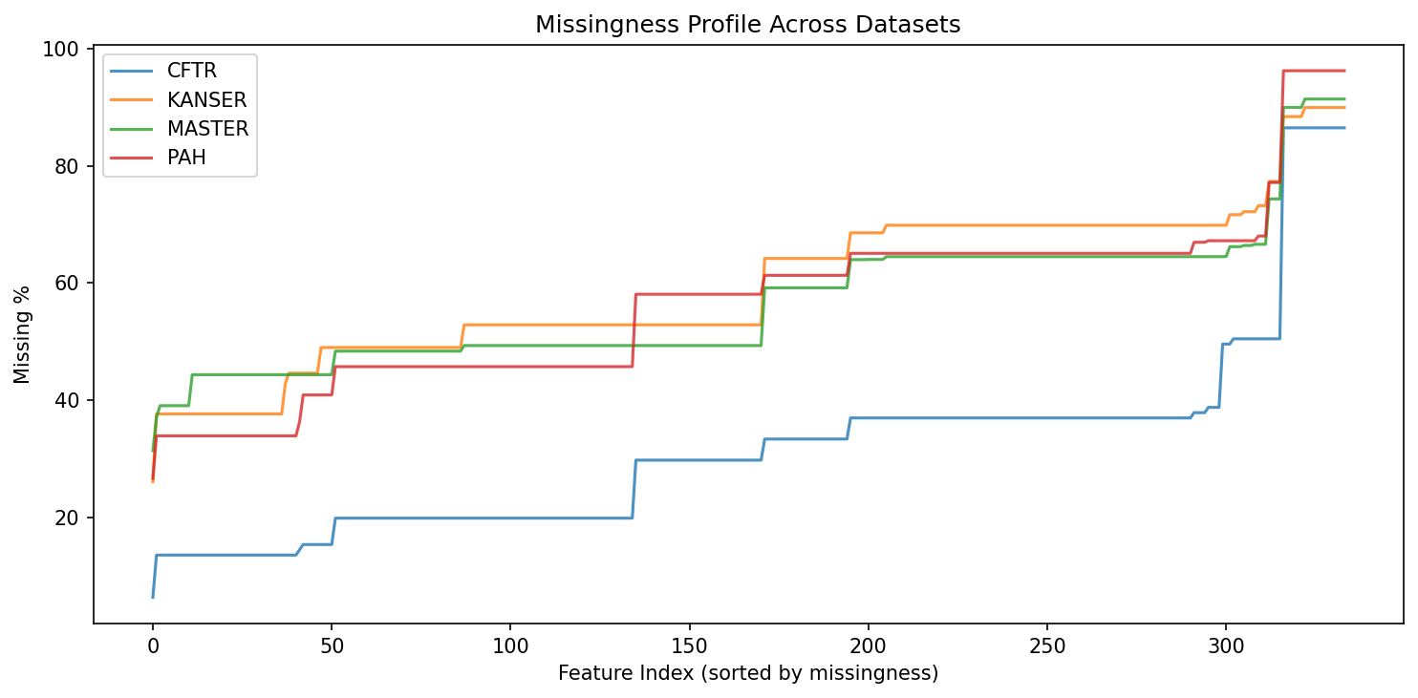

5. Distribution and Outlier Analysis
Feature Type | Count
Probability/Score [0,1] | 336
Binary (0/1) | 0
Generic Numeric | 6
Count/Position-like | 1
Highly skewed features (|skew|>3): 138
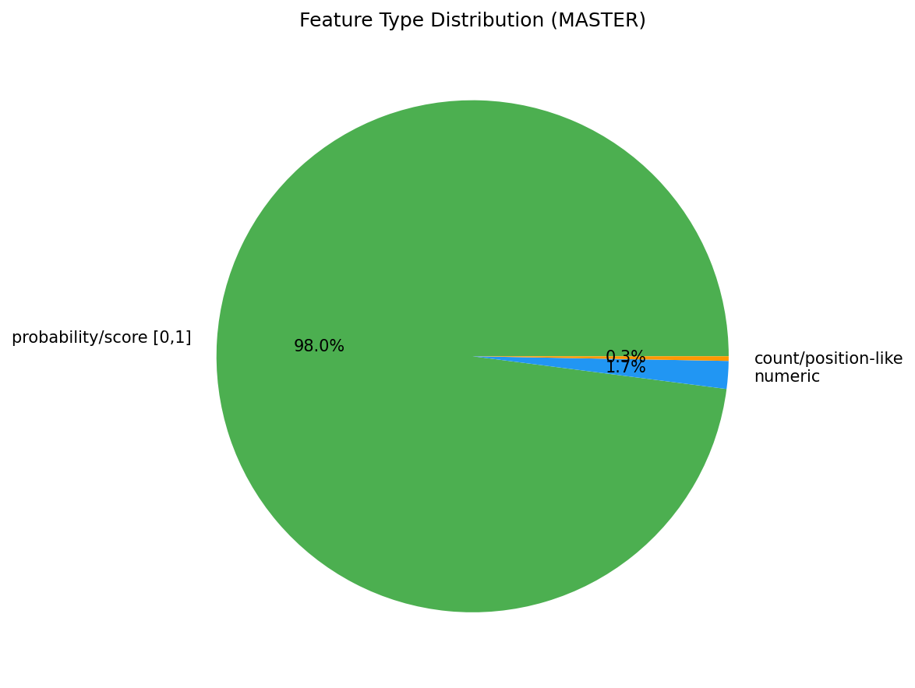

6. Feature-Target Association
Method: Mann-Whitney U test with rank-biserial effect size.
Total features tested: 343
Significant at p<0.001: 81
Large effect size (|r|>0.5): 0

Top 20 Features by Effect Size
Column | Median Diff (P-B) | Abs Effect Size | Mann-Whitney p-value
EK_7 | 4.17653 | 0.4761 | 5.72e-73
EK_9 | 2.287942 | 0.391 | 1.78e-45
EK_3 | 1.015824 | 0.3804 | 3.45e-33
EK_2 | 0.672027 | 0.3475 | 1.01e-39
AL_287 | -0.001739 | 0.3145 | 5.31e-17
AL_215 | -0.002096 | 0.2967 | 2.06e-12
AL_26 | -0.00269 | 0.2894 | 9.57e-24
EK_4 | 0.02142 | 0.2748 | 2.30e-27
AL_186 | -0.002225 | 0.2669 | 3.62e-21
AL_251 | -0.001544 | 0.2618 | 2.22e-12
AL_73 | -0.000949 | 0.2607 | 1.40e-15
AL_94 | -0.001451 | 0.2522 | 3.63e-13
AL_79 | -0.000863 | 0.2519 | 3.82e-13
AL_184 | -0.000594 | 0.242 | 1.07e-10
AL_327 | -0.001231 | 0.2382 | 1.98e-15
AL_136 | -0.000592 | 0.2266 | 1.02e-12
AL_224 | -0.00067 | 0.2199 | 1.79e-09
EK_6 | 0.014818 | 0.219 | 4.36e-18
AL_91 | -0.000471 | 0.2121 | 9.77e-10
AL_260 | -0.000392 | 0.2111 | 7.73e-09
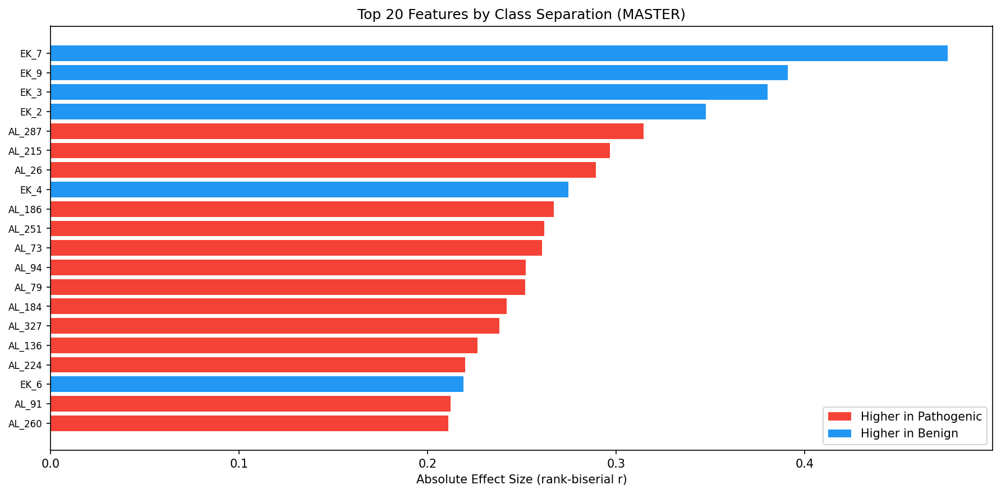

7. Correlation and Redundancy
Pairs with |r| > 0.85: 0
Pairs with |r| > 0.95: 0
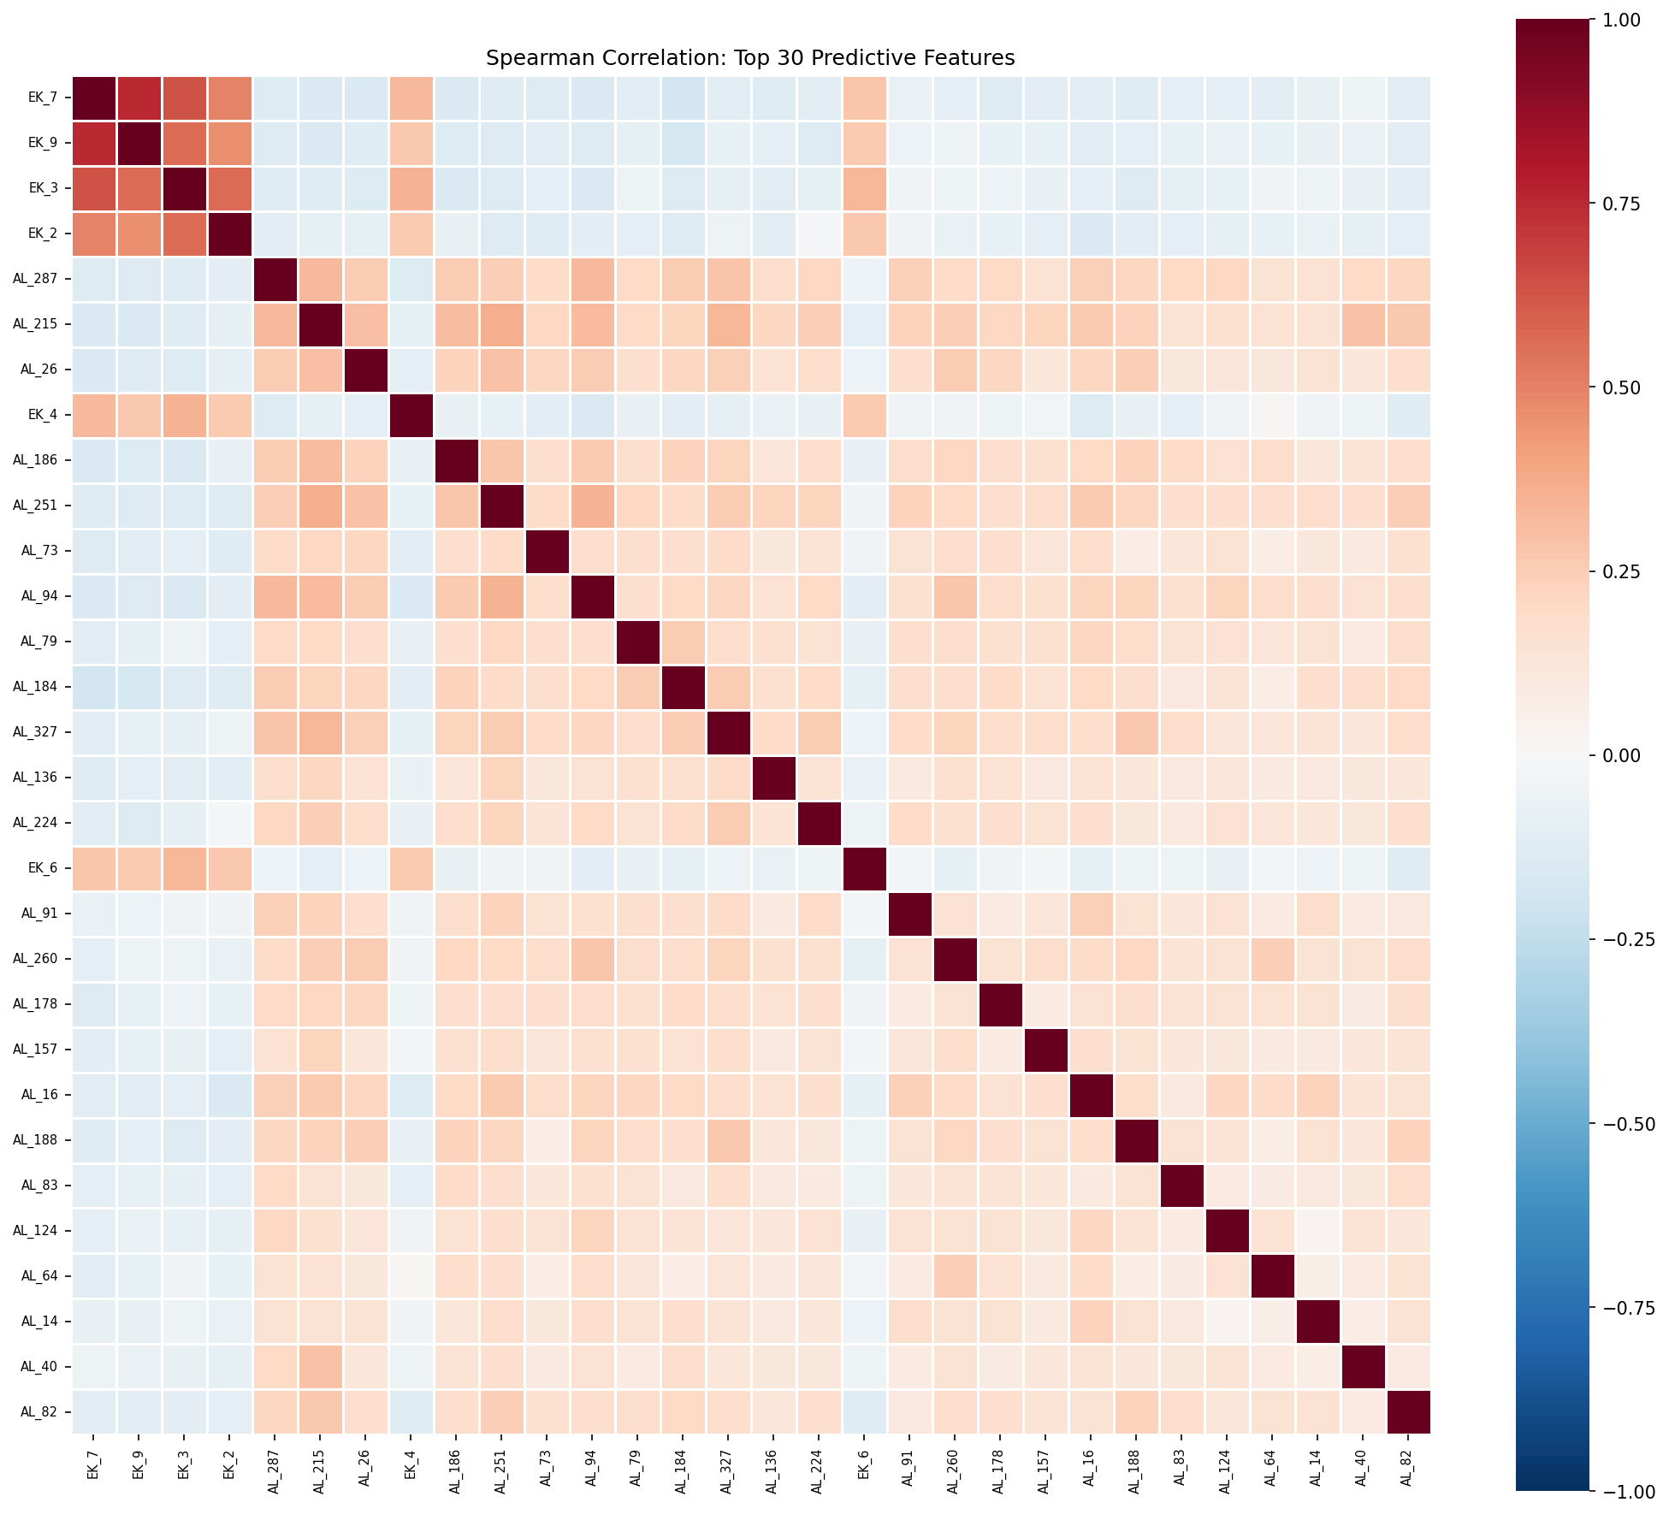

8. Panel Comparison
Dataset | Rows | Pathogenic | Benign | Pos Ratio | Mean Missing% (AL features) | Constant Cols | Difficulty Estimate
CFTR | 111 | 90 | 21 | 0.8108 | 31.43 | 70 | very small sample; imbalanced; high missingness; many constant cols
KANSER | 388 | 268 | 120 | 0.6907 | 59.48 | 69 | small sample; high missingness; many constant cols
MASTER | 2931 | 2149 | 782 | 0.7332 | 56.85 | 57 | imbalanced; high missingness; many constant cols
PAH | 372 | 310 | 62 | 0.8333 | 56.54 | 91 | small sample; imbalanced; high missingness; many constant cols

Variant ID Overlap Matrix
Dataset | CFTR | KANSER | MASTER | PAH
CFTR | 111 | 0 | 77 | 0
KANSER | 0 | 388 | 246 | 0
MASTER | 77 | 246 | 2931 | 255
PAH | 0 | 0 | 255 | 372

Distribution Shifts
CFTR: 4 features with significant distribution shift from MASTER
KANSER: 0 features with significant distribution shift from MASTER
PAH: 57 features with significant distribution shift from MASTER

9. Leakage Risk Register
HIGH severity risks: 3
MEDIUM severity risks: 12
LOW severity risks: 7
Risk | Severity | Mitigation
EK feature EK_1 (float64, 2541 unique values) - unclear provenance | MEDIUM | Verify EK features are not derived from clinical labels
EK feature EK_2 (float64, 2483 unique values) - unclear provenance | MEDIUM | Verify EK features are not derived from clinical labels
EK feature EK_3 (float64, 1601 unique values) - unclear provenance | MEDIUM | Verify EK features are not derived from clinical labels
EK feature EK_4 (float64, 1424 unique values) - unclear provenance | MEDIUM | Verify EK features are not derived from clinical labels
EK feature EK_5 (float64, 1940 unique values) - unclear provenance | MEDIUM | Verify EK features are not derived from clinical labels
EK feature EK_6 (float64, 1374 unique values) - unclear provenance | MEDIUM | Verify EK features are not derived from clinical labels
EK feature EK_7 (float64, 2470 unique values) - unclear provenance | MEDIUM | Verify EK features are not derived from clinical labels
EK feature EK_8 (float64, 2383 unique values) - unclear provenance | MEDIUM | Verify EK features are not derived from clinical labels
EK feature EK_9 (float64, 2163 unique values) - unclear provenance | MEDIUM | Verify EK features are not derived from clinical labels
Variant_ID could be used to look up external annotations | MEDIUM | Do not use Variant_ID as a feature; used only for identification
77 shared Variant_IDs between MASTER and CFTR | HIGH | Ensure train/test splits do not leak through shared variants
255 shared Variant_IDs between MASTER and PAH | HIGH | Ensure train/test splits do not leak through shared variants
246 shared Variant_IDs between MASTER and KANSER | HIGH | Ensure train/test splits do not leak through shared variants
EK_1 appears to be a continuous score (range 0.86-6.17) | MEDIUM | If this is a pre-computed pathogenicity score, it could be a strong but circular predictor
EK_2 appears to be a continuous score (range -11.90-6.17) | MEDIUM | If this is a pre-computed pathogenicity score, it could be a strong but circular predictor

10. Executive Summary and Recommendations

Key Findings
1. We have 2931 master variants + 3 panels (111 + 372 + 388) with 334 anonymized features.
2. Target is binary (Pathogenic/Benign) with positive ratio ~81.1% in MASTER.
3. 5 features show medium-to-large effect sizes.
4. EK_1, EK_2 are suspicious (potential pre-computed pathogenicity scores).
5. Panel datasets have distribution shifts and different missingness patterns.

Recommended Phase 2 Strategy
Baseline: LightGBM/XGBoost with native missing value handling
Validation: Stratified 5-fold CV with Variant_ID-aware splits
Primary metric: ROC-AUC; Secondary: PR-AUC, Sensitivity
Panel strategy: Global model first, panel-specific fine-tuning if needed
Explainability: SHAP values
Run models with AND without EK features to assess leakage risk

Top 5 Risks
1. EK features may cause circular prediction (label leakage)
2. Small panel sizes lead to high variance estimates
3. Anonymized features prevent feature validation
4. Distribution shift between MASTER and panels
5. High missingness in some features may correlate with label

