TEKNOFEST Healthcare AI
Phase 2.5: Preprocessing Audit
Generated: 2026-05-24
Missense Variant Pathogenicity Classification — Data Quality & Preprocessing Decision Report

Table of Contents
1. Data Readiness Verdicts
2. Missing Value Handling
3. Duplicate & Label Noise
4. Feature Transformation
5. Encoding Strategy
6. Leakage & Circularity
7. Panel-Specific Preprocessing
8. Class Imbalance
9. Pipeline Options
10. Executive Summary

1. Data Readiness Verdicts
Each dataset was evaluated for immediate modeling readiness.
Dataset | Verdict | Problems | Severity | Action | CanTrainDirect
CFTR | High-risk / unreliable without special handling | 70 constant cols; class imb 4.3:1; very small (n=111) | MEDIUM | See detailed plan | No — need special handling
KANSER | Requires careful preprocessing | high missingness (59%); 69 constant cols; small (n=388) | MEDIUM | See detailed plan | No — need special handling
MASTER | Requires careful preprocessing | high missingness (57%); 57 constant cols | MEDIUM | See detailed plan | No — need special handling
PAH | Requires careful preprocessing | high missingness (57%); 91 constant cols; class imb 5.0:1; small (n=372) | MEDIUM | See detailed plan | No — need special handling

MASTER: Can train direct GBDT baseline. 54.9% row missingness is the main challenge.
CFTR: HIGH RISK — only 111 samples. Must use global model + threshold only.
PAH: Careful preprocessing needed — 91 constant cols, 5:1 imbalance, distribution shift.
KANSER: Critical — 57% differential missingness between classes requires missingness indicators.

2. Missing Value Handling
Row-level missingness by class and panel:
Dataset | Label | Mean | Median | Max | Pct75
CFTR | 0 | 28.5 | 5.2 | 85.7 | 60.9
CFTR | 1 | 31.3 | 12.7 | 97.7 | 52.2
KANSER | 0 | 33.0 | 7.9 | 97.7 | 72.3
KANSER | 1 | 69.4 | 83.1 | 100.0 | 97.4
MASTER | 0 | 41.6 | 31.3 | 100.0 | 86.6
MASTER | 1 | 61.0 | 72.6 | 100.0 | 97.4
PAH | 0 | 54.9 | 59.6 | 100.0 | 78.6
PAH | 1 | 55.3 | 58.3 | 100.0 | 97.4

Key finding: KANSER has extreme label-associated missingness (57% difference for AL_16-25).
Primary strategy: Native GBDT missing handling + missingness indicator features.
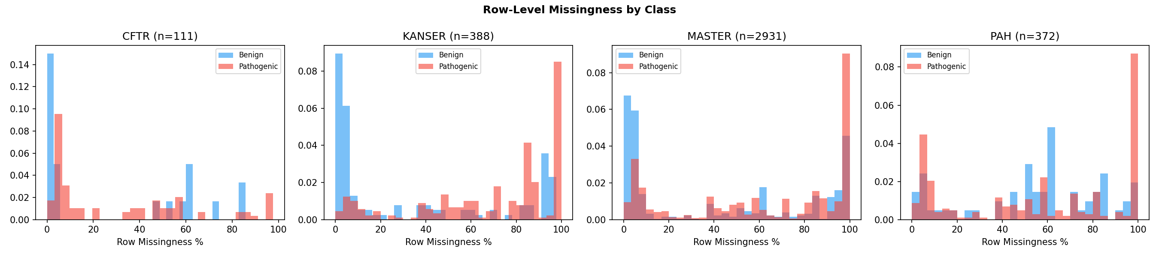
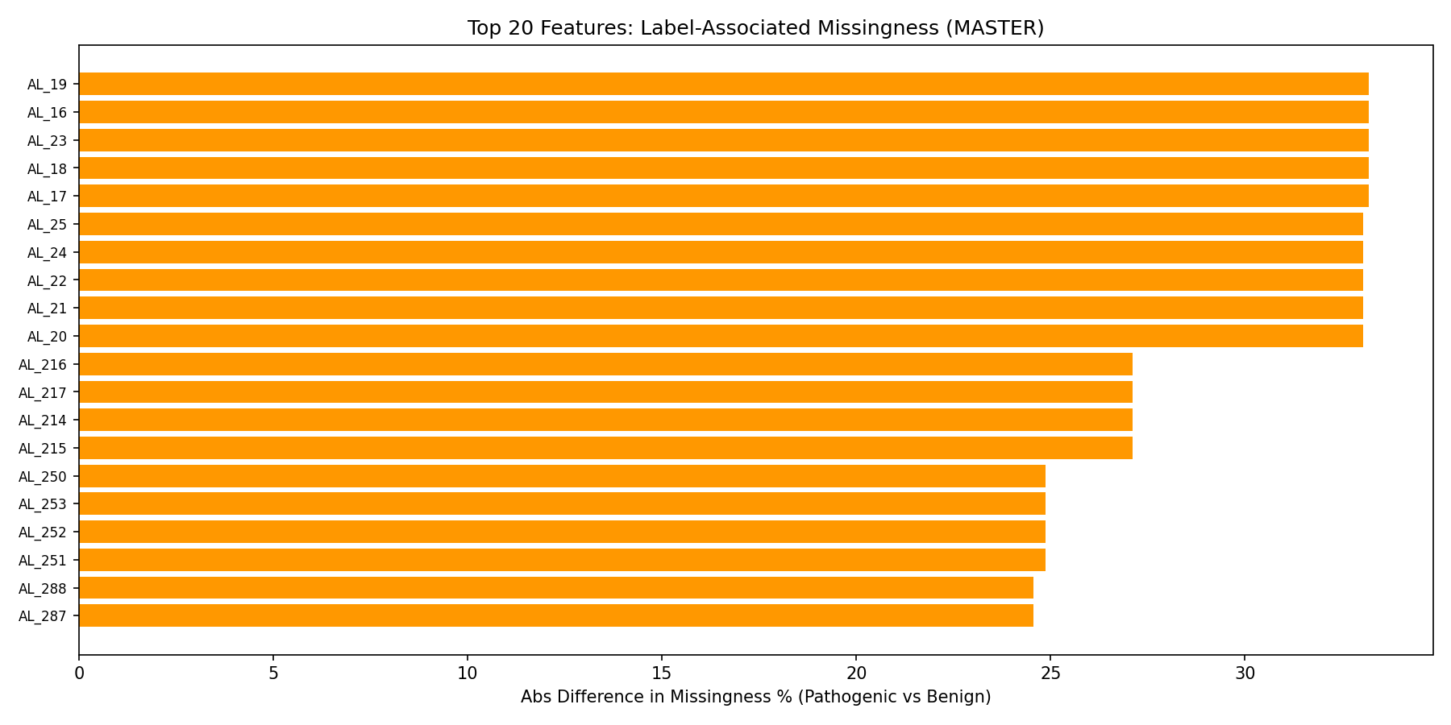

3. Duplicate & Label Noise
Dataset | ExactDuplicates | FeatureVectorDuplicates | ConflictingLabels | VariantIDDuplicates
CFTR | 0 | 0 | 0 | 0
KANSER | 0 | 3 | 0 | 0
MASTER | 0 | 116 | 1 | 0
PAH | 0 | 5 | 1 | 0
1 conflicting label in MASTER, 1 in PAH. Accept as label noise.
Variant_ID overlap exists between MASTER and all panels — use group-aware splitting.

4. Feature Transformation Plan
Feature type breakdown:
- Probability scores [0,1]: 336
- Binary flags: 0
- Continuous: 6
- Encoded categorical: 1
For tree-based models: NO transformation needed.
For linear models: StandardScaler for continuous, RobustScaler for EK outliers.

5. Encoding Strategy
Feature | NUnique | MissPct | SampleValues | RecommendedEncoding
CAT_1 | 30 | 37.02 | ['gnomADe_EAS', 'gnomADe_FIN', 'gnomADe_NFE', 'gnomADg_AMR', 'gnomADe_SAS', 'EUR | target_encoding_inside_CV (high cardinality) or CatBoost native
CAT_2 | 7 | 59.16 | ['AllofUs_EAS', 'AllofUs_EUR', 'AllofUs_AFR', 'AllofUs_AMR', 'AllofUs_OTH', 'All | target_encoding_inside_CV (high cardinality) or CatBoost native
CAT_3 | 5 | 12.25 | ['C/C', 'T/T', 'G/G', './.', 'A/A'] | ordinal (4-5 genotype values) or one_hot
CAT_4 | 5 | 12.25 | ['C/C', 'T/T', 'G/G', './.', 'A/A'] | ordinal (4-5 genotype values) or one_hot
CAT_5 | 5 | 12.25 | ['C/C', 'T/T', 'G/G', './.', 'A/A'] | ordinal (4-5 genotype values) or one_hot
CAT_6 | 3 | 97.71 | ['lcr', 'segdup', 'decoy&segdup'] | binary_flag (has_region_annotation)
AA_1 | 24 | 11.87 | ['R', 'N', 'P', 'V', 'G', 'L', 'I', 'S'] | ordinal_or_onehot (20 amino acids — physicochemical grouping optional)
AA_2 | 25 | 11.94 | ['Q', 'S', 'A', 'I', 'E', 'C', 'G', 'R'] | ordinal_or_onehot (20 amino acids — physicochemical grouping optional)
CAT_1: Label encode (30 categories); CAT_2: One-hot (7 categories)
CAT_3/4/5: One-hot (4-5 categories); CAT_6: Binary flag
AA_1/AA_2: One-hot or physicochemical grouping

6. Leakage & Circularity Preprocessing
Feature | Severity | Reason | Action | CorrWithLabel
EK_1 | LOW | Likely CADD (not ClinVar-trained); corr_w_label=0.085 | KEEP — low risk | 0.0851
EK_2 | LOW | Likely CADD (not ClinVar-trained); corr_w_label=0.316 | KEEP — low risk | 0.3163
EK_3 | MEDIUM | Unclear provenance; corr_w_label=0.296 | KEEP but monitor | 0.2961
EK_4 | HIGH | Likely ClinVar-trained meta-predictor [0,1]; corr_w_label=0.320 | ABLATION — test with and without | 0.3202
EK_5 | LOW | Unclear provenance; corr_w_label=0.154 | KEEP but monitor | 0.1545
EK_6 | HIGH | Likely ClinVar-trained meta-predictor [0,1]; corr_w_label=0.302 | ABLATION — test with and without | 0.302
EK_7 | NONE | Conservation score (phyloP/GERP++); corr_w_label=0.380 | KEEP — safe | 0.3797
EK_8 | LOW | Unclear provenance; corr_w_label=0.232 | KEEP but monitor | 0.2318
EK_9 | NONE | Conservation score (phyloP/GERP++); corr_w_label=0.322 | KEEP — safe | 0.3218
AL_223..AL_334 block | MEDIUM | Possible in-silico predictor outputs (avg |corr|=nan) | ABLATION — test model without this block | nan
Variant_ID | HIGH | Must not be used as feature; only for splitting/identification | EXCLUDE from features | nan
Critical: EK_4 and EK_6 are likely ClinVar-trained meta-predictors.
Action: Train models WITH and WITHOUT these features to quantify circularity.
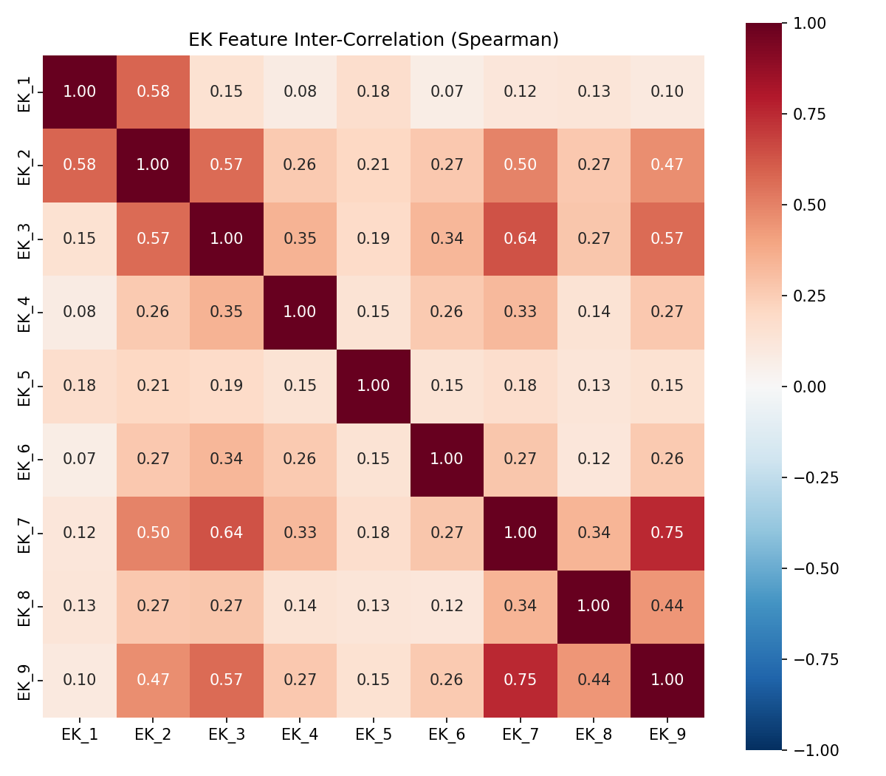

7. Panel-Specific Preprocessing
Panel | N | Pathogenic | Benign | ImbalanceRatio | MeanMissAL | ConstantCols | SharedWithMaster | Recommendation
CFTR | 111 | 90 | 21 | 4.3 | 31.4 | 70 | 77 | Global model + panel threshold; NO independent model
PAH | 372 | 310 | 62 | 5.0 | 56.5 | 91 | 255 | Global model + panel calibration; independent model risky
KANSER | 388 | 268 | 120 | 2.2 | 59.5 | 69 | 246 | Global model + panel calibration; test panel fine-tuning
CFTR: Global model only; PAH/KANSER: Global model + calibration
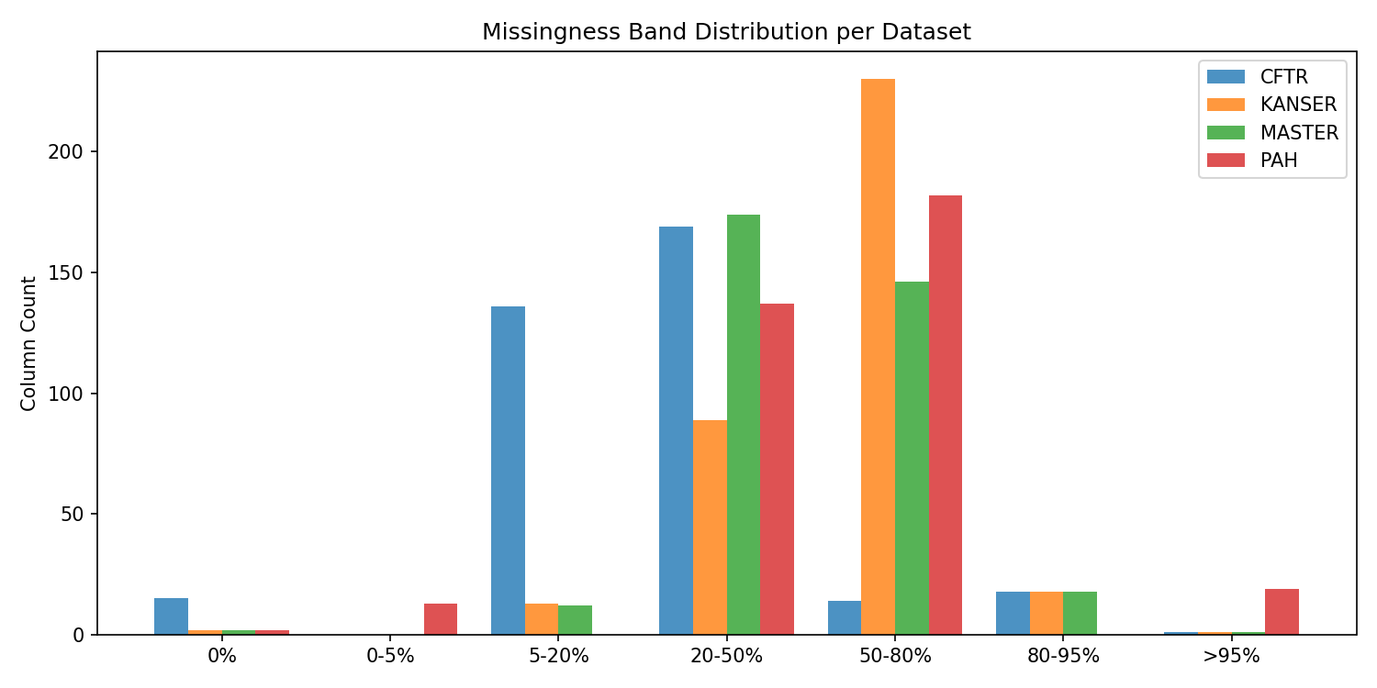

8. Class Imbalance Handling
Dataset | N | Pathogenic | Benign | PathRatio | ScalePosWeight | Recommendation
CFTR | 111 | 90 | 21 | 0.811 | 0.233 | class_weight + threshold_tuning
KANSER | 388 | 268 | 120 | 0.691 | 0.448 | class_weight
MASTER | 2931 | 2149 | 782 | 0.733 | 0.364 | class_weight
PAH | 372 | 310 | 62 | 0.833 | 0.2 | class_weight + threshold_tuning
Use class_weight/is_unbalance + PR-AUC optimization + sensitivity-constrained threshold.
Do NOT use SMOTE — synthetic genomic variants are biologically meaningless.

9. Preprocessing Pipeline Options

A: Minimal GBDT
Purpose: Fastest possible baseline to establish performance floor
Steps: Drop Variant_ID; drop global constants; native missing handling; class_weight; LightGBM
Benefit: Immediate benchmark; zero preprocessing risk
Risk: Missing categorical encoding; no missingness indicators
Proceed to Phase 3: YES — must do

B: Missingness-Aware GBDT
Purpose: Capture information in missingness patterns
Steps: Pipeline A + missingness indicator features + row-level miss count + one-hot CAT_3/4/5 + AA encoding
Benefit: Captures systematic missingness signal (especially KANSER differential)
Risk: Feature count increases; potential overfitting on indicators
Proceed to Phase 3: YES — recommended primary

C: Anti-Leakage GBDT
Purpose: Quantify circularity; honest performance estimate
Steps: Pipeline B minus EK_4, EK_5, EK_6; optionally minus AL_223..AL_334
Benefit: Proves model works without ClinVar-circular features
Risk: Performance will drop — that's the point
Proceed to Phase 3: YES — mandatory for report

D: Linear/Calibration Baseline
Purpose: Interpretable baseline + calibration reference
Steps: Impute median; standard scale; one-hot all cats; drop high-miss (>80%); LogisticRegression/ElasticNet
Benefit: Calibration analysis; linear separability check; SHAP baseline
Risk: Imputation introduces noise; lower performance expected
Proceed to Phase 3: YES — for calibration and interpretability

E: Panel-Calibrated Ensemble Prep
Purpose: Prepare meta-features for stacking with per-panel calibration
Steps: Pipeline B + OOF predictions from LGB/XGB/Cat + per-panel Platt scaling + threshold grid
Benefit: Highest expected performance; panel-specific adaptation
Risk: Complexity; overfitting meta-learner on small panels
Proceed to Phase 3: YES — final stage

10. Executive Summary
Is preprocessing needed? YES — but minimal for tree-based baseline.

Mandatory Steps (Before Any Model)
- 1. Drop Variant_ID from features
- 2. Drop 57 constant columns
- 3. Use class weights (73% pathogenic)
- 4. Stratified cross-validation

Recommended Steps (Pipeline B)
- 5. Add missingness indicator features
- 6. Encode CAT_3/4/5 (one-hot), CAT_1/2 (label encode)
- 7. Encode AA_1/AA_2 (one-hot)
- 8. CAT_6 → binary flag
- 9. Row-level missing count feature

Harmful Steps (AVOID)
- - Imputation for tree models
- - SMOTE/oversampling
- - Feature scaling for tree models
- - Target encoding outside CV folds

Phase 3 Start: Pipeline B
Day 1: Pipeline A baseline → Day 2: Pipeline B (main) → Day 3: Pipeline C (anti-leakage)

