TEKNOFEST Healthcare AI — Phase 3: Pipeline B Results
Generated: 2026-05-25 13:06
Model: LightGBM GBDT | CV: 5-fold Stratified | Features: 655

Executive Summary
OOF ROC-AUC = 0.8461
OOF PR-AUC = 0.9249
Best F1 = 0.8937 (threshold = 0.334)
Sensitivity ≥ 95% achieved at threshold = 0.359 (specificity = 0.5141)
Fold stability: ROC-AUC std = 0.0152
ECE (calibration error) = 0.0771

Overall OOF Metrics
Metric | Value
roc_auc | 0.8461
pr_auc | 0.9249
log_loss | 0.4127
brier_score | 0.1295
f1_at_05 | 0.8733
sensitivity_at_05 | 0.8660
specificity_at_05 | 0.6777
precision_at_05 | 0.8807
mcc_at_05 | 0.5361
balanced_accuracy_at_05 | 0.7719
accuracy_at_05 | 0.8158

Per-Fold Results
fold | roc_auc | pr_auc | f1 | sensitivity | specificity | mcc
1 | 0.8609 | 0.9350 | 0.8759 | 0.8698 | 0.6815 | 0.5449
2 | 0.8423 | 0.9265 | 0.8737 | 0.8767 | 0.6410 | 0.5210
3 | 0.8519 | 0.9318 | 0.8791 | 0.8791 | 0.6667 | 0.5457
4 | 0.8554 | 0.9266 | 0.8737 | 0.8605 | 0.6987 | 0.5456
5 | 0.8222 | 0.9035 | 0.8640 | 0.8438 | 0.7006 | 0.5252

Threshold Optimisation
Strategy | Threshold | Sensitivity | Specificity | F1 | MCC
default_05 | 0.500 | 0.8660 | 0.6777 | 0.8733 | 0.5361
best_f1 | 0.334 | 0.9563 | 0.4949 | 0.8937 | 0.5387
sensitivity_95 | 0.359 | 0.9502 | 0.5141 | 0.8935 | 0.5421
youden_j | 0.596 | 0.8288 | 0.7289 | 0.8600 | 0.5287
best_mcc | 0.370 | 0.9474 | 0.5205 | 0.8930 | 0.5417

Top 30 Features by Importance
Rank | Feature | Category | Gain
1 | EK_7 | extra_knowledge | 5335.0
2 | AL_327 | allele_annotation | 1340.6
3 | AL_16 | allele_annotation | 1270.4
4 | EK_9 | extra_knowledge | 1084.7
5 | EK_2 | extra_knowledge | 1049.5
6 | EK_6 | extra_knowledge | 915.6
7 | AL_26 | allele_annotation | 743.5
8 | AL_11 | allele_annotation | 741.7
9 | EK_8 | extra_knowledge | 717.7
10 | AL_7 | allele_annotation | 644.8
11 | EK_1 | extra_knowledge | 636.6
12 | EK_5 | extra_knowledge | 611.4
13 | AL_9 | allele_annotation | 610.4
14 | EK_3 | extra_knowledge | 602.7
15 | EK_4 | extra_knowledge | 588.3
16 | AL_8 | allele_annotation | 586.4
17 | AL_14 | allele_annotation | 572.4
18 | AL_10 | allele_annotation | 568.2
19 | AL_12 | allele_annotation | 523.9
20 | AA_1_R | amino_acid | 519.0
21 | AL_287 | allele_annotation | 496.0
22 | AL_215 | allele_annotation | 458.0
23 | AL_331 | allele_annotation | 420.5
24 | AL_315 | allele_annotation | 419.2
25 | AL_319 | allele_annotation | 374.6
26 | AL_18 | allele_annotation | 337.4
27 | AL_311 | allele_annotation | 326.0
28 | AL_186 | allele_annotation | 325.1
29 | AL_1 | allele_annotation | 316.4
30 | AL_15 | allele_annotation | 304.3

Per-Panel Performance
Panel | N | ROC-AUC | PR-AUC | F1@0.5 | Sens@0.5 | Spec@0.5
CFTR | 111 | 0.9402 | 0.9857 | 0.9371 | 0.9111 | 0.8571
PAH | 372 | 0.7720 | 0.9336 | 0.8893 | 0.8806 | 0.5000
KANSER | 388 | 0.9141 | 0.9547 | 0.9055 | 0.9478 | 0.6750

Figures
Roc Pr Curves
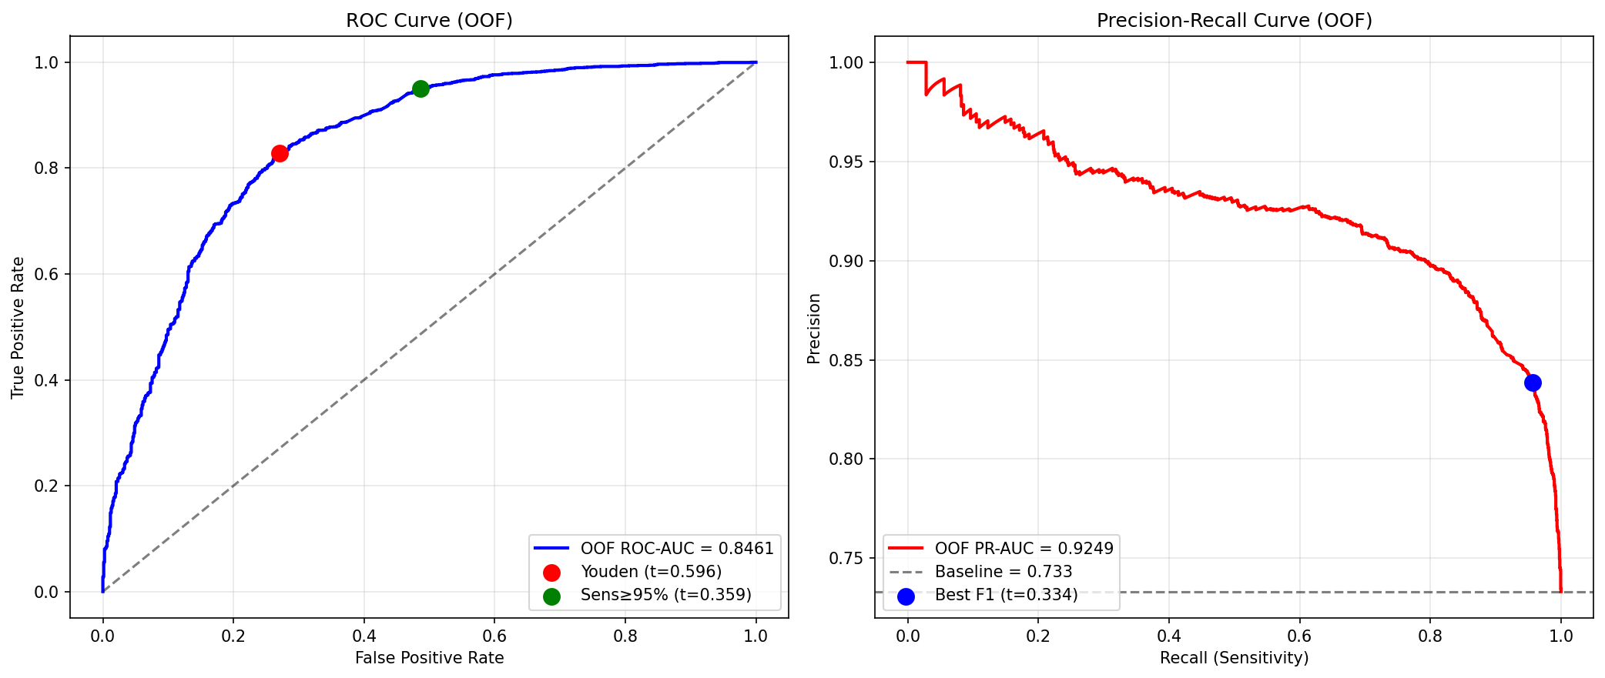
Confusion Matrices
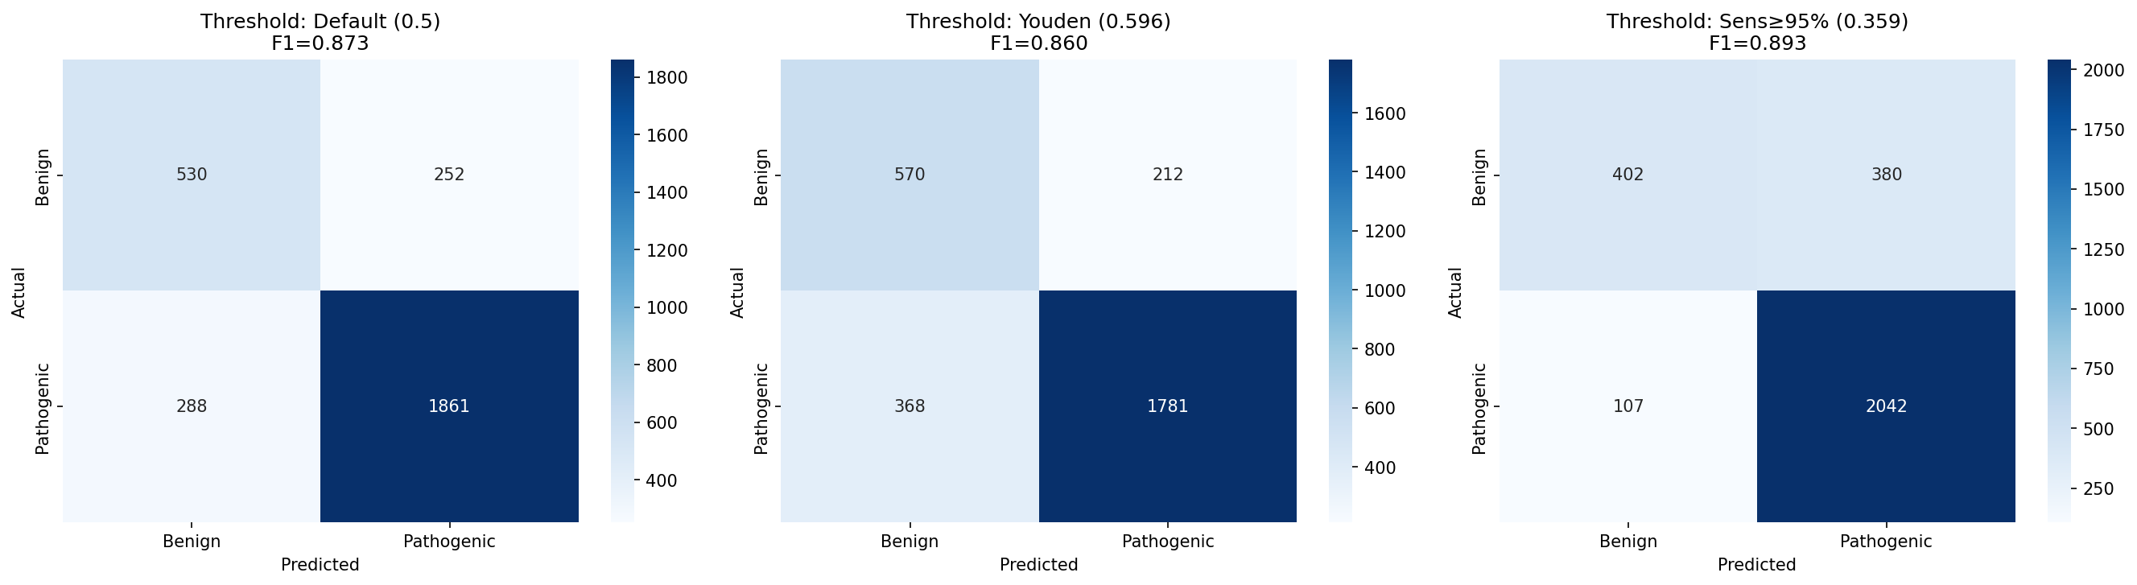
Feature Importance Top30
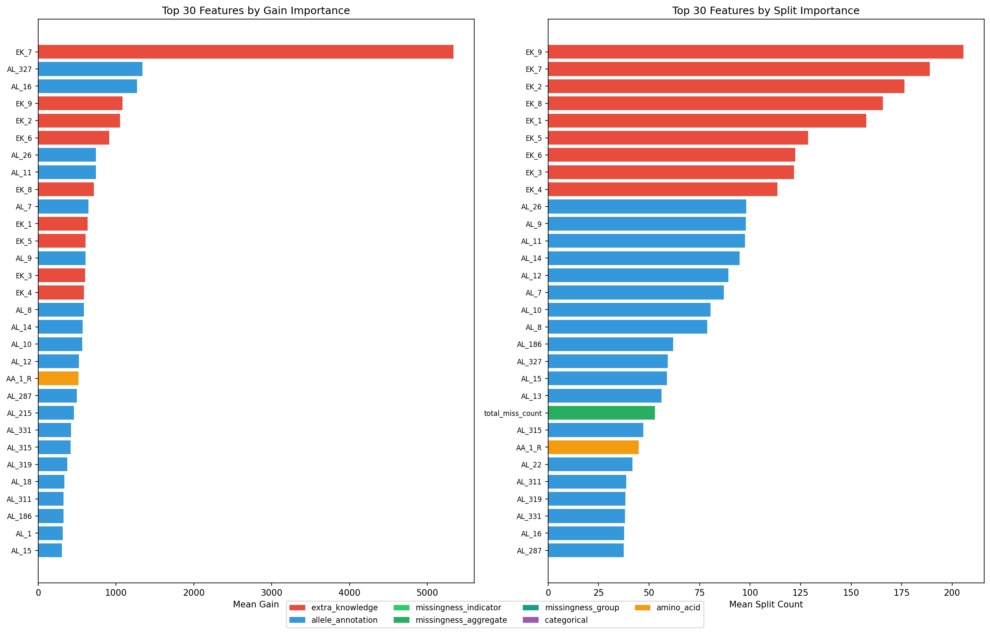
Prediction Distribution
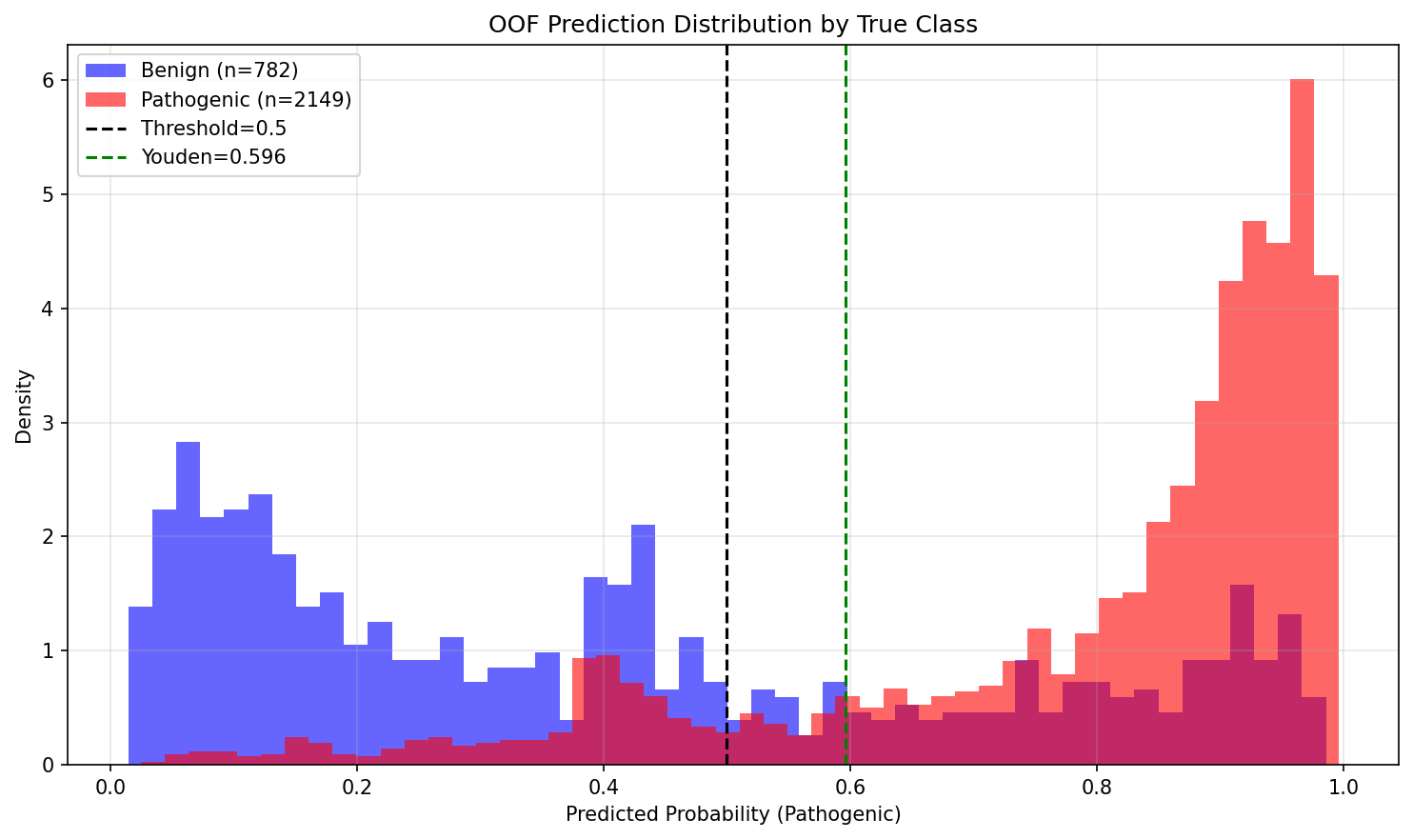
Calibration Curve
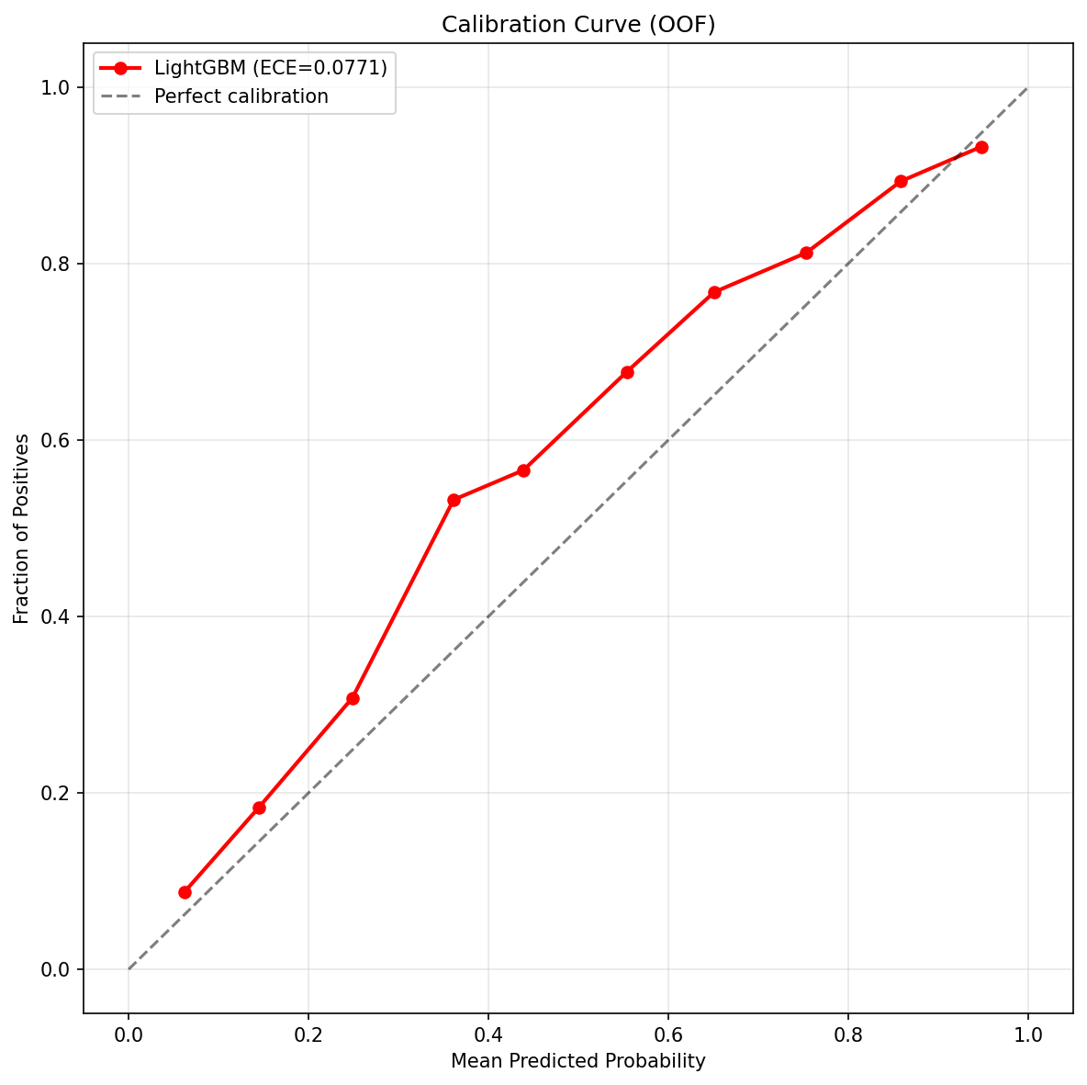
Fold Stability
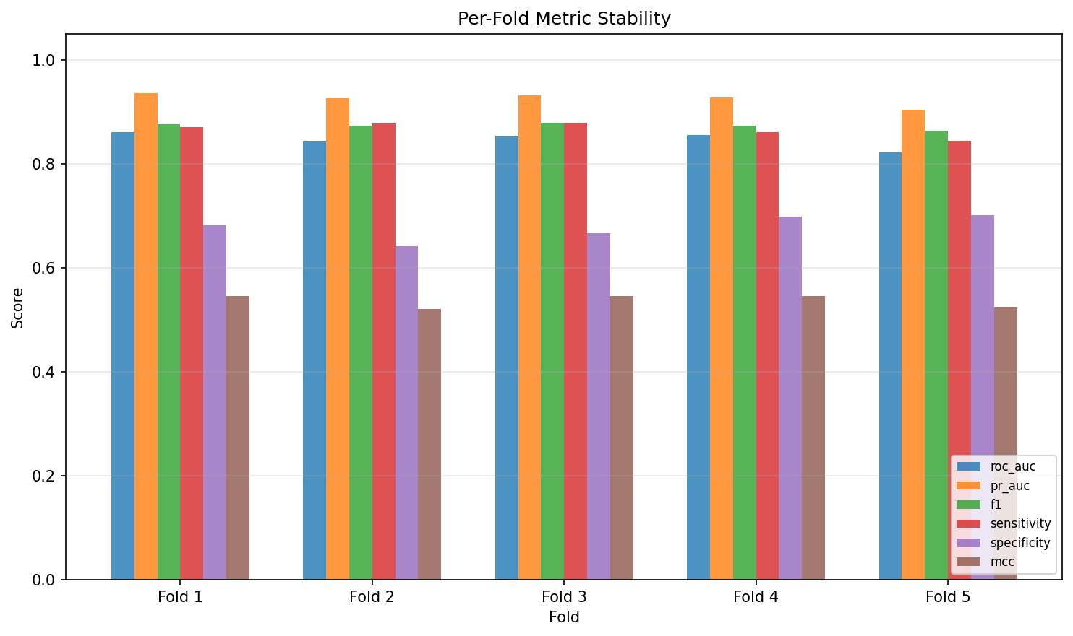
Threshold Sweep
