Phase 3 — Pipeline B: Missingness-Aware GBDT
TEKNOFEST Healthcare AI — Missense Variant Classification

1. Model Configuration
Parameter | Value
Algorithm | LightGBM (GBDT)
Learning Rate | 0.05
Num Leaves | 63
Early Stopping | 100 rounds
Class Balance | is_unbalance=True
CV Strategy | 5-fold Stratified
Total Features | 655
Training Samples | 2931

2. Preprocessing Steps
- Drop Variant_ID (leakage prevention)
- Drop 57 constant columns (zero information)
- Add 286 per-feature missingness indicators
- Add 7 group-level missingness counts + row-level totals
- One-hot encode CAT_3, CAT_4, CAT_5 (genotype fields)
- Label encode CAT_1, CAT_2 (population labels)
- Binary flag for CAT_6 (region annotation)
- One-hot encode AA_1, AA_2 (amino acids)

3. Overall OOF Performance
Metric | Value
ROC-AUC | 0.8461
PR-AUC | 0.9249
Log Loss | 0.4127
Brier Score | 0.1295
F1 @ 0.5 | 0.8733
Sensitivity @ 0.5 | 0.8660
Specificity @ 0.5 | 0.6777
MCC @ 0.5 | 0.5361
Balanced Accuracy @ 0.5 | 0.7719
Calibration Error (ECE) | 0.0771

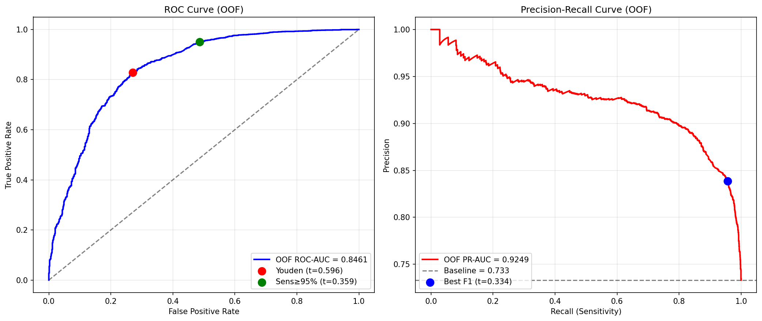

4. Per-Fold Stability
Fold | ROC-AUC | PR-AUC | F1 | Sens | Spec | MCC | Iters
1 | 0.8609 | 0.9350 | 0.8759 | 0.8698 | 0.6815 | 0.5449 | 90
2 | 0.8423 | 0.9265 | 0.8737 | 0.8767 | 0.6410 | 0.5210 | 101
3 | 0.8519 | 0.9318 | 0.8791 | 0.8791 | 0.6667 | 0.5457 | 59
4 | 0.8554 | 0.9266 | 0.8737 | 0.8605 | 0.6987 | 0.5456 | 83
5 | 0.8222 | 0.9035 | 0.8640 | 0.8438 | 0.7006 | 0.5252 | 52
Mean | 0.8465 | 0.9247 | 0.8733 | 0.8660 | 0.6777 | 0.5365 | 77
Std | 0.0152 | 0.0124 | 0.0056 | 0.0143 | 0.0234 | 0.0123 | 20

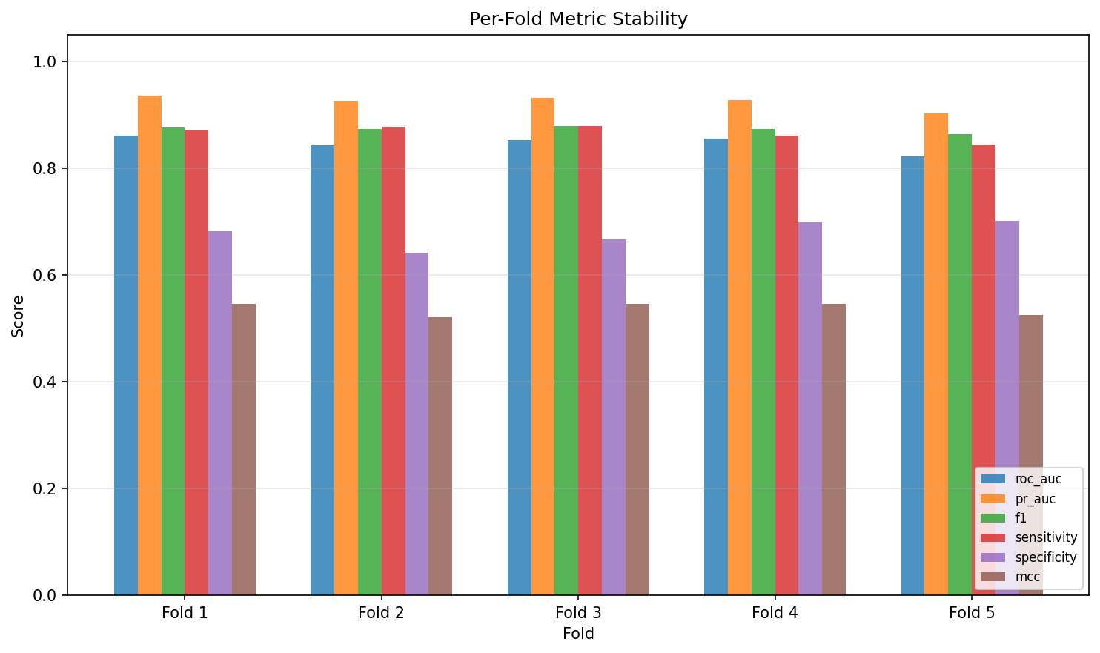

5. Threshold Optimisation
Strategy | Threshold | Sensitivity | Specificity | F1 | MCC
Default | 0.500 | 0.8660 | 0.6777 | 0.8733 | 0.5361
Best F1 | 0.334 | 0.9563 | 0.4949 | 0.8937 | 0.5387
Sens ≥ 95% | 0.359 | 0.9502 | 0.5141 | 0.8935 | 0.5421
Youden's J | 0.596 | 0.8288 | 0.7289 | 0.8600 | 0.5287
Best MCC | 0.370 | 0.9474 | 0.5205 | 0.8930 | 0.5417

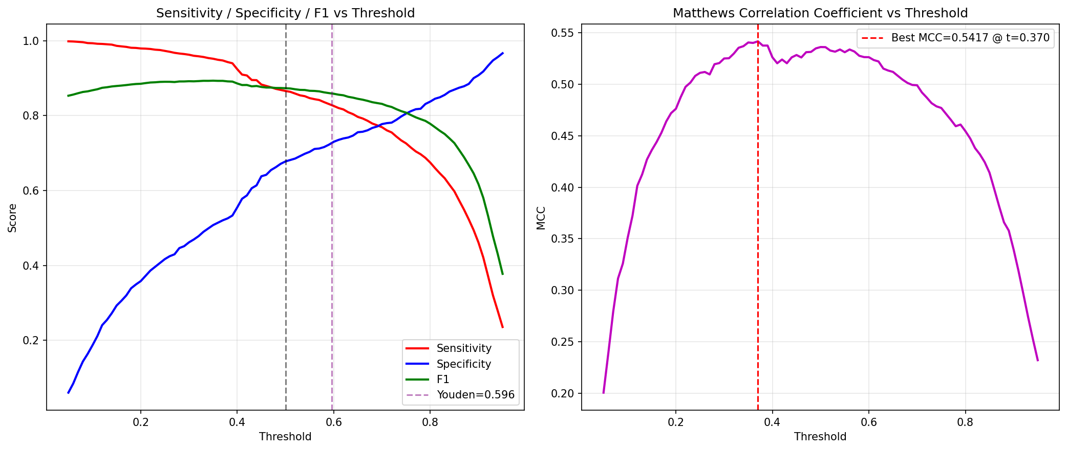

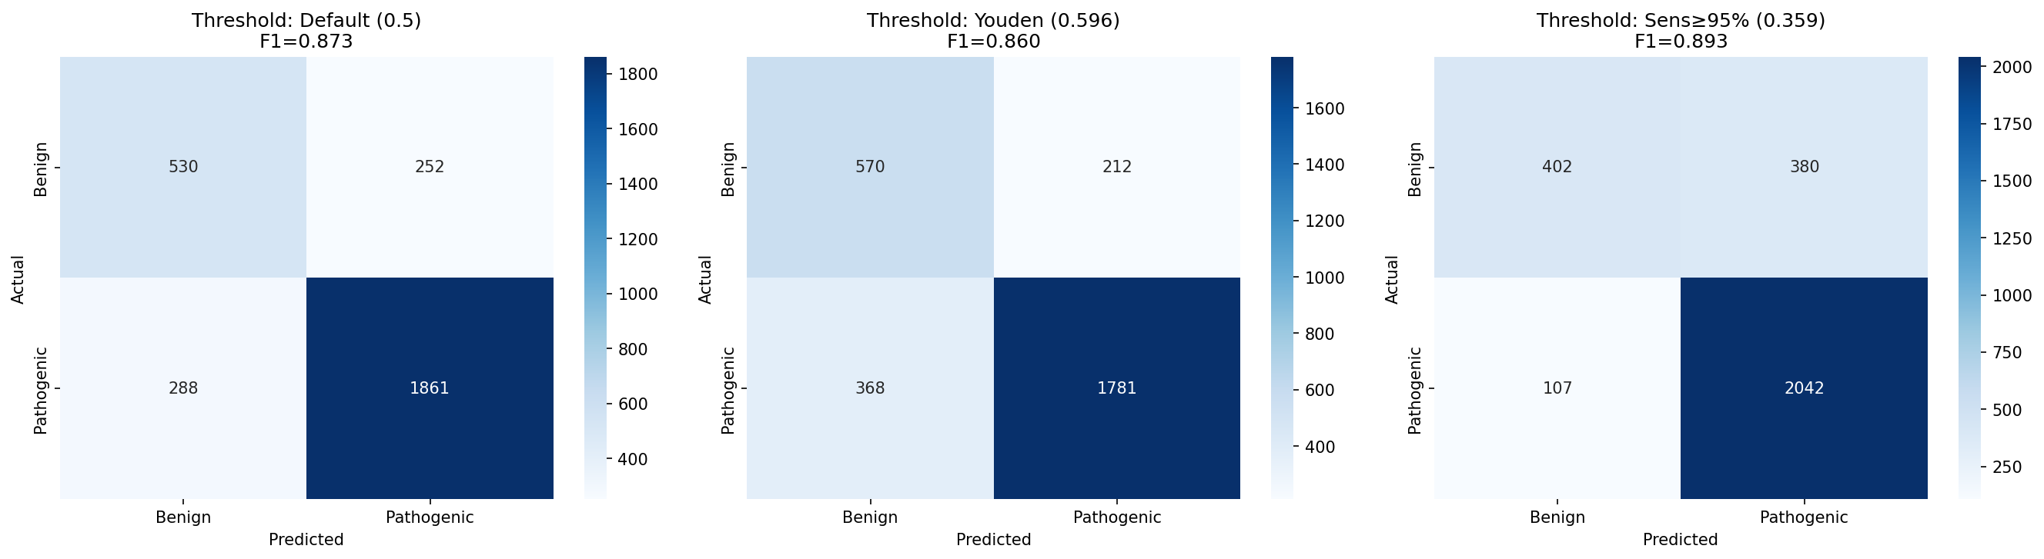

6. Top 30 Features
# | Feature | Category | Gain
1 | EK_7 | Conservation (phyloP) | 5335
2 | AL_327 | Allele annotation | 1341
3 | AL_16 | Allele annotation | 1270
4 | EK_9 | Conservation (GERP++) | 1085
5 | EK_2 | Extra (CADD raw) | 1050
6 | EK_6 | Extra (meta-predictor) | 916
7 | AL_26 | Allele annotation | 744
8 | AL_11 | Allele annotation | 742
9 | EK_8 | Extra knowledge | 718
10 | AL_7 | Allele annotation | 645
11 | EK_1 | Extra (CADD phred) | 637
12 | EK_5 | Extra knowledge | 611
13 | AL_9 | Allele annotation | 610
14 | EK_3 | Extra knowledge | 603
15 | EK_4 | Extra (meta-predictor) | 588
16 | AL_8 | Allele annotation | 586
17 | AL_14 | Allele annotation | 572
18 | AL_10 | Allele annotation | 568
19 | AL_12 | Allele annotation | 524
20 | AA_1_R | Amino acid | 519
21 | AL_287 | Allele annotation | 496
22 | AL_215 | Allele annotation | 458
23 | AL_331 | Allele annotation | 421
24 | AL_315 | Allele annotation | 419
25 | AL_319 | Allele annotation | 375
26 | AL_18 | Allele annotation | 337
27 | AL_311 | Allele annotation | 326
28 | AL_186 | Allele annotation | 325
29 | AL_1 | Allele annotation | 316
30 | AL_15 | Allele annotation | 304

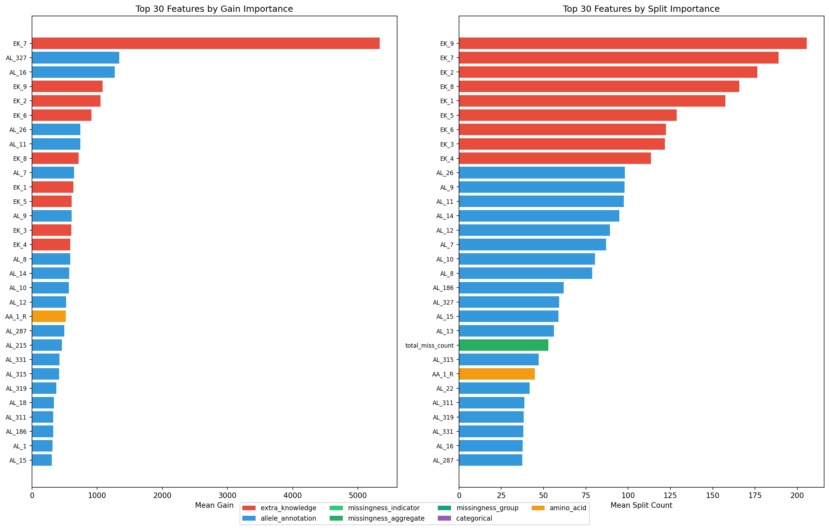

7. Feature Category Summary
Category | N | Mean Gain | Total Gain | Top Feature
Allele annotation | 277 | 84.1 | 23292 | AL_327
Extra knowledge | 9 | 1282.4 | 11541 | EK_7
Amino acid | 51 | 21.1 | 1078 | AA_1_R
Categorical | 23 | 15.7 | 361 | CAT_1_enc
Missingness (agg) | 2 | 144.8 | 290 | total_miss_count
Missingness (group) | 7 | 10.5 | 74 | miss_grp_al_39_95
Missingness (per-feat) | 286 | 0.0 | 5 | miss_EK_3
Missingness features contribution: 1.0% of total importance gain (368 / 36,641). Per-feature indicators were mostly unused; group-level and aggregate counts were more useful.

8. Per-Panel Performance
Panel | N | Shared | ROC-AUC | PR-AUC | F1@0.5 | Sens | Spec | Opt Thr
CFTR | 111 | 77 | 0.9402 | 0.9857 | 0.9371 | 0.9111 | 0.8571 | 0.413
PAH | 372 | 255 | 0.7720 | 0.9336 | 0.8893 | 0.8806 | 0.5000 | 0.205
KANSER | 388 | 246 | 0.9141 | 0.9547 | 0.9055 | 0.9478 | 0.6750 | 0.466

9. Calibration
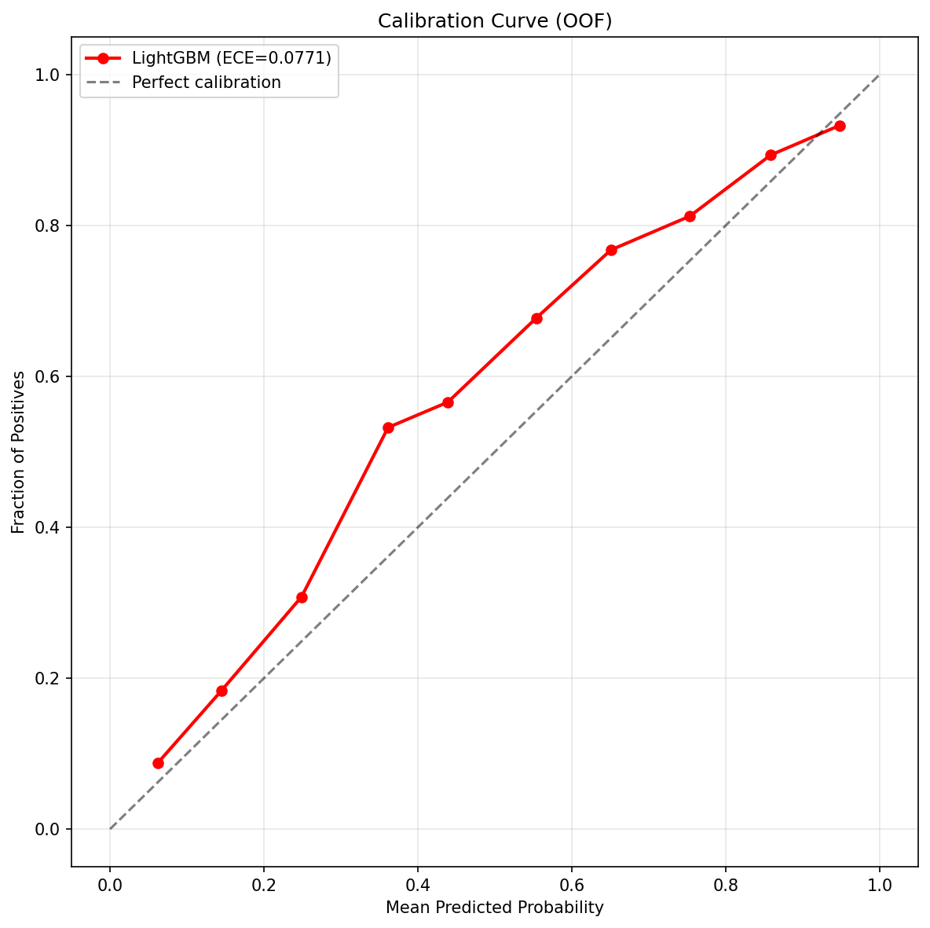

10. Prediction Distribution
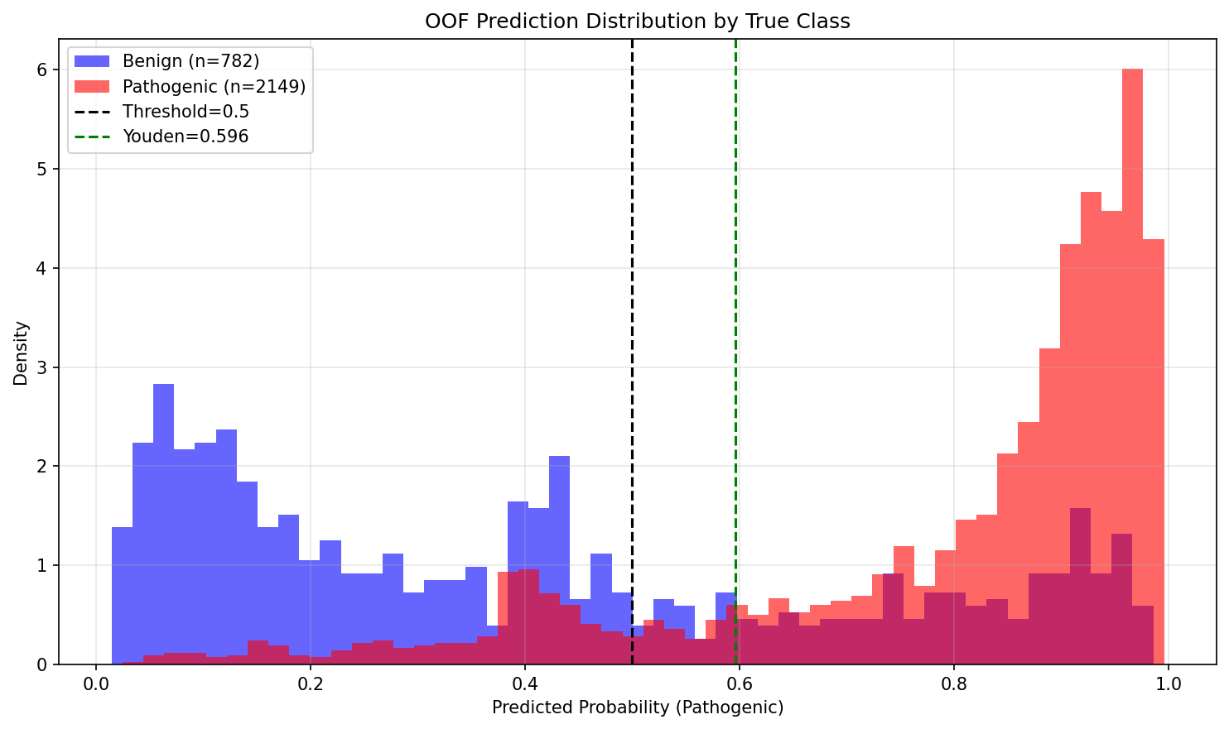

11. Next Steps
- Pipeline C: Drop EK_4/5/6, re-train to measure circularity impact
- Hyperparameter tuning via Bayesian optimisation
- XGBoost and CatBoost comparison runs
- Per-panel threshold calibration (especially PAH)
- Stacking ensemble (Pipeline E)

