**Gebze Technical University**

**Computer Engineering**

**CSE 222 - 2019 Spring**

**HOMEWORK 5 REPORT**

**AHMET MELIH YANALAK**

**151044044**

**COURSE ASISTANT:**

OZGU GOKSU

# INTRODUCTION

## Problem Definition

The running time of a program is one of the most necessary criterion for

programmers.If there is a possibility to make it faster then it should have been

done.One of the best ways to do is using threads.Thread is the structure that

provides running multiple different tasks parallel.While using multiple threads, the

thread doesn’t need to wait other threads to finish its task which is a considerable

profit in terms of running time.

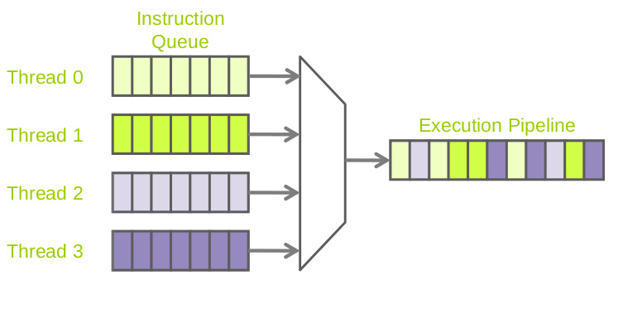

## System Requirements

This program requires a hardware with 9N byte memory(each pixel has 3 colors with 8 bit

and there are 3 queues),4 kernels that will provide to use 4 threads parallel,Operating

System that can run 4 threads properly and support IntelliJ IDEA Community Edition 2018

3.5 and also JVM and its libraries to process image.

# METHOD

## Class Diagrams

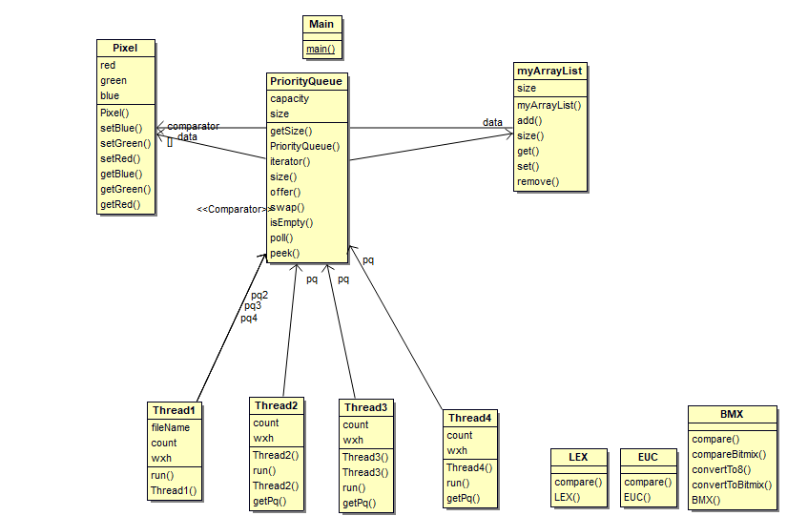

## Use Case Diagrams

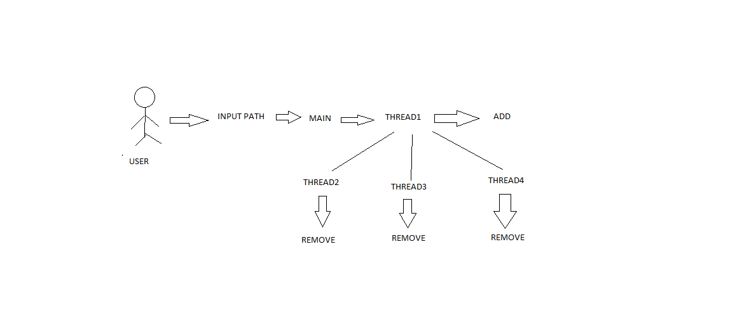

## Problem Solution Approach

In this project,the task is to process an image according to 3 different

filters.The program should read all the pixels from png file and insert them one by

one into 3 different filter type of queue.The program is splitted into 4 threads which   
  
will increase efficiency.

The task of thread 1 is to read pixels and insert each one into 3 different   
  
queues.While thread 1 doing it,the other threads(2,3,4) that is responsible for   
  
popping the pixel that has max priority and print it on screen.Of course,thread 2,3,4   
  
should give some time(100 pixels) to thread1 to insert acceptable pixels before   
  
removing pixels.

In order to insert pixels into queues by using offer method of   
  
PriorityQueue,the underlying self-implemented ArrayList has been used.Add method   
  
of ArrayList increases the capacity and copies the array to the new one.The time   
  
complexity of this method is O(n).

In the main loop add method is used for all pixels.If N is the number of pixels then the   
  
complexity of this program is O(n^2).Cause of using 3 pixel queue,the space   
  
complexity is 3N.

# RESULT

## Test Cases

The program is tested with different 2 picture file(png,jpg),different size of pixels with more than 300 000 and less than 100 which will cause of working thread 1 only.

## Running Results

PROCESSING EXAMPLE.PNG

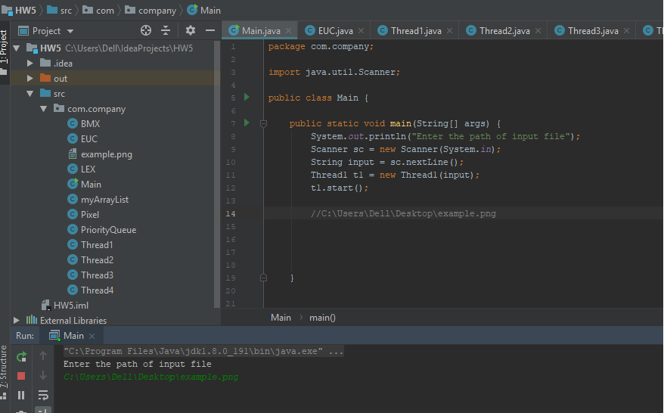

THREADS ARE RUNNING RANDOMLY

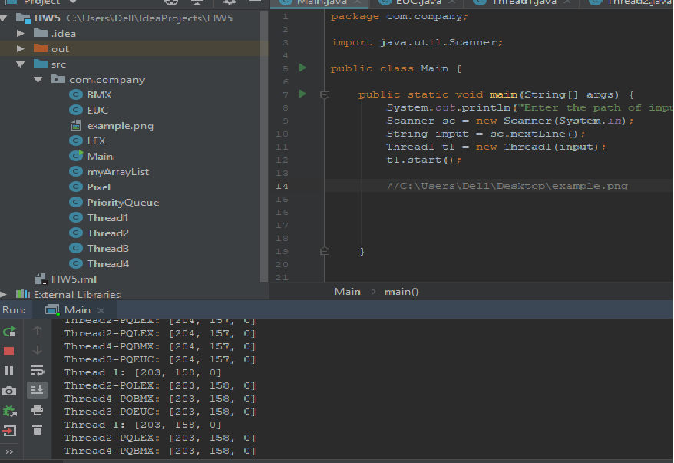

PROGRAM FINISHED PROPERLY

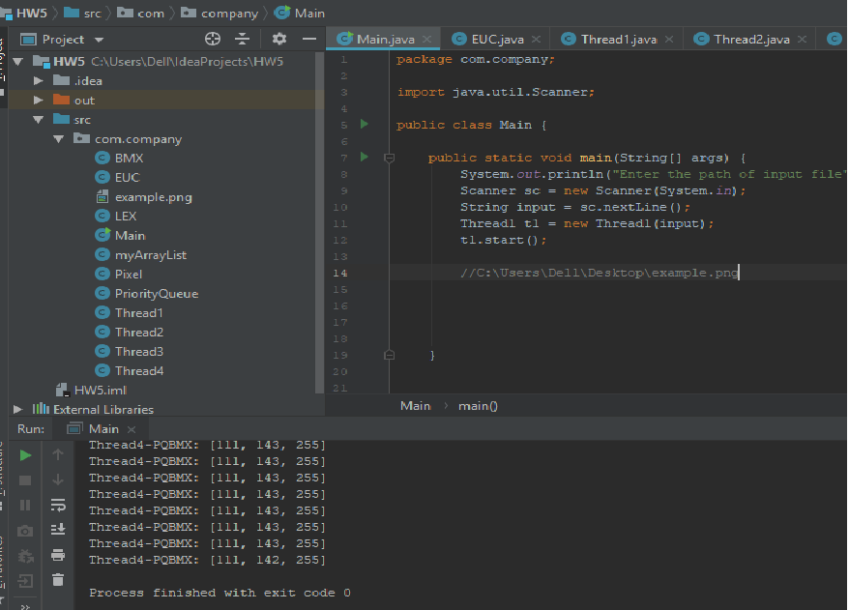

THE TEST WITH 70 PIXEL INPUT(ONLY THREAD1 SHOULD RUN)

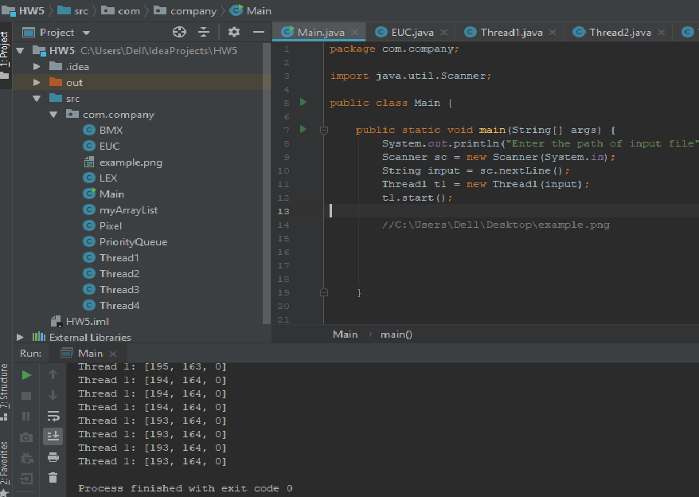

THE TEST WITH JPG FILE

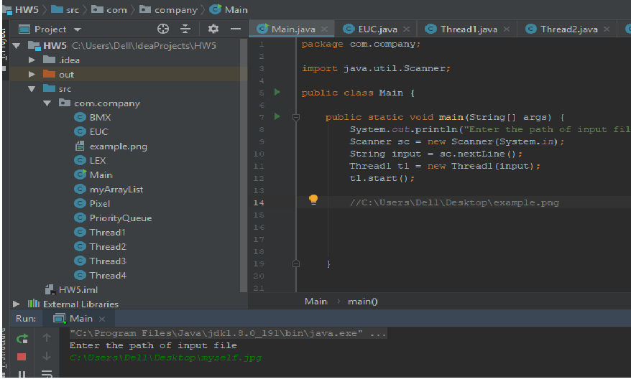

PROCESSING JPG FILE

