Current State of the Design (state of art)

gt30A

PARAMETERS/sandart

Insulating maeterial

layer design

2d design

effect of Er on design

**Gt30a Parameters.**

The subject transformer is classified as gas insulated inductive voltage transformer. The manufacturing and testing of the voltage transformer is done according to IEC 61869-1 / IEC 61869-3 standard. The voltage transformer satisfies the following parameters

Model Name : Gt30a

Rated System Voltage : 34.5 /√ 3( line - neutral)

Rated Frequency : 50 hz

Secondary Voltage Output : 100/√ 3 ( line - neutral)

Highest Voltage for Equipment Um : 36 kV (Rms)

Rated Power Frequency withstand Voltage : 70 kV (Rms)

Rated Lightning Impulse Withstand Voltage : 170 kV (peak)

Burden: 10 VA

Rated Accuracy Class: 3P

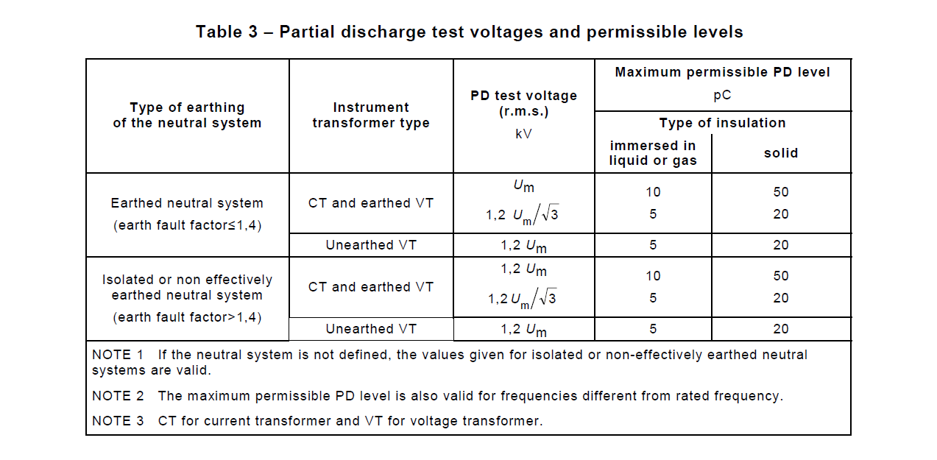

IEC 61869-1

Gt30a is a 36 kV transformer with non effectively earthed neutral system and therefore the partial discharge level should be below 10 pC at 43.2 kV and 5 pC at 24.9 kV. The discharge measurement is done in accordance with IEC 60060 and the noise level of the measurement system should be below the maximum allowed pC level for the given voltage.

The resultant values of the magnetic design

Primer Number of Turns: 50461 - Ø0.12mm magnet wire

Secondary Number of Turns:147 - Ø1.5mm magnet wire

Core Area:

The transformer is subjected to following tests;

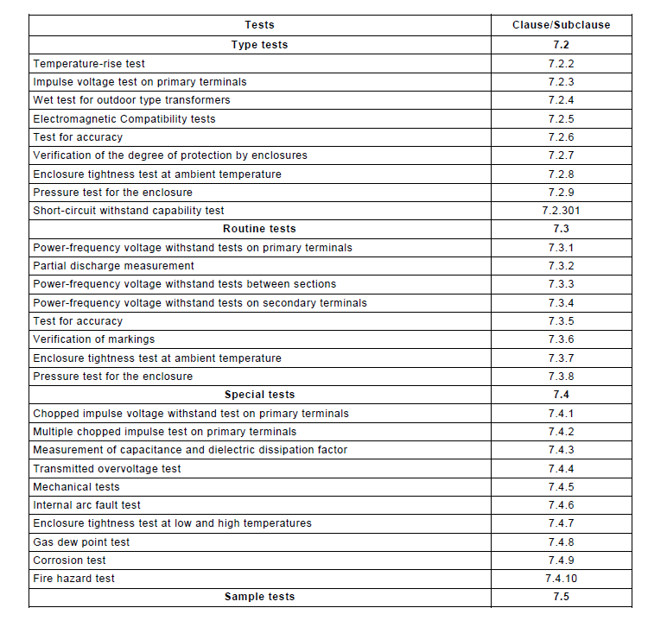

IEC 61869-3

Gt30a mainly fails in the partial discharge and power frequency voltage withstand tests therefore the main focus will be on those.

DIN boyutsal limitler eklenecek

**Insulating materials in Gt30a**

In high Voltage Insulation applications there are various insulation materials in all gas, liquid and solid forms. The main parameter of the insulation material is dielectric strength which also varies with the applied voltage being AC, DC or impulse. The other determining parameters of the material choice are the application conditions such as working temperature , type of the casing , humidity ..etc and the cost.

Gas Insulated Voltage transformers mainly have three insulation which are epoxy resin (solid) , Sf6 (gas) , kraft paper (solid). Since there is more than one type of insulation included the distribution of the electrical field will be effected by the difference of the relative dielectric constants and the design should be done with accordance. The failure of the transformer due to the partial discharges are related with the AC strenght of the insulation material.

***Epoxy Resin***

Üretimde kullanılan reçinen firma adı ve ürün kodu yazılmalımı ?

Epoxy resin is a mixture consisting of filler (silica or similar materials) , hardener , resin , accelerator and depending on the application flexibilizer. Epoxy resins are widely used in the both low voltage and high voltage applications. In this application the epoxy resin casing of the transformer both provides electrical insulation and mechanical support.

Typical values for a silica filled Epoxy resin Mixture:

Specific gravity (g/ml) :1.7-1.8

Relative Dielectric Constant : 3.8-4.6

Dielectric Loss Tangent: 30-200

Volume Resistivity( Ω.cm): 10^16

(Okabe et al. 2006)

The mechanical and the electrical properties of the epoxy resin mixture varies with the mixture receipt and resin papering process. For this specific application mechanical strength of the resin is secondary to the electrical values. Therefore the filler should be near to the lower allowed limit of the Resin Tds to increase the breakdown strength of the mixture.

To get a good quality of resin mixture in each production the process must be controlled and the temperature, humidity of the facility must be stable. To avoid the mistakes caused by the human factor , the resin should be prepared in a fully automatic enclosed system . The system used for the production of the gt30a is manual.

There are two methods of curing the epoxy resin. First one , the one will be utilized, is the conventional vacuum casting and the other one is APG (Automatic Pressure Geletion).In both methods after the initial curing process the product is moved to an oven for post-curing. The resin is susceptible to the thermal shock in this transfer stage therefore the should be no air current in the production area. After Post-curing it is better to reduce the temperature step by step again to avoid the thermal shock. Thermal shock causes the formation of the micro cracks inside the body and results in the partial discharge inception and sometimes puncture breakdown in the power frequency routine tests.

epoxy resin process flowchart ekle

Another factor that causes micro cracks in the resin is the internal mechanical stresses that are caused by the shrinkage of the body during cooling period after the post curing. To avoid any cracks , suitable amount of flexibilizer should be added in to the mixture. Flexibilizer reduces the glass transition temperature (Tg) of the resin but since voltage transformers operates with negligible power , rise of the temperature is not a problem.

The electrical properties of the epoxy used in the manufacturing is as following;

Er:4.0

Breakdown strenght: 24 kV/mm (under uniform AC voltage)

.....

......

The Er value of the resin mixture is very crucial for the design so a 8 mm plate sample is tested with shering bridge equipment to validify the value.

epoxy shering bridge ekle

***Sf6***

Most commonly used gas in the insulation applications is Sf6.

*Kraft Paper*

*Sf6*

**Layer design**

Layerların her zaman en baştan delindiğini analizlerin o yüzden en baş kısma uygulandığına burayamı yoksa baska yeremi yazılacak