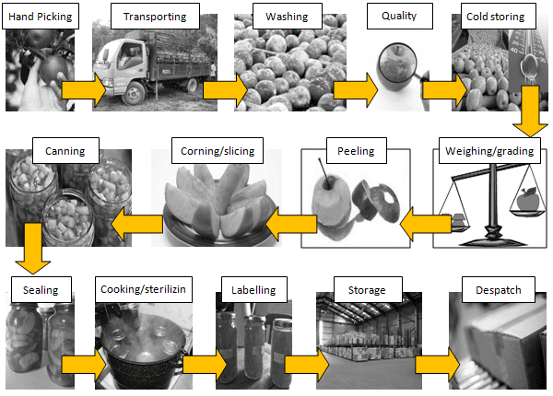

The diagram shows how fresh apple is canned and it gives information about the process to make canned fruit from apple.

Generally, apple is fresh fruit that can be saved by using a variety of way. So companies make canned from apple for durable, as a result, apple can be consumed by the society without having to wash it again and ready to eat.

Firstly, apple is picked from trees by hand. It is then transported to the cannery by large trucks. After that, at the cannery, apple is washed with using clean water and selected good quality, this mean, poor quality of apple is removed. Following, the selected good quality of apple is put into cold storage.

When it is ready for canning, apple is weighed and graded. The grading ensure that the apple of similar size is kept together. After this, apple is peeled and the cores are removed. It is then sliced into required size.

Secondly, apple is put into cans by using bottle, continuously juice or syrup is also added to cans. Once the cans have been filled, they are sealed. Then it is cooked over heat to ensure that the cans are sterilized. When the cans are cooled, a label is attached and they are placed into storage.

Finally, the canned of apple is ready to despatched to be sold to supermarket or it can be also imported to others countries.

Overall, the process is making canned apple that has many steps, totally 14 steps for getting good products. As a result, it can be durable before it is bought by consumer.