CAPSTONE PROJECT REPORT
(Project Term August-November 2025)

IOT-BASED MEDICAL EMERGENCY RESPONSE SYSTEM

Submitted by

Chiedza Mutinha | 12209501
Godswill Nkenganyi | 12223095
Precocious Ndebele | 12202863
Daniella Esther Melingui Ndiengwasa | 12224313
Alvin Awuku Akoamah | 12224362

Project Group Number: KC549

Course Code: CSE339

Under the Guidance of

Mr. Pardeep Kumar,
Assistant Professor,

School of Computer Science and Engineering



TABLE OF CONTENT
1. Introduction
1.1 Objective of the Project
1.2 Description of the Project
1.3 Scope of the Project
1.3.1 Use Case Model
• Use Case Diagram
• Use Case Table

2. System Description
2.1 Customer / User Profiles
2.2 Assumptions and Dependencies

2.3 Functional Requirements
2.3.1 Real-time Vital Signs Monitoring
2.3.2 Environmental and Contextual Monitoring
2.3.3 Automated Emergency Detection and Classification
2.3.4 Multi-Channel Notification & Alert Generation
2.3.5 Geofencing and Location Tracking
2.3.6 Dispatch Support and Resource Management
2.3.7 Secure Medical Data Retrieval & Sharing
2.3.8 Local and Remote Decision Support
2.3.9 Logging, Audit Trails & Forensics
• Functional Requirements Summary Table
• Figures
– Figure 2.3-1: System Block Diagram (Edge–IoT–Cloud)
– Figure 2.3-2: Wearable Sensor Placement
– Figure 2.3-3: Alert Workflow Diagram
2.3.10 Use Cases & Acceptance Tests

2.4 Non-Functional Requirements
2.4.1 Performance & Latency
2.4.2 Reliability & Availability
2.4.3 Security & Privacy
2.4.4 Scalability & Interoperability
2.4.5 Maintainability & Upgradability
2.4.6 Usability & Human Factors
2.4.7 Resilience & Fault Tolerance
2.4.8 Regulatory & Compliance
2.4.9 Privacy-Preserving Data Retention
• Non-Functional Requirements Summary Table
• Figures
– Figure 2.4-1: Latency Comparison Graph (Edge vs Cloud)
2.4.10 Testing, Validation & Certification Strategy

3. Design
3.1 System Design
3.1.1 E-R Diagram
3.1.2 Data Flow Diagrams (DFDs)
• Level 0 DFD
• Level 1 DFD
• Level 2 DFD
3.2 Database Design
3.2.1 Database Schema

4. Scheduling and Estimate
4.1 Project Timeline
4.2 Gantt Chart
4.3 Effort Estimate
4.4 Resource Requirements
4.5 Risks and Time Buffer

- Introduction
The IoT has swept the healthcare industry, making it possible to monitor the patient remotely and, computerized medical response technology. In the given project, the consideration is on the development of an IoT based medical emergency notification device which continuously checks vital signs and autonomously informs care providers when there is an emergency e.g. cardiac arrest[15], stroke, falls, or respiratory failure. The system will facilitate real-time tracking and fast response, which will be beneficial avoid serious complications or death. The device involves the application of IoT sensors, wireless communication, microcontrollers, and cloud platforms that would identify abnormal health conditions and communicate the same to the caregivers in real-time[4,19].
1.1 Objective of the Project
The primary aims of the medical emergency detecting device based on the IoT are:
- To provide constant monitoring of the heart rate, body temperature, oxygen. saturation, and movement with the help of IoT sensors[4].
- To automate the process of detecting anomalies or an emergency[3,10]. Mobile To provide real time alerts to family members or hospitals through SMS to notify them of the caregiver. app notifications, or email[2].
- To reduce the response time in case of an emergency and eliminate unnecessary losses[17].
- To design a cheap, lightweight, and energy efficient system that can be used by the elderly patients with chronic illnesses or high risks[1]. To store health information within cloud so that it can be analyzed and accessed remotely in the future[14].
1.2 Description of the Project
The device comprises of wearable or miniature sensors attached to a microcontroller like. ESP32, Arduino, or Raspberry Pi[4]. These sensors monitor vital information on a constant basis: heart rate, Body movement, e.g. SpO2, and body temperature. The microcontroller processes this data using predefined thresholds or machine-learning algorithms[20]. If an emergency is detected, the system:
- Notifies caregivers with patient details and GPS location[2].
- Contacts emergency responders, hospitals, or family members[7].

- Logs medical data to a cloud dashboard for healthcare providers[1].
The system works 24/7 and requires no user input during emergencies. It can be monitored remotely through a mobile or web interface.

1.3 Scope of the Project
This project will enhance emergency detection in homecare and clinical environments[19]. The scope includes:
- Continuous real-time monitoring of patient vitals[4].
- Early identification of health emergencies[3,10].
- Instant automated alerts via SMS / Email / App[2].
- Cloud-based data storage and monitoring dashboard[1,14].
- Support for elderly, disabled, remote, or chronic condition patients[7].
- Portable and low-power IoT design[4].
1.3.1 Use Case Model
Paste your Use Case Diagram here.
Use Case Table
Use Case ID | Use Case Name | Primary Actor | Preconditions | Postconditions | Description
UC-01 | Monitor Vital Signs | Patient | IoT device is powered on and attached. | Vital signs monitored and recorded. | System collects vital health data continuously.
UC-02 | Detect Emergency | System | Vital thresholds are set. | Emergency detected or not. | System analyses data to detect anomalies.
UC-03 | Send Alert | System | Emergency detected. | Alert sent to contacts. | System sends emergency alerts via SMS or email.
UC-04 | Access Patient History | Medical Provider | Database operational. | Data accessed. | Provider views historical patient health data.
UC-05 | Configure Thresholds | Admin/Doctor | Settings interface accessible. | Parameters updated. | Doctor customizes thresholds for monitoring.
UC-06 | System Maintenance | Admin | System is connected. | Maintenance completed. | Admin performs updates and system checks.

2. System Description
2.1 Customer/User Profiles
The proposed healthcare device is one that tracks and responds to data used by AI and IoT technologies. real-time observation of the emergencies can be beneficial to a varied user population[22]. These include:

Patients with Chronic Diseases: Constant reporting of vital signs such as glucose content, blood pressure. pressure, and heart rate would be highly beneficial to patients who control long-term ailments like diabetes, heart disease and hypertension[1]. The equipment assists in the identification of atypical patterns at a tender age leading to a prompt response of the medical staff.

Wearable health monitors can also be used by older adults, especially those that are older, to monitor such vital parameters as heart rate, blood temperature, oxygen levels, and temperature[4,19] in people who are living alone or in remote locations. As the health is detected, they can be assured of safety. resolving the issue before the heart attacks or strokes and reaction to the emergency.

Emergency Medical Personnel: This device may be used by medical practitioners in the Emergency treatment department and, in that manner, send real-time notifications related to important health-related data, such as paramedics or an emergency room team[5]. This would allow them to prepare in advance concerning the potential emergencies, and improve the speed and efficiency of care[8].

Post-Surgical Patients: Continuous monitoring of patients who have undergone surgery, particularly having a high risk profile is helpful in confirming that their recovery is going on well[1]. The machine will give the data to the healthcare practitioners that will enable them to identify complications including infections or heart attacks at an early stage.

Fitness Enthusiasts and Athletes: Fit people who monitor their fitness can use the device to monitor the real time heart rate, blood pressure, and other vital signs on exercises. The gadget will help them to be aware about any unusual health developments, avoiding overstrain or harm to their bodies in case of physical exercise.

These profiles depict a wide range of users who would find the healthcare device profiling very helpful to them as it can monitor and project medical emergencies in real-time, thereby guaranteeing improved results due to early identification of the condition and response.

2.2 Assumptions and Dependencies
- IoT devices will have stable internet connectivity.
- Users (patients and caregivers) can operate basic mobile applications.
- The healthcare or home environment supports cloud-based data storage.

- Sensors are properly calibrated for accurate readings.
- Emergency contact details are set correctly in the system.
- The system depends on availability of electricity or charged battery.

2.3 Functional Requirements
This section provides a list of functional requirements of the Smart Emergency Response Device and describes them. Functional requirements explain the functions that the device should be able to offer to identify, categorize, communicate, and assist the decision-making process in case of medical emergencies. Based on the uploaded review paper and the formatted material, the following descriptions have been obtained. The requirements include intent, input, output and acceptance criteria.
2.3.1 Vital Signs Monitoring in Real-time.
Purpose: To constantly record the physiological indicators of patients (heart rate, blood pressure, body temperature, respiratory rate, SpO2)[4,15].
Input: Wearable pulse sensor data, temperature sensor, ECG/Pulse Ox sensor, and sensor data.
Outputs: Vital streams with time stamps, aggregate health indicators, and anomaly flags.
Acceptance Criteria Before a normal network condition Sampling rate should be medically appropriate (at least 1 Hz heart rate, and higher), end-to-end latency between sensor and edge processing should be less than 100 ms, and the error margin should also fall within acceptable clinically acceptable criteria, as specified by device specifications[14,17].

2.3.2 Environmental and Contextual Monitoring.
Purpose: Keep track of the surroundings surrounding the patient (air quality, ambient temperature, smoke, CO, fall detection using accelerometers) to create context of emergency[18].
Components: Air-quality sensors (MQ-series or professional environmental sensors), accelerators (MPU6050) and gas sensors, as well as having Bluetooth location devices (BLE).
Outputs: Situational awareness of risky levels of CO, environmental monitoring and integrated risk score.
Acceptance Criteria: Detection of environmental anomalies within 2 seconds of reaching the threshold, the ability to combine patient vital information to produce composite levels of risk.
Automated Emergency Detection: This entails the use of a computer algorithm, which attempts to identify a vehicle with specific characteristics and specify its classification. Automated Emergency Detection and Classification: This involves applying a computer algorithm, which will seek to recognize a car with certain features and declare its classification.
Purpose: Train AI/ML models on the edge to identify events (cardiac arrest[15], seizure, severe fall, vehicle accident[9]) and differentiate between a real emergency and a false alarm[3,10,20].
Inputs: Raw sensor data, past baseline data, optional background data (location, ambient conditions).

Outputs: Emergency type, confidence level, determined level of severity (inferred), advice (alert hospital/dispatch ambulance/ notify caregiver).
Acceptance Criteria: Accuracy in target classification 90% in controlled tests, precision and recall measures optimized based on false negative reduction in life critical classes[10].

2.3.4 Notification Multi-channel and Alert Generation.
Purpose: Push notifications to the relevant authorities as quickly as possible through various mediums (GSM/SMS, cellular data push via HTTP, Whatsapp Business API, local siren/beacon)[12,7].
Input: Emergency type, location and name of patient, resources.
Outputs: Alert messages in a formatted format with a patient summary, GPS position, time of incident and suggested level of triage.
Acceptance Criteria: The first alert must be received within 30 seconds after established emergency was detected, success ratio of the delivery is over 95 percent in a nominal network environment.

2.3.5 Geofencing and Location Tracking.
Intent: The positioning of a patient should be accurate, both outdoors and indoors, using GPS positioning when outside, and inside, using either BLE, Wi-Fi RTT, or UWB. It should support preconfigured geofences[16].
Input sensors GPS module and BLE beacon signal, Wi-Fi signal, map/POI data.
Outputs: Latitude/ longitude/ indoor zone, distance to closest hospital/ EMS, geofence violation notification.
Acceptance Criteria: Accuracy outdoors with a 5–10-meter range; accuracy indoors with a zone level accuracy controlled enough to guide the responders (e.g. Room A, Floor 1).
2.3.6 Dispatch Support and Resource Management.
Purpose: Communicate with EMS dispatch to locate and reserve closest responder resources or staff by combining real time resource availability and ETA estimates[3].
Input: Real-time position of ambulances, routing data, traffic data and hospital capacities (where availed).
Outputs: Suggested dispatch itinerary suggested arrival time, and assignment approval.
Acceptance Criteria: ETA calculations will give an update in 10 seconds when requested; failure to integrate will automatically transfer to a manual dispatch.

2.3.7 Secure Retrieval and Sharing of Medical Data.
Purpose: Quickly, role-based access to patient medical history or important alerts of a patient by authorized responders without infringing on their privacy[7].
Input: medical record pointers (encrypted) in the form of patient ID token (consented), access control role.

Output: Filmed medical summary information, medications, allergies and critical notes provided to EMS through an encrypted channel.
Acceptance Criteria: The authorization of data access takes less than 2 seconds when connected to the secure network; HIPAA/GDPR style controls were observed in the case of their presence.

2.3.8 Local and Remote Decision Support.
Purpose: Provide triage advice, step by step first responder guidance and decision support advice (e.g., CPR instructions, medication reminders) according to identified condition[6,20].
Inputs: Type of a classified emergency, level of severity, role of responder and qualification.
Outputs: Checklist of actions to be taken, recommended interventions and trigger points to reach out.
Acceptance Criteria: The action recommendation is in agreement with the laid down EMS protocols and it has confidence measures to justify the decision.

2.3.9 Audit Trails, Forensics and Logging.
Purpose: Have tamper-evident sensor stream logs, incident, and alert logs, user activity logs, to review and comply with the law.
Inputs: Records of events, activity of the system, timestamps, user identities.
Outputs: Irrevocable logs (hashed or signed) incident reports that can be exported.
Acceptance Criteria: Each incident should have been captured in full and safely stored as per policy (e.g. 1-7 years according to regulations).
Functional Requirements Summary Table
Req ID | Requirement Title | Priority | Acceptance Criteria (short)
FR-01 | Real-time Vital Signs Monitoring | High | Sampling ≥1Hz; latency <100ms; clinical accuracy
FR-02 | Environmental & Contextual Monitoring | High | Anomaly within 2s; composite risk scoring
FR-03 | Automated Emergency Detection | Critical | Accuracy ≥90%; minimize false negatives
FR-04 | Alert Generation & Notification | Critical | First alert <30s; delivery >95%
FR-05 | Location Tracking & Geofencing | High | Outdoor accuracy 5–10m; indoor zone-level
FR-06 | Resource Management & Dispatch | High | ETA update <10s; fallback available
FR-07 | Secure Medical Data Sharing | Mandatory | Auth in <2s; role-based filtering
FR-08 | Local & Remote Decision Support | High | Protocol-aligned recommendations
FR-09 | Logging & Audit Trails | High | Immutable logs; exportable reports

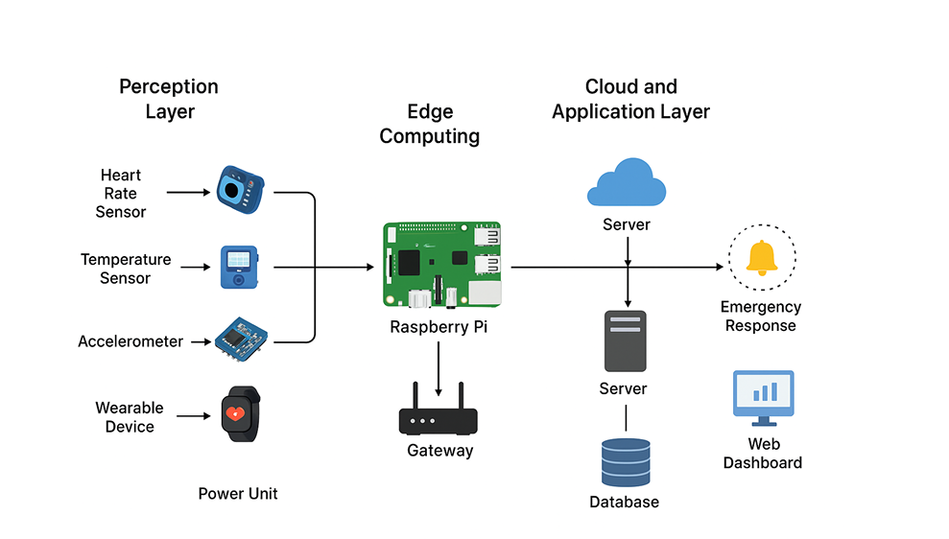
Figure 2.3-1: System block diagram (Edge–IoT–Cloud).

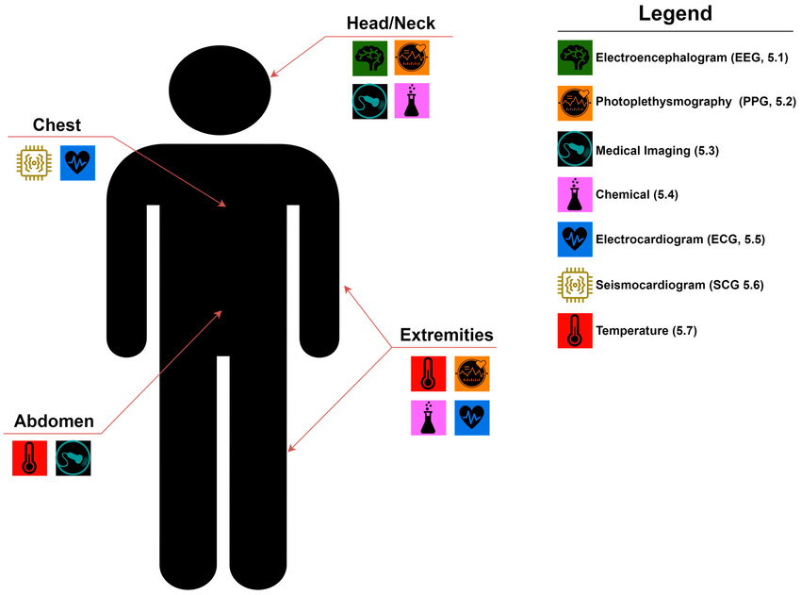
Figure 2.3-2: Example sensor placement on wearable device.
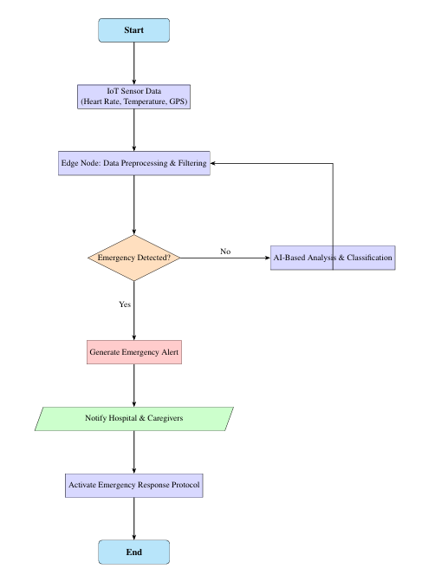
Figure 2.3-3: Alert workflow and notification channels flowchart.

2.4 Non-Functional Requirements

Non-functional requirements detail qualities of the system: performance, reliability, security, privacy, maintainability, scalability and usability. In the case of life-critical systems such as

SERS, these properties are valuable as much as functionality features. The non-functional expectations, metrics and acceptance criteria are outlined in the following subsections.

2.4.1 Performance & Latency

Requirement: End-to-end processing latency of critical paths should be bound.

Reasoning: Early capability to detect and warn is paramount; there is no time to lose the lives.
Measures: Edge processing latency Less than 100 ms; overall detection-to-alert latency Less than 30 seconds on confirmed emergencies[14,17].
Verification: Load testing of benchmarks simulated degradations of a network.
Edge computing in comparison to cloud-only variants Edge computing eliminates round-trip delays[16,17].

2.4.2 Reliability & Availability

Requirement Design requirement: The alerting and monitoring subsystems must have a system up time of 99.999% for critical functions[1].
Reason: When the need arises, emergency systems should be provided.
Measures: Mean Time Between Failures (MTBF), Mean Time to Recover (MTTR) less than 1 hour in case of non-critical parts.
Checking: Checking Fault injection tests checking: Redundancy validation
.
2.4.3 Security & Privacy

Requirement: PII and medical data End-to-end encryption End-to-end encryption of PII and medical data. Role-based access with multi-factor authentication Privileged functions[7].
Reason: Medical information is very sensitive and not following the laws and losing credibility.
Measures: Data at rest and data in transit is encrypted (AES-256/TLS 1.2+) and access access audit logs are kept; access data is periodically penetration tested.
Checking: Security checks, the HIPAA/GDPR compliance checklists, etc.

2.4.4 Scalability/Interoperability.

Support: Operate at horizontal scale (addressing the number of devices) and vertical scale (addressing the demand of edge computing)[22] Support: standard APIs (REST/ MQTT /FHIR where applicable) to integrate[1].
Reason: It can be deployed at the level of single buildings to the city-wide operation that demands varying magnitudes[22].
Measures: Scalability: The minimum possible number of devices in a cloud region (10000, in example) API: API response times of less than 200 ms at nominal load.
Verification Load testing and standards conformance tests.

2.4.5 Supportability and Upgradability.

Requirements: Firmware and model over-the-air (OTA) update; a codebase that is modular with CI/CD pipelines[1].
Reason: The patches and model upgrades should be rapid and should be done after deployment.
Measures: Response time to vulnerabilities (target, in extreme cases, under 72 hours), the ability to roll back.

Checking: Rollout and rollback training.

2.4.6 Usability & Human Factors

Requirement: Easy-to-use interfaces to allow responders to view important metrics in context, voice warnings to use hands-free.
Reason: Users will be working under stress, so interfaces need to keep cognitive load to the minimum.
Measures: Usability (SUS) to achieve more than 75 in the field trial, error of less than 2% in tasks with core activities.
Service validation: Field tests and training simulation.

2.4.7 Resilience & Fault Tolerance

Requirement: Graceful degradation modes in the sense of local detection in the disconnected mode; local buffering and retransmission of data[17,18].
Rationale: Network failure is typical of disasters.
metrics System continues core detection with >90% capability when network is dead; buffered data remained until synchronisation[14,17].
Check: Network partition test and disaster recovery tests.

2.4.8 Regulatory & Compliance

Requirement: Compliance with regulations of medical devices to target markets (e.g. IEC 62304 software lifecycle, local medical equipment requirements).
Reason: Clinical deployment might be required to be certified.
Measures: Conformance reports and certified components done and where necessary.
Check-up: Audits and regulatory inspection.

2.4.9 Data Retention in a Privacy-preserving way.

Requirement: Data minimization Implementation, retention policies and long-term analytics anonymization.
Justification: Long-term storage can be applied in the training of models, but privacy protection is necessary.
Measures: Retention records, anonymization records and periodic privacy impact assessment.
Verification Privacy audit and policy cross-checking.

Non-Functional Requirements Summary Table
NFR ID | Category | Target/Metric | Verification Method
NFR-01 | Performance & Latency | Edge latency <100ms; alert <30s | Load & latency tests
NFR-02 | Reliability & Availability | 99.999% uptime for critical alerts | Fault injection, failover tests
NFR-03 | Security & Privacy | AES-256/TLS; RBAC; MFA | Pen tests; compliance checks
NFR-04 | Scalability | Support 10k devices/region | Load testing
NFR-05 | Maintainability | OTA updates; rollback | Update drills
NFR-06 | Usability | SUS > 75 | Usability studies
NFR-07 | Resilience | Local detection >90% during outage | Partition tests
NFR-08 | Regulatory | IEC 62304 / local approvals | Regulatory audit
NFR-09 | Privacy Retention | Defined retention & anonymization | Privacy audit

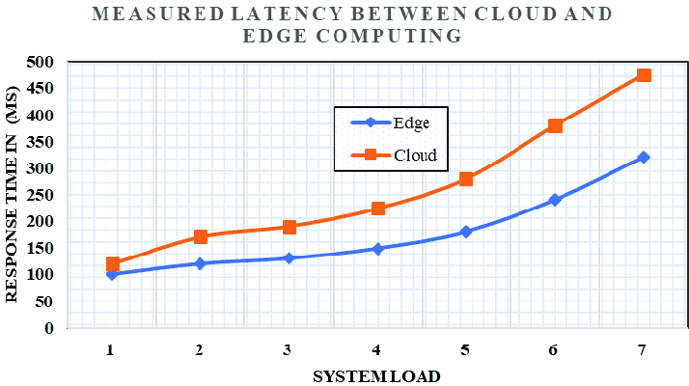

Figure 2.4-1: Latency comparison graph (Edge vs Cloud).

2.4.10 User Cases, Acceptance Tests.

Use case A: Sudden cardiac arrest identified using wearable ECG + motion sensors. The steps in the sequential acceptance tests include:

Testbed tachycardia and motion loss simulation of 30s.

Check local classifier flags cardiac arrest and confidence more than 0.9.

Check alert information contains vitals and GPS and timestamp and is delivered to pre- established EMS endpoint within 30s.

Check on the log that has been written and stored in audit store.

Application B: Vehicle collision detection and immobilization. The steps in the sequential acceptance tests include:

Pattern of the trigger accelerometer, which is characteristic of a collision, in a controlled test rig.

Confirm geolocation of auto escalation to emergency dispatcher.

Validate resource management suggestion nearest ambulance available and calculates ETA.

2.4.11 Strategy of Testing, Validation and Certification.

Testing strategy entails unit testing of the firmware, integration testing of edge-to-cloud flows, system-level latency and reliability tests[17], security penetration testing and field usability trials with the EMS partners. To be certified, develop documentation related to IEC 62304 (software) and adhere to local medical device regulatory directions; ensure that traceability matrices relating to the requirements to tests are maintained[1].

3. Design
In this section we will focus on the design of the system. We will explore different diagrams and schemas to help us better understand how the IOT-based model will collect data, store it and use it to send automatic alerts to emergency contacts in cases of emergencies.
3.1 SystemDesign

This is the internal functioning of the system, here the main characters include:
- The patient
- The Device
-The database

3.1.1 E-R Diagram
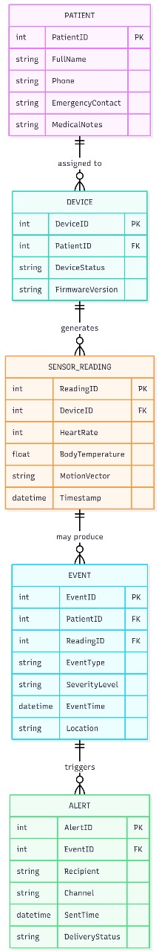

3.1.2 DFD’s (Data Flow Diagrams)
3.1.2.1 Level 0 DFD
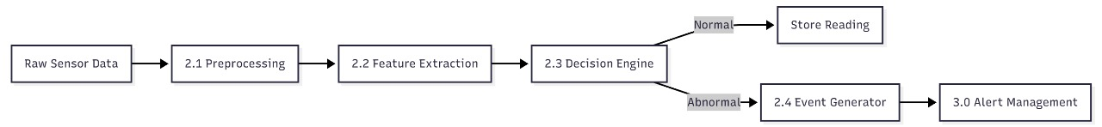
3.1.2.2 Level 1 DFD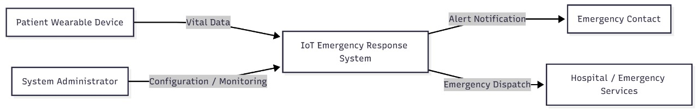

3.1.2.3 Level 2 DFD 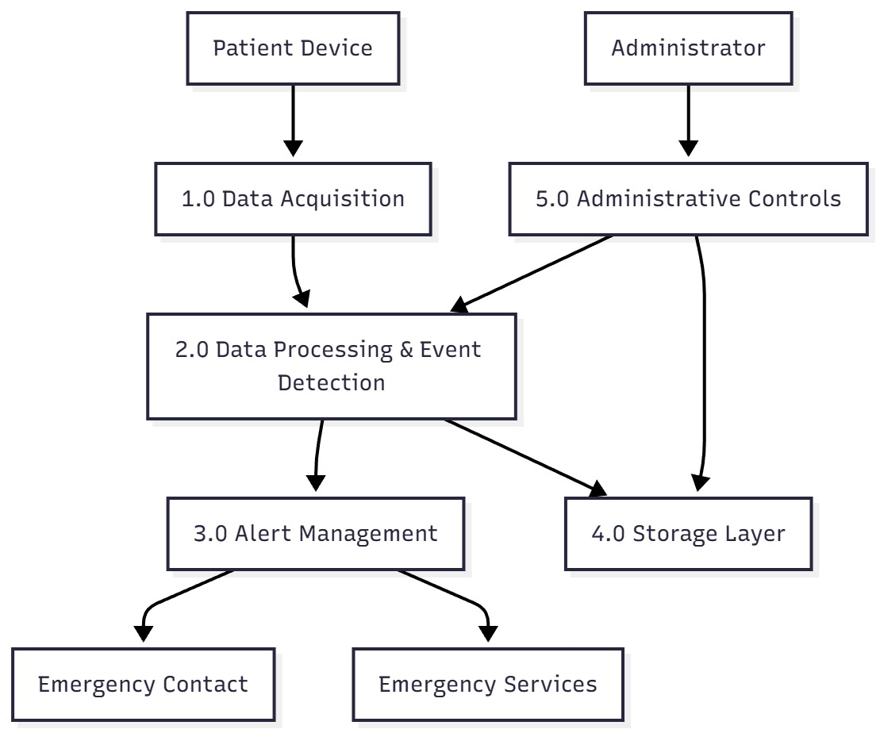

3.2 Database Design
3.2.1 Database Schema
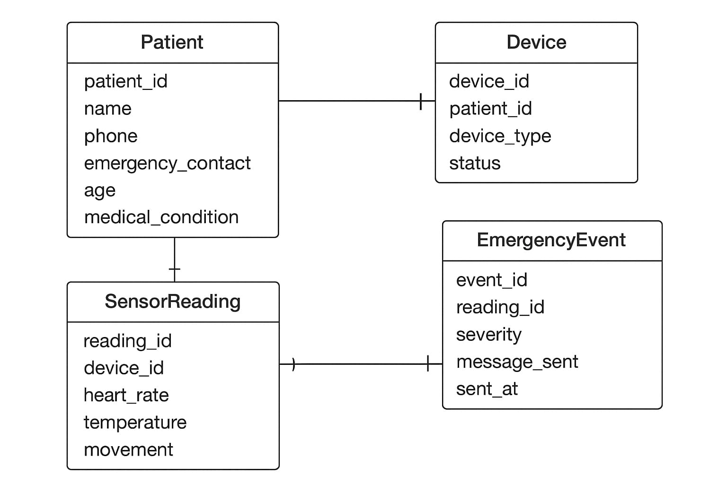

4 Scheduling and Estimate

4.1 Project Timeline

The project is organized to have a timeline of analysis, design, implementation, testing and documentation. All the tasks are allocated weeks and time to make sure that they are completed.
The project will be split into the following steps:
1 Requirement Analysis - Requirement knowledge of system and stakeholder requirements and limitations.
2 System Design System Design, hardware design, circuit design and database design.
3 Implementation IoT devices, sensor integration, backend API development, and mobile / web interface.
4 Testing - Unit testing, device testing, connectivity testing and reliability tests.
5 Deployment Final deployment and demonstration of the working prototype.

4.2 Gantt Chart
Below is the Gantt chart representing the project timeline:
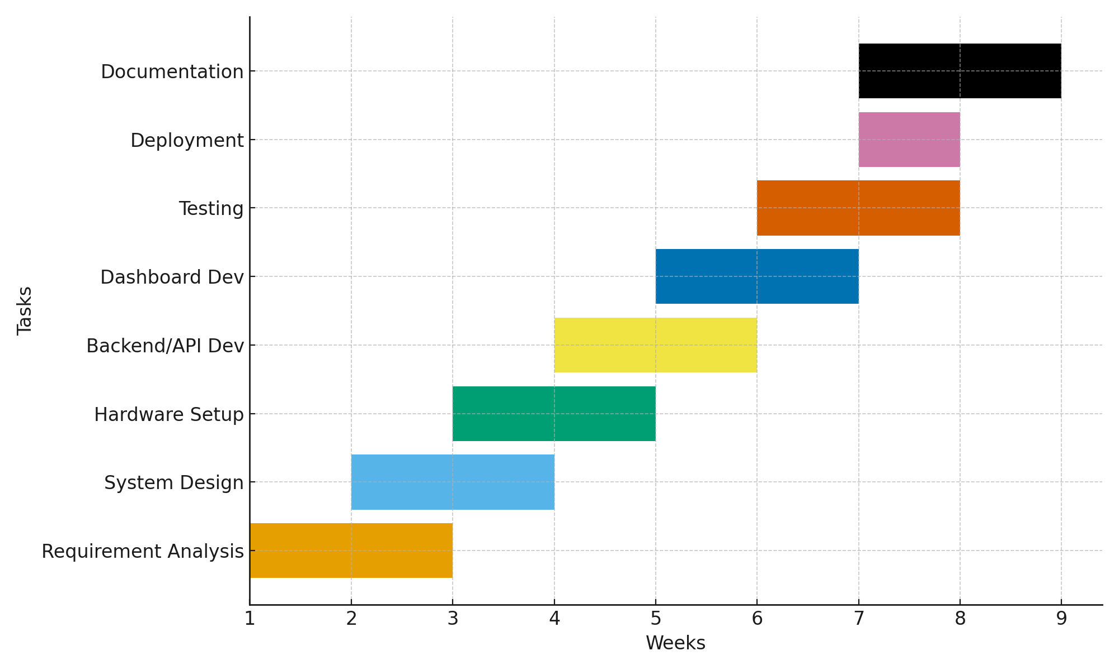

4.3 Effort Estimate
Component | Estimated Hours
Requirement Gathering and Research | 10–12 hrs
System Architecture and Design | 12–15 hrs
IoT Hardware Assembly | 20–25 hrs
Software Development | 30–35 hrs
Testing and Troubleshooting | 15–20 hrs
Documentation and Presentation | 10–12 hrs
Total Estimated Hours | 97–119 hrs

4.4 Resource Requirements
- Microcontroller (Arduino/ESP32)
- Medical sensors (Heart rate, Temperature)[4].
- GSM/WiFi Module
- Power supply/battery
- Dashboard/API development applications[14].
- Cloud database (Firebase / SQL)[21].
Software Resources
- Arduino IDE / MicroPython
- Cloud database
- API backend
- Dashboard/Android app interface
Human Resources
- IoT developer
- software developer
- tester
- documentation lead

4.5 Risk and Time Buffer
A time buffer of 10-15 percent is implemented to take care of risks like hardware failures, sensor calibration time, and integration problems.

REFERENCES
[1] A. Kumar, M. Singh, and R. Patel, “Internet of Things-Based Sensible Health Nursing Care Facility for Emergency Medical Care,” IEEE Access, 2023.
[2] P. Verma and R. Tiwari, “IoT-Based System for Detecting Accidents and Alerting Nearby Hospitals,” IEEE International Conference on Computing, Communication and Automation, 2024.
[3] M. Soni, A. AlGhamdi, M. A. Rusho, S. A. Hannan, H. Byeon, and P. R. Dave, “Artificial Intelligence-based Service Chains Scheduling for Medical Emergency in Healthcare,”7th International Conference on Contemporary Computing and Informatics (IC3I), 2024.
[4] R. Raj, T. K. Das, and K. Sharma, “An IoT-Based Wearable Healthcare Monitoring Device and Medical Emergency Response System,” IEEE Sensors Journal, 2024.
[5] A. Green, L. Brown, and S. Zhang, “Advancing Pre-Hospital Emergency Medical Services: An AI-Powered Approach to Voice-Activated Technologies,” IEEE Internet of Things Journal, 2024.
[6] S. Qureshi and H. Kim, “Q-VMedSim: A Training Platform for Emergency Response Procedures through Virtual Reality and AI Assistance,” IEEE Conference on Virtual Systems, 2025.
[7] K. Naidu, A. Gupta, and J. Thomas, “A Technology Assisted Framework for Medical Emergencies Involving Formal and Informal Caregivers,” IEEE BDCloud, 2018.
[8] M. Lee and J. Park, “An IoT-Based Stress Level Detection System for Emergency Medical Attention Personnel,” IEEE International Conference on Smart Health, 2024.
[9] D. Patel and S. Yadav, “A Confirmation-Based Accident Detection System Using IoT for Smart Vehicles,” IEEE International Conference on Computing, Power, and Communication Technologies, 2024.
[10] J. Chen and M. Ahmed, “Using AI to Improve Emergency Care: A Detailed Study of Benefits, Challenges, and What’s Next,” IEEE Transactions on Emerging Topics in Computing, 2025.
[11] K. Naidu, A. Gupta, and J. Thomas, “A Technology Assisted Framework for Medical Emergencies Involving Formal and Informal Caregivers,” IEEE BDCloud, 2018.
[12] M. Soni, A. AlGhamdi, M. A. Rusho, S. A. Hannan, H. Byeon, and P. R. Dave, “Artificial Intelligence-based Service Chains Scheduling for Medical Emergency in Healthcare,” IC3I Conference Proceedings, 2024.
[13] S. Li, L. Da Xu, and S. Zhao, “The Internet of Things: A Survey,” Information Systems Frontiers, vol. 17, no. 2, pp. 243–259, 2015.
[14] Md Tahmid Rashid, Daniel Zhang, and Dong Wang, “EdgeStore: Towards an Edge-Based Distributed Storage System for Emergency Response,”2019 IEEE 21st International Conference on High Performance Computing and Communications; IEEE 17th International Conference on Smart City; IEEE 5th International Conference on Data Science and Systems (HPCC/SmartCity/DSS), 2019.
[15] Samr Ali and Mohammed Ghazal, “Real-time Heart Attack Mobile Detection Service (RHAMDS) An IoT use case for Software Defined Networks,”2017 IEEE 30th Canadian Conference on Electrical and Computer Engineering (CCECE), 2017.
[16] Javaid Iqbal Zahid, Fatima Hussain, and Alex Ferworn, “A Model of Computing and Communication for Public Safety Integrating FirstNet, Edge Computing, and Internet of Things,”2019 IEEE 10th Annual Information Technology, Electronics and Mobile Communication Conference (IEMCON), 2019
[17] Bilal Khalid Dar, Munam Ali Shah, Saif Ul Islam, Castren Maple, Shafaq Mussadiq, and Suleman Khan, “Delay-Aware Accident Detection and Response System Using Fog Computing,” IEEE Access, vol. 7, 2019.
[18] Mohamed Aboualola, Khalid Abualsaud, Tamer Khattab, Nizar Zorba, and Hossam S. Hassanein, “Edge Technologies for Disaster Management: A Survey of Social Media and Artificial Intelligence Integration,” IEEE Access, vol. 11, 2023.
[19] P. Prince and C. Rajabhushanam, “A Smart Home Design with Intelligent Patient Monitoring Features by Using Internet of Things (IoT) Enabled Communication Technology,”2024 International Conference on Innovative Computing, Intelligent Communication and Smart Electrical Systems (ICSES), 2024.
[20] S. Divyabharathi and S. Madhavan, “An Explainable IoT-based Framework for Anomaly Detection and Emergency Decision Management in Smart Healthcare,”2025 3rd International Conference on Sustainable Computing and Data Communication Systems (ICSCDS), 2025.
[21] Rodolfo W. L. Coutinho and Azzedine Boukerche, “UAV-Mounted Cloudlet Systems for Emergency Response in Industrial Areas,” IEEE Transactions on Industrial Informatics, vol. 18, no. 11, 2022.
[22] Sahar Ebadinezhad, Mutaz Salah Mohammed Abdalkarim, Zainab Deen, and Fulbert Milrich Kiminou Nsimba, “The Role of IoT in Enhancing Public Safety in Smart Cities,”2024

