**POLYTECHNIC UNIVERSITY OF THE PHILIPPINES (PUP) SCHOLARSHIP AND FINANCIAL ASSISTANCE SERVICES MANAGEMENT INFORMATION SYSTEM**

A System Proposal presented to the

Faculty of the College of Computer and Information Sciences,

Polytechnic University of the Philippines, Sta. Mesa, Manila

**In partial fulfillment for the degree**

**Bachelor of Science in Information Technology**

**INTE 4213 – Capstone Project**

Alcobendas, Winsley P.

Margallo, John Gabriel A.

Pinga, Pauline Mariz R.

Torriña, Kim C.

***Proponents***

**September 2018**

**Table of Contents**

**Project Context** 3

**Chapter 3 – Methodology** 4

**3.1.** **Requirements Analysis** 4

3.1.1. Requirements – Features Matrix 4

3.1.2. Use Case Diagram 5

3.1.3. Use Case Report 6

**3.2.** **Design Specifications** 10

3.2.1. Activity Diagram 10

3.2.2. Class Diagram 17

3.2.3. GUI Design 24

3.2.4. Database Schema 42

3.2.5. Data Dictionary 44

**3.3.** **Development Methodology** 49

3.3.1. Process Model 49

3.3.2. Development Tools 50

**Project Context**

Scholarships open many doors to different students in the university. As a result, this makes the students take the impact of growth as an individual inside the campus. By giving scholarships to students they are given vast amazing opportunities. It reflects a student’s determination that takes on excellent education, and character with an air of confidence.

Polytechnic University of the Philippines offers numerous kinds of scholarships that are being handled by the Polytechnic University of the Philippines (PUP) – Scholarship and Financial Assistance Services. The office gives scholarship opportunities to students that are in likely to break from financial matter with the case of school expenses. The office’s mission is to aim in building Polytechnic University of the Philippines (PUP) students’ lives, who are in need of resources, virtues achieving academic careers. The organization brings off to harmonize, layout and professionalize the administration for the unprofitable yet talented and worthy students in the University System.

# **Chapter 3 – Methodology**

* 1. **Requirements Analysis** 
     1. 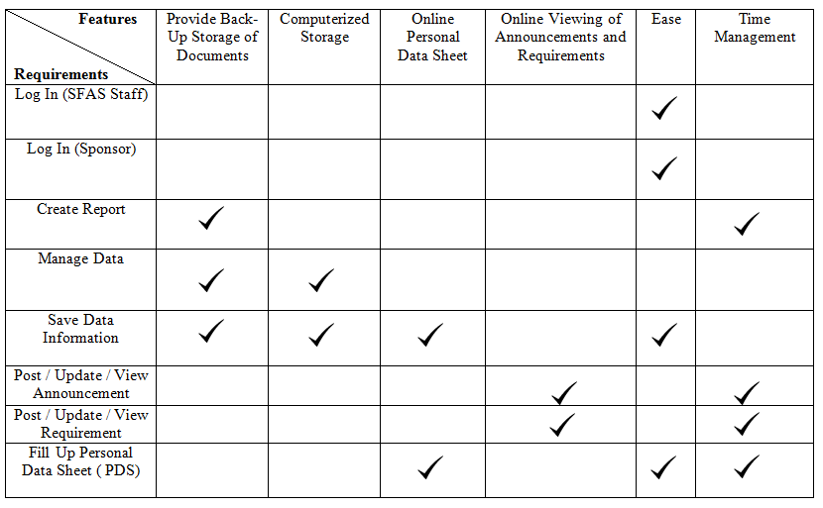Requirements – Features Matrix

**Table 1**: 3.1.1 - Requirements - Features Matrix

* + 1. 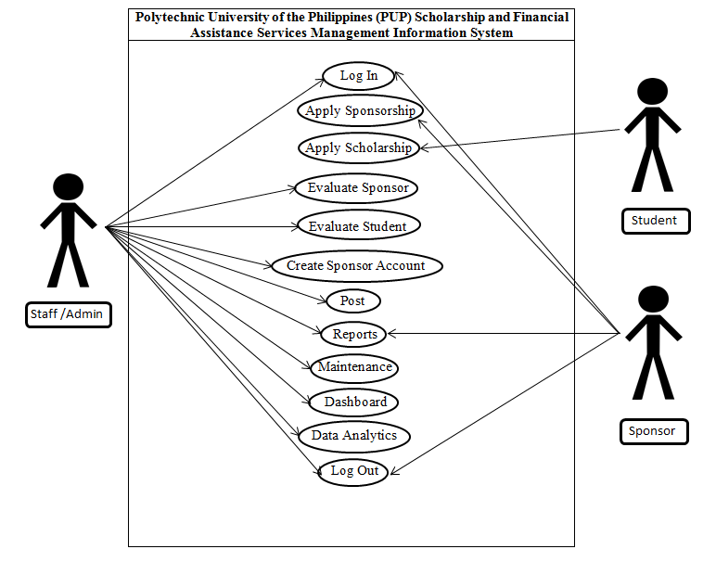Use Case Diagram

**Figure 1**: 3.1.2 - Use Case Diagram

* + 1. Use Case Report

|  |  |
| --- | --- |
| **Use Case** | **UC1 (Log In)** |
| **Brief Description** | Allow the Actors to log in on their respective accounts |
| **Actor** | SFAS Admin, Sponsor |
| **Pre-Condition** | Actors should fill username and its corresponding password in order to log in |
| **Post Condition** | System will notify actors if the username or password is wrong or doesn’t exist |
| **Basic Flow** | * Click log in button on SFAS Website * System displays the LOG-IN page * Actors will fill the username and password * Actors need to tap the button “LOGIN” to continue * System will direct you in admin page |
| **Alternate Flow** |  |

**Table 2**: 3.1.3 - Use Case Report (UC1 Log In)

|  |  |
| --- | --- |
| **Use Case** | **UC2 (Apply Sponsorship)** |
| **Brief Description** | Allows the Actor to apply sponsorship, and steps on how to become a sponsor. |
| **Actor** | Sponsor |
| **Pre-Condition** | Actor should pick one of the categories (company or individual) |
| **Post Condition** | System requires to have a soft copy of Letter of Intent and Memorandum of Agreement ( MOA) |
| **Basic Flow** | * Fill all the required fields * Actor should upload Letter of Intent and Memorandum of Agreement (MOA) in order to continue |
| **Alternate Flow** |  |

**Table 3**: 3.1.3 - Use Case Report (UC2 Apply Scholarship)

|  |  |
| --- | --- |
| **Use Case** | **UC3 (Apply Scholarship)** |
| **Brief Description** | Allows the Actor to apply for scholarship programs |
| **Actor** | Student |
| **Pre-Condition** | Actor should pick one of the scholarship programs |
| **Post Condition** | System will notify the Actor if the required fields are not filled completely |
| **Basic Flow** | * Choose one scholarship program and click “Apply Scholarship” * Fill all the required fields * It will display all the requirements (hardcopy) that are needed to be pass * It will notify the Actor if the application is successful |
| **Alternate Flow** |  |

**Table 4**: 3.1.3 - Use Case Report (UC3 Apply Scholarship)

|  |  |
| --- | --- |
| **Use Case** | **UC4 (Evaluate Sponsor)** |
| **Brief Description** | Allows evaluating all the requirements and documents Actor (Sponsor) have filled and passed. |
| **Actor** | SFAS Admin |
| **Pre-Condition** | Actor can review all (even the accepted forms) documents |
| **Post Condition** | Identify who is approved and disapproved for sponsorship |
| **Basic Flow** | * Must be log-in in Admin page * Click Pending Sponsor * Click any sponsor you want to evaluate * It will display personal information and MOA (Memorandum of Agreement) of the sponsor * Click “Accept” Button if the sponsor is approved * Sponsor status will be “Accepted” |
| **Alternate Flow** | * Must be log-in in Admin page * Click Pending Sponsor * Click any sponsor you want to evaluate * It will display personal information and MOA (Memorandum of Agreement) of the sponsor * Click “Decline” Button if the sponsor is declined * Sponsor status will be “Declined” |

**Table 5**: 3.1.3 - Use Case Report (UC4 Evaluate Sponsor)

|  |  |
| --- | --- |
| **Use Case** | **UC5 (Evaluate Student)** |
| **Brief Description** | Allows evaluating all the requirements and documents Actor (Student) have filled and passed. |
| **Actor** | SFAS Admin |
| **Pre-Condition** | Actor can review all (even the accepted forms) documents |
| **Post Condition** | Identify who is approved and disapproved for scholarship grantee |
| **Basic Flow** | * Must be log-in in Admin page * Click Students * Click any students you want to evaluate * It will display personal information and scholarship they want to apply * Click “Accept” Button if the sponsor is approved * Student status will be “Accepted” |
| **Alternate Flow** | * Must be log-in in Admin page * Click Students * Click any students you want to evaluate * It will display personal information and scholarship they want to apply * Click “Decline” Button if the sponsor is declined   Student status will be “Declined” |

**Table 6**: 3.1.3 - Use Case Report (UC5 Evaluate Student)

|  |  |
| --- | --- |
| **Use Case** | **UC6 (Create Account Sponsor)** |
| **Brief Description** | Allow creating an account for approved Actor (Sponsor) |
| **Actor** | SFAS Admin |
| **Pre-Condition** | Actor (SFAS Admin) should fill the required fields that shown here based on the Actor (Sponsor) description |
| **Post Condition** | It will notify the Actor (SFAS Admin) if the Actor (Sponsor) account exist |
| **Basic Flow** | * Fill up all the required fields * Specific fields must be unique * Password must be unique |
| **Alternative Flow** |  |

**Table 7**: 3.1.3 - Use Case Report (UC6 Create Account Sponsor)

|  |  |
| --- | --- |
| **Use Case** | **UC7 (Post)** |
| **Brief Description** | Allows the Actor (SFAS Admin) to publish all announcements both for Actor (Sponsor) and Actor (Student) |
| **Actor** | SFAS Admin |
| **Pre-Condition** | Actor (SFAS Admin) should fill all the required details to publish announcement |
| **Post Condition** |  |
| **Basic Flow** | * Must be log-in in Admin page * Click Students * Click any students you want to evaluate * It will display personal information and scholarship they want to apply * Click “Decline” Button if the sponsor is declined * Student status will be “Declined” |
| **Alternative Flow** |  |

**Table 8**: 3.1.3 - Use Case Report (UC7 Post)

|  |  |
| --- | --- |
| **Use Case** | **UC8 (Report)** |
| **Brief Description** | Allows the admin to create reports of Actor (Sponsor) and Actor (Student), and allows the Actor (Sponsor) to receive report from the Actor (SFAS Admin) |
| **Actors** | SFAS Admin, Sponsor |
| **Pre-Condition** | Actor (SFAS Admin) needs to analyze and finalize all the data for creating reports |
| **Post Condition** |  |
| **Basic Flow** |  |
| **Alternative Flow** |  |

**Table 9**: 3.1.3 - Use Case Report (UC8 Report)

|  |  |
| --- | --- |
| **Use Case** | **UC9 (Maintenance)** |
| **Brief Description** | Allows SFAS Admin to maintain the application to reflect changes in the organization’s business or to adapt to new operating environments. |
| **Actor** | SFAS Admin |
| **Pre-Condition** |  |
| **Post Condition** |  |
| **Basic Flow** |  |
| **Alternative Flow** |  |

**Table 10**: 3.1.3 - Use Case Report (UC9 Maintenance)

|  |  |
| --- | --- |
| **Use Case** | **UC10 (Dashboard)** |
| **Brief Description** | This use case is a user friendly. It is an organized and presents information easily |
| **Actor** | SFAS Admin |
| **Pre-Condition** | SFAS Admin must be logged in |
| **Post Condition** |  |
| **Basic Flow** | * Actor must be logged in * After page, it will redirect you on Dashboard |
| **Alternative Flow** | * Click Dashboard located left side of the Admin page |

**Table 11**: 3.1.3 - Use Case Report (UC10 Dashboard)

|  |  |
| --- | --- |
| **Use Case** | **UC11 (Data Analytics)** |
| **Brief Description** | Allows the actor to view how many student and sponsor applied and how many of them is accepted or declined |
| **Actor** | SFAS Admin |
| **Pre-Condition** | SFAS Admin must be logged in |
| **Post Condition** |  |
| **Basic Flow** | * Actor must be logged in * Click “Data analytics” located left side of the Admin page |
| **Alternative Flow** |  |

**Table 12**: 3.1.3 - Use Case Report (UC11 Analytics)

|  |  |
| --- | --- |
| **Use Case** | **UC12 (Log out)** |
| **Brief Description** | Allows the Actors (SFAS Admin, Sponsor) to log out their accounts |
| **Actor** | SFAS Admin, Sponsor |
| **Pre-Condition** | Actor (SFAS Admin, Sponsor) should click the logout button |
| **Post Condition** | After logout, the page will redirect to “Log-In” page |
| **Basic Flow** | * Click “Account” button for more options * Click “Logout” button to logout the current account |
| **Alternative Flow** | * Quit the application (it will automatically logout your account) |

**Table 13**: 3.1.3 - Use Case Report (UC12 Log Out)

* 1. **Design Specifications** 
     1. 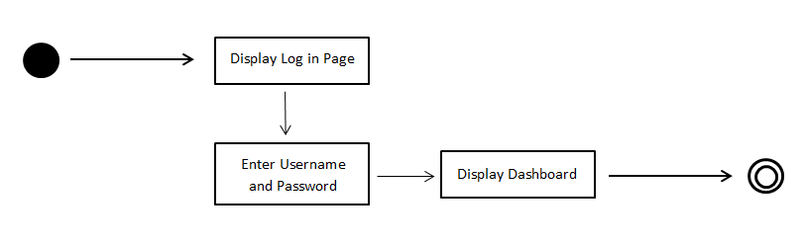Activity Diagram

**Figure 2**: 3.2.1 - Activity Diagram (Log In)

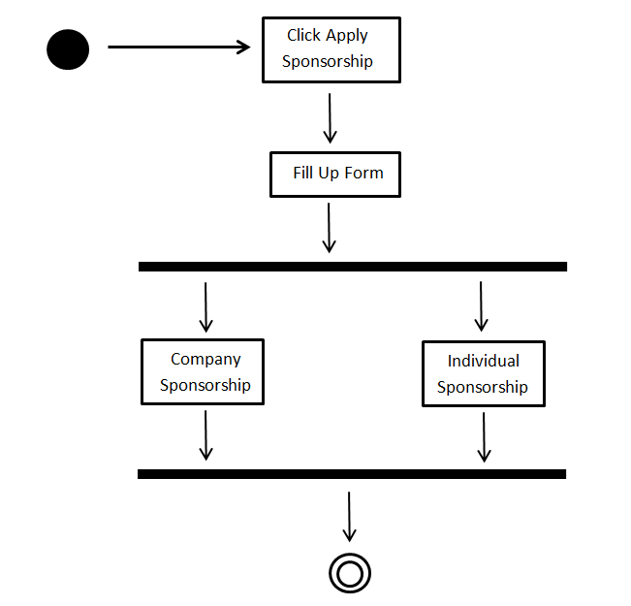

**Figure 3**: 3.2.1 - Activity Diagram (Apply Sponsorship)

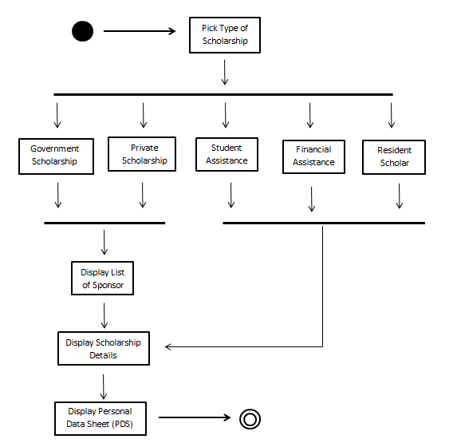

**Figure 4**: 3.2.1 – Activity Diagram (Apply Scholarship)

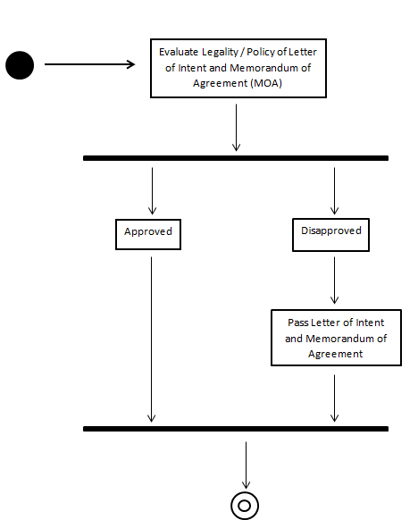

**Figure 5**: 3.2.1 - Activity Diagram (Evaluate Sponsor)

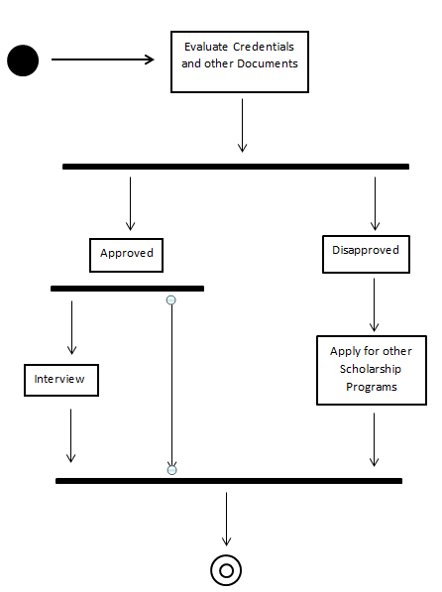

**Figure 6**: 3.2.1 - Activity Diagram (Evaluate Student)

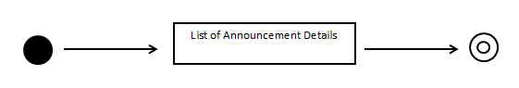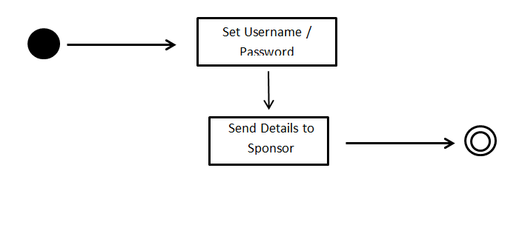

**Figure 8**: 3.2.1 - Activity Diagram (Post)

**Figure** 7: 3.2.1 - Activity Diagram (Create Sponsor Account)

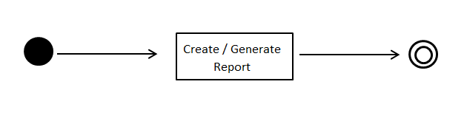  
  
  
  
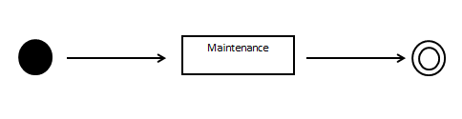

**Figure 9**: 3.2.1 - Activity Diagram (Reports)

**Figure 10**: 3.2.1 - Activity Diagram (Maintenance)

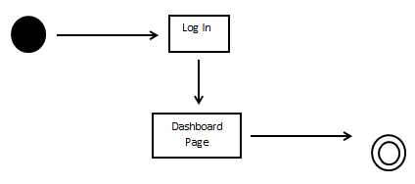

**Figure 11**: 3.2.1 - Activity Diagram (Dashboard)

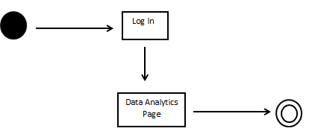

**Figure 12**: 3.2.1 - Activity Diagram (Data Analytics)

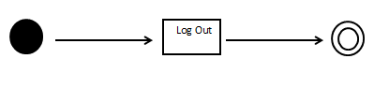

**Figure 13**: 3.1.2 - Activity Diagram (Log Out)

* + 1. 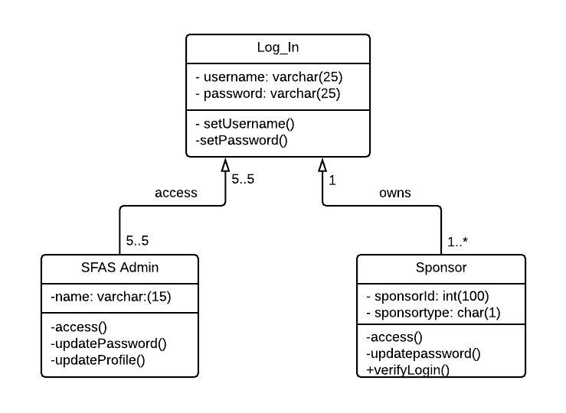Class Diagram

**Figure 14**: 3.2.2 - Class Diagram (Log In)

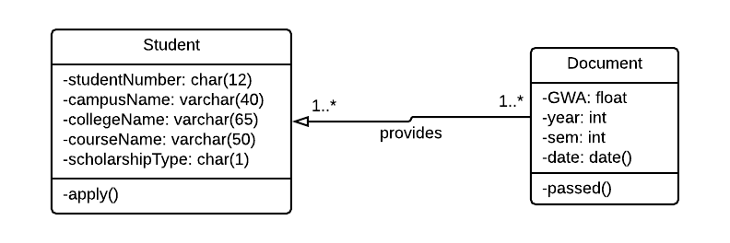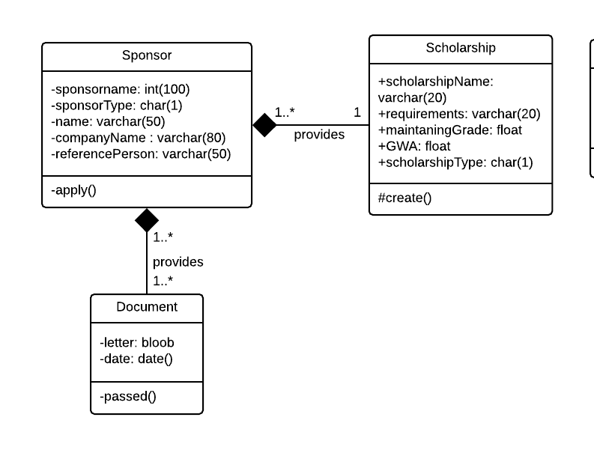

**Figure 16**: 3.2.2 - Class Diagram (Apply Scholarship)

**Figure 15**: 3.2.2 - Class Diagram (Apply Sponsorship)

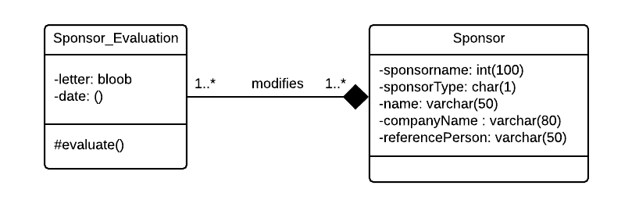

**Figure 17**: 3.2.2 - Class Diagram (Evaluate Sponsor)

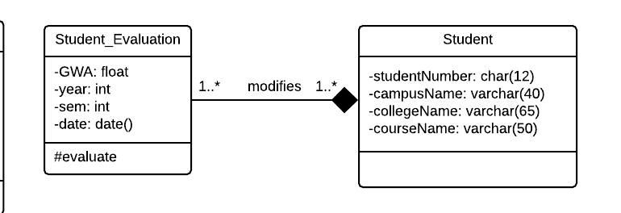

**Figure 18**: 3.2.2 - Class Diagram (Evaluate Student)

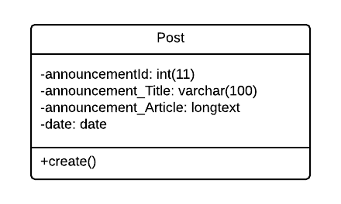

**Figure 19**: 3.2.2 - Class Diagram (Post)

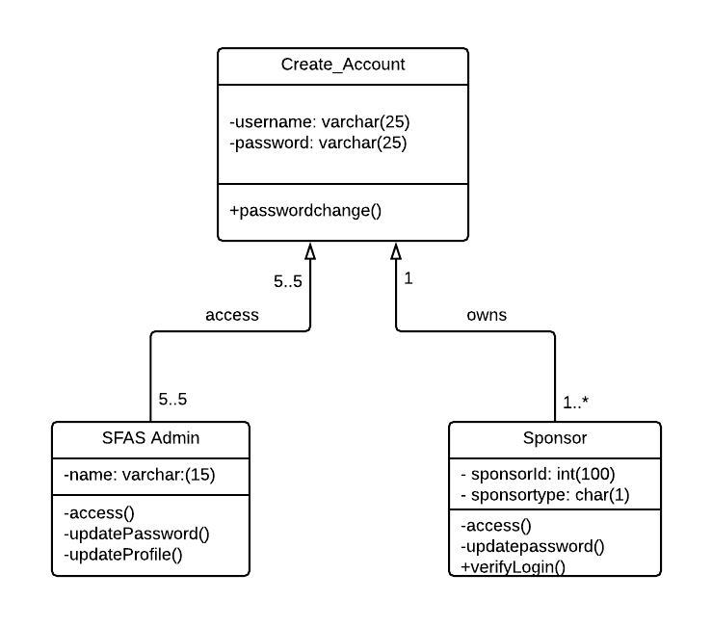

**Figure 20**: 3.2.2 - Class Diagram (Create Sponsor Account)

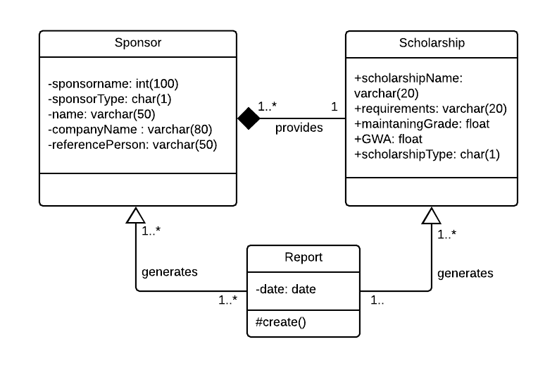

**Figure 21**: 3.2.2 - Class Diagram (Report)

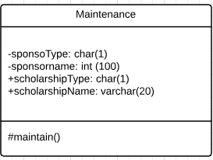

**Figure 22**: 3.2.2 - Class Diagram (Maintenance)

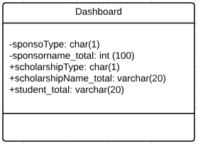

**Figure 23**: 3.2.2 - Class Diagram (Dashboard)

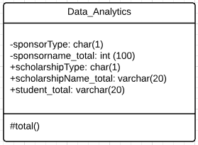

**Figure 24**: 3.2.2 - Class Diagram (Data Analytics)

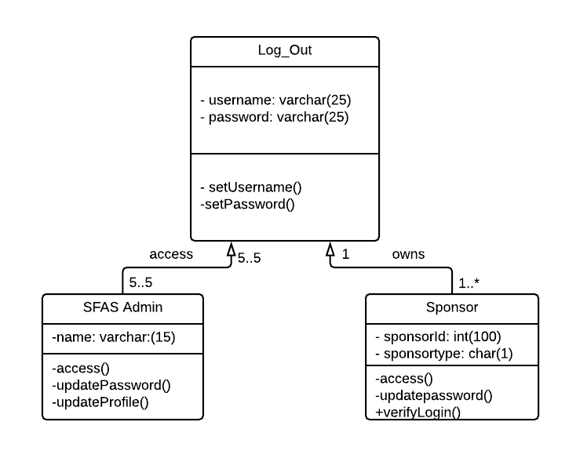

**Figure 25**: 3.2.2 - Class Diagram (Log Out)

* + 1. GUI Design

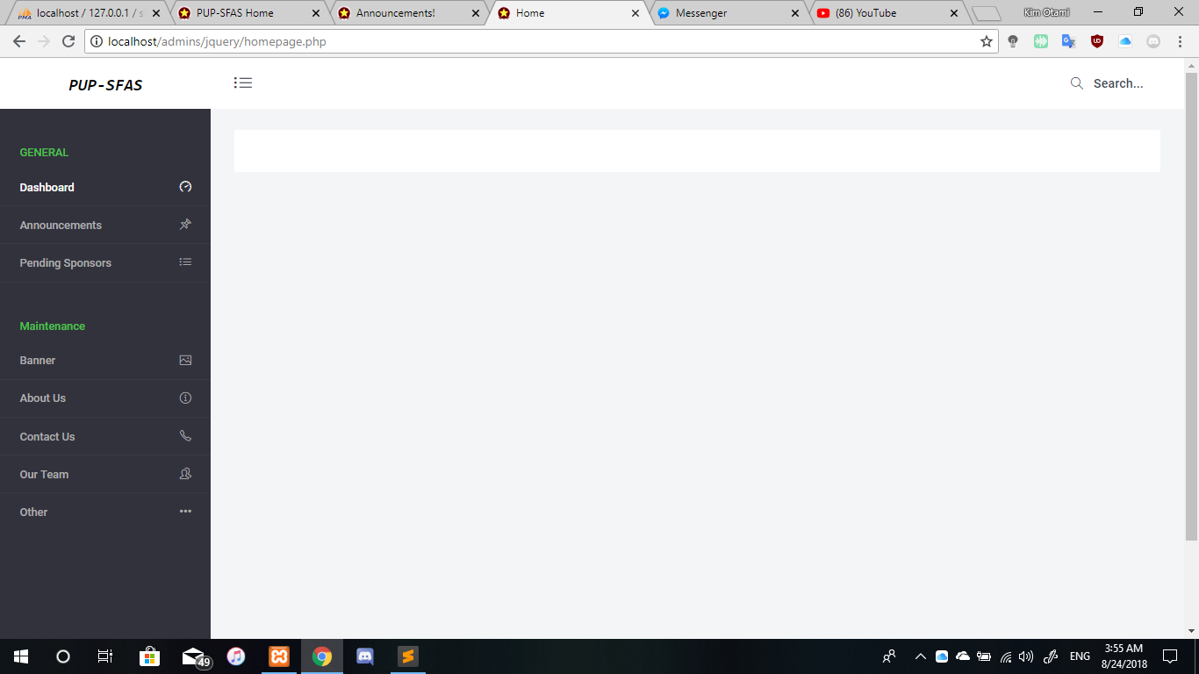

**Figure 26**: 3.2.3 - GUI Design (Dashboard)

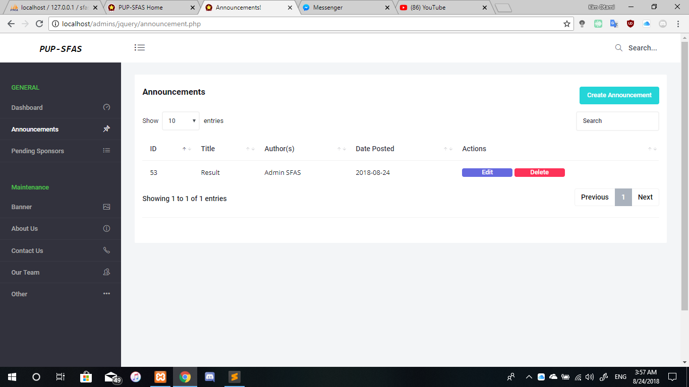

**Figure 27**: 3.2.3 - GUI Design (Announcement)

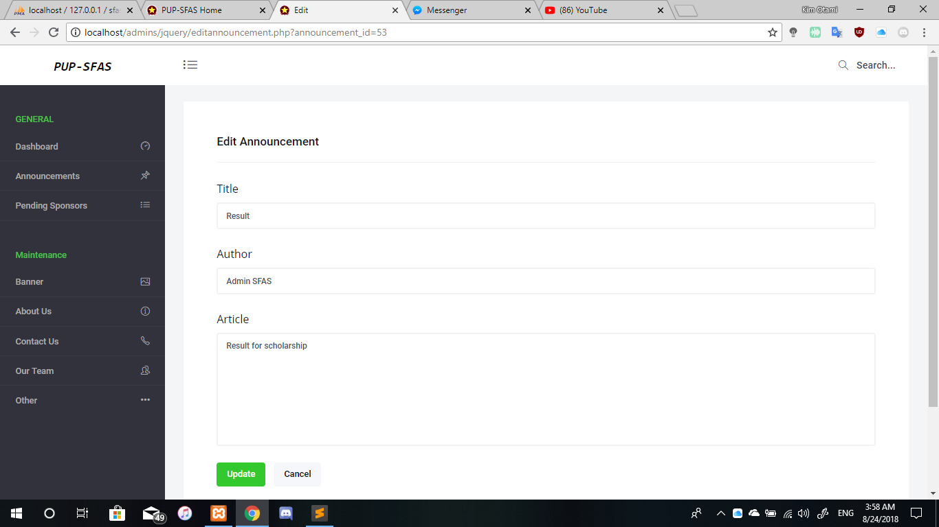

**Figure 28**: 3.2.3- GUI Design (Edit Announcement)

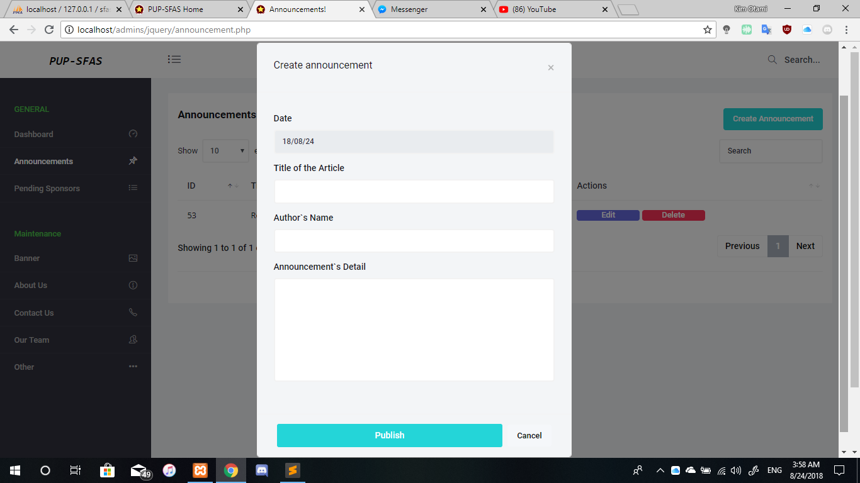

**Figure 29**: 3.2.3 - GUI Design (Create Announcement)

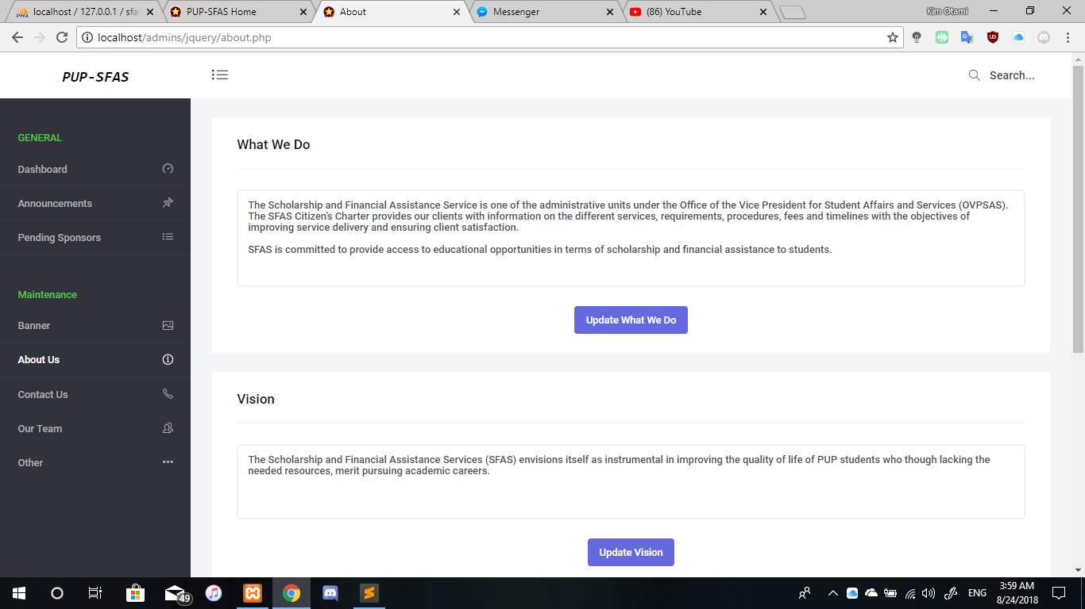

**Figure 30**: 3.2.3 - GUI Design (Announcement Post)

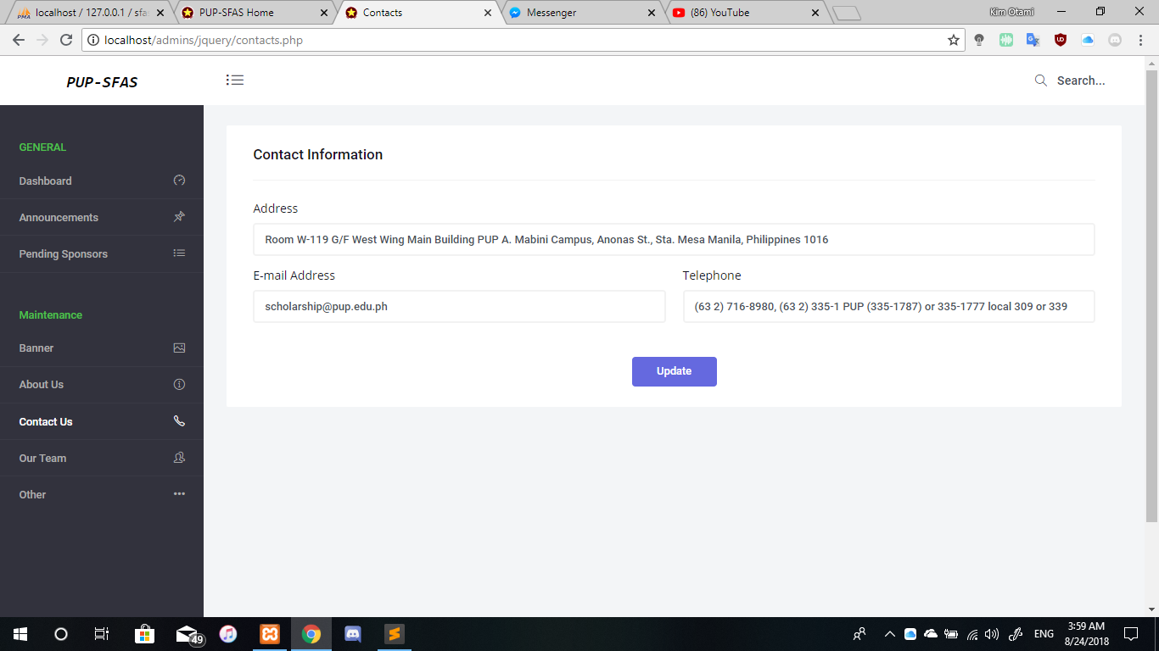

**Figure 31**: 3.2.3 - GUI Design (Contact Information)

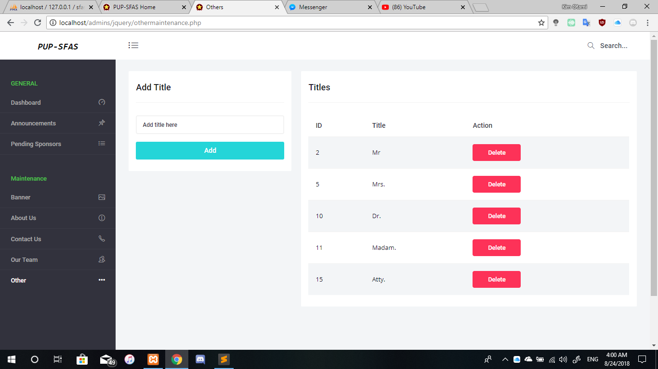

**Figure 32**: 3.2.3 - GUI Design (Titles)

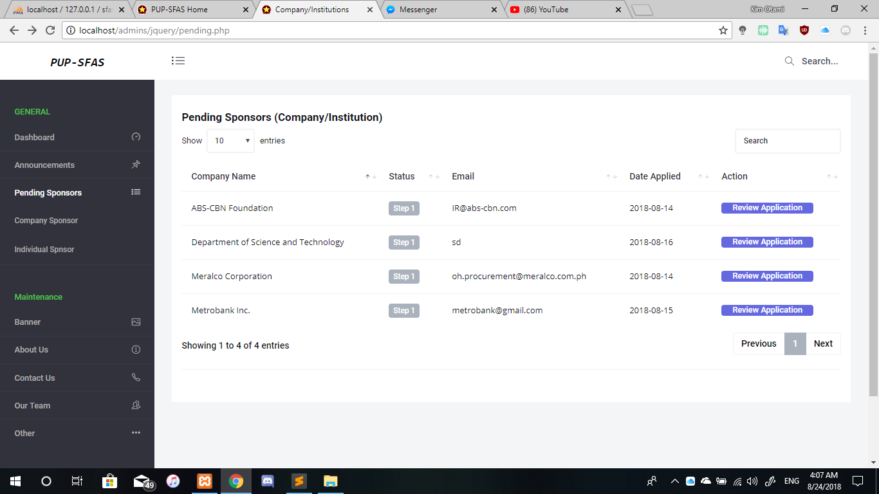

**Figure 33**: 3.2.3 - GUI Design (Pending Sponsors)

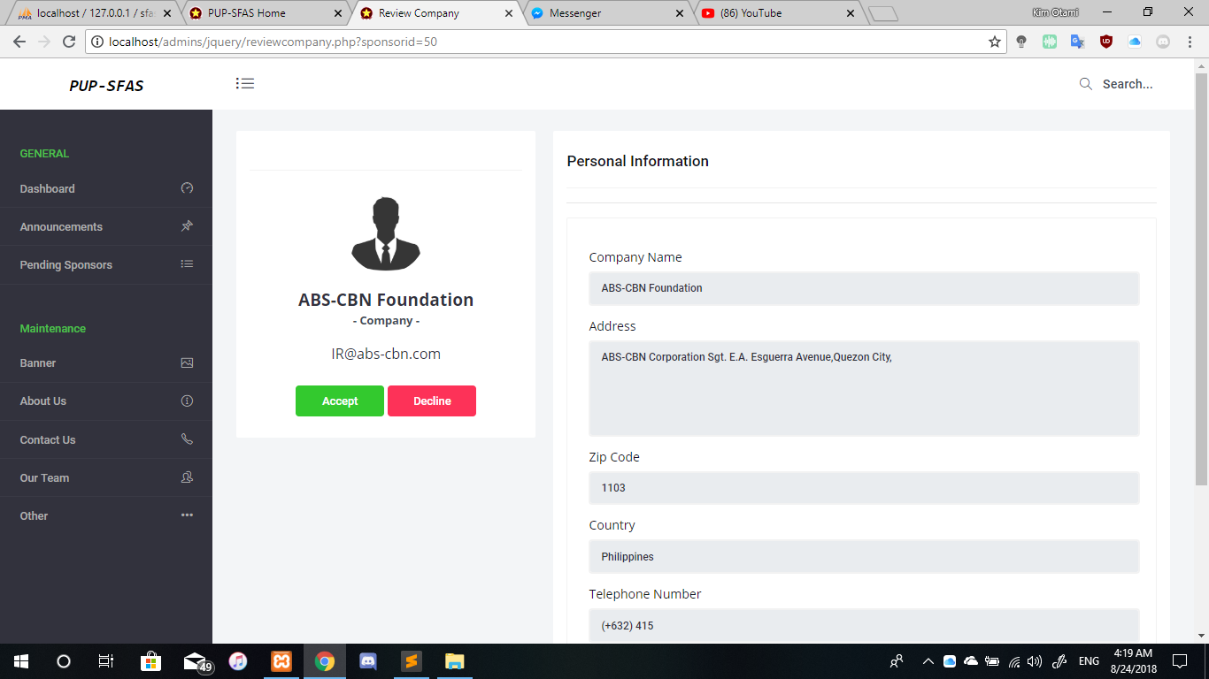

**Figure 34**: 3.2.3 - GUI Design (Personal Information)



**Figure 35**: 3.2.3 - GUI Design (Homepage)



**Figure 36**: 3.2.3 - GUI Design (Homepage)

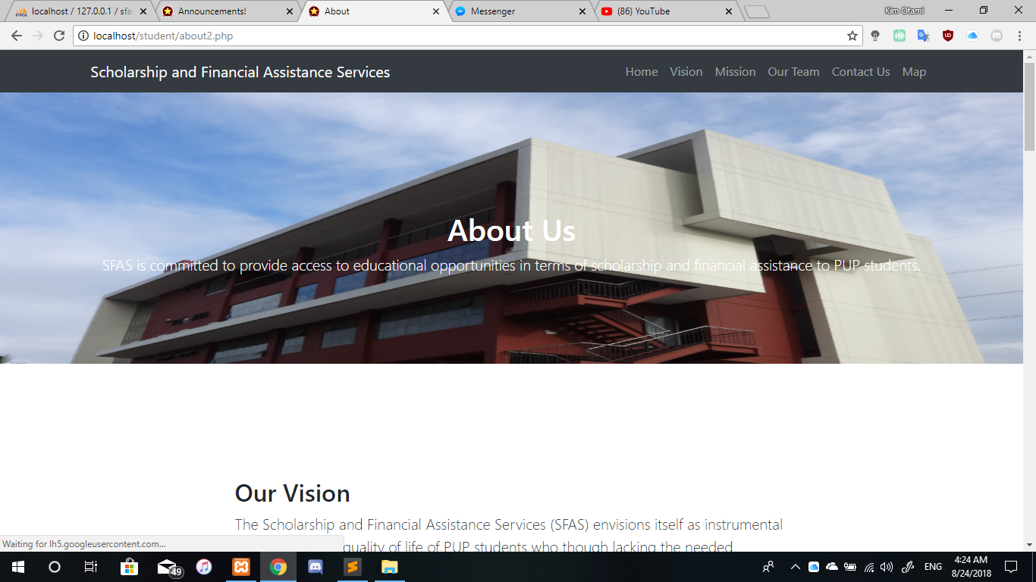

**Figure 37**: 3.2.3 - GUI Design (Homepage)

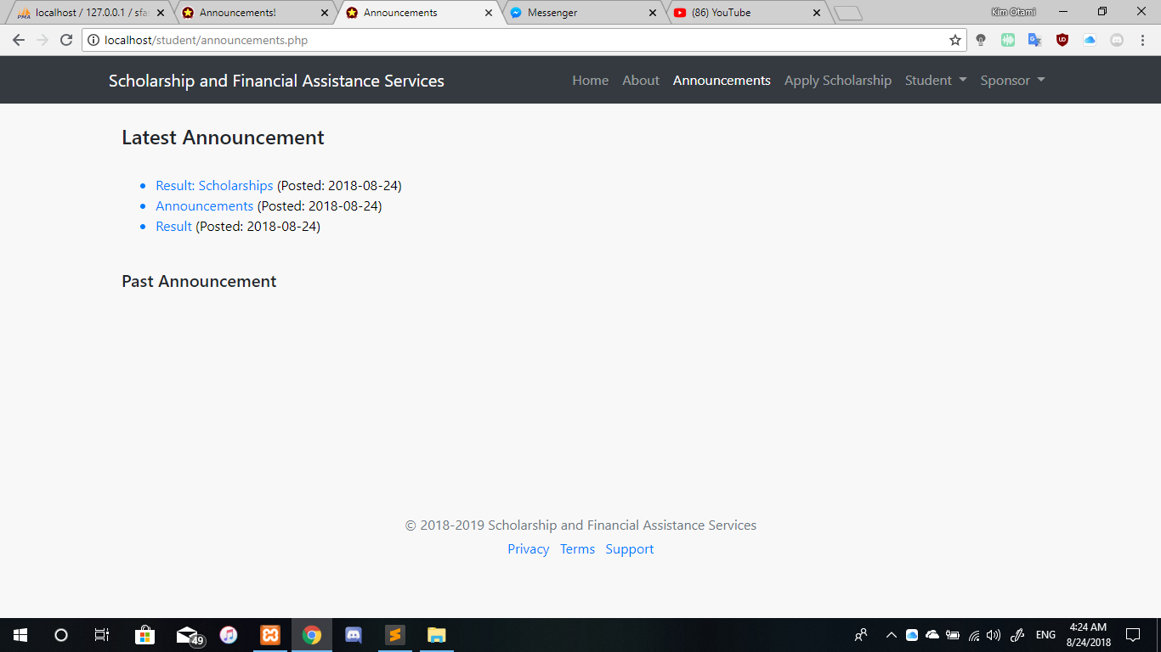

**Figure 38**: 3.2.3 - GUI Design (Homepage Announcement)

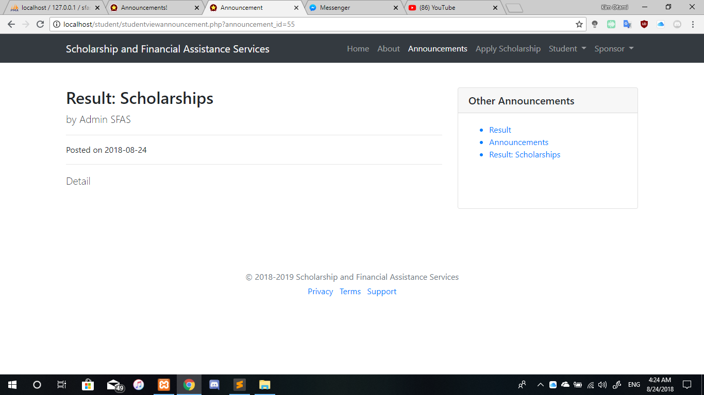

**Figure 39**: 3.2.3 - GUI Design (Homepage Announcement)

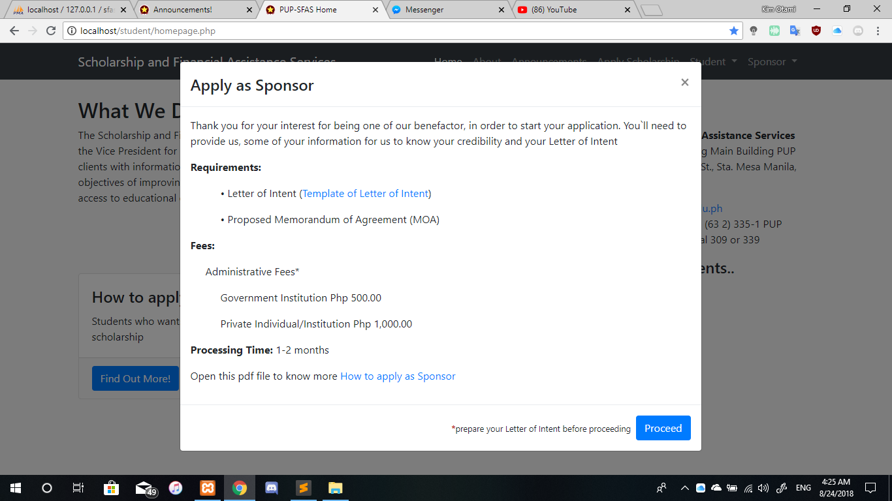

**Figure 40**: 3.2.3 - GUI Design (Homepage Apply Sponsor)

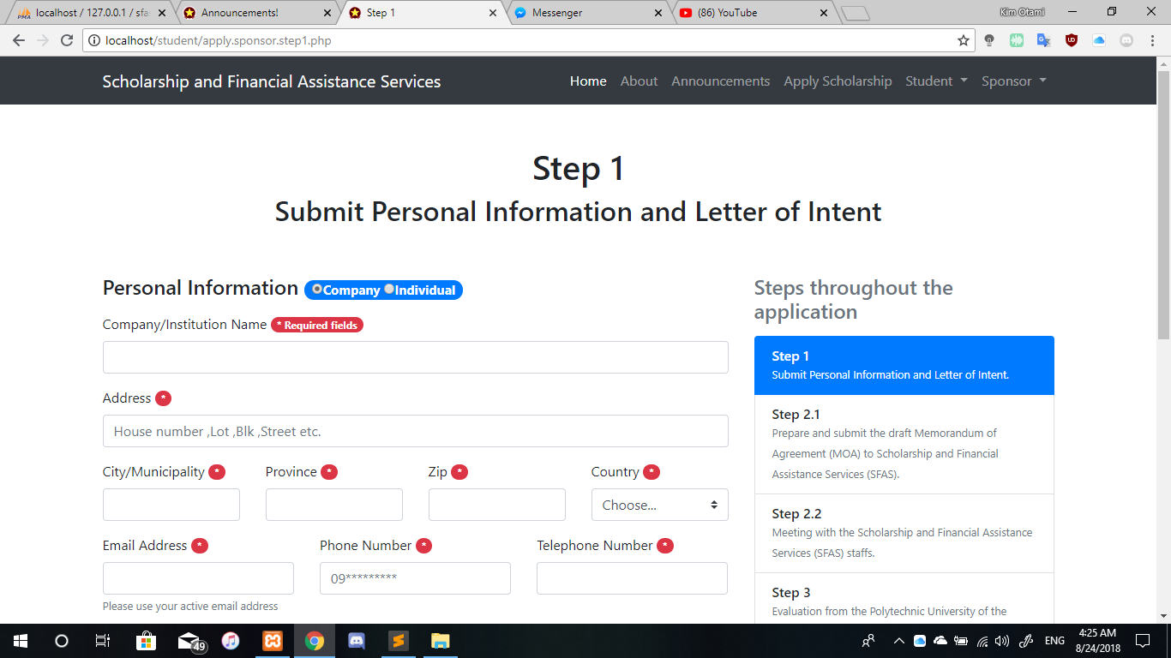

**Figure 41**: 3.2.3 - GUI Design (Homepage Apply Sponsor)

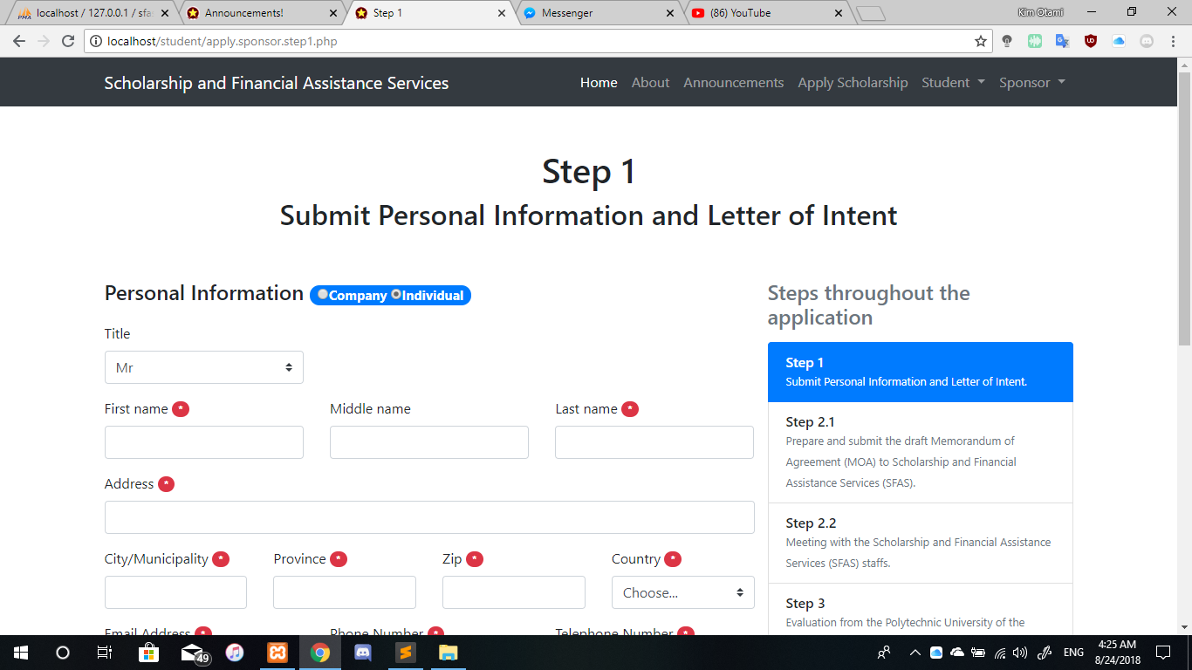

**Figure 42**: 3.2.3 - GUI Design (Homepage Apply Sponsor)

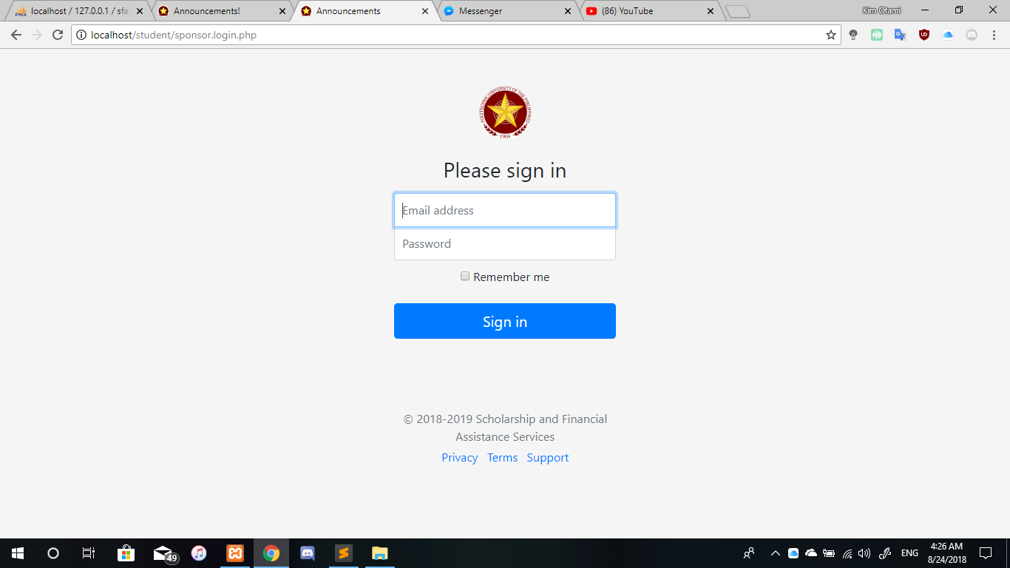

**Figure 43**: 3.2.3 - GUI Design (Sign In)

* + 1. Database Schema

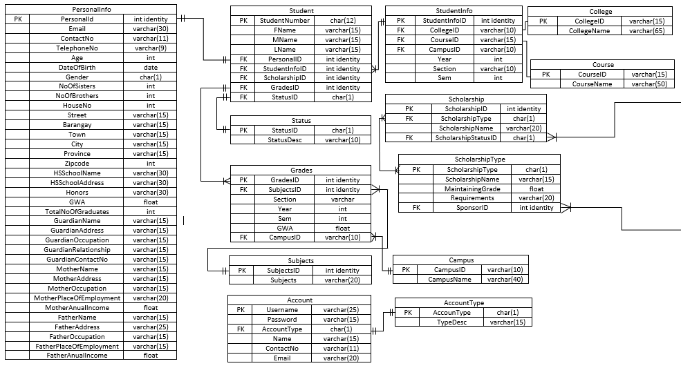

**Figure 44**: 3.2.4 - Database Schema (Part I)

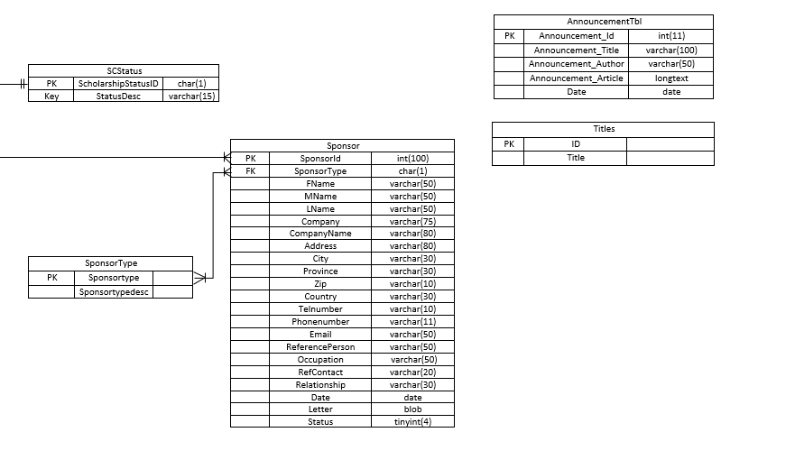

**Figure 45**: 3.2.4 - Database Schema (Part II)

* + 1. Data Dictionary

|  |  |  |  |  |
| --- | --- | --- | --- | --- |
| **Fieldname** | **Type** | **Key** | **Size** | **Value** |
| PersonalId | int identity | primary | 1,1 | 1 |
| Email | varchar |  | 30 | johnnybravo@gmail.com |
| ContactNo | varchar |  | 11 | 0912 245 6789 |
| TelephoneNo | varchar |  | 9 | (02)765 9758 |
| Age | int |  | 3 | 17 |
| DateOfBirth | date |  |  | 09/07/2001 |
| Gender | char |  | 1 | M |
| NoOfSisters | int |  | 5 | 0 |
| NoOfBrothers |  |  | 5 | 3 |
| HouseNo | int |  | 5 | 76 |
| Street | varchar |  | 15 | Baliwag St. |
| Barangay | varchar |  | 15 | 98 |
| Town | varchar |  | 15 | Maygawa |
| City | varchar |  | 15 | Navotas City |
| Province | varchar |  | 15 | NCR |
| Zipcode | int |  | 5 | 1765 |
| HSSchoolName | varchar |  | 30 | Maygawa National High School |
| HSSchoolAddress | varchar |  | 30 | Navotas City |
| Honors | varchar |  | 30 | Valedictorian |
| GWA | float |  |  | 97.36 |
| TotalNoOfGraduates | int |  | 10 | 6575 |
| GuardianName | varchar |  | 15 | Mark Burgos |
| GuardianAddress | varchar |  | 15 | Navotas City |
| GuardianOccupation | varchar |  | 15 | Driver |
| GuardianRelationship | varchar |  | 15 | Uncle |
| GuardianContactNo | varchar |  | 15 | 0998 765 4321 |
| MotherName | varchar |  | 15 | Maria Ganza |
| MotherAddress | varchar |  | 15 | Navotas City |
| MotherOccupation | varchar |  | 15 | Housewife |
| MotherPlaceOfEmployment | varchar |  | 20 |  |
| MotherAnualIncome | float |  |  | 5000 |
| FatherName | varchar |  | 15 | Manalo Ganza |
| FatherAddress | varchar |  | 25 | Navotas City |
| FatherOccupation | varchar |  | 15 | Security Guard |
| FatherPlaceOfEmployment | varchar |  | 15 | Manila City |
| FatherAnualIncome | float |  |  | 10,000 |

**Table 14**: 3.2.5 - Data Dictionary (PersonalInfo Table)

|  |  |  |  |  |
| --- | --- | --- | --- | --- |
| **Field Name** | **Type** | **Key** | **Size** | **Value** |
| Student Number | char | primary | 12 | 201504992MN0 |
| FName | varchar |  | 15 | Marco |
| LName | varchar |  | 15 | Ganza |
| PersonalID | int identity | foreign |  |  |
| StudentInfoID | int identity | foreign |  |  |
| ScholarshipID | int identity | foreign |  |  |
| GradesID | int identity | foreign |  |  |
| StatusID | char | foreign | 1 | F |

**Table 15**: 3.2.5 - Data Dictionary (Student Table)

|  |  |  |  |  |
| --- | --- | --- | --- | --- |
| **Field Name** | **Type** | **Key** | **Size** | **Value** |
| StatusID | char | primary | 1 | F |
| StatusDesc | varchar |  | 10 | Freshmen |

**Table 16**: 3.2.5 - Data Dictionary (Status Table)

|  |  |  |  |  |
| --- | --- | --- | --- | --- |
| **Field Name** | **Type** | **Key** | **Size** | **Value** |
| GradesID | int identity | primary |  |  |
| SubjectID | int identity | foreign |  | 7649 |
| Section | varchar |  | 5 | 1N |
| Year | int |  | 5 | 2018 |
| Sem | int |  | 5 | Second |
| GWA | float |  | 5 | 1.78 |
| CampusID | varchar | foreign | 10 | MN |

**Table 17**: 3.2.5 - Data Dictionary (Grades Table)

|  |  |  |  |  |
| --- | --- | --- | --- | --- |
| **Field Name** | **Type** | **Key** | **Size** | **Value** |
| SubjectID | int identity | primary |  | 7649 |
| Subjects | varchar |  | 20 | Logic |

**Table 18**: 3.2.5 - Data Dictionary (Subject Table)

|  |  |  |  |  |
| --- | --- | --- | --- | --- |
| **Field Name** | **Type** | **Key** | **Size** | **Value** |
| Username | varchar | primary | 25 | Admin2 |
| Password | varchar |  | 15 | nevergiveup |
| AccountType | char | foreign | 1 | Admin |
| Name | varchar |  | 15 | Melchor Diaz |
| ContactNo | varchar |  | 11 | 0976 273 2863 |
| Email | varchar |  | 20 | mdiaz@gmail.com |

**Table 19**: 3.2.5 - Data Dictionary (Account Table)

|  |  |  |  |  |
| --- | --- | --- | --- | --- |
| **Field Name** | **Type** | **Key** | **Size** | **Value** |
| StudentInfoID | int identity | primary |  |  |
| CollegeID | varchar | foreign | 10 | CBA |
| CourseID | varchar | foreign | 15 | BSBA-MM |
| Campus | varchar | foreign | 10 | MN |
| Year | int |  |  | 2018 |
| Section | varchar |  | 10 | 1N |
| Sem | int |  |  | 2nd |

**Table 20**: 3.2.5 - Data Dictionary (StudentInfo Table)

|  |  |  |  |  |
| --- | --- | --- | --- | --- |
| **Field Name** | **Type** | **Key** | **Size** | **Value** |
| ScholarshipID | int identity | primary |  | 0087 |
| ScholarshipType | char | foreign | 1 | P |
| ScholarshipName | varchar |  | 20 | Meralco Corp. |
| ScholarshipStatusID | char | foreign | 1 |  |

**Table 21**: 3.2.5 - Data Dictionary (Scholarship Table)

|  |  |  |  |  |
| --- | --- | --- | --- | --- |
| **Field Name** | **Type** | **Key** | **Size** | **Value** |
| ScholarshipType | char | primary | 1 | P |
| ScholarshipName | varchar |  | 15 | Meralco Corp. |
| Maintaining Grade | float |  | 5 | 2.00 |
| Requirements | varchar |  | 200 | Registration Card, Form 138 |
| SponsorID | int identity | foreign |  | 0076 |

**Table 22**: 3.2.5 - Data Dictionary (ScholarshipType Table)

|  |  |  |  |  |
| --- | --- | --- | --- | --- |
| **Field Name** | **Type** | **Key** | **Size** | **Value** |
| CampusID | varchar | primary | 10 | MN |
| CampusName | varchar |  | 40 | PUP Manila |

**Table 23**: 3.2.5 - Data Dictionary (Campus Table)

|  |  |  |  |  |
| --- | --- | --- | --- | --- |
| **Field Name** | **Type** | **Key** | **Size** | **Value** |
| AccountType | char | primary | 1 |  |
| TypeDesc | varchar |  | 15 |  |

**Table 24**: 3.2.5 - Data Dictionary (AccountType Table)

|  |  |  |  |  |
| --- | --- | --- | --- | --- |
| **Field Name** | **Type** | **Key** | **Size** | **Value** |
| CollegeID | varchar | primary | 15 | CBA |
| CollegeName | varchar |  | 65 | College of Business Administration |

**Table 25**: 3.2.5 - Data Dictionary (College Table)

|  |  |  |  |  |
| --- | --- | --- | --- | --- |
| **Field Name** | **Type** | **Key** | **Size** | **Value** |
| CourseID | varchar | primary | 15 | 002 |
| CourseName | varchar |  | 20 | BSBA-MN |

**Table 26**: 3.2.5 - Data Dictionary (Course Table)

|  |  |  |  |  |
| --- | --- | --- | --- | --- |
| **Field Name** | **Type** | **Key** | **Size** | **Value** |
| SponsorType | char | primary | 1 | P |
| SponsorDesc | varchar |  | 10 | Private |

**Table 27**: 3.2.5 - Data Dictionary (SponsorType Table)

|  |  |  |  |  |
| --- | --- | --- | --- | --- |
| **Field Name** | **Type** | **Key** | **Size** | **Value** |
| ScholarshipStatusID | char | primary | 1 |  |
| StatusDesc | varchar |  | 15 |  |

**Table 28**: 3.2.5 - Data Dictionary (SCStatus Table)

|  |  |  |  |  |
| --- | --- | --- | --- | --- |
| **Field Name** | **Type** | **Key** | **Size** | **Value** |
| SponsorID | int | primary | 100 | 0876 |
| SponsorType | char | foreign | 1 | P |
| FName | varchar |  | 50 | Manny |
| MName | varchar |  | 50 | Perez |
| LName | varchar |  | 50 | Pander |
| Company | varchar |  | 75 | Private |
| CompanyName | varchar |  | 80 | Meralco Corp. |
| Address | varchar |  | 80 | Ortigas |
| City | varchar |  | 30 | Pasig City |
| Province | varchar |  | 30 | NCR |
| Zip | varchar |  | 10 | 0017 |
| Country | varchar |  | 30 | Philippines |
| TelNumber | varchar |  | 10 | 875 1871 |
| PhoneNumber | varchar |  | 11 | 0982 338 7282 |
| Email | varchar |  | 50 | meralcocorp@gmail.com |
| ReferencePerson | varchar |  | 50 | Trisha Torme |
| Occupation | varchar |  | 20 | Secretary |
| RefContact | varchar |  | 20 | 0917 657 9980 |
| Relationship | varchar |  | 30 | Employee |
| Date | date |  |  | 09/07/2018 |
| Letter | blob |  |  |  |
| Status | tinyint |  | 4 |  |

**Table 29**: 3.2.5 - Data Dictionary (Sponsor Table)

|  |  |  |  |  |
| --- | --- | --- | --- | --- |
| **Field Name** | **Type** | **Key** | **Size** | **Value** |
| Announcement_ID | int | primary | 11 | 0079 |
| Announcement_Title | varchar |  | 10 | Sponsorship Availability |
| Announcement_Author | varchar |  | 15 | SFAS Admin |
| Announcement_Article | longtext |  |  |  |
| Date | date |  |  | 23/08/2018 |

**Table 30**: 3.2.5 - Data Dictionary (Announcement Table)

|  |  |  |  |  |
| --- | --- | --- | --- | --- |
| **Field Name** | **Type** | **Key** | **Size** | **Value** |
| TitleID | int | primary | 10 | 0091 |
| Title | varchar |  | 20 | Happy Graduation |

**Table 31**: 3.2.5 - Data Dictionary (Title Table)

* 1. **Development Methodology** 
     1. 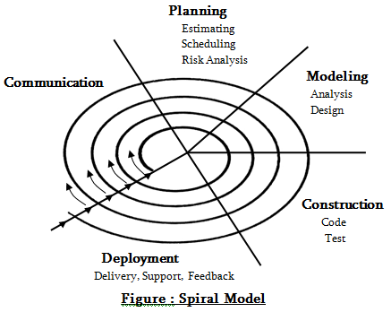Process Model

**Figure 46**: 3.3.1- Process Model (Spiral Model)

**Spiral Process Model** represents the processes with a spiral image than in the sequence of activities. This is designed to produce well features of a system.

Every loop of the spiral represents phases that are concerned with the feasibility of the system. Its aspiration is to define the objectives and risks that may fall the system. Detailed analysis must be conducted within the progress of system. Project must be reviewed and carefully planned to continue with the further loop of the process. This will help the developers to take care of any risk problems that can arise between the times they are developing the project.

* + 1. Development Tools

|  |  |
| --- | --- |
| **Development Tools** | **Name** |
| **Programming Language** | * HTML (Hypertext Markup Language) * CSS (Cascading Style Sheets) * PHP: Hypertext Preprocessor * JS (JavaScript) * JQuery |
| **Framework** | * Bootstrap |
| **Database** | * MariaDB, MySQL, PHP (XAMPP) |

**Table 32**: 3.3.2 - Development Tools



**Polytechnic University of the Philippines  
 College of Computer and Information Sciences**

**POLYTECHNIC UNIVERSITY OF THE PHILLIPINES (PUP)  
SCHOLARSHIP AND FINANCIAL ASSISTANCE SERVICES  
MANAGEMENT INFORMATION SYSTEM**

**ALCOBENDAS, Winsley P.**

**MARGALLO, John Gabriel A.**

**PINGA, Pauline Mariz R.**

**TORRIÑA, Kim C.**

**BSIT 4-1N**

**Group 6**



**POLYTECHNIC UNIVERSITY OF THE PHILIPPINES**

**COLLEGE OF COMPUTER AND INFORMATION SCIENCES**

**POLYTECHNIC UNIVERSITY OF THE PHILLIPINES (PUP)  
SCHOLARSHIP AND FINANCIAL ASSISTANCE SERVICES  
MANAGEMENT INFORMATION SYSTEM**

**ALCOBENDAS, Winsley P.**

**MARGALLO, John Gabriel A.**

**PINGA, Pauline Mariz R.**

**TORRIÑA, Kim C.**

**BSIT 4-1N**

**Group 6**