Bugs from [www.nagivator.ba](http://www.nagivator.ba):

* 4 Functional bugs
* 2 Visual bugs

1. **Name**: Navigation bar Twitter icon hover issue

**Type**: **Visual bug  
Description**: When hovering over the icons in the navigation bar (Facebook, Twitter, and Google Plus), a dropdown menu appears. The **Twitter icon** is not fully visible in the dropdown, as only a small part of the icon is shown. The icon remains **clickable** in the small visible area.  
  
**Steps to Reproduce**:

1. Open the website (e.g., [www.navigator.ba](http://www.navigator.ba" \t "_new)).
2. Hover over the **navigation bar** where the social media icons (Facebook, Twitter, Google Plus) are located.
3. Observe that the **Twitter icon** is partially hidden, but still clickable.

**Expected Result**: The **Twitter icon** should be fully visible in the dropdown, with no clipping or overlapping.  
**Actual Result**: The **Twitter icon** is only partially visible and remains clickable despite being hidden.  
**Resolution**: 1000x544   
**Severity**: Minor   
**Priority:** Low  
  
**Screenshot**: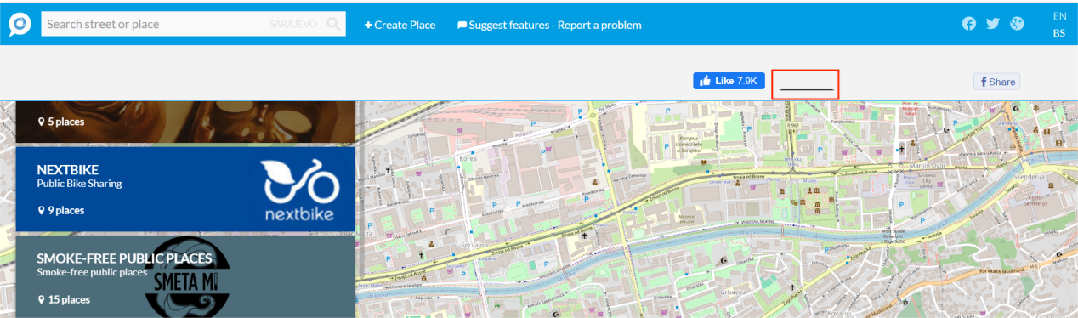

1. **Name**: Sending user feedback for application

**Type**: **Functional bug  
Description**: When filling out the **feedback form** on the "Report a Problem" section (accessed via the navigation bar), users are unable to successfully submit the form. Both options for sending feedback are non-functional, and after clicking the **SAVE** button, an error message appears. The error message is vague and does not provide sufficient information to understand or resolve the issue.

**Steps to Reproduce**:

1. Open the **Suggest features - Report a problem** on the navigation bar (https://www.navigator.ba/#/feedback).
2. Fill in the feedback form with valid information (Name and Surname, Email and Comment and there are two options to whome you can send feedback (both of them are not working) .
3. Click the **Send** button to submit the form.
4. Observe the error message that appears after clicking **Send**.

**Expected Result**: The feedback form should be submitted successfully, and the user should see a confirmation message.  
**Actual Result**: After clicking the **Send** button, an error message is displayed and the feedback is not submitted.  
**Error Message**: Unable to send your feedback. Some unexpected error occurred. Please try again  
**Severity**: Major   
**Priority:** High  
  
**Screenshot:**  
 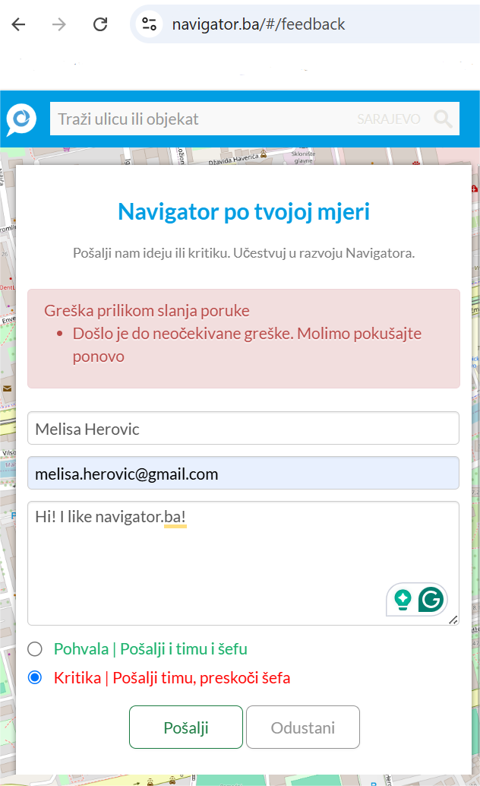

1. **Name**: Missing Validation on Invalid Form Submission

**Type**: **Functional bug  
Description**: When attempting to submit the feedback form on the **"Report a Problem"** page, if the form contains an **invalid email address**, the **Send** button is clickable, but **nothing happens**. No error message or warning is shown to the user, and the form is not submitted.

**Steps to Reproduce**:

1. Navigate to the **"Report a Problem"** feedback form on the website (https://www.navigator.ba/#/feedback).
2. Fill form with an **invalid form email** (e.g. example.com or user@@example.com).
3. Click the **Send** button to submit the form.
4. Observe that **no error message** appears, and **nothing happens** (form is not submitted).

**Expected Result**: If the form contains an invalid email, the user should receive an appropriate error message or warning e.g., "Email address must be in a valid format". The form should not be submitted until valid data is entered.  
**Actual Result**: After clicking the **Send** button, the form is not submitted. No error message or feedback is provided, and the user is not informed about the form's invalid state.  
**Error Message**: No error message is shown.  
**Severity**: Major   
**Priority:** High  
  
**Screenshot:**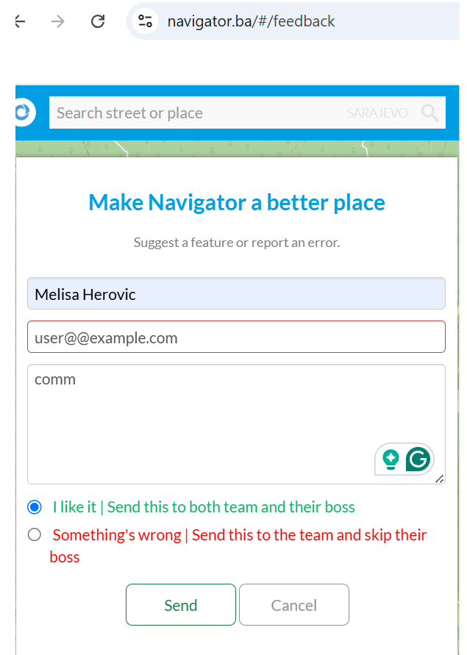

1. **Name**: Missing Validation on Empty Form Submission

**Type**: **Visual bug  
Description**: When attempting to submit the feedback form on the **"Report a Problem"** page, if the form is left **empty** the **Send** button is clickable, and there is red frame around comment field. No error message that comment is required field.  
  
**Steps to Reproduce**:

1. Navigate to the **"Report a Problem"** feedback form on the website (https://www.navigator.ba/#/feedback).
2. Leave the form empty.
3. Click the Send button to submit the form.
4. Observe that form is not submittet, there is red frame around comment field and no error message.  
     
   **Expected Result**: If the form is left empty the user should receive an appropriate error message with the warning e.g., "Please fill in required field". The form should not be submitted until valid data is entered.  
   **Actual Result**: After clicking the **Send** button, form is not submittet, there is red frame around comment field and no error message.  
   **Error Message**: No error message is shown.  
   **Severity**: Minor   
   **Priority:** Low  
   **Screenshot:**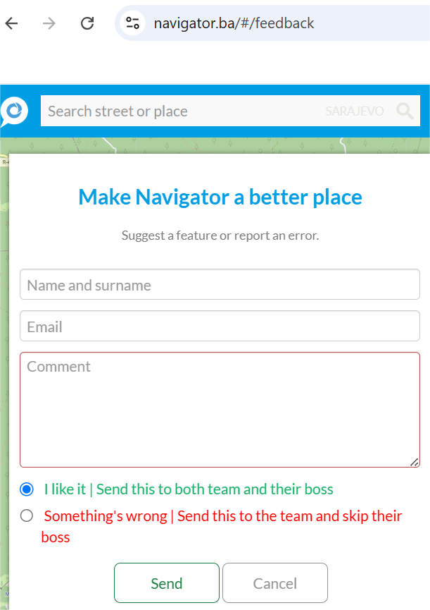
5. **Name**: Creating a new place not possible on Create button  
     
   **T**ype**: Functional bugDescription**: When trying to create a new place through the form, submitting the form results in an error message: "**Some unexpected error occurred. Please try again.**" The form is not submitted, and the user is unable to create a new place. The error message is generic and doesn't provide details about what went wrong, making it difficult for the user to understand how to resolve the issue.

**Steps to Reproduce**:

1. Navigate to the "Create a New Place" form on the https://www.navigator.ba/#/create-place
2. Fill in all required fields with valid data.
3. Click the **Create** button to create the new place.
4. Observe that the error message "**Some unexpected error occurred. Please try again.**" appears, and the form is not submitted.

**Expected Result**: After clicking **Submit**, the new place should be created successfully, and the user should receive a confirmation message or be redirected to a success page. If there’s an error, the message should be specific (e.g., "Missing field" or "Invalid input in location") rather than generic.  
**Actual Result**: After submitting the form, the error message "**Some unexpected error occurred. Please try again.**" appears, and the place is not created. No additional details are provided to inform the user about what went wrong.  
**Error Message**: "**Some unexpected error occurred. Please try again.**"  
**Severity**: Major   
**Priority:** High

**Screenshot:**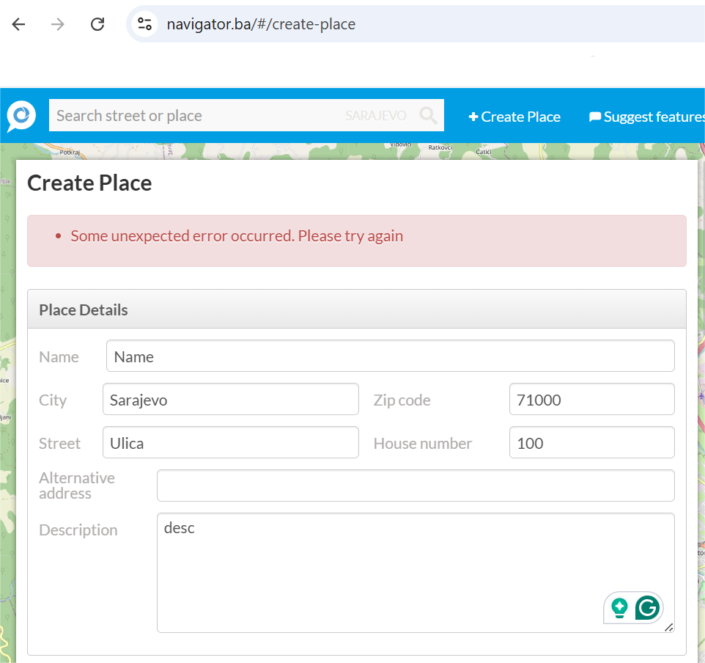

**6.Name**: Google Plus button in header leads to a random address  
  
**Type**: **Functional bug  
Description**: When clicking the **Google Plus** button in the header (next to the Twitter button), the user is redirected to a random or incorrect address instead of the intended **Google Plus** page. This behavior is not expected, as the button should lead to a legitimate Google plus page.  
  
**Steps to Reproduce**:

1. Navigate to the header of the page.
2. Click on the **Google Plus** button (it is located near the Twitter button).
3. Observe that you are redirected to a random address instead of a Google Plus page.

**Expected Result**: Clicking the **Google Plus** button should redirect the user to the official **Google Plus** page. If the platform is no longer available (e.g., Google Plus has been shut down), the button should either be removed or point to an appropriate replacement URL.  
**Actual Result**: Clicking the **Google Plus** button leads the user to a random or incorrect address, causing confusion and providing a poor user experience.  
**Error Message**: None   
**Severity**: Minor  
**Priority**: Low

**Screenshot**:  
**