- Create and print variables Write a Java program that declares an integer, a double, and a string. Assign them values and print them.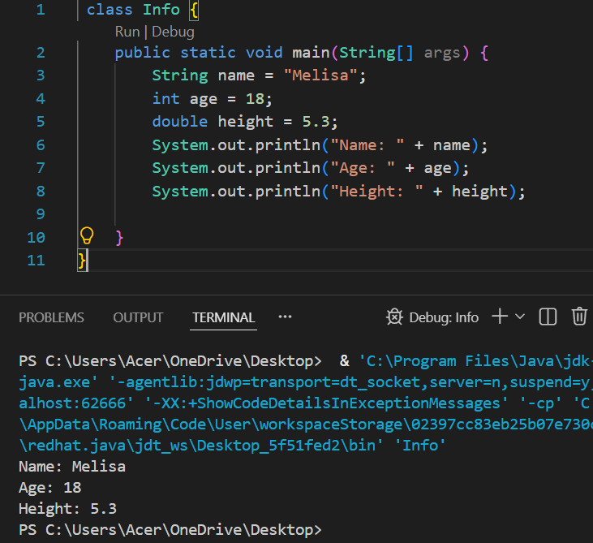

- Simple arithmetic operations Write a Java program that declares two integers and prints their sum, difference, product, and quotient.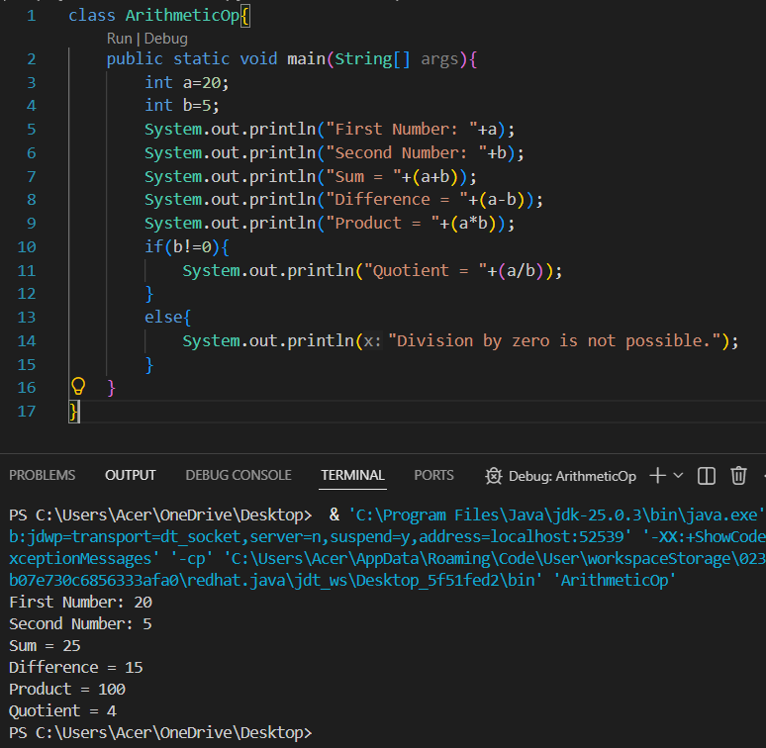
- Even or Odd Checker Write a Java program that checks if a number (taken as input) is even or odd using an if-else statement.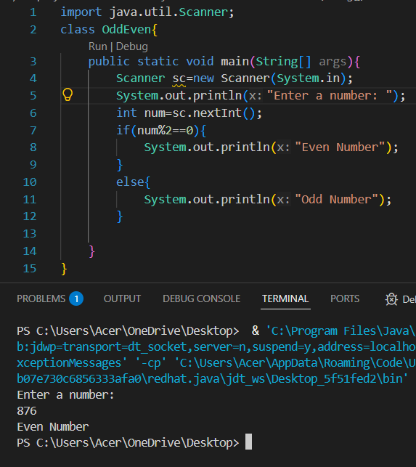

- Simple Class with a Method Create a class Student with two attributes: name and age. Create a method displayInfo() that prints the student's name and age. In the main method, create a Student object and call displayInfo().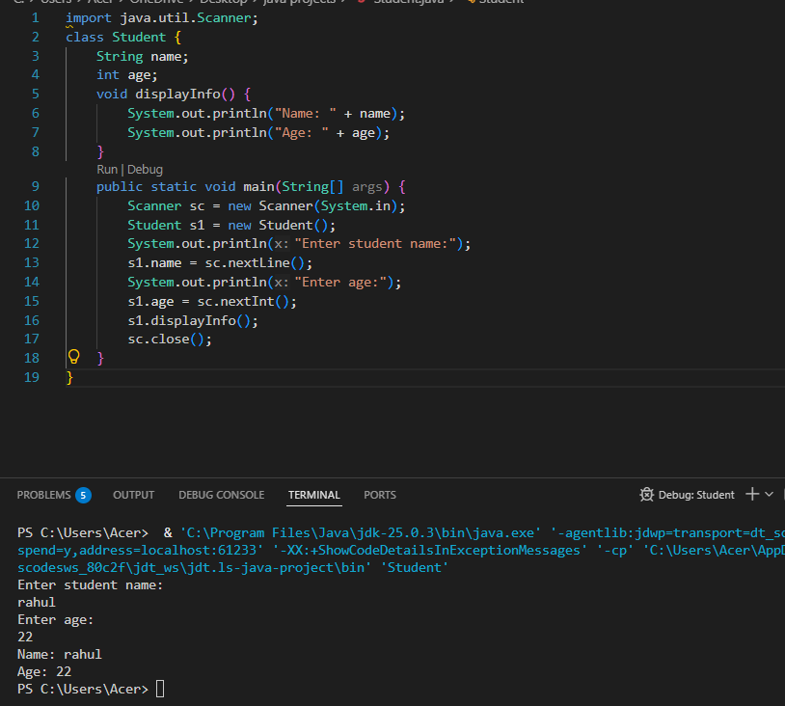
- Use of Logical Operators Write a Java program to check if a person is eligible to vote. (The person must be 18 or older and a citizen.)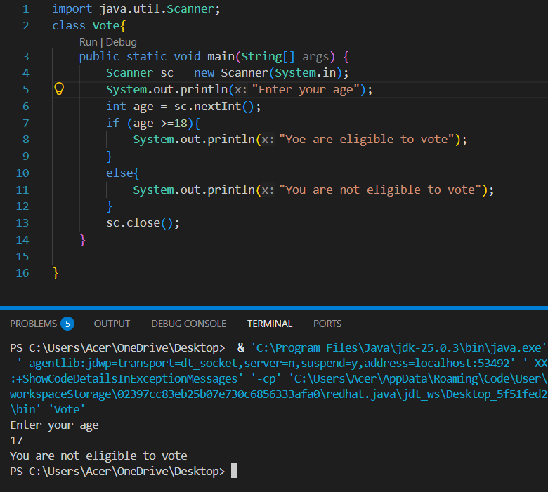
- Comparison using if-else Write a Java program that takes two numbers and prints the greater number.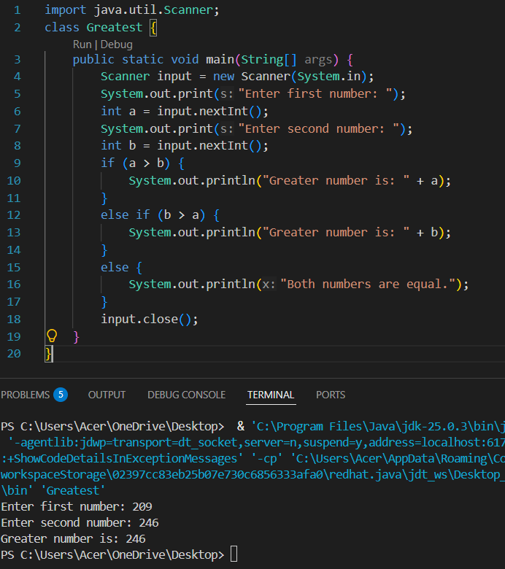

- Class Initialization through Constructor Create a class Book with attributes title and author. Initialize them using a constructor, and print the details using a method showBook().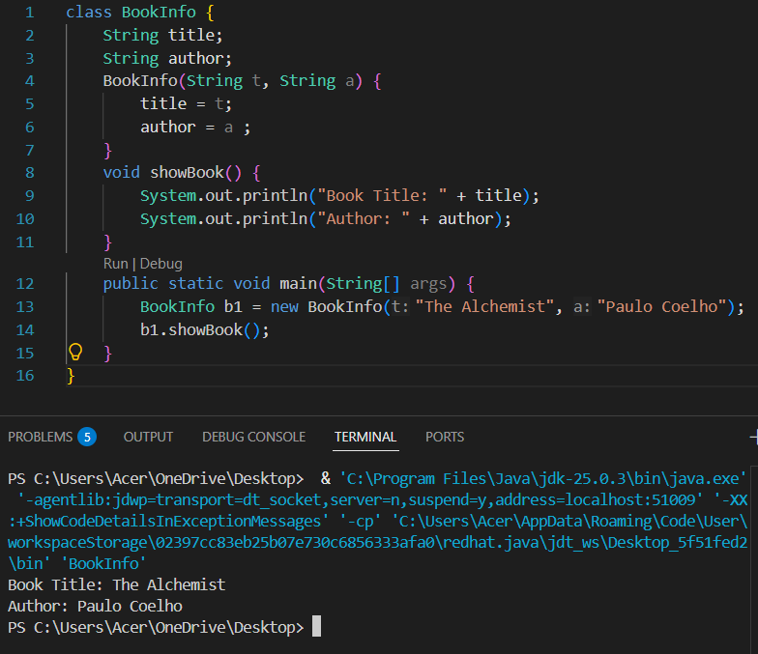

- Simple Calculator (if-else) Write a Java program that asks the user to enter two numbers and an operator (+, -, *, /) and then calculates the result based on the operator using if-else statements.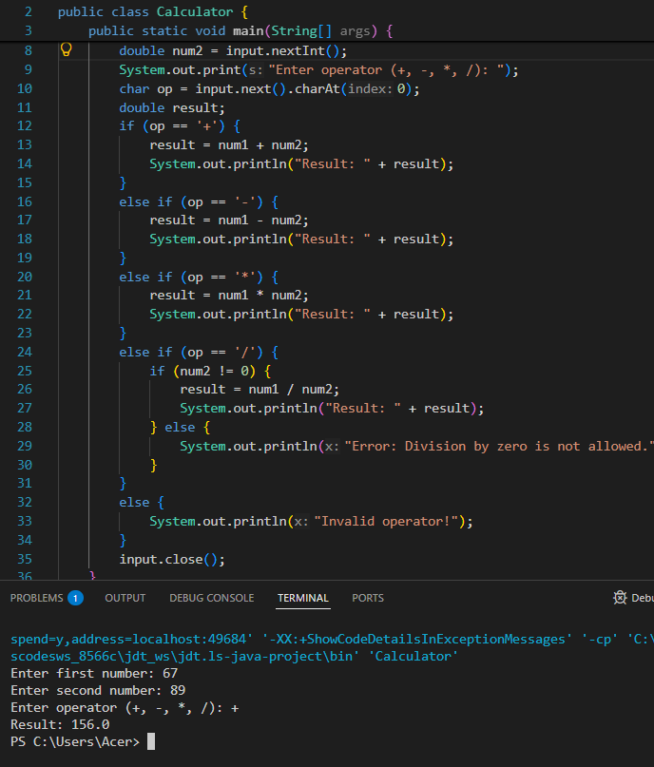
- Positive, Negative or Zero Write a Java program that takes a number and prints whether the number is positive, negative, or zero.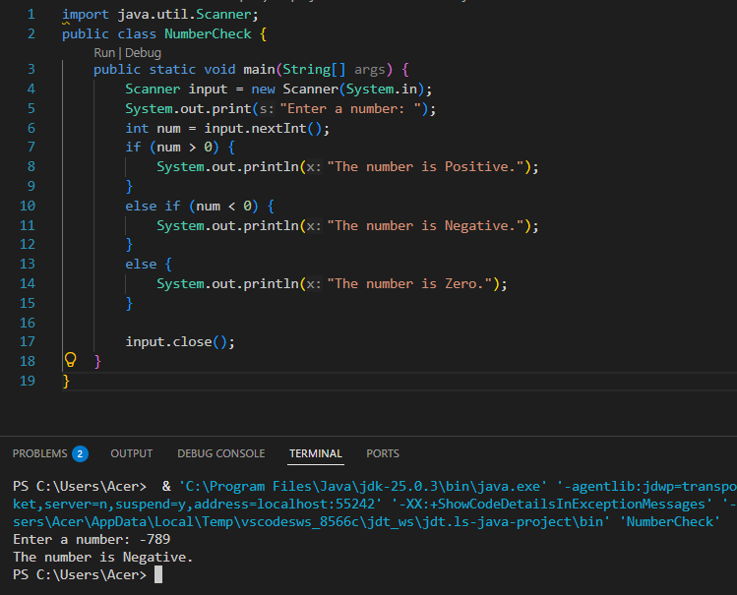
- Create Multiple Objects Create a class Car with attributes brand and year. Create two Car objects in the main method and display their details.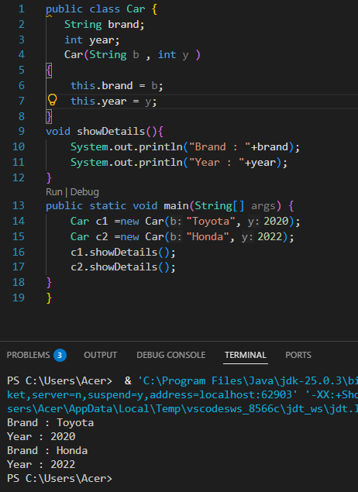

- Book Library (Manual Objects) Create a Book class with attributes: title, author, ISBN. In the main() method, create 5 different Book objects manually and display their details using a method showDetails().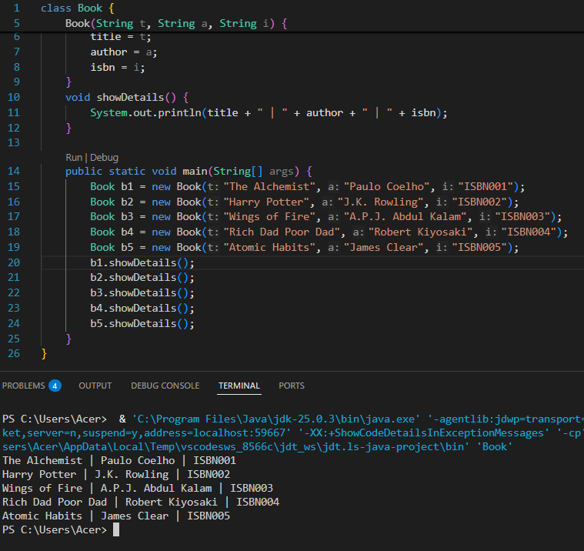

- Bank Account System Create a class BankAccount with attributes accountHolderName, accountNumber, and balance. Create a constructor to initialize them. Create methods deposit(amount) and withdraw(amount) which modify the balance. Show messages if withdrawal amount exceeds balance.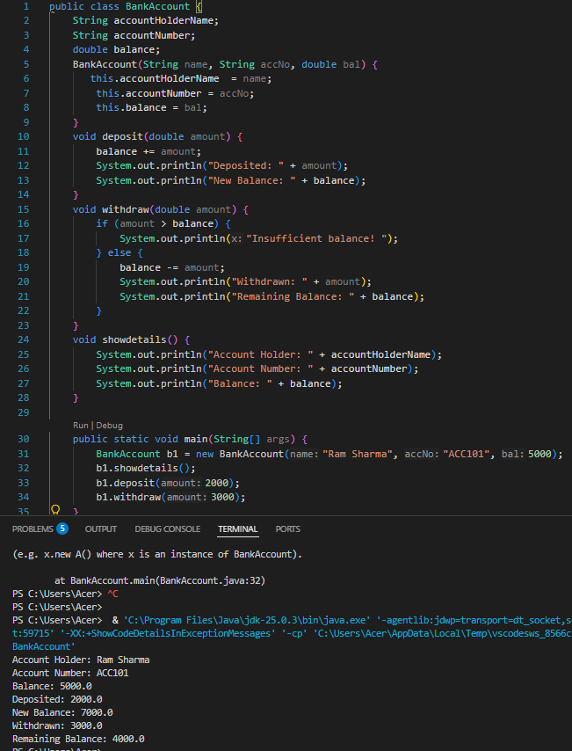

- Student Grading (Switch Statement) Create a Student class with name and marks. Write a method calculateGrade() that assigns a grade (A, B, C, D, F) based on marks using a switch or if-else ladder. Create 3 students and display their grades.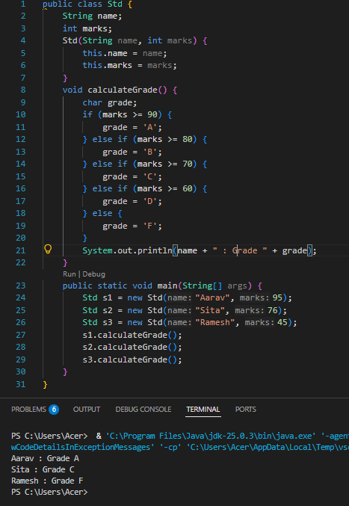

- Rectangle and Area Calculation Create a class Rectangle with length and width. Initialize using a constructor. Create a method calculateArea() that returns the area. Create 3 rectangles of different dimensions and display their areas.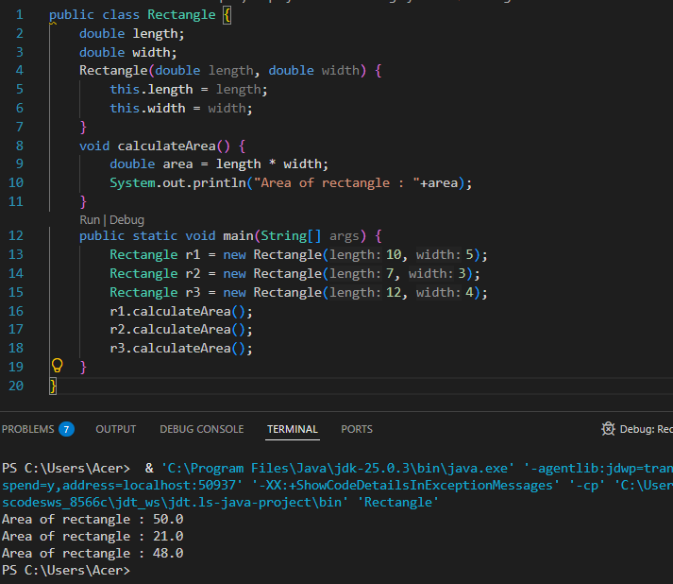

- Movie Details Manager Create a Movie class with attributes: name, language, rating (out of 5). Create a method displayMovieDetails(). In main(), create 4 Movie objects and call displayMovieDetails().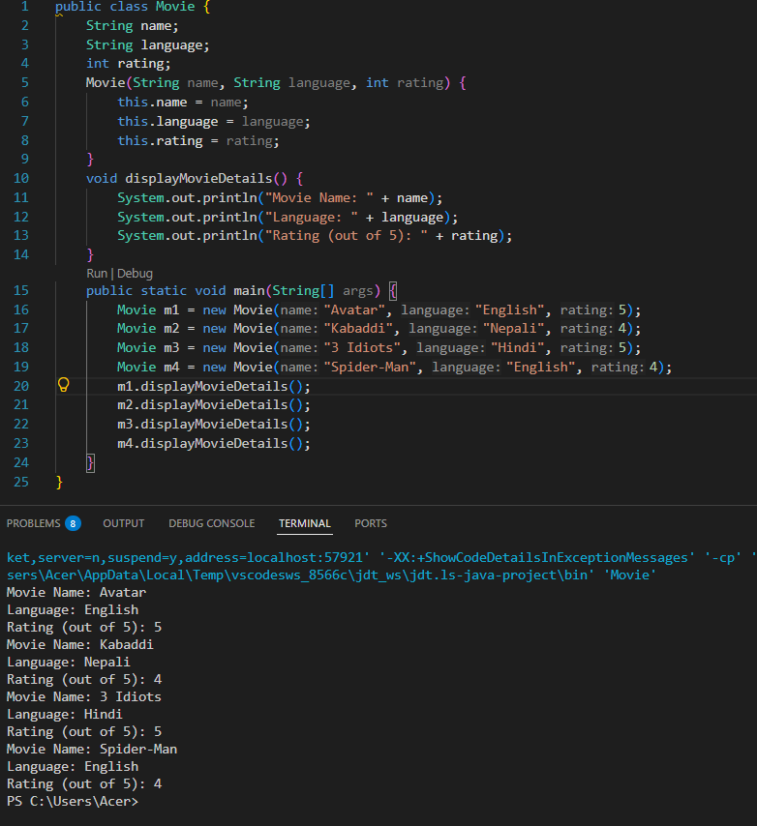

- Employee Bonus Calculation Create a class Employee with name, salary, and yearsOfExperience. Write a method calculateBonus():
If experience > 5 years, bonus = 20% of salary
Otherwise, bonus = 10% of salary Display the bonus amount for each employee.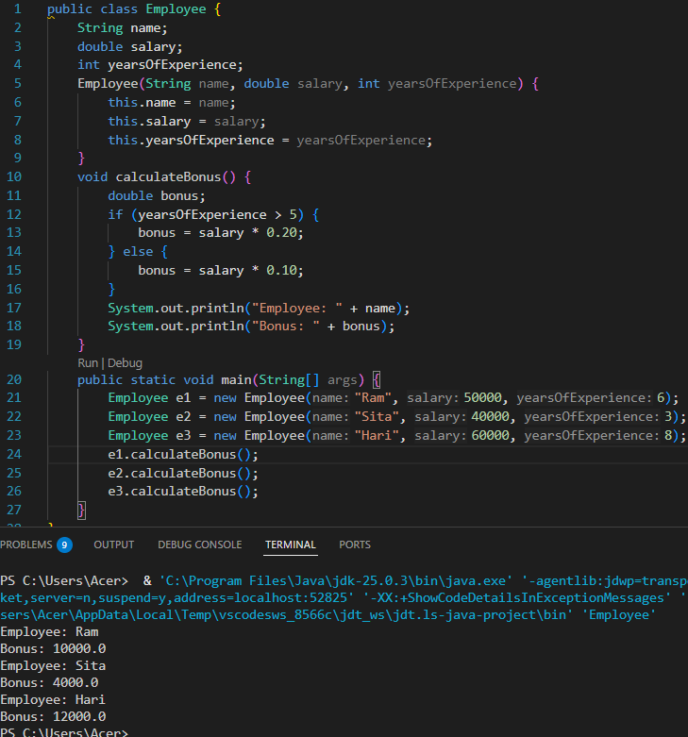

17.Product Discount Calculator Create a class Product with productName, price, and discountPercentage. Write a method calculateFinalPrice() which returns price after discount. Create 3 different products and print their final prices.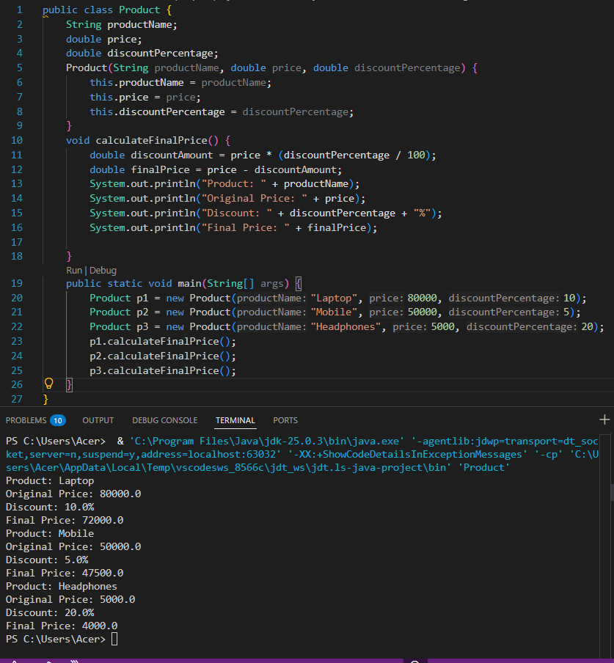

18.Simple Contact Management Create a class Contact with fields: name, phoneNumber, emailAddress. Create 3 Contact objects. Print the contact details only if the emailAddress is not empty (use if condition).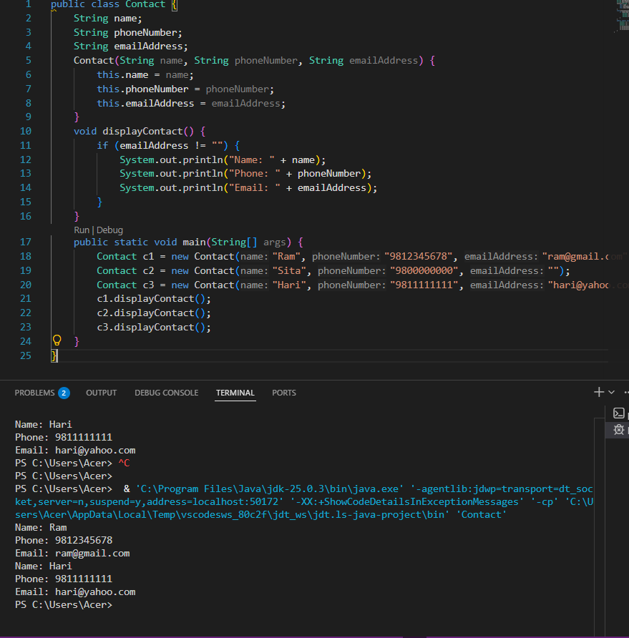

19.Constants Usage Example Create a Circle class with an attribute radius. Use a final constant PI = 3.14159. Write a method calculateCircumference() and calculateArea() using PI. Create two Circle objects and display their area and circumference.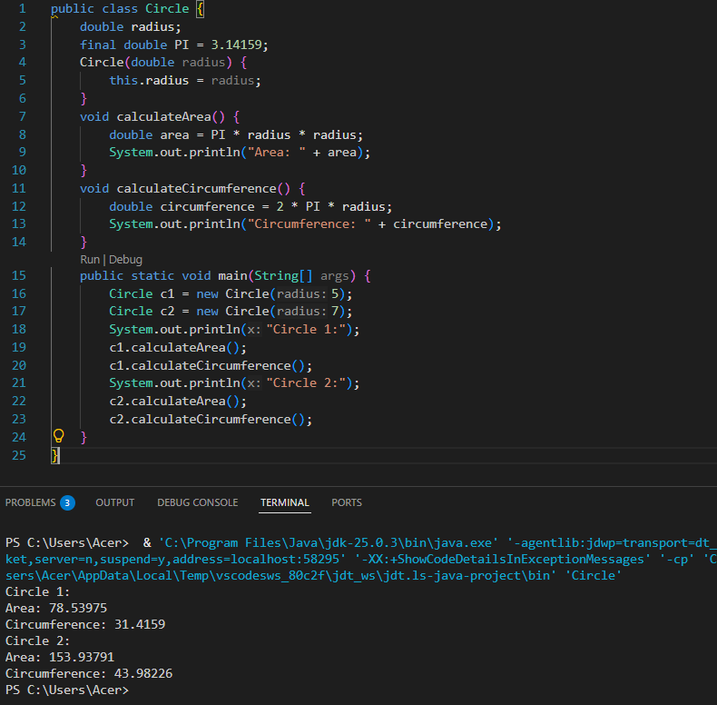

20.Manual Car Showroom Inventory Create a Car class with attributes: brand, model, price. Create 5 different Car objects with different details. Display the cars whose price is greater than 20,00,000 (use if statement).