INSTITUTO POLITÉCNICO NACIONAL

ESCUELA SUPERIOR DE CÓMPUTO

UNIT OF LEARNING

Analogics Electronics

Practice No. 7

“VOLTAGE COMPARATORS”

Group: 1CV5

Integrants

* Luciano Espina Melisa
* Mena Ortiz Erick Jafet

Introduction 3

Objetives 3

Material 3

Equipment 4

Experimental Development 4

 Zero crossing Detector Non Inverting 4

Photos 6

 Zero crossing Detector Inverter 6

 Detector of crossing for investing zero with histéresis 8

 Applications of the level detector of voltaje 10

Applications level detector voltage with hysteresis. 12

Simulated Analysis 13

Questionnaire 15

Conclutions 16

Luciano Espina Melisa 16

Mena Ortiz Erick Jafet 16

# Introduction

In this practice is studying circuits electronic comparators with emphasis on the comparators regenerative and in the monolithic comparators, operational amplifiers with the specific purpose of comparison or also called voltage comparators. In effect, the AOs can act as comparators when its gain in open loop is very high and its speed (SR) high.

The comparator function consists in considering two voltages, obtaining as a result two possible situations, corresponding to levels high or low. In theory we saw that, in open loop, the AO of general purpose behaves as level detector and the high and low voltages correspond to the output of saturation of the component.

Precisely this is the third critical constraint in choosing an AO of general purpose in an application of comparison, since the output levels may not be suitable for the application, as for example to a directional TTL logic. The concept of "open collector output" solves this problem.

The effects of noise on the circuits comparators may occur with the effect of overlay a square signal to a sinusoidal in a dial gauge not investor based on AO of general purpose. In general the noise is a random process.

Positive feedback the negative feedback force to a circuit to operate in the linear region, and in our case, with the AOs considered zero or almost zero the voltage differential input to the component. On the contrary, the feedback positive force the saturation, and consequently the imbalance between the voltages present in the entries and shuttle not of shuttle ao

# Objetives

* Check the use of the simple comparators and with hysteresis
* Perform with the simple comparators some applications
* Perform with the comparators with hysteresis some applications
* Follow the results obtained for the circuits made

# Material

* 1 Slat of experimentation (protoboard)
* 3 Coaxial cables 1m with BNC terminal-Cayman
* 4 cables of 1.50m Banana-Cayman
* 10 Operational amplifiers 741
* 13 Resistors of 1KΩ to ¼ W
* 1 Resistors of 1KΩ to ¼ W
* 2 Resistors of 1KΩ to ¼ W
* 2 Resistors of 1KΩ to ¼ W
* 1 Resistors of 1KΩ to ¼ W
* 1 Resistors of 1KΩ to ¼ W
* 4 Resistors of 1KΩ to ¼ W
* 1 Fotoresistors of 10KΩ
* 1 Zener diode of 5.1 V to ½ W
* 2 Triacs 2N6344
* 2 Optoacopler MOC3011
* 5 red leds or others
* 4 Preset of 10 KΩ
* Socket for focus of 40 W
* Focus of 40W
* 1 Peg
* 2m of Duplex cable No, 14

# Equipment

* 1 Dual power source +12v and -12v
* 1 Analog or digital multimeter
* generator of general purpose
* Oscilloscope function

# Experimental Development

**Note: In all circuits are used the 741 operational amplifier with ±12V Power Supply**

## Zero crossing Detector Non Inverting

Build the circuit as shown in the following figure, enter a sine signal of 16V at a frequency of 1 Khz in the input terminal

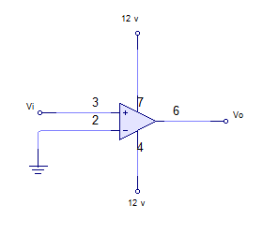

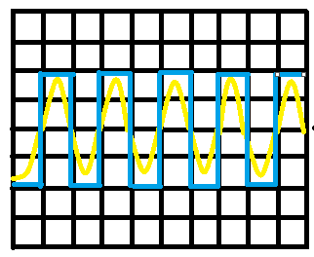Draw the Waveforms obtained of the input and output signals

**2.49** V/div canal 1

**500**mseg/div

**5 V/**div canal 2

With the same circuit and the same input signal note the transfer function on the oscilloscope in the x-y mode, draw the signal below

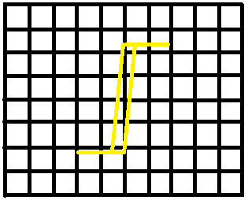

**5** V/div canal 1

**5** V/div canal 2

### Photos

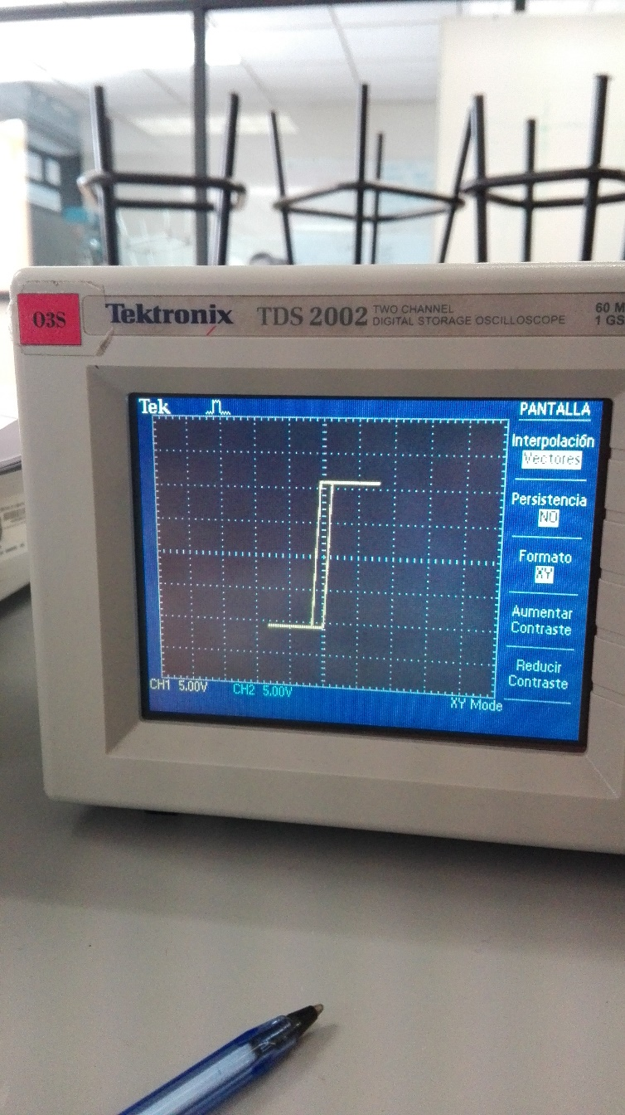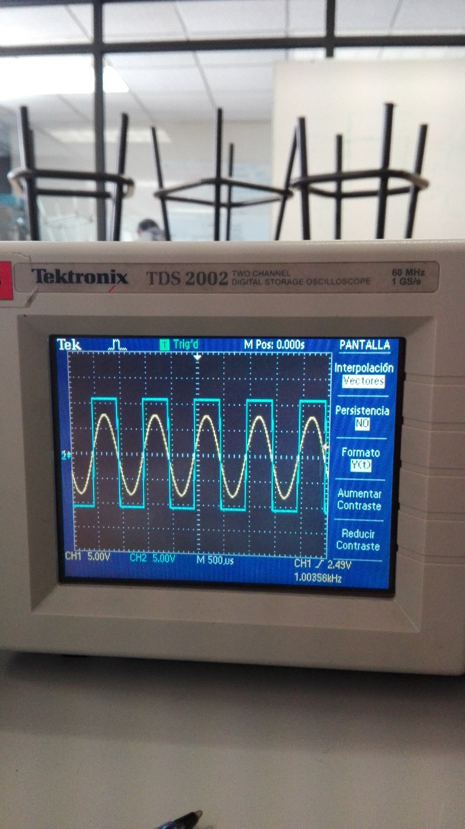

## Zero crossing Detector Inverter

Build the circuit as shown in the following figure, enter a sine signal 16VPP at a frequency of 1 in the input terminal

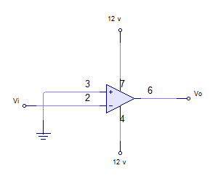

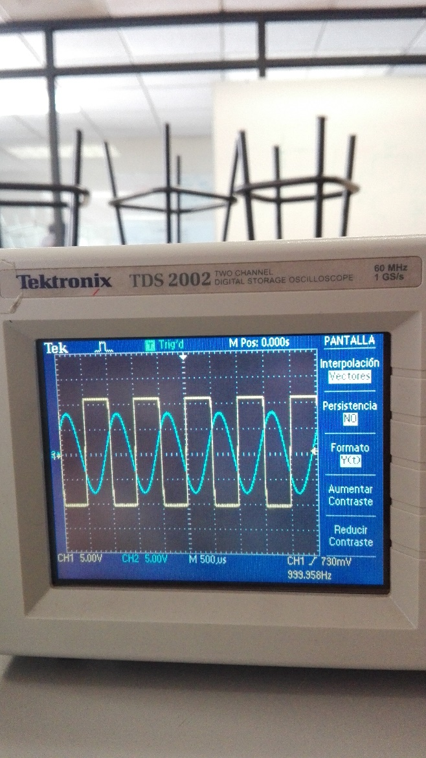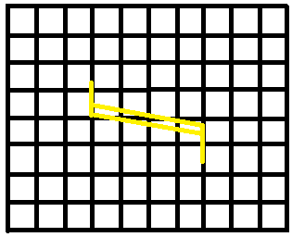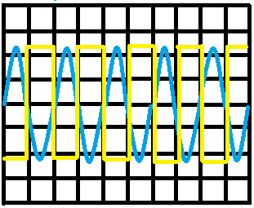

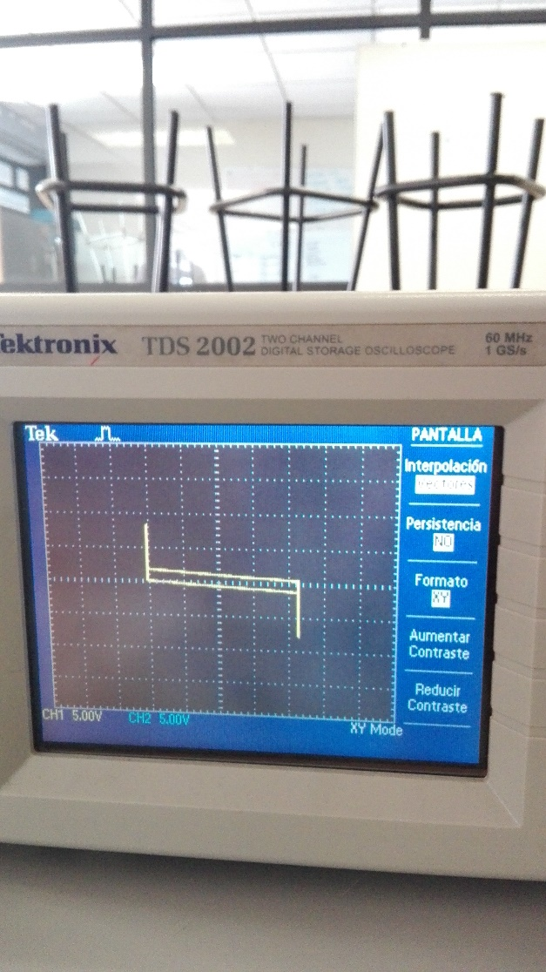

## Detector of crossing for investing zero with histéresis

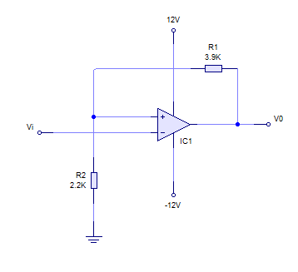Construct the circuit that appears in the following figure, introduce a sign senoidal of 16Vpp to a frequency of 1 KHz in the terminus of entry

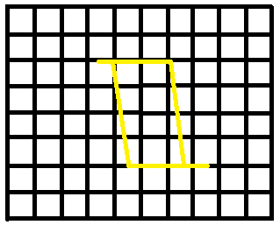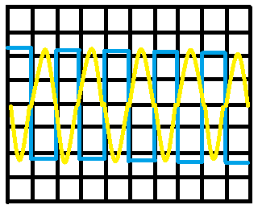

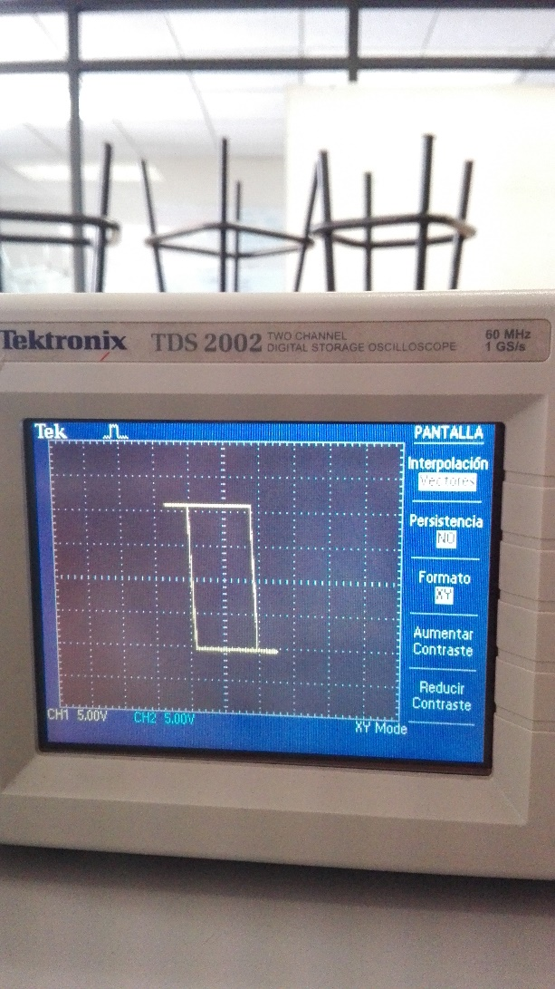

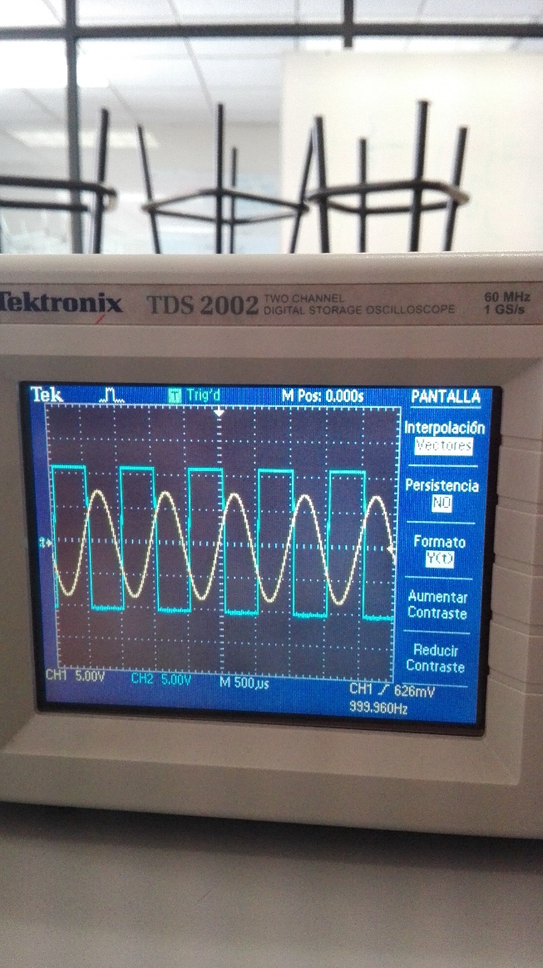

## Applications of the level detector of voltaje

Construct the circuit of the following figure.

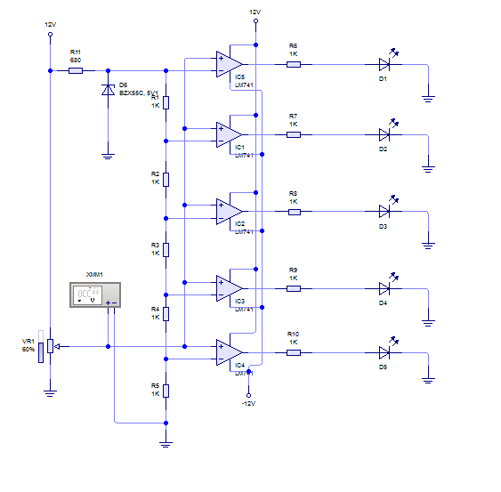

Measure with multimeter the voltage of entry the (vi)th and register to that voltage to which voltage of entry ignites each of the LEDs

|  |  |
| --- | --- |
| LED | Voltaje de entrada |
| 1 | 4.8v |
| 2 | 4.8v |
| 3 | 4.8v |
| 4 | 4.8v |
| 5 | 4.8v |

Later the preset arms the following circuit and adjustment until the area ignites and extinguishes when the suitable one happens the functioning

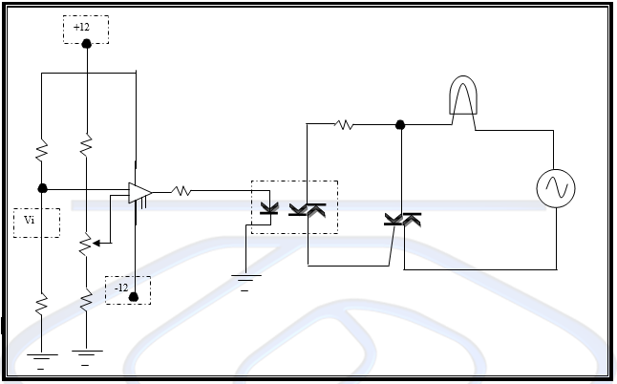

Measure the reference voltage (Vref) once you have adjusted the circuit in the table, also measure the voltage of the photoresistor (Vi) when there is light and when this dark and record also in the table.

|  |  |
| --- | --- |
|  | **Voltaje** |
| **Voltaje de Referencia** |  |
| **Voltaje de la Fotorresistencia a la luz** | 5.4 v |
| **Voltaje de la Fotorresistencia en la oscuridad** | 6.2 v |

# Applications level detector voltage with hysteresis.

Build the following circuit and adjust the presets until the focus turn on and off in an appropriate manner and in such a way that there are no oscillations (noise) in the focus.

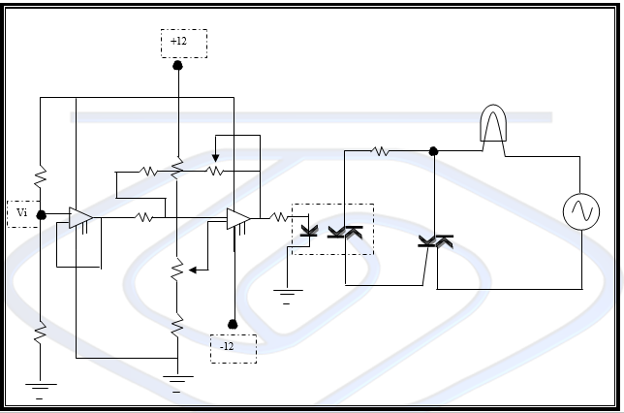

Measure the reference voltage (Vref) once you have adjusted the circuit and register it in the table, also measure the voltage of the photoresistor (Vi) when there is light and when this dark and record also in the table and the value of the resistance nR (the value of the resistance between terminals 3 and 6 of the operational amplifier that works as a comparator with the power supply off)

|  |  |
| --- | --- |
| **Voltaje de referencia** |  |
| Valor de la resistencia nR | 6.7 |
| **Voltaje de la Fotorresistencia a la luz** | 3.8 |
| **Voltaje de la Fotorresistencia en la oscuridad** | 5.0 |

# Simulated Analysis

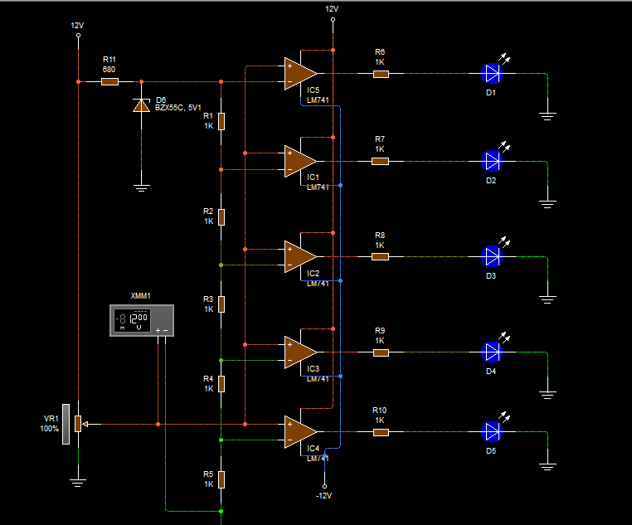

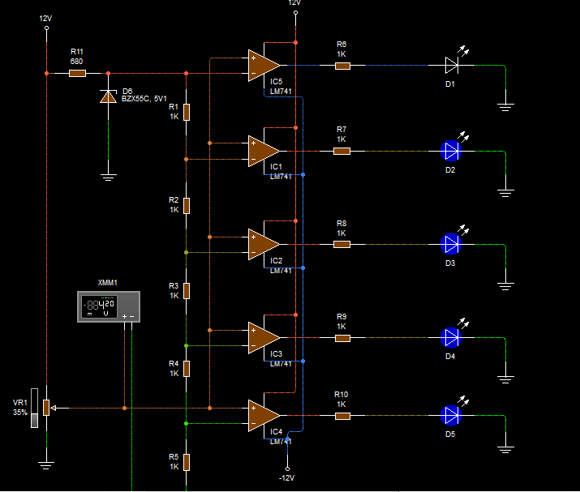

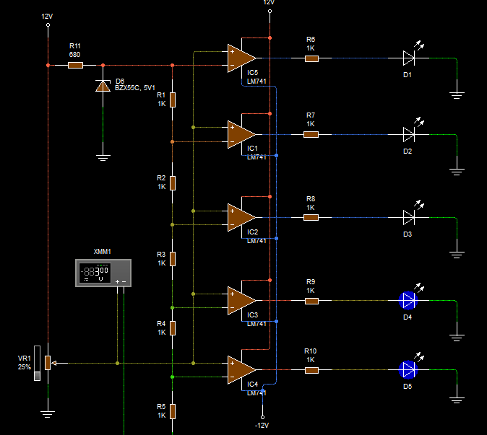

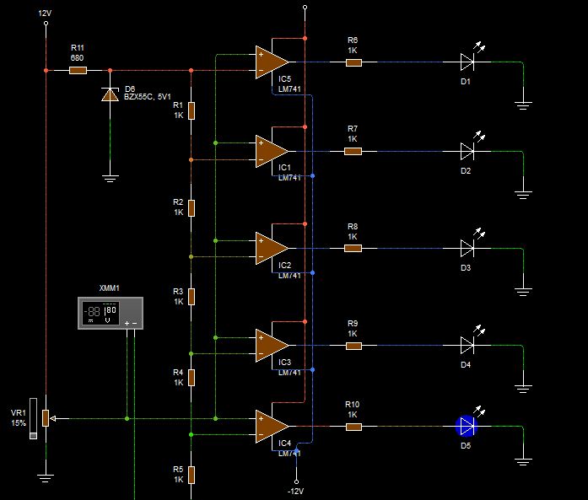

# Questionnaire

1. **It mentions 5 applications in which the comparadores are used**

* The Operational Amplifier as comparador
* The Operational not investing Amplifier
* The Operational Amplifier like investing
* Amplificador Operacional as resumptive investor

1. **Which is the maximum and the minimum output voltage in the circuits Comparators**

12 and -12

1. **Which is the case in which the output voltage is zero**

In the

1. **The reference voltages used in the comparators of voltages that circuits can come**

They it became of the comparator circuit

1. **What functionality is the follower of voltage in the circuit of the application of voltage detector with hysteresis?**

Principio del formulario

Final del formulario

Principio del formulario

Final del formulario

# Conclutions

### Luciano Espina Melisa

The opeationales, amplifiers are a whole world that had no idea existed, but apparently are widely used because they have different useful applications, along with the photoresist and focus. The interesting thing about this practice were the graphs on the oscilloscope noticed more than anything representation (x, y).

### Mena Ortiz Erick Jafet

In this practice we analyze and we understood the use of operational amplifiers as comparators of level

Analyzing the graphs obtained we can affirm that our practical results, are very similar to our theoretical values.