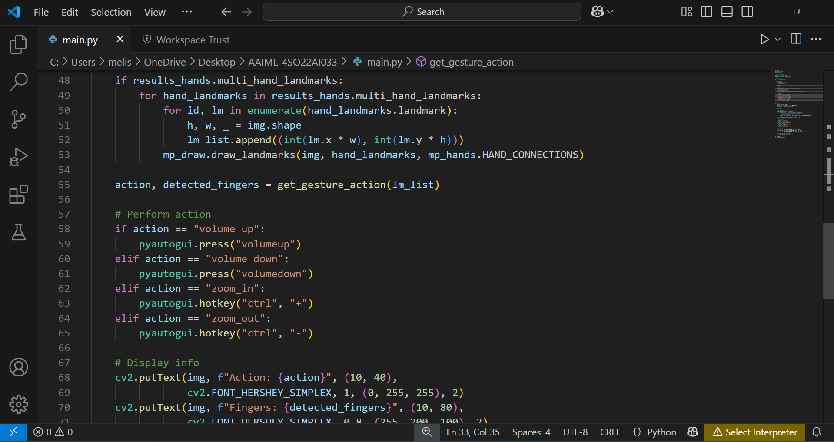

**Zoomed In Image(Finger Index:-[0,1,0,0,0])**

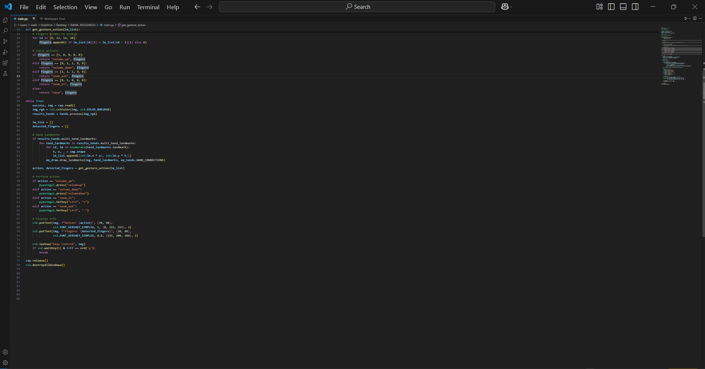

**Zoomed out Image(Finger Index:- [1, 1, 1, 0, 0])**

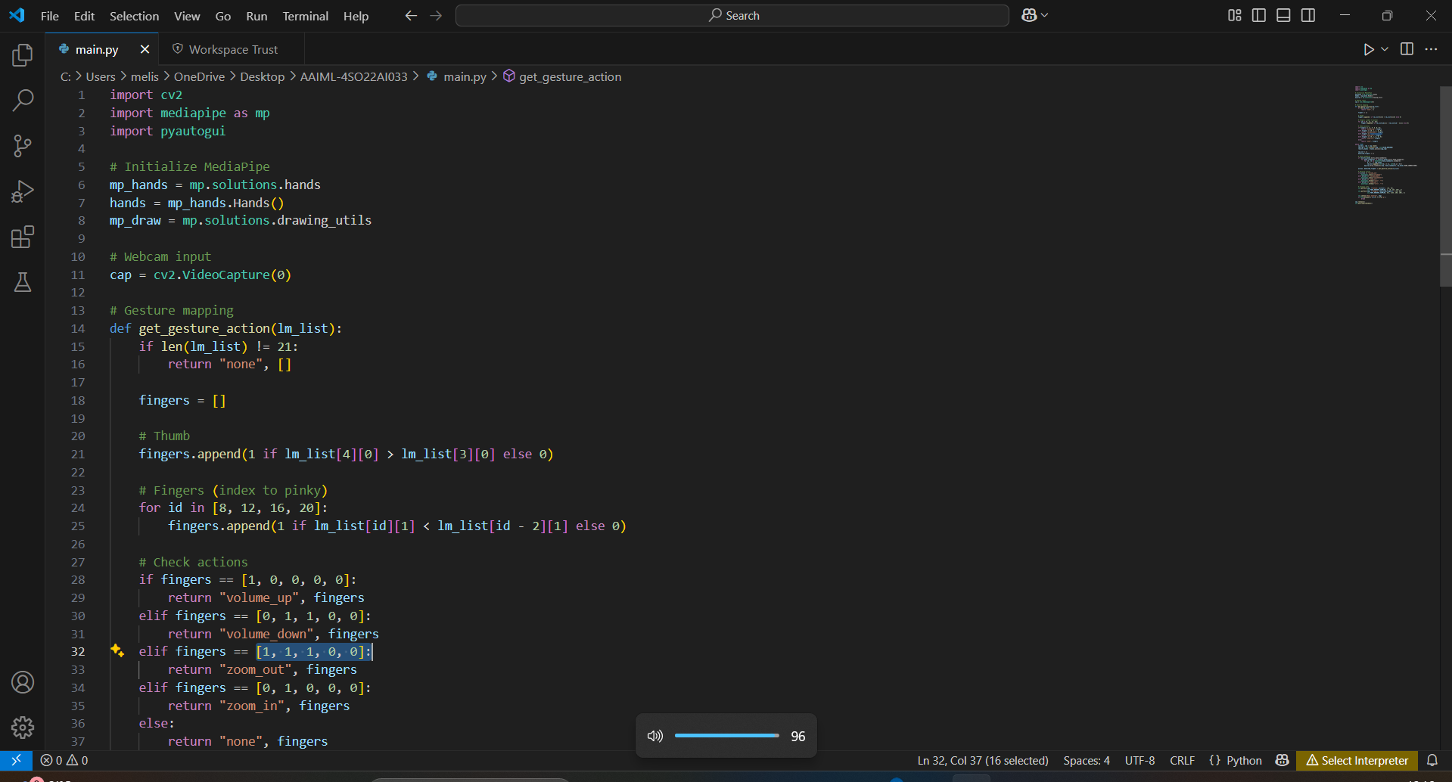

**Volume going up(Finger Index:-[1, 0, 0, 0, 0])**

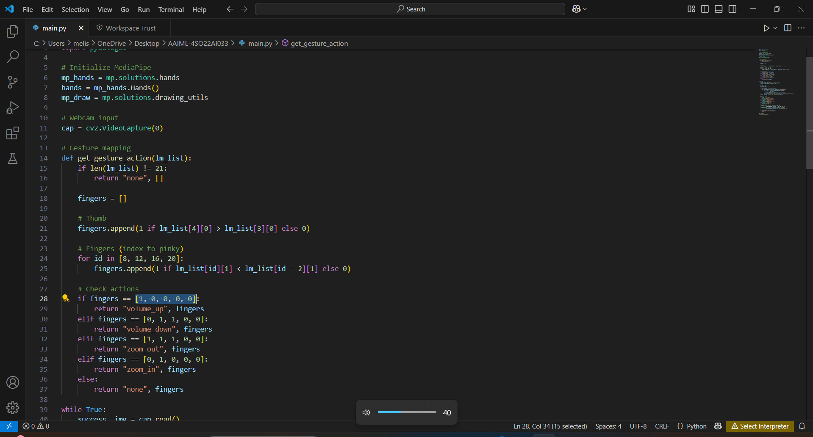

**Volume going down(Finger Index:-[0, 1, 1, 0, 0])**

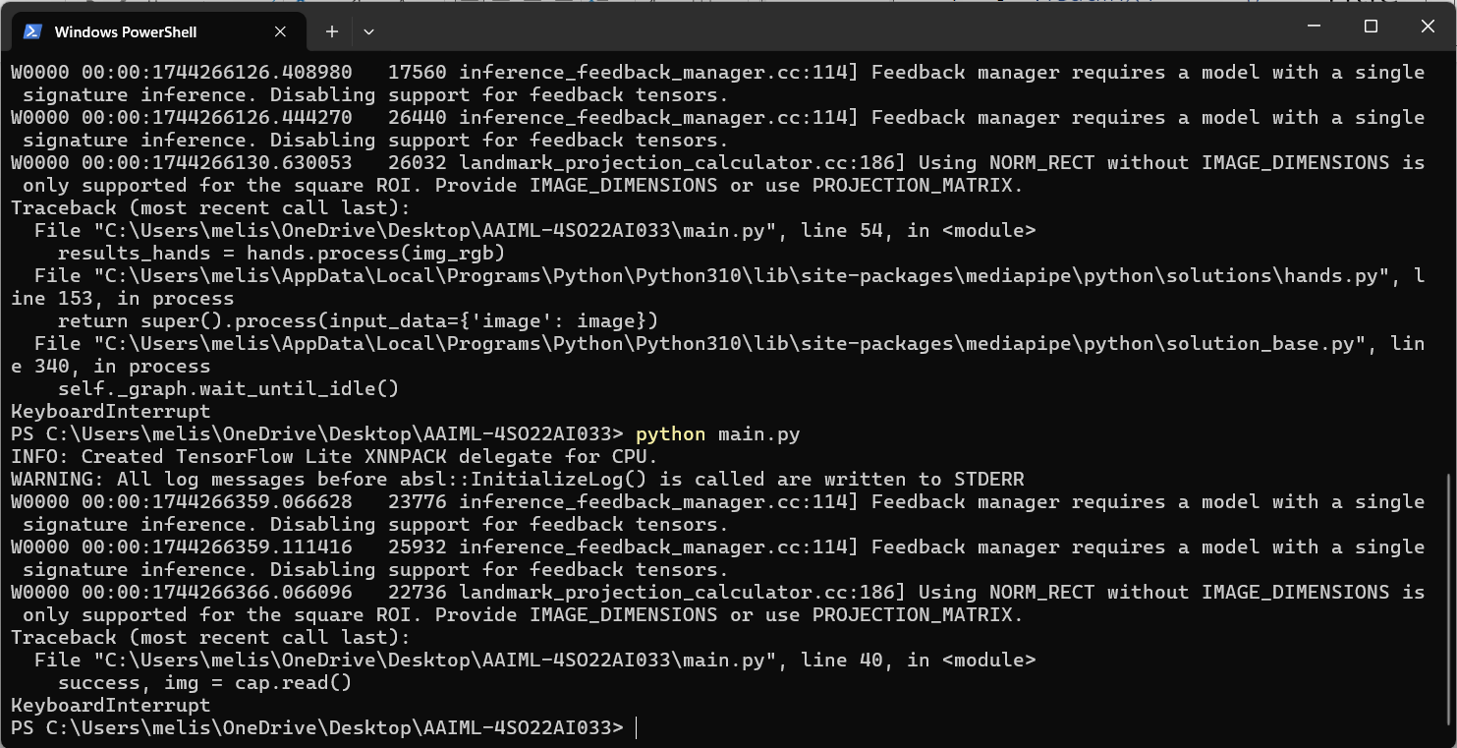

**Terminal Screenshot to Initiate the process**