**San Bernardino County – Women with Occupations in Computers, Engineering, or Science**

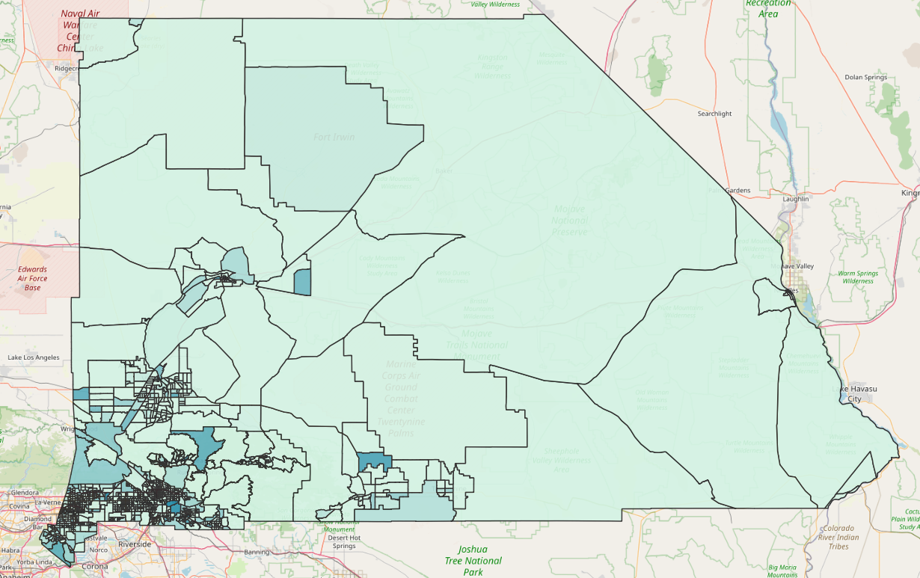

**Percent of Women by Population:**

