**Data Processing: Design 2**

Sara Aerssens, Nina Cialdella, Melissa Wijngaarden, Nik Gabel, Sven van Dam

Problem 1: Design critique

**Who is the intended audience?**

Movie lovers and market researchers.

**What tasks does the visualization enable?**

The visualization can be used to analyze how the popularity of certain movies is spread over time. Besides it can also be used by filmmakers to decide on the perfect time to release a movie.

**What data is represented in this visualization? Be specific.**

The box office revenue of movies throughout time. The width of a certain area at a given point represents the revenue of that day. Clicking on a movie also enables you to see a short summary about the movie.

**How is each data type visually encoded?**

Each movie has its own peak with a color that indicates the total domestic gross. The shape of the peak indicates how the movie did at the box office on a weekly basis.

**How do the visual elements and user interactions support the tasks?**

Users can look up a film and compare its revenue with other films released in the same period. The visual representation makes it easy to see the height and length of success for a film.

**Why do you like / dislike this visualization?**

While the visualisation is aesthetically appealing, it is rather uninformative. There are no values on the y-axis and the areas are grouped in only four groups of total revenue. The stacking of movies makes the viewer able to see the total movie revenue trends throughout time but it is hard to isolate information on one specific movie. There are way too many individual areas. The ‘small’ movies virtually disappear due to their relatively small revenues.

Besides that, an upwards trend from the center and a downward from the center both indicate positive revenue.

The visualization was probably made by a graphic designer rather than a data scientist or so.

From studying this visualization we have learned that it’s not always right to include all available information.

Problem 2: Questions corresponding to the readings

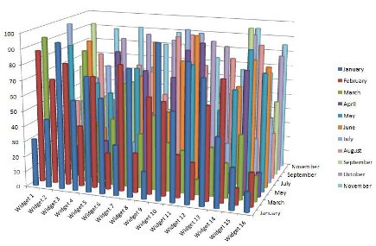

<http://data-visualization-software.com/dangers-of-bling-data-visualizations/>

**Consider Bertin’s characterization of visual variables (position, size, shape, value, color, orientation, and texture). Pick 2 of Bertin’s visual variables, and discuss them in relation to your visualization.**

**Color** - In this graph all the values of a certain month have the same color. On first sight, this suggest that there is a relation from left to right between the datapoints. This is, however, not the case. The datapoints are sales numbers of different widgets and are independent of each other. Hence, it would be advisable to give all datapoints of widget x the same color so that you can see how the sales of this widget develop throughout time.

**Position** - This graph uses a 3 dimensional space. Since it is sorted in months (January first, November last), we can not see the values behind January if they are smaller than that widget’s previous values. It is also unclear which months and/or widgets the bars in the back belong to. In this way the graph is not useful at all to analyze and compare the sales of widgets over months.

Altogether this visualization fails on all levels since the user is not able to make any comparisons between widgets or months, mainly due to the bad use of color and poor positioning. Besides, the graphic is not attractive to look at either.

**Ask yourself what the designer is trying to convey and think of three to four possible tasks this visualization should help you with. Does the visualization achieve any of your tasks?**

The aim of the designer was probably to show the sales revenue of various widgets over time. The data could be used to compare sales of various widgets, to compare sales of one widget in the course of one year or to compare the total sales of widgets for each month. The visualization does not achieve any of those tasks, because there is too much going on. A simple line graph would be preferred in this case.