Goal
In the assignment, I developed 5 basic morphological operators that will let me alter and tune images for further evaluation later in the class.
Algorithm
Erosion
For every pixel that has a value of 1 in the image, I multiply the structured element (SE) to the pixels around the image with the center of the pixel aligning with the center of the SE. If the SE has a value of 1 but the image doesn’t, I label that specific pixel. After iterating over all the pixels, I remove all the labelled pixels from the original image to achieve erosion
Dilation
Again, I loop over all the pixels and apply the SE however this time if the SE*img = 1 at any point within the analysis window, that pixel is labelled. At the end, all the labelled pixels are added to the original image which results in a “dilated” image.
Opening
Opening is the process of applying erosion followed by dilation to an image
Closing
Closing is the process of applying dilation followed by erosion to an image
Boundary
Boundary involves taking the original image and then removing the eroded image to get the boundaries of the original image
Highlighted Results (All are available in the submission)
I used different combinations of SE’s for each operation however I kept them consistent between the gun and the palm. The closing gave great results although I wasn’t able to remove noise without significantly decreasing the quality of the remaining image. The boundary hasn’t given great results since the original image has so many “holes”
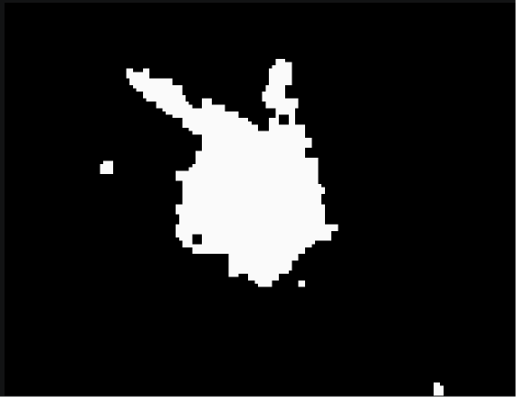 | 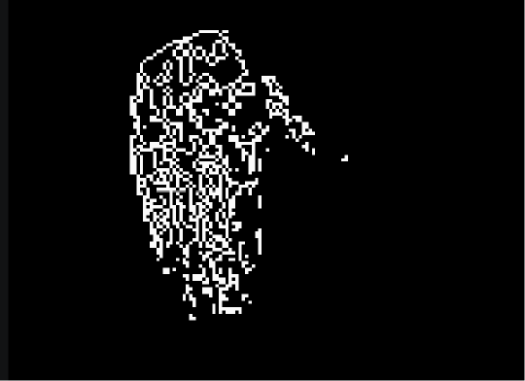
Gun – Closing | Palm - Boundary

