Goal
In this assignment I implemented the hough transform to do line detection on a set of test images
Algorithm
Edge Detector
The Canny edge detector from the previous MP was used to convert the image into Edges. This is stored in util.py
Parameterise
Using a configurable quantisation, a rho, theta parameterised space is created out of the x-y image.
Significant Intersections (Parameter Space)
I chose to do thresholding followed by non-maxima surpression to identify the significant intersection points (lines) in the image. This was still in the parameterised space. The configurable values were the size of the non-maxima surpression and the threshold percentage of the interesections that are kept (top 50%, 60% …). In the end, an array of rho/theta was returned
Unparameterise
The array was converted back into lines and overlayed on the original image for testing and analysis of results. I found 2 points sufficiently far so that the line seems to cross the entire image
Results
If you don’t tune the other parameters (threshold, dilation size), then a lower quantisation gives significantly worse results. For quantisation = 128 (128 bins). I begin losing out on lines in even the test cases
 | Test | Test2 | Input
Quant = 256 | 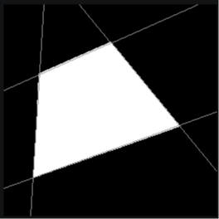 | 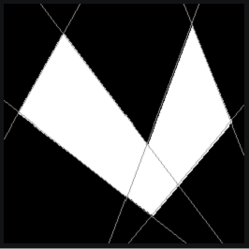 | 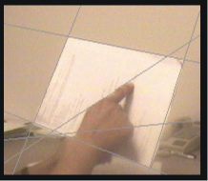
Quant = 128 | 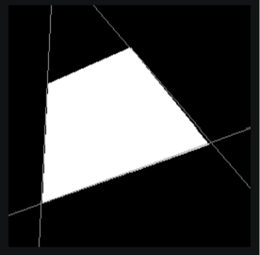 |  | 

