Goal
In this assignment, I implemented Template based Target tracking algorithm to track a person through a video. I achieved great results until the person spun around and was occluced by other people which would require additional processing to address since it’s a known downside of the utilised algorithm.
Algorithm
Initialization
A boundary box was drawn on the first frame to create the initial “Template”. This was created by eye and the overall size stays the same throughout the algorithm. The process in the next sections are to compare all the position in a region around the previous bounding box and minimise or maximise the algorithm being used.
SSD
In this algorithm, the sum of the squared difference between the current and previous frame is minimised to determine the bounding box
CC
Here, the cross correlation is maximised to determine the bounding box
NCC
Here the normalised cross correlation is maximised to determine the bounding box
Results
Start | Spin | Occlusions
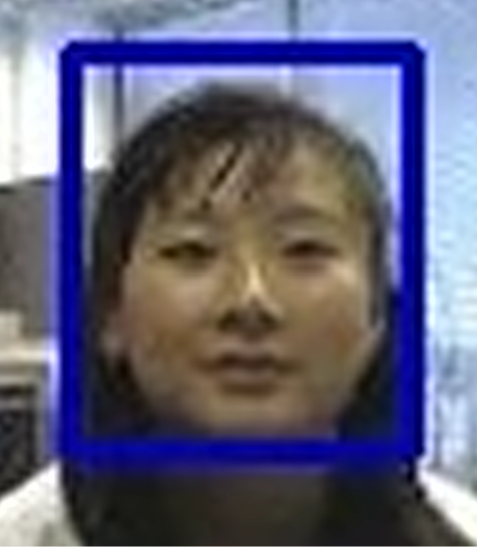 | 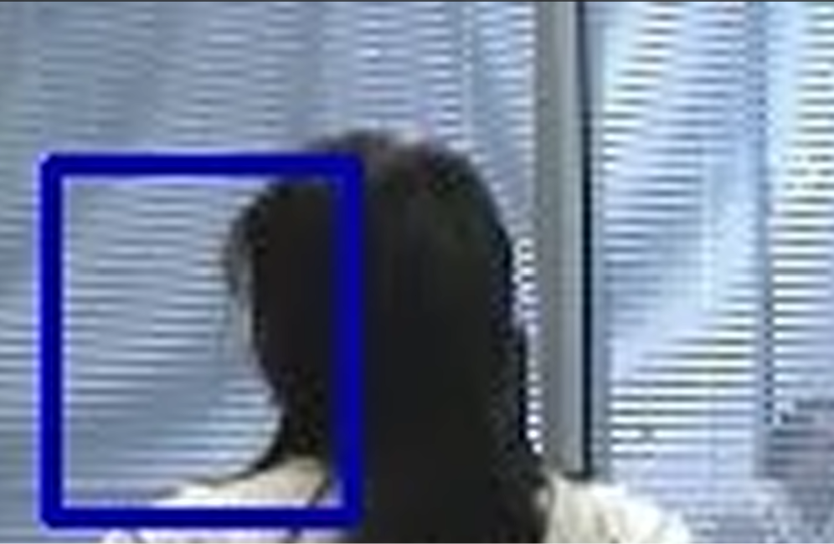 | 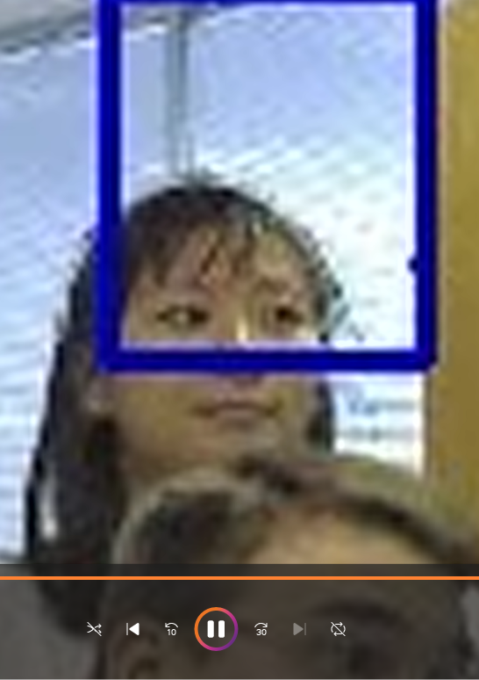

All 3 algorithms performed really well at the start, keeping a great tracking of the persons face. However all 3 started to perform poorly once the person spun since the intial template was now completely gone. It is hard to recover from this since the memory of the system is only 1 frame. Finally, the occlusion again prevented the box from latching onto the person completely.

