Goal
In this assignment I used histogram techniques to improve an image of the moon. Further on we also used lighting correction to improve the image further
Algorithm
Histogram
The intensity of each pixel is stored in an array which gives us a histogram of the number of pixels at each intensity. This is then normalised and converted into a cumulative histogram. Finally, the intensity of each pixel is used to extract the value from the cumulative histogram and multiplied by the range of the output image (0, 255) to give us the improved image.
Linear Lighting
In order to account for the lighting position of the image, a plane of best fit is created and then subtracted from the original image (and the average of the plane is added). I then chose to do truncation to remove values that are below 0 and above 255.
Results
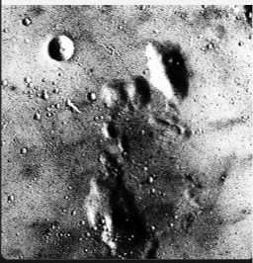 | 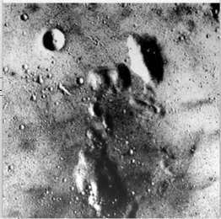
Histogram Equalisation | Lighting Correction

