Goal
In this assignment, I used the sequential CCL algorithm to label the isolated regions within an image. Additionally, a size filter is implemented to remove regions of noise
Algorithm
The sequential CCL algorithm assumes that only the pixels directly above and to the side are neighbours. We traverse along every pixel (starting at the top left) and, if it is a “white” pixel then we compare it against the pixel above it and to it’s left since those pixels would already have been labelled in our traversal.
This leads to 4 cases which each cause a different result for our pixel being analysed
- Both are non zero and have the same value: the new pixel gets that value
- One is zero, the other is non zero: the new pixel takes the non-zero value
- Both are non zero and have different values: the new pixel takes the smaller value *
  - Additionally the two values are stored as a set since they are now know to be the same isolated region
- Both are zero: the region is given the next value
Finally another pass over the pixels is completed to use the set_list and link all the labelled regions together.
An optional command to the function lets you remove feature with fewer pixels than your specified value. A value of 100 was found to remove some of the noise in gun.bmp while retaining the features in the rest.
Results
In order to show the efficacy of the program, I had it show each image with each region a brighter and brighter shade. Although some of the differences are harder to see, it still demonstrates that the program is working.
 | Test.bmp | Face.bmp | Gun.bmp
Without size_filter |  | 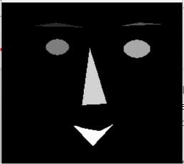 | 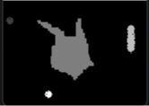
With size_fitler |  |  | 