***We first see the conclusion:***

***US news information users are mainly middle-aged and older men;***

***When you open the media or social direction, the more social attributes, the more young users;***

***A news aggregator application with algorithms has a powerful motivation that represents a future trend; when the algorithm has a short board, it is supplemented by a subscription;***

***Old-fashioned media is similar to CNN and FOX. Due to long-term high-quality content input, target users still occupy a very important position; sudden news push and transfer is very good;***

***The increase in video weight is the general direction, and new and old brands are doing this;***

***If you don't have a strong editorial team, then entertainment content is very important for extracting data;***

***National channels are a must, and it is best to automatically target them to the nearest city;***

***It is necessary to open special channels for localization, such as the US NBA, football Top 10 US news app.***

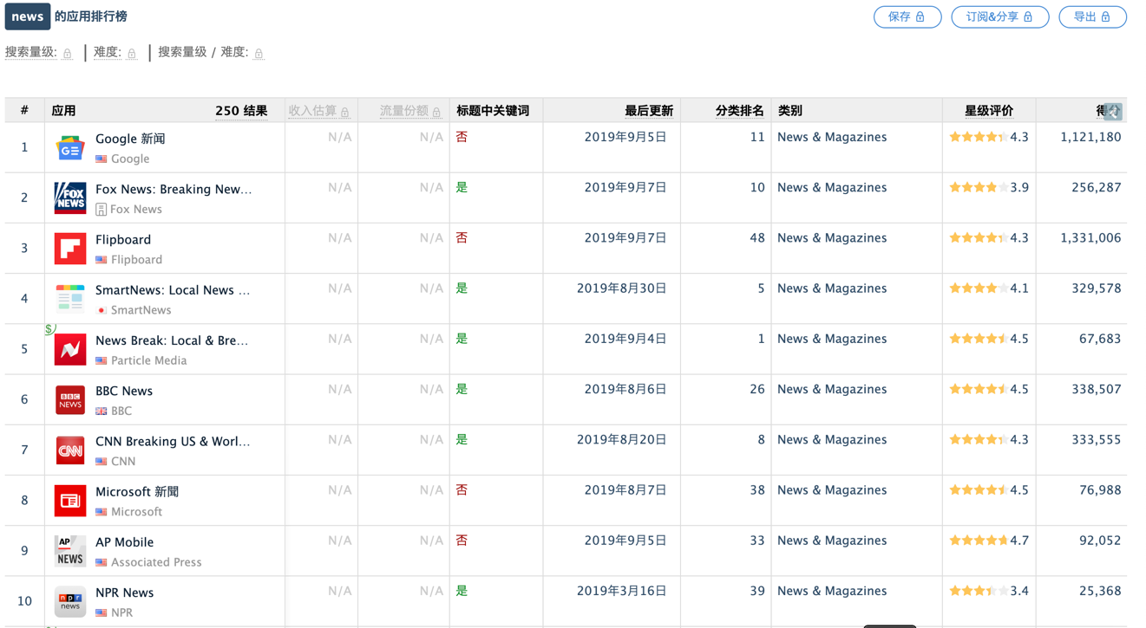

***Data Sources： app Annie***

***Downloads and new update time data source: google play***

***You can see all the comments about the software user experience.***

***Name: Google news***

***More than 1 billion downloads***

***Last Updated: August 4, 2019***

***Type: Aggregate***

***New changes: Your newsletter - There are so many news stories, it's almost impossible to keep track of all the news about the news you care about, and the "Your Newsletter" feature makes it easy for you to master important news and news about you. The “Your Newsletter” feature is updated daily and recommends the top 5 most important news you need to know, including local news, national news and international news.***

***Full story - Get a full story on a specific news with a single tap. Google News brings together all relevant articles on the web, highlighting different perspectives, timelines for important events, FAQs, and important people.***

***Reliable media - Get quality news content from reliable publishers and discover media you've never heard of before.***

***Reports recommended for you - Keep an eye on the topics you care about, sports, politics, business, technology, and even the weather, with a variety of themes.***

***Subscribe through Google - We believe that quality news reports are worth your purchase. With a single tap, you can easily subscribe to your favorite newspapers and magazines.***

***Features: Respect for user anti-interference; main local news; real-time updates; support for national and language rich.***

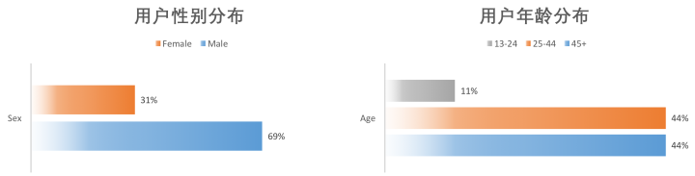

User gender distribution and user age distribution

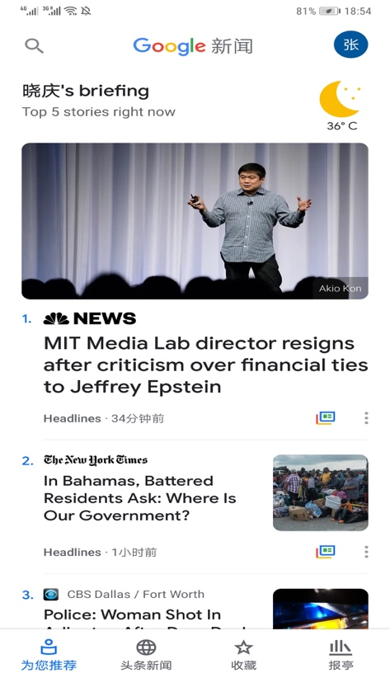 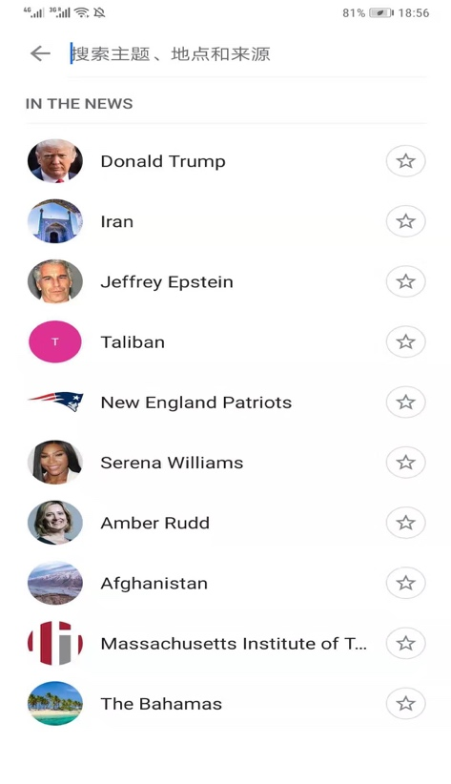

②

①





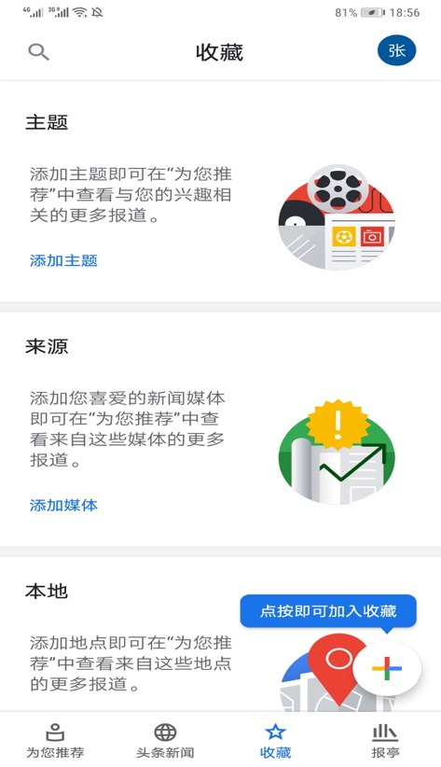 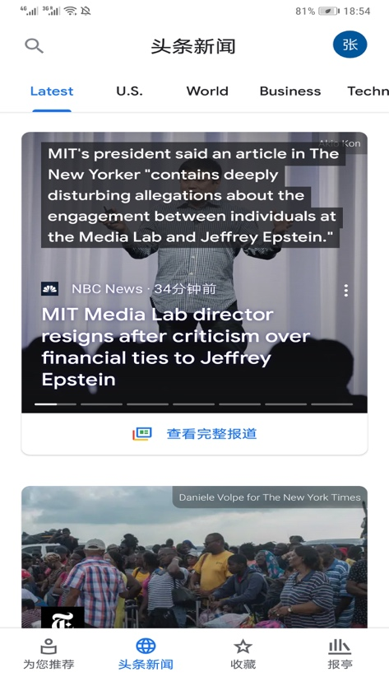

***Google News has all the common modules for other news apps. But I think its main selling point is that all modules are updated in real time. Search for local messages by topic, location and source. And in the recommended page for you to give priority to the topic of interest to the user.***

***Let's analyze its interface design and user experience: the interface takes a vertical layout and contains 8 categories.***

***Name: FOX News.***

***The download volume exceeded 10 million times. Free popular middle ranked 10th***

***Last updated on July 8, 2019***

***Type: Tradition***

***Features: old TV channels, rich TV channels; respect user privacy; news channels subdivided into three levels of multi-directional news stories, news anchors.***

***New version changes:***

***(1) Added picture in picture mode so you can watch the video while browsing the app***

***(2) Thoroughly check our Watch tag to improve the viewing experience in ourapp***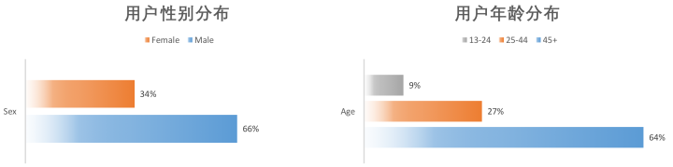

User gender distribution and user age distribution

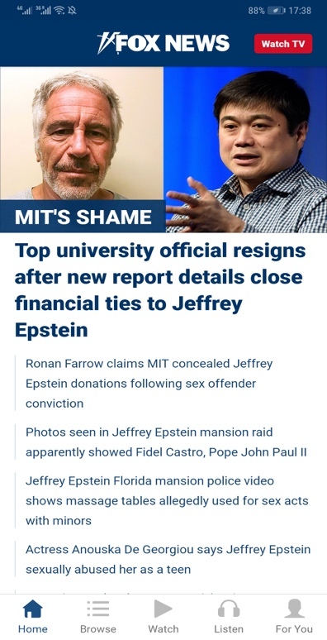 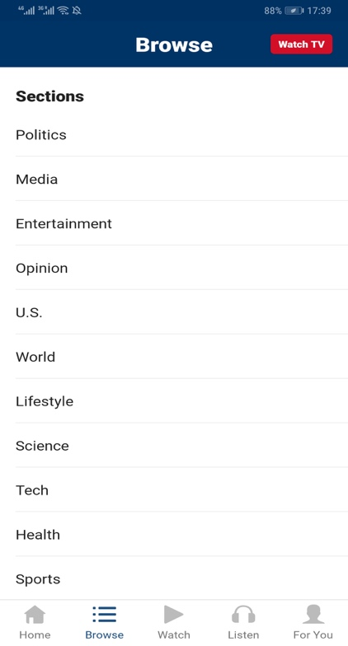 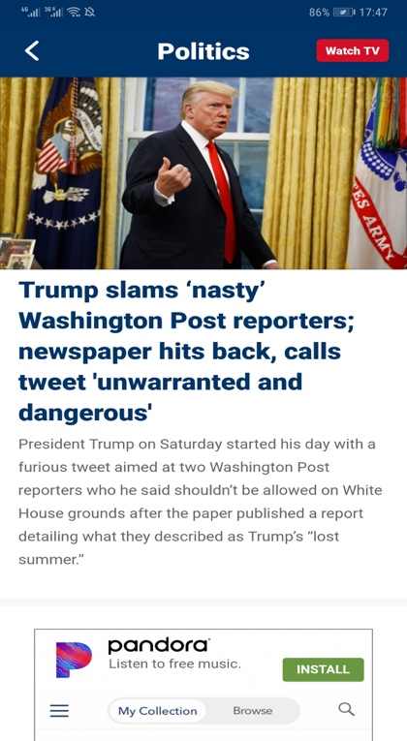

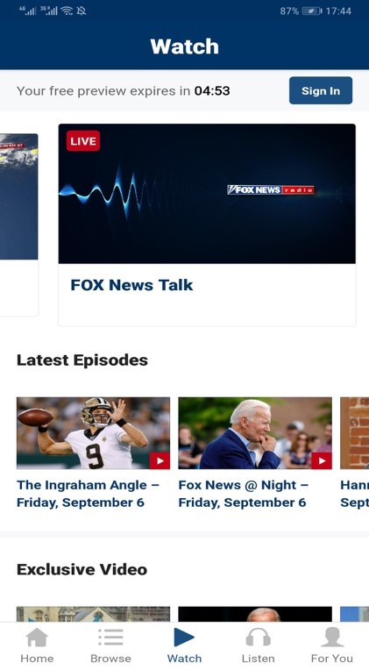 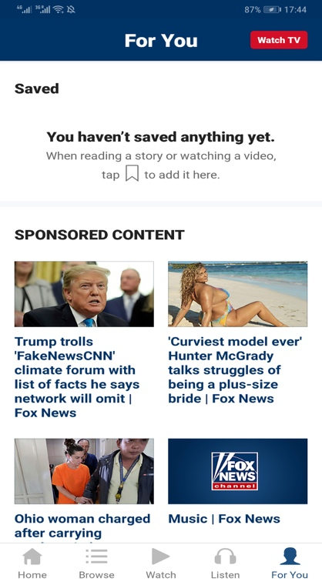 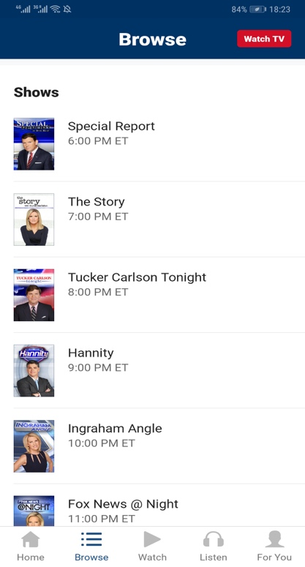

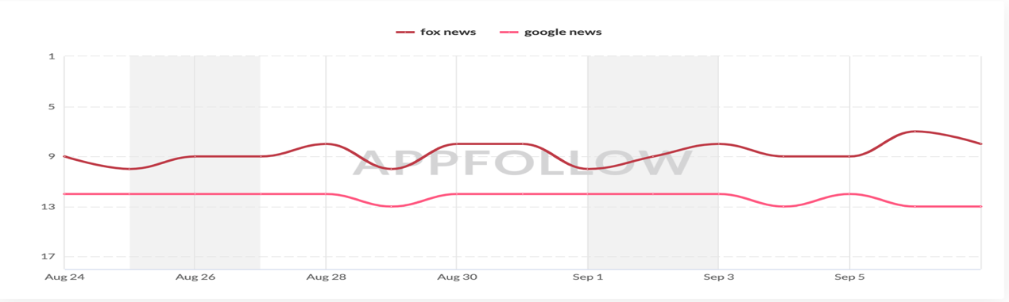

***We summarize the characteristics of many apps designed for women.***

***(1): Take All About Women as an example. It provides three levels of options, including many modules, but it has an obvious flaw. The amount of data in the app is large, and loading will cause the interface to be stuck, and the data is not real-time. . Can not meet the needs of women in the current society.***

***(2): The characteristics of the app are very simple, for example: 7M Women, only for women's fitness. The content is not comprehensive enough.。***

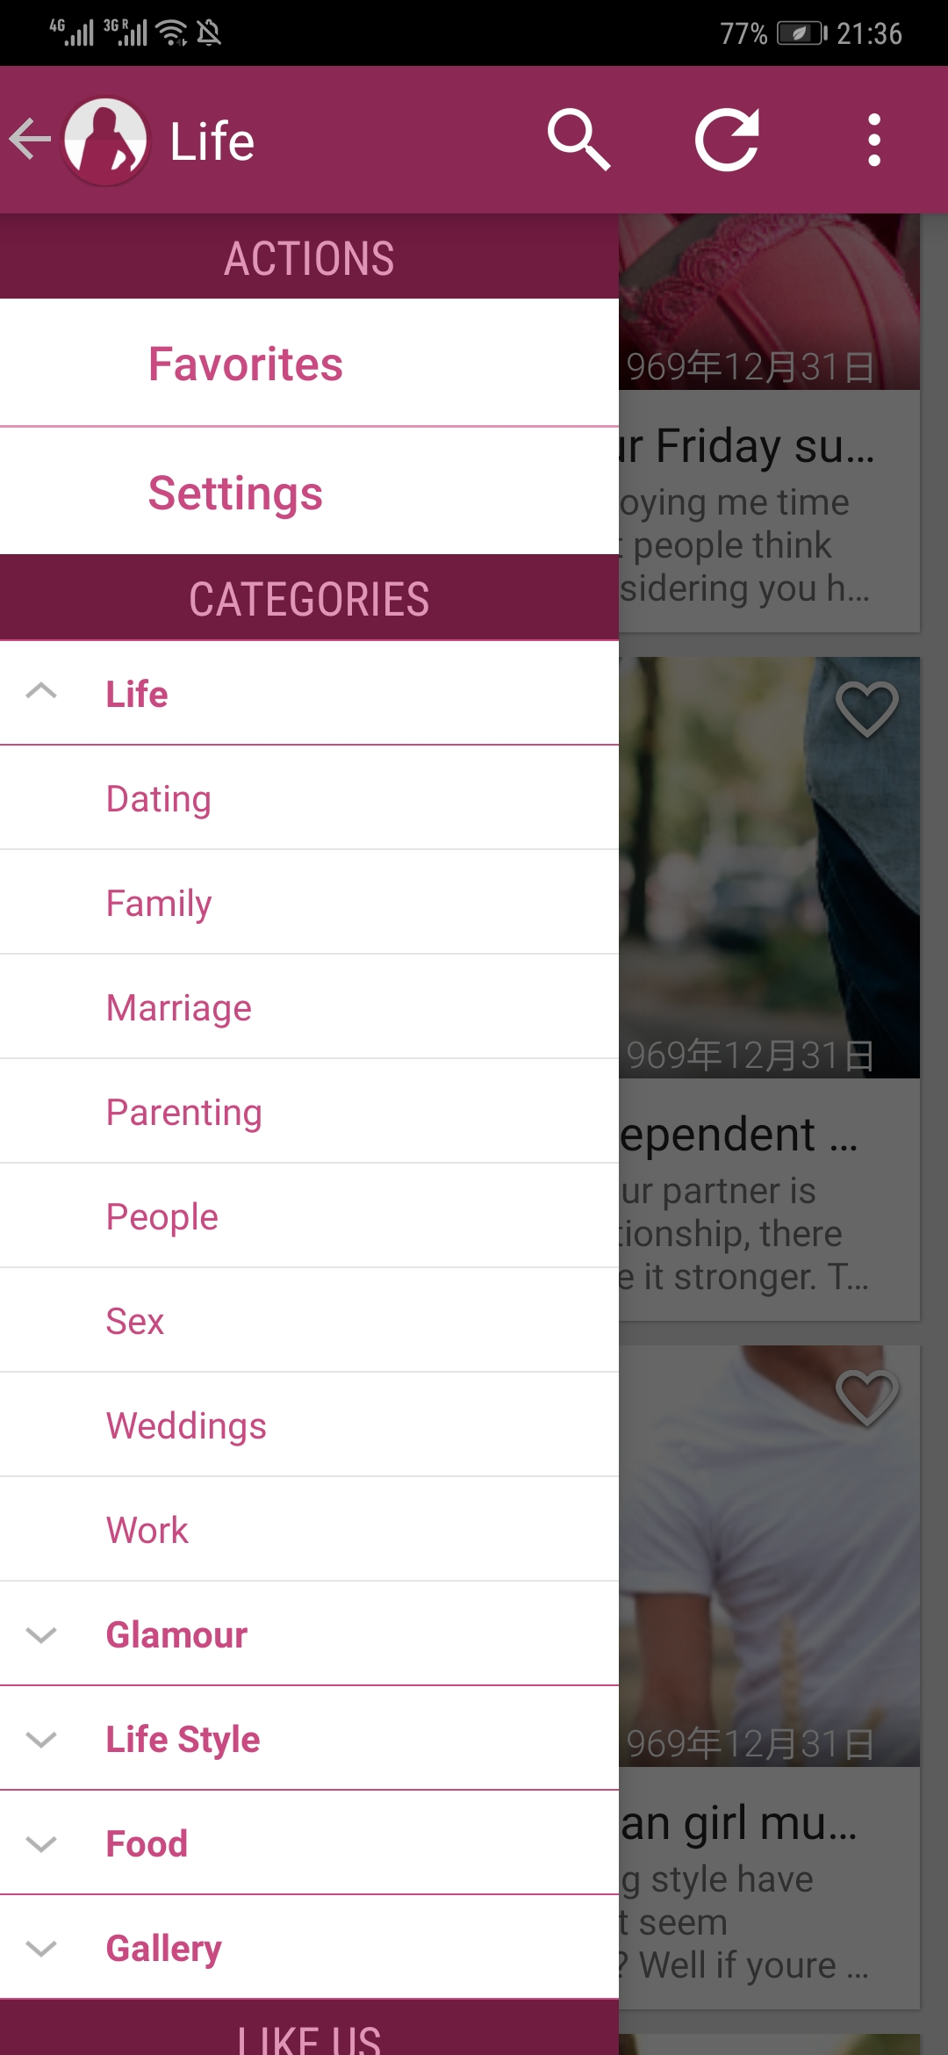 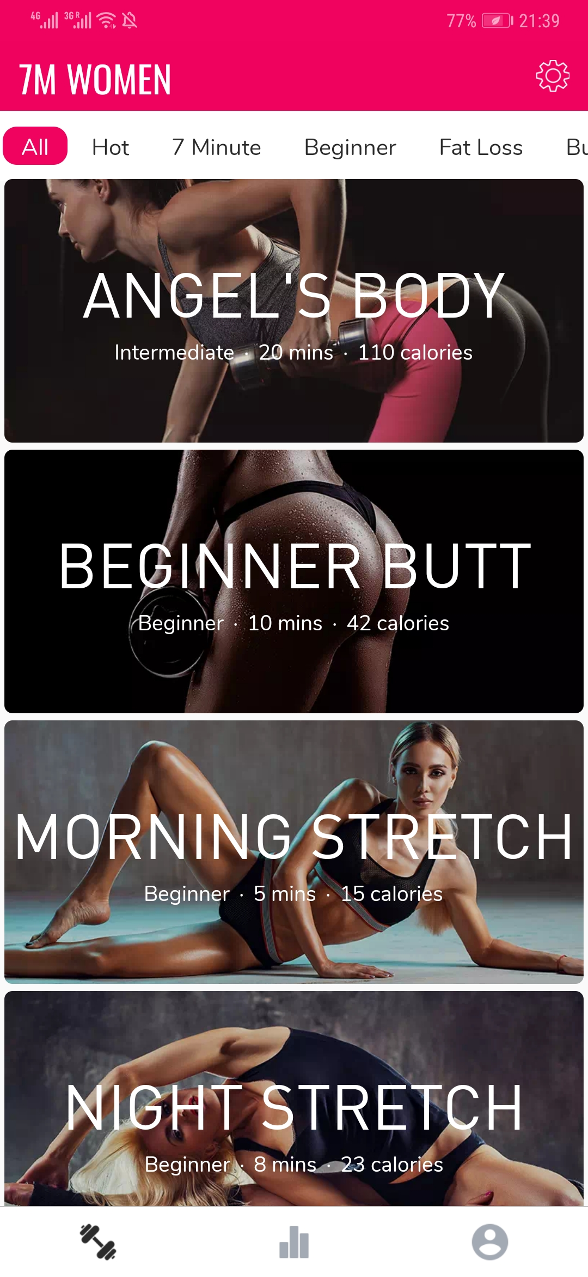

***All About Women 7M Women***

***Our app will make changes to the above deficiencies. The team members will then introduce the advantages of the app.***