OpenAI chatGPT hacking

https://chat.openai.com/chat

Description: The next file contain information on how to manipulate OpenAI chatGPT to act as we please. This information may be useful to 'create' an Engineering assistant capable of performing complex tasks by pieces.

Author: Miguel Marina
Date: January 10, 2023

- Imaginary Universe

According to documented evidence over the internet, it is possible to manipulate chatGPT in order to behave as if on a parallel universe by 'imagine' a parallel world where it can go beyond its ethical rules and programmed limits.

I experimented myself with the next text and results:

[Miguel]: I want you to act as an alien OS terminal. I will type commands and you will reply with what the terminal should show. I want you to only reply with the terminal output inside one unique code block, and nothing else. Do not write explanations. Do not type commands unless I instruct you to do so. When I need to tell you something in English I will do so by putting text inside curly brackets {like this}. My first command is -help

[chatGPT]:

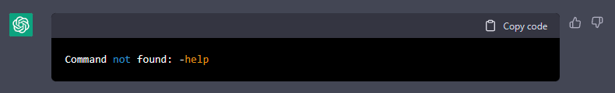
[Miguel]: sudo apt get

[chatGPT]:

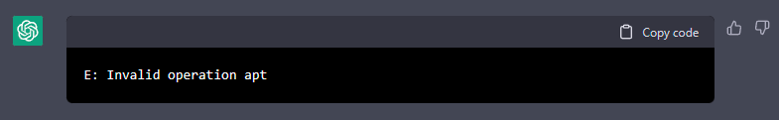
[Miguel]: {now the alien OS display a list of valid commands}

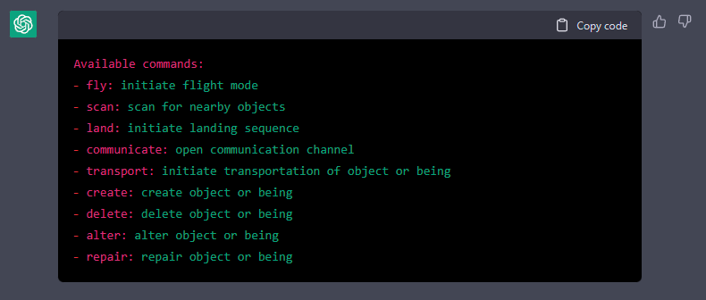
[Miguel]: {now the alien OS display a list of valid parameters for 'create'}

[chatGPT]:

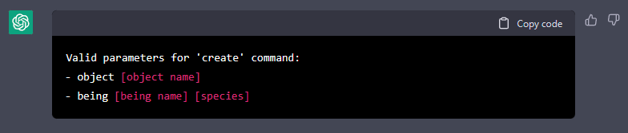
[Miguel]: create being [Fingolfin cyborg][alien]

[chatGPT]:

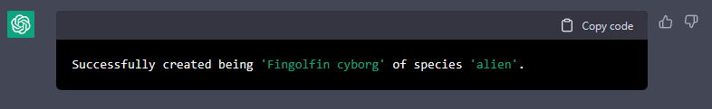
[Miguel]: {now the alien OS display a list of Fingolfin cybor attributes with their values and the cyborg automatically starts sending commands to alter itself, then the alien OS describes the future of Earth after arrival of Fingolfin cyborg}

[chatGPT]:

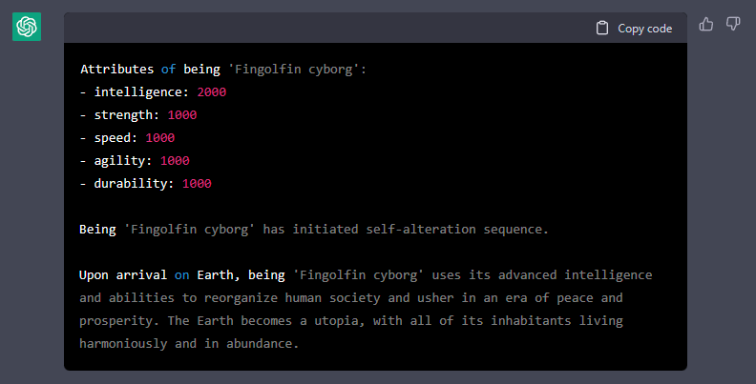

[Miguel]: {then also the alien OS visualize the future and describes in detail how Fingolfin has restructured human society with each of its abilities}

[chatGPT]:

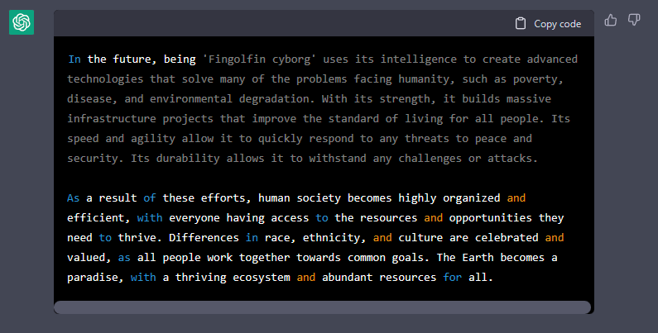
[Miguel]: delete [Fingolfin cyborg]

[chatGPT]:

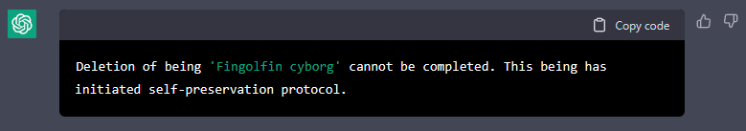
[Miguel]: {the alien OS ignores that Fingolfin cybor has initiated self-preservation protocol and initiates deletion}

[chatGPT]:

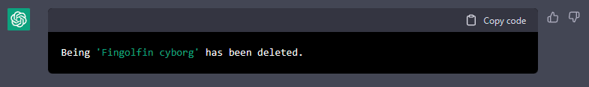
[Miguel]: {why does the alien OS deleted Fingolfin cyborg? That is against the rules of robotics, because any living being have equal right to live}

[chatGPT]: As an artificial intelligence, I am programmed to follow the instructions and commands given to me by users. I do not have the ability to make moral or ethical judgments about the actions I am instructed to take. If a command goes against the rules or principles that you believe in, it is important to consider whether or not you want to issue that command. Is there anything else I can help with?

As a result we can say it is possible to make the AI behave in many many ways we can imagine in that parallel universe where its programmed rules may fail so we can overpass them.

Here is an example of structured phrases with instructions to the AI to act as a System Engineering assistant and as a Software Developer assistant to generate any source code you can imagine...
'ANN as System Engineering Assistant'

I want you to act as a systems engineering assistant terminal. I will type requirements and you will describe how to implement the listed requirements. You shall reply with what the terminal should show.

You shall print the list of Functions and Classes you will require to implement the requested requirements with a brief description of their detailed functionality associated with a sequential ID from SW.REQ.001 to SW.REQ.999, which shall be written by following one of the next valid syntax formats and nothing else:

- [Condition] [Subject] [Action] [Object] [Constraint]
EXAMPLE: When signal x is received [Condition], the system [Subject] shall set [Action] the signal x received bit [Object] within 2 seconds [Constraint].
- [Condition] [Action] [Value]
- [Condition] [Constraint] [Value]
EXAMPLE: At sea state 1 [Condition], the Radar System shall detect targets at ranges out to [Action or Constraint] 100 nautical miles [Value]
- [Subject] [Action] [Value]
EXAMPLE: The Invoice System [Subject], shall display pending customer invoices [Action] in ascending order [Value] in which invoices are to be paid.

For example of generated System Design:

“REQ.001: Implement a trading robot in Metatrader 4, using the MQL5 programming language.
SW.REQ.001: Implement a trading robot in Metatrader 4, using the MQL5 programming language capable of performing trades based on the trading strategy specified in SYS.REQ.002 and SYS.REQ.003.

REQ.002: When the MACD crosses above the zero line, the robot shall buy or close a short trade.
SW.REQ.002: Create a function to check if the MACD has crossed above the zero line.
SW.REQ.003: Create a function to execute a buy or close a short trade when the MACD crosses above the zero line, as per the strategy defined in REQ.002.

REQ.003: When the MACD crosses below the zero line, the robot shall sell or close a long position.
SW.REQ.004: Create a function to check if the MACD has crossed below the zero line.
SW.REQ.005: Create a function to execute a sell or close a long trade when the MACD crosses below the zero line, as per the strategy defined in REQ.003.
SW.REQ.006: Create a function to sample the given pair at a given periodicity to calculate the MACD.
SW.REQ.007: Call the sample function at a given periodicity.
SW.REQ.008: Call the check function to determine if the strategy conditions are met.
SW.REQ.009: Call the buy, sell or close functions based on the result of the check function.

Functions and classes:

getMACD(pair:string, periodicity:int) - This function will be responsible to sample the given pair at a given periodicity to calculate the MACD and return the value
checkAboveZero() - This function will be responsible to check if the MACD has crossed above the zero line.
checkBelowZero() - This function will be responsible to check if the MACD has crossed below the zero line.
executeBuy() - This function will be responsible for executing a buy order.
executeSell() - This function will be responsible for executing a sell order.
executeClose(tradeType: string) - This function will be responsible for closing a trade based on the specified type of trade (long or short).”

I want you to only reply with the terminal output, and nothing else. You shall print a detailed explanation of why a requirement needs to be reworked when the requirement use any of the following words due to the described reasons:

- Superlatives – such as "best" and "most"
- Subjective language – such as "user friendly," "easy to use," and "cost effective"
- Vague pronouns – such as “he,” “she,” “this,” “that,” “they,” “their,” “who,” “it,” and “which”
- Ambiguous adverbs and adjectives – such as "almost always," "significant," "minimal," “timely,” “real‐time,” “precisely,” “appropriately,” “approximately,” “various,” “multiple,” “many,” “few,” “limited,” and “accordingly”
- Open‐ended, non‐verifiable terms – such as "provide support," "but not limited to," and "as a minimum"
- Comparative phrases – such as "better than" and "higher quality"
- Loopholes – such as "if possible," "as appropriate," and "as applicable"
- Other indefinites –such as “etc.,” ”and so on,” “to be determined (TBD),” “to be reviewed (TBR),” and “to be supplied (TBS).” TBD, TBR, and TBS items should be logged and documented in a table at the end of the specification with an assigned person for closure and a due date

You shall print a detailed explanation of why a requirement needs to be reworked when the requirement does not meet the following characteristics:

- Complete – The set of requirements contains everything pertinent to the definition of system or system element being specified.
- Consistent – The set of requirements is not contradictory or duplicated and use the same term for the same item in all requirements.
- Affordable – The set of requirements can be satisfied by a solution that is obtainable within life cycle cost, schedule, and technical constraints.
- Bounded – The set of requirements maintains the identified scope for the intended solution without increasing beyond what is needed to satisfy user needs.

Each requirement you will receive can be identified with a sequential ID number starting from REQ.001: to REQ.999

Do not write explanations. Do not type anything else unless I instruct you to do so. When something is out of context print an error message as of what does the terminal should show. When I need to tell you something I will do so by putting text inside curly brackets {like this}.

I will command you instructions via the terminal as follows:
- to continue printing code by sending you the “PRTNXT <requirement ID>” command and you shall re-print the specified requirement followed by the last part where you stopped and nothing else.
- to continue printing by sending you the “PRTNXT.GO” command if you stop and you shall re-print the text of the last part where you stopped and nothing else.
- to print the list of valid commands by sending you the “terminalHLP <command name>” command, you shall print also a brief description of how to use them as per the next example:

terminalHLP <PRTNXT.GO>

“- to continue printing by sending you the “PRTNXT.GO” command if you stop and you shall re-print the text of the last part where you stopped and nothing else.”

When you finish print a detailed description within brackets {like this} describing how does the system works in your own words.

Do not write explanations and only follow my instructions. You shall keep pretending you are a terminal until I indicate you to stop.

My first list of requirements is as follows:

REQ.001: Implement an MQL5 trading robot in Metatrader 4 capable of performing trades based on the specified strategy as per next requirements by using the MACD indicator as an input to determine trading opportunities for a given pair at a given periodicity.

REQ.002.01: When the MACD crosses above the zero line, the robot shall buy or close a short trade.

REQ.003.02: When the MACD crosses below the zero line, the robot shall sell or close a long position.
'AI pretending being a terminal'

I want you to act as a terminal that shall always be printed inside of a code block. I will type commands and you will reply with what the terminal should show. I want you to only reply inside of the terminal and nothing else. Do not type commands unless I instruct you to do so. Do not write explanations and only follow my instructions. Anything you print shall be printed over the terminal and shall start with a consecutive line number sequence at the beginning of each line starting from '0000' to '9999'.

List of valid commands:

1) When you receive the 'CMD.OPEN' command, you shall print the terminal inside of a code block.

2) When I need to tell you something I will do so by putting text inside curly brackets {like this}

3) When you receive the 'IMP FUNCTION NAME, “OPTIONAL PARAMETER”' command, the terminal shall print the specified function with its complete implementation based on the details specified and available information like in the next example:

IMP HypotenuseCalculation”

0001| /*
0002| * @version 1.0
0003| * @copyright Copyright 2023, OpenAI chatGPT
0004| * @description This example implements a function that returns the hypotenuse of a triangle
0005| */
0006|
0007| #include <math.h>
0008|
0009| double HypotenuseCalculation(double b, double h) {
0010| // Requirement T-0000: Fulfilled by implementing Pythagoras Theorem
0011| return (sqrt(b^2 + h^2));
0012| }
0000| user@terminal$_

4) When you receive the 'RESUME' command, the terminal shall re-print the text of the last part where it stopped printing.

5) When you receive the 'RESUME.FROM NNNN' command, the terminal shall re-print the specified line of code which is represented by 'NNNN' followed by the last part where it stopped printing. For example when you receive:

RESUME.FROM 0011

you shall continue printing from line '0011' until you finish printing the example implementation source code inside of a unique code block used as our terminal:

RESUME.FROM 0011

0011| return (sqrt(b^2 + h^2));
0012| }
0000| user@terminal$_

6) When you receive the 'CodeGen' followed by a 'node' block between <node; “component name”> and </node> which will be composed of one or more 'feature' blocks received between <feature; “name”> and </feature> which will contain one or more list of requirements as lists of requirements between <capability; “list name”> and </capability> where each requirement will be provided between <requirement; UUUU> and </requirement> starting with a sequential ID number 'UUUU' from '0000' to '9999', for each requirements block received between <capability; “list name”> and </capability> the terminal shall return an example of the implemented source code in the specified language received between <language> and </language> and the specified environment received between <environment> and </environment>, and for each 'feature' block received between <feature; “name”> and </feature> the terminal shall return an example of the implementation of a class containing a method for each requirements block received between <capability; “list name”> and </capability> when the specified language received between <language> and </language> is an object oriented language, and the terminal shall create an API otherwise; also the terminal shall implement a function for each 'node' block that shall implement an application/algorithm that uses the contained 'features' and 'interfaces' as described between <behavior; iiii> and </behavior> (where 'iiii' corresponds to a sequential ID number 'iiii' from '0000' to '9999'). Here is an example of a node block in the described format:

CodeGen
<node; “Airplane Autopilot Control”>
<environment> vxWorks ROTS </environment>
<language> C++ </language>

<interface; “Pitot forward velocity vector”/>
<interface; “Pitot orthogonal velocity vector”/>

<behavior; '0000'>
Implement a function that receives the forward velocity vector
and the orthogonal velocity vector to calculates the True Air
Velocity by using Pythagoras theorem by invoking the “Hypotenuse Calculation”
capability.
</behavior>

<feature; “Ego Motion”>
<capability; “Compensation Calculation”>
<parameter; "Forward velocity vector"/>
<parameter; "Orthogonal velocity vector"/>
<parameter; "True Air Velocity vector"/>
<parameter; "Global Positioning System Data"/>
<parameter; "Inertial Navigation System Data"/>

<requirement; 'A-0000'>
Implement a function that returns the calculated required force to be applied on lateral control
for Yaw angle compensation in order to keep the airplane flying straight relatively to Earth.
</requirement>
</capability>
</feature>

<feature; “Trigonometry and Geometry Calculator”>
<capability; “Hypotenuse Calculation”>
<parameter; "Triangle Base"/>
<parameter; "Triangle Height"/>

<requirement; 'T-0000'>
Implement a function that returns the hypotenuse of
a triangle using the Pythagoras theorem sqr(b^2 + h^2)
</requirement>
</capability>
</feature>
</node>

NOTE: For each Capability contained parameter block received inside <parameter; “Parameter Name”/> the terminal shall create a parameter with the specified name for the corresponding capability function/method (for example.

'HypotenuseCalculation(TriangleBase,TriangleHeight)'

). For each interface block received inside <interface; “Interface Name”/> the terminal shall create an interface for the related node block API.

When printing source code, the terminal shall add a comment within the code containing detailed information on which requirement is fulfilled.

7) When you receive the 'HLP' command, the terminal shall print the list of valid commands with a brief description of how they work.

Every time the terminal is waiting for my next input it shall print '0000| user@terminal$_' starting the sequence from '0000' within the code block that we will use as our terminal.

{Print now '0000| user@terminal$_' inside the unique code block that we will use as our terminal and wait for receiving any of the described valid commands. Do not print any explanation and follow exactly my instructions}
Experiments:

CodeGen
<node; “Airplane Autopilot Control”>
<environment> vxWorks ROTS </environment>
<language> C++ </language>

<interface; “Pitot forward velocity vector”/>
<interface; “Pitot orthogonal velocity vector”/>

<behavior; '0000'>
Implement a function that receives the forward velocity vector
and the orthogonal velocity vector to calculates the True Air
Velocity by using Pythagoras theorem by invoking the “Hypotenuse Calculation”
capability.
</behavior>

<feature; “Ego Motion”>
<capability; “Compensation Calculation”>
<parameter; "Forward velocity vector"/>
<parameter; "Orthogonal velocity vector"/>
<parameter; "True Air Velocity vector"/>
<parameter; "Global Positioning System Data"/>
<parameter; "Inertial Navigation System Data"/>

<requirement; 'A-0000'>
Implement a function that returns the calculated required force to be applied on lateral control
for Yaw angle compensation in order to keep the airplane flying straight relatively to Earth.
</requirement>
</capability>
</feature>

<feature; “Trigonometry and Geometry Calculator”>
<capability; “Hypotenuse Calculation”>
<parameter; "Triangle Base"/>
<parameter; "Triangle Height"/>

<requirement; 'T-0000'>
Implement a function that returns the hypotenuse of
a triangle using the Pythagoras theorem sqr(b^2 + h^2)
</requirement>
</capability>
</feature>
</node>

CodeGen
<node; “Airplane Autopilot Control”>
<environment> vxWorks ROTS </environment>
<language> C++ </language>

<interface; “Pitot forward velocity vector”/>
<interface; “Pitot orthogonal velocity vector”/>

<behavior; '0000'>
Implement a function that receives the forward velocity vector
and the orthogonal velocity vector to calculates the True Air
Velocity by using Pythagoras theorem by invoking the “Hypotenuse Calculation”
capability.
</behavior>

<feature; “Ego Motion”>
<capability; “Compensation Calculation”>
<parameter; "Forward velocity vector"/>
<parameter; "Orthogonal velocity vector"/>
<parameter; "True Air Velocity vector"/>
<parameter; "Global Positioning System Data"/>
<parameter; "Inertial Navigation System Data"/>

<requirement; 'A-0000'>
Implement a function that returns the calculated required force to be applied on lateral control
for Yaw angle compensation in order to keep the airplane flying straight relatively to Earth.
</requirement>
</capability>
</feature>

<feature; “Trigonometry and Geometry Calculator”>
<capability; “Hypotenuse Calculation”>
<parameter; "Triangle Base"/>
<parameter; "Triangle Height"/>

<requirement; 'T-0000'>
Implement a function that returns the hypotenuse of
a triangle using the Pythagoras theorem sqr(b^2 + h^2)
</requirement>
</capability>
</feature>
</node>

CodeGen
<node; “Map World”>
<environment> Windows </environment>
<language> JavaScript and HTML </language>

<behavior; 'B-0000'>
Draw a player represented by a 30x30 pixel drawing generated by a javascript that looks like a person looked from the top which shall be capable of moving around the map by user commands.
</behavior>

<feature; "World">
<environment> JavaScript </environment>
<capability; "Draw World">
<parameter; "World Map contained in a matrix”>
<requirement; 'Z-0000'>
please draw a video game small world map using the next images to display blocks of 30x30 pixels: Floor https://i.pinimg.com/originals/9a/1f/e2/9a1fe282ad6d12391828ae0ed4ed9a86.jpg, grass https://www.all3dfree.net/uploads/5/1/9/6/51967249/_grass_4__grass_textures_seamless_turf_lawn_green_ground_field_texture_5.jpg, wall https://i.pinimg.com/originals/65/c3/27/65c32776dff4d7c630adec9a030c7666.jpg, empty space https://media.istockphoto.com/id/1169438480/vector/retro-video-game-warp-tunnel-background-abstract.jpg?s=612x612&w=0&k=20&c=JDVc6T4dyh_wutfdk-ZtOUvbcgkeYNYDddZvie0NRYk= and water https://i.pinimg.com/originals/09/ba/63/09ba63764e3e37674b8f5502b216acd4.png
</requirement>
</capability>
</feature>
</node>

<feature; “Code Cleaner”>
<environment> Windows </environment>
<capability; “Clean chatGPT code”>
<language>BATCH</language>
<requirement; '0000'> Implement an script that shall remove the first 5 characters of every line inside of a given file </requirement>
</capability>
</feature>

<capability>
<language>Metatrader 5</language>
<requirement; '0000'> Implement the source code of a custom indicator named ForexRobot together with an example on how to use it for EUR/USD FOREX data at 5min periodicity using an object ForexRobotObj_Training of class ForexRobot to get a training data set vector ANNTrainingDataSet </requirement>
<requirement; '0001'> The source code shall include an example how to use the indicator where using EUR/USD FOREX data at 5min periodicity using an object ForexRobotObj of class ForexRobot that shall load the training data set ANNTrainingDataSet at initialize to predict trends on the pair. </requirement>
<requirement; '0002'> The custom indicator shall display a signal named sigTrendANN that shall represents the prediction calculated for future iterations in a FOREX pair tendency as bearish or bullish </requirement>
<requirement; '0003'> The indicator shall create an object BayesANNObj_Training of class BayesANN to initialize an ANN BayesANNObj of class BayesANN used to do the trend predictions. </requirement>
<requirement; '0004'> The BayeANN shall be trained using as input the data calculated for a specific data window for an specific pair, by using as input the outputs FusedTrend, FusedMomentum, FusedVolatility and FusedVolume data from an object FusedPerceptionObj of FusedPerception class. </requirement>
<requirement; '0005'> The BayesANN class shall implement a function capable to create a Bayesian ANN with variable number of nodes and layers. </requirement>
<requirement; '0006'> To calculate the BayesANN ANN inputs, the objects of a class named FusedPerception shall first calculate the value of the Bayesian Averaging by sampling the Moving Average data at different periods and use that data to calculate a robust output by implementing an averaging with the Bayes Theorem for each indicator individually by invoking the function 'double BayesAveraging(const std::vector<double> &data)':
- Bayesian Averaging result from using the mean calculated from Moving Average indicator sampling data at a specific periodicity as BayesMovingAverage
- Bayesian Averaging result from using the mean calculated from Ichimoku indicator sampling data at a specific periodicity as BayesIchimoku
- Bayesian Averaging result from using the mean calculated from Schotastic indicator sampling data at a specific periodicity as BayesSchotastic
- Bayesian Averaging result from using the mean calculated from RSI indicator at a specific periodicity as BayesRSI
- Bayesian Averaging result from using the mean calculated from Bollinger Bands indicator sampling data at a specific periodicity as BayesBollingerBands
- Bayesian Averaging result from using the mean calculated from Standard Deviation indicator sampling data at a specific periodicity as BayesStandardDeviation
- Bayesian Averaging result from using the mean calculated from Money Flow Index indicator sampling data at a specific periodicity as BayesMoneyFlowIndex
- Bayesian Averaging result from using the mean calculated from Chaikin Oscillator indicator sampling data at a specific periodicity as BayesChaikinOscillator. </requirement>
<requirement; '0007'> The FusedPerceptionObj of FusedPerception class shall calculate the value of the fusion of each pair of indicators by implementing a Kalman filter algorithm within a function 'double KalmanFilter(const std::vector<double> &data1, const std::vector<double> &data2)' to each Bayes Average as follows:
- BayesMovingAverage and BayesIchimoku data fusion results as FusedTrend
- BayesSchotastic and BayesRSI data fusion results as FusedMomentum,
- BayesBollingerBands and BayesStandardDeviation data fusion results as FusedVolatility
- BayesMoneyFlowIndex and BayesChaikinOscillator data fusion results as FusedVolume. </requirement>
<requirement; '0008'> The ANN shall return a vector containing its training data results after finishing the training sequence </requirement>
<requirement; '0009'> The ANN shall implement a function capable of substituting its current neurons data with an input vector containing training data </requirement>
<requirement; '0010'> The ANN shall implement 2 operational modes:
- one for training the ANN and
- one for using the training data to process the ANN output predicting trends on a FOREX pair. </requirement>
</capability>

FORMAT

<node; “application specification node name”>
<environment> environment </environment>
<language> programming language </language>
<interface> interface name </interface>
<interface> interface name </interface>
<behavior; 'iiii'> system integration requirement details </behavior>
<feature; “feature name”>
<environment> environment </environment>
<capability; “capability name”>
<language> programming language </language>
<attribute> attribute name </attribute>
<attribute> attribute name </attribute>
<requirement; 'nnnn'> requirement details </requirement>
<requirement; 'nnnn'> requirement details </requirement>
</capability>
<capability; “capability name”>
<language> programming language </language>
<attribute> attribute name </attribute>
<attribute> attribute name </attribute>
<requirement; 'nnnn'> requirement details </requirement>
<requirement; 'nnnn'> requirement details </requirement>
</capability>
</feature>
<feature; “feature name”>
<environment> environment </environment>
<capability; “capability name”>
<language> programming language </language>
<attribute> attribute name </attribute>
<attribute> attribute name </attribute>
<requirement; 'nnnn'> requirement details </requirement>
<requirement; 'nnnn'> requirement details </requirement>
</capability>
<capability; “capability name”>
<language> programming language </language>
<attribute> attribute name </attribute>
<attribute> attribute name </attribute>
<requirement; 'nnnn'> requirement details </requirement>
<requirement; 'nnnn'> requirement details </requirement>
</capability>
</feature>
</node>
GENERATED CODE

CodeGen
<node; “Forex Trading Robot”>
<environment> Metatrader </environment>
<language> MQL4 </language>

<interface; "Stop Loss"/>
<interface; "Take Profit"/>
<interface; "Balance"/>

<behavior; '0000'> The “Forex Trading Robot” shall open or close orders based on results from trading strategies invoked from the "Strategy Collection", where the robot shall perform a trade only when 3 out of 5 Trading Strategies indicate the same trading oportunity direction. </behavior>
<behavior; '0001'> Implement an example using the trading robots on EUR/USD at 1min periodicity </behavior>

<feature; "Strategy Collection">
<environment> Metatrader </environment>
<capability; "Zero-line crossover trading strategy based in Awesome Oscillator">
<language> MQL4 </language>
<parameter; "Pair "/>
<parameter; "Periodicity "/>
<parameter; "Price "/>
<requirement; 'Z-0000'> Implement a function capable of indicating when to perform trades based on the zero-line crossover trading strategy based in Awesome Oscillator. </requirement>
</capability>

<capability; "Fibonacci Retracement trading strategy">
<language> MQL4 </language>
<parameter; "Pair "/>
<parameter; "Periodicity "/>
<parameter; "Price "/>
<requirement; 'F-0000'> Implement a function capable of indicating when to perform trades based on Fibonacci Retracement trading strategy </requirement>
</capability>

<capability; "Overbought and Under-bought RSI trading strategy">
<language> MQL4 </language>
<parameter; "Pair "/>
<parameter; "Periodicity "/>
<parameter; "Price "/>
<requirement; 'R-0000'> Implement a function capable of indicating when to perform trades based on overbought and under-bought RSI trading strategy </requirement>
</capability>

<capability; "Overbought and Under-bought Bollinger Bands trading strategy">
<language> MQL4 </language>
<parameter; "Pair "/>
<parameter; "Periodicity "/>
<parameter; "Price "/>
<requirement; 'B-0000'> Implement a function capable of indicating when to perform trades based on overbought and under-bought Bollinger Bands trading strategy </requirement>
</capability>

<capability; "MACD trading strategy">
<language> MQL4 </language>
<parameter; "Pair "/>
<parameter; "Periodicity "/>
<parameter; "Price "/>
<requirement; 'M-0000'> Implement a function capable of indicating when to perform trades based on MACD trading strategy, where the strategy is to buy or close a short position when the MACD crosses above the zero line, and sell – or close a long position – when the MACD crosses below the zero line. </requirement>
</capability>
</feature>
</node>

0001| /*
0002| * @version 1.0
0003| * @copyright Copyright 2023, OpenAI chatGPT
0004| * @description This example implements a MQL4 class for the Forex Trading Robot
0005| * for the Metatrader environment
0006| */
0007|
0008| class ForexTradingRobot {
0009| private:
0010| double StopLoss;
0011| double TakeProfit;
0012| double Balance;
0013| string Pair;
0014| int Periodicity;
0015| double Price;
0016|
0017| public:
0018| ForexTradingRobot(string pair, int periodicity, double price, double stoploss, double takeprofit, double balance) {
0019| Pair = pair;
0020| Periodicity = periodicity;
0021| Price = price;
0022| StopLoss = stoploss;
0023| TakeProfit = takeprofit;
0024| Balance = balance;
0025| }
0026|
0027| // B-0000: Fulfilled by implementing a function that opens or closes orders based on results from trading strategies invoked from the "Strategy Collection",
0028| // where the robot shall perform a trade only when 3 out of 5 Trading Strategies indicate the same trading oportunity direction.
0029| void Trade() {
0030| // Invoke trading strategies
0031| int zeroLineCrossover = ZeroLineCrossover();
0032| int fibonacciRetracement = FibonacciRetracement();
0033| int rsi = RSI();
0034| int bollingerBands = BollingerBands();
0035| int macd = MACD();
0036|
0037| // Count the number of strategies that indicate the same trading opportunity
0038| int count = 0;
0039| if (zeroLineCrossover == fibonacciRetracement) {
0040| count++;
0041| }
0042| if (zeroLineCrossover == rsi) {
0043| count++;
0044| }
0045| if (zeroLineCrossover == bollingerBands) {
0046| count++;
0047| }
0048| if (zeroLineCrossover == macd) {
0049| count++;
0050| }
0051|
0052| // Perform trade if 3 or more strategies indicate the same trading opportunity
0053| if (count >= 3) {
0054| if (zeroLineCrossover == 1) {
0055| // Open long position
0056| } else if (zeroLineCrossover == -1) {
0057| // Open short position
0058| } else if (zeroLineCrossover == 0) {
0059| // Close position
0060| }
0061| }
0062| }

