Melle Dijkstra

Melle210202@gmail.com

REALIZATION

Cheery

Description

The realization document describes where to think about when realizing the product

# Table of contents

1 Table of contents 1

2 Planning 2

3 Documenting 2

4 Testing 2

5 Produced Products 2

6 Acceptation 2

# Planning

Before realizing the product there needs to be a planning in order to maintain stability when the project will be made. That way you also know which parts of the application are going to take more time than others. Everyone that works on the project needs to follow the project planner.

The planning is made in Microsoft Excel: [Cheery Project Planner.xlsx](Cheery%20Project%20Planner.xlsx)

# Documenting

The application shall be documented in multiple forms. The code of the project will get its documentation with code documenting standards. This way it’s clearer for the team which you work with and you know of course what the code actually does.

The code documentation will be done with PHPStorm. There is a feature in PHPStorm to auto-generate documentation for the code.

The documentation for the code will look like this:

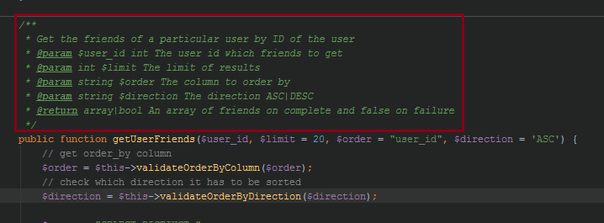

# Testing

Testing will be done throughout the realization of the project. Every time there is a big edition made with the code that part of the program will need testing and bugs fixed if there are any.

# Produced Products

The products that will be produced when realizing are the code of the project and the documentation for the whole project including this document.

Produced products from realizing the project:

* API (Application Programming Interface)
* Social platform base
* Users and Groups on a platform
* Different types of games for users and groups to play with each other
* Points System