# Pointour Tests and Technical Guide

Table of Contents

Pointour Tests and Technical Guide 1

2 Introduction 2

3 Testing 2

3.1 Browser Compatibility 2

3.2 Input Testing 3

3.2.1 Main Page 3

3.2.2 Tour Planning Page 3

3.2.3 Add Attractions Page 5

3.3 Web Server Response Time 5

3.4 Screen Size Testing 7

3.4.1 Apple iPad 7

3.4.2 Apple iPhone 6 8

3.4.3 Apple iPhone 6+ 9

3.4.4 Samsung Galaxy Note 3 10

3.5 Testing Results 10

3.6 Application Database Testing 11

4 Guides 11

4.1 User Guide 11

4.2 Administration Guide 11

4.3 Developer Guide 11

4.4 Installation Guide 12

5 Resources Used 12

# Introduction

This document is for reference, administrators, programmers, and maintainers should familiarise themselves with this document if they wish to improve, maintain, or deploy another version of “Pointour” and it’s associated source code.

# Testing

This testing is include a number of testing technique. To make sure this application is accessible to use. The people include user, testing controller, developer, program manager.

This testing will focus on the browser compatibility, features and functions to test include page turn, form submission, code standard, and the emulating different screen sizes.

This testing will follow the testing plan.

## Browser Compatibility

The application was tested in many browsers, these are the browsers that enabled full functionality. Other browsers may be used, but with a reduced feature set. The latest version of Safari for Windows is 5.0 which does not function correctly

|  |  |  |  |  |
| --- | --- | --- | --- | --- |
|  | Firefox | Chrome | IE | Safari |
| Windows XP | 12+ | 36+ | 9+ | 5 only |
| Windows 7 | 12+ | 36+ | 9+ | 5 only |
| Mac OS 10.9.3 | 12+ | 36+ | N/A | 7+ |
| iOS 8.1.3 | N/A | N/A | N/A | 7+ |

## Input Testing

### Main Page

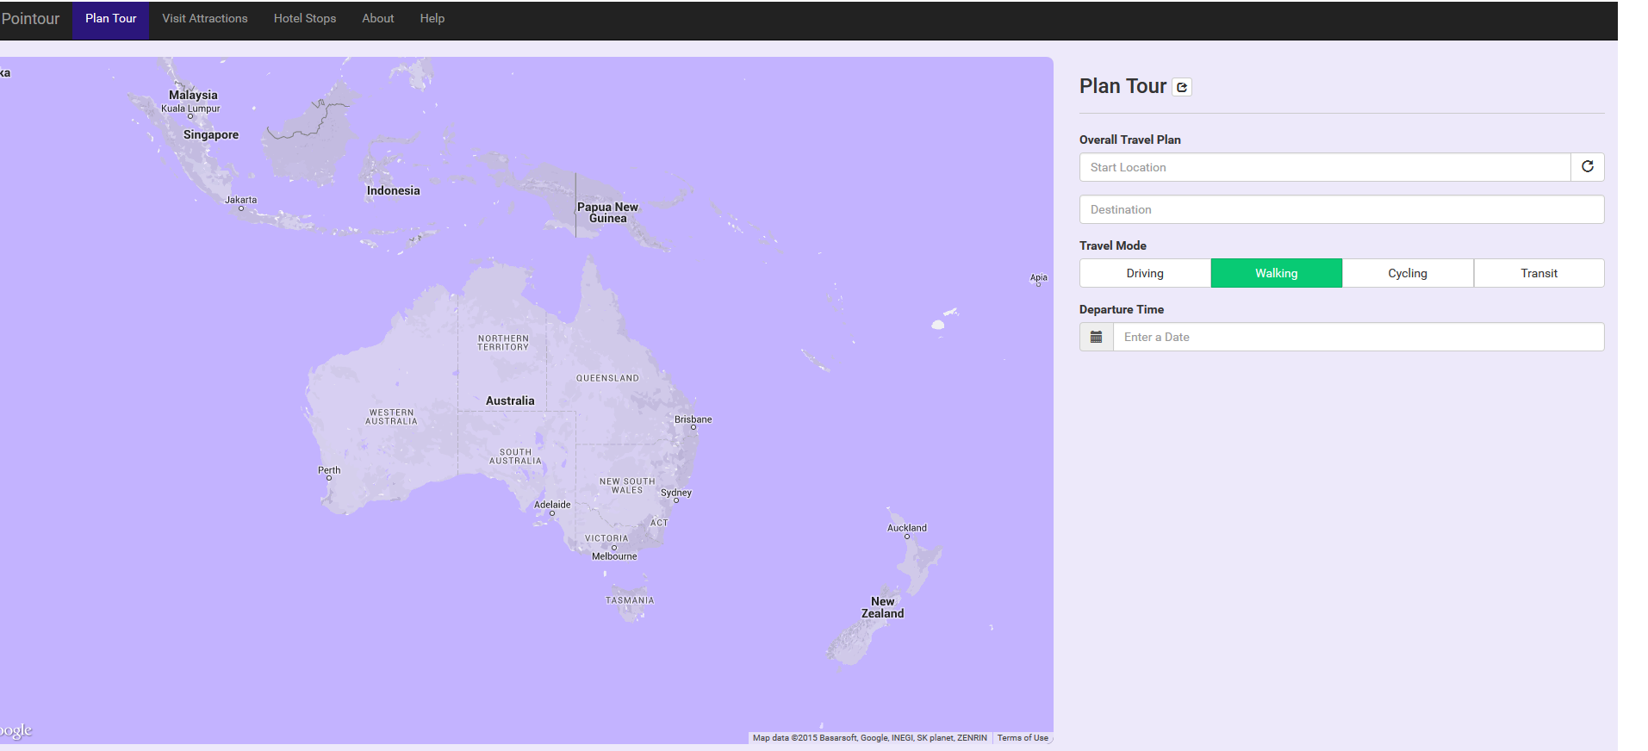

### Tour Planning Page

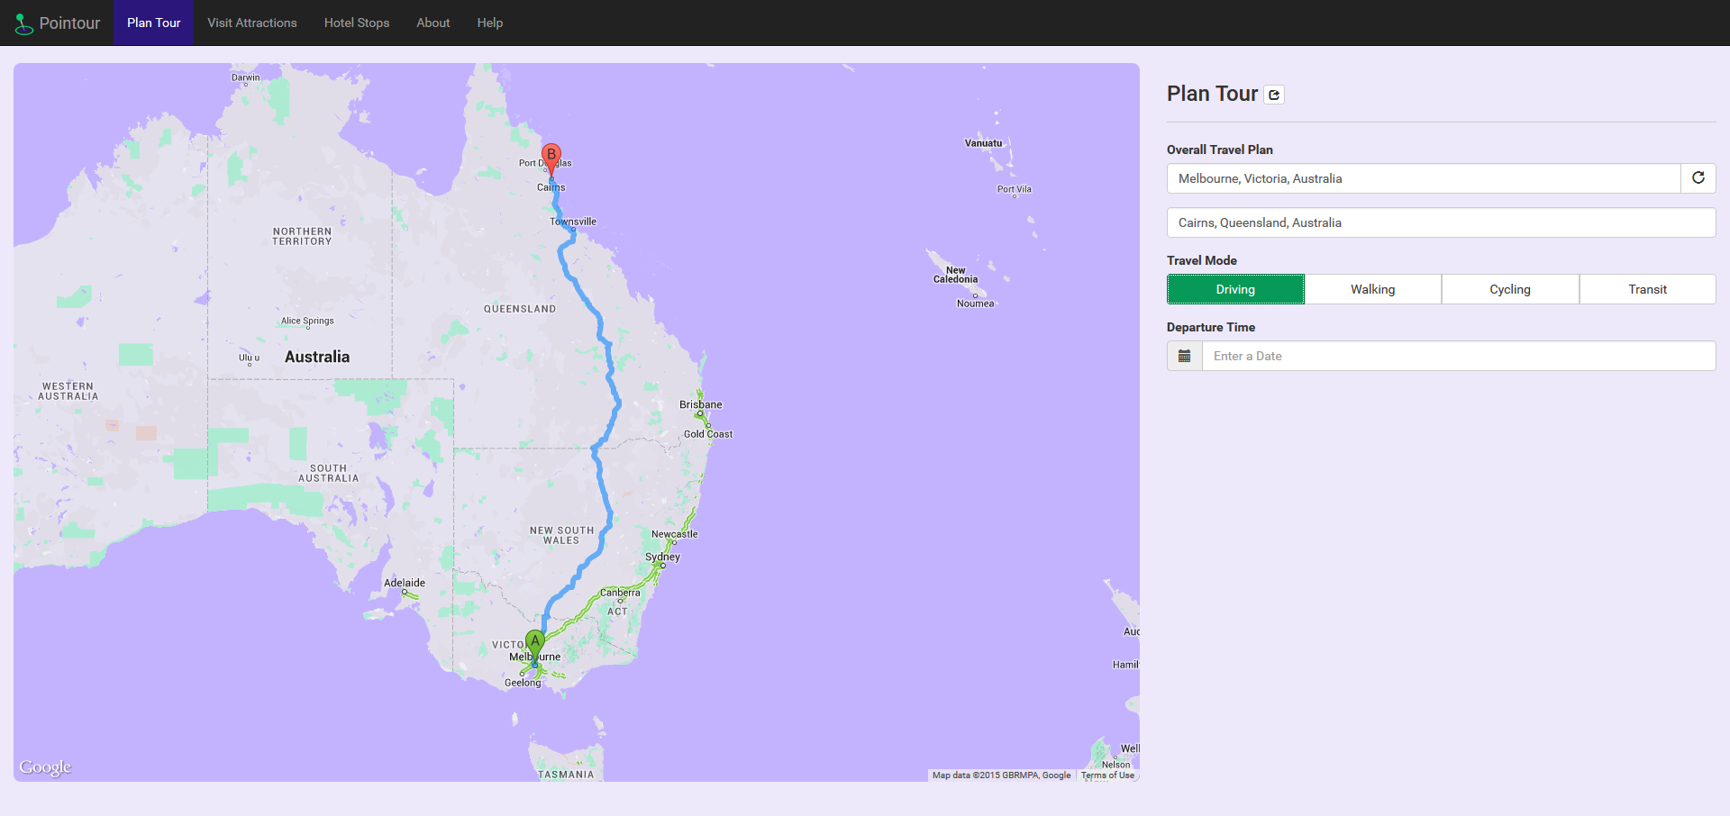

Entered a start location as Melbourne and the destination as Cairns. Selected the travel mode as Driving.

The map successfully plotted a route between these two points.

Different travel modes reroute correctly:

Walking

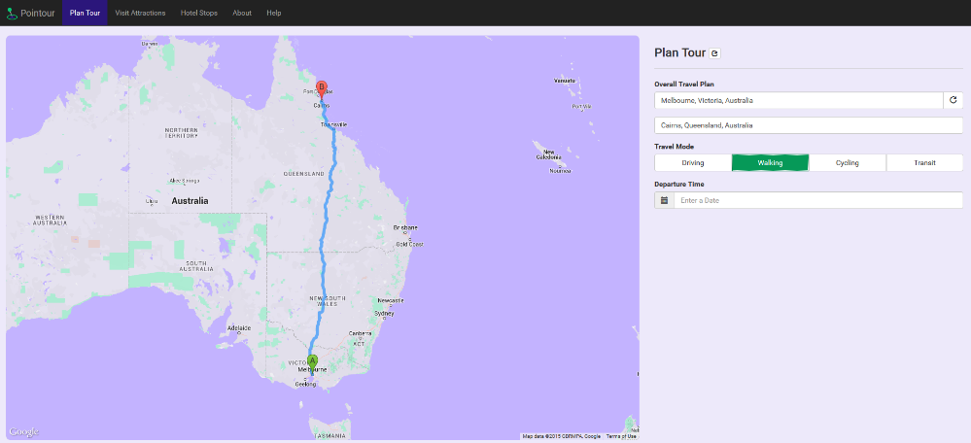

Cycling

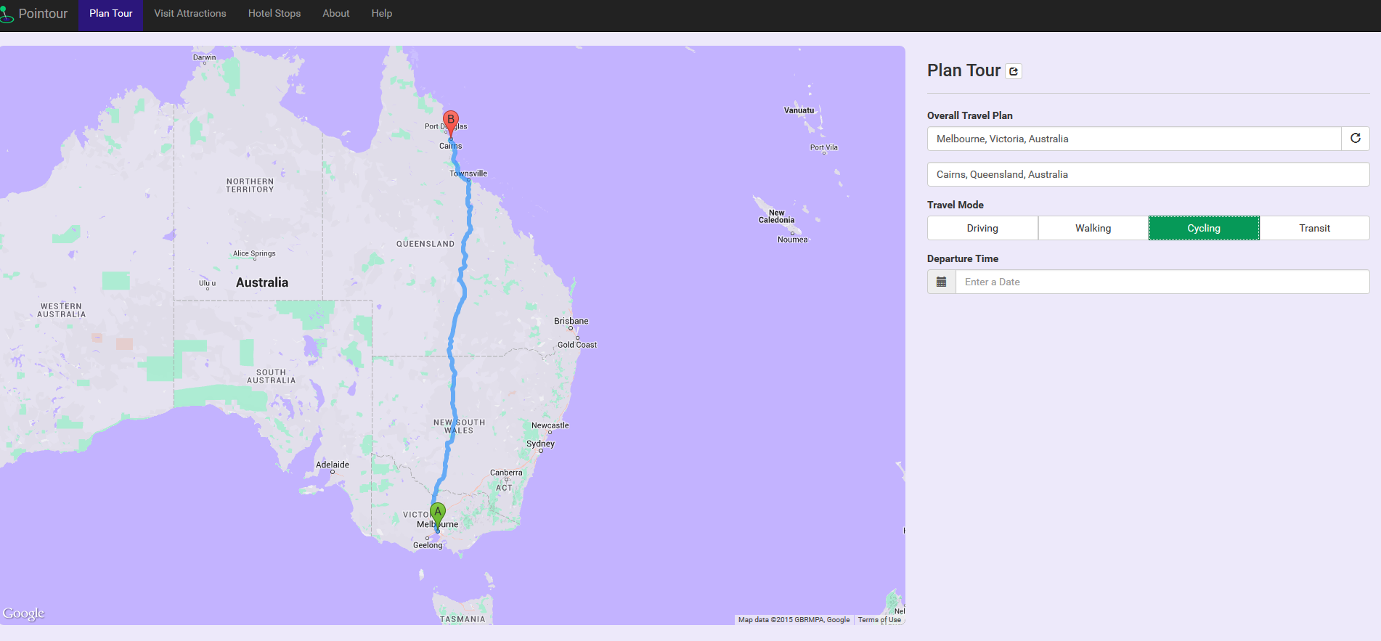

Transit

Transit fails at this point in time due to the lack of transit information provided by Google for Australia, The functionality is marked as unlikely to work via an orange highlight on the button when selected.

The date picker shows up and takes a date input in a simple trivial to use input shown to the user.

### Add Attractions Page

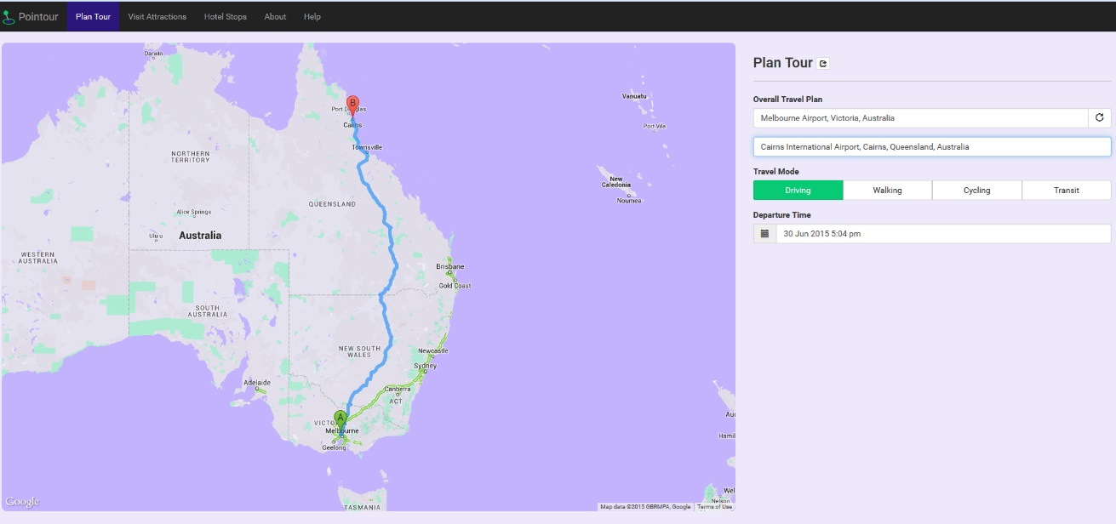

The add attraction button successfully adds a marker to the route, and the map successfully recalculates to find the shortest distance between all the points selected.

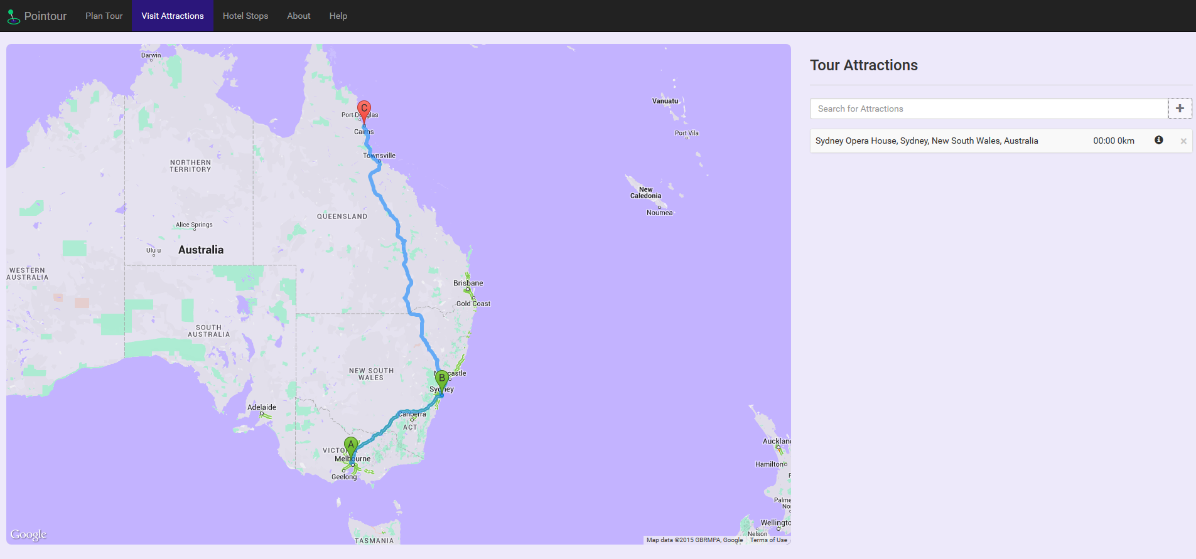

## Web Server Response Time

We used Pingdom to test the speed of the web app in terms of loading time. The figure below shows the requests made to the servers involved in loading the page, including CDNs, Font delivery systems, and the pages themselves.

The total downloads from the initial visit to the page, including mapping API data, is 450.4kB downloaded in 2.62 seconds, with 67 files successfully downloaded.

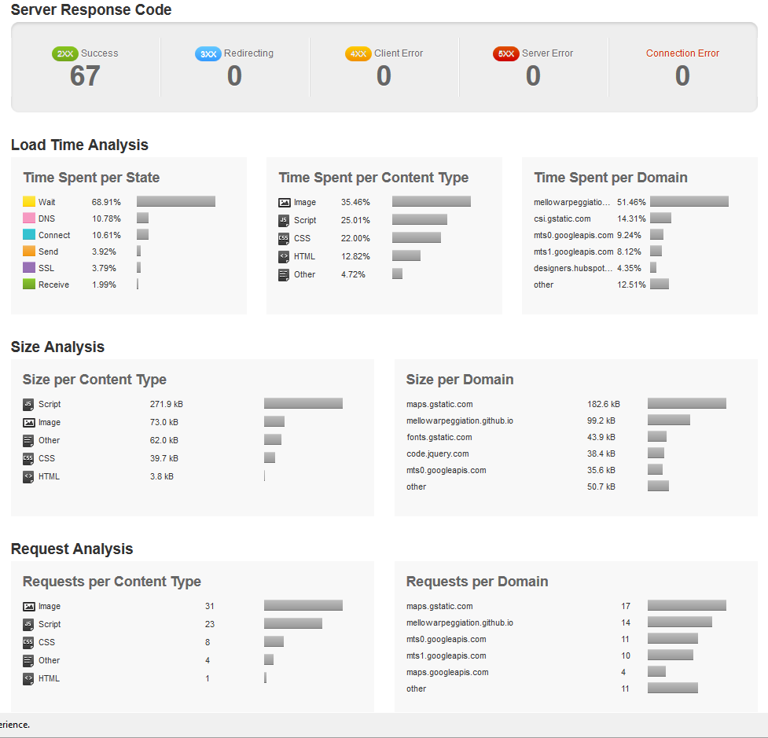

## Screen Size Testing

### Apple iPad

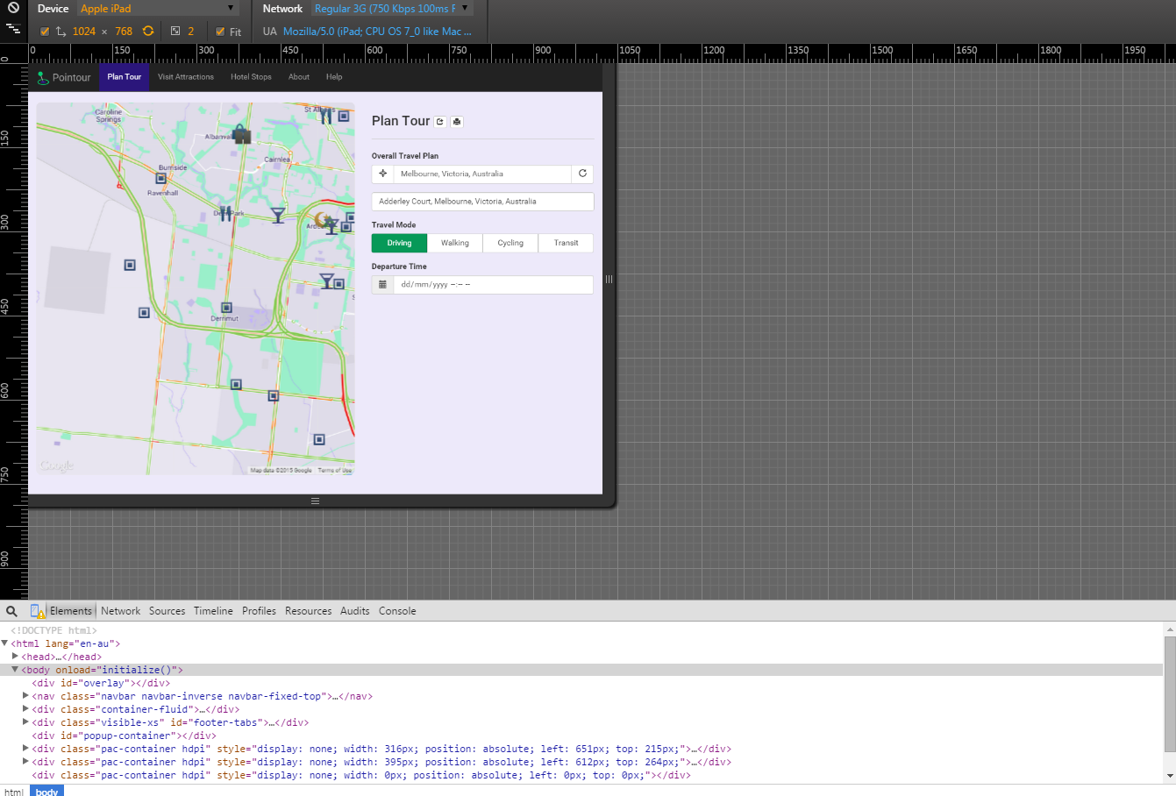

### Apple iPhone 6

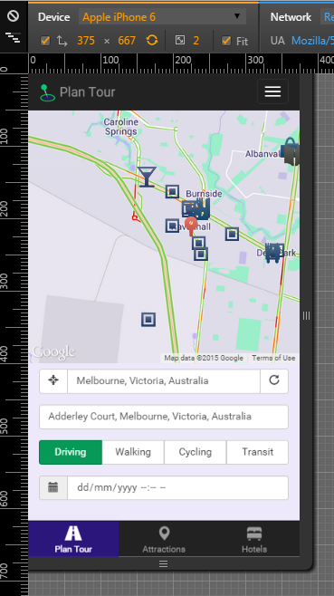

### Apple iPhone 6+

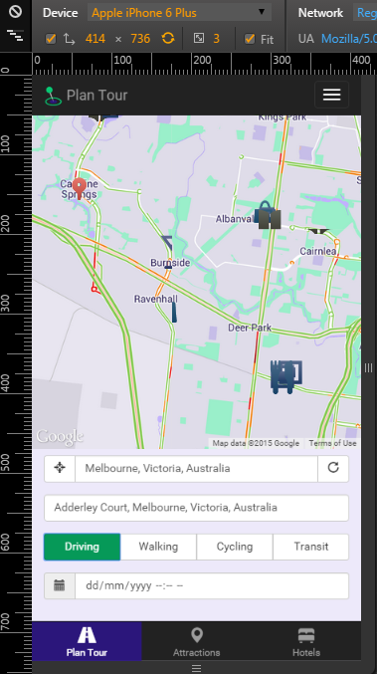

### Samsung Galaxy Note 3

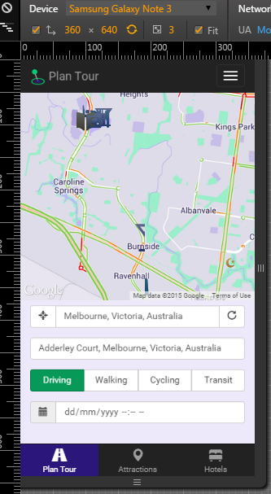

## Testing Results

All the purpose and object of the Application are achieved. This all testing are testing 16 buttons and 4 pages. Every button and page work well. All the code we programmed is tested for several times and the results show that our code is correct and all passed our testing. Then we started to test the implement fluency of the website. Include the each button’s test. We used several different and random ways to test each button and the results are satisfactory.

We used the Google Chrome device mode & mobile emulation test the different screen size. To prove the application is suited for many different screen types and permutations.

## Application Database Testing

The application uses the Local Storage API provided by most modern browsers to store application data. The data is stored as a simple keyvalue flat file, as shown below.

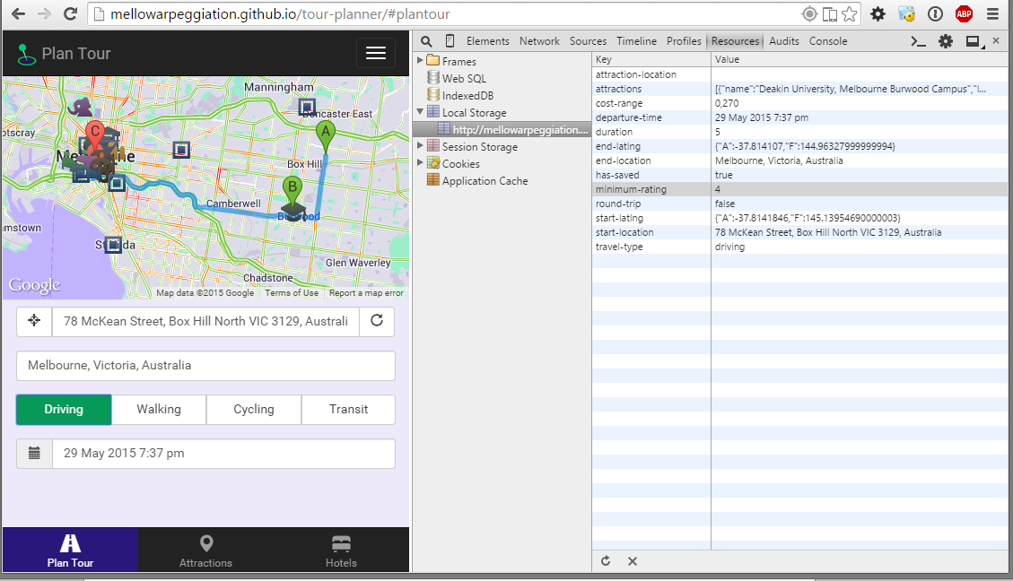

# Guides

## User Guide

The user guide is bundled into the application, under the navigation item “Help”, located at <http://mellowarpeggiation.github.io/tour-planner/help.html>

## Administration Guide

Administration of the application is simple, the code requires no compilation, as it is an entirely HTML/CSS/JS based application. Deploying the software is as simple as finding a host, and copying the files into the root “www/” (or in IIS, “inetpub/”) folder.

## Developer Guide

To develop for this application and to extend it, a developer will need to familiarise themselves with the following markup languages, scripting languages, and frameworks:

* HTML5
  + Bootstrap
* CSS
  + If modifying Bootstrap.theme, SASS
* JS
  + jQuery

A frozen copy for the sake of showcasing the application as it was before 11:59pm 29/05/2015 has been included with this document.

The application is open sourced, under the MIT license, and a pull request can be made at <https://github.com/MellowArpeggiation/tour-planner>

## Installation Guide

Installation of the application is simple. After navigating to the app, the page can be bookmarked, or, in the case of an iPhone, the application can be saved to the home screen as a web app. This can be achieved by tapping the context menu button (the box with an arrow coming out), and selecting “Add to Home Screen”. This will allow the app to run full screen in a sandboxed browser session.

# Resources Used

Pingdom, a web application and server testing tool. Available at <https://www.pingdom.com/>

Google Chrome Device Emulator. Available as a part of Google Chrome, which can be downloaded at <http://google.com/chrome/browser>