Game Design Document

# The Conqueror

## Game Name

The name of the game is “The Conqueror”.

## Tag line

The tagline of the game will be “Conquering till we’re the only one on top.”

## Elevator Pitch

We’ve all played tower defense games. You defending yourself from incoming attacks from the enemy. Now you will be the one attacking. You, as a conqueror in the Middle Ages, will be building your army up with knights, archers, mages etc. Conquering all the kingdoms in your way.

## Date of last update

17/01/2024.

# Game Overview

## Game Concept

You, as the player, are fighting in a tower defense game. This time you are the conqueror in the tower defense game. The game will be a single player game Every level you will be trying to conquer the opposing kingdoms while they are defending themselves. They will be having different defending units.

## Target Audience

My target audience will be teenagers to young adults. A game that will be easy to get into. Playing it to kill some time here and there.

## Genre(s)

The genres will many be tower defense and Real-Time Strategy, Tower defense.

## Game Flow Summary – How does the player move through the game? Include both the interface and the game itself.

You, as the conqueror, get to use a gold budget towards your conquest. The budget will be used for building up your own army. The army, you build, walks down a predetermined path where it encounters the opposing army you try to defeat. You will encounter themed enemies for every opposing kingdom; that will be ninjas, samurai, ottoman fighters etc.. Now you will have to strategize and optimize your army with the knowledge you have acquired from the battlefield, making it a fun diverse experience every time you encounter new units.

The interface will look like a simple clicker game

## Look and Feel – What is the basic look and feel of the game? What is the visual style?

The style of the UI & your own army will give you a Middle Ages feel. The battlefield itself will change according to the kingdom you will have to fight. Making a clear distinction between every kingdom you will have to fight. The only thing that will look the same is the path you have to take.

# Gameplay

## Objectives – What are the objectives of the game?

The main objective of the game is to get your troops to the castle and get the enemy health to 0. To achieve this goal you have a couple of sub-objectives. These are: defeating the combatant army, not losing your own army in the process and losing the budget you have for that level. There will be no way to save to make it more punishing when you made a bad decision and want to backtrack real quick. Losing your whole budget will make you lose the game

## Game Progression

You will be conquering other kingdoms around you on a map. It progresses by defeating the kingdoms, unlocking new units and unlocking new areas on the map. The growth of the kingdom makes the budget bigger and the size of the army greater. The game ends when you have conquered every kingdom.

## Play Flow – How does the game flow for the game player

It is very straightforward. The players don’t have a choice in movement or interaction. The only thing they can decide is what army units they want and in which order they want to make the army spawn. The game is quite fast paced and in waves of troops you send.

## Mission / Challenge Structure / Puzzle Structure

The challenge structure is finding out which defending units are strong and weak against your own units. Finding out how to order your own army and making it past the defending army into the castle.

# Mechanics

## Rules – What are the rules to the game, both implicit and explicit.

Rules:

* You can only walk on the predetermined path.
* You have limited amount of money to build your army.
  + Every level it is a different amount (based on difficulty)
* It will cost different amounts of gold to buy specific forces.
* You will have to get a certain amount of your own army into the defending castle to win the game.
* Some forces will have an advantage or a disadvantage against opposing types of forces.
* You will get gold for your own unit and the enemy unit dying.

## Model of the game universe. Think of it as a simulation of a world, how do all the pieces interact?

It is a very aggressive world where everyone is scared to not be strong enough to defend themselves. It’s a dog eats dog world.

## Economy – What is the economy of the game? How does it work?

The economy is very important. You will be having a certain budget every level. It will cost you certain amounts of coins to buy units. Every type of unit also has separate quantities of gold you need to use to get them onto the battlefield. It is all about managing the limited amount of gold that you have. And when the budget has run out, the level you played will be lost.

## Character / Game Piece movement in the game

The player itself cannot move. You don’t see him/her and don’t know what he/she sounds like. The player is you. The only thing that you have control over is the pieces of your army, but that too is limited. The limitations are in the actual movement of the pieces. The pieces walk in a predetermined path.

## Conflict: if present, how is this modeled?

The conflict is with all the other countries. It is shown immediately with the starting scene.

## Screen Flow -- How each screen is related to every other and a description of the purpose of each screen

There will always be a cutscene of commander Andy explaining everything and when defeating a kingdom there will be a congratulatory scene of the commander. There is also a starting screen and an options screen. You can also pause the game momentarily but not save.

## Game Options - What are the options and how do they affect game play?

I have an option screen. You can change the volume and the resolution of the game. Two of the most important options.

## Replaying and saving

You can always replay the game. The game is not savable, it was a choice to make the game more difficult. When you have completed your level it will remember that you have conquered the previous country.

# Story and Narrative

## Back story

You, as a conqueror, want all the land you can control. So you begin with your quest to conquer all the lands. Your commander Andy learns you the ropes of controlling the army. He is the one person that is always at your side. You will also come in contact with your troops, talk with them.

## Plot elements

There is no plot, it just is a progression game. You will keep having levels to fight until you get control of every country.

## Story progression

You progress is by getting control of every country/ kingdom on the map.

## Cut scenes -- descriptions include the actors, the setting, and the storyboard or script.

I have 2 cutscenes. The first one is a tutorial cutscene. You as the conqueror are talking to your commander and right hand, Andy. He learns you the ropes of controlling the army.

The second cutscene is Andy congratulating you and saying that there aren’t any more levels, for now.

## Accompanying game pieces – story booklets, art work

All the art/sprites used are from the unity asset store. I wanted to have the theme correspond with each other; sadly enough there aren’t enough (free) 2D-sprites that gave of the same feeling. So I had to pick and choose different ones.

# Game World

## General look and feel of world

The game takes place in the Middle Ages. Every level will look different depending on the opponent you will have to defeat.

## Areas

The areas are the different countries that you are invading.

## General description and physical characteristics

The game world is completely different every level. I want to make it look and feel different every time.

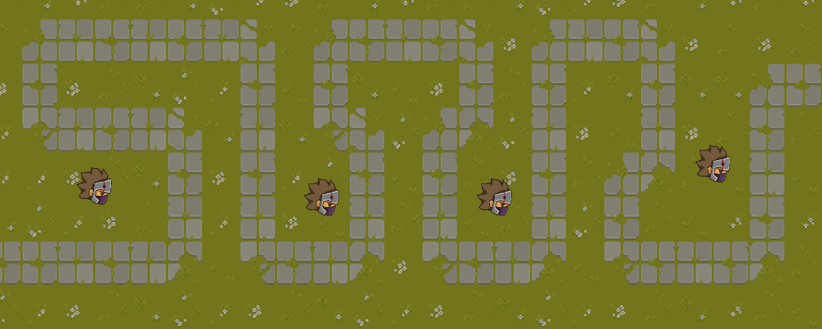

## How to relate to the rest of the world

All the areas aren’t really connected to each other. It is like all the Mario levels. There isn’t a visual connection but you feel that it operates the same way.

## What levels use it

All levels use different stylized variations of the first area (the tutorial area).

# Characters.

## For each character

The only character in the game is the commander for now.

You don’t see the conqueror because he is you.

The commander is called Andy.

## Back story

The commander is your right hand. He gives you the ropes of controlling the army. Outside of that he only is there to cheer you on.

## Personality

The commander is a fighter and is optimistic in the way “the conqueror” will handle the conquest.

## Appearance

He is a burly man with a sword on his back.

## Relevance to the story

He is the one that teaches you the ropes to the game.

## Artificial Intelligence Use in Opponent and Enemy

The opponents are programmed on a very basic level. They attack when you get in range. The enemies don’t move they only rotate and shoot.

# Levels

## Training Level

The first level is a training level. You will win this level no matter which decisions you make.

## Synopsis

All the levels will have the same path on which the army has to walk upon. Each level will have their own theme. The theme will be based upon what kind of opposing kingdom you have to fight. This will give it a more real feeling that everything is connected and that the countries have their own fauna & flora. The enemies on the battlefield will also be diverse, every single one of them with their own advantages and disadvantages. Those aspects will impel the player to really think about how they want to engage the battlefield. Picking and choosing the right soldiers to do the job.

## Required introductory material and how it is provided

The very basics you need to know about the game will be explained in the first cutscene. In the cutscene the commander will explained that you need gold, to deploy an army. That the army’s diversity is limited but that you can unlock everything just by winning fights. And that the enemy has a certain amount of health and you will need to get enough soldiers to the other side to win the battle.

## Objectives

The objective is to get enough soldiers to the other side.

## Details of what happens in the level

You deploy your army they come out of the left side. They walk down a predetermined path. Along the path you will have opposing soldiers waiting to kill your own soldiers. If you get past all the opposing soldiers you win.



# Interface

## HUD

## Menus

The game has a starting menu, an options menu and during the game you can pause the game to get to the main menu or quit the game.

## Camera model

The camera model is very simple. It is a top down look on the battlefield.

## Control System – How does the game player control the game? What are the specific commands?

You can control the audio and the resolution of the game in the options menu. That are all the control I gave the player for now.

## Audio, music, sound effects

the background audio is subtle but tense. Outside of that I have also made some sound effects for the army itself while they are walking you hear them walking.

## Help System / Manual

The help system is very straightforward. Everything was explained at the beginning of the game. If you want more information on the troops themselves you can hover over them to get a little more information.

# 10. Design guidelines

I wanted to game to be simple and easy to understand. No hidden mechanics, nothing that isn’t explained is knowledge you can only get by learning the game thoroughly.

Another guideline is to have some of the basic options that you could change in the game, like audio and resolution.

I also wanted to have a story, a simple one but a story nonetheless. The cutscenes is your first meet-up with Andy. He will always be part of the journey, a recurring character.

A guideline which is very important is progressive difficulty. So you get more difficult levels and more to think about the further you get.

The game also needed some unlockable aspects. Just like other game where you progressively get more tools to achieve victory.

This made is so I chose a couple of design principles:

* -The interest curve is a big one, where I want to have unlockable aspects for every level they win. Making it rewarding and garnering more interest in the game. Since the have more decisions to make.
* Skinner Box: During every level. The beginning is hard but when you have the hang of it. The rest of the level gets easier and easier.
* Problem-Solving Obstacles: There are multiple ways to win the game. I didn’t want the player to have the feeling that there was only one option for them to win/ one strategy. So I made it that if you do some things they work sometimes in certain areas.