class04.R
mel
2026-01-15
x <- 1:50
plot(x, sin(x))
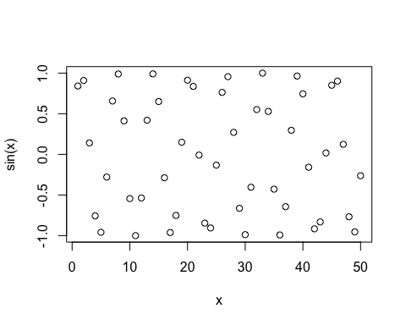
plot(x, sin(x), typ="l", col="purple", lwd=2)
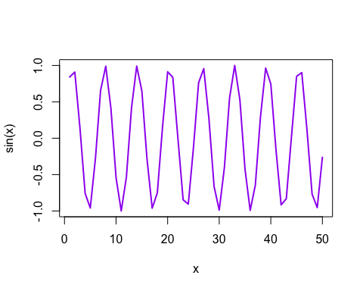
log(10, base = 10)
## [1] 1

