Technical specification

Site «Taxi Almaz»

Kazan 2016

Heading

General requirements 5

Design requirements 5

Navigation requirements 5

Software requirements 5

Server software requirements 5

Client software requirements 5

Site structure 6

Design 7

Main page 7

Authorization page 7

Sign up page 8

Client sign up page 8

Driver sign up page 8

Client pages 9

New order 9

Order list 9

Templates 10

Profile 10

Feedback 11

Driver cabinet pages 12

Current order 12

Free orders 12

Statistic 13

Analytic 13

Profile 14

Feedback 14

Programming 15

Main page 15

Main block 15

When you enter login, password and data of the order and clicking on button order should be created. 15

Menu block 15

Authorization page 15

Navigation bar (same for all) 15

Main block 15

Sign up page 15

Main block 15

Contains a link to the sign up page of the client and a link to the sign up page of the driver. 15

Client sign up page 15

Main block 15

Driver sign up page 16

Main block 16

Client account 16

Menu (same for all) 16

New order page 16

Main block 16

Order list 17

Search line 17

Orders table 17

Generate PDF 17

Templates 17

Templates table 17

Feedback page 18

Driver cabinet 18

Current order 18

Free orders 18

Free orders table 18

Statistic page 18

Button block(same to analytic page) 18

Main block 18

Analytic page 18

Chart block 18

Info block 19

Profile page (same as client profile page) 19

Feedback page (same as client feedback page) 19

# General requirements

## Design requirements

The site design should be performed using 1-2 primary colors associated with a logo design company.

Personal cabinet must have a minimalistic style, the main attention should be paid to functionality.

Pages should keep a unified style.

## Navigation requirements

All information must be divided into blocks for the convenience of working with.

The navigation is done via the main menu sidebar and cross-references in the page structure.

## Software requirements

### Server software requirements

The Internet site and its files should be optimized for the use of the following software:

* Tomcat
* Spring
* PostgreSQL 9.4
* Hibernate
* Spring Security
* Spring AOP
* FreeMarker

### Client software requirements

The website needs to be accessible to users who use browsers:

* Chrome
* Opera

**Information protection requirements**

To ensure the protection of information from unauthorized access shall be provided restricting access using authorization.

# Site structure

* Main page
  + New order
  + Personal account

• Login page

• Registration

* + Select role Page
  + Registration Page of the client
  + Registration Page of the driver

• Personal account

* + New order
  + List of orders
  + Templates
  + Profile
  + Opinion

• A personal account of the driver

* + Current order
  + List of free orders
  + A list of all orders with a search

• Statistic

* + Analytic
* Profile
* Feedback

# Design

## Main page

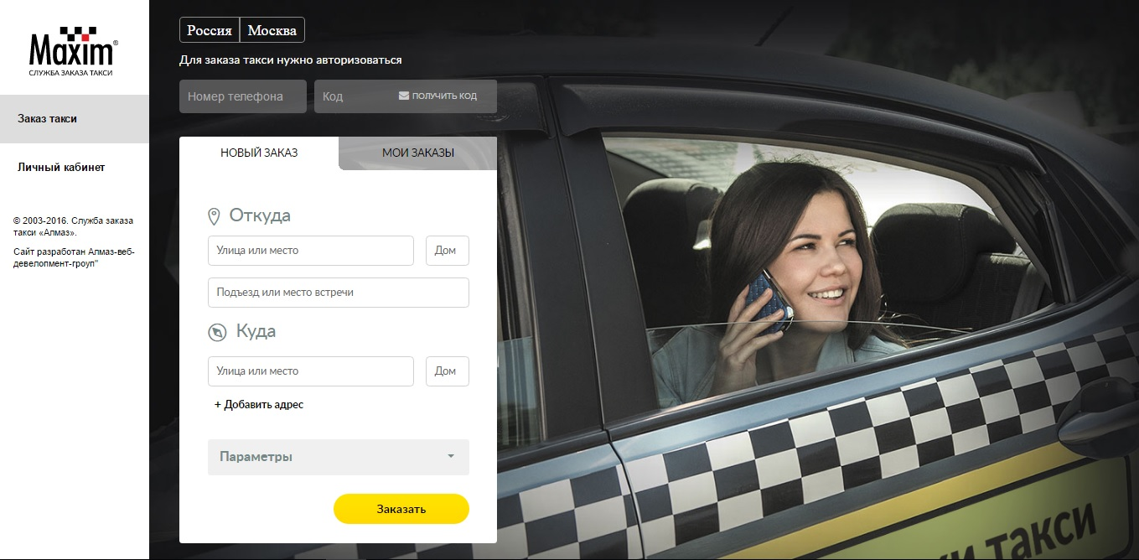

## Authorization page

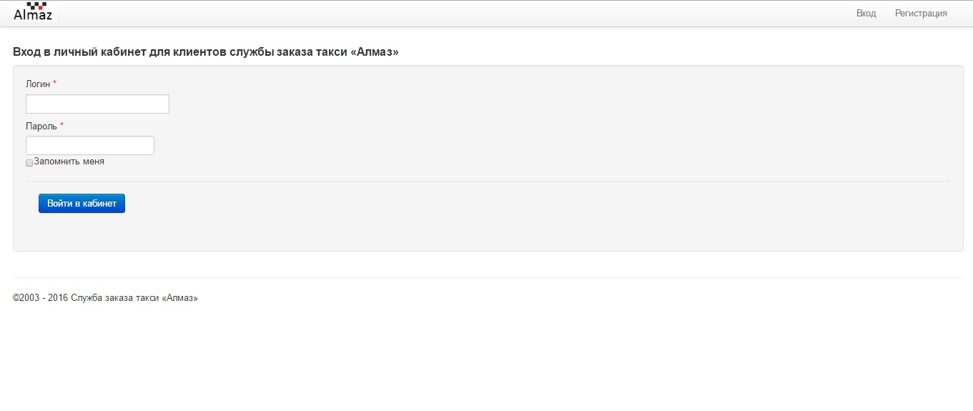

## Sign up page

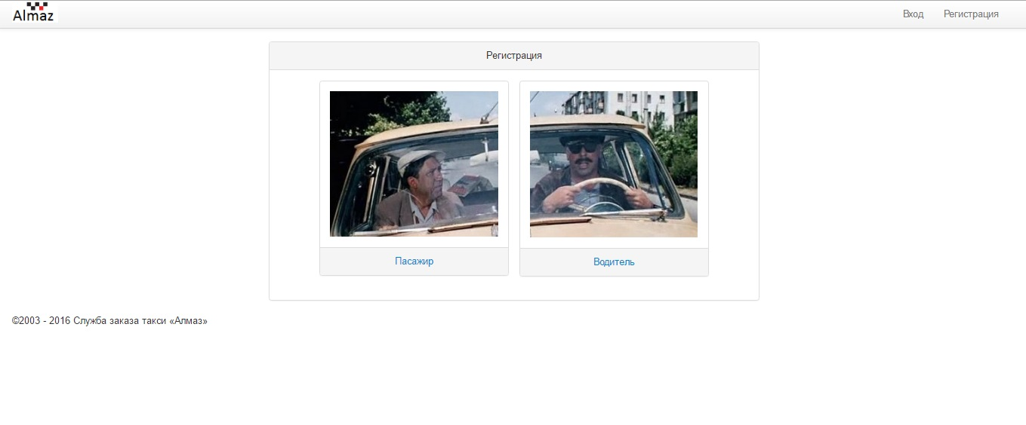

### Client sign up page

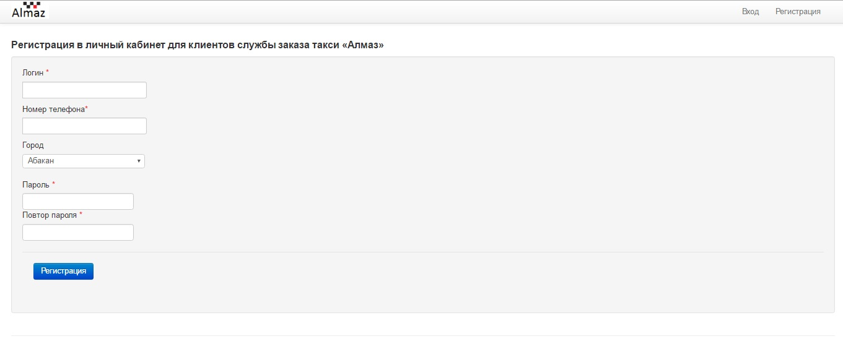

### Driver sign up page

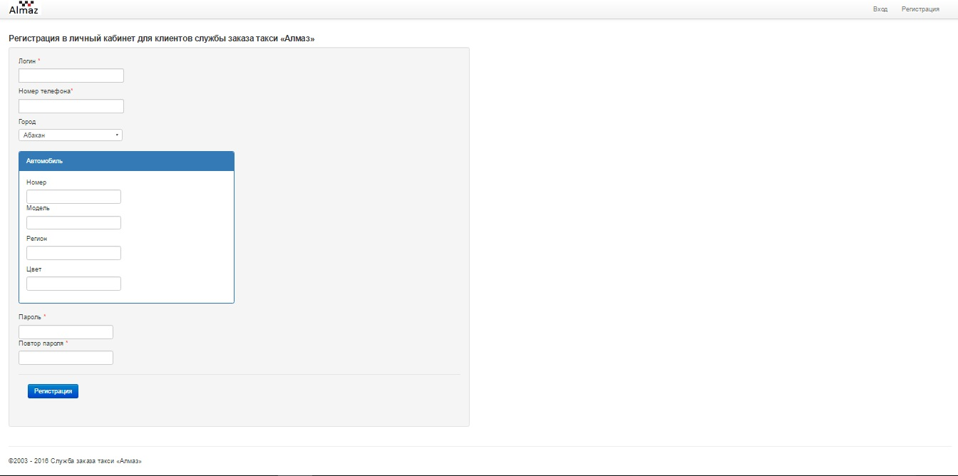

## Client pages

### New order

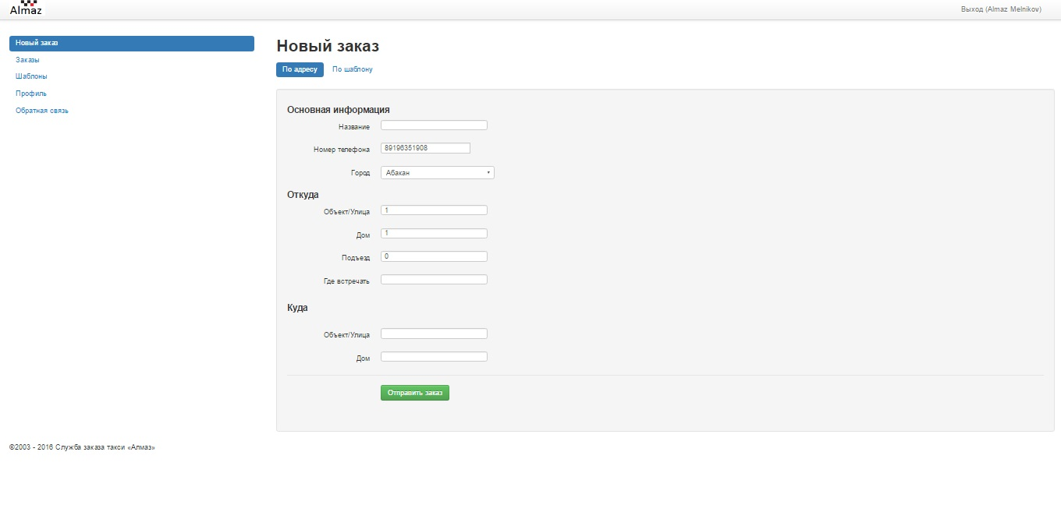

### Order list

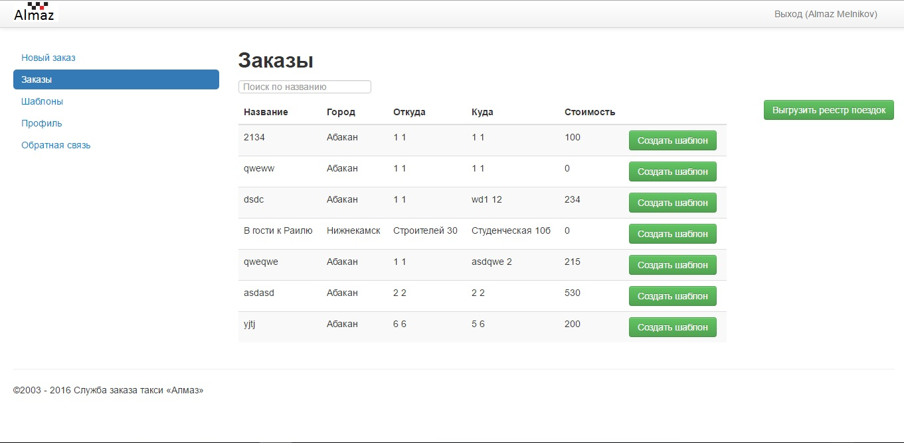

### Templates

### Profile

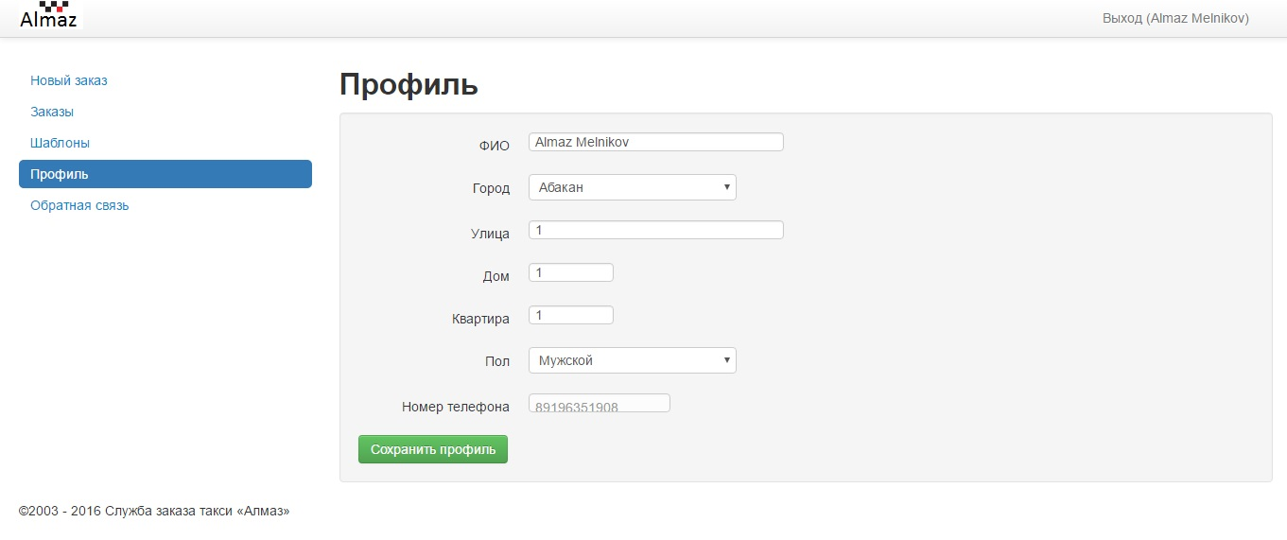

### Feedback

### 

## Driver cabinet pages

### Current order

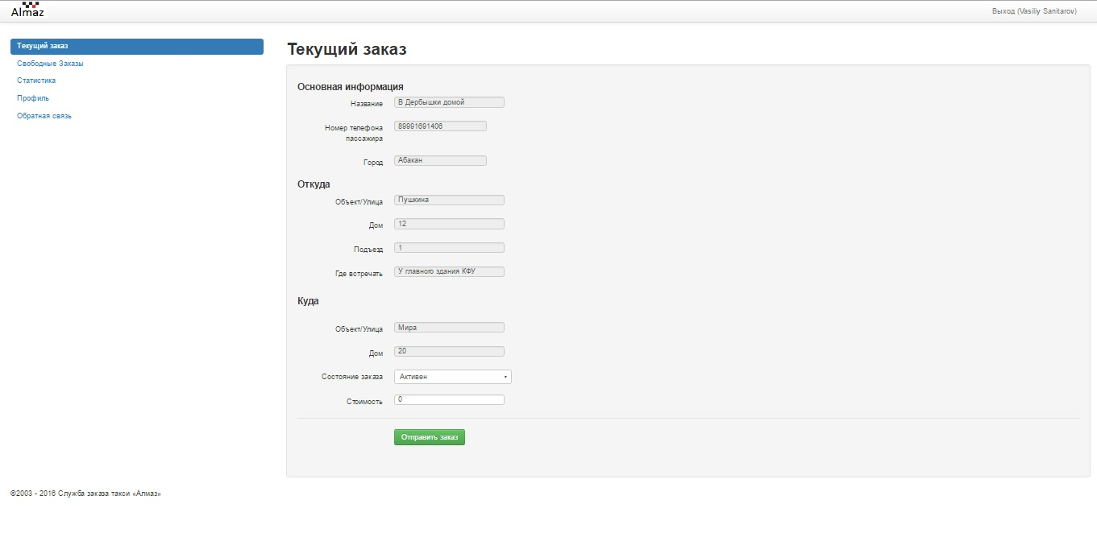

### Free orders

### 

### Statistic

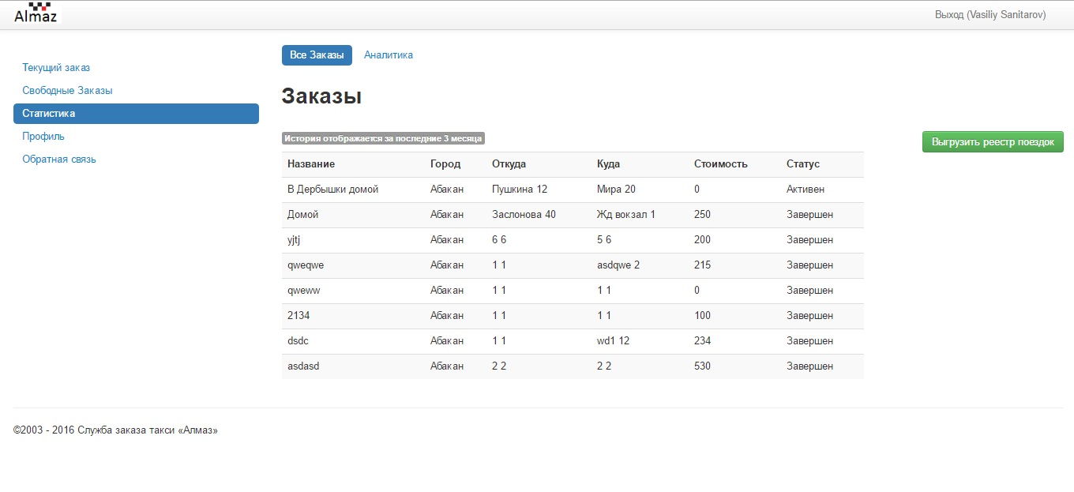

### Analytic

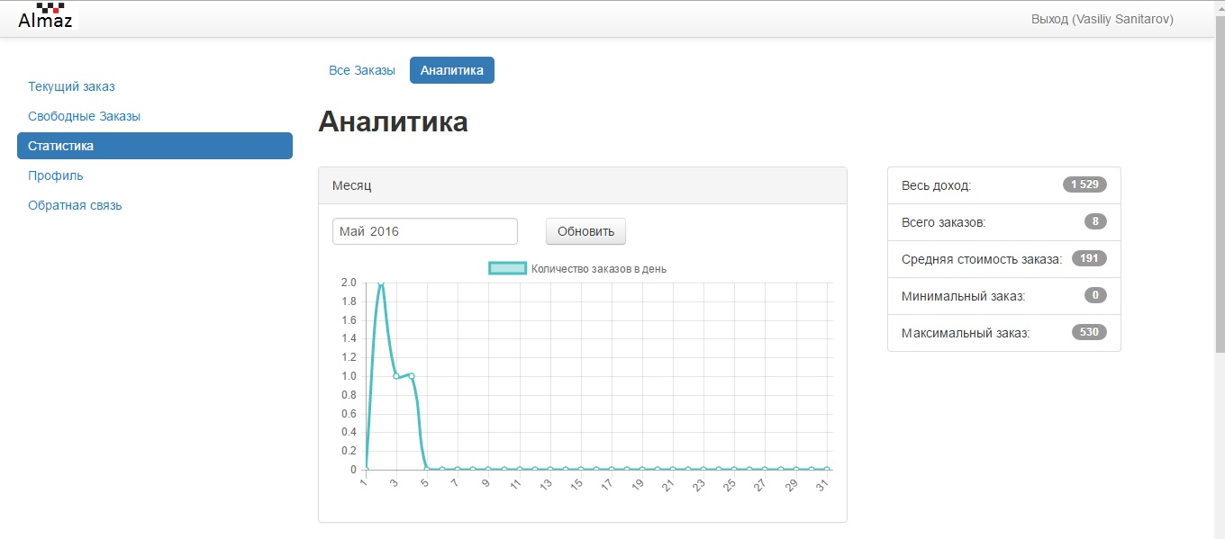

### Profile

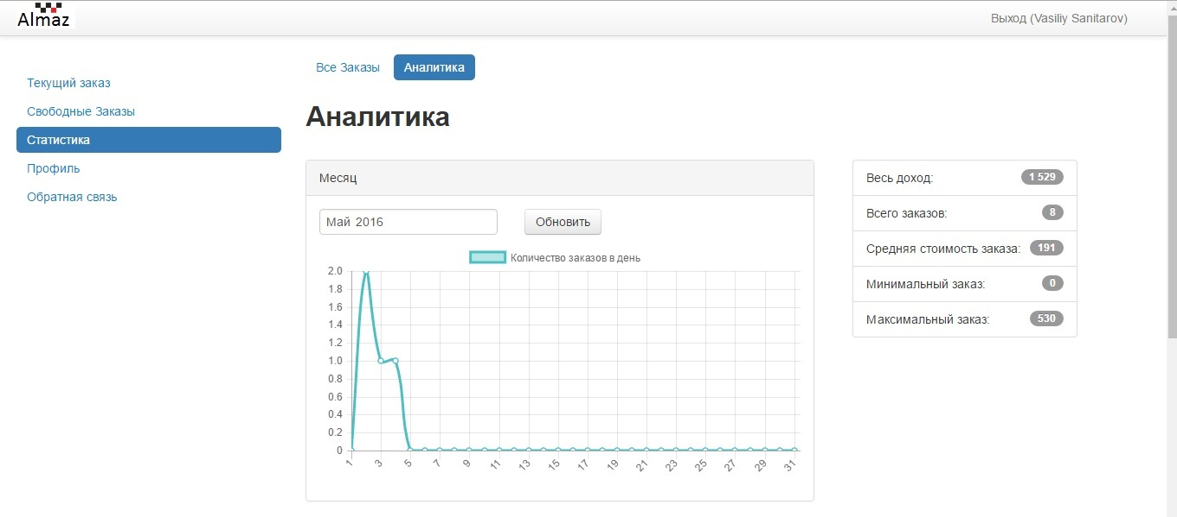

### Feedback

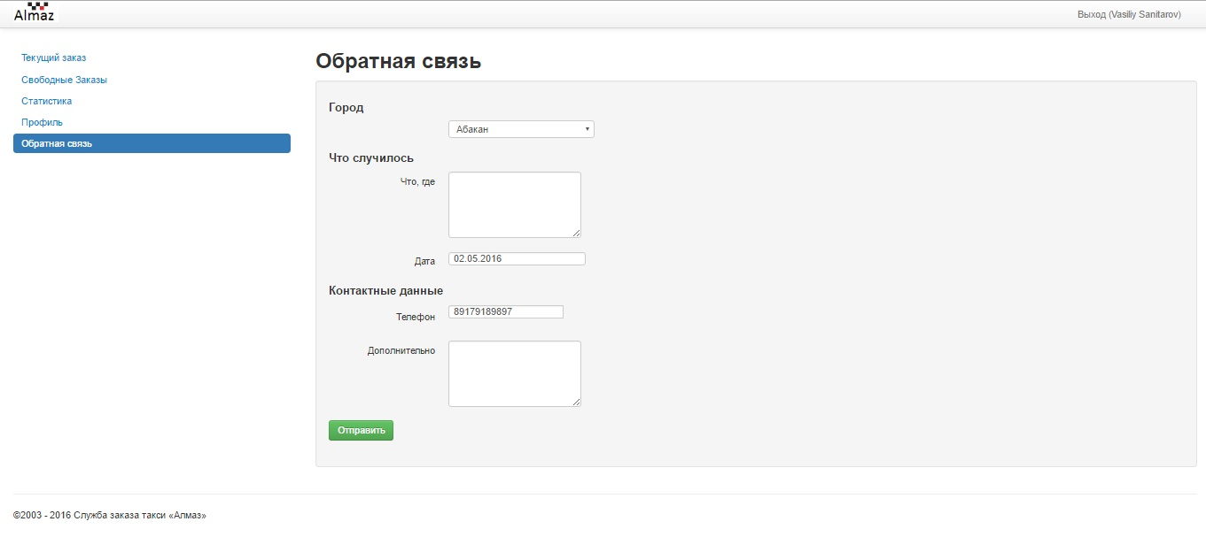

# Programming

## Main page

### Main block

### When you enter login, password and data of the order and clicking on button order should be created.

### Menu block

Consist of 2 links: Order taxi, account page.

* «Order taxi» redirect to main page.
* «Account page» redirect to account page, if user is authorized, else redirect to authorization page.

## Authorization page

### Navigation bar (same for all)

* In the right corner – linked picture to the main page.
* In the left corner the link "Login", that redirect to the login page, link "Sign up» redirect to the registration page if the user is not authorized, otherwise contains a link "Logout (username)", leading to the exit from the personal account.

### Main block

Contains input fields for authorization:

* Login
* Password

When you click on the "Login" button that redirect to personal account.

## Sign up page

### Main block

### Contains a link to the sign up page of the client and a link to the sign up page of the driver.

# Client sign up page

## Main block

* Login
* Phone
* City
* Password
* Confirm password

When you click on the "Sign up" button, that occurs client registration and takes you to the login page.

# Driver sign up page

## Main block

* Login
* Phone
* City
* Car
  + Number
  + Model
  + Region number
  + Color
* Password
* Confirm password

When you click on the "Sign up" button, that occurs driver registration and takes you to the login page.

# Client account

## Menu (same for all)

* New order redirect to page «New order»
* Orders redirect to page «Orders»
* Templates redirect to page «Templates»
* Profile redirect to page «Profile»
* Feedback redirect to page «Feedback»

## New order page

### Main block

Contains 2 buttons: By address-disabled, By template- redirect to templates page and new order form:

* Name – Text
* Phone number – Text (11)
* From
  + City – Select
  + Street – Text
  + House – Text
  + Field – Number
  + Place – Text
* To
  + Street – Text
  + House – Text

When you click on the "Send new order" button, create new order and takes you to the this page.

## Order list

### Search line

Search orders by name that contains inserted string.

### Orders table

Contains orders list with columns:

* Name
* City
* From = Street + House
* To = Street + House
* Cost
* Create template button – create template with orders data and redirect to this page

### Generate PDF

Generate PDF file with table content

## Templates

### Templates table

Contains template list with columns:

* Name
* City
* From
* To
* Order button - redirect to new order page and fill input lines with template data
* Delete – delete this template and redirect to this page

Profile

Contains profile data fields:

* FIO – Text
* City – Select
* Street – Text
* House – Text
* Flat – Number
* Sex – Select(Male, Female)
* Phone number – Non editable

When you click on the "Save profile" button change your profile and takes you to the this page.

## Feedback page

Contains feedback form:

* City – Select
* Main information – Text area
* Date – Date
* Phone number – Text(11)
* Additional info – Text area

When you click on the "Send feedback" button sends feedback and takes you to the this page.

# Driver cabinet

## Current order

Contains current order information, that cannot be disabled and 2 fields Order state and Order cost, that can be changed by driver.

When you click on the "Send order" button change order state and cost then takes you to the this page.

## Free orders

### Free orders table

Contains template list with columns:

* Name
* City
* From
* To
* Get button - redirect to current order page and fill input lines with order data

## Statistic page

Contains 2 buttons: all orders and analytic, orders table.

### Button block(same to analytic page)

All orders button redirect to Statistic page. Analytic button redirect to Analytic page.

### Main block

Orders table show all driver orders.

## Analytic page

### Chart block

Month chart show count of orders in each day of month, chart change by selecting month and clicking to Refresh button.

Year chart

Year chart show count of orders in each month of year, chart change by selecting month and clicking to Refresh button.

### Info block

Shows information about drivers work:

* Summary income
* Count of orders
* Average income
* Minimum cost of orders
* Maximum cost of orders

## Profile page (same as client profile page)

## Feedback page (same as client feedback page)