**北京邮电大学2021—2022学年第二学期**

**卷四:**Discrete Mathematics–Final Test

|  |  |  |  |  |  |  |  |  |  |  |  |  |  |  |  |  |
| --- | --- | --- | --- | --- | --- | --- | --- | --- | --- | --- | --- | --- | --- | --- | --- | --- |
| 考试注意事项 | 一、答题纸为空白A4纸；  二、考试结束后，老师通知结束答题。请将答案图片粘到word，导出为pdf，发往邮箱bupt_2021@163.com，邮件主题：离散-期末-姓名-学号。pdf名：离散-期末-姓名-学号.pdf。  三、学生作答试卷不得抄袭，如被发现，按相应规定严肃处理。 | | | | | | | | | | | | | | | |
| 考试课程 | | 离散数学 | | | | | | | | | | | | | | |
| 题号 | | 一 | 二 | 三 | 四 | 五 | 六 | 七 | 八 | 九 | 十 | 十一 | 十二 | 十三 | 总分 |
| 满分 | | 8 | 8 | 8 | 6 | 8 | 8 | 8 | 8 | 8 | 8 | 8 | 6 | 8 |  |
| 得分 | |  |  |  |  |  |  |  |  |  |  |  |  |  |
| 阅卷教师 | |  |  |  |  |  |  |  |  |  |  |  |  |  |

1. [8 points] For each of these relations on the set {1, 2, 3, 4}, decide whether it is reflexive, whether it is symmetric, whether it is antisymmetric, and whether it is transitive. Please answer in the form with √ and ×.

a) {(2, 3), (3, 2)}

b) {(1, 2), (2, 3), (3, 4), (2, 4)}

c) {(1, 1), (2, 2), (3, 3), (4, 4)}

d) {(1, 3), (1, 4), (1, 1), (2, 4), (3, 1), (3, 4)}

|  |  |  |  |  |
| --- | --- | --- | --- | --- |
|  | reflexive | symmetric | antisymmetric | transitive |
| a) |  |  |  |  |
| b) |  |  |  |  |
| c) |  |  |  |  |
| d) |  |  |  |  |

1. [8 points] Determine whether the relations represented by these zero–one matrices or the relation with the directed graph are equivalence relations. Determine the properties of an equivalence relation that the others lack.

a) $\left[\begin{matrix}1 & 0 & 0 \\ 0 & 1 & 0 \\ 0 & 0 & 1\end{matrix}\right]$

b) $\left[\begin{matrix}1 & 1 & 1 & 1 \\ 1 & 1 & 0 & 0 \\ 1 & 0 & 1 & 0 \\ 1 & 0 & 0 & 0\end{matrix}\right]$

c) 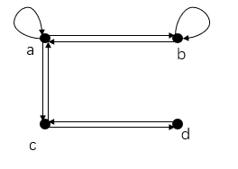

d) 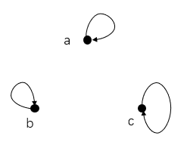

1. [8 points] Suppose A ={2,3,5,6,7,10,12,14,15,21} and R is the partial order relation defined on A where xRy means x is a divisor of y.

a) Draw the Hasse diagram for R.

b) Find all maximal elements.

c) Find all minimal elements.

d) Find lub({3,7}),if it exists.

e) Find glb({12,15}),if it exists.

f) Is the poset(A,R) a lattice? Explain your answer.

1. [6 points] Use Warshall’s algorithm to find the transitive closure of R on {a,b,c,d,e} where R= {(a, b), (a, c), (a, e), (b, a),(b, c),(c, a),(c, b),(d, a),(e, d)}.
2. [8 points] Answer the following questions about chromatic number.

a) Find the chromatic number of Cn, where n ≥ 3.

b) Find the chromatic polynamial PG for the given graph and use PG to find χ(G).

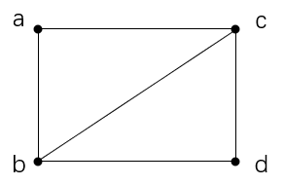

1. [8 points] Answer the following questions about recurrence relation.

a) Solve the recurrence relation an = 8an-1 – 16an-2 for n≥2 with the initial condition a0 = 0 and a1 = -4.

b) Use generating functions to solve the recurrence relation an = 3an-1 for n≥1 with the initial condition a0 = 5.

1. [8 points] Let H and N be subgroups of the group G. Prove that if N is a normal subgroup of G.then H∩N is a normal subgroup of H.

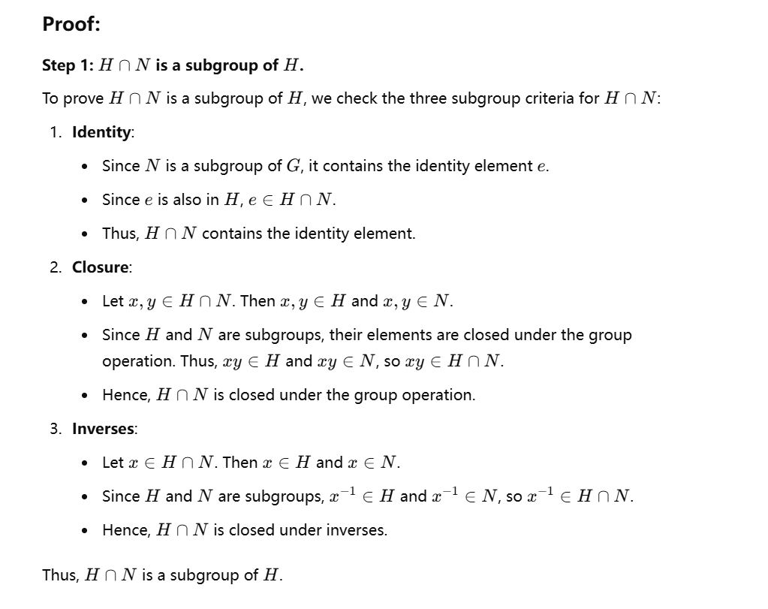

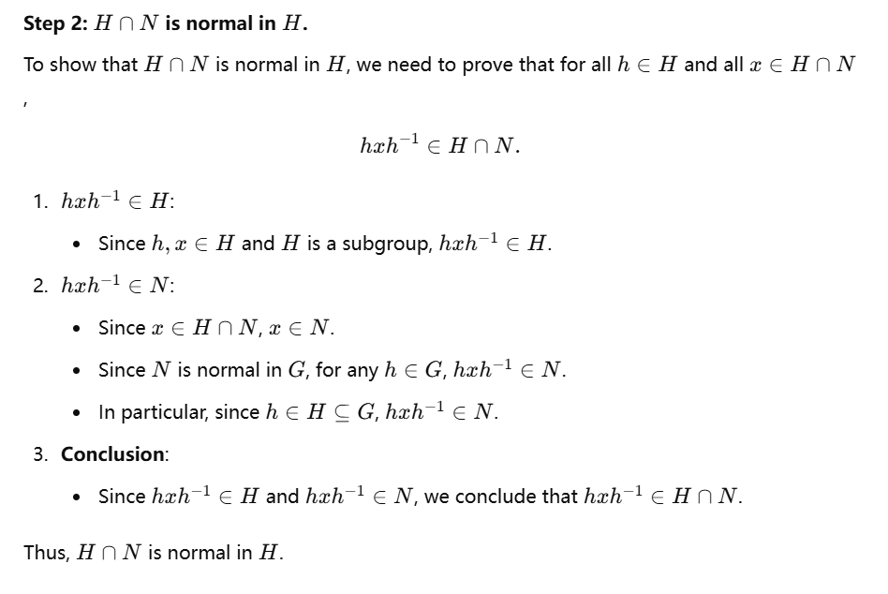

1. [8 points] Answer the following questions about group.

a) Write the multiplication table for the group Z2×Z3.

b) <Z6, +6> is a group, Z6 = {[0], [1], [2], [3], [4], [5]}, determine all the subgroup of <Z6, +6>.

c) Let G = Z4. Determine all the left cosets of H = {[0], [2]} in G.

1. [8 points] Let

$$H = \left[\begin{matrix}1 & 1 & 0 \\ 0 & 1 & 1 \\ 1 & 0 & 0 \\ 0 & 1 & 0 \\ 0 & 0 & 1\end{matrix}\right]$$

be a parity check matrix. Decode the following words relative to a maximum likelihood decoding function associated with $e_{H}$.

a) Find all left cosets of $e_{H}(B^{2})$ in $B^{5}$.

b) For each coset, find a coset leader, and compute the syndrome of each leader.

c) Decode the word 10101 relative to a maximum likelihood decoding function.

1. [8 points] Use Dijkstra’s algorithm to find the length of a shortest path from *a* to all vertices in the given weighted graph.

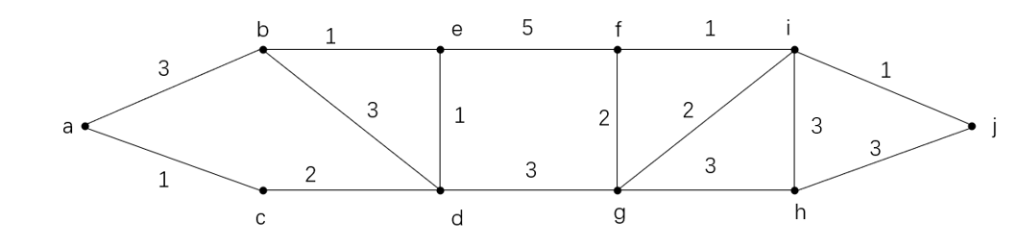

1. [8 points] Find the maximal flow for the network N given in following figure.



1. [6 points] Use Huffman coding to encode the following symbols with the frequencies listed: A: 0.08, B: 0.10, C: 0.14, D: 0.15, E: 0.18, F: 0.35.

a) Write down the prefix code of these symbols.

b)What is the average number of bits used to encode a character?

1. [8 points] Use Prim’s algorithm to find a minimum spanning tree for the given weighted graph.

