**北京邮电大学2019—2020学年**

Discrete Mathematics – Final Examination (Paper B)

|  |  |  |  |  |  |  |  |  |  |  |  |  |  |  |
| --- | --- | --- | --- | --- | --- | --- | --- | --- | --- | --- | --- | --- | --- | --- |
| 考试注意事项 | 一、学生参加考试须带学生证或学院证明，未带者不准进入考场。学生必须按照监考教师指定座位就坐。  二、书本、参考资料、书包等与考试无关的东西一律放到考场指定位置。  三、学生不得另行携带、使用稿纸，要遵守《北京邮电大学考场规则》，有考场违纪或作弊行为者，按相应规定严肃处理。  四、学生必须将答题内容做在试题答卷上，做在草稿纸上一律无效。 | | | | | | | | | | | | | |
| 考试课程 | | 离散数学 | | | | 考试时间 | | | | 2020年6月30日 | | | | |
| 题号 | | 一 | 二 | 三 | 四 | 五 | 六 | 七 | 八 | 九 | 十 |  |  | 总分 |
| 满分 | | 10 | 10 | 10 | 14 | 6 | 10 | 10 | 10 | 10 | 10 |  |  |  |
| 得分 | |  |  |  |  |  |  |  |  |  |  |  |  |
| 阅卷教师 | |  |  |  |  |  |  |  |  |  |  |  |  |

1. **[**10 points**]** Suppose *A*={*a,b,c,d,e*}. Let *R* and S be the relations on *A described by*

*R={(a,c), (b,c),(c,e), (d,a), (d,b),(e,c)} and S={(a,b),(a,c),(c,d),(d,e),(e,a)}.*

Use Warshall’s algorithm to compute the transitive closure of S°R.

1. [10 points] Answer these questions for the partial order represented by this Hasse diagram.

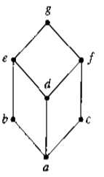

* 1. Compute LUB({*b,c*}).
  2. Compute GLB({*f, b*}).
  3. Is the poset a lattice? Explain your answer.

1. [10 points] *Prove that if (G,*) and (G’,*’) are Abelian groups, then (G × G’,*’’) is an Abelian Group.*
2. [14 points] Let m=3, n=6, H=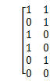 be a parity check matrix
3. Determine the (3, 6) group code *eH*: *B*3→*B*6.
4. Find the minimal distance of *eH.*
5. How many errors will *eH* detect ?
6. Decode the following words relative to a maximum likelihood decoding function associated with *eH*.

(1) 101011 (2) 111011 (3) 000111

1. [6 points] Determine whether the given graphs have an Euler circuit or a Hamilton circuit. If not, determine whether the given graphs have an Euler path or a Hamilton path. And determine whether the given graphs are planar.

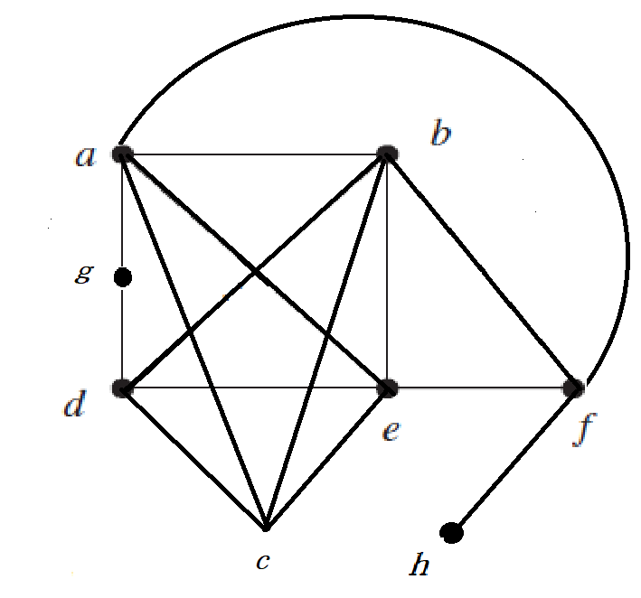

1. [10 points] Finding the shortest path length between any two vertices using distance matrix.

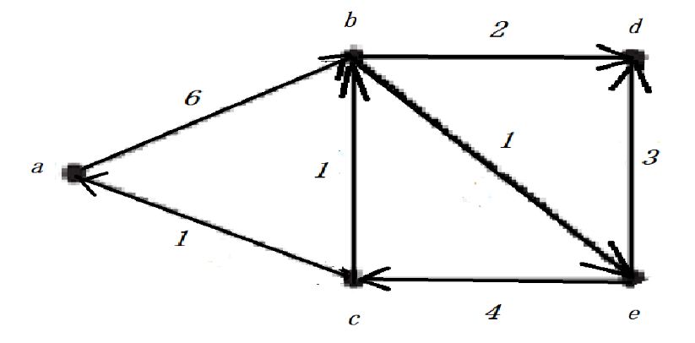

1. [10 points] Use Kruskal’s algorithm to design a minimum-cost communications network connecting all the computers represented by the graph in next Figure.

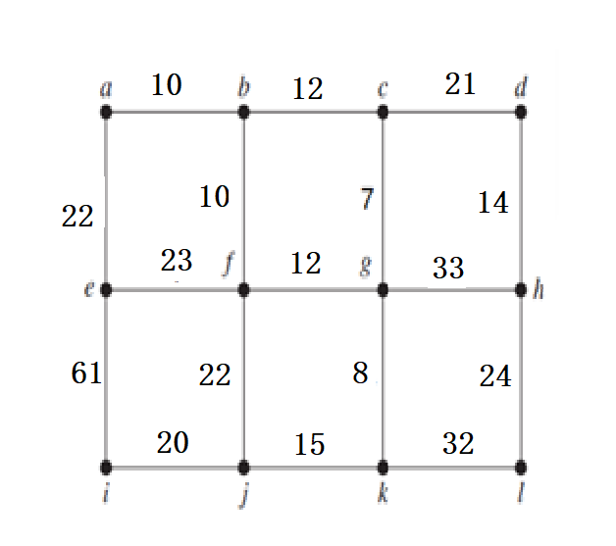

1. [10 points] Find a maximum flow in the given network by using the labeling algorithm. And find a minimum cut of this network. (Please give out the labeling graph of every flow.)

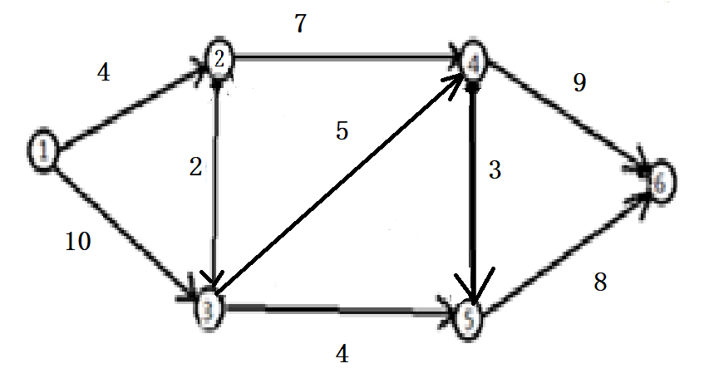

1. [10 points] Find the solution to the recurrence relations

*an*  5*an*  1  4*an*  2, *a*0  1, *a*1  9.

1. [10 points] Set up a generating function and use it to find the number of ways in which eleven identical coins can be put in three distinct envelopes (labeled A, B, C) if envelope A has at least three coins in it.