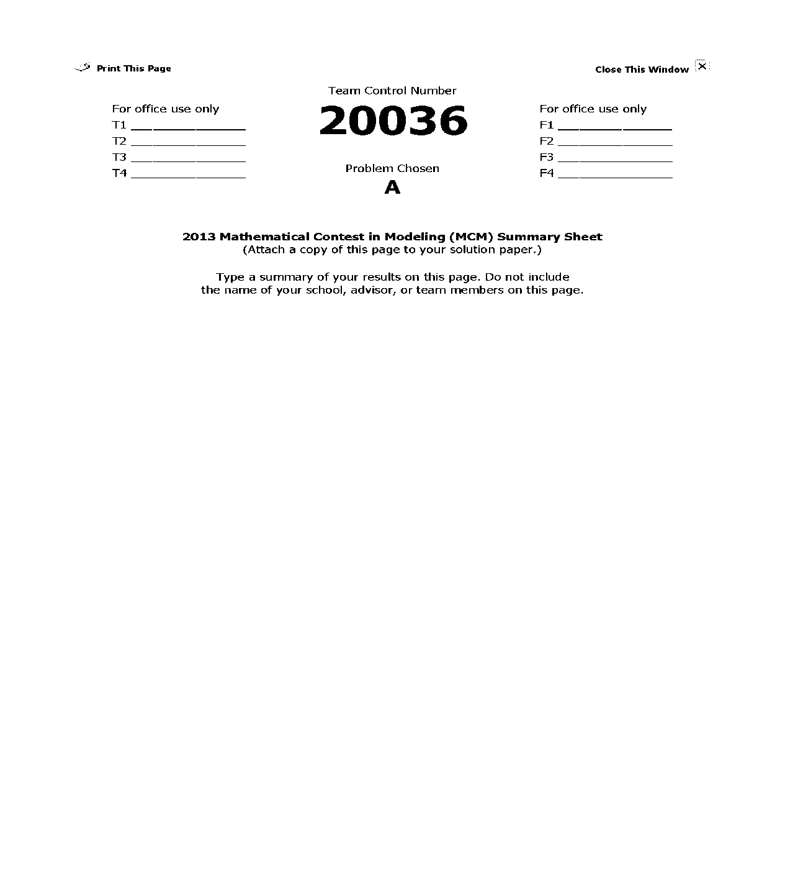

**The Ultimate Brownie Pan**

**Summary**

This paper mainly studies the heat distribution for different shapes of pans, the space utilization rate and the heat uniformity of different pans. Firstly, we establish a boundary heat distribution model with Dirichlet boundary conditions and Neumann boundary conditions. Based on this, we establish a heat conduction model, which can describe the internal temperature of the pan at each moment. For numerical simulation, five-point difference scheme is adopted in space discretization and the third-order TVD-Runge-Kutta method is adopted in time discretization for heat conduction equation. Next, we use the immersed boundary method to deal with the boundary domain of arbitrary shape. Finally, we use numerical simulation to get the temperature changes of the polygon, ellipse and rounded corners rectangle, and we find that the temperature changes fast on the corners of the rectangle while changes pretty uniformly on circular region. Thus we introduce the non-uniformity index to measure the degree of unevenness of different shapes of pans.

As for the space utilization rate, we establish a model to reflect the maximum number of pans which can put inside the oven. Firstly, we calculate the size of each shape and determine the layout. Secondly, we determine the maximum number and the space utilization rate of each layout.

In order to determine the optimal shape, we define the non-uniformity to measure the degree of the unevenness of different shapes. And we determine the optimal shape.

Considering the space utilization rate and the heat uniformity comprehensively, we firstly establish the bi-objective model. Then we give weights to the two factors and turn the model to a single objective function, which is defined as the comprehensive index. Based on this, we evaluate the layout of different shapes and get the local optimal solution. Then we use the control variables method to discuss the layout when  and changes. Finally, we change the parameters of pans to find the new optimal solution.

Keywords: TVD-Runge-Kutta method, immersed boundary method, heat uniformity

Contents

Contents 2

1Introduction 3

2 Basic assumptions and Symbols 3

3 model 4

3.1 question 1 Determining heat distribution when the pan into different shapes. 4

3.1.1 the analysis of question 1 4

3.1.2 the solution to the question 1 4

3.1.3 the result of the question 1 7

3.2 question 2 Determining the maximum number of pans 16

3.2.1 The assumption of the problem 2 16

3.2.2the analysis of question 2 16

3.2.3 the solution to the question 2 16

3.2.3 the result of question 2 24

3.3 question 3 Determining the shape of the pan to make it heat most evenly. 25

3.3.1 the analysis of question 3 25

3.3.2 the result of question 3 25

3.4 question 4 Determining the shape and placement of the ultimate pan 25

3.4.1 the analysis of question 4 25

3.4.2 the solution to the question 4 27

4 Advertising sheet for the new Brownie Gourmet Magazine 30

5 strengths and weaknesses 30

6 Future work 31

References 31

1Introduction

Oven has been widely used in our daily life. When we use the oven to heat the food, if the pan is a rectangle, the food at the four corners could be overheated easier, while the round pan is heated uniformly. However, since ovens are usually rectangle, using the round pan would not have a high efficient. Thus, it will have an important meaning to measure the heat distribution of different shapes of the pans when heating food and to improve the oven space utilization.

So our goal is pretty clear:

* Determine the heat distribution when using the different shapes of pans. (Including round, rectangle and other shapes)
* Determine the maximum number of pans placed when the width-length ratio oven is constant.
* Find out the most suitable shape which can be heated uniformly.
* Consider the space utilization and heat uniformly to determinate the shape of pan and placement plan.

Our approach is:

* Determine the ways of heat transfer of the various parts of cakes in the pan.
* Analyze the heat transfer between the outer and inner parts of the cake.
* Analyze the heat transfer at edge of cake.
* Determine the temperature distribution of the cake and define uneven heating indicators, quantitative measure its unevenness.
* Use polygon to fill a rectangle as much as possible. To determine the space utilization of the different shapes of the pan.
* When W/L and weight change, determine the most efficient shape by linear weighted composite measure space utilization and heat uniformity of the composite indicator.

2 Basic assumptions and Symbols

For the above problems, this paper uses the following assumptions:

* Required heating of the upper and lower surfaces of the cake is the same.
* When the oven is working, the inside temperature is 
* When putting the pans into the oven, the inside temperature has reached.
* Before putting the cake into the oven, the heat distribution is uniform.
* The main component of the pan is aluminum. Due to its large heat transfer coefficient, the temperature of aluminum pan can be considered that it can be raised to  soon and the pan keeps the temperature.
* Before putting the cake into the oven, its temperature is the same with room temperature 20.

**Symbols**

:  Width-length ratio of rectangle oven.

: The area of each pan.

: The maximum number pan can be placed in the oven.

: Pans the maximum heat is evenly distributed.

3 model

3.1 question 1 Determining heat distribution when the pan into different shapes.

3.1.1 The analysis of question 1

Question one requires us to determine the temperature distribution of different shapes of the pans. Because we only care about whether the cake bakes evenly, we choose the cake as the research object. Therefore, to solve the question one, we will solve the following issues:

* Analysis cakes uneven heating.
* Derivation of the heat conduction equation.
* Define the index of the degree of non-uniformity.

3.1.2 The solution to the question 1

**Step1: analysis cakes uneven heating**

For the outer layer of the cake, it receives heat: radiant heat emitted by the oven heating element; pan underlying the thermal conductivity of the upper layer cake; pan thermal conductivity of the edge of the cake edge. For the inner layer of the cake, it receives heat: radiant heat emitted by the oven heating element; pan underlying the thermal conductivity of the upper layer cake; the cake the thermal conductivity of the outer layer of the cake inner layer. By assumption, the oven heat distribution, so we can think that the radiant heat emitted by the heating element of the oven, and pan underlying the thermal conductivity of the upper layer cake is constant, does not affect the uniformity of the heat. Uneven heating is mainly caused by thermal conductivity of the pan edge, so we can be simplified to only consider temperature distribution of cake-section paralleling to the bottom of the pan.

**Step2 derivation of the heat conduction equation**

Because the amount of radiation emitted by the infrared tube oven within a unit time per unit volume is uniform, while the bottom of the pan on cake bottom of heat transfer is also uniform. So we only need to consider the heat transfer of the cake the outer layer to the inner layer of the cake. We analyzed a cross-section of the cake; the problem is transformed into a two-dimensional heat conduction problem. Using the function u (x, y, and t) represent the cake within the specific coordinates of a point (x, y) and the temperature of the time t. Based on the Fourier heat transfer experimental laws, we have

 （1）

k (x, y) is the coefficient of thermal conductivity of the cake at the point (x, y); it should be a positive value. The negative sign in the formula (1) appears because the heat always flows from a high temperature side to the side of the ground.

Take any one closed curve of the cake ; it is surrounded by the area referred to as. From the time  to , all the heat flows into the closed domain is

 （2）

As (2) equals to (3), and use Green's formula,

, (3)

Where c is the specific heat capacity of the cake,  is the density of the cake.

Let ，then

. （4）

The initial conditions of the heat conduction equation is

.

The boundary conditions is

,  is the cake boundary curve.

**Cake heat conduction model.**

**Model One (The Dirichlet boundary conditions)**

Cake outside temperature is a constant temperature, the surrounding environment is a stable temperature field, the cake no internal heat source. The corresponding initial boundary value problem of the heat conduction equation is

 (5)

Where  may take for constant.

**Model two (Neumann boundary conditions)**

Since the coefficient of thermal conductivity of the cake itself is very small [1], which indicates the heat absorbed by the cake is very slow. Thus, the outer layer of the temperature of the cake cannot be increased in a short time, and to reach equilibrium.

To make the model closer to the actual situation, we may improve the boundary conditions. We consider the heat because the temperature inside the oven is a constant flow rate of each point of the surface of the cake, and therefore the normal derivative of the cake of temperature  on the surface is decreasing, and ultimately its value will tend to zero. Therefore, the model corresponding initial boundary value problem of the heat conduction equation:



**Step 3 Define measure cake heat index of the degree of non-uniformity.**

Taking into account the variance has a measure of deviation from the nature of the expectations, We used the mean square deviation () to measure the heat unevenness of the cake pan of different shapes, Namely,

, (6)

where  and  is the point in time at the actual value and average value of the cake temperature.

The inhomogeneity  is greater, the cake temperature distribution is more uneven.

3.1.3 the result of the question 1

To get the result of the question 1, we divided the process into 4 steps.

**Step1: discrete**

In space, we use a five-point format method to discrete space [2]. Point of the second order central difference quotient space processing



,

where  represent an approximation of .

Let

, (7)

where

 represent an approximation of .

**Step2: Time discretization**

We use the third-order TVD-Runge-Kutta method to discretize time[3].

Denote



where  denotes the approximation of .

Thus the discrete scheme is

 (8)

Remark1: the system becomes stiff differential equations after space discretization. Thus the time discretization usually uses implicit scheme. If using the explicit scheme, the time steps will be less. This paper uses explicit scheme with a small step, which has a high accuracy. The numerical simulation proves that this method is feasible.

**Step 3: The processing of the boundary conditions**

We take the rectangular area and circular area for example and explain the process in details.

1. **The rectangular area**

Dissect the rectangular area and the schematic diagram is shown Figure 1.

Figure 1 the schematic diagram for the rectangular

The corresponding boundary conditions are

.

1. **The** **circular area----polar coordinate transformation**

Firstly, we use the method of polar coordinate transformation, then the heat conduction equation turn into

. (9)

Then split the circular area into N parts equally. The schematic diagram is shown Figure2.

Figure 2 the schematic diagram for the circle

Denote



The corresponding discrete scheme is



The boundary conditions of the original equation is

.

1. **The other arbitrary boundary area**

* **Immersed boundary method**

The basic idea: Firstly, we use the Lagrange grids to split the border area, and then use the Euler grids to cover the Lagrange grid. Secondly, we introduce a function as basis function . Then use the temperature of each node of the Eulerian grid to interpolate the each node of the Lagrange grid. The curve integral of the function  on the boundary curve  is used as artificial heat source. Finally, add the artificial heat sources to the discrete format of the heat conduction equation.

**The advantage of this method** is that it can handle a boundary region of arbitrary shape. The steps are shown as follows.

* **Step 1**: **use the Euler grid to cover the Lagrange grid.**

The specific schematic diagram is shown in Figure 3.

EULAR1 Figure3 The thick red line is the boundary with solid circle symbol representing the boundary point[4].

* **Step 2: interpolation**

Introduce the function （ are the indexes of the Eulerian mesh point in -and -directions, respectively ）[5].

 (10)

With



where  denotes the abscissa of the point on Eulerian grid while is the vertical coordinate. denotes the coordinate of the -th point on Lagrange grids.  denotes the space step. Then we use the temperature of each node of the Eulerian grid to interpolate the each node of the Lagrange grid. Thus we have

,

where  denotes the temperature of the point in space at the time , and  denotes the interpolation of the -th point on Lagrange grid.

Denote

,

where  denotes the temperature of the -th point of the boundary on Lagrange rid .Use the curve integral of the function  on the boundary curve  as artificial heat source, which can be shown after discretization**.**

,

where  denotes the number of boundary triangulation, anddenotes the -th arc length.

* **Step 3: Correction equation**

    We add the artificial heat source obtained from the second step to the discrete format of the heat conduction. Then we get corrected format

 (11)

The flow diagram of the process of solving the problem is shown in Figure 4.

K=k+1

Y

N





Immersed boundary

method

Calculate 

Figure 4 The flow diagram of the process of solving the problem

The heat conduction equation can be solved in accordance with the above steps. We can get the heat distribution of the cake by computer simulation. The result is shown in Figure.

* Square (Figure 5)

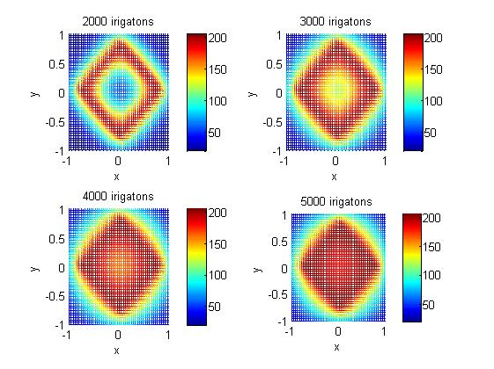

Figure 5

* Regular Pentagon(Figure 6)

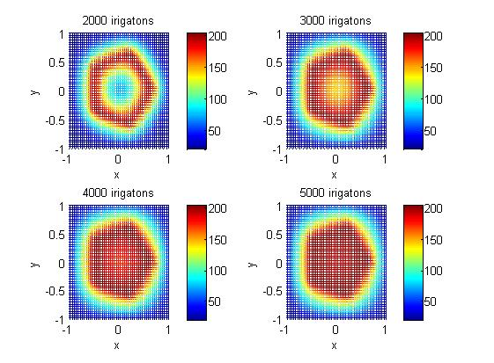

Figure 6

* Regular hexagon (Figure 7)

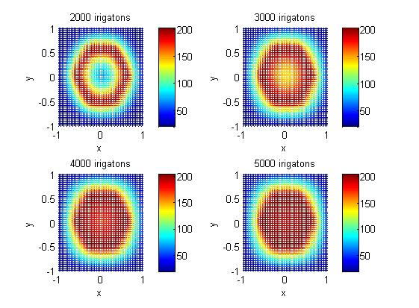

Figure 7

* Regular octagon (Figure 8)

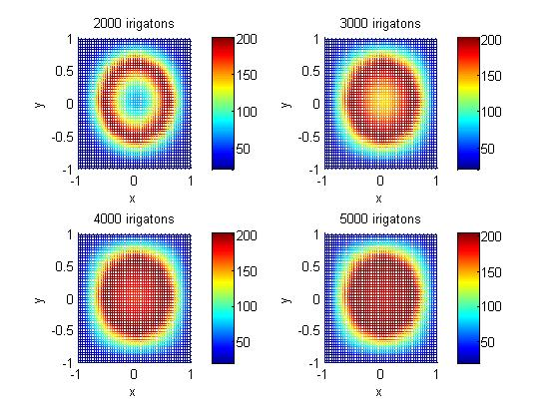

Figure 8

* Round(Figure 9)

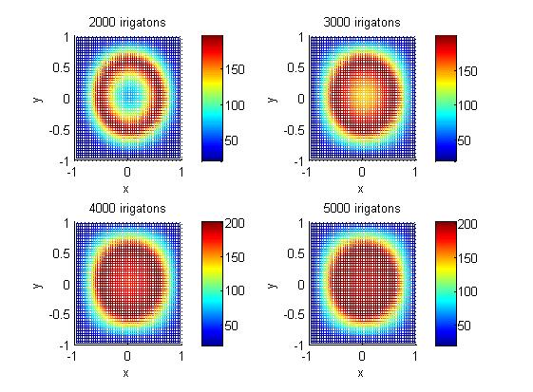

Figure 9

To test the model of question 1 is right. We draw figure of the distribution of heat across the outer edge of a pan for pans of different shapes (rectangular to circular).

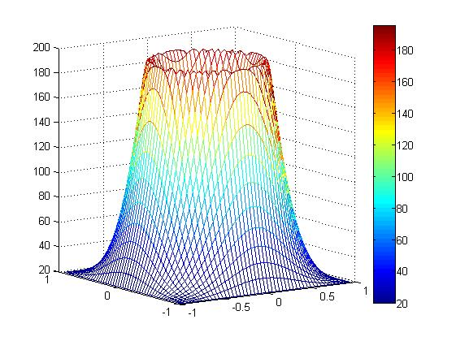

Figure 10 the distribution of heat across the outer edge of a pan for pans of circular

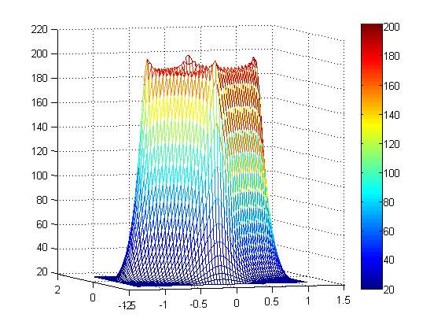

Figure 11 The distribution of heat across the outer edge of a pan for pans of rectangular

From the Figure10 and Figure11, we can know the 4 corners temperature of rectangular is very high. This is the reason why the product gets overcooked at the corners.

3.2 question 2 Determining the maximum number of pans

3.2.1 The assumption of the problem 2

* Placed on each grill pan cannot overlap.
* Each baking, the number of the dish is as large as possible

3.2.2the analysis of question 2

Our goal is to determine the aspect ratio under certain circumstances; an oven can be placed within the maximum number of pan. The question is broken down into the following three parts to solve:

* Selected pan of different shapes arbitrarily, to get its side length.
* Using computer simulation to determine the pan number into the oven arrangement.
* Calculate the optimal arrangement of the number of the dish

3.2.3 the solution to the question 2

According to the assumption, the width-length ratio of the oven and the area of the pan can be determinate. Thus, we can mark the width by W, length by L and the area of the pan by A.

Step 1 Determining the radius and the plan of the round to cover the oven.

Because we have the area of the plan is A.

So

.

where

: The radius of pan.

When we cover the area by round, we are sure to get well-distributed. The schematic diagram is shown in Figure 12.

yuan.emf

Figure 12 The schematic diagram

In this condition

The number of pans we can put in vertical is

.

The number of pans we can put in lateral is:

.

Due to the oven have two racks.

So

.

where

: The maximum number of round.

Step 2 Determining the regular n-side length and the plan of the round to cover the oven.

* A rectangle with the width-length ratio W/L

Because the area of the pan is A.

So

.

.

Where

: The width of the rectangular pan.

: The length of the rectangular pan.

To simplify the model, we consider two cases where cover the rectangle plan by lateral and by vertical.

1. Cover the oven by lateral

The number of rectangle pans we can put in vertical is

.

The number of rectangle pans we can put in lateral is

.

Due to the oven has two layers of the grill, so we can put rectangular pans in it at most by

.

2. Cover the oven by vertical

The number of rectangular pans we can put in vertical is

.

The number of rectangle pans we can put in lateral is

.

Due to the oven have two layers of the grill, so we can put rectangle pans in it at most by

 .

When considering placing the rectangular pans by lateral or vertical, there is sure to be some remain place. In order to improve the utilization ratio, we can make some adjustment.

* A regular pentagon(Figure 13)

wu.emf

Figure 13

Suppose the side length of regular pentagon is a. Divide the regular pentagon into 5 triangles. denotes the angle that the arrow shows. We have  here.

Thus we can get the side length of regular pentagon from



So



When place the pentagon like the Figure 14 shows, we have the maximum utilization.

5pai.emf

Figure 14 Place the pentagon

Consider that we use the regular pentagon to fill rectangle, and upper and lower sides of the two rows of the regular pentagon spell graphics inverted mutually parallel. So we use it as a place unit. The feature of this kind of unit are:

1. The height of the unit is h

.

1. The laying unit placed in two rows of the upper and lower number of regular pentagon may be different, a difference of 1；may be the same，The details of the specific circumstances will be introduced in the following model.
2. The laying number of the number of rows are placed depends on .  can be figured out by

.

Denote





When 

The maximum number of rows placed pans inside the oven is.

When 

The maximum number of rows placed pans inside the oven is .

When 

The maximum number of pans placed in one row is ，and another is.

When 

The maximum number of pans placed inside in each row is .

Thus

The maximum number of pans placed inside the oven could .

* **Regular hexagon**

Suppose the length of side for regular hexagon is. In order to calculate, we divide the regular hexagon into 6 equilateral triangles equally.  denotes the angle which the arrow aims at. Here .(shown in Figure 15 )Thus the length of side for regular hexagon  can be calculated by the equation shown as

.

Thus



Because regular hexagons can be put together without gap, we can get infinite hexagonal grid. Since the length and the width of the oven are known, we denote the coordinate values of the four vertexes are. What’s more, . So we can search in infinite hexagonal grid so as to find the appropriate rectangular which contains the regular hexagons as many as possible.

liu.emf

Figure 15

* **Regular octagon**

Suppose the length of side for regular octagon is. In order to calculate, we divide the regular octagon into 8 triangles equally.  denotes the angle which the arrow aims at. Here.(shown in Figure 16 ) Thus the length of side for regular octagon  can be calculated by the equation shown as

.

Thus



Because of the particularity of the regular octagon, its occupied space is equal to that of the square whose length of side is, which is shown below.

babian.emf

Figure 16

The maximum of the pans placed longitudinally in an oven is



The maximum of the pans placed laterally in an oven is



Since that there are two racks in the oven, evenly spaced, the maximum number of the pans placed in an oven is



With the number of edges increases, we can find that its space utilization rate is equal to that of the square, which is similar to the solution to solving the problem of regular octagonal pans. (shown in Figure 17)

正八边形.emf

Figure 17

* **Ellipse**

Suppose denotes the ratio of the elliptical long axis and short axis, namely 

According to, we can know that the long axis and short axis are

, .

In the process of placing the pans, the space utilization rate of the elliptical pans is equal to that of the rectangle and the length and the width of the rectangle are  and respectively. Therefore the placement is similar to the placement of the rectangular pans, whose space utilization rate is high. However, elliptical pans’ uniformity of the heat distribution is better than rectangular pans’. So we can adjust the ratio of the long axis and short axis to find a better one to balance the influence of the space utilization rate and heat uniformity.

tuoyuan.emf

Figure 18

* **Rectangles with rounded corners**

Suppose the central angle corresponded with the arcs is , and the width-length ratio of the rectangle is . Thus, we can denote the width is , while the length is . Therefore, the width and length can be calculated by the following equation.

.

Thus

.

So the width and the length which is defined as  are

, .

Because the space utilization rate of the rectangles with rounded corners is equal to that of the rectangles whose width is ,and the length is . So the placement scheme is similar to that of rectangles.

3.2.3 the result of question 2

According to the analysis of question 2, considering the different value of the ,we can get the maximum number of pan as for different shape. The result is shown in Table 1.

Table1 The maximum number of pan

|  |  |  |  |
| --- | --- | --- | --- |
| Ratio  Shape | 1.0/2.0 | 2.0/3.0 | 1 |
| Square | 32 | 28 | 25 |
| Regular hexagon | 21 | 24 | 25 |
| Regular octagon | 21 | 24 | 25 |
| Round | 21 | 24 | 25 |
| Ellipse (k=2) | 25 | 20 | 24 |
| Ellipse (l=4/3) | 24 | 21 | 20 |

In the Table 1, k, l is the ratio of the elliptical long axis and short axis.

3.3 question 3 Determining the shape of the pan to make it heat most evenly.

3.3.1 the analysis of question 3

When we solve the question 1, We have introduced the indexes to measure the heat evenly.

According to the values of the indexes, we can determine the shape of the pan.

3.3.2 the result of question 3

From the result of question 1, we can get the temperature of the pan. Put the value to the equal(5)

We can get the variance about the time variation curve



Figure 19

We can know that, round is the most uniform heat distribution.

3.4 question 4 Determining the shape and placement of the ultimate pan

3.4.1 the analysis of question 4

The question4 requires us to consider the influence of the space utilization rate and heat uniformity comprehensively. We define the space utilization rate and the heat uniformity firstly. The index to measure the space utilization rate is defined as , namely,

 (11)

The index to measure the heat uniformity is defined as .

We have defined the index to measure the non-uniformity of the heat distribution ahead, namely. In order to eliminate the influence of the dimension, we define the index  to replace the index to measure the non-uniformity of the heat distribution, which is shown below.



Where

 denotes the variance of the temperature in the moment of  .

 denotes the mean of the temperature in the moment of  .

Therefore we define a double objective function shown in below.

Max ()

Min ()

In order to consider the influence of the heat uniformity and the space utilization rate comprehensively, we turn the bi-objective model into single objective function. So we define the comprehensive index to measure the quality of the placement scheme. According to the importance of the space utilization rate and the heat uniformity, the weight of the space utilization rate is, while the weight of the heat uniformity is.Thus the comprehensive index is



Thus our objective function is

max().

As for the solutions put forward to filling the rectangular oven with polygon pans, we measure the qualities by using the comprehensive index respectively. Then we can find a better shape of the pans to filling the rectangular oven.

3.4.2 the solution to the question 4

According to the equation (11), we can get the space utilization rate of each shape of the pans. The results is shown in Table 2.

Table 2 The space utilization rate of each shape of the pans

|  |  |  |  |  |  |  |  |
| --- | --- | --- | --- | --- | --- | --- | --- |
| shapes  w/L | Rectangle | Oval(2/1) | Oval(1.25/1) | Oval(4/1) | Hexagon | Octagon | Round |
| 1/2 | 0.96 | 0.75 | 0.72 | 0.69 | 0.63 | 0.63 | 0.63 |
| 2/3 | 0.84 | 0.6 | 0.63 | 0.72 | 0.72 | 0.72 | 0.72 |
| 1/1 | 0.75 | 0.72 | 0.6 | 0.75 | 0.75 | 0.75 | 0.75 |

Due to the analysis, we should analyze the different situations under two conditions. The first one is the situation where the width-length ratio of the oven changes. And the other one is the situation where the weights of the heat uniformity and the space utilization rate change.

So we divide the shapes into three classes, the first one is polygon, and the second one is ellipse, and the last one is the rectangles with rounded corners.

1. **Polygon**

Based on the real life and the consideration of space utilization, we define the range of the width-length ratio is within. So we can get the following constraints.

The objective function is Max ().

Constraints are

 (1) Analyze the optimal polygon corresponded with the different  when

 is a constant.

According to the Table 3, we can determine the optimal polygon under the different conditions of  when =2/3. The result is shown in below.

When =0.8, 0.4, 0.2, the optimal polygon is square, regular octagon and regular octagon respectively.

(2) Analyze the optimal polygon corresponded with the different  when is a constant.

According to the Table 3, we can determine the optimal polygon under the different conditions of  when =0.8. The result is shown in below.

When=1/2, 2/3, 1/1, the optimal polygon is square, regular octagon and regular octagon respectively.

**2. Ellipse**

Due to the ratio of elliptical long axis and short axis is indefinite, ellipse has some advantages. Firstly, the space utilization rate of ellipse is close to that of rectangle, which has a high space utilization rate. Secondly, we can also adjust the ratio of elliptical long axis and short axis to approach a circle, which has a high quality of heat uniformity. So we can adjust the ratio of elliptical long axis and short axis to find an optimal ratio to balance the two factors.

The objective function is Max ().

Constraints are



Where

 denotes the ratio of elliptical long axis and short axis.

1. Analyze the elliptical comprehensive index corresponded with the different  when and  are constants.

According to the Table 3, we can find that the comprehensive index of the ellipse is better with the increasing of the .

1. Analyze the optimal ratio of elliptical long axis and short axis corresponded with the different  when  is a constant.

According to the Table 3, we can determine the optimal  under the different conditions of  when =1/2. The result is shown in below.

When=0.8, 0.4, 0.2, the optimal  is 2/1, 4, 4 respectively.

1. Analyze the optimal ratio of elliptical long axis and short axis corresponded with the different  when is a constant.

According to the Table 3, we can determine the optimal  under the different conditions of  when =0.8. The result is shown in below.

When=1/2, 2/3, 1/1, the optimal  is 2/1, 4, 4 respectively.

Table 3 The comprehensive index of different shapes

=0.8

|  |  |  |  |  |  |  |  |
| --- | --- | --- | --- | --- | --- | --- | --- |
| shapes | Oval(2/1) | Oval(3/2) | Oval(4/1) | Square | Hexagon | Round | Octagon |
| p |  |  |  |  |  |  |  |
| 1/2 | 0.24239771 | 0.1944338 | 0.1253754 | 0.6 | -0.164511 | 0 | -0.048894 |
| 2/3 | -0.0485114 | 0.0762519 | 0.37992 | 0.6 | 0.2354886 | 0.4 | 0.3566062 |
| 1/1 | 0.59148861 | -0.023748 | 0.61992 | 0.6 | 0.6354886 | 0.0.8 | 0.7566062 |

=0.4

|  |  |  |  |  |  |  |  |
| --- | --- | --- | --- | --- | --- | --- | --- |
| shapes | Oval(2/1) | Oval(3/2) | Oval(4/1) | Square | Hexagon | Round | Octagon |
| p |  |  |  |  |  |  |  |
| 1/2 | 0 | 0.037847 | 0.012487 | -0.2 | -0.49353 | 0 | -0.13018 |
| 2/3 | --0.14553 | -0.02124 | 0.13976 | -0.2 | -0.29353 | 0.2 | 0.069819 |
| 1/1 | 0.17446 | -0.07124 | 0.25976 | -0.2 | -0.09353 | 0.4 | 0.269819 |

=0.2

|  |  |  |  |  |  |  |  |
| --- | --- | --- | --- | --- | --- | --- | --- |
| shapes | Oval(2/1) | Oval(3/2) | Oval(4/1) | Square | Hexagon | Round | Octagon |
| p |  |  |  |  |  |  |  |
| 1/2 | -0.18194 | -0.07959 | -0.07218 | -0.8 | -0.7403 | 0 | -0.19527 |
| 2/3 | --0.2183 | -0.09437 | -0.04036 | -0.8 | -0.6903 | 0.05 | -0.14527 |
| 1/1 | 0.1383 | -0.10687 | -0.01036 | -0.8 | -0.6403 | 0.1 | -0.09527 |

**3. The** **rectangles with rounded corners**

Because the rectangle with rounded corners is similar to rectangle, its space utilization rate is high. Since the vertex is circular, the heat uniformity is good. So we can adjust the width-length ratio and the arc radius to find a better shape whose comprehensive index is best.

The objective function is Max ().

Constraints are



where

 denotes the width-length ratio.

 denotes the arc radius.

What we should do is to analyze the following problems.

(1) Analyze the optimal  corresponded with the different  when  and  are constants.

(2) Analyze the optimal  corresponded with the different  when  and  are constants.

Since the method is similar to that of the ellipse, we only show the feasibility of the shape.

4 Advertising sheet for the new Brownie Gourmet Magazine

Frustrated that your delicious brownies get overcooked or burnt on their edges? There are two ultimate brownie pans which help you bake the perfect brownies. With their unique shapes by design, the heat is distributed much more evenly over the entire outer edge when baking comparing with a conventional rectangular pan. Now we will introduce our pans in details.

Our designed pans include two kinds of shapes. One is ellipse, and the other is rectangle with rounded corners. Both of them have some common advantages, which is listed below.

* They all have a good quality of **heat uniformity** in order not to bake the brownies overcooked, which is good for health as well as mood. It is really bad when the brownies are burnt, isn’t it?
* They all have a high **space utilization rate** which can help save the energy and the space.
* The edges of them are all smooth. It is not only a matter of **beauty**, but also a matter of the **efficiency**. After all, the brownies can be heated quickly with these pans, which save time, too.
* Both of them can adjust the parameters of the shape to balance the influence of the space utilization rate and the heat uniformity. Thus we can produce a series of different specifications of the pans to adapt to the different requirements.

Do you want to bake the perfect brownies by yourself? If your answer is yes, don’t hesitate, try our designed pans!

5 strengths and weaknesses

**Strengths ：**

* In order to simplify the model, we make many reasonable assumptions.
* In the process of establishing the model, we pay attention to the main factors and ignore many secondary factors, which make our model simple but can also solve the problems effectively.
* Because the immersed boundary method can handle a boundary region of arbitrary shape, our model is more adaptable.
* We not only get the local optimal solution by evaluating the quality of different shapes of pans and the layout, but also get the new optimal solution by changing the parameters of the pans.
* We use the control variables method to discuss the layout when  and changes, thus we can get the optimal solutions under the different conditions.

Weaknesses

* In order to mainly illustrate the heat conduction process from the edge of the cake to the inner cake, we assume that the temperature of the edge is a constant, which belongs to the Dirichlet boundary conditions. However, it is not true in real life.
* Since the heat conduction is a three-dimensional process, we treat it as a two-dimensional model is not accurate. What’s more, the heat conduction from the bottom to the surface is uneven.

6 Future work

The heat conduction is actually a three-dimensional process. In the discussion ahead, we think that the radiant heat and the heat conduction from the bottom of the cake to the surface cake are uniformly, which have no influence in the heat uniformity. Thus we can only discuss the two-dimensional model. However, since the cake has a certain thickness, actual situation is that the heat conduction from the bottom of the cake to the surface of the cake is not a uniformly process. Thus the heat conduction under this situation is:

.

We can get a more accurate heat distribution of the cake by solving the equation.

References

[1] X.W. Zhao, C.W. Li. The thermal conductivity research progress of dough and its products. Cereal & Feed Industry, 2008(5),17:20.

[2] Ronghua Li, Guochen feng. Numerical Solutions for Differential Equation. 3rd edition, Beijing: Higher Education Press, 2002.

[3] Dinghua Feng, Hua Li, Guohao Ding etal. TVD - Runge - Kutta time format in the research on the application of WEN05 format. The 14th national shock and shock tube academic conference, 2010,467:469.

[4] X.D. Niu, C. Shu *, Y.T. Chew, Y. Peng. A momentum exchange-based immersed boundary-lattice Boltzmann method for simulating incompressible viscous flows, Physics Letters A,2008(3):173-182..

[5] C. Shu, Y.T. Chew, X.D. Niu, Least-squares-based lattice Boltzmann method: a meshless approach for simulation of flows with complex geometry, Physical Review E, 2001(4): 045701.