CSCI6444 Big Data and Analytics
Class project #1
R and Arxiv GR-QC Graph Analysis

Ran Wei
Feb 10, 2022

Part 1 Dataset Loading
In order to learn how to use RStudio for graph analysis, I used the dataset of Arxiv GR-QC (General Relativity and Quantum Cosmology) collaboration network. This dataset contains 5242 nodes and 14496 edges in total and covers papers in the period from January 1993 to April 2003 (124 months).

a. Loading Approach 1: Import
File → Import Dataset →From Text (base)
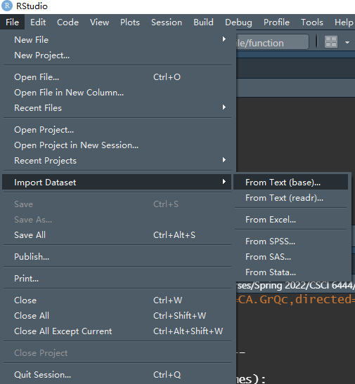

b. Loading Approach 2: read.table() function
CA.GrQc = read.table(file="CA-GrQc.txt", header = TRUE, comment.char="#")

Then I got a dataframe variable named ‘CA.GrQc’.

Part 2 Initial Graph Plotting
I installed the igraph package from CRAN mirrors using the install.package() function and loaded the package by library() function. Before continuing, I Ire required to convert the dataframe into an igraph format using graph_from_data_frame(). I named this object 'graph' and then used plot.igraph() to create the plot for the entire dataset as shown in Figure 1.
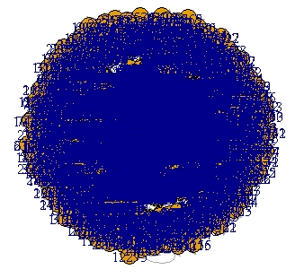
Figure 1. Raw Dataset

Due to the large amount of data, I can hardly observe the data structure, even though I set parameters like ‘vertex.label.cex’ and ‘vertex.size’, to view the graph more clearly (Figure 2).
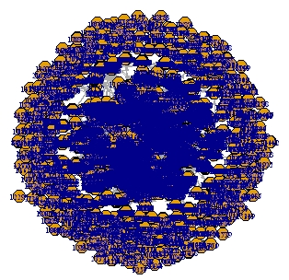
Figure 2. Raw Dataset (Clearer Version)

Part 3 Dataset Simplifying and Plotting
To solve the problem described above, I took the following steps towards graph simplification:

- Step 1. Choose the nodes with degree greater than or equal to 20 and plot the graph.

Code Implementation:
verticies_lt20 = V(graph)[igraph::degree(graph)<20]
graph1 = igraph::delete.vertices(graph,verticies_lt20) #remove nodes (degree <=20)
plot.igraph(graph1, edge.arrow.size=0.3, vertex.size=10, vertex.label.cex=0.5)

Plot Result as Figure 3:
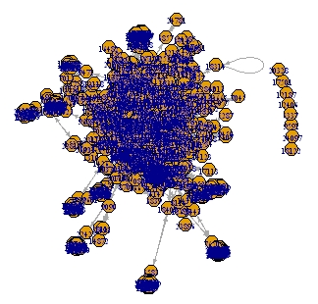
Figure 3. Simplify-Step 1

It is still hard to see the internal structure, so I continue to step 2.

- Step 2. Choose the first 200 edges and plot the graph.

Code Implementation:
graph1_df = as_data_frame(graph1, what="edges") #convert igraph object to dataframe
graph2_df = graph1_df[1:200,] #choose the first 200 edges
graph2 = graph_from_data_frame(graph2_df)
plot.igraph(graph2, edge.arrow.size=0.3, vertex.size=10, vertex.label.cex=0.5)

Plot Result as Figure 4:
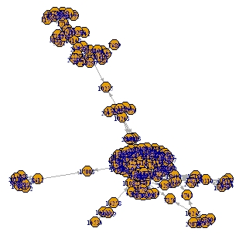
Figure 4. Simplify-Step 2

Now the structure is become clearer, but I can still simplify some more.

- Step 3. Choose the nodes with degree larger than 2 and plot the graph.

Code Implementation:
verticies_lt2 <- V(graph2)[igraph::degree(graph2)<2]
graph.sim = igraph::delete.vertices(graph2, verticies_lt2)
plot.igraph(graph.sim, edge.arrow.size=0.3, vertex.size=10, vertex.label.cex=0.5)

Plot Result as Figure 5:
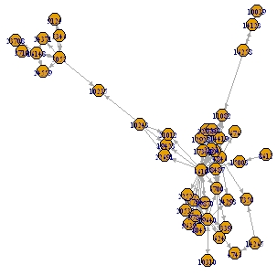
Figure 5. Simplify-Step 3
Finally, I arrive at a three-cluster igraph object for deeper analysis and plotting.

Using the graph from figure 5, I applied the functions from Introduction to Graph Analytics and received the following results:
- Vertices of the Graph
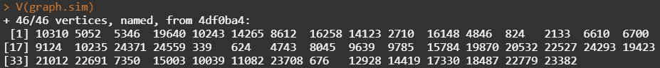

- Edges of the Graph
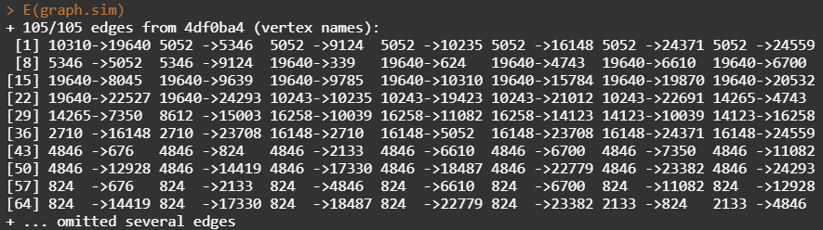

- Adjacency Matrix: Indicates which vertices are connected by edges
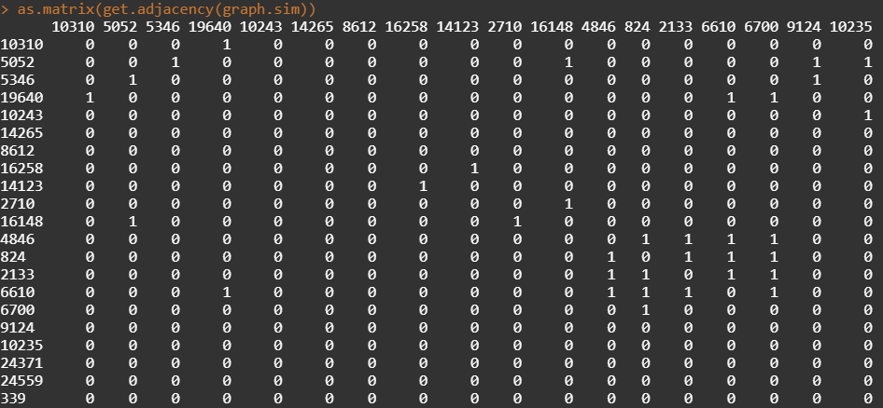
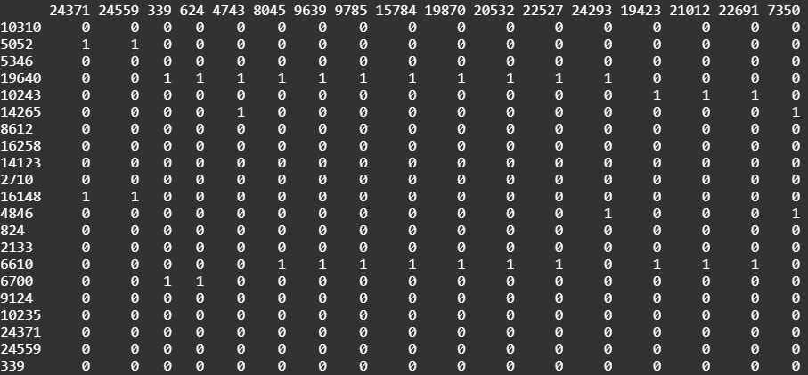
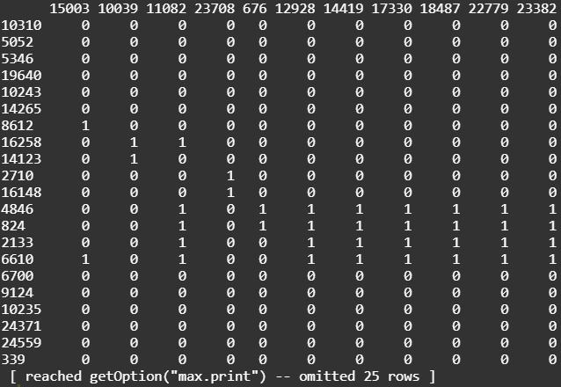

- Density: Gives us the ratio of edges in the graph vs the maximum number of possible edges in a graph. When loops = T this means that the maximum counts self-loops. Note: I use as.matrix() for compatibility with the sna functions.
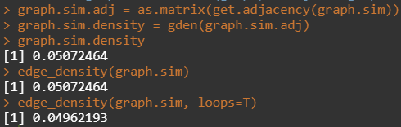

- Egocentric Network and Degrees: Creates a subgraph of a given node and its immediate neighbors. At the bottom there is the number of degrees per node, which is a measurement of the number of edges connected to it
​ 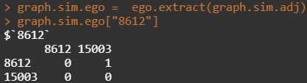
​ 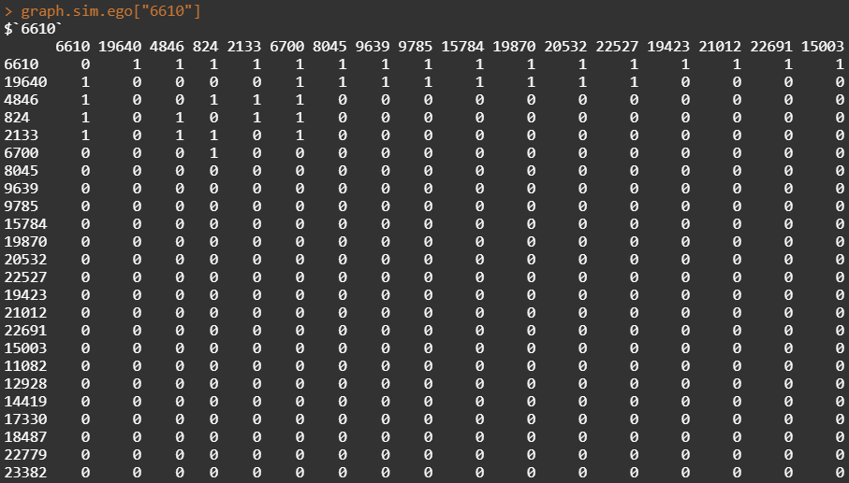
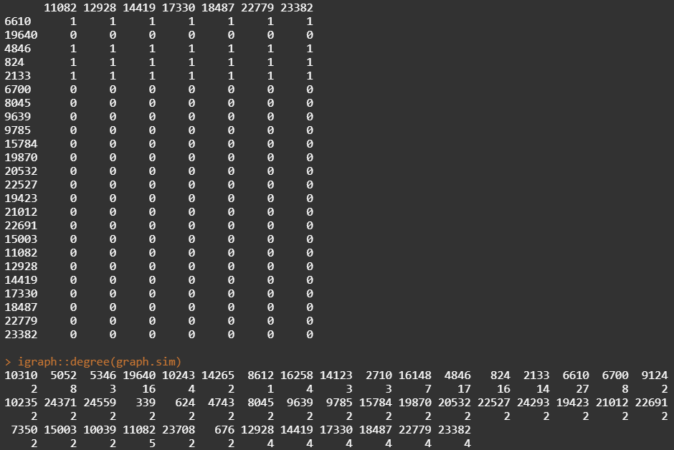

- Betweenness Centrality: The betweenness centrality is measured through the number of times a node is present in the shortest path. The centralization is the graph level centrality, and the theoretical max is the maximum possible centrality for a graph with these parameters
​ 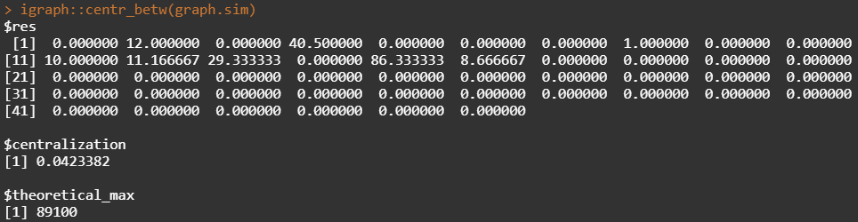
​
- Closeness Centrality: The closeness centrality is similar to betIenness but is calculated using the average shortest path.
​ 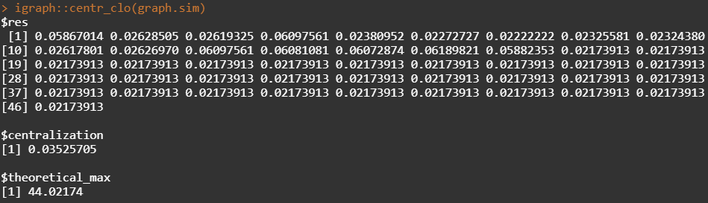

- Shortest Paths: The length of the shortest path between any 2 nodes in the graph. I also show all the shortest paths for node 6610.
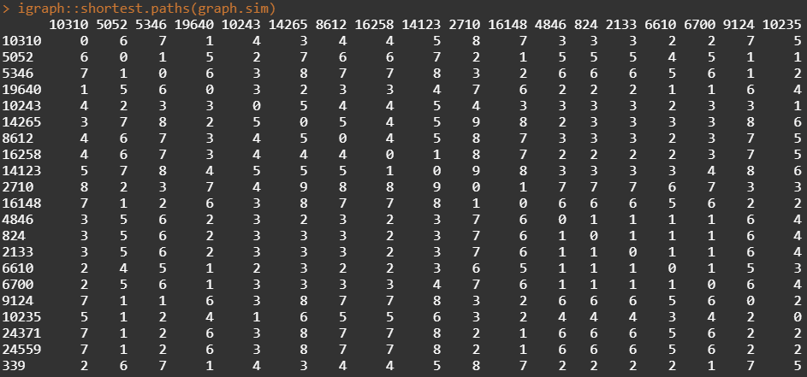
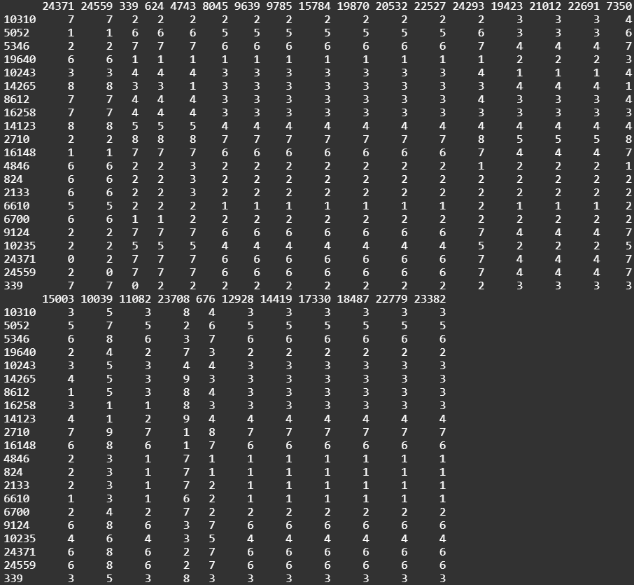
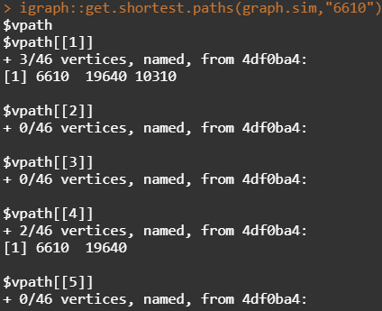​
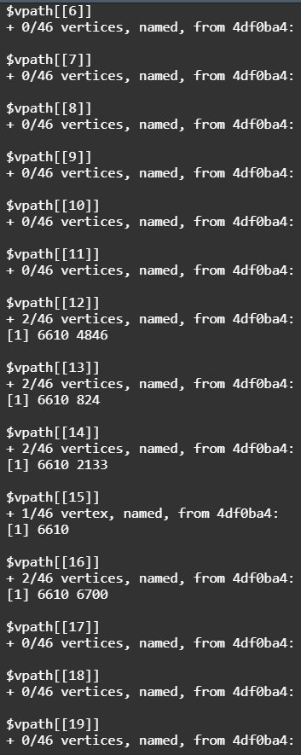
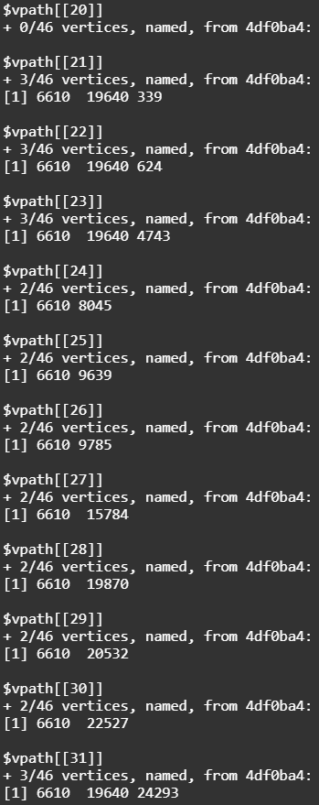
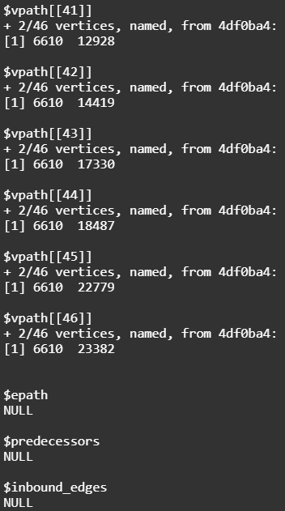
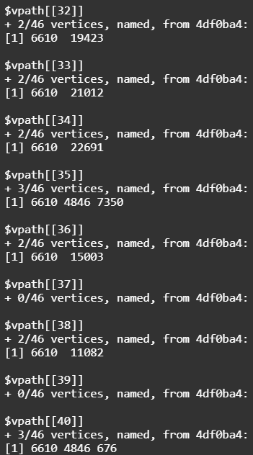

- Geodesic: The shortest path between any two nodes in the network
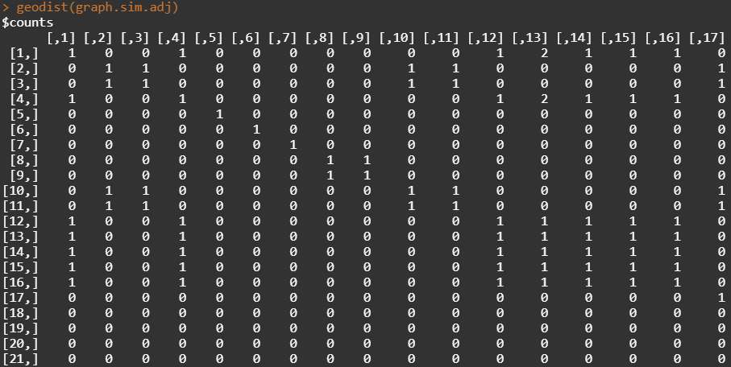​
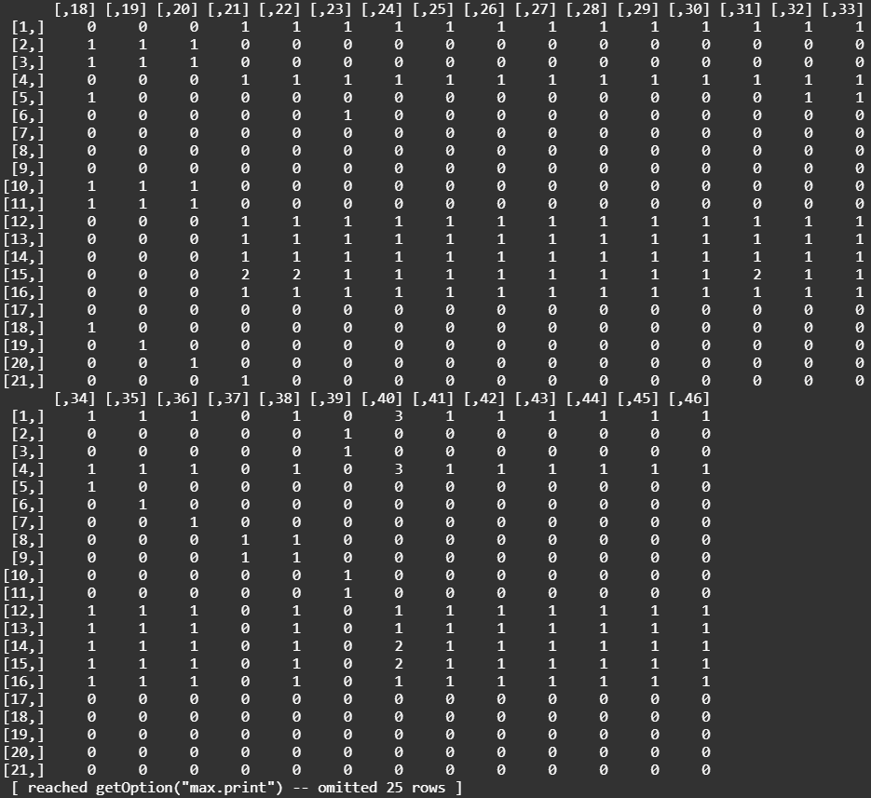
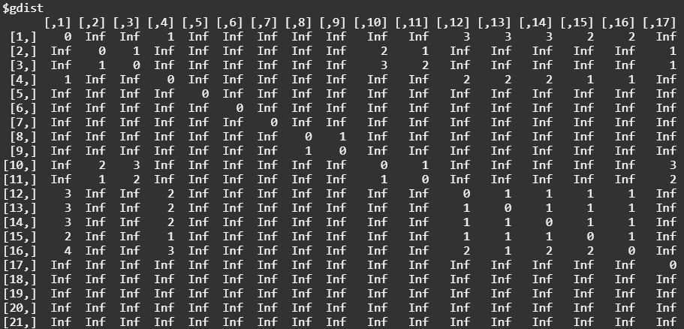
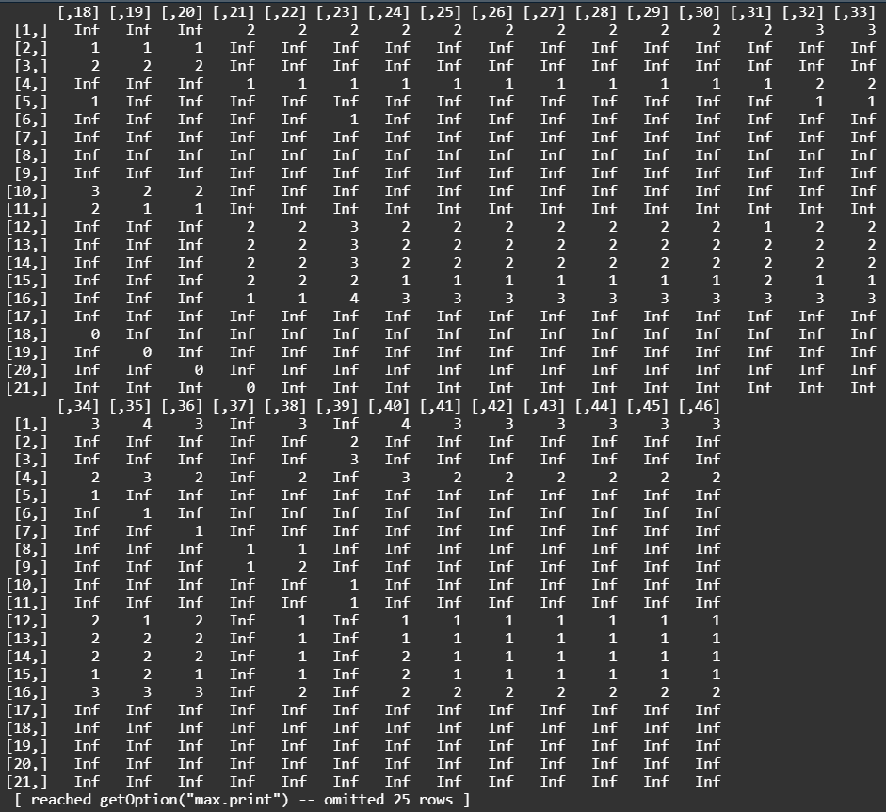

- Number of Paths Between Nodes: Gives the total number of possible paths betIen nodes
​ 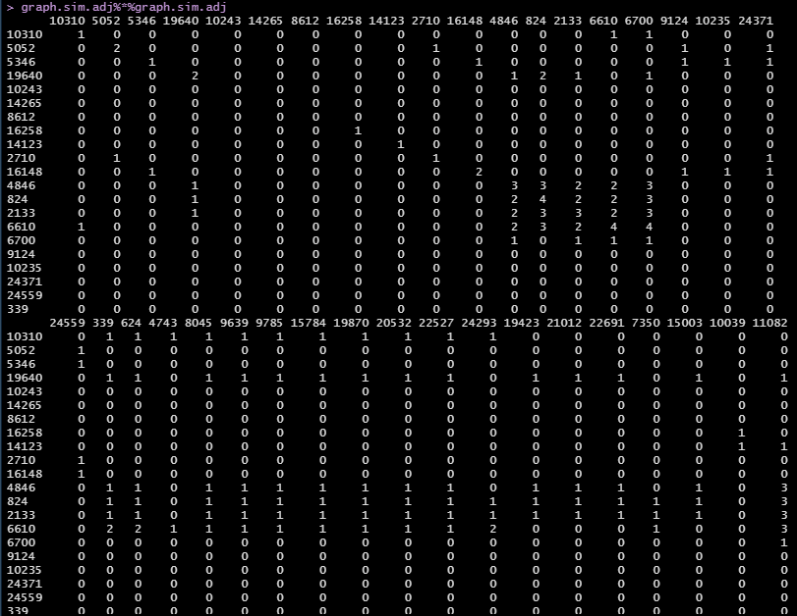 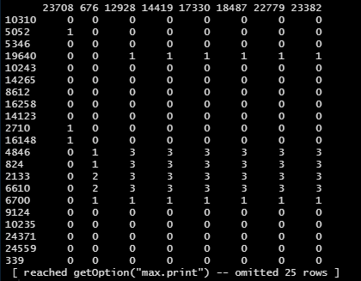

- Histogram: Shows the distribution of the number of degrees per node
​
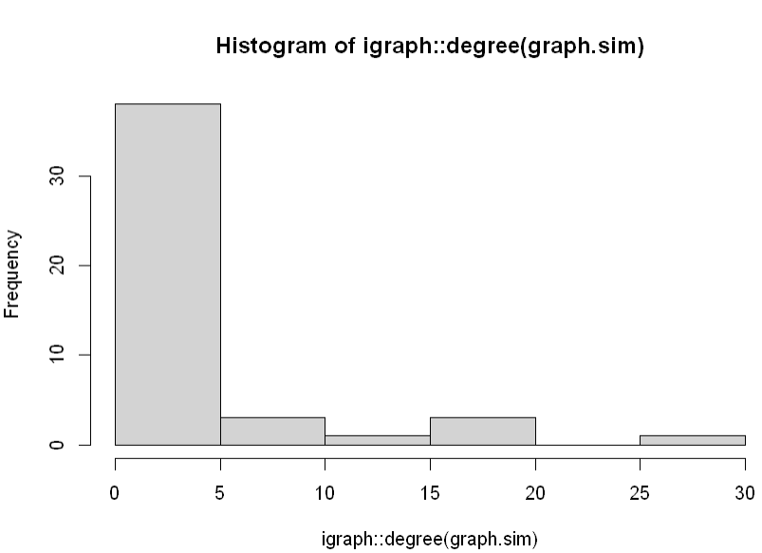
- Diameter: The greatest distance between any pair of vertices
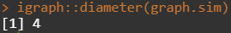​

- Max Cliques: Returns all the cliques for a given node in the graph
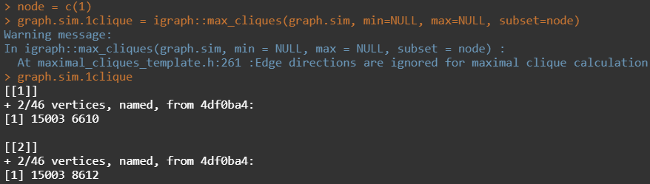​
- Largest Cliques: Returns the largest clique in the graph
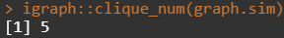

- Alpha Centrality: Another measurement of centrality which is calculated similarly to eigenvector centrality
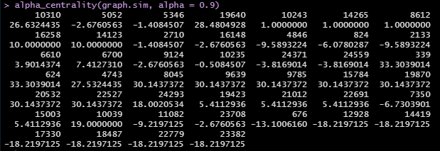

- Walktrap Communities: Automatically clusters nodes in order to determine a structure to the graph
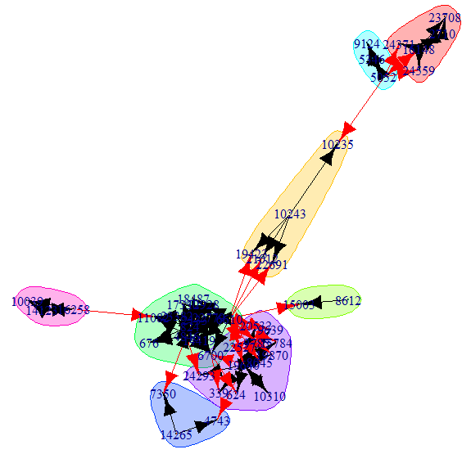

Part 4 Explore Functions
Igraph is a powerful package which contains over 700 functions for graph plotting. I chose to explore and exercise by 11 of them.

- Look at more available layouts in igraph
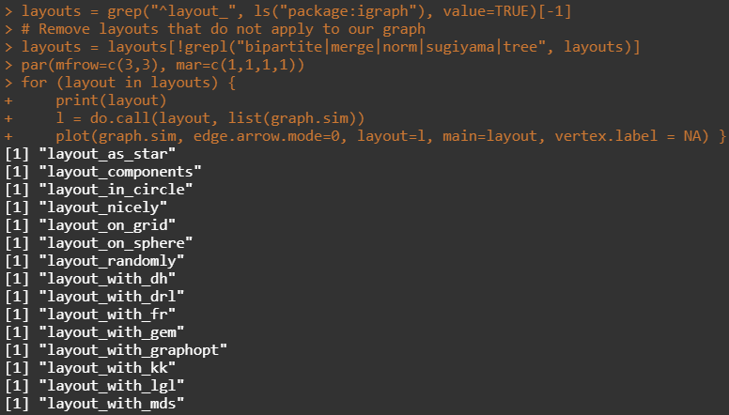
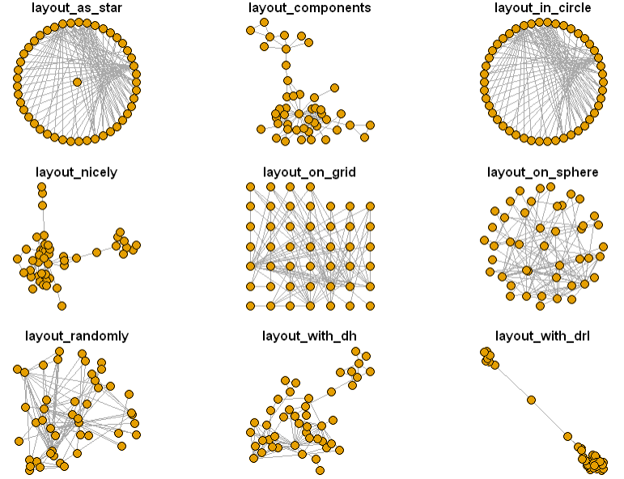
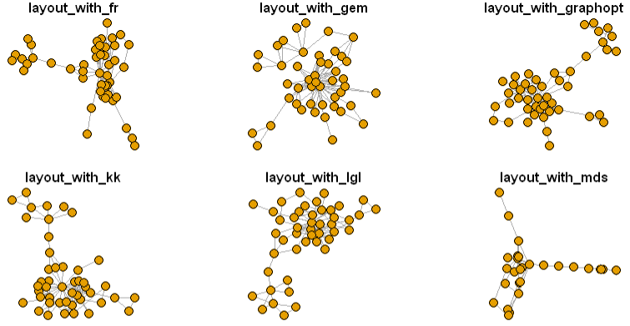

- Reset the graphical parameters
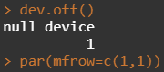

- Interact with the plotting of networks
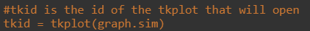
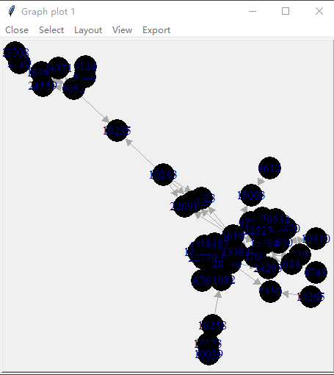
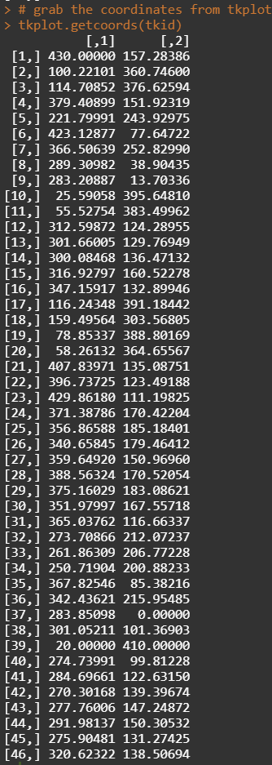
- Create a heatmap of the network matrix
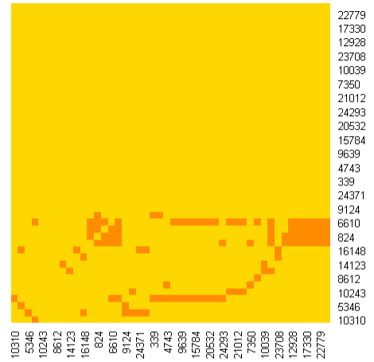

- Reciprocity: the proportion of reciprocated ties
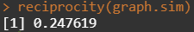

- Transitivity: which is calculated according to two different ways: global and local
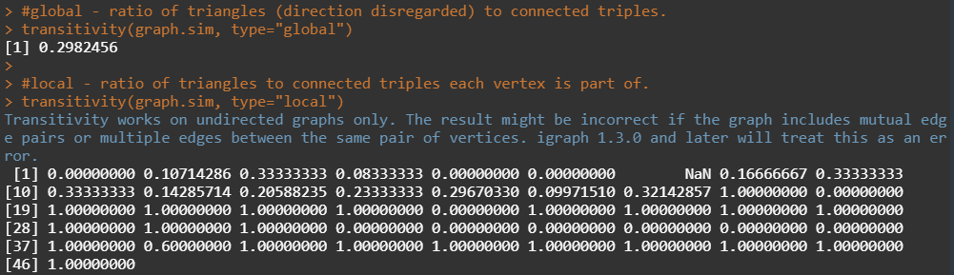

- get_diameter()
#In igraph, diameter() returns the distance, while get_diameter() returns the nodes along the first found path of that distance.
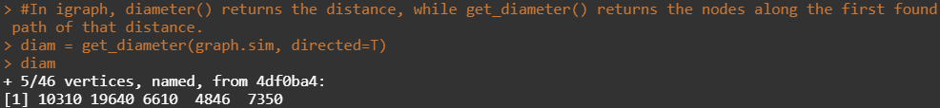

- Color nodes along the diameter:
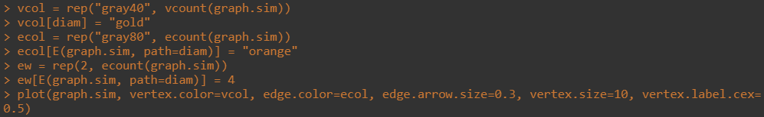
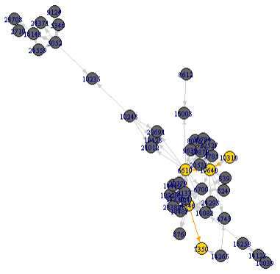

- Values of the first eigenvector of the graph matrix.
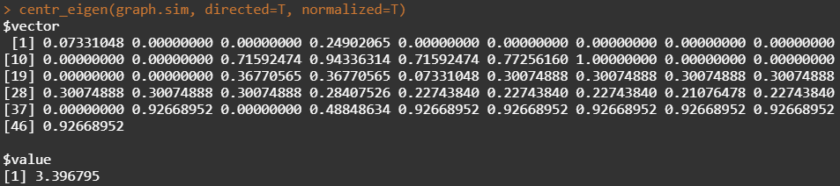

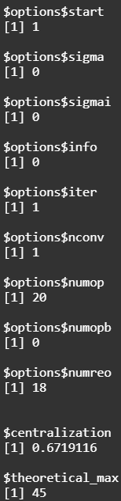
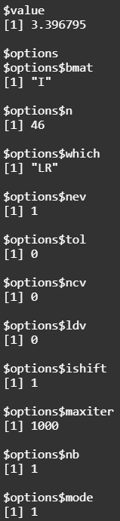

- Average path length
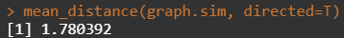

- Hubs Score (contain a large number of outgoing links) and
Authorities Score (contain many incoming links from hubs)
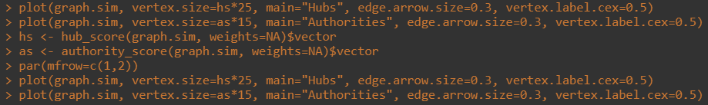
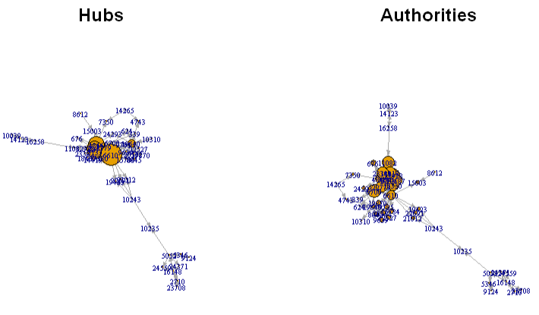

Part 5 Determine Several Technical Values
(a) central node(s)

Code Implementation:
d = igraph::degree(graph.sim)
d = as.data.frame(d)

The central node is the nodes with the high number of degrees in the graph. For this question, I took the degrees of each node and used the sorting tool within R to find the largest value. For our graph, the central node is 6610.
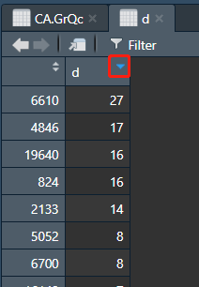
Figure 6. Dataframe of Degree

(b) longest path(s)

Code Implementation:
igraph::diameter(graph.sim)
diam = get_diameter(graph.sim, directed=T)
diam

I can get the length of the longest path simply by using the diameter function in igraph. I can also use get_diameter to get the nodes that follow this longest path. For this graph, I have a longest path of length 4 using the following sequence of nodes shown in Figure 7.
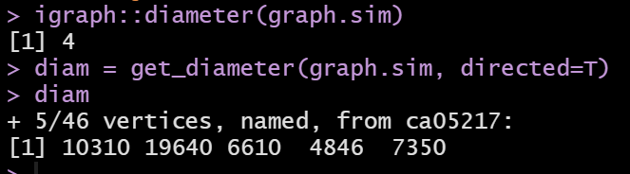
Figure 7: Longest Path Calculation

(c) largest clique(s)

Code Implementation:
vcol = rep("grey80", vcount(graph.sim))
vcol[unlist(largest_cliques(graph.sim))] = "gold"
plot(as.undirected(graph.sim), vertex.color=vcol, vertex.label.cex=0.5, vertex.size=15)

Plotting Result:
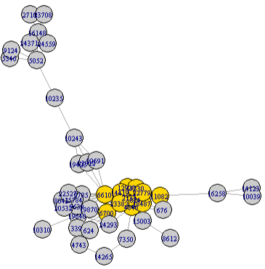
Figure 8: Largest Clique (Gold)

(d) ego(s)

I can find the biggest immediate neighborhood for all nodes by ego() function, here I only show the result for our central node: 6610.
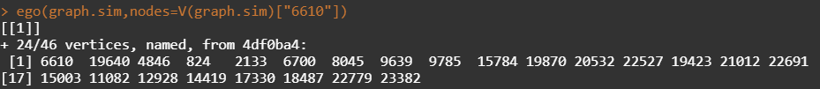
Figure 9: Ego for node 6610

(e) power centrality
power_centrality takes a graph (data) and returns the Boncich power centralities of positions (selected by nodes).
Code Implementation:
pc = power_centrality(graph.sim, exponent = 0.9)
pc_df = as.data.frame(pc)
pc_df <- cbind(node = rownames(pc_df), pc_df)
rownames(pc_df) <- 1:nrow(pc_df)
pc_df[which.max(pc_df$pc),]

Using power_centrality() from the igraph package, I Ire able to calculate the power centrality for each node in the graph, as Ill as the central node. Note: I must set exponent = 0.9 to avoid an error
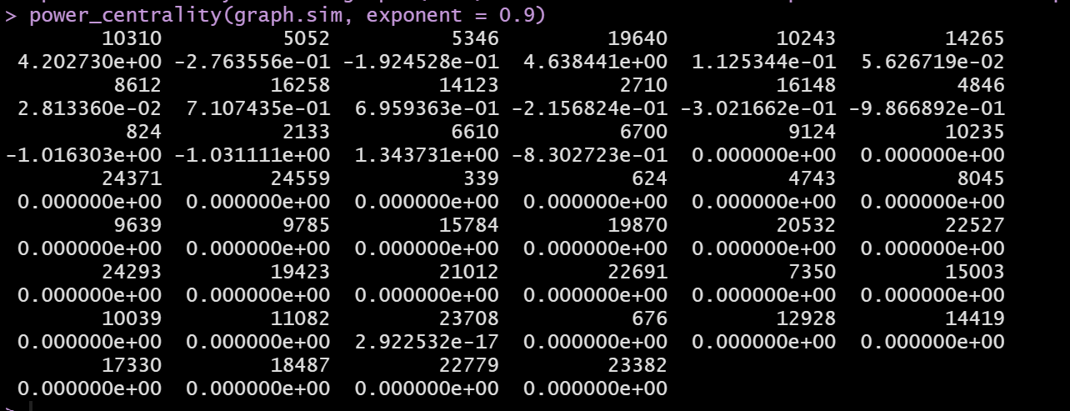
Figure 10a: Power Centrality for All Nodes
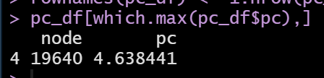
Figure 10b: Central Node using Power Centrality

Part 6 Discussion and Conclusion
For this project, I loaded a large data set of authors and co-authors into a graph using the igraph package in R. Since this dataset contained over 5000 nodes and 14000 edges, it was clear I would need to implement some graph simplification strategies.
I applied multiple strategies before successfully completing our simplification. Firstly, I order our nodes based on frequency and selected the top 300 authors. This strategy helped simplify our graph, but I Ire concerned this would not have enough randomness within the sample. Instead, I selected 400 nodes randomly, and then reduced this number by mandating the nodes have at least one degree. This strategy performed better, but resulted in a graph containing two subgraphs, and I preferred to work with just one. The final strategy had us performing degree removal first, dropping all nodes with less than 20 degrees, then I took the first 200 nodes of the resulting graph and dropped the remaining nodes with less than 2 degrees. The result was the graph shown in Figure 5, which contains 46 vertices, 105 edges, and no subgraphs, this is the graph I used for the remainder of our analysis
The rest of our analysis includes practicing with the igraph functions mentioned in the rubric, as Ill as some others. This exploration helped us become much more comfortable working with, visualizing, and understanding graph. The functions made it easier for us to identify and label cliques that occurred within the dataset. I also learned how to use different measurements for centrality, including closeness, betweenness, alpha, and power centrality. Finally, I learned the difference between directional measurements, such as hubs and authorities, and how to represent them in our graph.

