IT CareerPilot
An Explainable Hybrid Reasoning System for IT Student Internships and
Graduate Employment

Group Number: 28
Group Members: Zhao Jiayi A0329873M
Sun Wenjing A0326610N

Table of Contents

Table of Contents 2
1. Introduction 3
1.1 Project Overview and Expected Value 3
1.2 Project Objectives 3
2. Project Background 3
2.1 Target Users and Usage Scenario 3
2.2 usage Flow 5
3. Market Research 5
3.1 Competitor Analysis 5
3.2 Compliance Boundary and Automated Applications 6
3.3 Market Trends 6
3.4 Market Gap 6
4. Project Scope 7
4.1 In Scope 7
4.2 Out of Scope 8
4.3 Constraints and Assumptions 8
5. Data Collection and Preparation 9
6. System Design 10

1. Introduction

1.1 Project Overview and Expected Value
IT CareerPilot supports students applying for IT internships and graduate roles by providing job discovery, job matching, job description analysis, resume optimization, and mock interview preparation. After a student uploads a resume and specifies their job preferences, the system parses the student's skills, project experience, and preferences, recommends suitable opportunities from public job information, explains each recommendation, and generates resume revision suggestions and a mock interview question bank for a selected role. It also displays preparation progress for target roles.
The project's core value is not simply to increase the number of applications, but to help students direct limited time toward roles that are more worthwhile. The system uses rule-based filtering to remove clearly unsuitable roles, semantic matching and a skill knowledge base to explain fit and skill gaps, and fact-grounded generation to rewrite resume bullet points. It also generates mock interview questions, response records, and feedback suggestions. Students can therefore understand why a role is worth pursuing, how their application materials should be improved, and what they should prioritize before an interview.

1.2 Project Objectives
The project focuses on the following objectives:
Project Objectives
Recommend suitable IT internships or graduate roles based on a student's career intentions, skills, and project experience.
Explain each recommendation through matched skills, relevant experience, and major skill gaps.
Provide targeted resume revision suggestions for a selected job description without fabricating experience.
Generate role-specific mock interview questions, response records, and feedback suggestions to connect application-material preparation with interview readiness.

2. Project Background
When applying for internships and graduate roles in the IT industry, students commonly face fragmented job information, difficulty interpreting technical requirements in job descriptions, generic resumes, and insufficient feedback on skill gaps. Many students submit the same general resume to different roles, even though IT positions vary substantially in technology stacks, project experience, and role orientation. General applications therefore struggle to demonstrate fit. This project proposes an intelligent reasoning system that helps students identify suitable roles more efficiently and improve how their experience is presented for a specific job description.

2.1 Target Users and Usage Scenario
The primary users are students applying for IT internships or graduate roles in Singapore. In addition to skills and project experience, location, graduation date, work-pass status, sponsorship requirements, and the time available each week affect eligibility and preparation. The composite persona below brings these system-design inputs together in one representative user.

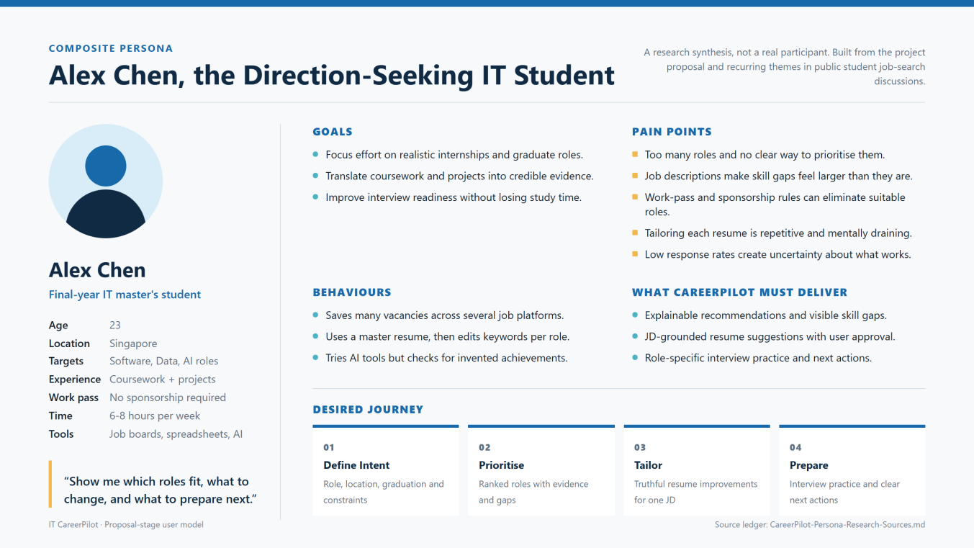
Figure 1. IT CareerPilot composite persona. Work-pass and sponsorship status are treated as hard constraints in job eligibility screening.

To ensure that the identified pain points are not based solely on the team's assumptions, the project conducted small-scale qualitative coding of ten public Reddit discussions about job seeking. Recurring themes included unclear career direction, difficulty assessing skill gaps, the time required to tailor each resume, limited feedback after applying, and concerns about the truthfulness of AI-generated content. This material supports exploratory requirements analysis and is not presented as a statistically representative survey.
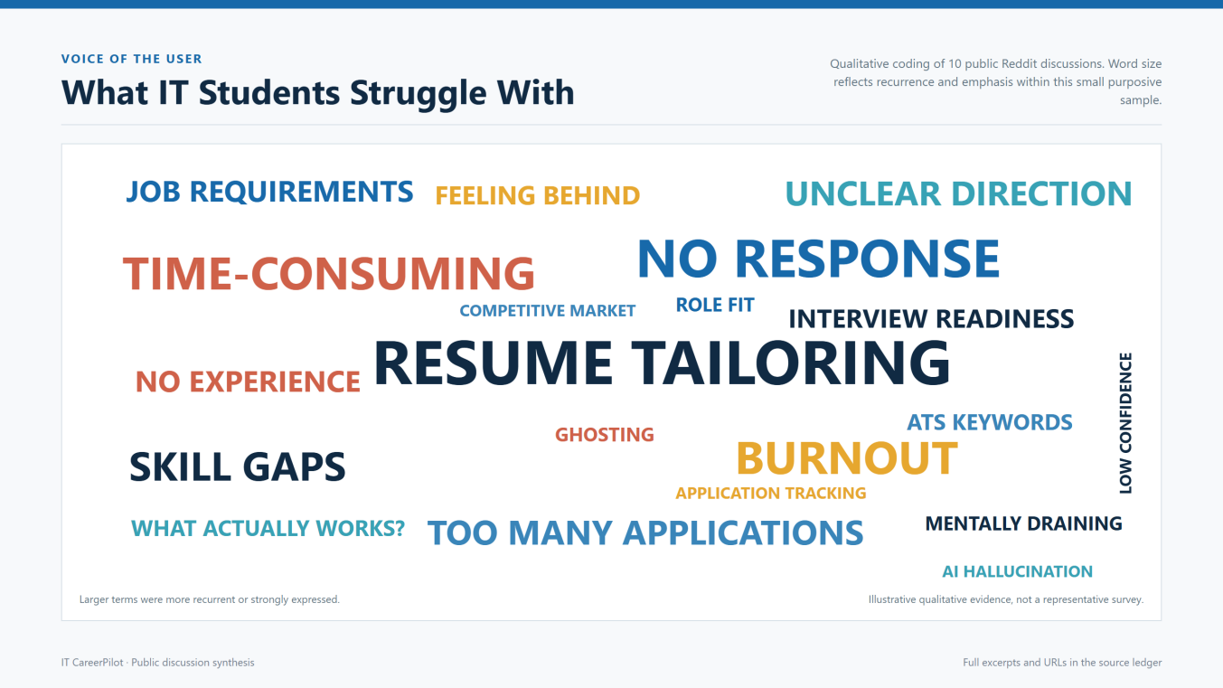
Figure 2. Word cloud of IT student job-search pain points. Word size reflects recurrence and emphasis within the qualitative sample.
Sources: public discussions in Reddit communities including r/Resume, r/csMajors, and r/careeradvice. The full set of ten excerpts, thematic codes, and original links is available in proposal-assets/CareerPilot-Persona-Research-Sources.md in the project repository.

2.2 usage Flow
The typical usage flow combines student-visible interactions with a background job-data pipeline. Job descriptions are collected, cleaned, and structured outside the user flow. The system provides recommendations, explanations, and revision suggestions, while the student retains control over factual confirmation, final review, and application submission.
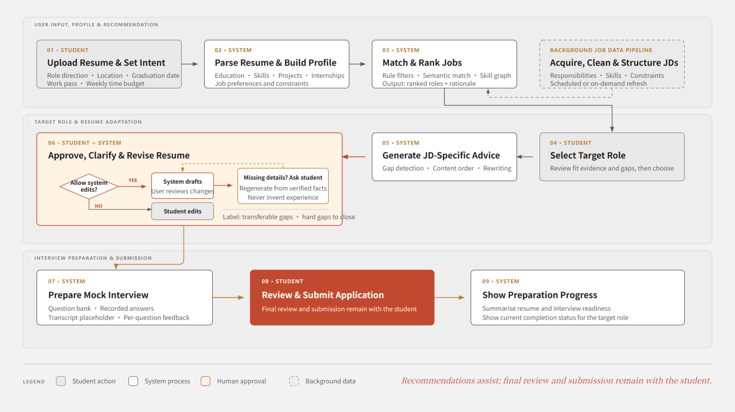
Figure 3. Typical IT CareerPilot usage flow. The background job-description pipeline supports recommendations, while the main flow concludes with preparation progress.

3. Market Research

3.1 Competitor Analysis
Recruitment platforms, resume optimization tools, and automated application tools each address part of the job-search process, but they do not provide a complete student-focused workflow. The following table summarizes major competitors and their limitations.
Product | Category | Matching Approach (Publicly Disclosed) | Pricing | Principal Limitation
LinkedIn Jobs | Job board + recommendation | Activity embeddings based on 28-day APPLY/SAVE/DISMISS sequences; CNN, LSTM, and Transformer sequence models | Free tier | LinkedIn's engineering blog reports that only around 20 million of its 830 million members were active job seekers, creating severe cold-start and sparsity problems. Batch processing adds serving delay, and the model uses job-interaction signals only.
Indeed / Glassdoor | Job board | Technical details not disclosed | Free to job seekers | No resume tailoring, skill-gap analysis, or explanation.
MyCareersFuture | Government portal (WSG) | Claims skills-based matching; algorithm not published | Free | MOM reported that around six in ten users from the 2023 cohort secured employment within six months. The service provides no match explanation or resume tailoring and is limited to Singapore.
InternSG | Job aggregator | None; keyword search and browsing only | Free | No personalization.
Handshake | Student platform | Profile-based suggestions; model not disclosed | Not disclosed | Requires institutional participation and does not provide resume optimization.
Jobscan | Resume optimization | Match rate calculated across five priorities: hard skills, education level, job title, soft skills, and other keywords | Not verified | The vendor states that scores above 75% may be difficult without keyword stuffing and warns against over-optimization. It provides lexical matching only and no job discovery.
Teal HQ | Tracker + resume builder | Keyword match score against a pasted job description | Free tier; Teal+ US$29/month | The free tier is limited to the top five keywords and ten AI bullet credits. It provides no job discovery and does not reason over skill relationships.
Rezi | Resume builder | Rezi Score based on 23 ATS-compatibility metrics | Free; Pro US$29/month; Lifetime US$149 | Outcome claims are self-reported and no public methodology is provided. It offers no job discovery or ranking.
LazyApply | Bulk auto-application | Volume automation; no matching | US$99-US$999 one-time | Directly conflicts with Indeed's terms of service (see Section 4.2).
AIHawk / Jobs_Applier_AI_Agent | Open-source auto-application agent | Browser automation | Free and open source | The project's own documentation instructs users to respect website terms and rate limits and not to submit content that has not been reviewed by a person.
Table 1. Competitor analysis and principal limitations.

3.2 Compliance Boundary and Automated Applications
The project will not submit applications automatically. It will generate application guidance and draft materials for students to review and submit themselves.
This design respects the restrictions that major recruitment platforms place on automated applications and avoids the decline in application quality associated with bulk submission. IT CareerPilot is positioned as a decision-support tool rather than an autonomous agent that performs irreversible actions on a student's behalf.

3.3 Market Trends
As the use of AI tools in job seeking increases, application volumes are rising rapidly and employers are relying more heavily on automated screening. Students consequently need more targeted role selection, clearer interpretation of job descriptions, and role-specific resume optimization rather than a simple increase in application volume.

3.4 Market Gap
Existing tools mainly fall into three categories: job search, keyword scoring, and automated application. None fully covers the student's core journey from role screening to resume tailoring.
- Keyword-based resume tools can identify coverage of terms from a job description, but they generally cannot understand relationships between skills or explain why a role is suitable for a student.
- Bulk auto-application tools increase submission volume, but they introduce platform-compliance risks and may reduce application quality.
- Recruitment sites and government portals aggregate vacancies, but their recommendation processes are often opaque and they lack integrated resume optimization and preparation-progress tracking.
The opportunity is therefore to build an intelligent job-search assistant for IT students that recommends roles, explains the basis of each match, and generates actionable, appropriately framed resume improvements and mock interview preparation content for a specific job description.

4. Project Scope

4.1 In Scope
The project focuses on the general job-search workflow for students entering the IT industry. It may cover common technical roles in software development, data, artificial intelligence, cloud computing, and cybersecurity, while the exact coverage will depend on the job-description data collected and the demonstration scenarios. In-scope functions include job recommendation, job description analysis, resume optimization, skill-gap explanations, a video mock interview prototype, and preparation-progress display for target roles.
Module | Proposal-Stage Function | Description
Job Data Acquisition | Collect, clean, and deduplicate public IT job descriptions | Supplies data for job recommendation and job-description analysis
Resume Parsing | Extract education, skills, project experience, and internship experience | Creates a structured student job-seeker profile
Job Description Analysis | Extract responsibilities, technical skills, experience requirements, and constraints | Creates a structured job profile
Skill Knowledge Base | Organize IT skill aliases, related skills, and relationships between jobs and skills | Supports skill matching and gap explanations
Rule-Based Screening | Process hard constraints such as location, education, work-pass status, and deadlines | Prevents ineligible roles from ranking highly
Job Recommendation | Combine rules, keywords, and semantic similarity to generate recommendations | Outputs matching scores and rankings
Recommendation Explanation | Describe matched skills, relevant projects, and missing skills | Improves trust in recommendations
Resume Optimization | Rewrite or suggest revisions to resume bullet points for a target job description | Maintains factual consistency and does not fabricate experience
Mock Interview | Generate questions from role skills, responsibilities, and resume content, with a front-end prototype for recording, transcription, and feedback | Supports preparation for technical, behavioral, and communication questions
Preparation Progress | Summarize resume and mock interview readiness on the target-role page | Allows students to review current completion status
System Orchestration | Coordinate parsing, recommendation, explanation, generation, and mock interview modules | Keeps the workflow clear and auditable
User Interface | Display job recommendations, match explanations, resume suggestions, and mock interview content | Prioritizes a Web UI that can be demonstrated quickly
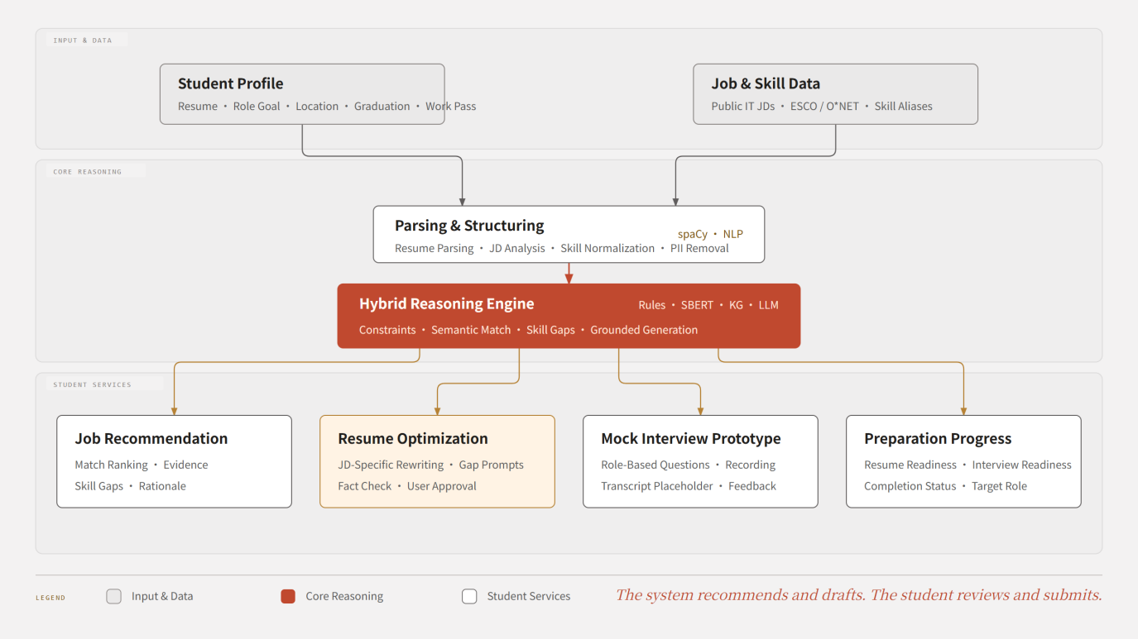
Figure 4. IT CareerPilot functional module diagram. Core services include job recommendation, resume optimization, mock interviews, and preparation-progress display.

4.2 Out of Scope
The following items are excluded from the project scope:
Excluded Item | Reason
Automatic application submission | Major recruitment platforms commonly restrict automated submission, and irreversible actions should not be delegated without human review. The system generates application materials and job links, while students submit applications themselves. This preserves the main benefit while maintaining compliance.
Guaranteeing interviews or offers | The system is a decision-support tool. Outcomes depend on factors outside its control.
Generating experience the student does not have | This is a hard design constraint enforced by the factual consistency controls. The system improves how genuine experience is expressed; it does not invent experience.
Non-IT sectors and mid-career or executive roles | Skill ontologies and requirement structures differ substantially. Within a budget of ten person-days per team member, broader coverage would reduce depth.
Chinese-language resumes and job descriptions | The first version supports English only. Chinese-language support is reserved for future work.
Closed-loop learning from real application outcomes | No outcome labels are available at project start. The current stage uses team annotation and sample testing for preliminary evaluation; learning from real application outcomes is future work.
Large-scale scraping of commercial job boards | Major platform terms commonly restrict such activity. Data acquisition relies on open datasets and small, rate-limited, robots.txt-compliant collection from company career pages to demonstrate multi-source integration.

4.3 Constraints and Assumptions
- The scope and implementation plan prioritize a demonstrable core workflow. The initial stage focuses on job parsing, matching and recommendation explanations, job-description-specific resume optimization, a video mock interview prototype, and preparation-progress tracking for target roles.
- Because real application-outcome data is not available during the initial stage, recommendation quality will be evaluated provisionally through human relevance assessment, representative scenario testing, and comparisons of matching scores.
- The availability and compliant use of job data are the project's main external dependencies. The project will prioritize open datasets, publicly available job-description samples, and small, systematically prepared datasets to support prototype development and evaluation.
- Resumes contain personal information. All test materials will be anonymized before processing or replaced with synthetic or pseudonymized data, with restrictions applied to their purpose and accessibility.
- Large language models will primarily support unstructured-text extraction, explanation generation, and user-approved resume rewriting. Hard-constraint screening and match ranking will preferably be implemented with explainable and reproducible local rules and algorithmic components to control cost, response latency, and output uncertainty.

5. Data Collection and Preparation
Dataset | Source | Purpose
Job descriptions | Open job-posting datasets, company career pages, and manually collected IT job-description samples | Job recommendation, job-description analysis, and matching evaluation
Skill ontology | ESCO, O*NET, and a team-maintained alias list for IT skills | Skill knowledge graph and skill-gap assessment
Resumes | Anonymized team resumes, public resume samples, or purpose-built test resumes | Resume parsing, recommendation testing, and resume-optimization testing
Mock interview materials | Public question banks, interview-experience materials, and common questions for technical roles | Mock interview question bank, response feedback, and feedback-rule design
Relevance judgments | Team annotation and sample testing | Recommendation evaluation and weight calibration

Preparation includes cleaning and deduplicating job-description text; extracting job title, company, location, responsibilities, and skill requirements; parsing education, skills, projects, and experience from resumes; normalizing skill aliases; and processing personally identifiable information before any external call.

6. System Design
The revised architecture organizes system components along an end-to-end data flow. The main process comprises six layers: input, job data, parsing, reasoning, generation, and interface. A local deployment layer supports the runtime environment. The architecture also retains a human-in-the-loop boundary, making clear that the system provides recommendations, explanations, and drafts only.
Input layer: React and TypeScript provide resume upload and preference forms. FastAPI and Pydantic receive and validate fields, while pdfminer and python-docx extract text from resumes together with source locations.
Job-data layer: Python and httpx support small-scale job collection and batch import. pandas performs normalization, deduplication, and expiry filtering, while ChromaDB stores job-description chunks and vectors. This layer operates outside the user flow and supplies structured job data to the recommendation module.
Parsing layer: spaCy identifies skill entities in resumes and job descriptions, sentence-transformers generates vectors for student and job profiles, and Cypher MERGE writes normalized profiles into the skill knowledge structure.
Reasoning layer: The rule engine first processes hard constraints such as work-pass status, location, and education, which must not be offset by similarity scores. Neo4j, PyKEEN, vector retrieval, and statistical models then perform skill-relation reasoning, relevance assessment, job ranking, and gap analysis.
Generation layer: LangChain coordinates retrieval and tool use. Fact-grounding controls verify that resume revisions are supported by evidence from the student, while Jinja2 templates produce structured resume suggestions, mock interview question banks, and feedback.
Interface layer: React and TypeScript display job matches, recommendation rationales, resume-revision review, mock interviews, and preparation progress. The single-file HTML implementation preserves the current demo, while the FastAPI JSON API will subsequently connect it to the actual reasoning modules.
Local deployment layer: uvicorn serves the API locally, and Docker Compose manages the API, Neo4j, and ChromaDB consistently. Model weights and resume data remain on the local machine to reduce deployment complexity and privacy risk during demonstrations.
The human-in-the-loop principle applies throughout the architecture. The system may recommend roles, explain gaps, and generate revision drafts, but it cannot fabricate experience or submit applications automatically. Students supply missing facts, approve revisions, and complete final submission themselves.

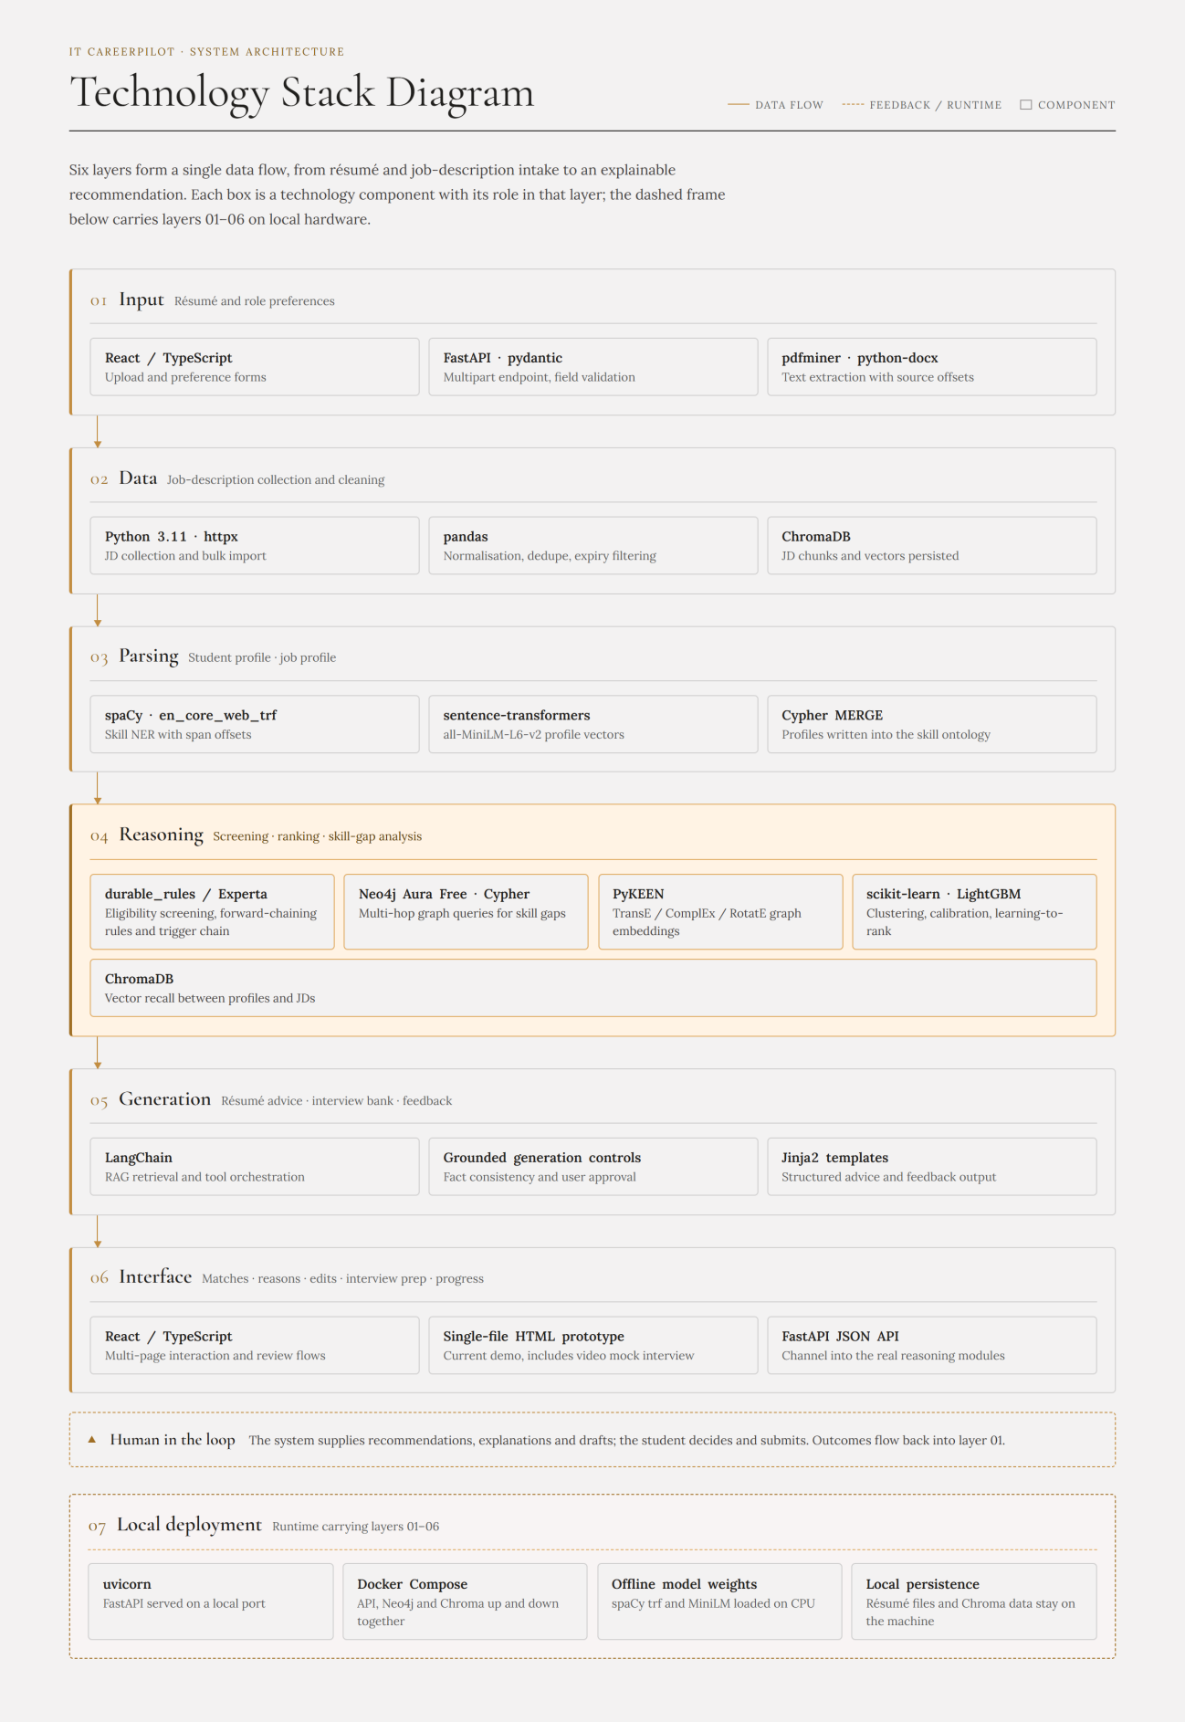
Figure 5. IT CareerPilot system architecture and technology components.

