Woah.trip

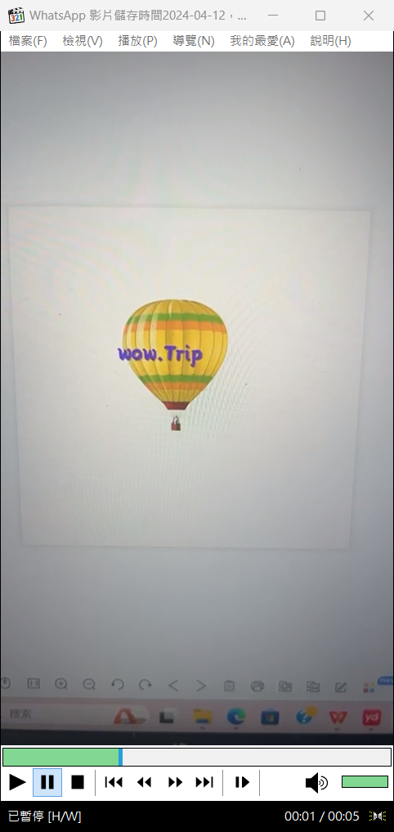

**Index.html(Home page)**

-Introduction: woah.trip

-Contact window

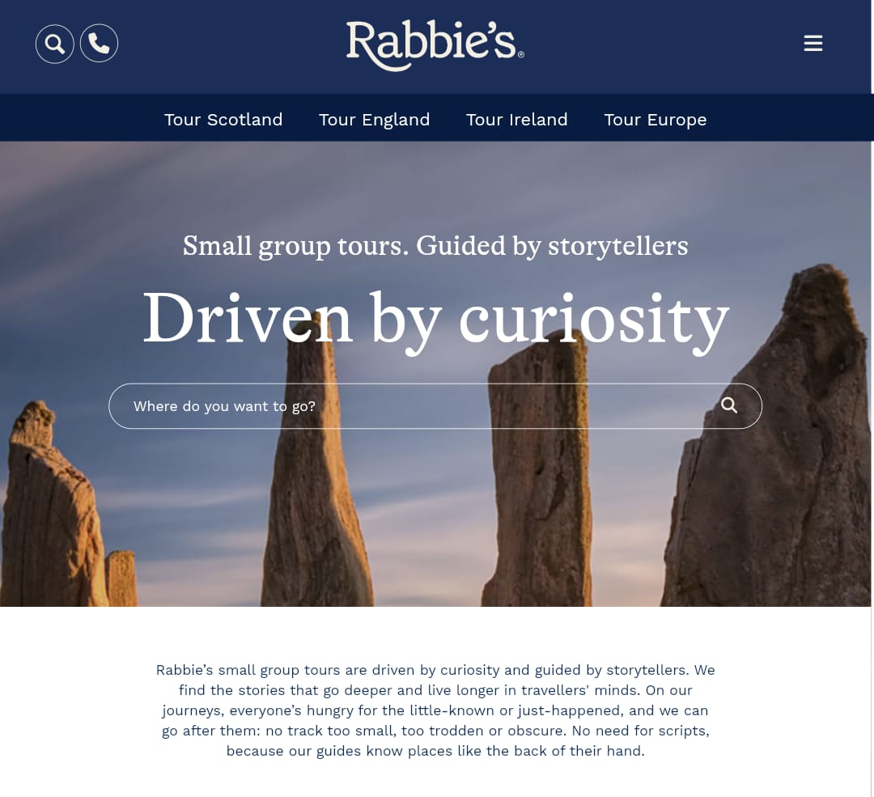

**Tour in Europe(product)**

-Italy

-Germany

-Czech

-Denmark

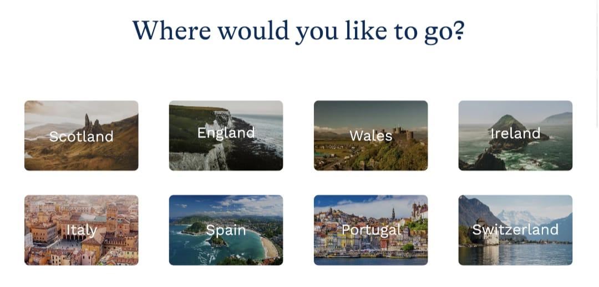

Form(sign up a tour)

-Name

-Phone

-Email

-Tour

-Remark

Win a prize (small game)

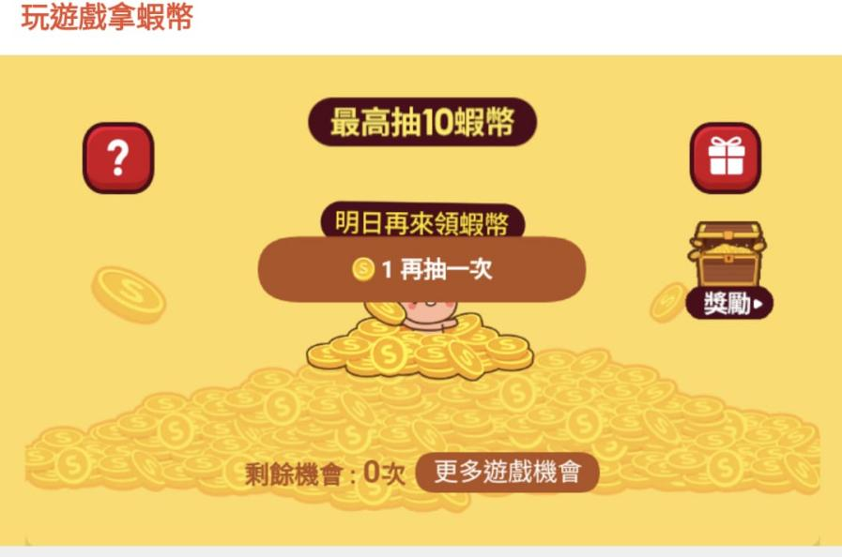

[Heliskiing in New Zealand | 100% Pure New Zealand (newzealand.com)](https://www.newzealand.com/uk/heliskiing/)