**Homework_4: Exploration of Landsat satellite imagery with R and QGIS**

1. Utilizing openstreesmap plugin in QGIS to find and download the map of the Doubs river (map: https://www.openstreetmap.org/relation/156145#map=9/47.1085/6.1057&layers=H), and download the map as a geojson format, which is becoming popular for encoding a variety of geographic data structures. 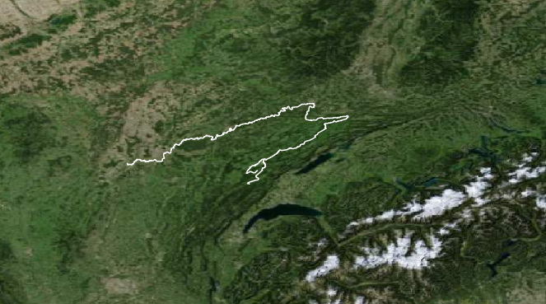

QuickOSM：

快速查询 —— 关键字waterway、值river、位于Le doubs —— 运行查询

Save features as geojson format

2. You’d better to check the structure of the regions object by plotting the simple feature collection and dissolve the internal boundaries of the region if the geojson file contains. After that, please set the area that the river undergoes as the area of interest (AOI).

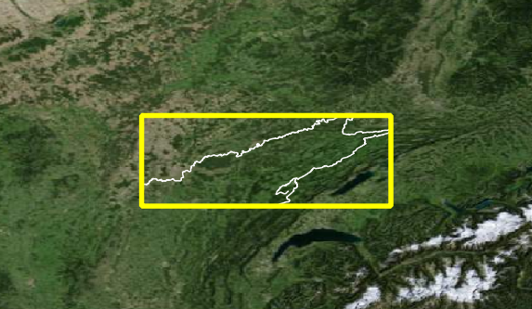

矢量 —— 研究工具 —— 按位置选择 —— 框选AOI

3. Create an account of one of these geospatial official websites, such as USGS, EARTHDATA, Copernicus data space, and login in for check the images that the river covers. Filtering the records to keep only Landsat images with LandCloudCover lower than 10%, and try to find what products levels. Please note whether the records contain sr_ndvi. The normalized difference vegetation index, NDVI, provides a rough estimate of the abundance of healthy vegetation and provides a means of monitoring changes in vegetation over time. You can download through manual methods directly from the geospatial websites or by other means, including QGIS and R package.

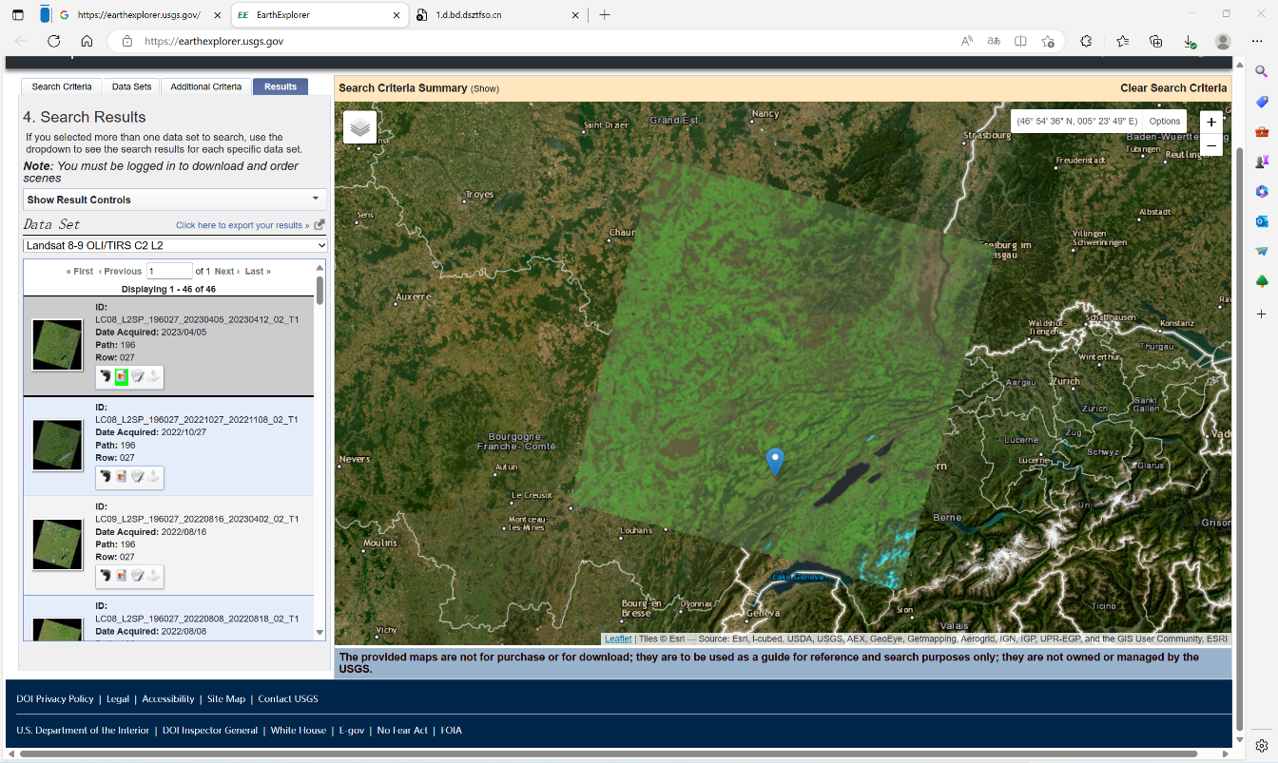

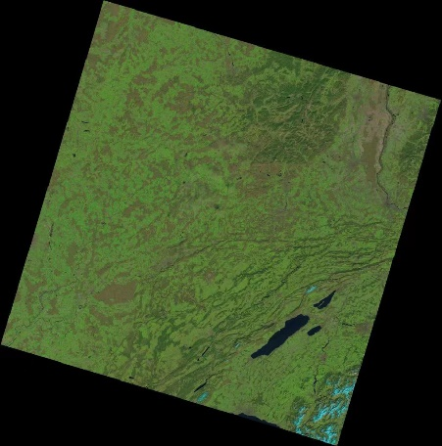Search criteria：world features

Feature name：doubs

Cloud Range： (0-10%)

Datasets:

Landsat 8-9 OLI/TIRS C2 L2/L1

获得结果，下载图片

4. Load the NDVI raster file and check whether its crs is identical to AOI. If not, transform the crs of AOI vector into the another which is the same as that of NDVI. After that, you can crop and mask the NDVI for a small area, which just covers the AOI. Plot the cropped NDVI.

library(raster) #读取栅格数据

NDVI <- raster(NDVI.tif)

library(rgdal) #读取矢量数据

AOI <- rgdal:readOGR(doubs.geojson)

identicalCRS（NDVI, AOI）

AOI_trans <- spTransform(AOI, st_crs(NDVI)) #把矢量数据重投影到栅格数据上

plot(NDVI)

plot(AOI)

NDVI_crop <- crop(NDVI, AOI_trans) #裁切

NDVI_mask<- mask(NDVI_crop, AOI_trans) #仅保留AOI覆盖区