  Security Features in Typical Web Applications  Analysis and Implementation Recommendations for ASP.NET Web Applications | Abstract  This report analyzes two key web application features, Login Page and Account Registration Page and explains common security issues associated with each. It proposes practical mitigation techniques based on OWASP best practices and outlines how these features should be securely implemented in a typical ASP.NET web application.  Loh Xin Wen Melody, 244677K  IT2163-01

I have chosen the following security features for my Assignment:
Statement on Plagiarism and Academic Dishonesty 2
1. Account Registration Page 3
1.1 Assumptions 3
1.2 Security Issues 1 3
1.2.1 Description 3
1.2.2 Mitigation Techniques 3
1.2.3 Implementation Techniques 4
1.2.4 Supporting Evidence/Justification 4
1.3 Security Issues 2 4
1.3.1 Description 5
1.3.2 Mitigation Techniques 5
1.3.3 Implementation Techniques 5
1.3.4 Supporting Evidence/Justification 6
1.4 Security Issues 3 6
1.4.1 Description 6
1.4.2 Mitigation Techniques 6
1.4.3 Implementations Techniques 6
1.4.4 Supporting Evidence/Justification 7
2. Login Page 8
2.1 Assumptions 8
2.2 Security Issues 1 8
2.2.1 Description 8
2.2.2 Mitigation Techniques 8
2.2.3 Implementation Techniques 8
2.2.4 Supporting Evidence/Justification 10
2.3 Security Issues 2 10
2.3.1 Description 10
2.3.2 Mitigation Techniques 10
2.3.3 Implementation Techniques 11
2.3.4 Supporting Evidence/Justification 13
2.4 Security Issues 3 13
2.4.1 Description 13
2.4.2 Mitigation Techniques 13
2.4.3 Implementations Techniques 13
2.4.4 Supporting Evidence/Justification 15
3. References 16

Statement on Plagiarism and Academic Dishonesty

I certify that this assignment/report is my own work, based on my personal study and/or research and that I have acknowledged all material and sources used in its preparation, whether they be books, articles, reports, lecture notes, and any other kind of document, electronic or personal communication.

I also certify that this assignment/report has not previously been submitted for assessment in any other unit, and that I have not copied in part or whole or otherwise plagiarised the work of other students and/or persons.

Name | Loh Xin Wen Melody
Signature
Date | January 5, 2026

Account Registration Page

Assumptions
- Account Registration is the process of creating a new digital identity for a user. This identity will later be used to authenticate the user when accessing the application.
- The Account Registration Page collects essential details such as Name, Email or Phone Number, Address, Occupation, and requires setup of Multi-Factor Authentication (MFA) options (e.g., SMS OTP, Email OTP, or Authenticator App).
- Authentication refers to verifying that an individual, entity, or website is who or what it claims to be by validating one or more authenticators (e.g., passwords, fingerprints, or security tokens).
- All communication between client and server during registration is conducted over TLS (HTTPS) to prevent interception or tampering.
- The application is assumed to be built on ASP.NET Core, using ASP.NET Identity for user management.

Security Issues 1
- Weak Password Policies

Description
Allowing users to set weak passwords (short, simple, or common) makes accounts vulnerable to brute force, dictionary, and credential stuffing attacks. This can lead to account compromise and session hijacking.

Mitigation Techniques
  - Enforce Minimum Password Length:
    - Require at least 15 characters if MFA is not enabled.
    - Require at least 8 characters if MFA is enabled.
  - Allow all characters including Unicode, whitespace, and special characters to support passphrases and international users.
  - Use regex validation to enforce length and printable character rules, while avoiding outdated composition rules.
  - Integrate HaveIBeenPwned API to block passwords found in known breaches.
  - Provide a password strength meter (e.g., zxcvbn library) to guide users.

Implementation Techniques
- Use ASP.NET Core data annotations with regex validation to enforce password rules. When a weak password is entered, the system generates an error message to guide the user.

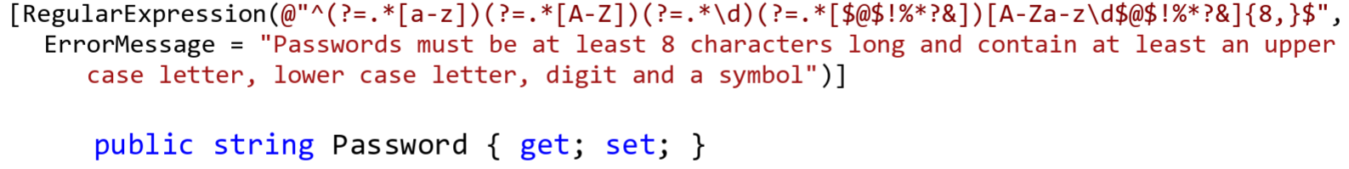
Figure 1: Example of regex validation for enforcing strong password policies

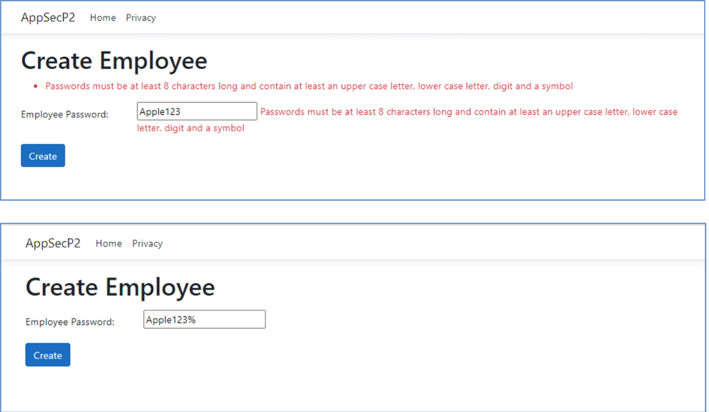
Figure 2: Example of creating an employee password with ASP.NET Core annotations
This ensures that passwords meet minimum length and complexity requirements, and the error message provides immediate feedback to the user.

Supporting Evidence/Justification
This solution aligns with the OWASP Authentication Cheat Sheet and NIST SP800-63B Digital Identity Guidelines, which recommend enforcing strong password policies and providing user feedback. It is effective because it prevents trivial passwords, increases entropy, and reduces the risk of brute force or credential stuffing attacks.

Security Issues 2
- Input validation

Description
Improper input validation allows attackers to inject malicious data (SQL injection, XSS) or submit malformed values that corrupt the database or bypass business logic.

Mitigation Techniques
  - Validate all inputs using allowlist patterns.
  - Use regex for structured fields like email and phone number.
  - Enforce length limits and required fields for name, address, and occupation.
  - Normalize Unicode input to prevent homoglyph attacks.
  - Reject or sanitize unexpected characters to prevent injection attacks.

Implementation Techniques
- Use ASP.NET Core data annotations ([Required], [EmailAddress], [StringLength]) to validate inputs server-side. Apply regex for email format. Enforce maximum length for text fields. Normalize Unicode input.

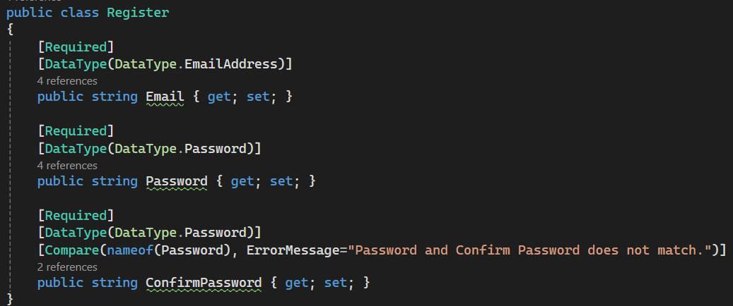
Figure 3: - Example of input validation using data annotations ([Required], [EmailAddress])
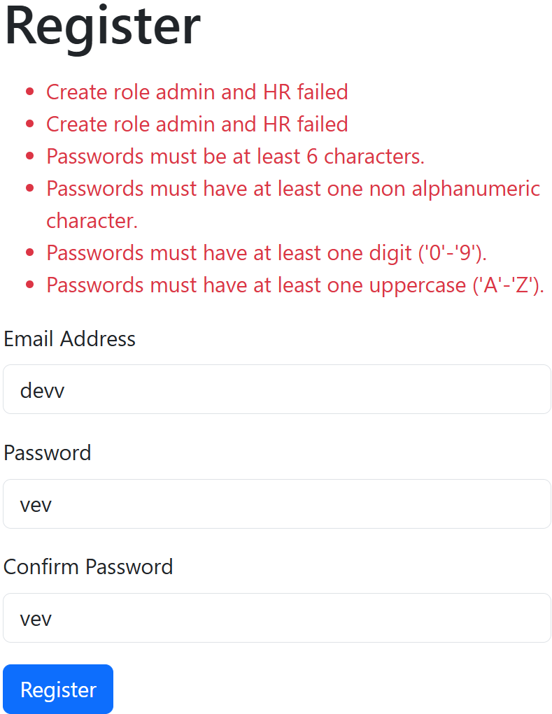
Figure 4: Example of registering an account with enforced validation rules

Supporting Evidence/Justification
This approach follows the OWASP Input Validation Cheat Sheet and OWASP Top 10 (A03:2021 Injection). Validating inputs early reduces the attack surface and ensures data integrity.

Security Issues 3
- Captcha/ Bot Prevention

Description
Attackers may use automated scripts to create fake accounts, overwhelming the system and enabling fraud, spam, or denial‑of‑service conditions.

Mitigation Techniques
  - Implement CAPTCHA or reCAPTCHA to distinguish humans from bots.
  - Apply rate limiting to restrict the number of registration attempts per IP or session.
  - Log and monitor suspicious registration patterns for anomaly detection.

Implementations Techniques
- Integrate Google reCAPTCHA widget in the registration form. Verify CAPTCHA token server-side. Apply rate limiting per IP. Log suspicious attempts.
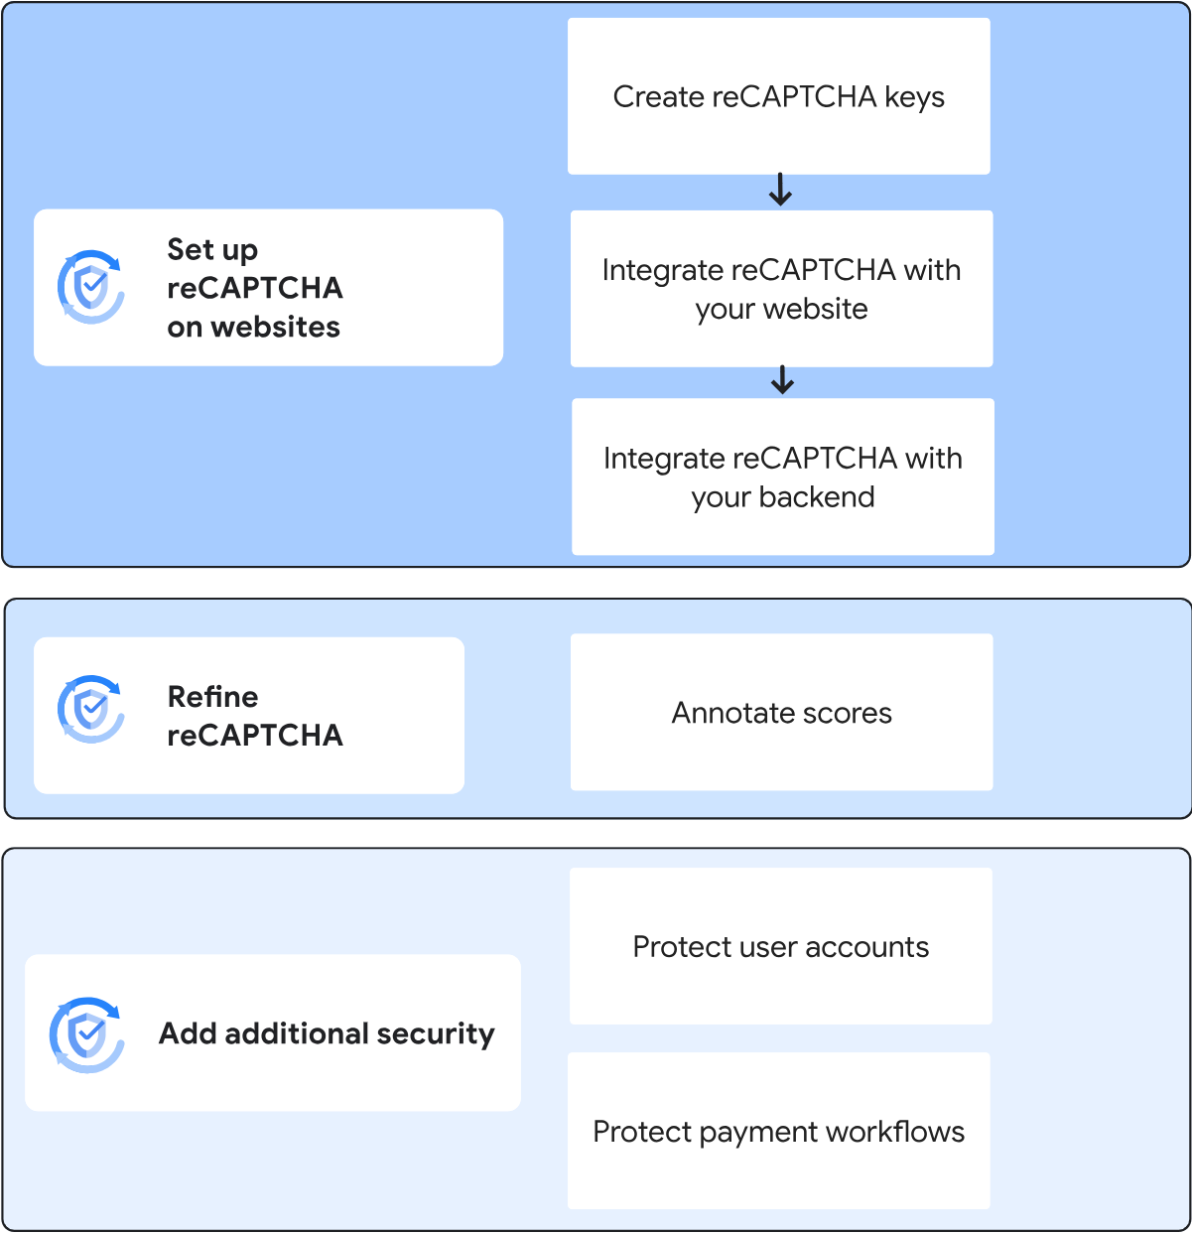
Figure 5: Flowchart showing CAPTCHA implementation process

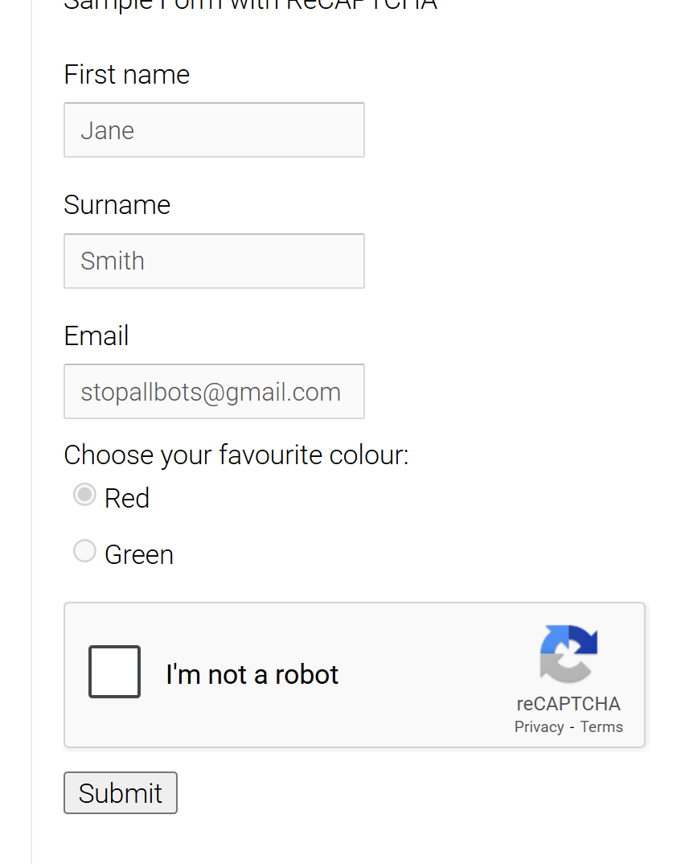
Figure 6: Example of CAPTCHA displayed on a website
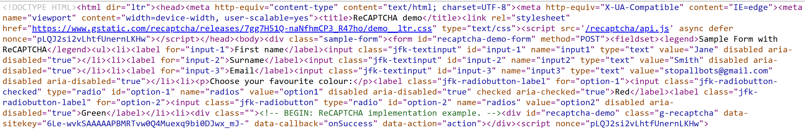
Figure 7: Frontend CAPTCHA integration snippet
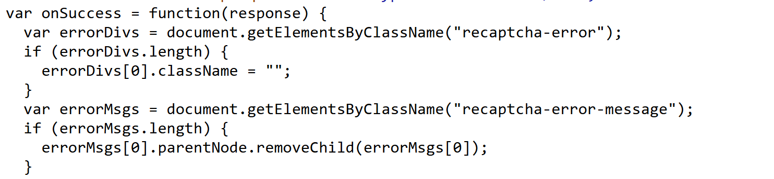
Figure 8: JavaScript Callback for CAPTCHA validation

Supporting Evidence/Justification
This solution aligns with the OWASP Automated Threats to Web Applications and OWASP Authentication Cheat Sheet. CAPTCHA makes automated account creation more difficult and costly for attackers, while rate limiting and logging provide layered defense.

Login Page

Assumptions
- Login refers to the process of verifying an entity’s identity.
- A user who has been authenticated is often not authorized to access every resource and perform every action that is technically possible through a system.
- User will need to provide their username and password in order to login to the system
- The application is built on ASP.NET Core with ASP.NET Identity for authentication.
- Login requires username/email and password; MFA is optional but encouraged.
- All login requests are transmitted securely over TLS (HTTPS).
- Session management uses secure cookies with HttpOnly, Secure, and SameSite attributes.

Security Issues 1
- Session Hijacking

Description
Session hijacking occurs when attackers steal or predict session identifiers, allowing them to impersonate legitimate users. This can happen through XSS stealing cookies, session fixation, or insecure session handling.

Mitigation Techniques
  - Use secure cookie attributes: HttpOnly, Secure, SameSite.
  - Regenerate session ID after login or privilege changes.
  - Ensure session IDs have ≥128 bits entropy and are randomly generated.
  - Implement claims-based authentication and authorization policies to tightly control access.

Implementation Techniques
In ASP.NET Core, configure cookie authentication with secure options and regenerate session IDs after login. The following example shows how to implement cookie authentication, enforce claims, and configure login paths.

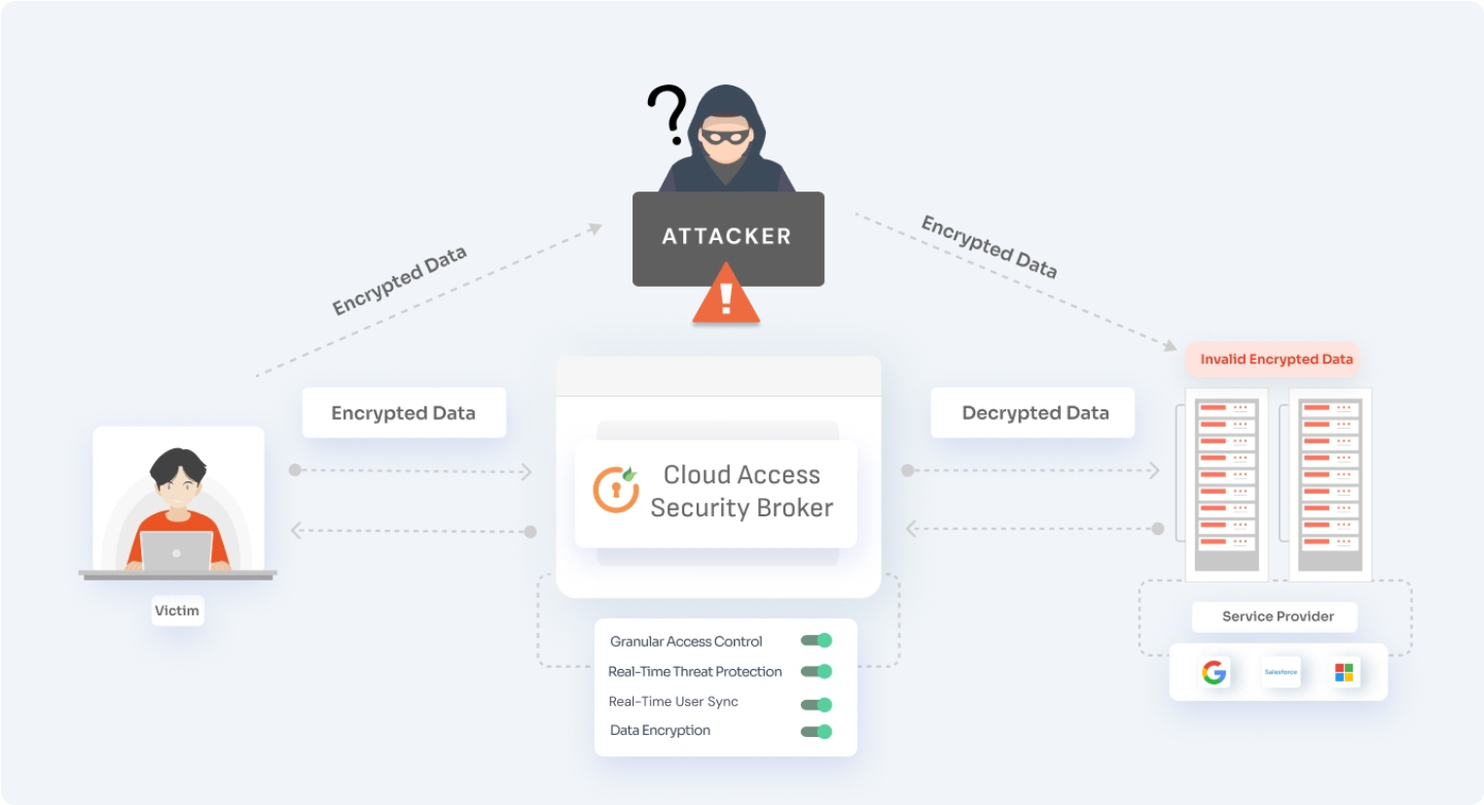
Figure 9: Example of how session hijacking can be executed
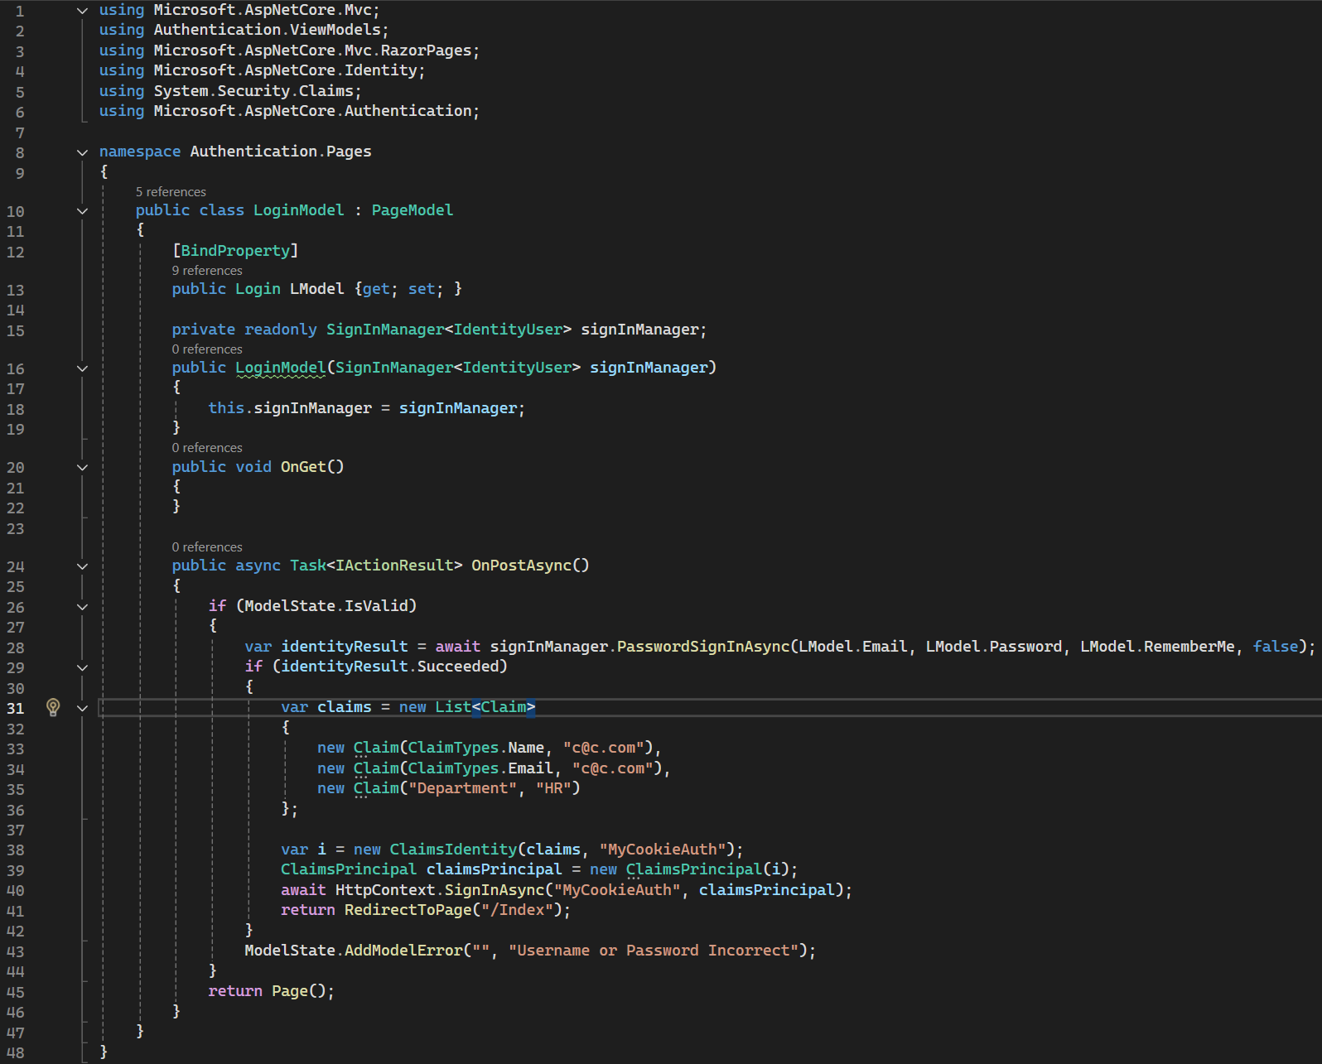
Figure 10: Configuration in Login.cshtml.cs for cookie authentication
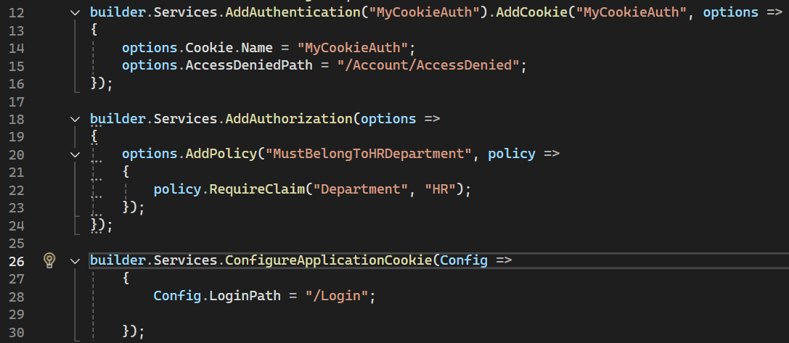
Figure 11: Configuration in Program.cs for cookie/session setup
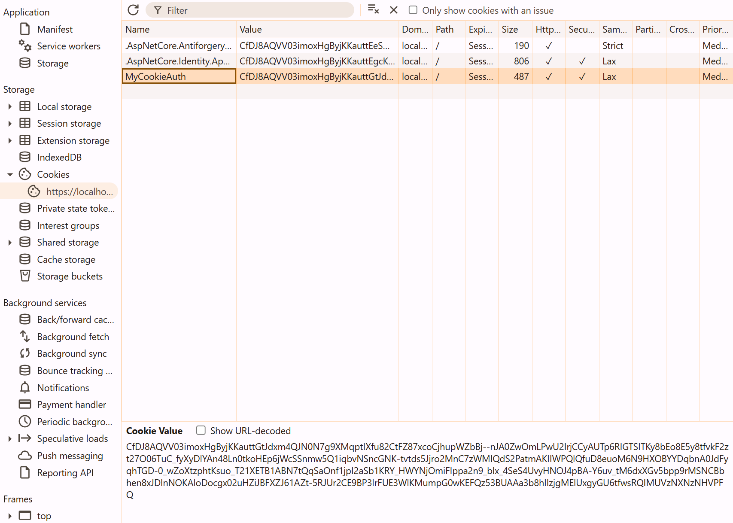
Figure 12: Example of user login with claims-based authentication
This ensures cookies are properly configured, sessions are tied to claims, and unauthorized access is redirected securely.

Supporting Evidence/Justification
  - This solution aligns with the OWASP Session Management Cheat Sheet, which requires secure cookie flags, session ID regeneration, and strong entropy for identifiers. Using claims-based authentication further enforces authorization policies, reducing the risk of hijacked sessions being misused.

Security Issues 2
- Credential Storage

Description
If login systems store or handle credentials insecurely (e.g., plaintext passwords), attackers can steal and reuse them. Replay attacks may also occur if tokens or credentials are reused without validation.

Mitigation Techniques
  - Hash passwords using strong algorithms (e.g., bcrypt, Argon2, PBKDF2).
  - Use salted hashes to prevent rainbow table attacks.
  - Implement replay protection by invalidating old tokens and enforcing expiration.

Implementation Techniques
- ASP.NET Identity uses PBKDF2 by default but can be configured to use stronger algorithms like Argon2. Ensure passwords are hashed with a unique salt per user. Tokens should be single-use and expire quickly.
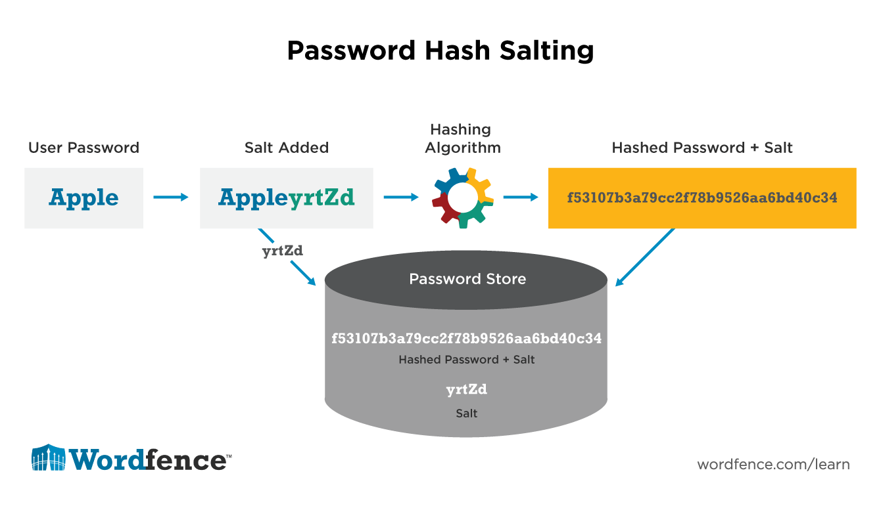
Figure 13: Flowchart of password hashing and salting process
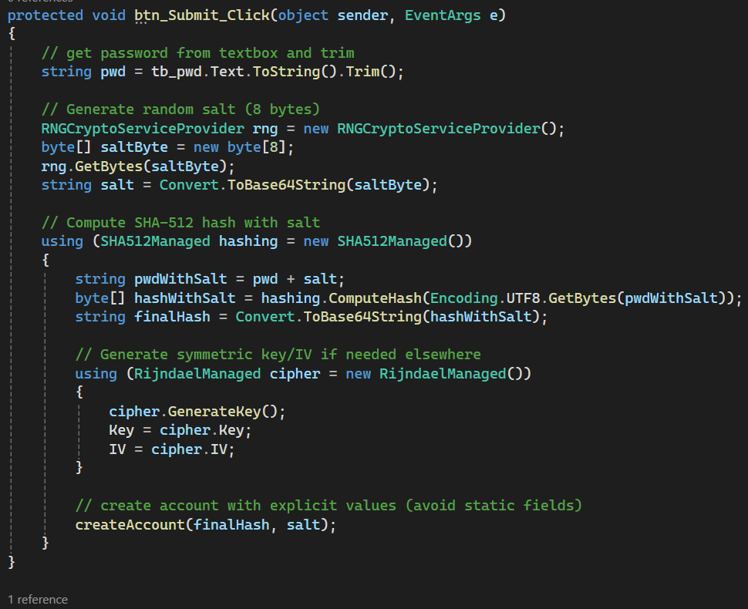
Figure 14: Example of password salting and hashing with SHA‑512
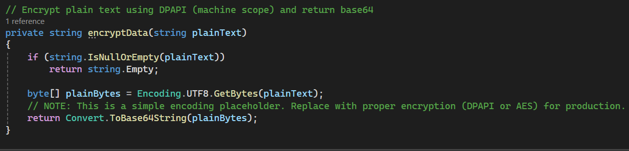
Figure 15: Example of encrypting sensitive data (e.g., NRIC, mobile numbers)
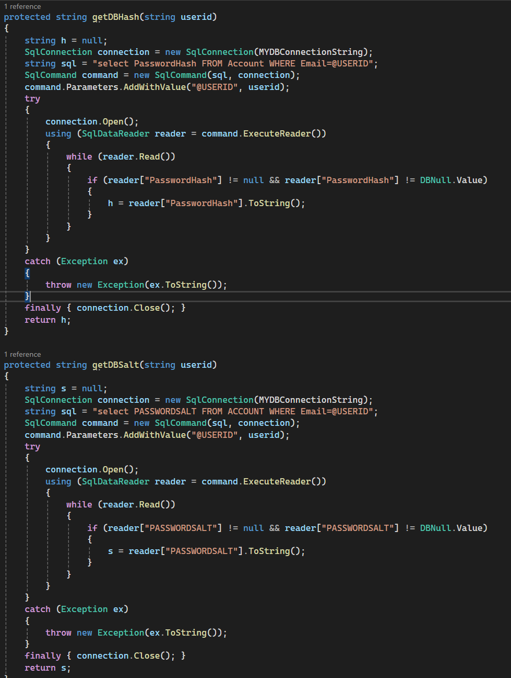
Figure 16: Example of retrieving stored hash and salt securely from database
Figure 17: Example showing password hashed and salted securely in database

Supporting Evidence/Justification
  - This solution aligns with the OWASP Password Storage Cheat Sheet, which recommends salted, adaptive hashing algorithms and secure credential retrieval. It also follows OWASP Cryptographic Storage Guidelines, which emphasize strong encryption and secure key management. These practices prevent credential theft, replay attacks, and database compromise.

Security Issues 3
- Cross-Site Request Forgery

Description
CSRF attacks trick authenticated users into unknowingly submitting requests on their behalf, such as login or state-changing actions. Without protection, attackers can exploit the trust between the browser and the server to hijack sessions or perform unauthorized actions.

Mitigation Techniques
  - Implement anti-CSRF tokens in all forms that perform state-changing actions.
  - Validate tokens server-side for every POST request.
  - Use SameSite cookies to prevent cross-site requests.
  - Configure session services with strict timeouts to reduce exposure.

Implementations Techniques
- In ASP.NET Core, you can apply [ValidateAntiForgeryToken] to controller actions to enforce CSRF protection. The framework automatically generates and validates tokens. Session services are configured with strict idle timeouts to limit exposure.
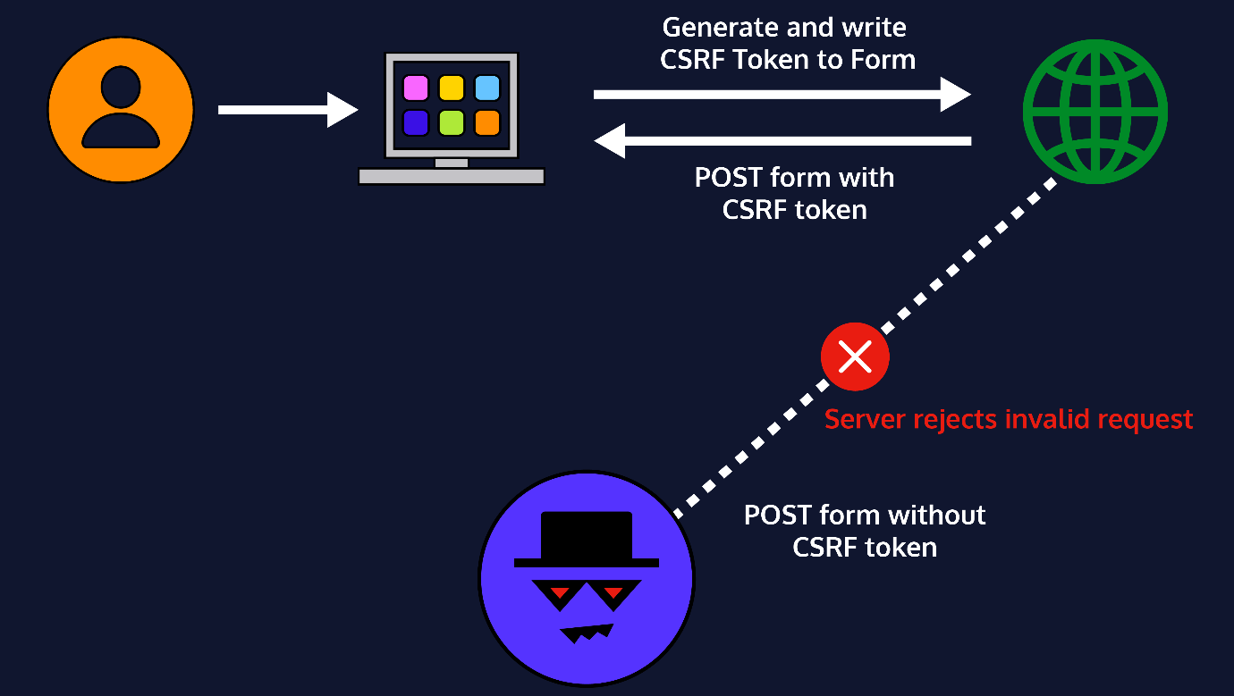
Figure 18: Flowchart showing CSRF token workflow
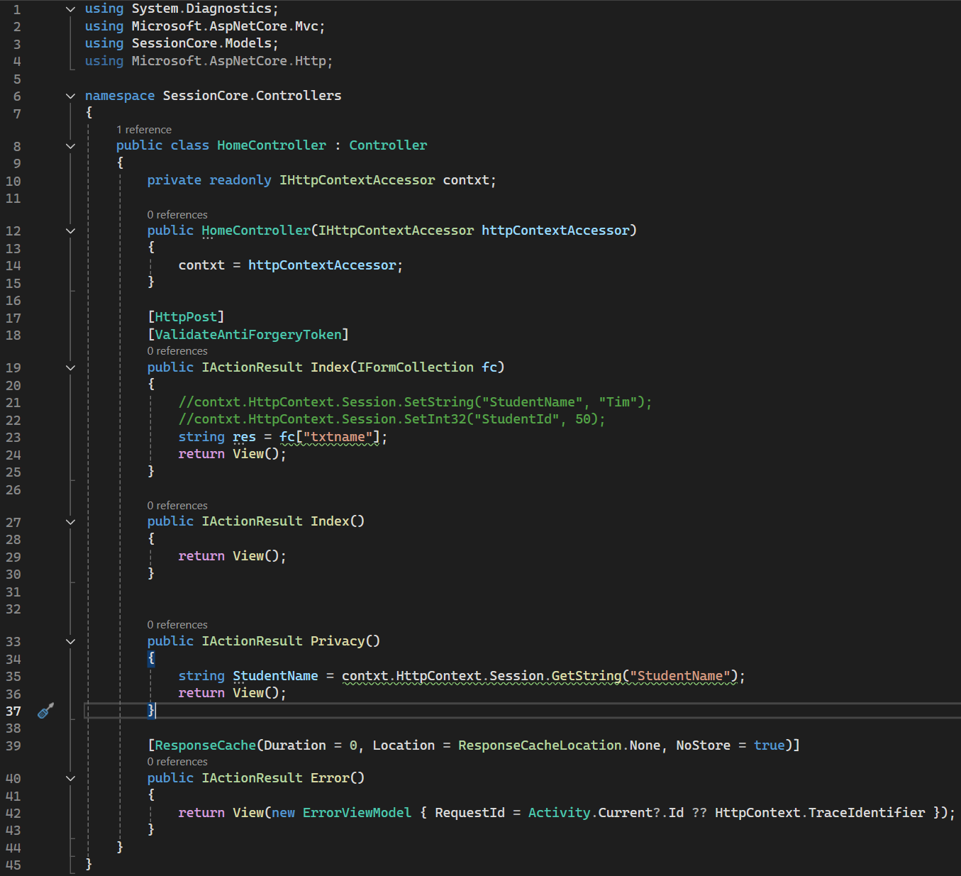
Figure 19: Example of controller configuration with [ValidateAntiForgeryToken]
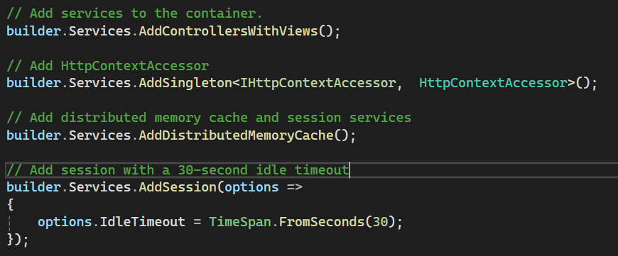
Figure 20: Example of Program.cs configuration for CSRF/session services
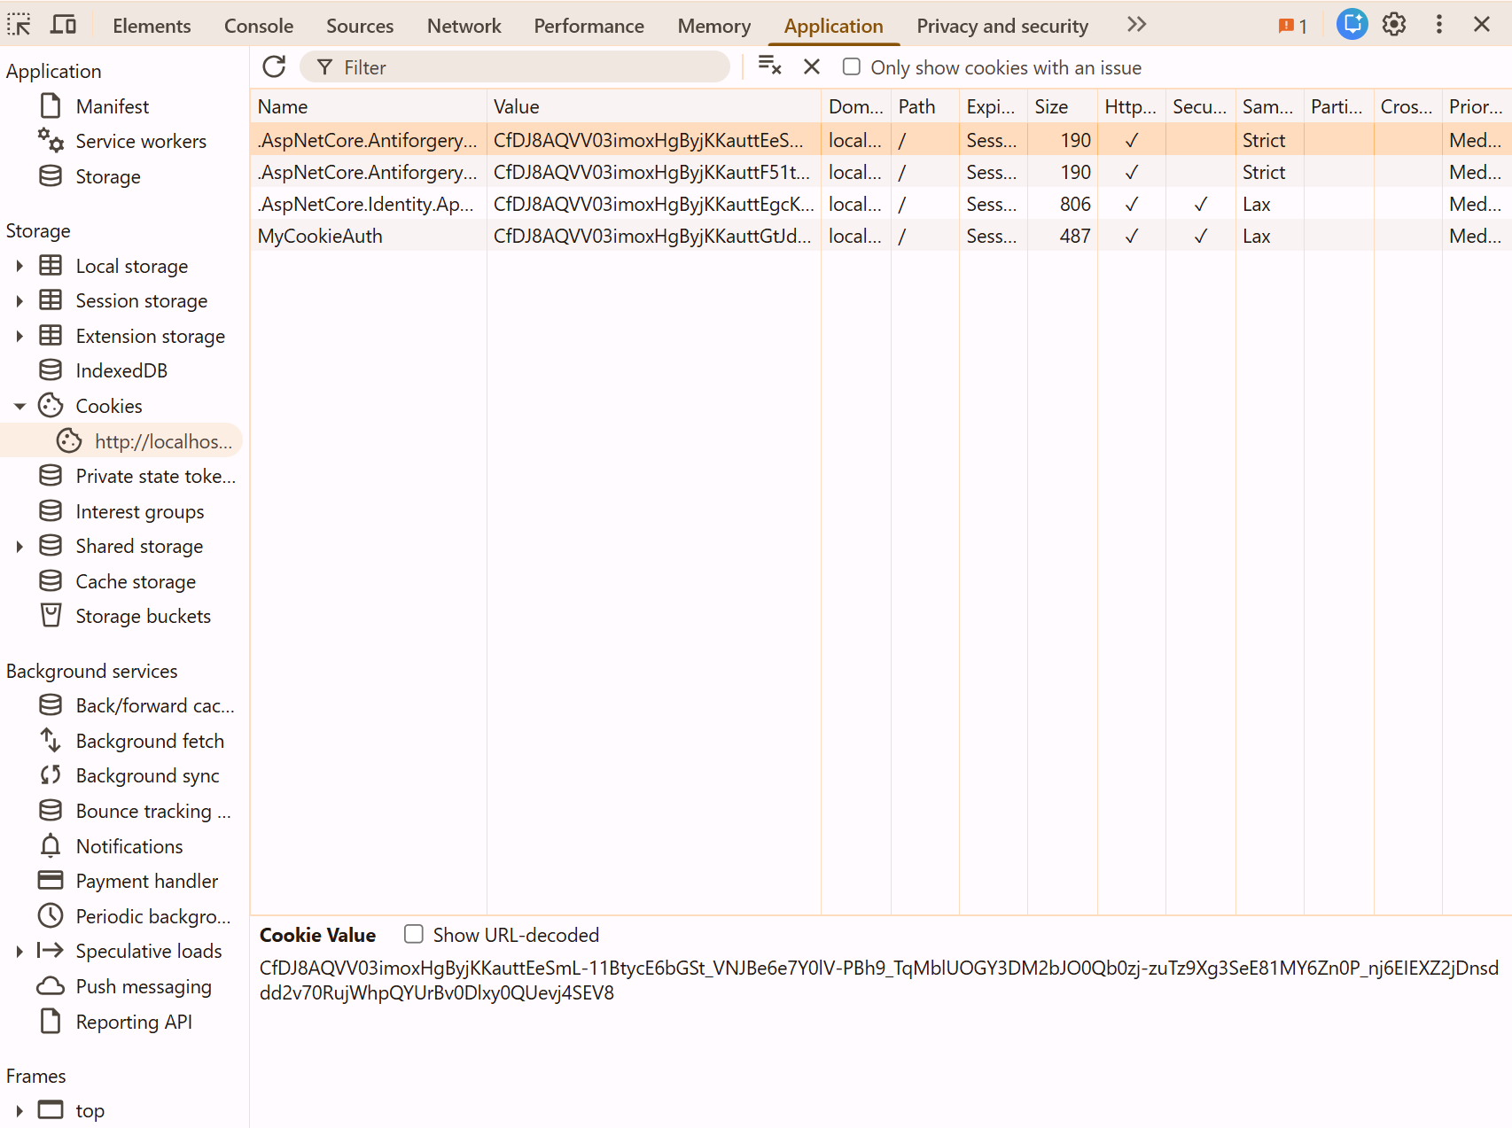
Figure 21: Example of AntiForgeryToken in Razor view

Supporting Evidence/Justification
  - This solution aligns with the OWASP CSRF Prevention Cheat Sheet, which recommends unique anti-CSRF tokens validated server-side. By enforcing token validation and strict session handling, forged requests are blocked, ensuring that login and other sensitive actions are intentional and user-initiated.

References
  - Authentication cheat sheet¶. Authentication - OWASP Cheat Sheet Series. (n.d.). https://cheatsheetseries.owasp.org/cheatsheets/Authentication_Cheat_Sheet.html
  - Input validation cheat sheet¶. Input Validation - OWASP Cheat Sheet Series. (n.d.). https://cheatsheetseries.owasp.org/cheatsheets/Input_Validation_Cheat_Sheet.html
  - Owasp automated threats to web applications. OWASP Foundation. (n.d.). https://owasp.org/www-project-automated-threats-to-web-applications/
  - Session management cheat sheet¶. Session Management - OWASP Cheat Sheet Series. (n.d.). https://cheatsheetseries.owasp.org/cheatsheets/Session_Management_Cheat_Sheet.html
  - Password storage cheat sheet¶. Password Storage - OWASP Cheat Sheet Series. (n.d.). https://cheatsheetseries.owasp.org/cheatsheets/Password_Storage_Cheat_Sheet.html
  - Cross-site request forgery prevention cheat sheet¶. Cross-Site Request Forgery Prevention - OWASP Cheat Sheet Series. (n.d.). https://cheatsheetseries.owasp.org/cheatsheets/Cross-Site_Request_Forgery_Prevention_Cheat_Sheet.html
  - Transport Layer Security Cheat sheet¶. Transport Layer Security - OWASP Cheat Sheet Series. (n.d.). https://cheatsheetseries.owasp.org/cheatsheets/Transport_Layer_Security_Cheat_Sheet.html

