|  |
| --- |
|  |
| Taniti Tourism Website |
|  |

|  |
| --- |
| Richard Menz  9-11-2020 |

Contents

A. Timeline 3

B. Persona 4

C. WireFrame 5

C.1. Site Map 5

C.2. Home Page 6

C.3. Transportation 6

C.4. Entertainment 6

C.5. Weddings 6

C.6. Business 6

C.7. Contact Us 6

C.8. Contact Form 6

D. guerrilla Testing 7

D.1. Users 7

D.2. Summary 8

D.3. Incorporating Feedback 8

E. Interactive Prototype 9

# Timeline

|  |  |
| --- | --- |
| Activity | Timing |
| Requirements Workshops | 0.5 days |
| Personas | 0.25 days |
| Wireframe | 1.25 days |
| Guerilla User Testing | 0.5 days |
| Prototype | 2.0 days |
| Usability Testing | 1.0 days |
| Summarize findings and feedback to client | 1.0 days |
| Build Site | 5.0 days |
| Launch/Host | 1.0 days |

# Persona

Male

Age 37

Married

One Child - Not with them

USA

Operations manager

$67,870 Salary

Businessman/Husband

Attitude Towards Technology:

uses many different types of devices,

which includes PCs, Tablets, and Smart Phones.

influenced by social media ads mainly, no time for print or television.

uses social media on a regular basis including Facebook, Instagram, and Twitter.

Customer Segmentation Data: 40%

Key Drivers: looking for the next vacation spot with the wife. While being able to perform business activities

Key wants car rental, quiet places to relax, guided tour and local attraction, hotel discounts

Problems: lack of Wi-Fi hotspots, dirty hotel amenities, and overcrowded public spaces

# WireFrames

# Site Map

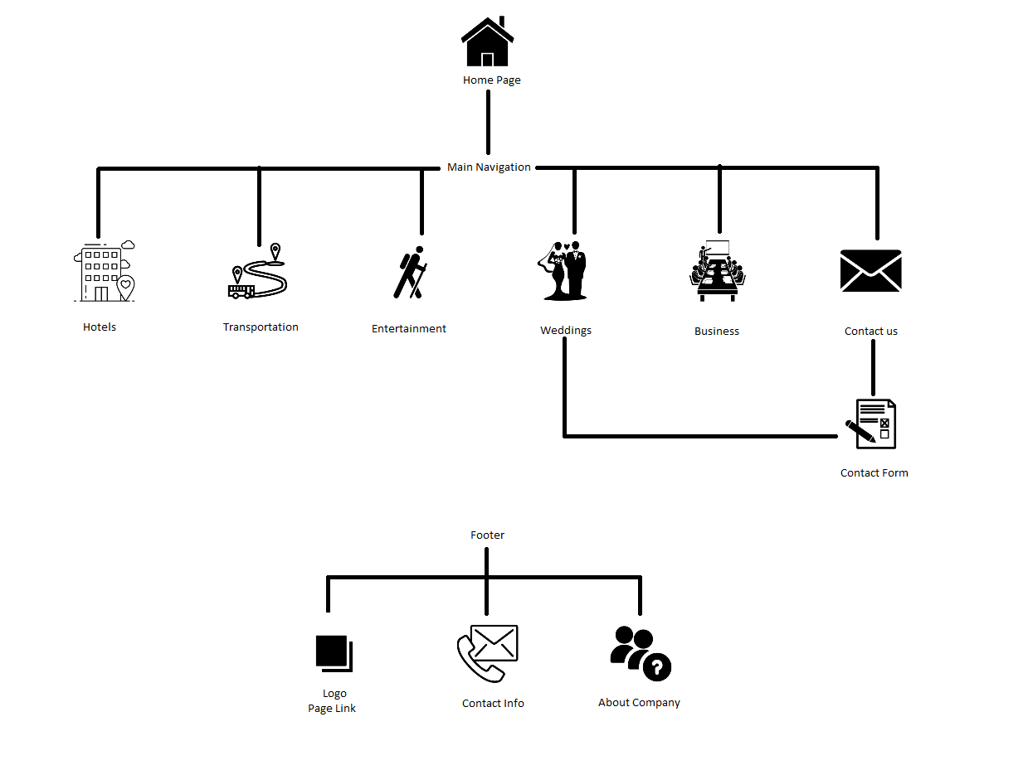

# Home Page

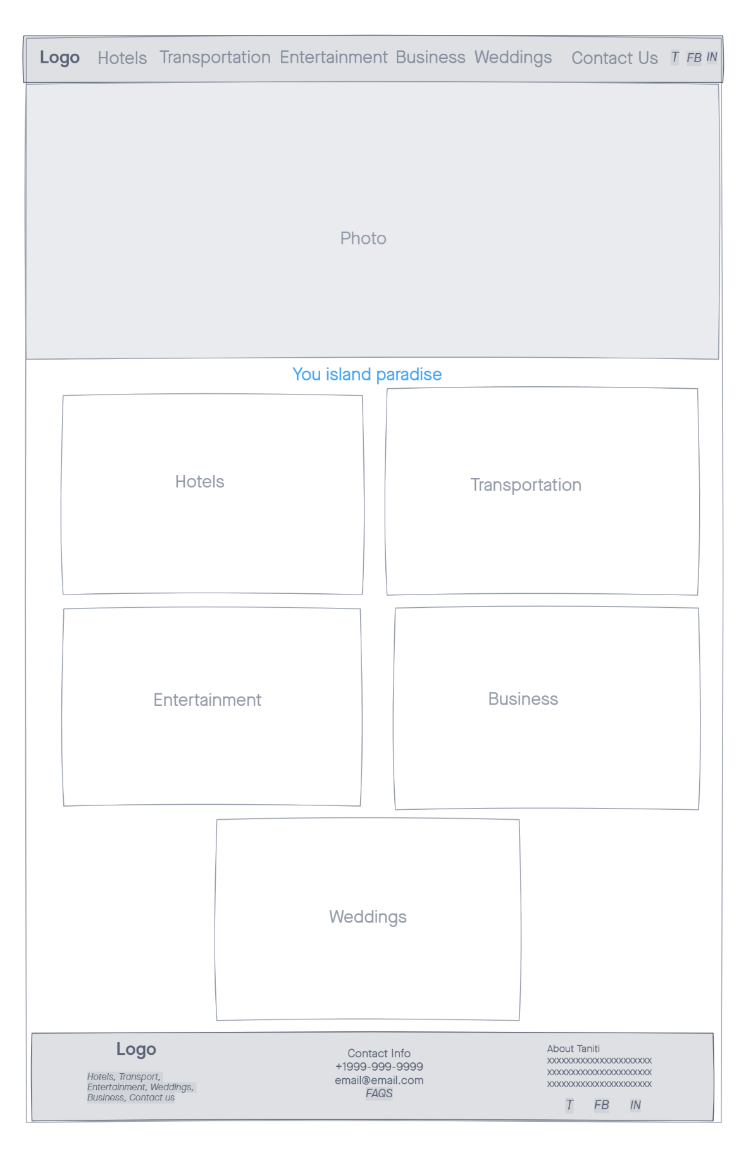

# Transportation

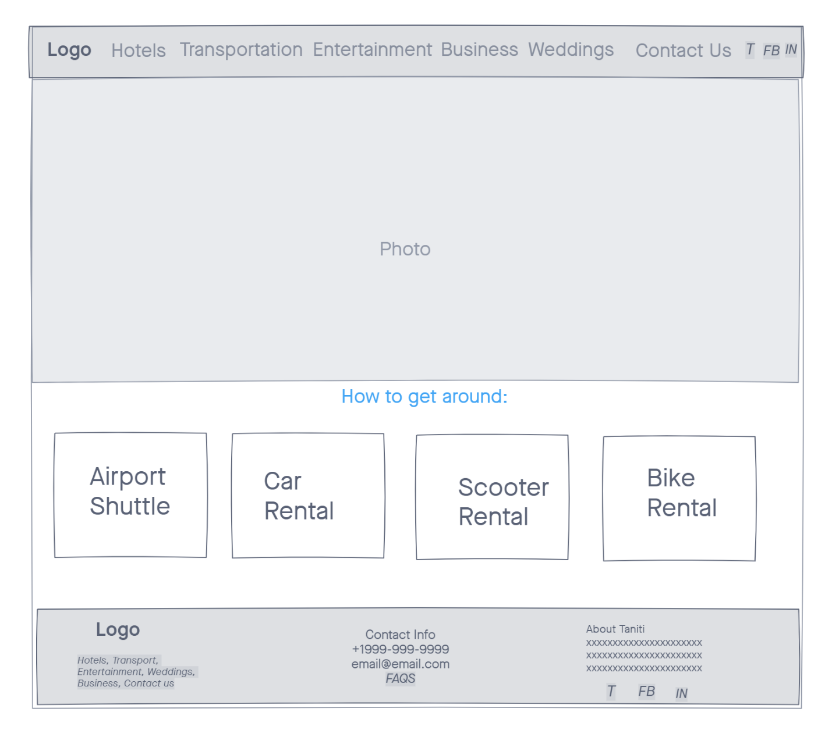

# Entertainment

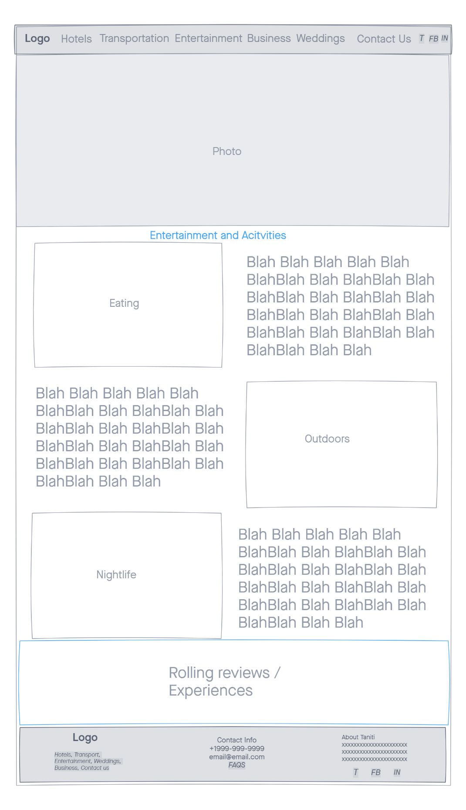

# Weddings

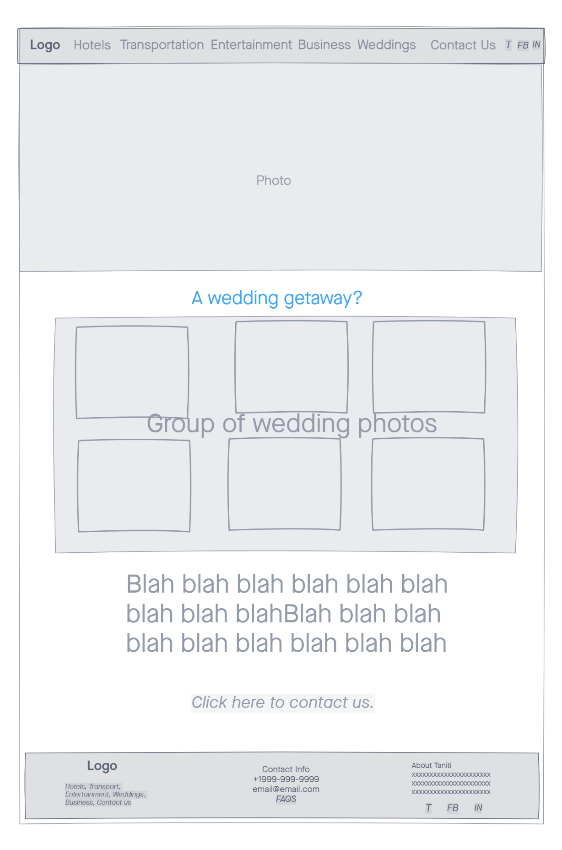

# Business

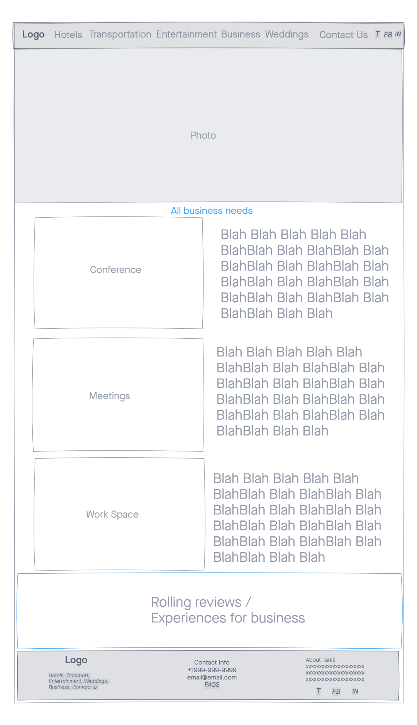

# Contact Us

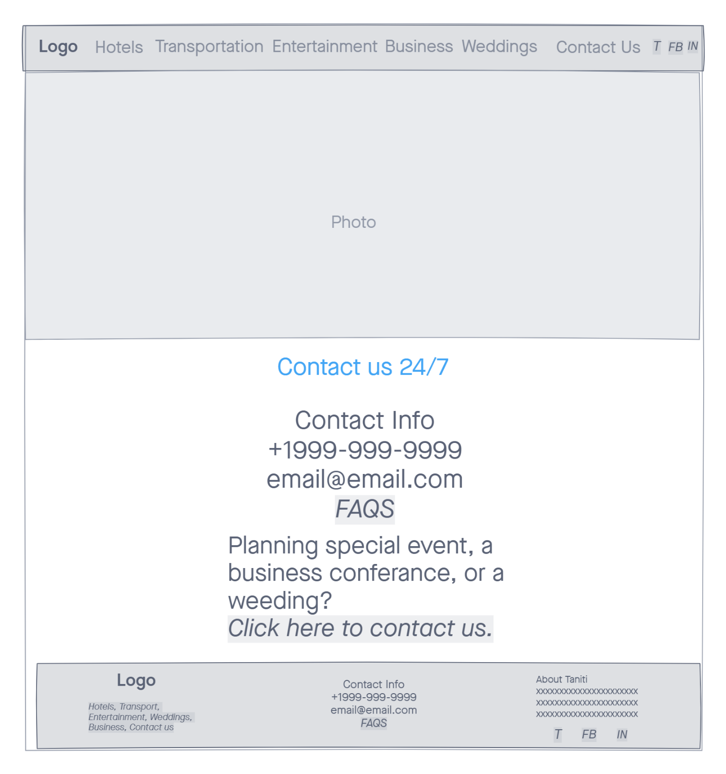

# Contact Form

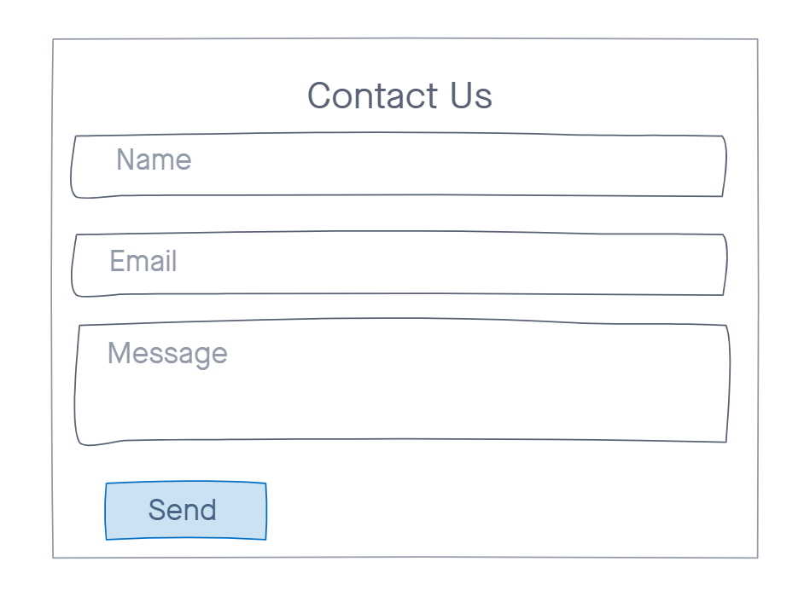

# guerrilla Testing

# Users

 Name: James

Age: 32

Occupation: Painter

Ideas: Social media links should be removed from the top.

Actionable: Yes

Name: Babs

Age: 58

Occupation: Inventory specialist

Ideas: Restaurants should be part of entertainment.

Actionable: Yes

Name: Sherri

Age: 37

Occupation: Human resources manager

Ideas: Sports bars should be a featured item.

Actionable: Yes

# Summary

The feedback of the guerilla testing was mainly positive. All users loved the idea of the website being easy to use and easy to follow.

James thought removing the social media links from the top would make the page flow better. He thinks if they remained on top people would not explore the site at all. He is fine if they stay where they are since it is common to be in the top or bottom.

Babs thinks that restaurants should be part of the entertainment page. She loved how simple the site it has an easy to understand flow. She thinks that on the contact page the social media links should look different.

Sherri wanted to have a section focus on sports bars because it is a main way she relaxes and many of her colleagues.

# Incorporating Feedback

All the suggestions are easy to add to the site. Some of the ideas are good add which I will implement on the prototype showing in section E. Other ideas are good in theory but can clash with other website contents.

Regarding James suggestion for removing the social media links from the top I am going to remove them. Normally people like having two ways for navigation, but to many social media links can cause issues.

Regarding Babs idea of making a different social media icon for the contact page would be a good choice if every page did not have two ways to navigate to such sites, so I will not be implementing that change. I will make sure that restaurants are a main part of the entertainment page since it is one of the main pillars of entertainment.

Regarding Sherri input of having a bigger focus on sport bars is to specific to put in but making sure potential vacationers that a lively bar scene exist would be a good point to add to the site.

# Interactive Prototype

Website prototype can be found here:

[Click here](index.html)

All photos and vectors sourced from non-credit website <https://unsplash.com/>