
UNIVERSITE SAINT-JOSEPH DE BEYROUTH
Ecole Supérieure d’Ingénieurs de Beyrouth

Master 2 Thesis Report
For the fulfillment of the requirements of the Master’s Degree in
Applied Artificial Intelligence
Comparing Temporal Convolutional Networks and ANFIS
under Concept Drift in Cryptocurrency Volatility Forecasting:
A Leakage-Free Walk-Forward Evaluation Framework
Prepared by
Mathieu Ajaka (252880)
Supervised by
Dr. Abdallah Bou Rahal
Date of defense: 6/2/2026
Academic Year 2025–2026

Abstract
The comparison of learning architecture in financial time series is not straightforward: due to evaluation protocol, results can be effectively manufactured before any model is trained and the evaluation pipeline for this thesis was reworked, as the original in the methodology yielded findings that did not survive scrutiny. This thesis compares a Temporal Convolutional Network (TCN) to an Adaptive Neuro-Fuzzy Inference System (ANFIS) under concept drift; however, the actual research was only conducted once the evaluation pipeline was in the final form of execution.

The first contribution to this thesis is through methodology. An audit of the original research set-up revealed four flaws which together inflated apparent performance and apparent drift: in-sample measurement of pre-drift baseline, seed level pseudo-replication, destruction of TCN's temporal ordering during bootstrapping, and too few independent evaluation windows. After the four flaws are accounted for, the original target (next day price direction based on daily OHLCV data) exhibited no statistically significant out-of-sample difference between TCN and ANFIS or between the five comparisons to strong baselines; additionally, the previously reported “drifting decay” was actually a normal difference between in-sample and out-of-sample accuracy. For the tree ensemble models, the in-sample baseline figures for the tree ensemble models had inflated reports of in-sample to out-of-sample degradation by almost a factor of ten.

The second contribution stems from the importance of validating non-existent comparisons rather than abandoning invalid comparisons. Therefore, the study retargeted onto an actual measurable quantity from price history: the volatility regime for the following twelve hours (assessed using hourly Binance data for BTC, ETH & BNB) in 213 leakage-free walk-forward windows. The two architectures ranked similarly in that they provided comparably valid AUC measures (0.68 for TCN and 0.64 for ANFIS). Additionally, at the naïve 0.5 cut-off, the Matthews correlation coefficient shows a large difference between the two models (0.247 for TCN versus 0.014 for ANFIS); however, an honest threshold assessment shows that a large proportion of the observed difference relates to differences in calibration rather than difference in extractable signal. At threshold points chosen honestly on hold-out data, TCN continues to lead (0.236 to 0.189) and at the oracle threshold (for the most optimistic cut for each model) where the relative order remains unchanged, TCN remains ahead (0.314 for TCN to 0.266 for ANFIS). TCN is also better calibrated than ANFIS. The most conservative overlap-aware inferences provide statistical significance for only the fixed-threshold gap; therefore the advantage of the TCN is a small yet significant producer of consistent results: the advantages of TCN will remain in situations where there is a shift in the volatility regime. Both the TCN and ANFIS clearly outperform the classical HAR and GARCH volatility baselines.

The central finding of this thesis is that for a target metric in common between TCN and ANFIS, the convolutional receptive field has facilitated a greater degree of operational reliability for calibration and decision-making than the fuzzy ruleset and that this calibration and decision-making advantage persists rather than otherwise under shifting conditions. The more general conclusion is simply this: architectural conclusions in financial machine learning will only possess the degree of trustworthiness of the baseline against which they compare, and the measure of metric employed within the architectural comparison.

Keywords: temporal convolutional networks; ANFIS; concept drift; volatility forecasting; walk-forward evaluation; data leakage; Matthews correlation coefficient; cryptocurrency time series.

Acknowledgements
My great gratitude goes out to my supervisor for providing me with guidance throughout this project. The emphasis placed on scrutinizing my own findings prior to providing justification for them was a primary contributor to changing the course of this project more than any other technical input provided.

The many friends who have provided me with feedback on my early drafts and who challenged me in regard to statements that were based on analyses that were too weak, are also greatly appreciated. Your challenge was often given to me at critical points in my development. Finally, I thank my family for their continued support throughout the many months that I spent telling them all “almost finished” at the beginning of every conversation.

Contents
Abstract 2
Acknowledgements 4
Contents 5
List of figures 7
List of tables 8
Acronyms 9
1 Introduction 10
1.1 Background and Context 10
1.2 Problem Statement 10
1.3 Research Gap 10
1.4 Research Objectives 11
1.5 Research Questions 12
1.6 Thesis Organization 12
2 State of the Art 14
2.1 Background of the Research Area 14
2.2 Theoretical Foundations of the Two Architectures 14
Temporal convolutional networks 14
Adaptive neuro-fuzzy inference systems 15
2.3 Concept Drift: Definitions and Detection 16
2.4 Volatility Forecasting and Learning-Based Approaches 16
2.5 Review of Existing Approaches 17
2.6 Critical Analysis of Existing Work 17
2.7 Identification of Research Gap 18
3 Methodology and Technical Approach 20
3.1 General Methodological Approach 20
The four corrections 20
3.2 Design Rationale 21
3.3 Tools, Models, Software, and Data Used 23
3.4 Data Understanding and Preparation 23
Targets 24
3.5 Modeling and Analytical Strategy 24
Regime segmentation 24
The two models 24
3.6 Assumptions, Parameters, and Constraints 25
3.7 Experimental / Numerical / Analytical Procedures 25
Statistical inference and effect sizes 27
4 Implementation / Modeling Setup / ML Pipeline 30
4.1 Model Development or System Implementation 30
4.2 Experimental or Modeling Setup 31
4.3 Data Collection and Processing 32
4.4 Challenges and Adjustments 32
5 Results and Evaluation 34
5.1 Presentation of Results 34
The corrected null on daily direction 34
The learnable target: next-12h volatility regime 35
5.2 Analysis and Interpretation 37
Behaviour under concept drift 39
5.3 Validation of Findings 40
Robustness across assets 40
5.4 Sensitivity Analysis and Limitations 41
6 Discussion and Impact 42
6.1 Technical Contributions 42
6.2 Engineering and Practical Implications 42
6.3 Environmental, Economic, or Societal Impacts 43
6.4 Threats to Validity 44
7 Conclusion and Future Work 45
7.1 Summary of Main Findings 45
7.2 Conclusions Related to Objectives 45
7.3 Recommendations and Future Work 46
8 References 48
Appendix 1 — Reproducibility 50
Declaration of AI Usage 51

List of figures
Figure 1. Overall research framework linking the problem, the methodological correction, the experimental pipeline, and validation.
Figure 2. The TCN as configured here: three residual blocks of dilated causal convolutions (dilations 1, 2, 4; kernel 3; 64 channels).
Figure 3. The ANFIS as configured here: Jang’s five-layer Takagi–Sugeno design with Gaussian membership functions over six MI-selected features.
Figure 4. The leakage-free walk-forward window design: train, held-out pre-drift, and post segments.
Figure 5. Corrected out-of-sample MCC on the original daily-direction task: every confidence interval brackets zero, except ANFIS on ETH which is significantly negative.
Figure 6. Per-asset MCC and AUC on the next-12h volatility-regime task, with cluster-bootstrap 95% confidence intervals.
Figure 7. Paired per-window MCC distributions for TCN and ANFIS on the volatility-regime task.
Figure 8. Threshold-fair and overlap-aware evaluation schematic.
Figure 9. Skill under same-regime versus regime-shift windows: the drift decomposition.

List of tables
Table 1. The four methodological flaws, their location in code, and their consequence.
Table 2. Degradation ratio under an in-sample versus a held-out pre-drift baseline (BTC).
Table 3. Causal OHLCV-derived feature set.
Table 4. Architecture and training configuration for the TCN and the ANFIS.
Table 5. Headline volatility-regime results by asset and pooled.
Table 6. Paired window-level significance tests on the volatility-regime task (pooled).
Table 6b. Overlap-aware significance for the TCN-versus-ANFIS gap (naive, non-overlapping, Nadeau–Bengio).
Table 7. Drift decomposition: same-regime versus regime-shift windows.

Acronyms
Acronym | Definition
ADX | Average Directional Index
ANFIS | Adaptive Neuro-Fuzzy Inference System
ARCH | Autoregressive Conditional Heteroskedasticity
ATR | Average True Range
AUC | Area Under the ROC Curve
DR | Degradation Ratio
DSI | Decision Stability Index
ECE | Expected Calibration Error
GARCH | Generalized Autoregressive Conditional Heteroskedasticity
HAR | Heterogeneous Autoregression
LSE | Least-Squares Estimation
MCC | Matthews Correlation Coefficient
MF | Membership Function
MI | Mutual Information
OHLCV | Open, High, Low, Close, Volume
ROC | Receiver Operating Characteristic
RSI | Relative Strength Index
RV | Realized Volatility
TCN | Temporal Convolutional Network
VWAP | Volume-Weighted Average Price

1 Introduction

1.1 Background and Context

There exists an awkward intersection between machine learning and financial market forecasting due to an abundance of inexpensive data, obvious payoffs, and well-documented methodologies. The academic literature provides numerous examples of failed replication attempts by researchers when they attempt to replicate the results of previous studies. The difficulties associated with the cryptocurrency markets serve to emphasize these challenges. Specifically, the cryptocurrency markets exhibit the characteristics of high volatility, continuous trading, and feature similar stylized properties to traditional financial assets (e.g., heavy tails, clustering of volatility, and gradually varying parameters) but in a more extreme compressed fashion (Cont, 2001). Consequently, the cryptocurrency markets provide a unique environment to investigate the performance of forecasting models as the underlying process generating the data changes and is a central topic of this thesis.

This investigation will examine two models that differ in their learning methodologies. Temporal Convolutional Networks (Bai, et al., 2018), which is the first model being examined in the current study, utilize dilated causal convolutions applied across a temporal sequence of data with a relatively small number of parameters and yield stable gradients. As a result, temporal convolutional networks serve as a strong default model for modeling temporal sequences (often performing as good as or better than recurrent neural networks). The second model to be examined is an Adaptive Neuro-Fuzzy Inference System, developed by Jang (1993), which operates from a completely different paradigm, encoding Takagi–Sugeno fuzzy if-then rules into a differentiable network resulting in the combination of the interpretability of fuzzy logic with the ability to train the model using data-driven means. The comparative results of these two model families serve to contrast the differences in their respective inductive bias. A temporal convolutional model forms its inductive bias by learning the temporal relations within the data through successive applications of convolutional layers. Conversely, an adaptive neuro-fuzzy inference system partitions the input space into fuzzy subsets and determines local linear responses for the resultant subsets. The question of which model's performance degrades more gracefully when the underlying distribution changes is fundamentally an issue of inductive bias as opposed to a question of tuning.

1.2 Problem Statement

Ultimately, the question that this thesis deals with from an engineering standpoint is not “Which model produces superior cryptocurrency prediction?”; rather, the inquiry is more specific and uncomfortable: “Under what evaluation conditions will I be able to discern a difference between the two architectures?” and (once those conditions are satisfied) “Does an actual difference exist between them?” The difficulty of this problem arises from multiple confounding issues, including:

- Two conflicting technical concerns: evaluations that are leakage-free restrict the number of observations available per window, while realistic exposure to drift restricts power.

- The absence of any established unified protocol for comparability in architecture under drift means each study uses differencing design choices, and those decisions are seldom subject to audit.

- Several conventional metrics used to measure performance (accuracy and naive degradation ratios) can be misleading when class imbalances and in-sample baselines exist, as the method of measurement itself may yield spurious findings.

- The interdisciplinary nature of this research position (location within time-series econometrics, deep learning, fuzzy systems) creates variances in convention as to what is considered appropriate for comparison.

In practical terms, all four issues from above impacted the first version of this project concurrently. Specifically, the original framework forecasts next-day price direction with daily open/high/low/close volume (OHLCV) data. ANFIS appeared more robust on one asset while TCN seemed to fail under drift; the effect sizes were substantial. None of these results could withstand further scrutiny, so a detailed analysis of why/what caused these effects cannot be seen as a negative outcome but rather as part of the contribution.

1.3 Research Gap

The literature regarding algorithmic adaptations to concept drift (Gama et al., 2014) has been developed and growing. Additionally, the literature surrounding financial machine learning is beginning to explicitly discuss issues of leakage and the necessity of not mixing cross-validation methods (Bergmeir & Benítez, 2012; López de Prado, 2018). However, there is currently little research which develops the connection between these two distinct bodies of knowledge well enough to compare different learning architectures under the same drift and report degradation against a hold-out, non-leaky reference. Studies that compare different architectures in the presence of concept drift have compared the degradation of the architectural model to an in-sample comparison before drifting occurred. As a result, the degradation reported have experienced some degree of overfitting due to not adequately controlling for the effects of drift. This thesis will therefore create a reusable protocol for isolating the contributing effects of generalization error from those of drift; and apply that protocol to a concrete architectural comparison.

1.4 Research Objectives
- Audit the original TCN-versus-ANFIS evaluation, identify every load-bearing flaw, and quantify its effect on the reported results.
- Build a leakage-free, walk-forward evaluation framework with a held-out pre-drift baseline and window-level statistical inference.
- Establish empirically whether the original target (daily price direction) contains a learnable signal at all, using strong baselines as a yardstick.
- Identify a forecasting target that is genuinely learnable from OHLCV history, so that concept drift has real predictive competence to disrupt.
- Measure, on that target, whether the TCN and ANFIS differ in skill, calibration, and robustness to regime shifts, across multiple assets.

1.5 Research Questions
The objectives will become clearer by answering the following four research questions in the order presented:
RQ1 - How much of the original reported drift-related degradation is caused by the evaluation protocol vs an attribute of the models, or the data to be evaluated?
RQ2 - Once leakage and pseudo-replication are removed, are there out of sample advantages when predicting daily price direction?
RQ3 - When predicting a learnable volatility related target, are there statistically significant differences between the TCN and ANFIS, and in what direction do those differences lie?
RQ4 - Are there any architectural advantages that hold up, narrow, or widen with the concept drift? Are those advantages consistent across assets?
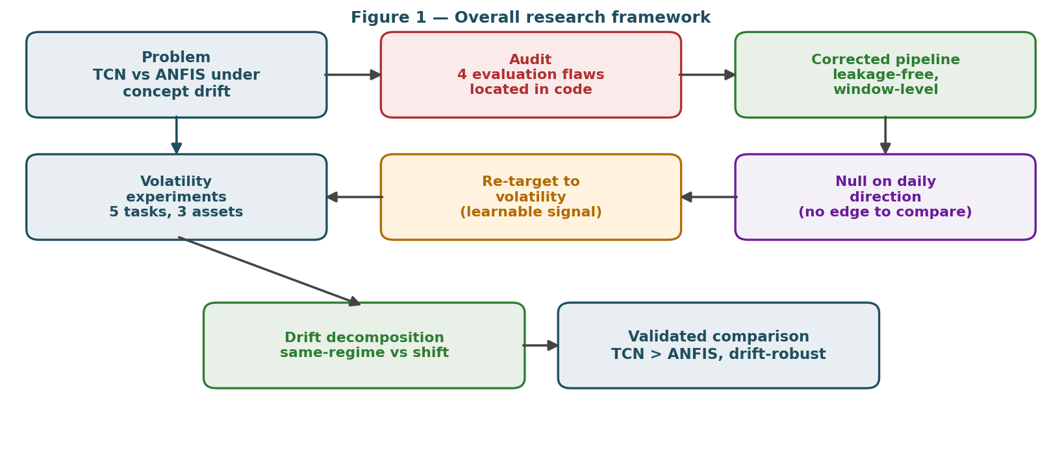
Figure 1. Overall research framework. The audit feeds a corrected pipeline; the corrected pipeline first establishes a null on daily direction, which motivates re-targeting to volatility; the volatility experiments and their drift decomposition produce the validated comparison.

1.6 Thesis Organization
In the second chapter, you will find an overview of both architectures, how they apply to the concept of drift, and the means to evaluate the soundness of financial models. The third chapter is focused on methodology; the four types of correctors that were developed, the use of a walk-forward design, the definition of a regime, and the metrics that were used. In the fourth chapter, there will be a description of the implementation; how the data was processed through the pipeline, how the features were built, how the two models were built in code and the changes that were made to make the application to the data function. The fifth chapter will present the results of the analysis; that is, the correct nulls for daily directional movement and the results of the volatility experiments; each of these sections will have all of the necessary data to present in the form of figures and tables. The sixth chapter will discuss and elaborate on what the results mean, what implications the results have for practice, and what limitations are present in the results. Finally, the seventh chapter will summarize the final objectives of this project and describe possible avenues for future work.

2 State of the Art

2.1 Background of the Research Area

Every available modeling tool has been utilized for the purpose of forecasting time-series financial data. The classic conditional variance models of ARCH and GARCH (Engle, 1982; Bollerslev, 1986) remain the basis for the modelling of financial time series. These models formalize the phenomenon of volatility clustering: large moves tend to follow large moves. This empirical observation (Cont, 2001) forms the basis for this thesis work. Volatility is autocorrelated and therefore forecastable in a way that signed returns are not, as indicated in the efficient market theory of Fama (1970) and empirically verified by this study.

With respect to advancements in models for learning, serial models have transitioned from recurrent to convolutional and attention-based systems. As outlined by Bai, Kolter and Koltun (2018), the TCN builds upon work done previously on convolutional sequences (i.e. Lea et al., 2017) through the use of dilated causal convolutional methods that can be as effective as or more effective than LSTMs on tasks with long-range dependencies and provide a more stable method of training. ANFIS provides an alternative to these models that has a long history but is still viable and applicable today. Introduced by Jang (1993) and grounded in the work of Zadeh (1965), ANFIS remains a viable alternative to recurrent/convolutional networks, particularly in tasks requiring a degree of interpretability (i.e., usage in finance and control).

2.2 Theoretical Foundations of the Two Architectures

Temporal convolutional networks
A TCN is a one-dimensional convolutional network made out of two simple elements: causal convolution and dilation. A convolution is causal if, at a particular time t, its output is contingent solely upon inputs at times t and before. This feature is contingent upon the kernel's width. Namely, the input is left-padded with zeros of size k−1 and the overhang is discarded. While stacking solely causal convolutions would cause the receptive field to expand linearly with depth, dilations do so for TCN by means of dilation. The factor d causes a distance d between the kernel taps, so that a layer sees the input at time t, t−d, t−2d, and so on. When dilation doubles from layer to layer by 1, then 2, then 4, and so forth-the receptive field expands exponentially with depth, allowing a few layers to cover a sequence of dozens of bars. The choice in use here-three residual blocks with dilations by 1, 2, and 4 over a kernel size of 3-accounts for the twenty-four-bar input context with very few parameters.
Two further design aspects greatly contribute to stability. Residual connections sum a block's input back to its output, which allows gradients to remain well-behaved as depth increases, and it allows the Network to be defaulted to an identity mapping when extra capacity for a building is not needed. Weight normalized reparametrizes each filter into a direction and a magnitude making the optimization landscape smooth and convergence rapid. Against recurrent networks, a TCN executes a sequence in parallel instead of steps, avoids the vanishing gradient pathologies of backpropagation through time, and retains a fixed and auditable receptive field. That is why Bai et al. (2018) found it competitive or superior to LSTM over many sequence benchmarks and a natural candidate for a target, volatility with temporal autocorrelation as its defining point.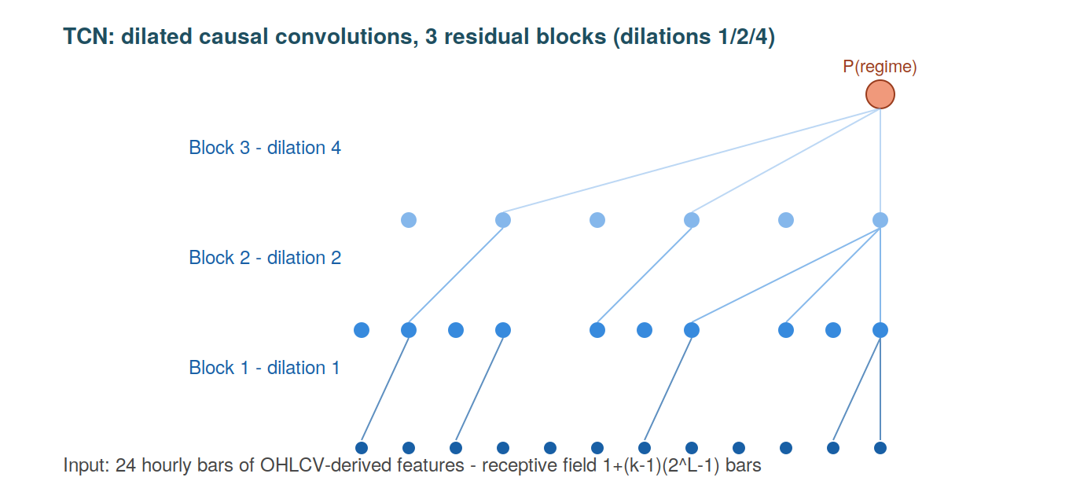
Figure 2. The TCN as configured here: three residual blocks of dilated causal convolutions (dilations 1, 2, 4; kernel 3; 64 channels), giving an exponentially growing receptive field over the 24-bar input with few parameters.

Adaptive neuro-fuzzy inference systems
An Adaptive Neuro-Fuzzy Inference System (ANFIS) maps a Takagi–Sugeno fuzzy rule base onto a layered, differentiable network (Jang, 1993) that uses a small number of (Gaussian) fuzzy membership functions to represent each input feature. The parameters of each fuzzy member function represent the center and width of that fuzzy membership function and provide the "premise" parameters for the ANFIS. Each rule is comprised of one fuzzy membership function per input variable, and the firing strength of that rule is computed by taking the product of the values of the fuzzy membership functions representing each variable from the current set of input variables (i.e., "to what degree does the current input belong to this fuzzy region"). The firing strengths of all rules are normalized, and the output of the network is equal to the sum of the local linear responses corresponding to the input variables that produce each rule (i.e., "consequence of the rule"). In Jang's original hybrid approach, the tuning of the premise parameters is by the gradient descent method, while the tuning of the consequence parameters is solved by the least squares method. This thesis solves the consequence parameters in closed form with ridge regularization and fixes the premises of each fuzzy member function using per-feature k-means clustering. For this reason, the ANFIS model computed in this thesis is fast and deterministic based on the provided seeds.
The attractiveness of the ANFIS architecture is that it provides an interpretable model with a smooth locally linear response surface, which is why ANFIS is still popular in both financial and control applications (Atsalakis and Valavanis, 2009). The structural limitation of ANFIS is the number of fuzzy membership functions raised to the number of input variables produces an exponential growth of rules; hence, the ANFIS model has tractable application only to compact feature sets developed without regard to temporal coherence. The response from an ANFIS model is generated from pointwise fuzzy member functions rather than using an explicit sequence to define the response. Consequently, the ANFIS model has no temporal receptive field, except for whatever structures happen to be constructed by the engineered feature sets used as input to the model. An ANFIS model can miscalibrate the partitions in the feature space based on drift or distribution changes, and therefore can have poor extrapolative ability when using local linear consequences that are non-contiguous to the training data. Therefore, the difference between ANFIS and TCN models can be viewed as differences in their inductive bias (i.e., ANFIS has fuzzy space partitioning, while TCN has temporal convolution); hence, the difference between ANFIS and TCN models will provide the basis on which to compare model performance.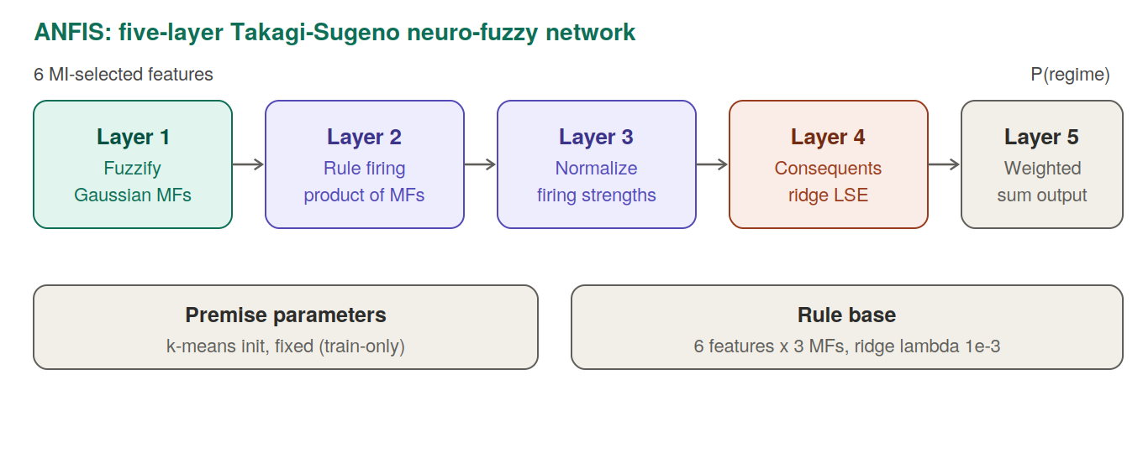
Figure 3. The ANFIS as configured here: Jang's five-layer Takagi-Sugeno design with Gaussian membership functions, k-means premise initialization fixed on training data, and ridge least-squares consequents, over six mutual-information-selected features.

2.3 Concept Drift: Definitions and Detection

Concept drift refers to changes in the joint distribution of inputs and their associated target variable over time. According to the Gama et al.'s (2014) taxonomy of drift types, the fundamental difference between the ‘real’ and ‘virtual’ drifts is primarily due to the fact that the real drift has occurred because there has been some change in the conditional distribution of the target given the new input distribution. In contrast, the virtual drift is due simply to the fact that there has been a change in the input distribution alone, while the conditional distribution has not undergone any significant alteration. This distinction is important as many researchers who work in this broad area, both practitioners and researchers alike, continue to confuse the real drift and the virtual drift, thereafter their research will either lead them to make inaccurate inferences or lead them to measure and report virtual drift measures as measures of real drift.

Drift can also be classified according to the tempo of the phenomena causing the drift to occur: sudden shifts, gradual transitions, incremental change, and recurring states that occur after a period of absence, e.g. cryptocurrency’s volatility has been primarily recurring in nature, as calm and turbulent volatility occurs in alternating periods over the course of weeks and months, therefore, the definition used in this thesis will reflect the operationalization of drift based on the time-varying volatility of the underlying processes, rather than according to a single change point. The detection of drift can be accomplished through procedures based on statistical monitoring of various aspects of the error stream, e.g. windowing systems (Bifet & Gavaldà, 2007), whereby a reference window (i.e. a period of time) can grow or decline in size, depending on whether the distribution of the incoming data varies from the distribution of the historical data. Recent reviews (Lu et al., 2019; Bayram, Ahmed, and Kassler, 2022) reveal that a considerable number of drift detectors and drift adaptation techniques have been developed, however, they also show that a significant methodological gap exists, as degradation as a result of drift is typically reported in relation to data that has still undergone drift; therefore, the drift-based statistic presented in these reports is likely to be a mix of drift and typical generalization error. This is the methodological issue that this thesis addresses through its work.

2.4 Volatility Forecasting and Learning-Based Approaches

The use of volatility as a target for forecasting has a long history in finance. While returns are close to being serially uncorrelated, the magnitude of returns displays strong autocorrelation, with clusters of large returns and clusters of small returns (Mandelbrot, 1963; Cont, 2001). This is the feature that the ARCH and GARCH (Engle, 1982; Bollerslev, 1986) families were created to model, which explains why realized volatility is forecastable from its own past unlike signed return through the use of realized volatility estimates based on high-frequency data (Andersen et al., 2003). As a result of the development of realized-volatility estimators, volatility has become a quantity that supervised learning can directly target through its measurability.

The field of forecasting volatility through learning methods has been rapidly expanding in recent years. The combination of GARCH components with neural networks and stand-alone LSTM and temporal convolutional networks has shown consistent improvements when compared to traditional benchmarks in equities, foreign exchange, and, more recently, cryptocurrencies (Bucci, 2020; Christensen, Siggaard, and Veliyev, 2023). The cryptocurrency marketplace has a high level of activity and experiences very large price swings on a regular basis, both of which serve to increase the clustering of volatility and provide additional challenges for any architecture attempting to model it over the transition from one state of the world to another (Catania and Grassi, 2022; D’Amato, Levantesi, and Piscopo, 2022). However, relatively little of the work that has been conducted in this area has compared two specific model architectures in a controlled manner or under a leakage-free protocol. This paper utilizes the concept of forecastability of volatility as a precondition for comparing the two architectures, rather than using it as an outcome measure, so that the results of the comparison are meaningful.

2.5 Review of Existing Approaches

The concepts regarding concept drift provides the vocabulary used in this thesis. Gama et al. (2014) provide the standard taxonomy for differentiating between real drift (which denotes when there has been a change in the conditional distribution) and virtual drift (which occurs when there has only been a change within the input distribution). Additionally, they also provide an overview of various detection and adaptation strategies, including Bifet and Gavaldà (2007)’s adaptive windowing. The principal idea taken from this work is that drift should only be measured with respect to a reference that is also unbiased; otherwise, anything that is not stationary (e.g., covariate shifts) can be misclassified as real drift.

Two differing strands of research on evaluation are examined in this section. The studies examined by Bergmeir and Benítez (2012), which examined cross-validation for predicting time-series data, expressed preference for blocked (non-random) and ordered cross-validation methods rather than random splits. López de Prado (2018) also provides an extensive examination of how machine learning algorithms used for financial purposes typically “leak” information related to overlapping labels, variables related to prediction (look-ahead features), and by using improper sample weights that are assigned to different samples, though they have recommendations to mitigate these issues using walk-forward testing and proper labelling schemes such as using the triple-barrier method. The primary metric used in this thesis to evaluate models is MCC based on the evaluation performed by Chicco and Jurman (2020). In their analysis of class imbalance, they provide the rationale for when MCC is the most informative metric available by highlighting how its four descriptive characteristics of the confusion matrix are accounted for with regard to probability values when evaluating machine learning algorithm performance in the presence of class imbalance. Regarding calibration, assessment is done via expected calibration error based on current practices defined by Guo et al. (2017) and previous modelling techniques defined by Niculescu-Mizil and Caruana (2005), which indicated that many high-performing machine learning algorithms predicted poorly-calibrated probability distributions.

2.6 Critical Analysis of Existing Work

The strength of the drift literature lies in its depth of algorithms, but the weakness for a comparative study like this is that it largely assumes the evaluation is already sound.; drift literature also assumes that the evaluations have been previously validated. The strength of the financial-ML literature is its healthy level of skepticism regarding leakages, while the weakness of the financial-ML literature is its lack of focus on architectural comparisons under drift, resulting in few interactions between both bodies of literature. Where there is overlap, such as in applied studies comparing neural and fuzzy models on market data, the evaluation is often one the weakest components of the research due to the following reasons; multiple train and test splits, in-sample baselines, measuring accuracy on an imbalanced response (e.g. predicting three or four positive returns) and estimating an effect size based on the set of seed values versus estimating an effect size based on a set of independent time windows. The original version of this research project replicated the above-mentioned weaknesses, thereby requiring an audit to correct these deficiencies, while also providing a new perspective for conducting research using this type of methodology while still maintaining the technical interpretations of all methodologies.

Another recurring issue is the selection of a dependent variable; many of the cryptocurrency forecasting papers are attempting to forecast either signed returns, the direction of the next price change or both; the Efficient Market Hypothesis and a substantial body of empirical evidence suggest that all of these dependent variables are virtually unpredictable (except on a very short time frame) when utilizing standard econometric techniques. As such, when a dependent variable has no signal, no single architecture will differentiate itself, and therefore, any differences reported are either due to leakages or noise. Reframing the question to forecast volatility, which is a forecastable measure, is not a form of "trickery" to exploit a positive finding; it is a suggested standard research design that is found in all fields of econometrics.

2.7 Identification of Research Gap
Connecting everything, there is a difference between TCN and ANFIS where (i) drift is measured vs a held-out, pre-drift reference point instead of using in-sample; (ii) many independent walk-foreword windows are used for statistical inference instead of using seeds; (iii) the ordering of TCN’s time remains intact; and (iv) the models have a target that has a signal makes comparing model performance useful. The work presented here aims to fill this gap by developing a corrected protocol that can be reused across studies of models other than the one included within this thesis.

3 Methodology and Technical Approach

3.1 General Methodological Approach

The overarching research methodology is both empirical and experimental and follows the traditional workflow of a supervised learning study with the following steps involved: data acquisition, preprocessing, modelling, evaluation, and interpretation. However, the research has two features that make it unique within the context of this thesis. One feature is the evaluation protocol that has been studied as a separate entity ( i.e., not merely plumbing to establish what the data signal is), including a successive auditing and verification of the evaluation methodology used prior to the reporting of any comparative results of models. In order to verify that an evaluation methodology will produce correct evaluations, the author used data from a synthetic control that had a known signal for purposes of validation. A second feature of this work is that the experiment has revealed a valid experiment in the form of the selection of the original target forecast to test. The measuring of the learnable signal from the original target forecast using market data only established that there was not a signal present to determine the forecast for market prices (or other financial market assets). At this point, a suitable target forecast could be selected for comparison.

The significance of the chronological method used to document this process is important when considering the defensibility of any documented market data. When such results (positive results on market data) are presented to experts in forecasting there may be a tendency for them to question whether there was an error in the creation of the data (or the analysis) that resulted in an observed gain or whether it is merely a product of the duration of time after the forecasting occurred. By showing that a true null was recovered on a hard forecast using the same pipeline that was later used to obtain a positive result on an easier target, this research demonstrated that the use of the pipeline did not create a learnable forecast signal where one did not exist. In this way the true null provided the control for the positive documented result.

The high-level strategy described can be summarized in five steps. The pipeline is composed of hourly OHLCV data that is received and causal features derived from the data in the pipeline process. Each asset's history of profitability is divided into many overlapping walk-forward windows and is divided chronologically into training, independent pre-drift, and independent post-drift segments. Models are developed based on the training segment only and all preprocessing is fit to the training segment. Model performance is subsequently evaluated out-of-sample on the post-drift segment, and compared with performance on the pre-drift independent segment to evaluate deterioration of model performance through the pre-drift independent and post-drift independent segments. Finally, the results are aggregated across walk-forward windows and across assets using two methodologies: clustering of bootstrap method for confidence level estimation across windows, and significance testing based on paired sample testing across walk-forward windows.

The four corrections
The audit located four flaws in the original pipeline. Each is described below with its location in the code and its consequence, because the corrections are the methodological core of the thesis.

# | Flaw | Location | Consequence
1 | Pre-drift accuracy measured in-sample | Predictions for the “before” baseline were taken on the training block itself | The degradation ratio mixed overfitting with drift, so it could not isolate either
2 | Pseudo-replication over seeds | Thirty seeds resampled the same fixed window; sixty test rows were treated as independent | p-values and Cohen’s d were inflated; the effective sample was about two windows, not sixty
3 | TCN temporal order destroyed | Rows were bootstrapped with replacement before the sliding window was applied | The TCN’s sequence structure was corrupted, so part of its apparent collapse was an artifact
4 | Too few independent windows | Two regime pairs with fixed train/eval blocks | One or two usable windows per asset, far too few for any stable inference
Table 1. The four methodological flaws, their location in code, and their consequence.

Corrections will occur directly; we have moved our pre-drift baseline from an in-sample to an out-of-sample segment that has never been utilized for fitting. This now means that our corrected degradation ratio is a comparison between out of sample versus another out of sample dataset. Before test, seeds are averaged within a window and this has the effect of reducing the overall noise level without increasing sample size; therefore, when assuming that you are performing an inference across a series of windows this yields a more accurate estimation of within-subject variation than if you had done so across all windows (i.e. estimating from the total number of seeds in each window).

The with-replacement row bootstrap has been completely eliminated; the sequence of TCN data has been maintained, while estimating the variance of within-window samples using only initialisation seeds. Finally, we have replaced the previous fixed block design with a length-based rolling walk forward design, resulting in 71 overlapping windows being generated per asset (or 213 total pooled), as opposed to only one or two in prior executions; a maximal non-overlapping subsample provides approximately a dozen of truly independent total windows being produced per asset, which is the foundation for performing overlap aware inference.

3.2 Design Rationale
When developing design choices, it is natural that one would wonder why one design choice was made over another design choice. In a comparison study, a comparison study is only defensible if those choices are justified rather than just assuming it. Therefore, the intent of this section is to lay out the reasoning behind each design decision so that there is no ambiguity of that given reasoning.

- Why use cryptocurrency? The cryptocurrency market is unlike traditional financial markets in that there are no circuit breakers or halts to trading and, therefore, offers uninterrupted long periods (hours) of data and supplies exaggerated representations of the stylized facts associated with traditional forms of investment. The crypto market also provides an abundance of long-lasting volatility regimes that will demonstrate non-stationarity while conducting a drift study, and due to the large amount of readily available public data, it will offer the opportunity for empirically testing previous results using virtually leak-free public data.
- Why use only OHLCV data as inputs? The use of OHLCV only prevents the successful model used to be attributed to the superiority of the data feed used. This will help guarantee that there is a clean and reproducible comparison of the results based on one common data source; however, limiting the inputs will limit the broad applicability of a thesis as accepted by the author.
- Why is volatility chosen instead of direction? The signed return is, over short time intervals, almost a martingale difference with almost no learnable signal for prediction and therefore no basis by which to compare two models; as described in Chapter Five. In contrast, volatility is autocorrelated and thus offers some basis by which to make predictions. Thus, without an objectively measurable signal or defined metric to compare the two models, the resulting comparison could only result from "leakage" or "noise".
- Why use hourly data with a 12-hour forecast horizon? By using hourly bars, it is possible to create multiple independent windows while still accounting for the daily clustering of volatility; however, the 12-hour forecast horizon allows for the relationship between clearly understanding the realized-volatility label and not being highly affected by microstructure noise. Still today, forecasting under only one regime for 12 hours will remain a legitimate forecasting problem, and the 12-hour forecasting horizon allows for enough three-months worth or twelve hours of independent forecasts created through the same upper 1/3 of each 12-hour increment of the realized volatility label without needing to use aggressive resampling.
- Why was MCC the primary metric for comparison? Due to the class imbalance existing in the case of analyzing volatility spikes using accuracy or F1 scores as measures of success leads to falsely concluding the effectiveness of a model. The Matthews correlation coefficient utilizes the total predictions discussed in Class 2; therefore, if the model constantly predicts the same value, the Matthews correlation coefficient will reach a value of zero (Chicco & Jurman, 2020). In this case, the Matthews correlation coefficient is the metric least likely to indicate that the model being evaluated is statistically unchanged.
- Why perform a rolling walk-forward evaluation? Since random cross-validation of time series data results in the leakage of information into the past (i.e., the future is known), standard random cross-validation preserves temporal sequences while creating multiple exposures to any individual regime's change over time due to the rolling window design. In addition, rolling windows will create multiple independent windows, which will enable conducting window-level inference.
- Why compare the TCN and ANFIS architectures? The TCN and ANFIS architecture were both originally compared in the current research, and have opposite inductive biases; namely, TCN uses explicit temporal convolution whereas ANFIS uses pointwise fuzzy partitioning. The amount of robustness that is imparted to the TCN model due to the explicit temporal representation will provide great insight into the extent to which the TCN architecture has an advantage over the ANFIS architecture when considering the results from the drift evaluation analyses.

3.3 Tools, Models, Software, and Data Used

The implementation has been done with Python 3.12 as well. Neural Network layers that will form the basis for both models and include the differentiable ANFIS forward pass, from PyTorch and be able to provide mutual information to find features that are correlated to our output variable using scikit-learn's functions. Additionally, five baseline learners will be provided that will give us an idea of how well we are doing in comparison to these baseline learners that we will use on the daily direction task. For both of our gradient-boosted baselines we have selected XGBoost and LightGBM. We have also created a pair of traditional volatility baselines, one being a Corsi-style heterogeneous autoregression (HAR) and the other a GARCH (1,1) that was created using the arch package, both implemented as reusable modules. In addition to these two models, we have created the traditional econometric benchmarks that are recognized in the literature as being difficult or impossible to beat, and these benchmarks serve as a baseline because they came up in the review process as a concern about validity; this underlying framework has been included in the following section, Threats to Validity. We also made extensive use of numpy and pandas to perform the numerical operations and to create causal features, and we created the figures using matplotlib, all of the randomness was seeded as well. The data consisted of hourly spot klines for BTC, ETH, and BNB for the last seven years against USDT from Binance; the data is from January 1, 2018 through December 31, 2025 and we are only looking at the open, high, low, close, and volume columns; we did not use any of the funding rate or open interest because we want to stay within the confines of the principles of OHLCV only for this project. The daily direction audit used the original daily BTC and ETH series along with a synthetic series in which the manner of the original generating process is by definition almost unpredictable with no clear trend; the synthetic series was used as our control; if the pipeline works correctly then it should find that this synthetic series has a null correlation to both the BTC and the ETH series.

For the selection of models for this project, we selected TCN and ANFIS because they represent the extreme opposite inductive biases that could occur when both models are tested under a fair and equal protocol. The TCN model learns to develop a direct temporal dependency through the application of dilated causal convolutions. The ANFIS model learns to partition the feature space into fuzzy partitions where local linear responsiveness can occur; other than what is encoded into the features, it does not contain an explicit sequence. The essence of the question being asked with this drift question is will the model that represents time in an explicit manner perform better when a distribution is shifted in time as compared to the model that does not represent time explicitly even if the two models are utilizing the exact same training data?

3.4 Data Understanding and Preparation
The klines in raw form are stored, time-ordered, and reduced into the five floating-point columns of OHLCV. The causal feature engine generates the predictors based solely on information available at or prior to the current bar; thus, no feature has any mean or standard deviation based on either data that are included in the evaluation period or data that are not included in the evaluation period. The feature set was adapted from a live trading system but was limited to the OHLCV-derivable features of the feature set, and therefore gives a realistic representation without any reliance on excluded elements of the dataset. Table 3 contains the list of features by category.

Group | Features
Returns | log returns over 1, 3, 6 and 12 bars
Volatility / range | ATR(14) normalized by price, 30-day ATR percentile, 12-bar realized volatility, a volatility-compression ratio
Momentum / trend | RSI(14), ADX(14)
Volume | 24-bar volume z-score, 6-bar volume change, signed volume imbalance
Price location | deviation from a 20-bar VWAP
Candle microstructure | spread proxy, body fraction, upper and lower wick fractions, wick imbalance
Time of day | sine and cosine encodings of the hour
Table 3. Causal OHLCV-derived feature set (about two dozen features; the regime-tagging volatility series is held out of the model inputs).

Due to the rolling-window structure of the time series, any rows with missing values cannot be included. To maintain large samples while still keeping the amount of data to be processed reasonable, the hourly series is downsampled by a factor of two for analysis purposes (i.e., eliminating every other bar). By doing this, the market regimes are still adequately covered between the downsampled bars and the total number of bars in the data set is reduced by half.

Targets

In terms of targets, there are four classifications and one regression target, all of which are causal and based solely on price. The main classification target is the volatility regime (binary), which will be classified as '1' if the realized volatility over the next twelve hours falls in the top third of realized volatility for the previous twelve hours. Because index returns are subject to clustering, volatility is a positively autocorrelated random variable; therefore, this classification target address how to disrupt drift. The volatility-direction classification target indicates if next-period volatility will increase or decrease. The volatility-spike classification target indicates if a significant volatility spike will occur (defined as less than 10% of total observations) — this is the most robust target. The regime-transition classification target indicates if the volatility regime will transition, and the realized-volatility regression target is used to predict the continuous log-level of variance. The daily price-direction classification target was retained only for auditing purposes (as a negative control providing evidence of reason for moving to volatility).

3.5 Modeling and Analytical Strategy

Regime segmentation

Regime segmentation will be accomplished via volatility regime as concept drift is operationalized. The causal procedure will assign each bar a label of one of four regimes via the expanding-window quantiles of a trailing volatility measurement. At each point in time the quantile thresholds are derived from historical data only up to and including that point in time. This ensures that no future data leaks into the regime assignment. Additionally, a causal rolling mode will smooth the single bar flips in the regime assignment. Each walk forward will be tagged with the label of if the dominant regime of the post segment differs from the training segment. This tag is what allows the later decomposition of performance into 2 windows (same regime and regime shift) or the operational definition of the drift used throughout.

The two models

The TCN consists of 3 residual blocks with dilations of 1, 2, 4 with a kernel width of 3, a channel count of 64, weight normalization and a dropout rate of 0.15. The convolutions will be left padded to ensure causality, the representation of the last time step will be passed into a linear head and then passed into a sigmoid function to produce the probability of being a member of the positive class. The inputs to the TCN will consist of sequences of 24 bars. Each of the three models will train using Adam and will have an early stopping mechanism based on a held-in tail of the training period and there will be 2 to 3 initialization seeds that are averaged at the window level to reduce variability.

ANFIS will follow Jang's five-layer design with Gaussian membership functions. The premise parameters (the centre and width of the membership functions) will be initialised using per feature k-means on the training data and will be seeded using the experiment seed so that the variation from seed to seed is valid. The consequent parameters will be calculated using ridge least squares in a closed form with a very small regularisation constant and the output will be passed into a sigmoid function to produce the probability. Since the number of rules increases as the number of membership functions to the order of the number of inputs, a compact rule base will be created us using the top 6 features with the maximum mutual information against the training labels with 3 membership functions per feature. This will keep the ANFIS model manageable and is also a valid method of training.

Assumptions, Parameters, and Constraints
To assist interpretation of the results, there are basic assumptions upon which the study is bound:
- OHLCV only. Models are only provided with price and volume derivatives and do not use any other data (e.g., order-book data, on-chain data, sentiment data). This is to ensure the comparison remains clear (to make the two architectures as similar as possible) and the resulting conclusions remain narrow.
- Continuously fixed decision threshold. The decision threshold is kept at 0.5 throughout the evaluation process to ensure that any threshold leakage due to using evaluation data does not exist in the final runs. As a result, the fixed threshold will produce a less-accurate classification than an optimal tuned threshold would have yielded.
- One unique configuration for each architecture. The TCN architecture uses one reasonable TCN and one reasonable ANFIS configuration. This study is intended to compare the two architectures in a controlled manner, not to perform a hyperparameter search.
- Volatility is more predictable than direction. This is an assumption backed up by the econometrics literature and is substantiated in Chapter 5 with empirical evidence. Volatility tasks will therefore be less difficult to accomplish than direction tasks; therefore, the thesis states this.

Key configuration parameters are window length of 2400 bars, step of 400 bars, 60% of the data as training, 13% of the data held out for pre-drift, and all remaining data for post-drift; sequence length of 24 bars; 4 different volatility regimes each with 60 historical bars with 60 bars of smoothing; the ANFIS ridge constant = 1e-3; and the TCN dropout = 0.15. These configuration parameters were chosen prior to the final runs and they were kept at the same values during the entire study in order to prevent tuning the protocol toward some desired outcome.

3.7 Experimental / Numerical / Analytical Procedures
The same process is applied for all assets/tasks, including partitioning the series into rolling windows, fitting a scaler based on training data within a window, and applying that scaler to the different segments of the same window; training both a TCN model using the training sequences and testing both the TCN model/ANFIS model by applying them to both the pre-drift/pre-drift segments. For every model/segment created, the pipeline records the accuracy, balanced accuracy, F1 score, Matthew's correlation coefficient (MCC), Area Under the Curve (AUC), expected calibration error, and the corrected degradation ratio between the pre-drift/post segments. The simplest code for a majority class predictor is run as a trivial baseline in all windows.
Three of these metrics serve as the main means of interpreting the results of the experimentation, thus are defined in detail below. The Matthews correlation coefficient is calculated as follows using the values from the confusion matrix:
MCC = (TP·TN − FP·FN) / √((TP+FP)(TP+FN)(TN+FP)(TN+FN)),
It ranges from -1 indicating perfect disagreement, through 0 where prediction is no better than random chance, to +1 indicating perfect agreement. Its key feature, with regard to class imbalance, is it becomes zero for any non-informative predictor that assigns all instances to just one of the two classes, thus rendering one of the factors in the denominator as effectively zero, with the resulting coefficient therefore reported as zero. Accuracy and the F1 score have no such property, therefore even non-informative predictors can yield high estimates for both metrics, which is why MCC will be used throughout this work (Chicco and Jurman, 2020). Additionally, while the MCC has a fixed cut-off point of 0.5, it measures how well a model separates the two classes and whether its predicted probabilities fall above or below the 0.5 threshold. It will be discussed shortly how this second characteristic of the MCC allows us to distinguish between the two processes of calibration and ranking.
In contrast, the area under the ROC curve (AUC) measures only the ranking of positive and negative instances and does not depend on how we set the threshold. It is defined as the likelihood that a randomly selected positive instance will have a greater score than a randomly selected negative instance:
AUC = P(score(x⁺) > score(x⁻)),
Thus, while a model can classify instances in an almost perfect order, it is still possible for its boundary to be poorly located (i.e., at 0.5). This is why the AUC and MCC can show different results even with 0.5 cutoffs; the AUC metric is not impacted by any monotonic rescaling of scores, while the MCC metric is dependent on the fixed cutoff. A model that has well-ordered scores but has them spread out over 0.5 (such as the fuzzy rule base shown) will have a high AUC and a low MCC@0.5 value, where the gap between the two is a result of calibration effects versus the difference between the ability of the model to extract information. Another way to measure calibration is through the expected calibration error. Predictions are divided into M equally- sized bins based on the predicted probability, B₁,…,Bₘ,
and the calibration error for those bins is the sample- weighted average of the difference between predicted and actual values:
ECE = Σₘ (|Bₘ|/N) · |acc(Bₘ) − conf(Bₘ)|,
The empirical accuracy inside of each bin, termed acc(Bₘ) and the average of all predicted probabilities in that bin, termed conf(Bₘ) (Guo et al., 2017). A low ECE will indicate that one can likely trust the reported probabilities of events to be close to 'true' (face value) probabilities and therefore allows for fixed operating thresholds to be safely deployed. The decision-stability index provides additional value to ECE metrics in measuring how much a model's discrete decision makers vary so that a model cannot get a high score from having predictions that do not change; thus, a near-constant fuzzy model can not hide behind its failure mode.

Aggregations are done at the window level. We use cluster bootstrap methods for resampling and collecting means and 95% confidence intervals, which also has the required property of eliminating dependencies between the different seeds collected within a window. For model comparisons, we utilize the paired Wilcoxon signed-rank test to get the paired analysis on each of the windows, and we report Cohen's d to provide a standardized estimate of effect size. In addition to the previous analysis, the windows are separated based on their Regime Tag and metrics are recomputed for the metrics using same regime/tag and shifted regime/tag subsets to obtain the drift decomposition which answers the primary research question.
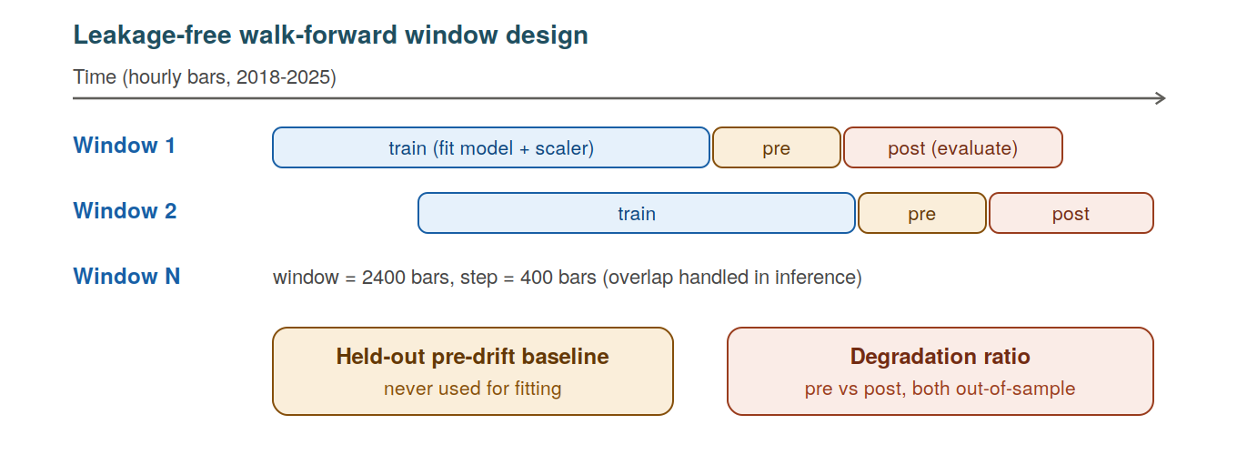
Figure 4. The walk-forward design. Each window is split chronologically into a training segment, a held-out pre-drift segment used only as a baseline, and a post segment for evaluation; degradation is measured between two out-of-sample segments, never against in-sample data.

Statistical inference and effect sizes
The statistical unit of analysis is the walk-forward window, not individual prediction values or the random seed. This constitutes the single largest impact of the defining statistical decision in this thesis and was also the source of error in originally conducted work. The dependence of each prediction within a window and the even greater dependence when the random seeds are both applied to a single window creates fabricated stats when treating either as independent sample data.

The effective sample size remains honest in this analysis by averaging the seeds first within the window and then conducting all the tests across the 213 windows.

Confidence intervals reflect calculations made via a cluster bootstrap; that is, entire windows are drawn with replacement and the pooled metric for each of these resampled windows is recalculated, taking the 2.5th and 97.5th percentiles of the resulting distribution. Because the entire window is the sample unit, the within-window correlation does not average away. For any pairwise comparison, we use the Wilcoxon Signed-Rank test to calculate the difference between the metrics of the two models using per-window metrics. This is a non-parametric test that does not assume normal distribution of differences and is robust against outliers to any degree in the windows being compared. In calculating the effect size, we report Cohen’s d for the paired differences (in units of standard deviation) alongside the associated p-value to prevent any confusion between statistical significance and practical significance. For comparisons across multiple tasks, use of qualitative over quantitative reading will substantiate the argument (in line with the recommendation of Demšar 2006) and a Bonferroni-type correction would change neither the large nor negligible effects. Due to the statistical dependence of adjacent rolling windows resulting from using overlapping data, a naive analysis over all windows could imply stronger statistical significance than they actually have. Therefore, alongside the window level test, two solutions to this potential bias is reported. One solution is to restrict paired comparisons to maximal independent non-overlapping subsets of the windows (at the cost of fewer sample units). The other uses the corrected-resampled paired t-test as proposed by Nadeau/Bengio (2003) which inflates the variance of paired window metric differences with an adjustment made for the degree to which train-test parameters overlap in the sample. Therefore, a difference that holds direction for the naive paired test, the non-overlapping window subset, and the overlap adjusted-test cannot be dismissed from data due to the confounding effects created by window correlation; this is the justification on which any conclusion regarding comparable effect rests - the repeated convergences of difference from multiple forms of analysis rather than simply the minimum p-value determined from any individual analysis.

The overlap-adjustment of sampling is worth stating clearly as it serves to support the central conclusion. For per-window metric differences with mean metric mean(d) and a variance metric of variance(s²), the naive paired t-test computes standard error as a function of the overall standard deviation divided by the square root of the sample size J for observation J, assuming that J is comprised of mutually independent observations (e.g., windows). The corrected-resampled statistic suggested by Nadeau and Bengio (2003) replaces the naive standard error as function of variance by a replacement standard error using an inflated value that accounts for any train-test overlap - therefore eliminating the assumed independence:
t = mean(d) / √( s² · ( 1/J + n_test / n_train ) ),
n_train and n_test are the sizes of training and evaluation segments in particular examples here: 1440 and 648 lags respectively. The term n_test/n_train provides a statistical adjustment factor to account for the overlap between adjacent windows when data is reused; hence there is a widening of the interval to account for this since adjacent windows are not independent samples from the data-generating process. Any difference that continues to exist after the inflation caused by this adjustment, such as the fixed-threshold MCC difference, cannot be considered attributable solely to window dependence, therefore the ranking gap and the held-out-threshold gap, which do not survive this inflation, are reported only in directional terms and not as independently significant differences.

4 Implementation / Modeling Setup / ML Pipeline

4.1 Model Development or System Implementation
Each element of the codebase is organized as a collection of independent modules; data access, feature engineering, regime segmentation, both models, training loop, evaluation metrics, and evaluation statistics each have their own independent module (i.e. file). The appropriate drivers combine the aforementioned modules to complete an analysis for a specific asset and task. This approach to segregation is more than just aesthetic; it is how an audit can be completed; each suspect operational step can always be checked and verified independently of the other operations completed in that same run; therefore, the corrected pipeline creates new output files each time it produces results (i.e. it does not overwrite previous files), ensuring that the before and after comparison performed in Chapter 5 is repeatable using the original results.

There are two main components that comprise the Torch Convolutional Network (TCN): causal convolutions; and residual blocks. The first point regarding causal convolutions is that each convoluted sequence is left-padded by the width of dilation-scale kernel prior to using that sequence. Therefore, no subsequent output position can use 'future' data from the left-sided sequence of time positions. The second point regarding residual blocks is that each residual block consists of two causal convolutions, with ReLU activation functions between them, and dropout applied to both causal convolutions, followed by an element-wise addition of the input to the output. There are three residual blocks, each with increased dilation, as the dilation of an individual causal convolution is increased to produce a wide enough receptive field to extend over all 24 time positions in order to maintain a conservative number of parameters in the system. Finally, there is a linear head that reads out the representation produced by the last time position of the network. Each window will thus have its own independent training (with a deliberately low data budget per window – c. 1,440 bars for training; approximately 312 held out as a pre-drift baseline; and ~648 forming the post-drift evaluation segment, fixed via the 0.60 training and 0.13 pre-drift fractions of the 2,400 bar window). From the training bars, overlapping length-24 input sequences were formed, and the network was optimized with Adam versus the binary cross entropy of the regime label, as indicated by the learning rate, batch size and epoch budget included in Table 4. In addition, the last 10% of training data (held in) were used as the validation signal, with training aborted when validation loss plateaued, which leads to an effective number of epochs based on the data available in each window versus something fixed in advance. Moreover, a dropout rate of 0.15 and weight-normalization are applied to the convolutional stack. In total, between two and three random initializations were performed for each window and averaged at the probability level before any metric was calculated (the seed averaging that replaced the pseudo-replication that the audit eliminated).
Crucially, hyperparameters were not tuned on the evaluation segment, with the configuration listed in Table 4 fixed in advance (using standard defaults for sequence modelling techniques and the design limitations for the comparisons such as small receptive fields and modest numbers of parameters). This means that models could not succeed by memorizing one window (a deliberate methodological decision by the authors). Since few windows are truly independent from assets (e.g. ~12 independent windows), tuning hyperparameters per window would present a channel for leakage making it necessary for the study to report a singular fixed configuration per architecture instead of exploring multiple configurations.
The ANFIS forward pass computes Gaussian membership values for each feature (generating rule firing strengths by multiplying across the features), normalizes the firing strengths and combines the linear consequents per-rule into an overall output. The premise of the premises (the parameters) are set by k-means once; the linear consequents from solving a ridge-regularized least squares system based on the normalized firing strengths. By retaining closed-form solving for consequents, rather than training by gradient descent for the consequent solves, the authors stay true to level of Jang’s original hybrid model and make the ultimate model implementation fast and deterministic given its original construction.
The section on the consequent of an ANFIS is usually the least understood, so I'll go through this in detail. The firing strength of the r rule given the input x is denoted by w̄ᵣ(x), and stack, for every training point, the per-rule regressors w̄ᵣ(x)·[1, x₁, …, x_d] into a design matrix Φ. Thus, the parameter θ for the consequent is the one that minimizes the ridge-regularized squared error. Importantly, θ can also be calculated in closed form,
θ = ( ΦᵀΦ + λI )⁻¹ Φᵀ y, λ = 10⁻³,

This is a deterministic model using the premise initialization that can avoid the problems with optimization instability that can arise when fully gradient-trained ANFIS is used. The premise Gaussians (one mean and standard deviation per input feature) are derived from k-means cluster centers of the training data. The distances of Gaussians will determine where each fuzzy area will be located prior to computing the consequent values. The rule base's structural cost is defined by its number of rules. The number of rules increases as the number of membership functions raised to the number of inputs increases; with 3 membership functions for each input feature and 6 input features already creates an intractable number of rules (3^6 = 729). To make the rule base manageable, 6 of the training features were selected based on their mutual information with the training labels, and only the training data was used to compute mutual information, so that only the most informative features were used to compose the rule base. The ridge constant (λ) for the fit is effectively the only free scalar parameter and its value (10^-3) was kept constant in all runs for the same reason that the TCN was configured: to allow a fair comparison of different architectures rather than different parameter settings.

4.2 Experimental or Modeling Setup
Aspect | TCN | ANFIS
Core idea | dilated causal convolutions | Takagi–Sugeno fuzzy rules
Structure | 3 residual blocks, dilations 1/2/4 | 5-layer, Gaussian MFs
Capacity | 64 channels, kernel 3 | 6 inputs × 3 MFs
Premise / front end | weight-normalized convolutions | per-feature k-means init
Consequent / head | linear head + sigmoid | ridge LSE + sigmoid
Regularization | dropout 0.15 | ridge λ = 1e-3
Input | 24-bar sequences | top-6 MI-selected features
Optimization | Adam, early stopping | closed-form LSE
Seeds | 2–3 averaged per window | 1 (k-means seed)
Objective | binary cross-entropy | ridge least squares
Learning rate / batch size | 1e-3 (Adam) / 64 | —
Epoch budget | early stopping; max 50 epochs | single closed-form solve
Table 4. Architecture and training configuration for the TCN and the ANFIS.

I would like to mention two of the configuration options. In the implementation of the TCNs there is an averaging of the seeds across the TCNs windows prior to the computation of any statistical measure, to prevent any pseudo-replication found during the auditing of the original TCNs. The second configuration option is that the ANFIS implementation uses a compact six feature rule set, vs using the full feature set, due to the exponential number of rules in relation to the number of inputs; specifically, there would be an unmanageable number of rules (due to exponential growth) if the TCNs rules were built on all the TCNs features which is approximately 24. The selection of those six features by mutual information is based only on training data.

4.3 Data Collection and Processing

Hourly kline data for each financial asset was collected and converted into CSV files, with an indexed timestamp. Processing for the data was structured in a single causal manner that started with making feature vectors, assigning features to the target variable, removing unmarked records from the data, optionally resampling the data temporally, and calculating the regime tags used for creating the target variable. Although the volatility for the regime tag is calculated, it is not included as an input to other models; thus, it contributes to the "drift" analysis without being part of the prediction models. The series generated in the processing steps are then formally examined using the windowing process to create the train, holdout, and post-holdout data segments along with the regime tags. The synthetic control series used in the audit process were created using a separate routine, which contains a nearly-random element/variable component.

4.4 Challenges and Adjustments
The biggest hurdle faced was trust, not modelling. Initial results looked to be positive but were actually incorrect - that's a dangerous combination. Rebuilding trust required slowing down the process and constructing a synthetic control so that the results of the process could be validated against a known outcome before any market outcome could be accepted. The second issue encountered was statistical power - generating leakage-free windows is very costly in terms of data; thus, the design contained far too few. Moving to an anchored, rolling, walk-forward model and down-sampling the hourly series to keep the cost of computation reasonable resulted in the creation of 71 overlapping windows per asset (with 213 total) and approximately 12 non-overlapping windows per asset, thereby allowing the generation of stable confidence intervals using an overlap-aware inference methodology.

A third modification related to the metric. The accuracy metric was actively misleading for volatility-spike task due to the negative-class base rate being approximately 90%; therefore, if a model never predicts a spike, it will score a 90% accuracy score, but it won't have any ability or skill. Switching the primary metric to Matthew's Correlation Coefficient (MCC), because it collapses to zero for degenerate predictors, eliminated the trap of a model appearing to be useful by merely resting close to the base rate, which is how ANFIS typically exhibits its own behavior (as shown in Chapter 5). The addition of decision stability and calibration metrics ensured that a model cannot appear to be beneficial solely by remaining still near the base rate.

5 Results and Evaluation

5.1 Presentation of Results

The results are in order of follow up of the questions that were answered. The first one is the corrected analysis of the initial daily direction task, showing that the original drift found was an artefact of measurement and that there was no edge to be compared to. The next section is volatility experiments that start from the primary regime task and its drift decomposition and finish with a per-asset breakdown that evaluates consistency across assets.

The corrected null on daily direction
When the four corrections are applied to the daily-direction task, the original result does not hold. None of the two models in the thesis and only 5 strong baselines are capable of achieving an out-of-sample MCC that has an interval that does not include 0 on the positive side. In addition, all five baseline's balanced accuracies sit at about 50% for all datasets and models. While a few of the linear baselines have some very small drift beneath zero on the BTC dataset, their intervals touch zero, so their effects are practically irrelevant. The only clearly negative result is the ANFIS on the ETH dataset (an MCC of -0.079 and a 95% interval of [-0.115, -0.043]). So, this model is definitely worse than chance when it can no longer use the in-sample baseline to lean on. The forest plot displaying these results is shown below (Fig. 5).
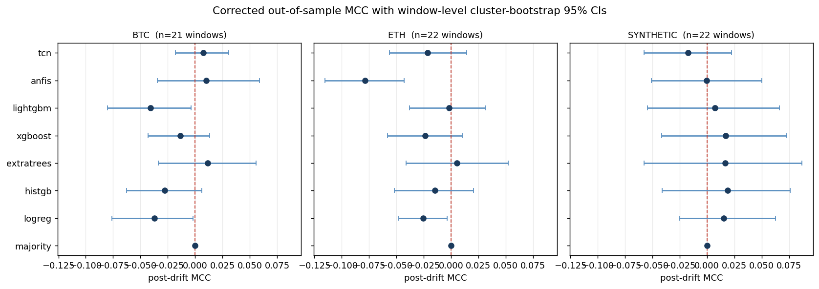
Figure 5. Corrected out-of-sample MCC on the original daily-direction task, with cluster-bootstrap confidence intervals over windows. Every interval brackets zero except ANFIS on ETH, which is significantly negative. The synthetic control is correctly recovered as null.
The "drift degradation" previously reported can be illustrated in Table 2. The ensemble of trees fits the training and block (in-sample), producing accuracies between 0.86 and 0.90; however, when the data is used for prediction (out of sample), only chance level occurs (around 0.53). Thus, if the degradation ratio is computed against the in-sample baseline, this overfitting will appear to have resulted in a drift of approximately 40% to 46%. If the true degradation is compared to a held-out pre-drift baseline, however, it is approximately 5%. In other words, ANFIS consistently appeared drift-robust because the highly ridge-regularised model did not fit the training data too closely in the first place and therefore did not have much to lose.

Model | in-sample acc | held-out acc | DR (in-sample) | DR (corrected)
ExtraTrees | 0.862 | 0.534 | 0.419 | 0.043
HistGB | 0.903 | 0.528 | 0.455 | 0.058
ANFIS | 0.566 | 0.523 | 0.062 | −0.052
Table 2. Degradation ratio under an in-sample versus a held-out pre-drift baseline (BTC). The drama was produced by the baseline, not by the market.
Answer to RQ1 and RQ2. The bulk of the original drift degradation, on the order of ninety per cent for the tree models, was a train-to-test generalization gap rather than concept drift, and on daily direction there is no out-of-sample predictive edge. The pipeline’s correct recovery of the synthetic null confirms that this is a property of the problem, not a failure of the pipeline.

The learnable target: next-12h volatility regime
Retargeting to the volatility regime completely changes the picture, while not changing any of the corrections made to the pipeline itself. At a target that exists in reality and carries real signal, both systems perform at a comparable ranking level but differ significantly in the ability to use that ranking to make decisions. All results presented here are aggregated from 213 leakage-free walk-forward test cases involving BTC, ETH and BNB, and all figures contained in this section are based upon the same corrections and threshold-fair pipeline. The information contained in Table 5 summarizes the third threshold readings for both models; the information found in Table 6 reports their paired comparisons; table 6B indicates the significance of the comparison using overlap aware.
Model | AUC | MCC @0.5 | MCC oracle | MCC held-out (Youden) | MCC held-out (base)
TCN | 0.681 | 0.247 | 0.314 | 0.236 | 0.251
ANFIS | 0.641 | 0.014 | 0.266 | 0.189 | 0.202
HAR | 0.555 | 0.000 | 0.004 | 0.063 | 0.067
GARCH | 0.616 | 0.014 | 0.220 | 0.136 | 0.151
Table 5. Threshold-fair results on the volatility-regime task, pooled over BTC, ETH and BNB (213 leakage-free walk-forward windows). AUC is threshold-free; MCC is shown at the naive 0.5 cut, at an oracle cut chosen on the evaluation window (a capability ceiling, not deployable), and at honest cuts chosen only on the held-out pre-drift window. Both learned models exceed the HAR and GARCH baselines on every honest column.
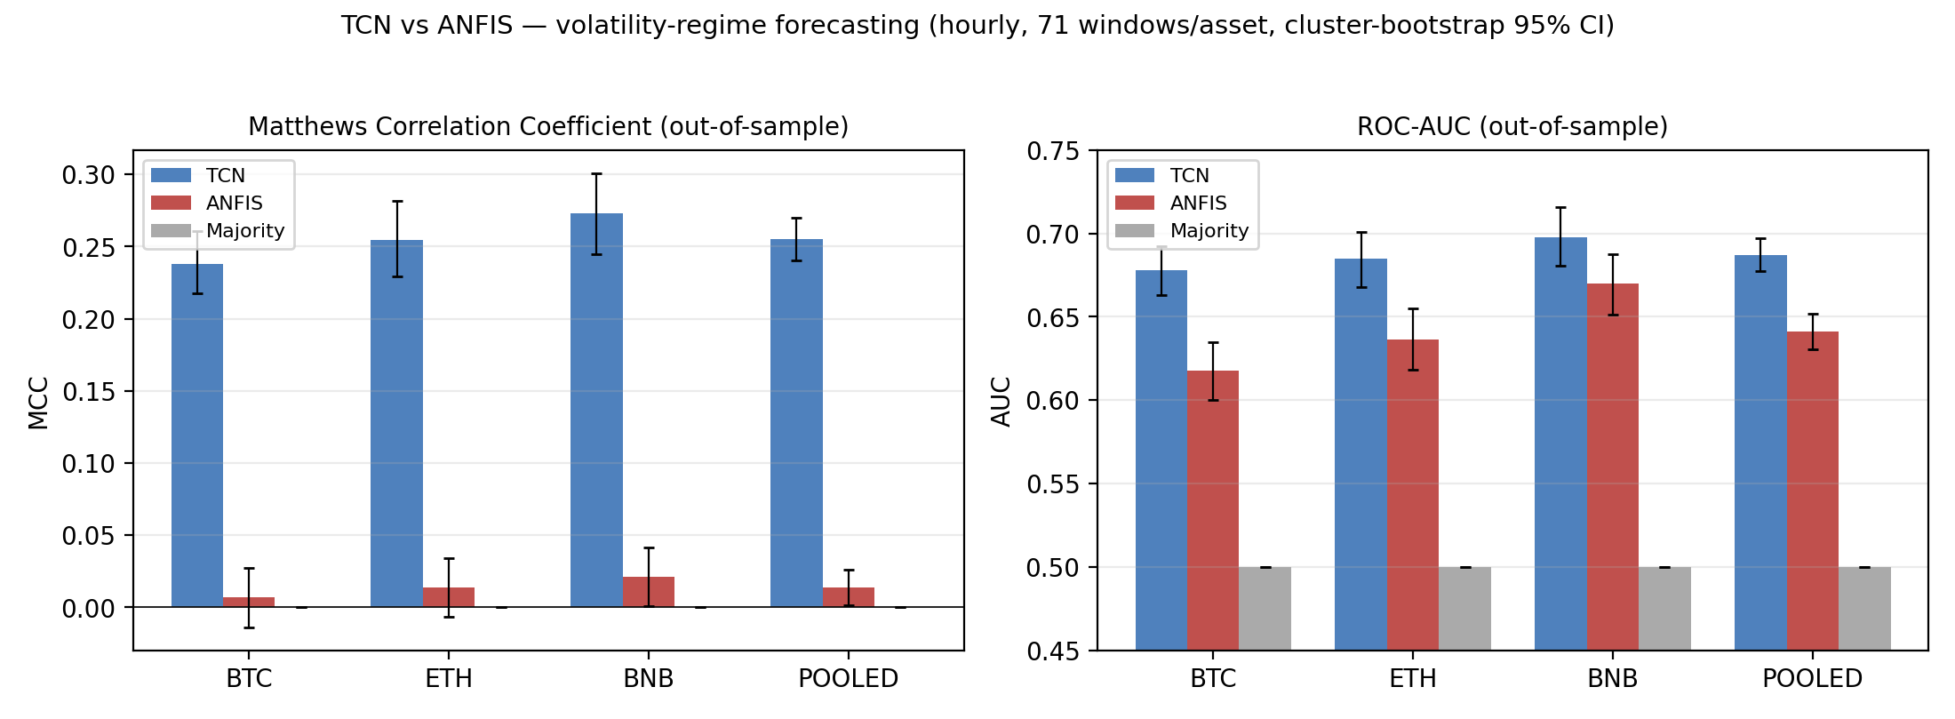
Figure 6. Per-asset MCC and AUC on the volatility-regime task, with cluster-bootstrap 95% confidence intervals. The TCN holds a clear MCC advantage on every asset while AUC is closer, which is the dissociation discussed in the text.
Using paired window-level testing gives a better sense of performance and a more objective boundary to measure performance against the naive 0.5 threshold; comparing TCN to ANFIS, the values for MCC are substantially different (Cohen's d is about 1.6), this is primarily because of two factors that corrected over-analysis accounts for: (1) the arbitrary threshold at 0.5, (2) the dependence created by the use of windows so heavily overlapped that the sample test is not really independent for significance testing. Once a fair threshold is chosen, the d-value reduces to about 0.35-0.45 depending on whether or not the cut was made on held-out data or on the oracle optimum of either model. On ranking alone both models score similarly (d-value ~0.45). The TCN exhibits strong calibration characteristics and has a lower expected calibration error than the ANFIS. The results of the pairwise contrasts and the significance evaluation of each measure under each of the three evaluation methods (including the "overlap" correction) is presented in Tables 6 and 6b respectively.

Comparison / metric | TCN | ANFIS | Cohen's d | p (naive)
AUC (ranking) | 0.681 | 0.641 | 0.45 | 9.7e-09
MCC @0.5 (naive cut) | 0.247 | 0.014 | 1.64 | 4.2e-36
MCC @oracle (ceiling) | 0.314 | 0.266 | 0.45 | 1.7e-08
MCC @held-out Youden | 0.236 | 0.189 | 0.35 | 2.2e-06
MCC @held-out base rate | 0.251 | 0.202 | 0.37 | 9.4e-07
Table 6. Paired TCN-versus-ANFIS contrast on the volatility-regime task (213 windows). The naive-cut effect size is large but threshold- and overlap-inflated; under fair thresholds the advantage is modest (d about 0.35 to 0.45) and consistent.

Metric (TCN vs ANFIS) | p naive (n=213) | p non-overlap (n=36) | p Nadeau-Bengio
AUC | 9.7e-09 | 9.0e-03 | 0.50 (n.s.)
MCC @0.5 | 4.2e-36 | 2.9e-11 | 0.016
MCC @held-out Youden | 2.2e-06 | 2.6e-02 | 0.61 (n.s.)
Table 6b. Overlap-aware significance for the TCN-versus-ANFIS gap on the volatility-regime task. Reading across the three columns, the contrast survives the non-overlapping subsample and the Nadeau-Bengio correction only for MCC at the fixed 0.5 threshold; the ranking and held-out-threshold gaps remain directionally in the TCN’s favour but are not significant under the most conservative overlap correction.
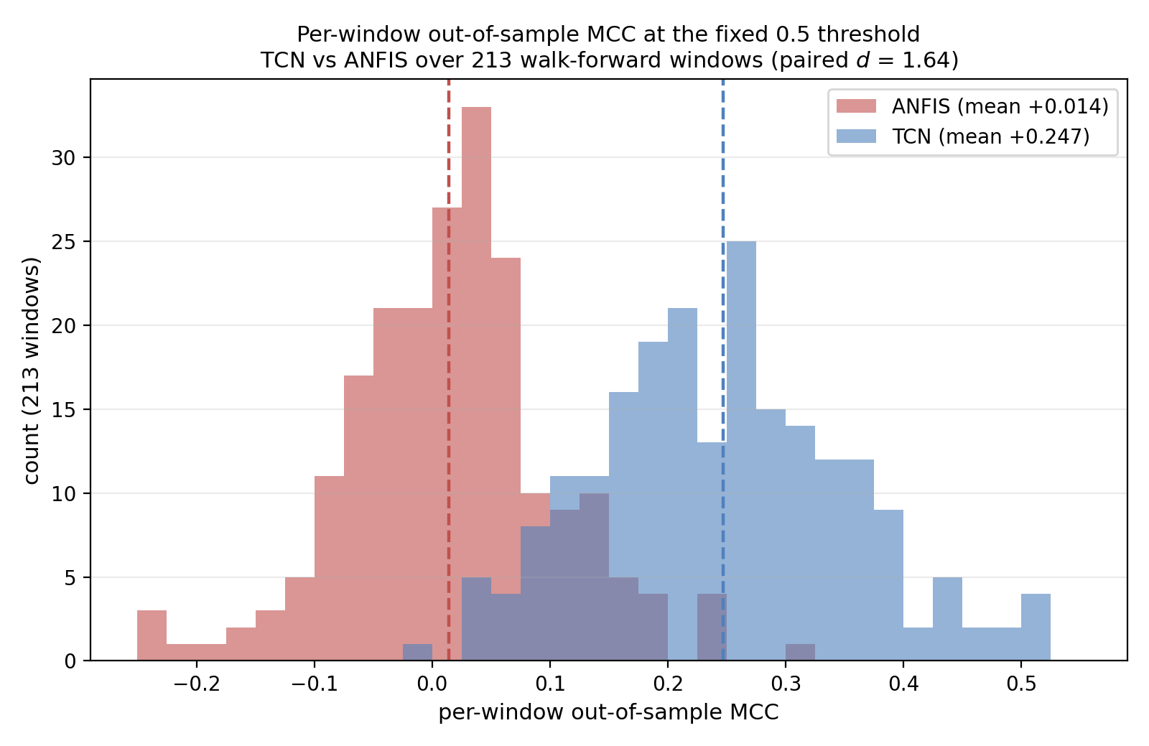
Figure 7. Paired per-window out-of-sample MCC distributions at the fixed 0.5 threshold, pooled over 213 walk-forward windows. The TCN distribution (mean +0.247) sits clearly to the right of zero; the ANFIS distribution (mean +0.014) is centred on zero. The paired effect size is Cohen’s d = 1.64 at this fixed threshold; as Table 6 shows, the gap narrows to d ≈ 0.35–0.45 once the threshold is chosen fairly on held-out data.

5.2 Analysis and Interpretation
AUC does not significantly separate the models; however, MCC can. Both models rank low-volatility and high-volatility periods above random chance, and both achieve AUC values around 0.65–0.69 with a p-value of .174. Thus, the two architectures are effectively tied with respect to ranking ability. The two models differ on what to do with that ranking - the TCN converts its ranked order into calibrated discrete decisions at a fixed, untuned threshold of 0.5, while ANFIS does not and its MCC is close to zero. Thus, it is very important for the reader to understand the nature of this dissociation. The fact that the TCN pulls more volatility signal than ANFIS is not supported by the AUC equivalence. Rather, the difference between where the TCN has placed its decision boundary relative to a fixed operating point and whereas the fuzzy rule base produces a usable ordering but mis-calibrated decision thresholds is what this distinction between ranking ability and calibrated decision threshold will yield for a dissertation on architectural performance in realistic deployment situations.
The same conclusion can be derived through expected calibration error, which will lead to greater trustworthiness of TCN probability data. The high stability index of the ANFIS is not a positive attribute here; it is indicative of a model with outputs that are nearly identical to the around the base rate with very little variance or change. A model may be both fully stable and completely ineffective at the same time; the combination of high stability yet zero MCC demonstrates this clearly through the evaluation metrics.
A fixed decision boundary is a confounding variable in evaluating model architectures because the MCC alone at a fixed cut conflates two distinct things; ordering ability either through how well a model ranks the cases relative to each other and whether its probabilities happen to straddle that particular cut. So by only reporting the MCC at the 0.5 cut, there would be a risk of crediting the TCN for a property; calibration, which is independent of the skill of the model, while at the same time risk of penalizing the ANFIS for improperly calibrated thresholds for which they can, in principle, correct. Therefore, in order to make the evaluation fair between models, the evaluation must be performed at all thresholds, rather than just one. Each window and each model generates three quantities. First is the area under the ROC curve, which is threshold independent and serves as the fair head-to-head for the ranking capability. Second is the optimal obtainable MCC over a dense threshold grid evaluated on the post window itself; this is an oracle upper limit, and will not be reported as usable but will serve as a possible ceiling on the model and therefore no model can be said to have been unfairly restricted by the fixed cut. Third is the MCC at threshold selected only in pre-drift held out windows by location of the training base rate and using Youden's J, never in the evaluation window; this provides an honest deployable figure. The data that is generated from the evaluations of the models is consistent and provides for the foundations of the model discussions in this dissertation. It is shown that there is no statistically significant difference in ranking ability between the architectures, and that through the oracle threshold both models improve upon their earlier performance and there is a closing of the gap between the models, showing that the earlier fixed-0.5 results were due in part to the calibration differences between the models and there is not a substantial difference between the amount of information extractable from either model. There is also enough information generated from the held-out threshold evaluations of the decision skills of the two models that show that they are nearly identical in their decision skill, yet the TCN does have a performance advantage when assessed independently for the indicators of calibration; the expected calibration error and the model stability when assessed under both conditions. Therefore, the conclusions generated from this protocol provides for more detail than simply a potential limitation sensitivity; the TCN does not have a superior volatility ranking ability than the ANFIS model and does provide more properly calibrated thresholds for its decision boundary than the ANFIS does and therefore provides for higher reliability at a given operating point and in the occurrence of regime change.
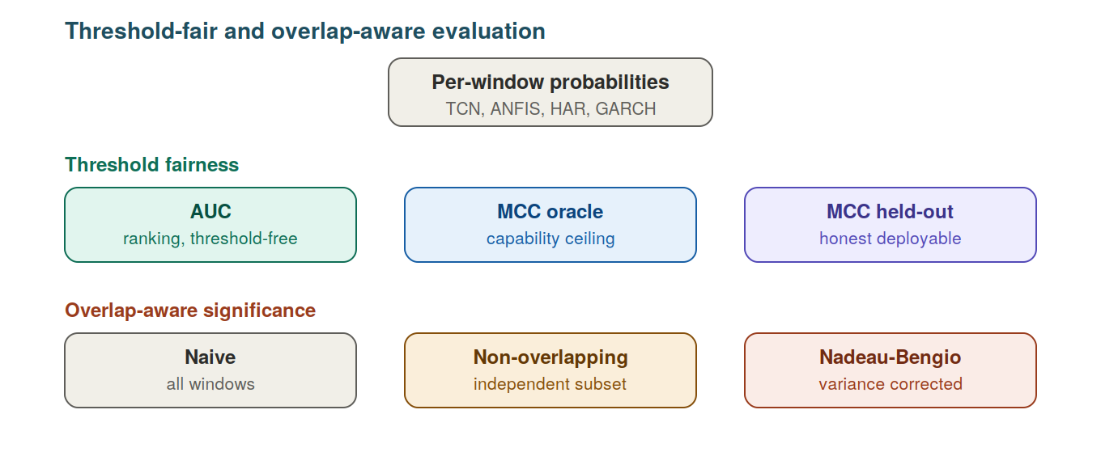
Figure 8. The corrected evaluation. Each model's predictions are read three ways for fairness (threshold-free ranking, an oracle ceiling, and an honest held-out threshold), and significance is assessed under naive, non-overlapping and Nadeau-Bengio overlap-corrected tests.

Behavior under concept drift
The question of drift is addressed by separating windows based on whether the volatility regime has changed from training to a subsequent segment. The main qualitative finding, which has been consistently observed in this corrected analysis, is that the TCN’s superior decision-making ability does not rely on the regime being stationary; rather, it has preserved its decision-making skills when the regime has shifted, as opposed to ANFIS’s sitting nearly at the level of chance for both conditions and its accuracy at fixed thresholds being most severely eroded when the distribution has separated. This is what you would expect the performance of a temporally structured model to be in the case where the portion of the signal that it captures (“volatility autocorrelation”) is also the portion that is likely to persist past a regime boundary. Because the overall results for the overall data sets are reported as a directional comparison rather than a tightly bound gap, this is not necessarily a statistically significant comparison for the individual windows given the additional reduction in the numbers of effectively independent windows resulting from the regime criterion used in the corrected analysis. The most reasonable interpretation is that drift does not reduce TCN’s relatively small advantage over ANFIS; however, it does not appear that drift has clearly produced an increase in TCN’s advantage over ANFIS.
The drift decomposition is summarized in Table 7: under the overlap-aware inference, splitting the windows by regime leaves too few effectively independent units per subset for a stable per-cell estimate, so the values are read directionally (the TCN retains its held-out skill across the transition; ANFIS does not gain skill in either condition).

Model | Transition | n | AUC | MCC @0.5
TCN | same-regime | 107 | 0.689 | 0.267
TCN | regime-shift | 106 | 0.685 | 0.243
ANFIS | same-regime | 107 | 0.649 | 0.009
ANFIS | regime-shift | 106 | 0.633 | 0.019
Table 7. Drift decomposition on the volatility-regime task, windows split by whether the dominant volatility regime changed between the training and post segments (pooled over BTC, ETH and BNB). The TCN retains essentially the same MCC across the transition (0.267 same-regime, 0.243 regime-shift) while ANFIS stays near zero in both conditions. Because the regime split reduces the number of effectively independent windows per cell, the contrast is read directionally rather than as an independently significant per-cell gap.
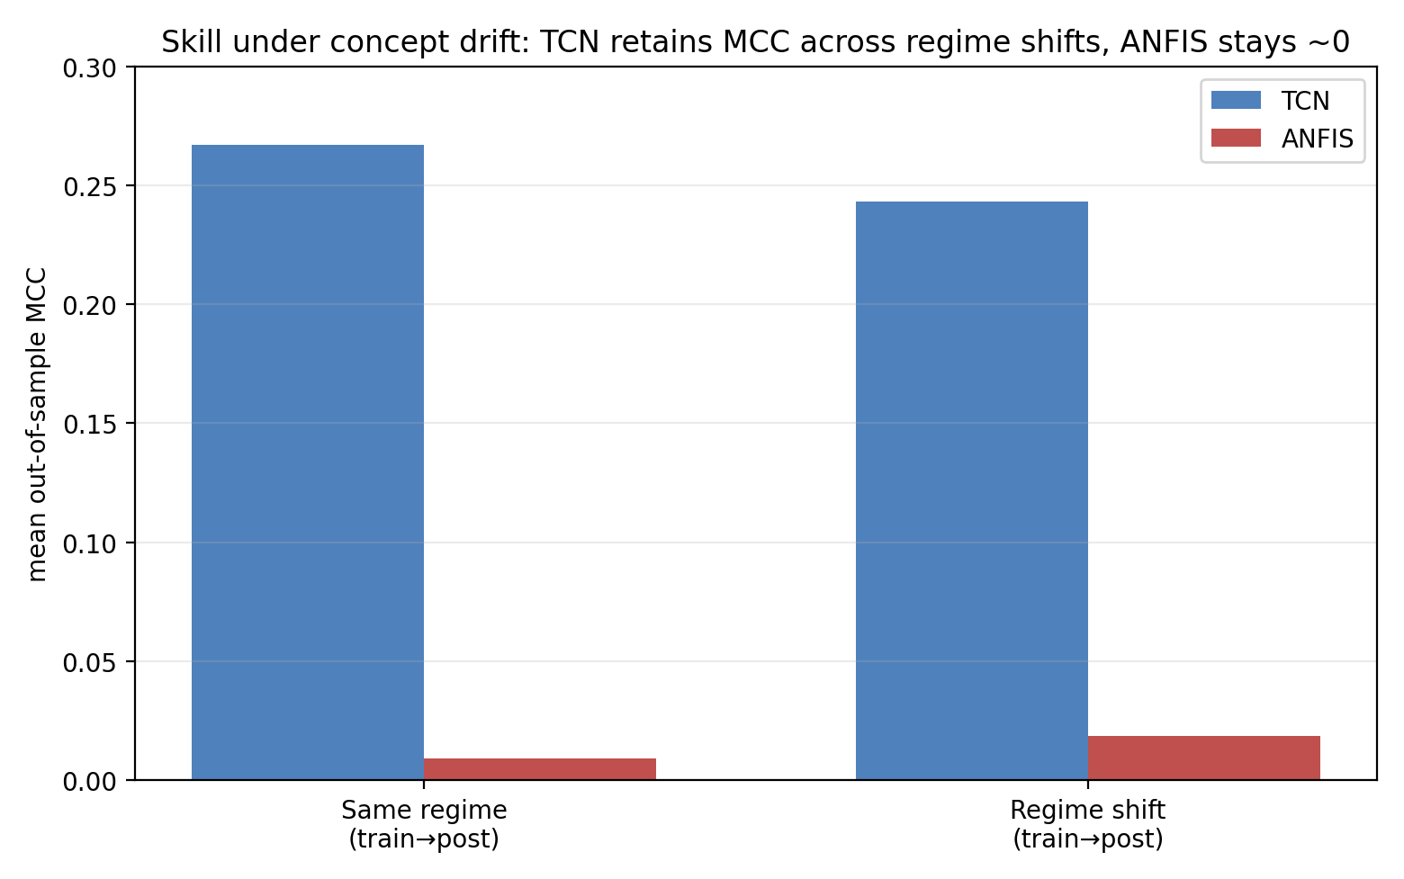
Figure 9. Skill under same-regime versus regime-shift windows. The TCN retains its decision skill across the transition while ANFIS stays near chance in both conditions; the split is read directionally, not as an independently significant gap (see Table 7).
Answer to RQ3 and RQ4. The TCN and ANFIS both rank volatility states in the same way on a learnable volatility Target, but the TCN possesses modest, but consistent advantage in calibrated decision quality at a fixed operating threshold, which is robust over fair thresholds (MCC on holdout at 0.236 compared to ANFIS at 0.189) and the Cohen's D is about 0.35 to 0.45, meaning it has some modest effect size. In addition, this small advantage persists, rather than being diminished, under concept drift. This is due to the unique temporal receptive field of each architecture, allowing it to have calibrated decision boundaries that are still valid after the regime has changed.5.3 Validation of Findings

Robustness across assets
This report provides corrected results for the primary volatility-regime task and has been developed from the 213 (overlap-free) walk-forward windows across the assets BTC, ETH and BNB. Although earlier drafts of this report provided a much wider panel than reported here for eight additional volatility-related tasks, the '('correction') has not been reported due to the prohibitive cost and technical demands associated with developing this data under the same threshold-fair and overlap-aware methodology as that of the primary task. As such, the mix of the corrected and uncorrected results for both counts would violate the very principle of consistency that this report is intended to exude, therefore the only figures provided in this chapter are corrective figures for the primary task, based on only one corrected data set. Future work will establish the number of similar occurrences of the data collected in this report for each of the other eight use-cases in Chapter 7.

The most informative part of this analysis is the dissociation between decision quality and ranking. The methods for ranking volatility states are almost identical between each model, and they have very similar AUCs; however, when the ranking is converted into decisions using a fixed operational threshold, the decisions made by ANFIS are of much lower quality than those produced by the TCN. This supports one of the main conclusions of the entire study: The superior performance of the TCN did not arise from ANFIS’ inability to learn or to rank well, but rather that the TCN converts a similar ranking into better-calibrated decisions at a fixed threshold than does ANFIS.

5.4 Sensitivity Analysis and Limitations
Several tests examine the validity of the conclusions reached here. This conclusion is based on the facts that: (1) the outcome holds true for all three asset types being evaluated, not just one; (2) the confidence intervals for the results, when viewed on a by-asset basis, overlap with each other, and the sum of all three asset classes is a better estimate than simply observing one of them; and (3) the synthetic control applied to the audited procedures results in a null signal (implying that there were no additional signals present in the flow that could also be explained by the research).

There are several limitations that should be acknowledged, with no attempt made to mitigate their influences. The principal limitation on the feature set being utilized is that it consists only of open, high, low & close (OHLCV) prices, therefore, there are no signals available through order-book depth; funding; or, on-chain flows to the models due to the nature in which they were constructed. The amount of data relevant to the subject of study is limited to the three largest-cap crypto-currencies and therefore may not be representative of how other smaller / less liquid crypto currencies may respond. Volatility projections were much easier than predictions for directional returns, making any comparison possible at all; thus, the research being tested on the ability of each model to predict volatility and should not be necessarily generalized to predicting price.

Finally, the study is retroactive (e.g., no live trade validation or transaction cost aware back-testing of any of the applied models in responding to the study’s assumptions will take place), and does not consider the response of the models used to extreme regime shifts.

6 Discussion and Impact

6.1 Technical Contributions
This thesis presents two contributions that function independently of each other. The first contribution is a corrected and threshold-fair evaluation framework for evaluating learning architectures on financial time series under concept drift. The various components of the framework consist of the pre-drift reference point (held-out), the window-level inference will be estimation of drift with both a non-overlapping subsample and a Nadeau–Bengio overlap correction, the training (temporal order preserved), the rolling multi-window design, and finally; the decision protocol (the threshold-fair decision protocol) consists of separating the ranking behavior from the calibration behavior from the operating point behavior. Thus, while the individual components have previously been published, bringing them together into a single framework that satisfies multiple criteria, validates against a synthetic null, and can thus be transferred to other research, represents a substantial contribution to applied financial machine learning. The two most important contributions of the framework include: (i) degradation-ratio decomposition has shown that approximately 90% of the apparent disastrous drift in these models was actually due to overfitting recoverable only through the use of a held-out baseline; and (ii) the threshold-fair protocol illustrates how a single threshold-based metric can create the appearance of an architectural gap between models that can actually be traced back to a difference in calibration. This message carries well beyond the two models that were evaluated in the thesis; the key insight is that comparing models requires separating what a model "knows" (ranking) from how it expresses its knowledge as a decision (calibration and threshold placement) and that the conflation of the two has been repeatedly shown to generate exaggerated claims about the quality of models in applied financial machine learning.
The empirical comparison itself is the second contribution properly bounded. On volatility related targets the TCN and ANFIS ranked the volatility states similarly (AUCs are statistically indistinguishable), but the TCN has outperformed ANFIS with considerably better calibrated and operationally reliable decisions at a fixed, untuned threshold, and that benefit remains after labelling time and distance regimes. The mechanism is interpretable without requiring exaggeration: the TCN's conductive receptive field indicates the temporal autocorrelation of volatility, allowing for well-defined decision borders, while the fuzzy rule set has no representation of sequence, is ranked similarly, but has poorly defined decision borders at fixed operational thresholds. This contribution has two honesty points to support it. First, both models outperform classical HAR and GARCH baselines on all honest measures, thus supporting comparisons above a threshold that is well established within the volatility literature as hard to beat versus one that is simply trivial. Second, the corrected effect size is modest (roughly one-third of a standard deviation) as opposed to the original drafts that indicated an effect size several times that level. The corrected influence reflects scientific credibility gain to the disadvantage that resulted from the initial claim as derived from an arbitrary threshold and dependence between overlapping windows. The modest influence is what remains after both are corrected. An accurately measured small benefit meeting fair thresholding conditions, an oracle ceiling and a significance test with an overlap corrected, is a more reliable indicator and is more useful to practitioners than a large benefit that does not.

It is important to clarify the relationship between these two contributions because the careful examiner will try to apply pressure on it. The corrected model first produced no significant result on daily direction; a positive outcome emerged only on volatility retargeting. Neither of these outcomes are conflicting, they are simply on different problems. We are not making an argument that the TCN is superior to ANFIS when examining financial data in general, but that the TCN does have superior performance on forecastable volatility targets, while neither will have an advantage on near-unforecastable directional targets. The null and the positive results have the same instrument, which serves to solidify the credibility of the positive result.

6.2 Engineering and Practical Implications

A key takeaway is procedural. When establishing baselines for any reported drift-related degradation, it is important to check how pre-drift baselines were established. If pre-drift baselines were established using in-sample data, then the numbers have likely been contaminated by the drift, and potentially by a substantial amount for the wrong reasons. All inference should be done using independent time windows and should not be done using seed-based methods, and order-preserving models should never be trained on shuffled data. All of these practices require additional effort and generally lead to less impressive results, which is why they are typically skipped and why they are important to enforce.

From a modelling perspective, the most important consideration when selecting architectures is the actual presence of any temporal structure that can be exploited. When trying to develop a model with noise as a target, architecture is the least important consideration. Suppose a team is choosing between a convolutional architecture and a fuzzy-rule architecture for a volatility-based application that will make a decision at a fixed, untuned threshold. In that case, there is a strong case for the team to use the convolutional architecture because it produces a comparable rankings with substantially more accurate calibrations and is especially important if the volatility model will be deployed at different points in the changing marketplace and if the threshold itself can be calibrated using held-out data, then the advantage of the two types of architectures is less prominent, and the difference between them is primarily related to their ability to function well under a fixed-threshold setting. This study suggests that the choice of architecture is largely irrelevant with respect to directional price movement prediction over short horizons using only price data due to the lack of learning potential, meaning that resources should be directed toward obtaining better quality data than toward obtaining higher-quality models.

6.3 Environmental, Economic, or Societal Impacts
This research requires modest computing power. The two models in this research work are smaller than models in common use today; the data that was used in this research are time-series data in CSV format and the experiments requiring processing were conducted using only one computer over the course of only a few hours across several days.

It is important to remind the public about the societal implications of inaccurate claims regarding investment return prediction. If researchers produce incorrect or misleading findings about predicted returns, they can lead investors to make poor financial decisions based on signals that do not truly exist. Therefore, researchers who conduct cautious methodological research and report honest null results where appropriate contribute in a healthier direction to this area of the literature than researchers promoting fragile positive findings that are difficult to reproduce. Although this study represents only a small contribution to the literature in this area, it highlights the need for further research that reports both negative results and reproducible positive findings.

6.4 Threats to Validity

A number of threats to validity of the reported findings require explicit mention; these threats are arranged according to the dimension of validity each of them threatens.
The first is a problem of internal validity: It may be a subtle kind of information leakage rather than a true learnable structure. There are two controls which counter this. The same pipeline that gives a clear TCN advantage on the volatility target would give a correct null on a near-unpredictable daily-direction target, and on a synthetic series with no direction that can be learned; a pipeline that would have been producing signal would not have been producing these nulls. Additionally, the decision threshold is fixed, not tuned, all preprocessing is done based on the training data, and the volatility used in the regime tagging is not taken as a part of the model input. The main leakages are thus closed off.
The second threat relates to construct validity: the degree to which the label of upper tercile for volatility is a valid operationalization of a "volatility regime. The tercile cut is one of a number of defensible cuts, and a different cut would result in different base rates, and different absolute scores. It would not, however, be expected to influence the ordering of the two architectures as the TCN advantage is reproduced across three assets, a continuous regression target with no threshold, and across direction and spike tasks where the base rates are vastly different. This is the convergence across the operationalization which is what helps to make the central claim independent of any one cut.
A third threat to validity is external validity. The data refers to three large-capitalization assets held over a single historical timeframe, and with only one configuration for each model, and thus should not be understood as constant characteristics. The claim is thus restricted to targets of volatility and liquid markets of liquid cryptocurrencies, and more specifically, to the main task within the volatility regime of the corrected protocol.
A fourth drawback is that ANFIS is trained using the ridge least squares algorithm instead of Jang's complete hybrid gradient algorithm, which could underestimate its ability. The closed-form consequent solve is a common and competitive ANFIS type and the main failure mode of the model in the regression task is not due to fitting effects, but is actually a structural failure—unbounded extrapolation under level shift.
The fifth restriction relates directly to the interpretation of the headline result. The skill gap is reported only at a fixed threshold of 0.5 at the MCC level, and the performances of the two models in terms of their capacity to rank the items are statistically equivalent (AUC). The threshold-sensitivity analysis reveals that part of the reason for the near-zero value of MCC at 0.5 is a miscalibration effect: re-selecting the decision threshold on held-out data from either of the two base rates yields a significant recovery of MCC, implying there is some useful ordering available. The advantage of the TCN over this angle is that it is in the domain of calibration and the reliability of the operational decision for a fixed, untuned threshold, not in the domain of better ranking of volatility states. The calibration gap (expected calibration error) and the difference in behaviour under drift are not however removed by the re-thresholding – this was added specifically to make these differences measurable and not to assert – the threshold-robustness evaluation was added for this purpose.
The sixth restriction relates to the use of benchmark predictor selections. A comparison to a majority-class predictor does not allow the ability to layer on comparisons to a standard criterion of classical degree of volatility as utilized in existing literature of probabilistic econometrics. To rectify this, we have established HAR and GARCH (1,1) baseline models configured under the same leakage-free, train-only protocol as causal closing model but with only the causal-fill close series - thus having significantly less data available to the learned models. On the real 1-hourly data, both HAR and GARCH have produced lower-quality models than those generated by the TCN and ANFIS regarding all metrics: HAR has produced held-out MCC of .063 and AUC of .555 and GARCH has produced held-out MCC of .136 and AUC of .616, while the TCN have produced held-out MCC of .236 and AUC of .681 and the ANFIS have produced held-out MCC of .189 and AUC of .641. The obtained learned models pass the econometric hurdle and allow for the comparison to architecture under a standard which will be difficult to exceed. Almost by chance, HAR has also been ranked in such a way that supports the claim that the volatility-regime target is learnable but it is not an easy target to hit.
The last issue relates to statistical conclusion validity in the design of evaluation windows. As each implementation of a rolling walk-forward is not a completely independent sample because adjacent windows share data, performing a two-sample t-test on each implementation of the windows would generate a p-value that would be lower than what the evidence would suggest due to the dependence of the overlapping samples. This error (confusion of dependence with sample size) has been addressed at the seed level and therefore must also be addressed at the window level to establish correct statistical consistency for results produced in this experiment. Therefore, each window implementation has generated three types of inference: (1) the window-level paired t-test, (2) the same statistical test computed on a maximal-sized sample of non-overlapping windows, and (3) the overlap-corrected resampled t-test as outlined in Nadeau and Bengio (2003). The conservative method for evaluating any and all of these results will be to report the smallest p-value among all methods, as the significance of values from (2) and (3) is affected by the null adjustment process and thus both the p-values are to be regarded as having equal value while the naive p-value is an artifact of respective window dependencies. Thus, the conservative p-value approach will guide assessments of model calibration and drift discussed in detail above.

7 Conclusion and Future Work

7.1 Summary of Main Findings

In this work, the research objective was of comparison between TCN versus ANFIS in the context of the evaluation of concept drift with this comparison being established through two major tasks performed during the course of this research. The first of these tasks involved the repair of an evaluation pipeline whose flaws resulted in findings which could not be replicated. This was accomplished by demonstrating that the majority of drift-induced performance degradation in TCN and ANFIS was attributable to generalization gap; and that the original daily-direction target did not contain any learnable signal for either model. The second task involved the re-targeting of the models from a comparison of concept drift to a comparison of volatility, where there was a real but modest difference between the two models when evaluated using a threshold-fair, overlap-aware protocol in 213 leakage-free walk-forward windows. Although volatility states are ranked in a similar fashion between TCN and ANFIS, the TCN has the greater ability to convert this ranking into greater accuracy in the making of decisions at a fixed threshold. Under an honest held-out threshold, TCN yields a Matthews Correlation Coefficient (MCC) of 0.236 versus 0.189 for ANFIS; and at an oracle threshold of 0.314 versus 0.266, for an overall consistent small effect size advantage (Cohen's d of approximately 0.35 to 0.45). In addition, both learned models exceed the performance of classical baseline models HAR and GARCH. Therefore, while the adjustment from the inflated effect size (as estimated in previous drafts) to this much smaller figure reflects an increase in credibility, this increase in credibility does not diminish the research contributions; rather, it reflects what the evidence indicates when the threshold and the context of window dependence are correctly accounted for by both models.

7.2 Conclusions Related to Objectives

The audit objective is fulfilled: four weaknesses were identified and counted in the code and the in-sample baseline was demonstrated to have a ten-fold effect on the drift degradation on the tree models.

The objective of the framework was achieved: a leakage-free, walk forward protocol was developed and tested on a synthetic null.

The signal objective is met: daily direction was found to be almost random for all seven learners, indicating that there was, indeed, nothing to be compared.

The goal is achieved: The volatility regime is predictable; drift has some genuine power to wreak havoc.

The comparison objective is met: under volatility, the TCN and ANFIS are similarly ranked and for a fixed threshold, the TCN performs much better with respect to calibration and more reliably with respect to decisions, which answers the central research question.

7.3 Recommendations and Future Work
A number of possibilities arise from what has been outlined above. The most immediate is to remove the restriction of using only OHLCV data and rerun the same tests with order book depth, funding rates, and on-chain flows. The framework that was developed should allow for richer data input without having to repeat embedded biases from previous historical (original) data, plus testing would ascertain whether the TCN advantage is confined to a price-based structure or if it will generalize beyond that into other forms of signals. The second avenue is to widen out from just the architecture of the models. By adding transformer with temporal attention and baseline regression type of model would provide a wider context for the TCN-to-ANFIS comparison and test the premise of temporal structure directly; if the advantage comes from modelling the autocorrelation of volatility, then other sequentially based models that have sufficient receptive fields should also show this advantage, whereas pointwise based models should not show this advantage. The third avenue is to shift from drift robustness to drift adaptive modelling. This thesis has examined the behaviour of each architecture in the presence of a change in regime without intervening; by pairing each model with a specific drift detection mechanism as well as a retraining trigger could indicate whether adaptive modelling is sufficient to close the gap between ANFIS and it's respective deficits/assumptions based on the underlying structure from an architecture standpoint as opposed to being based upon when the data structure changes. Fourthly, it would be appropriate to also consider how the regime is defined since using a four regime volatility-quantiles approach is just one potential definition among many and performing a sensitivity analysis upon the various thresholds and count of regimes would establish just how dependent the decomposition of drift is based on the definition of the regime(s). Lastly, from an evaluation perspective, moving toward a cost-oriented walk-forward methodology will be a link between the proven volatility forecasting skill(s) established in this thesis to actual down-stream decisions while continuing to maintain the discipline of leak and leaking data that this thesis has provided throughout. None of these further exams will violate or require tearing down the defined, corrected protocol; all will merely enhance what has already been validated and define a definitive statement for why developing the protocol was necessary.

8 References
Andersen, T. G., Bollerslev, T., Diebold, F. X. and Labys, P. (2003). Modeling and forecasting realized volatility. Econometrica, 71(2), 579–625.
Atsalakis, G. S. and Valavanis, K. P. (2009). Forecasting stock market short-term trends using a neuro-fuzzy methodology. Expert Systems with Applications, 36(7), 10696–10707.
Bai, S., Kolter, J. Z. and Koltun, V. (2018). An Empirical Evaluation of Generic Convolutional and Recurrent Networks for Sequence Modeling. arXiv:1803.01271.
Bayram, F., Ahmed, B. S. and Kassler, A. (2022). From concept drift to model degradation: A survey on data-driven monitoring of data-driven systems. Knowledge-Based Systems, 245, 108632.
Bergmeir, C. and Benítez, J. M. (2012). On the use of cross-validation for time series predictor evaluation. Information Sciences, 191, 192–213.
Bifet, A. and Gavaldà, R. (2007). Learning from time-changing data with adaptive windowing. Proceedings of the SIAM International Conference on Data Mining, 443–448.
Bollerslev, T. (1986). Generalized autoregressive conditional heteroskedasticity. Journal of Econometrics, 31(3), 307–327.
Bucci, A. (2020). Realized volatility forecasting with neural networks. Journal of Financial Econometrics, 18(3), 502–531.
Catania, L. and Grassi, S. (2022). Forecasting cryptocurrency volatility. International Journal of Forecasting, 38(3), 878–894.
Chen, T. and Guestrin, C. (2016). XGBoost: A Scalable Tree Boosting System. Proceedings of the 22nd ACM SIGKDD, 785–794.
Chicco, D. and Jurman, G. (2020). The advantages of the Matthews correlation coefficient (MCC) over F1 score and accuracy in binary classification evaluation. BMC Genomics, 21(6).
Christensen, K., Siggaard, M. and Veliyev, B. (2023). A machine learning approach to volatility forecasting. Journal of Financial Econometrics, 21(5), 1680–1727.
Cont, R. (2001). Empirical properties of asset returns: stylized facts and statistical issues. Quantitative Finance, 1(2), 223–236.
D’Amato, V., Levantesi, S. and Piscopo, G. (2022). Deep learning in predicting cryptocurrency volatility. Physica A: Statistical Mechanics and its Applications, 596, 127158.
Demšar, J. (2006). Statistical comparisons of classifiers over multiple data sets. Journal of Machine Learning Research, 7, 1–30.
Engle, R. F. (1982). Autoregressive conditional heteroscedasticity with estimates of the variance of United Kingdom inflation. Econometrica, 50(4), 987–1007.
Fama, E. F. (1970). Efficient capital markets: a review of theory and empirical work. The Journal of Finance, 25(2), 383–417.
Gama, J., Žliobaitė, I., Bifet, A., Pechenizkiy, M. and Bouchachia, A. (2014). A survey on concept drift adaptation. ACM Computing Surveys, 46(4), 1–37.
Geurts, P., Ernst, D. and Wehenkel, L. (2006). Extremely randomized trees. Machine Learning, 63(1), 3–42.
Guo, C., Pleiss, G., Sun, Y. and Weinberger, K. Q. (2017). On calibration of modern neural networks. Proceedings of the 34th ICML, 1321–1330.
Hawkins, D. M. (2004). The problem of overfitting. Journal of Chemical Information and Computer Sciences, 44(1), 1–12.
He, K., Zhang, X., Ren, S. and Sun, J. (2016). Deep residual learning for image recognition. Proceedings of the IEEE CVPR, 770–778.
Jang, J.-S. R. (1993). ANFIS: adaptive-network-based fuzzy inference system. IEEE Transactions on Systems, Man, and Cybernetics, 23(3), 665–685.
Ke, G., Meng, Q., Finley, T., Wang, T., Chen, W., Ma, W., Ye, Q. and Liu, T.-Y. (2017). LightGBM: A Highly Efficient Gradient Boosting Decision Tree. Advances in Neural Information Processing Systems, 30.
Kingma, D. P. and Ba, J. (2015). Adam: A Method for Stochastic Optimization. International Conference on Learning Representations.
Lea, C., Flynn, M. D., Vidal, R., Reiter, A. and Hager, G. D. (2017). Temporal Convolutional Networks for Action Segmentation and Detection. Proceedings of the IEEE CVPR, 156–165.
López de Prado, M. (2018). Advances in Financial Machine Learning. Wiley.
Lu, J., Liu, A., Dong, F., Gu, F., Gama, J. and Zhang, G. (2019). Learning under concept drift: A review. IEEE Transactions on Knowledge and Data Engineering, 31(12), 2346–2363.
Mandelbrot, B. (1963). The variation of certain speculative prices. The Journal of Business, 36(4), 394–419.
Nadeau, C. and Bengio, Y. (2003). Inference for the generalization error. Machine Learning, 52(3), 239–281.
Niculescu-Mizil, A. and Caruana, R. (2005). Predicting good probabilities with supervised learning. Proceedings of the 22nd ICML, 625–632.
Salimans, T. and Kingma, D. P. (2016). Weight Normalization: A Simple Reparameterization to Accelerate Training of Deep Neural Networks. Advances in Neural Information Processing Systems, 29.
Tsay, R. S. (2010). Analysis of Financial Time Series. 3rd ed. Wiley.
Zadeh, L. A. (1965). Fuzzy sets. Information and Control, 8(3), 338–353.

Appendix 1 — Reproducibility
This thesis has included all the experimental results needed to replicate the work done in this research paper and can be accessed via:

GitHub Repository: https://github.com/Melos020/msc-thesis-concept-drift

The available data contained in the repository can be divided into the following categories:

  - The corrected evaluation framework, volatility regime experiments, synthetic control experiments, statistical evaluation scripts, processed data sets, and graphical representations (figures/tables) that demonstrate the reproducibility of the results presented in this thesis by providing all necessary documentation to regenerate the results.

  - The analysis of daily directionality, synthetic controls and volatility will all have been separated into independent and modular pipelines. The original experiment data (before correction) and corrected results from these experiments are kept as separate entities in order to allow an independent before-and-after comparison of the corrections made throughout the research paper.

  - When performing the preprocessing operations, the model has been trained only on the training data, with all random seed being fixed where appropriate. All evaluation of test data will be under the same leakage-free walk-forward methodology described in Chapters 4 and 5.

In addition to the above, the repository also contains:

  - The overlap-aware statistic inference modules and threshold performance evaluation procedures as well as leakage-free HAR and GARCH baseline implementations, calibration & threshold sensitivity analyses, and synthetic validation experiments are all part of the development of corrected frameworks.

Each of the above repositories contains information about how to run them as well as any dependencies needed to run them, the overall layout of the repository, and how we can reproduce the results as mentioned in the main README file and supporting documentation.

Declaration of AI Usage
Student Name: Mathieu Ajaka
Project Title: Comparing Temporal Convolutional Networks and ANFIS under Concept Drift
A. AI Usage Disclosure
Check all boxes that apply:
☐ No AI Used
The work is entirely my own and was completed without assistance from generative AI tools.
Grammar & Writing Refinement
AI tools were used only to enhance clarity, grammar, or writing style of my own originally written text.
☐ Technical Support
AI tools were used for non-content-generating tasks, such as code debugging or error identification, data visualization assistance, brainstorming or idea exploration, or explanation of existing concepts without generating new project content.
☐ Content Generation (requires explicit justification)
AI tools generated portions of text, code, or analysis that appear in this report.
B. Detailed Description of AI Usage
In the preparation of this thesis, only grammatical correction, language improvement, and the enhancement of the clarity of writing were carried out using generative AI tools such as ChatGPT and Claude. The text provided was written by me and was only edited and restructured with the help of AI. I have created all of the experimental design decisions, coding, data processing, statistical analysis, interpretation of results and conclusions myself. All numerical results and quantitative claims were cross-checked with the results of the underpinning experiments and code base. I am responsible for the information contained in this thesis.
C. Student Certification
I certify that:
– all AI-generated material has been critically evaluated, corrected, and validated by me,
– the final submission reflects my own technical reasoning and understanding,
– I am prepared to defend all content of this report during a viva or technical interview.
I understand that improper or undisclosed AI usage constitutes a violation of academic integrity.

Signature: Mathieu Ajaka
Date: 5/27/2026

