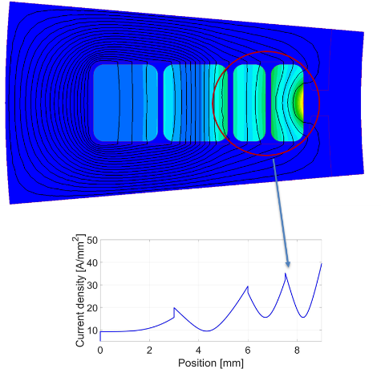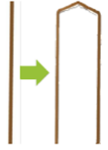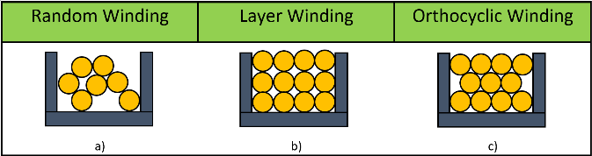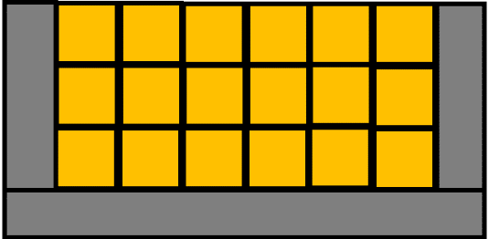

**Segmented Hairpin**

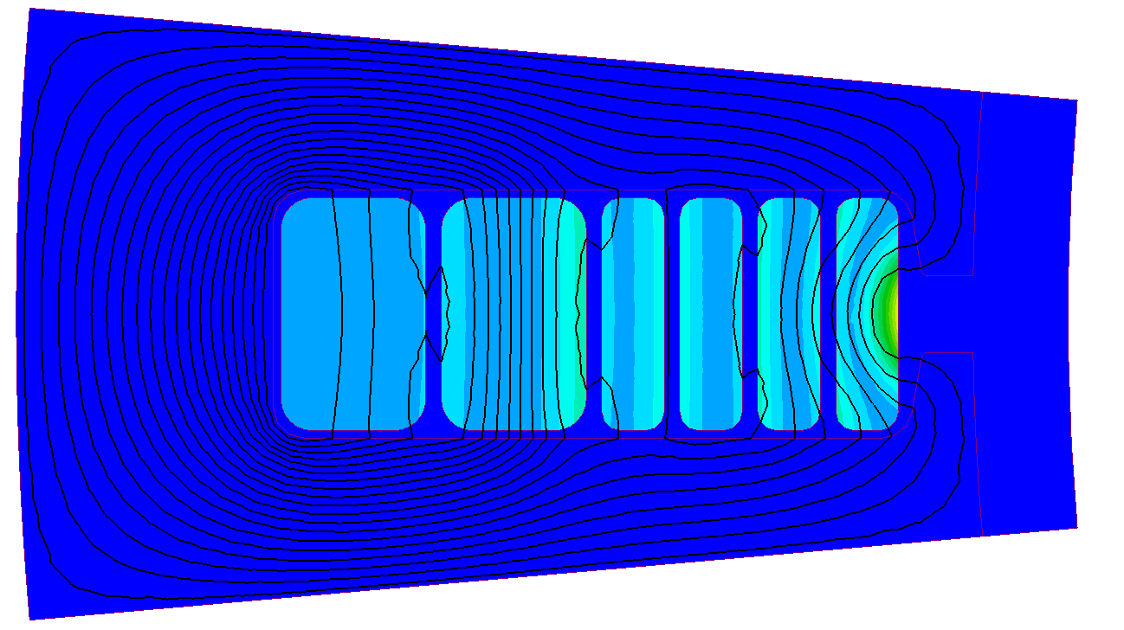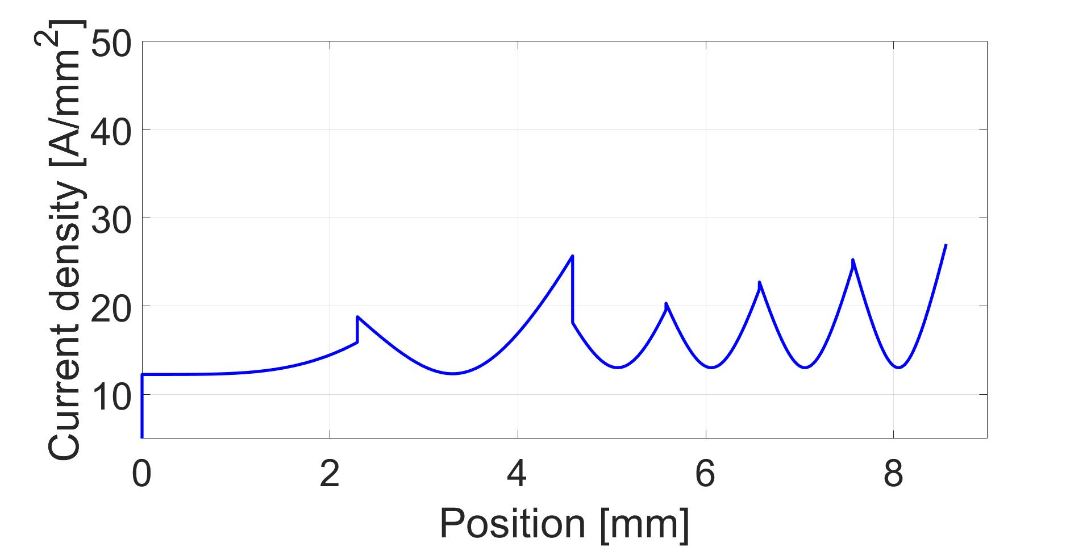

**Asymmetric Hairpin**

**AC losses**

**Dimensioning, bending and contacting**

**Future opportunities**

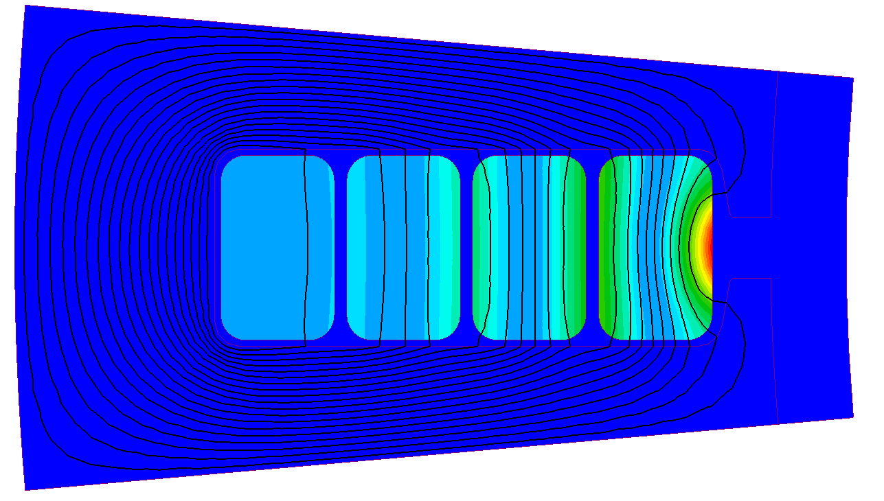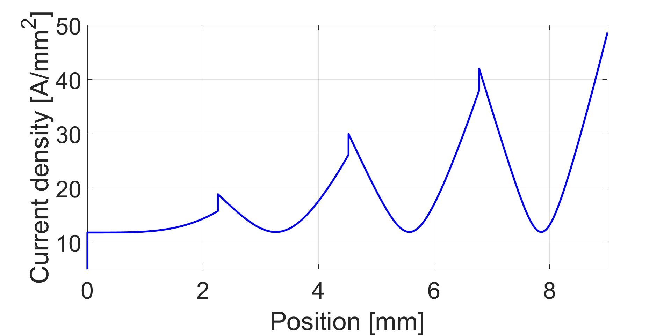

**Challenges**

**Rectangular**

**≈80%**

**Round**

**≈40%**

**Winding technology FILL FACTOR**

**Objective: Power density enhancement**