**Research and Innovation Actions (RIA)**

|  |  |
| --- | --- |
|  |  |

|  |  |
| --- | --- |
| **AUTO-MEA** | |
| **AUTO**mated **M**anufacturing of  wound components for next generation  **E**lectrical m**A**chines | |
| Proposal Number: 865354 | |
| Topic reference: JTI-CS2-2018-CfP09-SYS-03-19 | |
| Duration: | 30 Months |
| Project Officer: | Mr. Jean-Francois BROUCKAERT |
| Topic Manager: | Prof. Chris Gerada (UoN) |
| Project Coordinator: | Davide Barater (UniMore) |
| Type of document: | WP1 – Report D1.1 |
|  |  |

Hairpin Technologies:

Different Automated Coil

Forming and Joining Methods

# Introduction

In the last years, there has been increased need and attention towards greener, lighter, more efficient and reliable technologies in all industrial fields [1]. Among these, the automotive, marine and aerospace industries are replacing their traditional hydraulic, pneumatic and mechanical systems with electrical ones, as this has allowed to achieve significant reductions in fuel use and/or emissions [2]. Therefore, electrical motors and generators are assuming an ever-increasing role in these sectors. The performance of vehicles is very sensitive to the components’ power/torque and mass. Hence, nowadays, maximisation of power-to-weight and/or torque-to-weight ratios represents always a primary objective when designing electrical machines and, in general, electric drives for transportation applications.

A number of methods are available to the increase power density [3]-[5]. However, simplistically, two main knobs can be manipulated to maximise it: the output torque and the angular speed. According to the Lorentz force method, the maximum ratio of electromagnetic torque to rotor volume in an electrical machine can be expressed as the product between magnetic and electric loadings [6]-[7]. The electric loading deals with the conductors’ current density and thus relies on the cooling system. Hence, today, there is an ever-increasing need of powerful computational tools to analyse complex thermo-fluid phenomena, innovative cooling systems to increase the current density and new insulation materials to withstand very high temperatures [8] -[9]. On the other hand, there is also interest in exploiting new materials [10] featuring excellent magnetic characteristics to increase the magnetic loading.

The angular speed represents the second knob for maximising the power density and increasing it allows to achieve more compact and lighter designs [3]. Therefore, besides their magnetic properties, the materials employed in today’s electrical machines must feature good mechanical properties to withstand the high speeds required today. In addition to this researches at machine-level, a lot of improvements have been done at power electronic-level, where the arrival on the market of new power devices based on wide bandgap semiconductors are enabling higher fundamental frequencies [11]-[12] However, to fully exploit these new opportunities, a number of challenges need to be addressed. In fact, as higher operating frequencies contribute to improve power density of electrical machines, they also reflect on increased power losses in cores and windings [13], as well as faster devices commutations are known to trigger Partial Discharges and faster degradation of coil insulation [14].

Table 1 summarizes the key enablers for power density discussed above. The two main branches, i.e. torque and speed, are highlighted. In the table, it can be observed that a communal enabler for both parameters is represented by the winding technologies. Windings are currently a main bottle-neck for improved performance. Whilst techniques such as hairpin windings have been developed, these are often limited to solid conductors resulting in high alternate current (AC) losses.

Table 1: Summary of the key enablers for power density maximization in electrical machines

|  |  |  |
| --- | --- | --- |
| **Power density** | **Torque** | **Speed** |
| * Air gap flux density   E.g. improved electromagnetic properties of materials   * Linear current density   E.g. new cooling systems and improved thermal management   * Operating conditions   E.g. innovative tools of analysis, optimal control | * Mechanical properties of materials   E.g. increased yield strength with no impact on magnetic properties   * Optimal machine design   E.g. optimal pole pair number, interaction with converter design   * Parasitic effects   E.g. compensation for skin effect, increased reliability |
| * **Winding technologies** * Decrease winding resistance, e.g. through larger wire diameters, reduced end winding lengths * Decrease AC parasitic effects, e.g. through multi-stranded and smaller wire diameters, reduced stray inductances via optimal end winding shape * Increase fill factor, e.g. through pre-formed profile wires | |

To cope with the desire of operating at high fundamental frequencies (>1kHz), coils are often required to be multi-stranded with small cross-sectional areas or Litz-wire to reduce power losses and with appropriate insulation to withstand the fast switching edges. This in turn leads to poor overall fill factors, large end windings, higher coil thermal resistance, and higher likelihood of winding failure. New winding concepts and manufacturing techniques are thus required to mitigate these, as high reliable and power dense machines require high fill factors and low losses in automotive and aerospace environments. This paper reviews the methods for increasing the fill factor, focusing on the hairpin technologies, their challenges and future opportunities.

# Fill factor: Round & Rectangular comparison

The electric fill factor is defined as the ratio of the amount of electric conductor material Acopper (with no insulation) to the available winding space Aslot. It has a significant impact on the power density, but also on thermal conductivity, manufacturability and overall costs [15]-[16]. The fill factor has a direct correlation with the current density limitations and thus on torque and power. In general, high fill factor means high conductor area with respect to the slot’s one. This ensures higher thermal conductivity, as proven in [17], since the amount of copper is larger compared to dielectric material, that suffers from higher thermal resistance. Improvements in the insulation material thermal properties can reduce the thermal stresses, due to the higher capability of heat dissipation, allowing higher temperatures in the machine. For example, in [18], the 60% increase in the stator current density is predicted at the cost of a temperature rise by 70 °C (from 130 °C to 200 °C). In simplistic terms, two main families of conductors can be defined according to their cross section: round and rectangular wires. While round conductors inherently feature low fill factors, rectangular wires match well with the slot shape and they are thus characterized by high fill factors. However, in high-frequency applications, round conductors are still preferred and several methods are used to increase the fill factor. These are discussed in the next sub-section.

One of the main reason why the round-wire windings are replaced with rectangular cross section conductors concerns the slot fill factor augmentation. A larger cross section for the conductor allows a higher current density in slots so power density improves too.

## Round wire fill factor

The insertion mechanism of round conductors within the slot affects the fill factor of such type of winding. Wires can be located in the slot with different patterns [19].

The winding mechanism can occur randomly and thus a random winding is achieved as shown in Figure 1a. This is the most common solution for an automated process and big scale production, but achieves very low fill factors, usually lower than 55% [20]. A second winding mechanism consists in placing tidily the wires in layers, as seen in Figure 1.b This winding type, known as layer winding, can reach higher fill factors than random windings, but only when these layers are placed as in Figure 1.c the fill-factor can rise up to 75%.

In this case, an orthocyclic winding is realised. Layer and orthocyclic windings can be achieved using special needle machinery. With this technology, each wire is placed inside the slot in a very precise position.

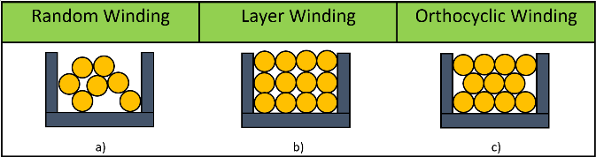

Figure 1 Basic winding patterns

Another way to improve the fill factor of round wires is to use a segmented stator, as reported in Figure 2.a [21]. Here fill factors up to 60% can be achieved, but the design is limited to only concentrated windings, since the winding is wound directly on the tooth. Concentrated windings have advantages like shorter end windings (reduced copper loss) and higher fill factor compared to distributed windings, but they come at the cost of a lower fundamental of flux linkage and induced voltages and higher eddy current losses in permanent magnets (when present).

To achieve even higher fill factors, in some cases on-tooth coils can be pressed as shown in Figure 2.b [22][23][24]. With this technology, the fill factor is ≈80%, since the coils are wound directly on the tooth. Similar values of fill factors have been achieved by using soft magnetic composite structures and prepressed windings. The purpose of this process is to lower the amount of voids in the windings, but the process is bonded by the deformation and by the mechanical properties of the insulation layer [25]. A 75% slot ﬁll factor is obtained by using a “joint-lapped core” [26].

|  |  |
| --- | --- |
| Image |  |
| a) | b) |

Figure 2 a) segmented stator and b) laminated plug-in tooth

The round wires are squared by lamination, thus achieving a fill factor of ≈83%. Even in this case the insulation material was under investigation to ensure no electric faults in the coils.

## Rectangular cross section conductors

Another solution that does not require concentrated windings or deformation of the coil insulations is obtained with a new segmented stator geometry allowing for a distributed winding to be implemented: the windings are mounted on a flat band-shaped stator that is bent and welded in a second moment. In [27], a new proposal motor has a distributed winding stator that can be flat band shaped easy to wind without dividing winding acquiring both distributed and concentrated windings pros.

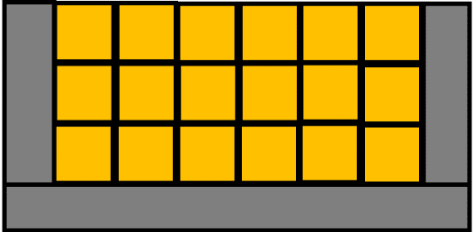

Figure 3 Rectangular cross section conductors

A better thermal management is achieved when adopting hairpin windings, as opposed to round conductors, Figure 3. However, due to the inherently high copper losses at high frequencies, hollow hairpin and u-profile conductors, i.e. cooled conductors, are proposed [28]. This allows for an axial coolant to flow through the machine, but comes at the cost of decreasing the fill factor within the slot. Nevertheless, thanks to a better cooling and thermal management, a higher current density is achieved. A comparison with oil-cooled hollow hairpin and solid one can be performed demonstrating that the former allows for higher torque capability paying with lower efficiency with respect to the latter. The relevant geometries should be designed in such a way that they can host dedicated liquid-carrying pipes for a direct cooling of the stator end windings. While this concept has been already applied to round conductors, it is expected that there will not be extreme technical obstacles for the application of such a concept to the end windings of hairpin windings.

# Manufacturing process

A preparatory process is performed before hairpin production. Referring to [29], a single rectangular cross section conductor is prepared for the manufacturing chain straightening it to ensure unwanted deformation of the material shape during the following steps. Stripping of the conductor is performed in order to avoid dielectric impurities in the contacting area that will be welded in the last phase; this precaution is adopted to ensure high quality contact. Finally, cutting of the single conductor is executed depending on the application and the number of units avoiding deformation of dwarf that will cause discontinuity in terminals of hairpins’ legs.

After the preparatory process, the effective manufacturing phases are described to obtain the final stator structure.

The hairpin manufacturing process is totally automatized in order to satisfy mass production requirements [30]. The systematic actions can be divided in 4 main phases referring to Figure 5: shaping, assembly, twisting, contacting. In phase 1, the rectangular cross section conductors are bent to assume the preferred hairpin shape. Various solutions are shown in . Opened, half opened and closed represent types of bar-wound windings that differentiate in: complexity preforming of coils, i.e. the complexity in the process of shaping, complexity assembly of coils, i.e. the mounting process, number of contacting operations [31].

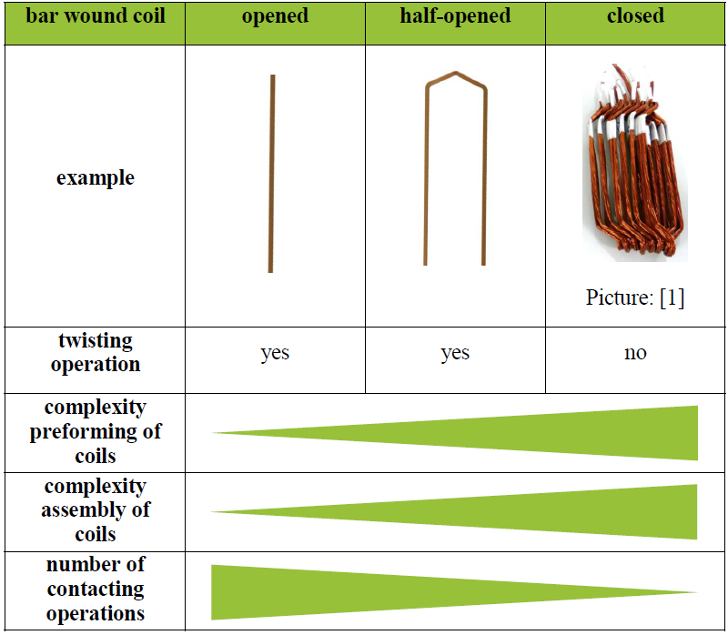

Figure 4 Main shapes of rectangular conductors

In phase 2, the insertion mechanism is obtained introducing a leg of each hairpin in all slots following the planned filling scheme of the slots. In phase 3, the pattern of hairpins defined during machine design is achieved for each electrical phase at the same time exploiting a gear element, in place of rotor, that deforms the other hairpin extension, the one out of the slot, forcing the conductor to pass from a slot to another one. Phases 2 and 3 are of crucial importance in AC losses. In fact, exploiting transposition mechanism it is possible for current to experience the same displacement along all conductors in one slot reducing variation of AC resistance among hairpins of the same slot. In particular, among *n* parallel paths, transposition of conductors must be performed *n-*1 times otherwise increase of AC losses is experienced. . Finally, in phase 4 the contacting process is performed [32], [33]. Various techniques are available to complete this goal, the preferred one is laser welding in terms of final product quality. In particular, during this process it must be taken into account that welding depth is directly proportional to contact resistance.

|  |  |  |  |
| --- | --- | --- | --- |
| Shaping | Assembly | Twisting | Contacting |
|  |  |  |  |

Figure 5 Hairpins manufacturing phases

Design of hairpin shape improves different aspects of manufacturing process and final product quality. Continuous hairpin allows improvements in manufacturability reducing the number of welding points, i.e. the numbers of terminal lines of the motor, and cycle time too [30]. The single conductor is formed by two continuous α-shaped coils. Wiring is easier with respect classic hairpin assembly discussed above, copper losses are improved and the process is still automatized due to the fact that all coils could be simultaneously formed and inserted into stator. Composing one single element of the winding as two continuous α-shaped allows to lower the number of welding points allowing improvements in contact resistance and reducing cycle time in welding [34]. Compared to the classical hairpin structure, continuous hairpins consist in a lower number of terminal lines reducing the number of contacts [35].

# Soldering or Welding: main processes

The choice of the appropriate welding technique must satisfy different requirements. First of all, as obvious, the contact resistance must be lower than the reference one, i.e. the resistance of a hairpin’s leg [29]. Then, this process must guarantee low thermal stress within the conductor body as this ensure unwanted burning of electrically isolating coating and conductor spatter on stator surface. In fact, both of them can cause short circuit during operation of electric machines and lower thermal strength, i.e. overheat of the machine. In general, insulator coating must be out of the welding region.

Referring to [29], the best solution to achieve the hairpins connection is “*laser welding*”. Various solutions are compared and the literature is concordant that the automation of the contacting process is achievable only with laser.

The results of comparison are summarized in Table 2 with the main characteristics.

In Table 2 Main welding and soldering techniques compared [29], the following nomenclature is introduced: “Automation capability”: the possibility to automatize the process, “Flexibility”: fast moving nature and high product fluctuation requirement, “Tool wear”: tools involved in welding or soldering resistance, “Process stability”: consistency of the process with respect to the quality reproducibility, i.e. constant quality pattern, “Accessibility”: the process must be actuated in small and confusing windings.

Table 2 Main welding and soldering techniques compared

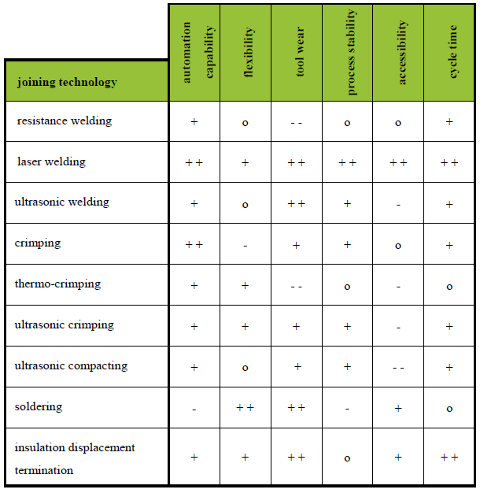

In “*resistance welding”* the pros are related to mass production due to low costs [36]. Automation of the process is possible and also the cycle time is low. A limited flexibility and accessibility are observed in this process due to complex plant structure. It lacks in process stability due to electrode wear. In details, different approach of resistance welding solution can be listed: Resistance welding using refractory tipped electrodes, projection welding and capacitive discharge welding. The first promotes electrode-sheet surface heating/melting and/or expulsion, deep indentation and electrode deterioration, the second requires additional maintenance of the projection geometry and control of electrode force, the third has been shown to be sensitive to weld time. Resistance Mash Welding is presented in [37] as a controlled in contact force and current. The former to compensate copper collapse, the latter to avoid too high thermal stress. Here, two types of welding joints are investigated: cross-wire joint configuration, Figure 6, where the contact area between two hairpin legs is obtained putting one over the other, and parallel wire joint configuration, Figure 7, where hairpins legs are putted one near the other without cross overlap area. Different parameters are involved in the definition of the process, including: weld force, weld time, weld current, forge delay time, forge force.

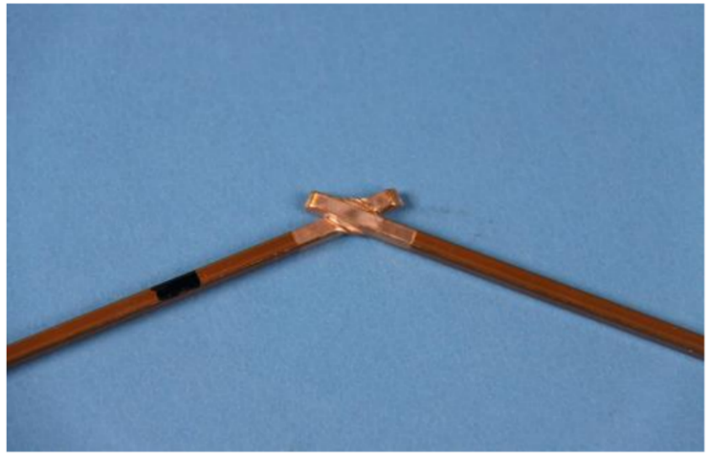

Figure 6 Cross-wire joint configuration

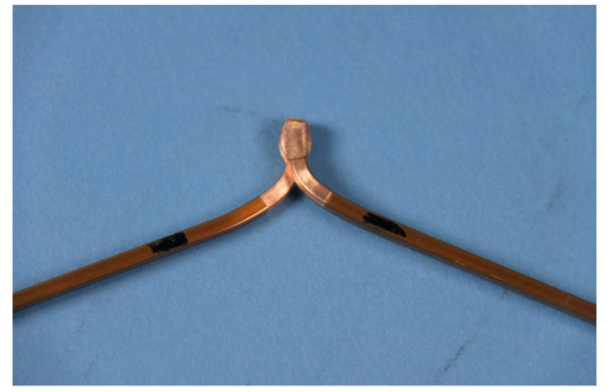

Figure 7 Parallel wire joint configuration

In “*ultrasonic welding”* the contacting process is obtained by high frequency vibrations of the materials involved. This solution is cheaper with respect to “*laser winding”*, the benefits of this solution are related to the short cycle time and the possibility of automation. However, the high frequency vibrations are responsible to potential material damage in the structure so quality and reliability may be compromised.

Another solution with good benefits in flexibility, accessibility and costs is represented by “*soldering*” [29]. This solution is adopted in prototyping phase as its costs are very low. Additional material is necessary to obtain the contact. Obviously, this solution is not automatable and so mass production is unfeasible.

“*Laser welding”* represents the best solution and the most adopted one in the stator winding assembling [38]. All characteristics fit with the requirements of contacting process as it is able to realize a large number of contact points in the smallest possible space, automation is possible, cycle time is the lowest one compared to the other processes, low thermal stress is required [15]. Infrared solid-state lasers with high beam intensity are mainly implemented. The unique drawback is associated to costs. With the advent of machine learning, laser welding performance is improved as the contacting surfaces between two terminals are opportunely controlled to perform the best welding [39].

It is important to underline that the contact zone resistance must be lower with respect to the reference resistance of the single hairpin leg. With infrared laser it is possible to achieve this goal.

“Beam Wobble” is a laser beam technique based on a small size of the focused on the conductors’ contact, it preheats the contact parts in a controlled manner allowing low thermal stress and so no form errors. This ensure low resistance associated to the contact [40].

As mentioned in [20], insulator coating must be out of the contacting region. In Table 3, different techniques are listed as solutions for dielectric removal out of contacting region. Among these, the parameters taken into account are the applicability of the process, i.e. complications involved, and the quality of the final product, in terms of residuals and net separation between dielectric and conductor regions. Hence, laser solution can be applied also in this process as it possible to modulate laser power to achieve high quality in stripping. The insulator layer of the end windings can be removed totally before welding and this ensures high quality contacting as no spatters of insulation will be present. In Table 4, various skinning techniques with laser are compared. The reference values are the average quantity of residues and their standard deviation. The preferred solution is obtained with the combination of CO2 and fibre lasers where the process permits to ensure almost the total elimination of dielectric material from the contacting region.

Table 3 Comparison between different techniques for insulator removal at contacting area

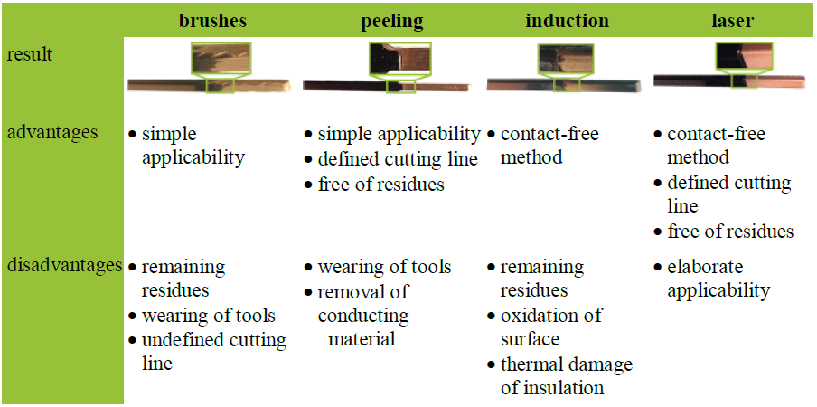

Table 4 Skinning results comparison with different laser technique applied

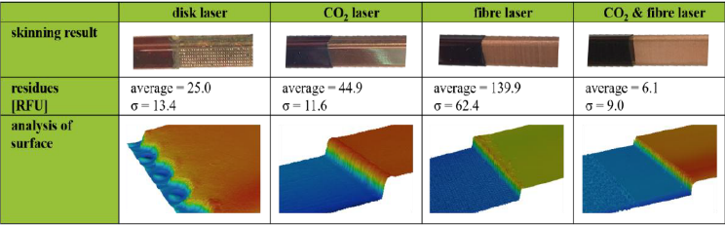

# Hairpin dimensions: standards

Dimensions for hairpin conductors are standardized by IEC 60317-0-2 [41]. This relates conductors’ width and thickness, i.e. recommended ratio taken from the R 20 and R 40 series, Rénard series with k=20, k=40 respectively, according to ISO 3 for mass production. It is possible to access to the thickness of the insulator in order to ensure structural reliability. When reference for a conductor is defined following this standard, the related characteristics are nominal conductor dimensions in millimetres (width and thickness) and the insulation grade (defining the range of thickness of the insulation of a wire). Minimum recommended cross section is , where the first dimension refers to the width and the second one to the thickness. The maximum recommended ratio, on the other hand, is 16. For the sake of completeness, in [27], the American Wire Gauge (AWG) is another standardized system which defines the cross-section area reference to build hairpins. Here, no specification on thickness and width are present, so ideally the standard defines only their ratio. The maximum number of hairpin conductors in a slot is dependent from the torque, angular velocity and power density that are listed by requirements. Ideally, limits in fulfilment of slots are related to the space available to conductors’ insertion. Manufacturer experience refers that up to 8 conductors per slot are possible; physical limits are principally related to the total coil-end height due to the transposition requirements. Referring to the standard IEC 60317-0-2, the grade chosen implies the specific range of thickness of the insulation of a wire. Two grades are defined in this standard and they concern the geometries highlighted in Table 5. This table defines the increases in width or thickness due to insulation recommended by standard. Standard reference values for width and thickness are listed in Table 6.

Table 5 Insulation: increases in dimensions

|  |  |  |  |
| --- | --- | --- | --- |
| Grade | **Increase in dimensions (mm)** | | |
| **Minimum** | **Nominal** | **Maximum** |
| **1** | **0,06** | **0,085** | **0,11** |
| **2** | **0,12** | **0,145** | **0,17** |

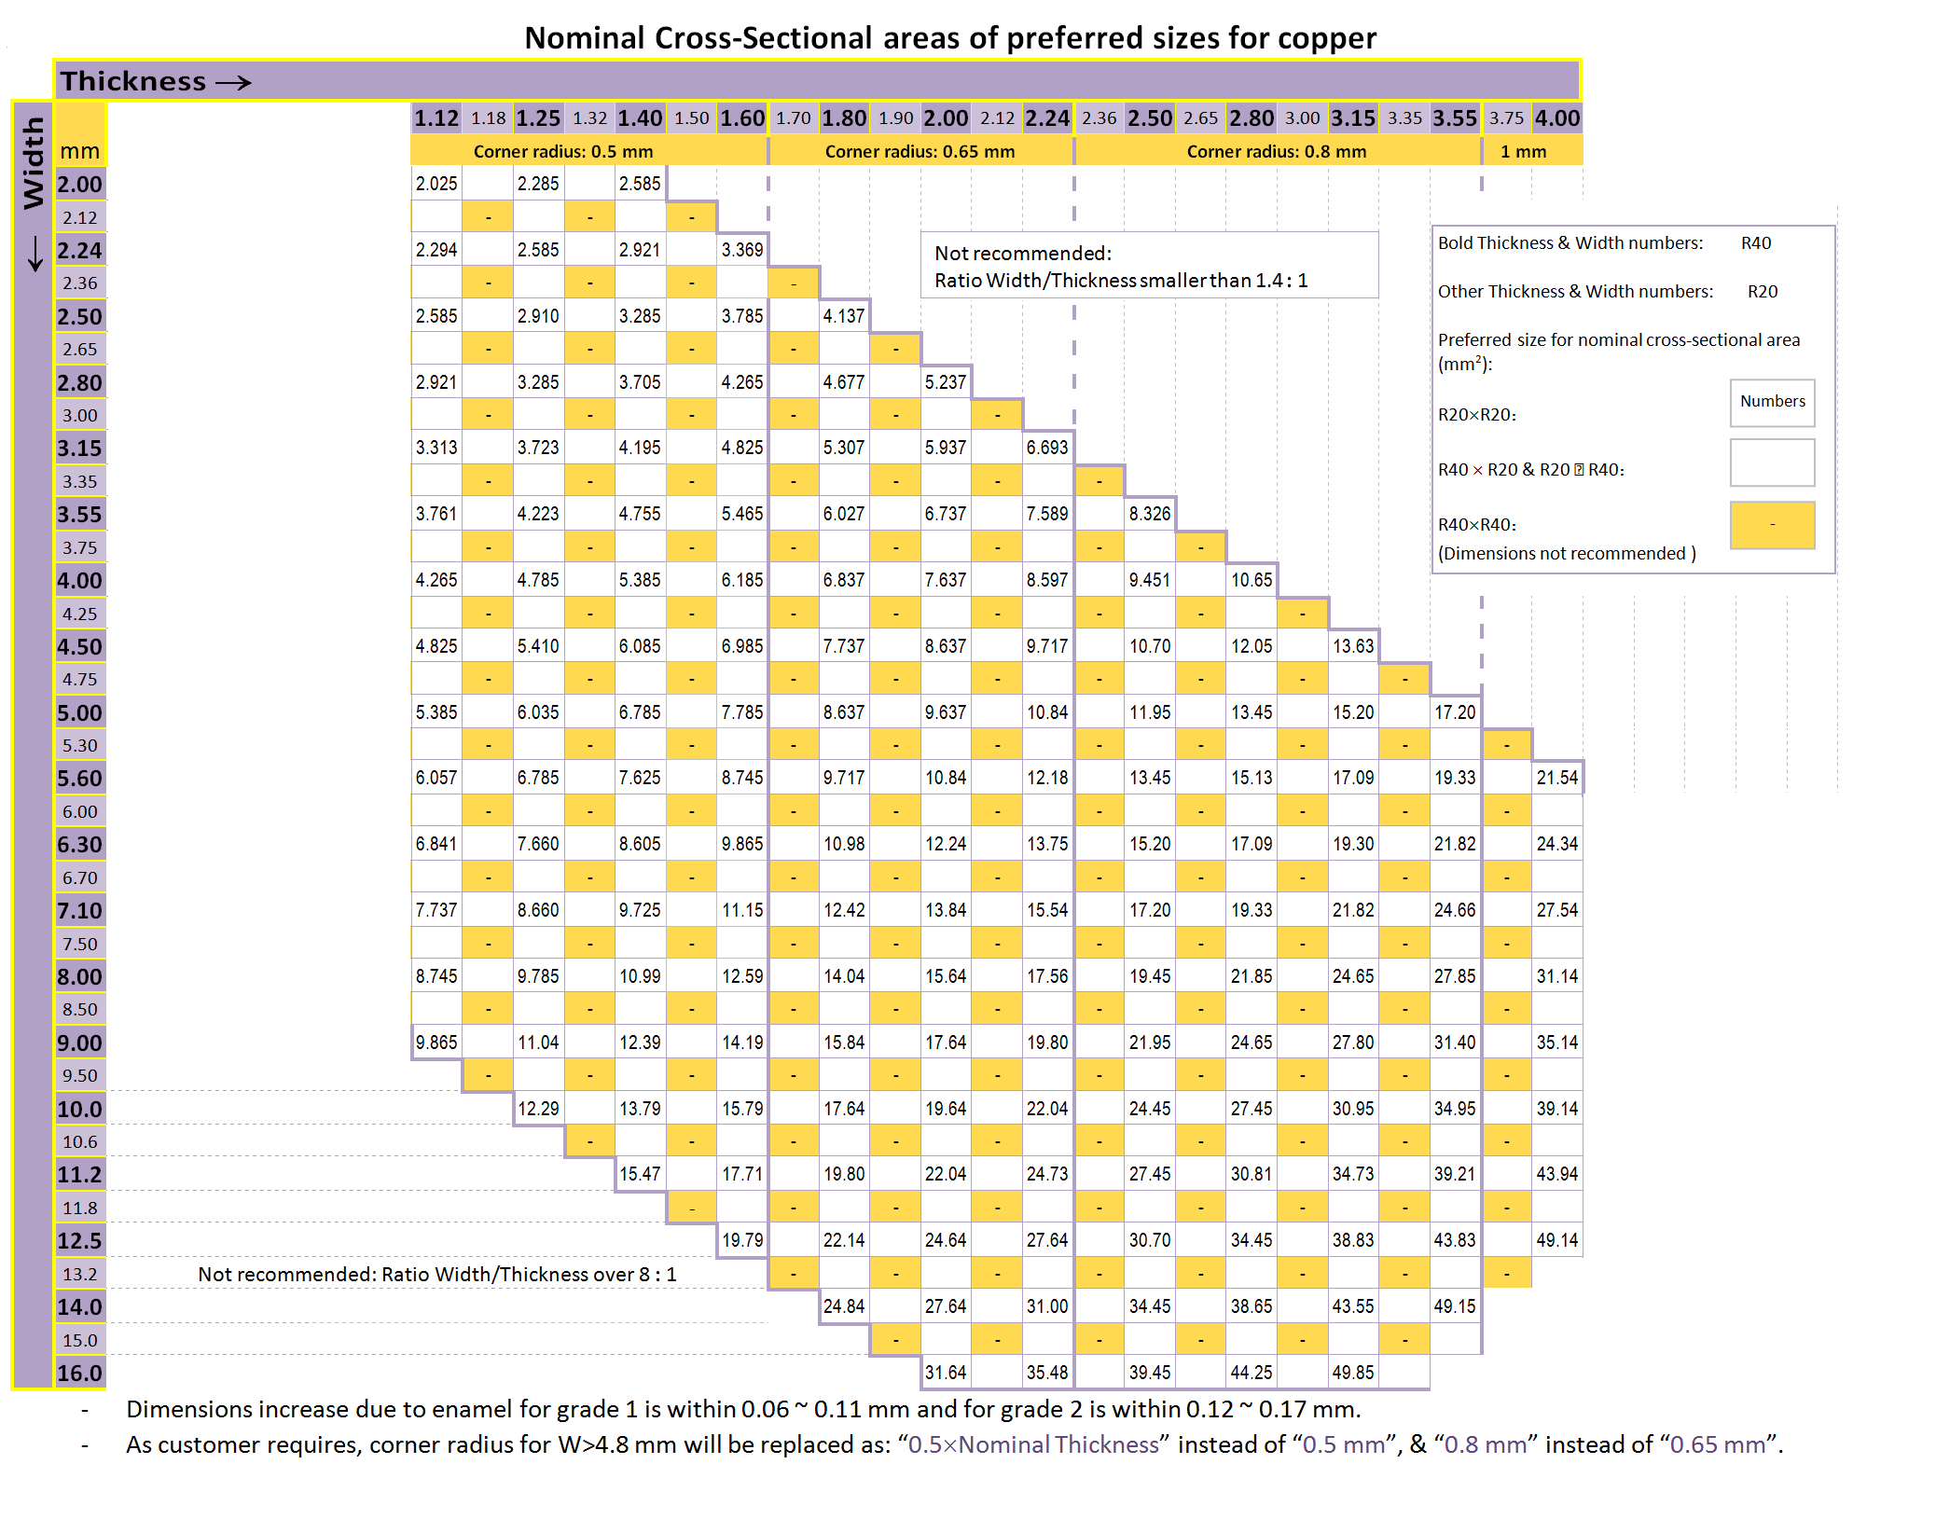

Table 6 IEC 60317-0-2 standard width and thickness

# AC losses

Although the higher fill factor , the higher reliability, the automation of the manufacturing process, the thermal improvements that can be achieved with hairpin technologies, some drawbacks must be underlined to solve them. Hairpin windings have been demonstrated to improve efficiency at low speed region while they suffer at higher frequency. As the area of conductor augments, the resistance observed in AC domain increases due to skin effect and proximity effect [42]-[43]. The former is proportional to the frequency and causes the displacement of current along the surface of conductors in slot. This phenomenon affects the effective improvements of a larger area dedicated to conductor [44]. The latter effect instead causes different displacement in current path in the conductors involved in the same slot due to interaction between all conductors that transport current flows; the interferences experienced by each one are different. In particular, the opening of the slot at the air-gap causes a variation of reluctance observed by the magnetic flux related to the current flow of each hairpin in slot. With respect to the centre of the stator, the farthest conductor current isn’t affected by magnetic flux of the others due to the absorption of the flux itself by the surrounding ferromagnetic material. Instead, the conductors nearer the air-gap will observe a current path displacement in the direction of the centre due to magnetic flux generated. To solve this problem, it is possible to close the opening of the slot at the air-gap allowing a surrounding material able to force the magnetic flux path. Others solution available against skin and proximity phenomena are the transposition mechanism and differentiation of size among hairpins belonging to the same slot [45]. The former has been already briefly discussed in manufacturing process section, while the latter consists in the fulfilment of the slot by assembling conductors of smaller size as their position is nearer the air-gap. The combination of these two solutions and the parallel path design allow a multitude of design solutions defining the best contacting pattern and the most suitable sizes [46]. Some examples are compared in the following sub-sections.

## Classical hairpin arrangement

As seen in Figure 8, the classic hairpin layout consists of conductors featuring the same size in the slot. The contacting pattern for a single current path is the series of all conductors. Transposition is performed to reduce AC losses.

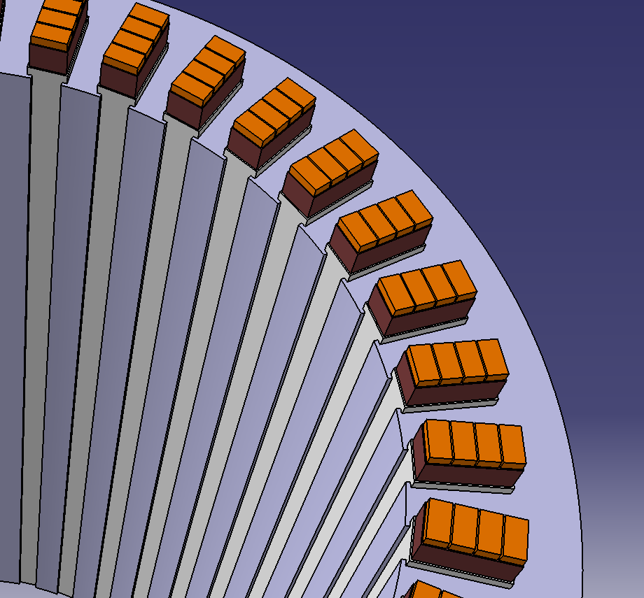

Figure 8 Hairpin with same size

The current density is plotted in Figure 9 for an example featuring 4 conductors per slot. Here, the variation of this quantity along the radial direction due to proximity and skin effects can be appreciated. In the following sections, some solutions are proposed to obtain a uniform distribution of the current among conductors.

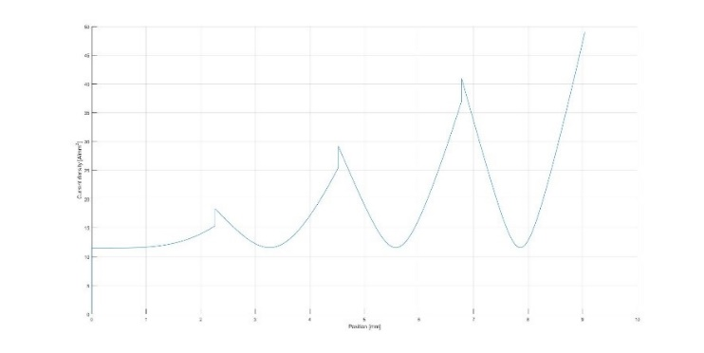

Figure 9 Classic hairpin current density

## Hairpins with variable cross section

The first proposal to reduce AC losses in hairpin windings concerns conductors with variable thickness along the slot. Transposition mechanism has been applied to the series of hairpin, i.e. no parallel paths are exploited. In Figure 10 the proposed idea is depicted.

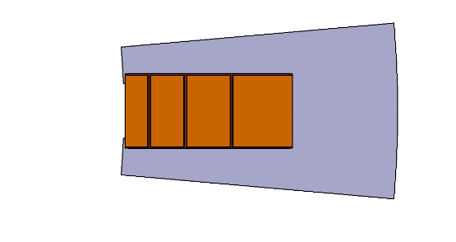

Figure 10 Hairpins with variable size

The resistance observed in a single current path will be the sum of resistances associated to each hairpin composing the slot. Current displacement is compared in Figure 11 between the classic solution (orange line) and the variable size one (blue line). It is possible to appreciate a current density distribution with lower difference between the maximum value experienced by each hairpin in slot.

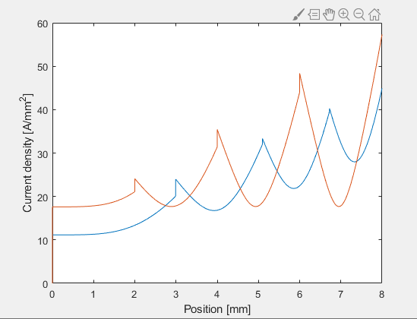

Figure 11 Current density in Hairpins with variable size (conductors disposition as in Figure 10 Hairpins with variable size

## Hairpins with parallel paths

This solution represents the first one that combines benefits of transposition, variable size hairpins and contacting pattern. Indeed, the hairpins areas are the double for those farthest the centre with respect the ones nearer it. In Figure 12 the disposal is depicted underlining that, starting from the outer one, the first two conductors areas are identical , whereas the last 4 conductors’ cross section (i.e. the thickness) is half of it. These conductors with reduced thickness can be then connected in parallel. This solution allows a more homogenous current density distribution among conductors as plotted in Figure 13. As mentioned before, the transposition mechanism must be performed in combination with parallel paths, otherwise the method is ineffective. In particular, the resistance is the sum of the series of the first two conductors, with respect the outer one, in series with the parallel of the series of a couple of the half area ones. This concept can be observed in Figure 14 where R is the DC resistance associated to one of the 2 larger conductors and 2R is the DC resistance of a single half area conductor.

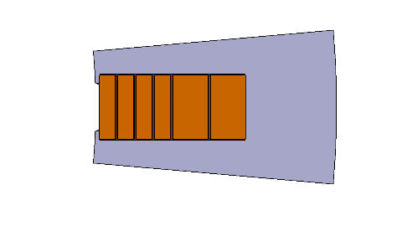

Figure 12 Hairpins - parallel solution

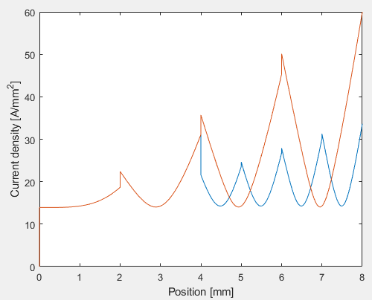

Figure 13 Hairpins - parallel solution (conductors disposition as Figure 12 Hairpins - parallel solution) in blue line, classic hairpin in red line

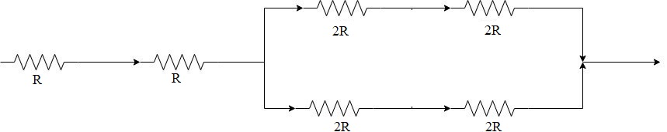

Figure 14 Resistance seen for by a single current path in a slot

## Hybrid solution

This solution results from merging of the parallel and variable size solutions. All conductors have different areas among them. The design of these is obtained using a genetic algorithm optimization tool that has been developed to define an optimum size for each conductor. The input parameters are: slot geometry, thickness of the conductor, working frequency, current density, parallel path desired and the number of conductors in each slot.

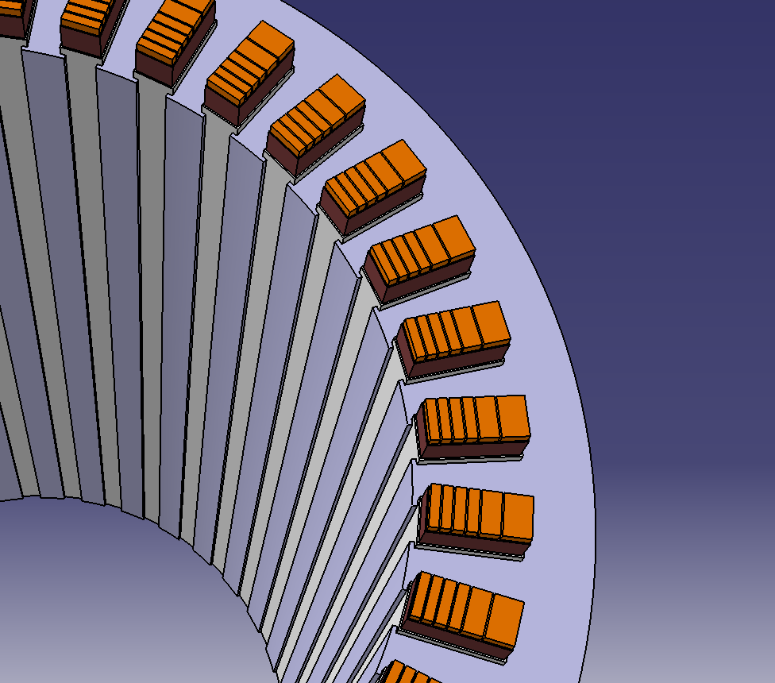

Figure 15 Hybrid solution with hairpins

In Figure 15, one possible optimal design is schematized in order to observe the slot structure where 6 different conductors compose one single slot and the 4 ones closer to the air-gap are connected in parallel as qualitatively illustrated. Current density distribution is the most homogeneous obtained by simulations as depicted in Figure 16.

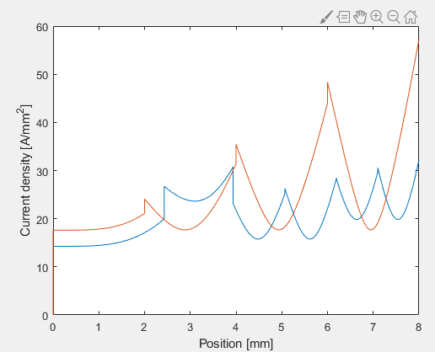

Figure 16 Current density in hybrid solution (from the outer region) in blue line, classic hairpin in red line

Although the above techniques might effectively lead to improved scenarios of AC losses, their impact on the manufacturing should be carefully evaluated. Designing the conductors with variable cross section is challenging since this implies that the two “legs” of an elementary hairpin would be different, i.e. a different production method must be used for production (e.g. 3D printing). Another way is to maintain the size of the conductors equal for two layers, as described in [45], with no added manufacturing complexity. In the case of parallel paths, it is important to notice that the number of welding spots increase. Therefore, ways to mitigate this challenge should be investigated in future.

# Conclusions

In this treatise, focuses on soldering & welding, manufactory process, associate electrical losses and new design proposal about hairpins are described in details. Main welding techniques and soldering are presented to understand the state of the art in mass production, laser welding, and prototyping, soldering, phases for rectangular cross section conductors. Manufactory process is detailed with particular attention to the shaping process underlining different techniques available in this field. AC losses are studied to highlight the most relevant drawbacks of hairpin technology and they are here proposed with design solution in order to improve efficiency and to reduce electrical losses. Finally, all new architectures are described taking into account current density distribution in order to understand how different design approach can change the current flow.

# Reference list

1. M. Lukic, P. Giangrande, A. Hebala, S. Nuzzo and M. Galea, "Review, Challenges, and Future Developments of Electric Taxiing Systems," in IEEE Transactions on Transportation Electrification, vol. 5, no. 4, pp. 1441-1457, Dec. 2019.  
   doi: 10.1109/TTE.2019.2956862
2. Dr J. Goss, CEO of Motor Design Ltd, Motor Design Limited, "Performance Analysis of Electric Motor Technologies for an Electric Vehicle Powertrain",2019
3. M. Van der Geest et al., “Power Density Limits and Design Trends of High-Speed Permanent Magnet Synchronous Machines”, IEEE Trans. Transport. Electriﬁc, vol. 1, no. 3, pp- 266-276, 2015.
4. A. Al-Timimy, P. Giangrande, M. Degano, Z. Xu, M. Galea, C. Gerada, G. Lo Calzo, He Zhang, L. Xia, “Design and Losses Analysis of a High Power Density Machine for Flooded Pump Applications”, IEEE Transactions on Industry Applications, vol. 54, no.4, 2018.
5. Y. Wang, G. Vakil, S. Nuzzo, M. Degano, M. Galea, C. Gerada, H. Zhang, N. Brown “Sensivitity analysis for performance and power density improvements in salient-pole synchronous generators”, IEEE Workshop on Electrical Machines Design, Control and Diagnosis (WEMDCD), pp. 33-38, 2017.
6. A. Tenconi, S. Vaschetto, and A. Vigliani, “Electrical machines for highspeed applications: Design considerations and tradeoffs,” *IEEE Trans. Ind. Electron*., vol. 61, no. 6, pp. 3022–3029, Jun. 2014.
7. Scitech Europa,"Ultra lightweight motors for the next electric vehicles", 25th March 2019

1. [A. Boglietti](https://ieeexplore.ieee.org/author/37267752100) ; [M. Cossale](https://ieeexplore.ieee.org/author/37078217900) ; [M. Popescu](https://ieeexplore.ieee.org/author/37271590800) ; [D. Staton, “Calibration Techniques of Electrical Machines Thermal Models”, *2018 XIII International Conference on Electrical Machines (ICEM)*, pp. 1108-1115, 2018.](https://ieeexplore.ieee.org/author/37267755400)
2. K. Bersch, S. Nuzzo, P. H. Connor, C. N. Eastwick, M. Galea, R. Rolston, and G. Vakil, “Combined Thermofluid and Electromagnetic Optimisation of Stator Vent Cooling,” in *23rd International Conference on Electrical Machines (ICEM 2018)*, pp. 1116–1122. 2018.
3. A. Krings, M. Cossale, A. Tenconi, J. Soulard, A. Cavagnino, A. Boglietti,"Magnetic Materials Used in Electrical Machines: A Comparison and Selection Guide for Early Machine Design", IEEE, Nov.-Dec. 2017
4. D. Barater, C. Concari, G. Buticchi, E. Gurpinar, D. De and A. Castellazzi, "Performance Evaluation of a Three-Level ANPC Photovoltaic Grid-Connected Inverter With 650-V SiC Devices and Optimized PWM," IEEE Trans. Ind. Appl, vol. 52, no. 3, pp. 2475-2485, May-June 2016.
5. D. Barater, E. Gurpinar, G. Buticchi, D. De, C. Concari, A. Castellazzi, and G. Franceschini, "Performance analysis of unitl-h6 inverter with sic mosfets,” IEEE International Power Electronics Conference (IPEC), pp. 1-7, 2014.
6. Bianchi, V.; Savi, F.; De Munari, I.; Barater, D.; Buticchi, G.; Franceschini, G. Minimization of Network Induced Jitter Impact on FPGA-Based Control Systems for Power Electronics through Forward Error Correction. Electronics 2020, 9, 281.
7. D. R. Meyer, A. Cavallini, L. Lusuardi, D. Barater, G. Pietrini and A. Soldati, "Influence of impulse voltage repetition frequency on RPDIV in partial vacuum," in IEEE Transactions on Dielectrics and Electrical Insulation, vol. 25, no. 3, pp. 873-882, June 2018. doi: 10.1109/TDEI.2018.006722
8. M. Popescu, J. Goss, D. A. Staton, D. Hawkins, A. Boglietti, Y. C. Chong; “Electrical Vehicles - Practical Solutions for Power Traction Motor Systems,” in IEEE Transactions on Industry Applications 2018
9. K. Hee Nam, "AC Motor Control and Electrical Vehicle Applications", CRC Press, 3rd September 2018"Fundamentals of Small Parts Resistance Welding", Amada Miyachi America, 2015
10. M. Stöck, Q. Lohmeyer, M. Meboldt,"Increasing the power density of e-motors by innovative winding design",Product Development Group Zurich, Eidgenössische Technische Hochschule ETH Zürich, Switzerland, CIRP 25th Design Conference Innovative Product Creation, December 2015
11. R. Ranjan, J. Tangudu,"Thermal Design of High Power-Density Additively Manufactured Induction Motors", United Technologies Research Center, East Hartford, CT 06118, 13 November 2014
12. N. Raabe, “An algorithm for the Filling Factor calculation of electrical machines standard slots”, 2014
13. T. Glaessel, J. Seefried, A. Kuehl and J. Franke, "Skinning of Insulated Copper Wires within the Production Chain of Hairpin Windings for Electric Traction Drives", Institute for Factory Automation and Production Systems, Friedrich-Alexander-University of Erlangen-Nuremberg, Nuremberg, Germany, Int. J. Mech. Eng. Rob. Res, 2020
14. T Albrecht, W Konig and B Bickel, “Proceedings for wiring integrated winding of segmented stators of electric machines,” 2011.
15. M. C. Kulan, N. J. Baker and J. D. Widmer, “Design of a High Fill Factor Permanent Magnet Integrated Starter Generator with Compressed Stator Windings,” 2016.
16. M C. Kulan, N J. Baker and J D. Widmer, “Design and Analysis of Compressed Windings for a Permanent Magnet Integrated Starter Generator,” IEEE TRANSACTIONS ON INDUSTRY APPLICATIONS, 2017.
17. J. D. Widmer, R. Martin and B. C. Mecrow, “Pre-Compressed and Stranded Aluminium Motor Windings for Traction Motors,” 2015.
18. M. C. Kulan, N. J. Baker and J. D. Widmer, S. M. Lambert,“Modeling the Mechanical and Thermal Properties of Compressed Stator Windings”, 2016
19. H. Akita, Y. Nakahara, N. Miyake, and T. Oikawa, “New core structure and manufacturing method for high efficiency of permanent magnet motors,” in Conf. Rec. IEEE IAS Annual Meeting, vol. 2, pp. 367–372, 2003.
20. S. Makita, Y. Ito, T. Aoyama and S. Doki, "The proposal of a new motor which has a high winding factor and a high slot fill factor," 2014 International Power Electronics Conference (IPEC-Hiroshima 2014 - ECCE ASIA), Hiroshima, 2014, pp. 3823-3827.
21. A. Reinap, M. Andersson, F.J. Márquez-Fernández, P.Abrahamsson, M. Alaküla, "Performance Estimation of a Traction Machine with Drirect Cooled Hairpin Winding", Lund University, Sweden, 2019
22. T. Glaessel, J. Seefried, J. Franke, "Challenges in the Manufacturing of Hairpin Windings and Application Opportunities of Infrared Lasers for the Contacting Process", Institute for Factory Automation and Production Systems, Friedrich-Alexander-University, Erlangen-Nuremberg, Germany, Tobias.Glaessel@faps.fau.de, 02 April 2018
23. T. Ishigami, Y. Tanaka, H. Homma, "Development of Motor Stator with Rectangular-Wire Lap Winding and an Automatic Process for Its Production", June 2014,Electrical Engineering in Japan 187(4)T. Ishigami, Y. Tanaka, H. Homma,"Motor Stator with Thick Rectangular Wire Lap Winding for HEVs", IEEE Transactions on Industry Applications, 10.1109/IPEC.2014.6869841,2014
24. F. Wirth, T. Kirgör, J. Felischer,"FE-based Simulation of Hairpin Shaping Processes for Traction Drives",Institute of Production Science Karlsruhe Institute of Technology (KIT), IEEE, 2018
25. G. Berardi and N. Bianchi, "Design Guideline of an AC Hairpin Winding," 2018 XIII International Conference on Electrical Machines (ICEM), Alexandroupoli, 2018, pp. 2444-2450
26. N. Bianchi and G. Berardi, "Analytical Approach to Design Hairpin Windings in High Performance Electric Vehicle Motors," 2018 IEEE Energy Conversion Congress and Exposition (ECCE), Portland, OR, 2018, pp. 4398-4405.
27. A. Kampker, K.D. Kreisköther, M. Kleine Büning, P. Treichel, M.Krebs, "EX-ANTE PROCESS-FMEA FOR HAIRPIN STATOR PRODUCTION BY EARLY PROTOTYPICAL PRODUCTION CONCEPTS",a.kampker@pem.rwth-aachen.de, 7 march 2019
28. T. Ishigami, Y. Tanaka, H. Homma, “Development of Motor Stator with Rectangular-Wire Lap Winding and an Automatic Process for Its Production”, Electrical Engineering in Japan, Vol.187 No.4 2014
29. "Fundamentals of Small Parts Resistance Welding", Amada Miyachi America, 2015
30. J. S. Agapiou, T. A. Perry, "Resistance mash welding for joining of copper conductors for electric motors", Manufacturing Systems Research Laboratory, General Motors R&D, Warren, MI 48090, United States, 2013M. C. Kulan, N. J. Baker and J. D. Widmer, “Design of a High Fill Factor Permanent Magnet Integrated Starter Generator with Compressed Stator Windings,” 2016.
31. T. Glaessel, J. Seefried, M. Masuch, A. Riedel, A. Mayr, A. Kuehl and J. Franke,"Process Reliable Laser Welding of Hairpin Windings for Automotive Traction Drives", 10 October 2019
32. A. Mayr, B. Lutz, M. Weigelt, T. Gläßel, D. Kißkalt, M. Masuch, A.Riedel, J. Franke"Evaluation of Machine Learning for Quality Monitoring of Laser Welding Using the Example of the Contacting of Hairpin Windings", 7 march 2019
33. Coherent ROFIN, "Laser methods to support e-mobility", septemberoctober 2018, AMS
34. IEC 60317-0-2 Specifications for particular types of winding wires - Part 0-2: General requirements - Enamelled rectangular copper wire,IECwebstore, 2013-10-07, [Online].https://webstore.iec.ch/publication/1347
35. C. Du-Bar,O. Wallmark, "Eddy Current Losses in a Hairpin Winding for an Automotive Application", IEEE, 2018
36. I. Lope, C. Carretero, J. Acero,R. Alonso, J. M. Burd´ıo,"AC Power Losses Model for Planar Windings With Rectangular Cross-Sectional Conductors"
37. C. Du-Bar, A. Mann, O. Wallmark and M. Werke, “Comparison of Performance and Manufacturing Aspects of an Insert Winding and a Hairpin Winding for an Automotive Machine Application”, 2018
38. S. Islam, I. Husain, A. Ahmed e A. Sathyan, «Asymmetric Bar Winding for High Speed Traction Electric Machines,» 2019
39. G. Berardi and N. Bianchi, "Design Guideline of an AC Hairpin Winding," 2018 XIII International Conference on Electrical Machines (ICEM), Alexandroupoli, 2018, pp. 2444-2450