WEBTESTING SE1LENIUM

CC1

MELVIN

727721EUIT089

Q1]

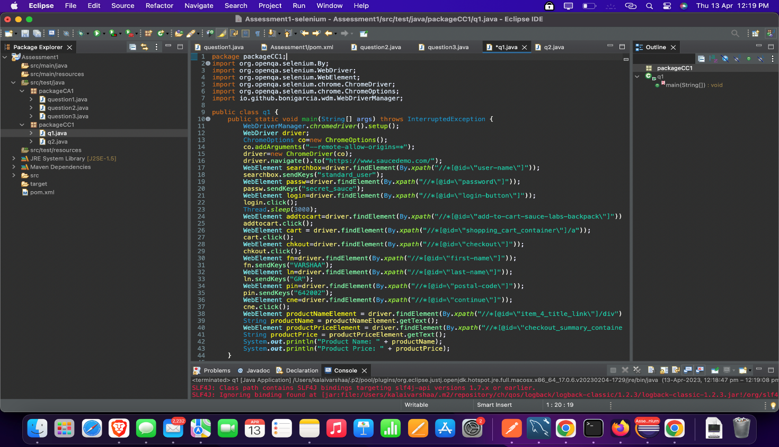

OUTPUT:

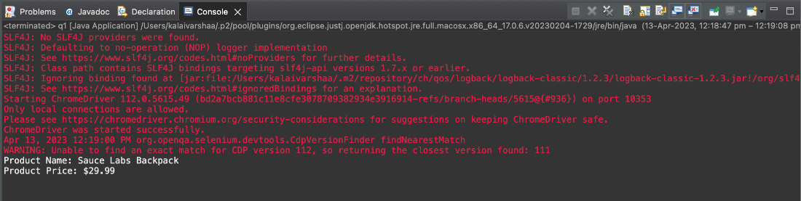

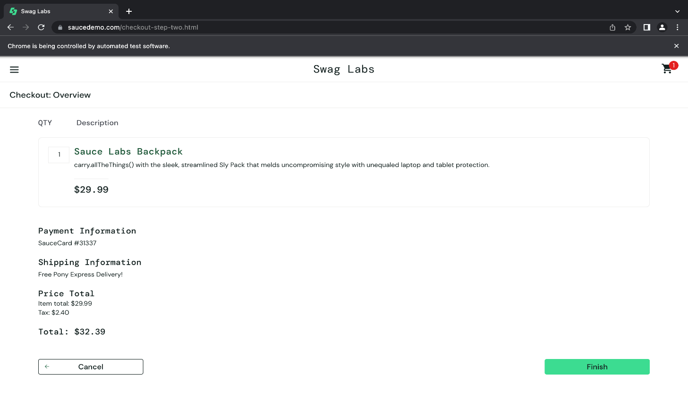

Q2]

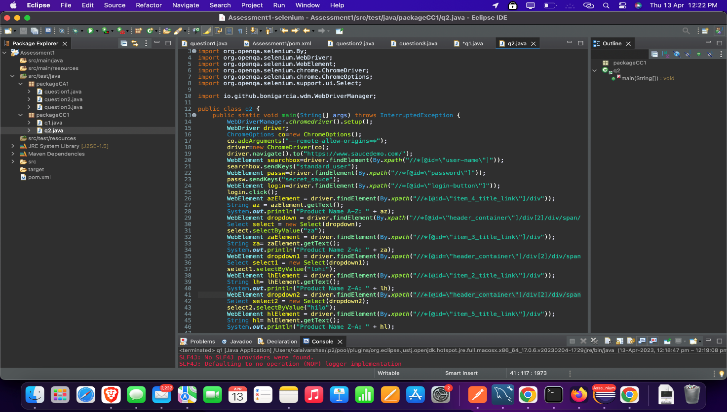

OUTPUT:

