Melvin’s Toon Addon
This shader addon does not use proper lighting and was more customized for my games needs, but is very esoteric in function and does not use proper lighting.
Objects:
Character Light Controller HQ:
The Character Light Controller HQ acts as a light vector, and gets access to TintZone Parameters. Create materials, save them and add them to the array.
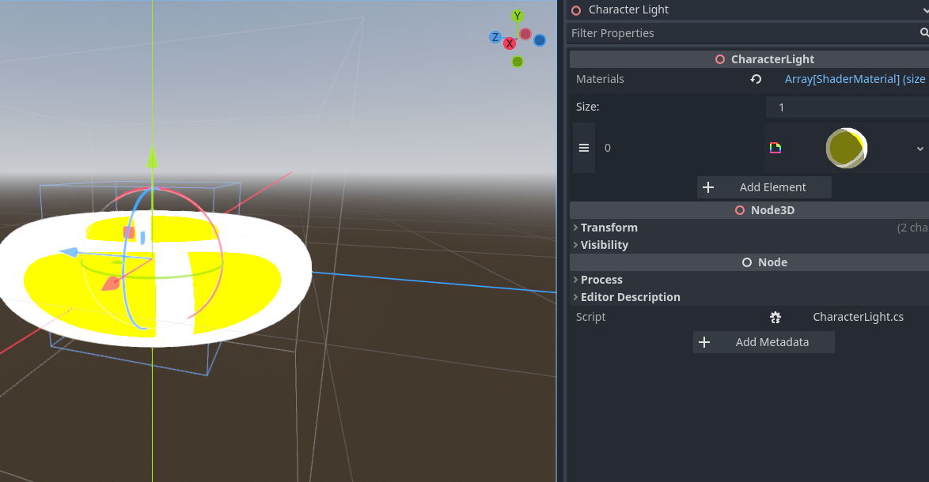
Tint Zone:
A tint zone will tint objects that the center passes through. It uses areas and collisions so it doesn’t work in editor, only in game unfortunately.
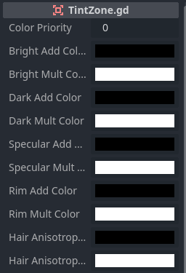
Parameters:
Color Priority: Priority of the Tintzone. Overlapping Tintzones will have the Character Light Controller choose the highest priority Tintzone.

Add Colors: The Add Color Parameters Apply an Additive Color to the parameter.

Mult Colors: The Mult Color Parameters apply a Multiplicitave Color to the parameter.

Shaders:
AnimeDrawingHQ:
The AnimeDrawingHQ shader is the main toon shader. Create a new ShaderMaterial and assign the shader to it. Optionally apply a Character Light controller HQ to it.
Parameters:
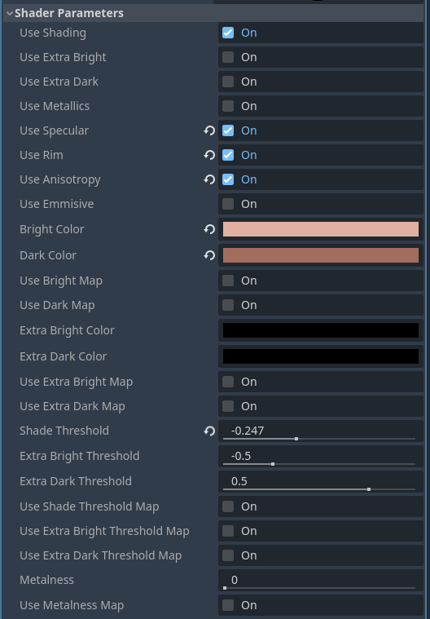
Use Shading: Use the basic shading.
Use Extra Bright: Add an extra bright shade to the material
Use Extra Dark: Add an extra dark shade to the material
Use Metallics: Add a metallic effect to the material
Use Specular: Add a basic specular highlight
Use Rim: Add a Rim style highlight
Use Anisotropy: Add a thing anisotropic style highlight.
Use Emmisive: Use a supplied emmisive texture that is uneffected by any lighting and is overlaid on the image.

Bright Color: The Bright Shaded Part Color.
Dark Color: The Dark Shaded Part Color.
Use Bright Map: Use a texture for the bright part.
Use Dark Map: Use a texture for the dark part.
Extra Bright Color: Color of extra bright part.
Extra Dark Color: Color of extra dark part.
Use Extra Bright Map: Texture of extra bright part.
Use Extra Dark Map: Texture of extra dark part.
Shade Threshold: Offsets the dark and bright parts position.
Extra Bright Threshold: Offsets the position of the extra bright.
Extra Dark Threshold: Offsets the position of the extra dark.
Use Shade Threshold Map: Use texture to control threshold. 50% Grey in a texture is the value that equals 0.
Use Extra Bright Threshold Map: Texture to control bright threshold.
Use Extra Dark Threshold Map: Texture to control dark threshold.
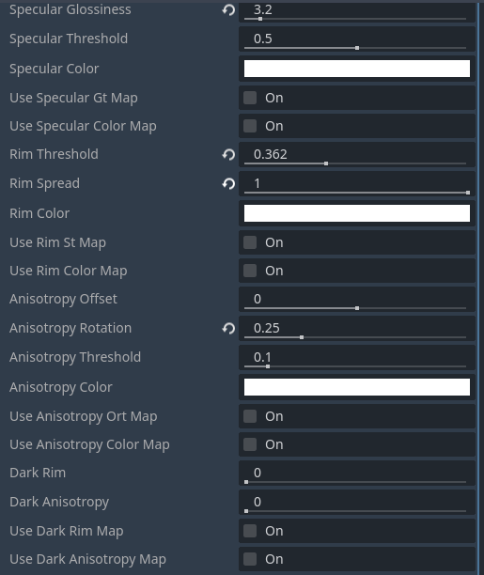
Specular glossiness: The Glossiness of the specular highlight.
Specular Threshold: The Threshold of the specular highlight.
Specular Color: The color of the specular highlight.
Use Specular Gt Map: Use a texture to control the glosiness and threshold of the highlight.
Use Specular Color Map: Use a texture for the specular highlight.
Rim Threshold: Threshold of rim lighting.
Rim Spread: Spread of rim lighing.
Rim Color: Color of rim lighting.
Use Rim St Map: Use a texture to control Spread and Threshold.
Use Rim Color Map: Use a texture for rim color.
Anisotropy Offset: The offset of the anisotropy, this shifts it on a perpendicular axis to the highlight.
Anisotropy Rotation: The angle of the anistotropic highlight.
Anisotropy Threshold: The threshold of the anisotropy.
Use anisotropy Ort Map: Use a texture to control Offset, Rotation and threshold.
Use Anisotrpy Color Map: Use a texture for anisotropy color.
Dark Rim: How much rim light bleeds over dark shades.
Dark Anisotropy: How much anisotropy bleeds over dark shades.
Use Dark Rim Map: Controls dark rim with a texture.
Use Dark Anisotropy Map: Controls dark anisotropy with a texture.
Tint Colors: Extra tint color parameters. Not reccomended to use as they are for tint zones.
Textures should be self explanitory based on the above parameters. Textures with data will be in color order, example: anisotropy Ort map will have O in r, R in g, and T in b.

Outline:
An inverse hull outline. It is reccomended to have a seperate object for outlines that is perfectly smooth shaded. This will make the outline completely connected.
Parameters:
Outline Mode: How the outline scaled with the world. 0 is a constant screen space size, 1 is a sqare root of screen space size and provides the best results, 2 is a constant screen space size.
Outline Color: Color of outline.
Outline Width: Width of outline.
Use Outline Width Map: Use a texture to change the outlines width. Pure white will keep the outline width property, and pure black will shrink it.
Use Outline Color Map: Use a texture to color outline.

