Kortstepad

In onze server voeren wij alle kortstepad berekeningen uit. Voor ons kortstepad algoritme gebruiken wij het algoritme van Dijkstra.

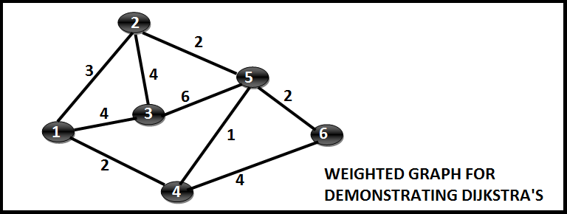

Images source: http://techieme.in/shortest-path-using-dijkstras-algorithm/

Dijkstra Algorithm: Short terms and Pseudocode
Using the Dijkstra algorithm, it is possible to determine the shortest distance (or the least effort / lowest cost) between a start node and any other node in a graph. The idea of the algorithm is to continiously calculate the shortest distance beginning from a starting point, and to exclude longer distances when making an update. It consists of the following steps:
- Initialization of all nodes with distance "infinite"; initialization of the starting node with 0
- Marking of the distance of the starting node as permanent, all other distances as temporarily.
- Setting of starting node as active.
- Calculation of the temporary distances of all neighbour nodes of the active node by summing up its distance with the weights of the edges.
- If such a calculated distance of a node is smaller as the current one, update the distance and set the current node as antecessor. This step is also called update and is Dijkstra's central idea.
- Setting of the node with the minimal temporary distance as active. Mark its distance as permanent.
- Repeating of steps 4 to 7 until there aren't any nodes left with a permanent distance, which neighbours still have temporary distances.

1: | function Dijkstra(Graph, source):
2: | for each vertex v in Graph: | // Initialization
3: | dist[v] := infinity | // initial distance from source to vertex v is set to infinite
4: | previous[v] := undefined | // Previous node in optimal path from source
5: | dist[source] := 0 | // Distance from source to source
6: | Q := the set of all nodes in Graph | // all nodes in the graph are unoptimized - thus are in Q
7: | while Q is not empty: | // main loop
8: | u := node in Q with smallest dist[ ]
9: | remove u from Q
10: | for each neighbor v of u: | // where v has not yet been removed from Q.
11: | alt := dist[u] + dist_between(u, v)
12: | if alt < dist[v] | // Relax (u,v)
13: | dist[v] := alt
14: | previous[v] := u
15: | return previous[ ]
Source: http://www.gitta.info/Accessibiliti/en/html/Dijkstra_learningObject1.html

