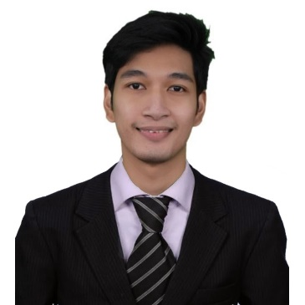

**THOM R. CRUZ**

Block 1 Lot 7 Phase 2, Pabahay 2000

Muzon, San Jose Del Monte City, Bulacan,

Central North Luzon, 3023

Contact Number: 09098726246

Email: cruzthom@icloud.com

**OBJECTIVE:**

To seek a challenging career with a progressive organization which may utilize the skills, ability and education that I presently possess. And also share to the company some of the skill and technique I have incurred in my former obligations.

**EDUCATIONAL ATTAINMENT:**

**TERTIARY**  **ACCESS COMPUTER COLLEGE**

Lagro, Quezon City

**Bachelor of Science in Information Technology**

S.Y: 2018 – 2022

**SECONDARY ACCESS COMPUTER COLLEGE**

**Senior High** Recto, Manila

**Information, Communication and Technology**

S.Y: 2015 – 2018

**SECONDARY**  **BRENTWOOD ACADEMY OF DASMARIÑAS INC.**

**Junior High** Dasmariñas City, Cavite

S.Y: 2012 – 2015

**PRIMARY BRENTWOOD ACADEMY OF DASMARIÑAS INC.**

Dasmariñas City, Cavite

S.Y: 2006 – 2012

**WEBINARS ATTENDED**

**Windows Server Management and Hardware Configuration (3-Day Webinar)**

Philippines

February 4, February 18, & March 4, 2022

**CERTIFICATES**

**National Certification II – Computer Software Servicing (2022 - 2027)**

**SKILLS**

* Computer Hardware Knowledge.
* Computer Software Knowledge.
* Operating Systems.
* Troubleshooting.

**PERSONAL INFORMATION:**

Height: 5’9

Weight: 57kgs.

Age: 23 years old

Sex: Male

Birth Date: March 20, 1999

Birth Place: Dasmariñas City, Cavite

Citizenship: Filipino

Civil Status: Single

Religion: Roman Catholic

**CHARACTER REFERENCE**

**John Kils V. Mambat**

BETA FOAM Production Planner

Contact No. 09161520991

**Grechille Ferrer**

Manila Memorial Park Cemetery, Inc.

Contact No. 09615822338

I hereby certify that the above information is true and correct with the best of my knowledge and skills.

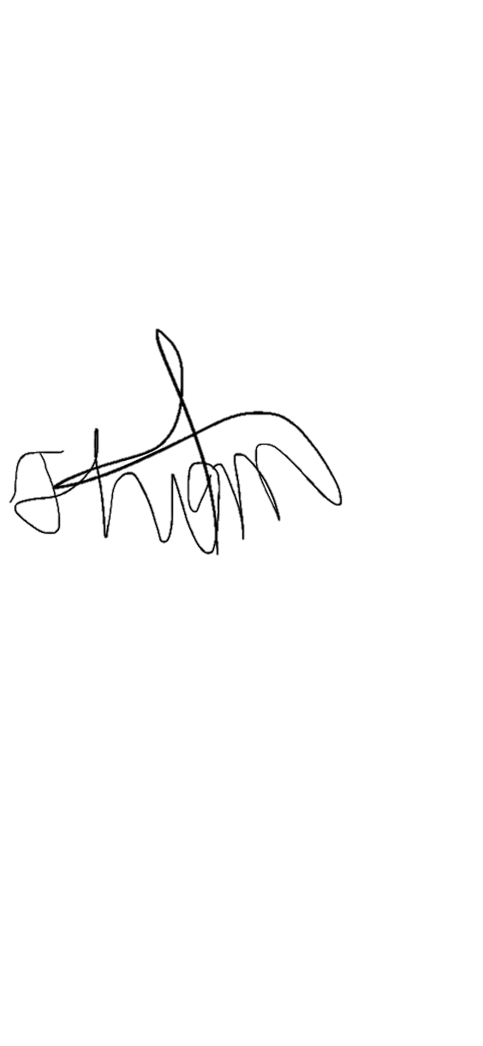

Thom R. Cruz