1. **Descriptive statistics**
   1. Read the covid data and remove top 100 cases. Then, clean the variable “nationality” and rename it to be “NationalityGroup” that composes of three groups: “Thai”, “Non-Thai”, and “N/A”. It is not allowed to clean the data directly from the source file. Capture the frequency of each group in “NationalityGroup”.

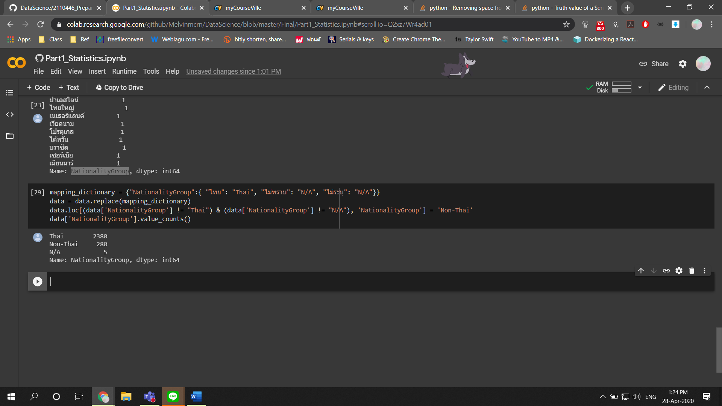

[assume ว่า Thai มีแค่ไทย ส่วนไทยใหญ่ไม่ใช่ไทย]

* 1. Compute the statistics of “age” – min, max, median, SD, n, nmiss, IQR, skewness, kurtosis.

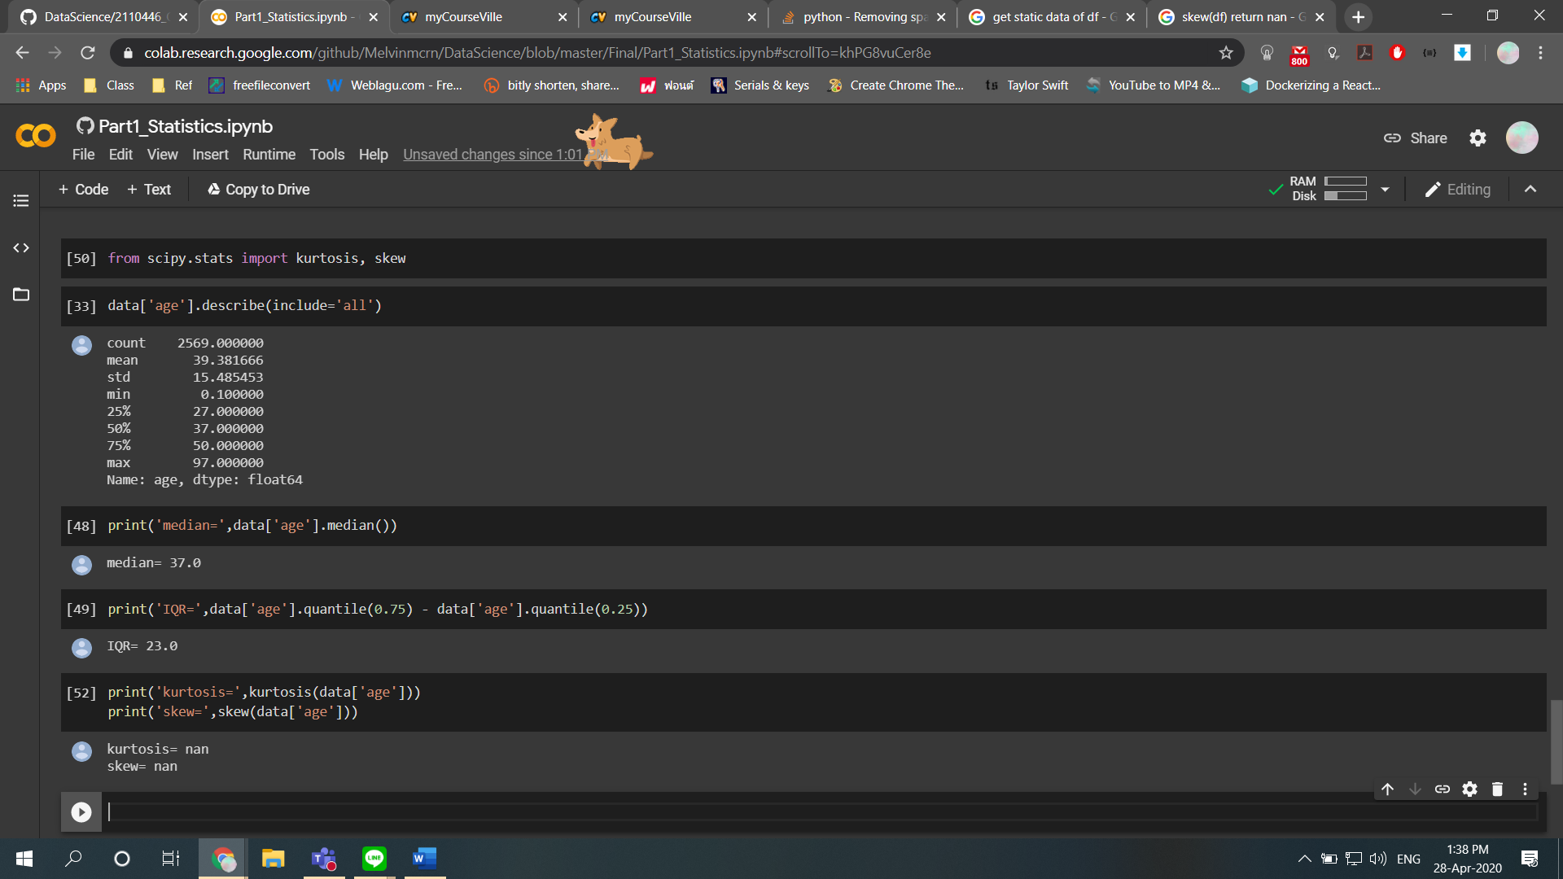

* 1. Plot the histogram of “age”, where min and max ages are 0 and 100 using 10 years interval.

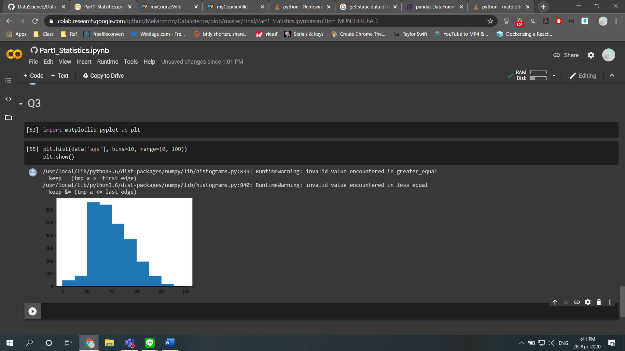

* 1. Create a boxplot of “age” by “gender”.

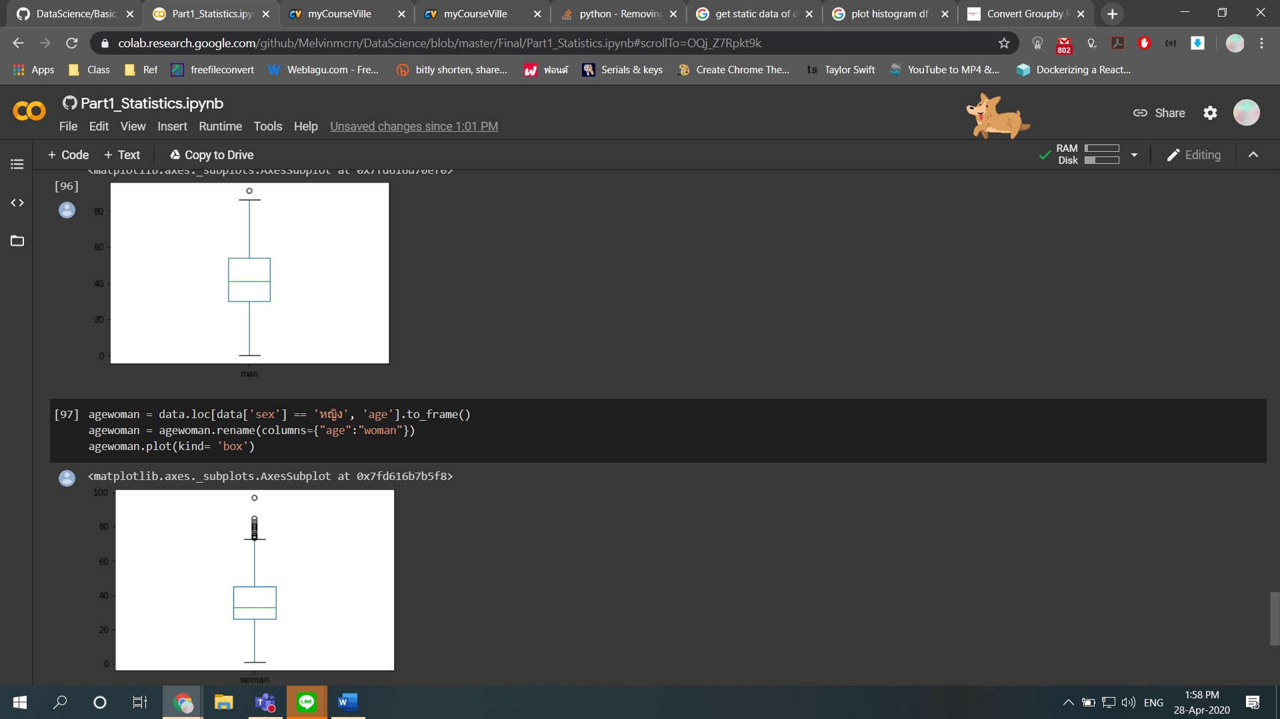

* 1. Create a boxplot of “age” by “NationalityGroup”.

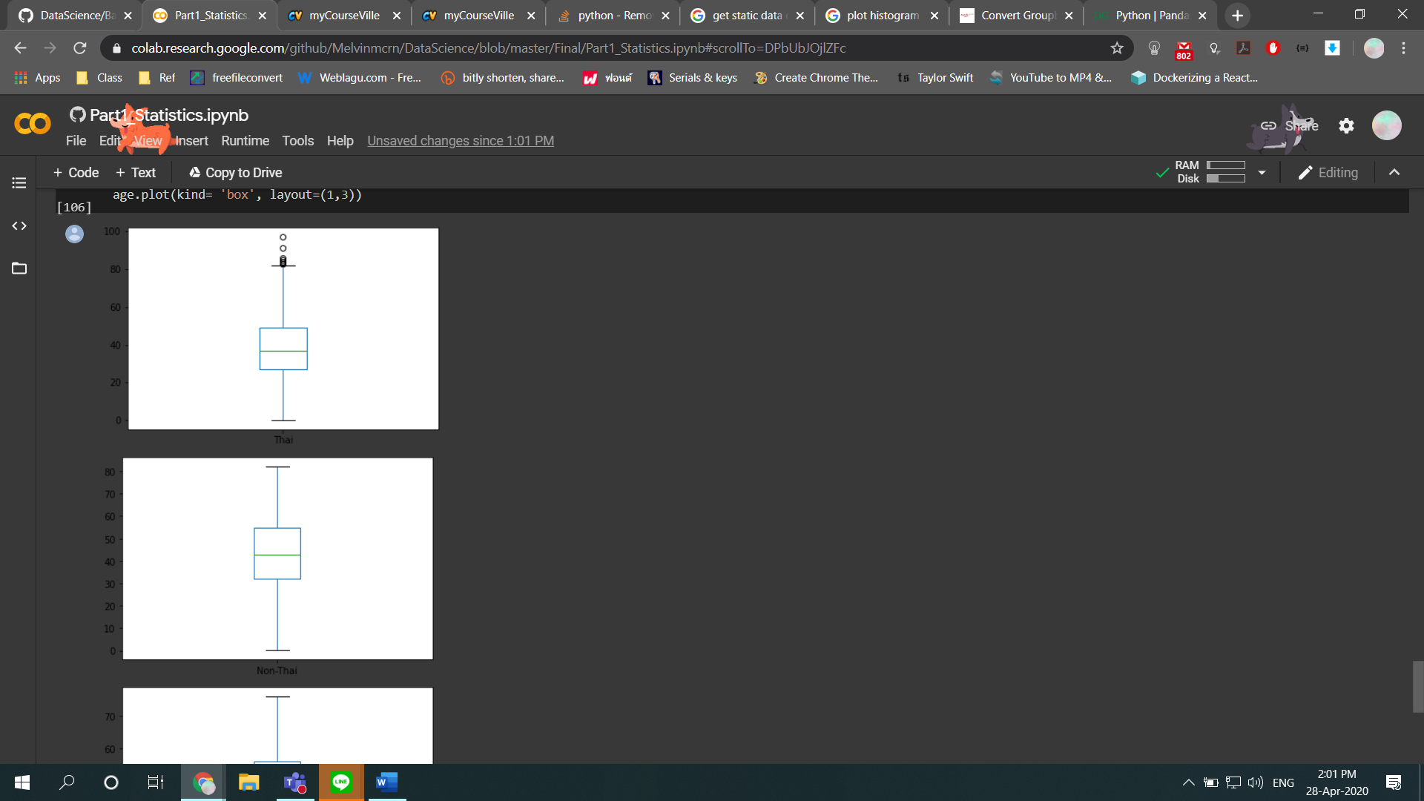



1. **Descriptive statistics**

Assume the given data is a sample of the whole population of Covid-19 patients in Thailand. The inferential statistics is needed to refer to facts about ages of the covid patients.

* 1. Find a point estimate of “age” by “sex” using n, mean, SD (not including missing cases)
  2. Find a range estimate of “age” by “sex” using Confidence Interval (CI) of 99% (not including missing cases)

1. **A/B Testing**
   1. Identify the right statistical test to answer *“Are there any differences of ages between genders (sex)?”*. Please explain the name of the statistical test, stats value, p-value along with an explanation to answer the question.
   2. Identify the right statistical test to answer *“Are there any differences of ages between NatinalityGroup?”*. Please explain the name of the statistical test, stats value, p-value along with an explanation to answer the question.
   3. Create and show a crosstab to count the number of patients, where row and column refers to “NationalityGroup” and “sex”. Identify the right statistical test to answer *“Are there any relationships between NationalityGroup and sex?”*. Please explain the name of the statistical test, stats value, p-value along with an explanation to answer the question.