TuberXpert
The expert system that adjusts treatments

Health situation in Tanzania
Tanzania is a country with a high incidence of tuberculosis, a deadly airborne lung disease. Every year, 120'000 people contract the disease. However, only half of them receive treatment and most of the time it fails. In one to two-thirds of tuberculosis patients, the peak concentration of the antitubercular drug is below the reference range. In addition, one-third of people with tuberculosis must take antiretroviral drugs that further lower the concentration of the antitubercular drug. The risk of treatment failure is real.
Taking a not suitable treatment is dangerous. The patient may become drug resistant, intoxicated or even die. In consequences, the Tanzanian government wants to end tuberculosis by 2035.

Therapeutic drug monitoring
Fortunately, the fight is not lost. The main ally is therapeutic drug monitoring, which is a specialized practice in measuring drug levels in the blood for a treatment. This allows us to know how a drug behaves in a patient's body. However, the whole process is slow. In addition, it takes an experienced pharmacologist to interpret the samples and recommend an effective adjustment.

To facilitate this part, Professor Yann Thoma in partnership with the Lausanne University Hospital, has developed a software called Tucuxi. However, it still needs to be handled by an experienced practitioner.
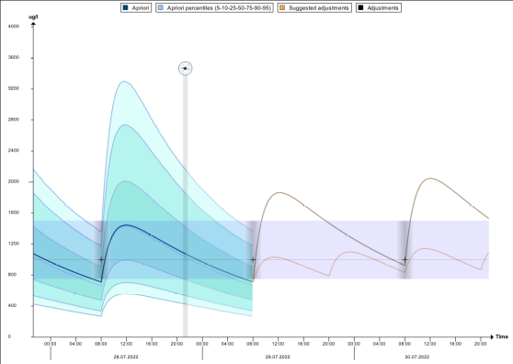
The software becomes pharmacologist
In view of the current situation, TuberXpert is a project between Switzerland and Tanzania that aims to create a clinical decision support system to democratize access to therapeutic drug monitoring. Based on the Tucuxi computation core, this Bachelor’s thesis consists in developing a first version of the software.
Indeed, by obtaining data on the patient, TuberXpert is able to evaluate the plausibility of the received data and to propose a first adapted treatment or an adjustment by providing a complete report in English or French.
Since the software was developed with a basic knowledge of therapeutic drug monitoring, the results are very encouraging. In its final form, with more knowledge of pharmacology, TuberXpert should be a real success.

