.

## task – REVERSED ALPHABET (ATBASH) CIPHER

**Objective of the application:**

This application allows us to encode/decode text using an *Atbash Cipher* (a particular mono-alphabetic cipher formed by taking the alphabet and mapping it to its reverse).

|  |  |  |  |  |  |  |  |  |  |  |  |  |  |  |  |  |  |  |  |  |  |  |  |  |  |  |
| --- | --- | --- | --- | --- | --- | --- | --- | --- | --- | --- | --- | --- | --- | --- | --- | --- | --- | --- | --- | --- | --- | --- | --- | --- | --- | --- |
| Plain | A | B | C | D | E | F | G | H | I | J | K | L | M | N | O | P | Q | R | S | T | U | V | W | X | Y | Z |
| Cipher | Z | Y | X | W | V | U | T | S | R | Q | P | O | N | M | L | K | J | I | H | G | F | E | D | C | B | A |

**Examples**:

* The text: **AbCd**

Would be encoded as: **ZyXw**

* The text: **Flee, we have been discovered!**

Would be encoded as: **Uovv, dv szev yvvm wrhxlevivw!**

**Take note, the cipher only applies on letters of the alphabet. Upper and lower casing is being retained.**

**The modes of the application:**

• **Interactive mode:**

Allows the user to enter one line of text and then encode/decode it through an Atbash cipher. The resulting encoded/decoded text will be displayed on the screen. The user can repeat this multiple times. Below is a screen shot that demonstrates the application running in Interactive mode.

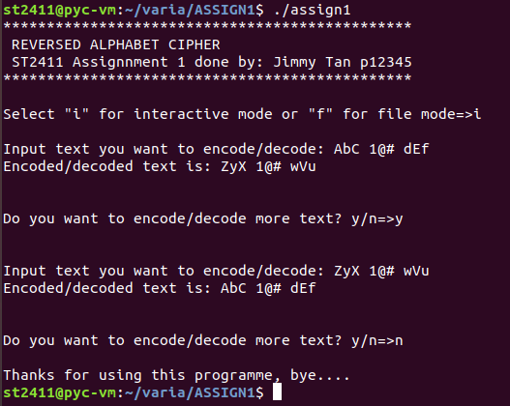

• **File mode:**

Allows the user to encode/decode text read from an input file and store the result in an output file.

Below is a screen shot that demonstrates the application running in Interactive mode.

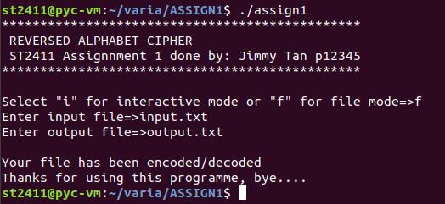

If the input text was as follows:

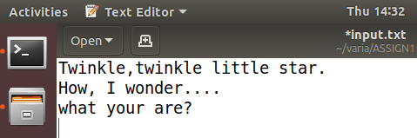

The output file would then be:

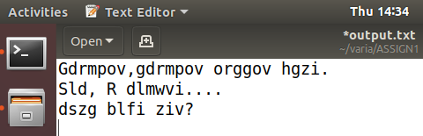

**Deliverables:**

Your task is to implement a standalone C program that allows users to encode/decode text with a reversed alphabet (Atbash) cipher.

1. Your application should display your name and class in a header formatted as is shown below:

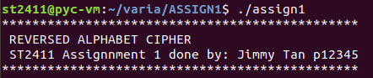

1. Your application should prompt the user to choose either between Interactive mode or File mode. You should validate the user input as to ensure that the application only proceeds to the next step with either an ‘i’, or ‘f’ input.



1. Your application should allow the user to Encode/Decode a single line of input text (interactive mode). You must validate the input, so as to ensure file exists, and that the file is of the correct format(.txt format).
2. Your application should allow the user to Encode/Decode an input text that is read from a file and then stores the result in an output file (file mode).

You are also required to include an Assignment Report (A MS Word Document of maximum 2 pages). The report should cover:

a. The problems you have encountered.

b. The knowledge you have gained from this assignment.

## Marking scheme

|  |  |  |
| --- | --- | --- |
| Category | Description | Weightage |
| Proper Submission | -Fulfilling the submission requirement stated in this document | 5 marks |
| Documentation | -Inline comments  -Function overview and documentation  -Reference (if any) | 5 marks |
| Programming techniques | -Proper choice of programming constructs eg linked list/arrays/for loops/while loops etc.  -Proper choice of algorithms  -Proper breakdown of the program with sub functions | 25 marks |
| Validation | - Proper validation of user input  - Proper file validation | 5 marks |
| Encoding/decoding | Correctness of the encoding/decoding according to Reversed Alphabet (Atbash) cipher. | 15 marks |
| File IO | Can read from input file, and write back to file. | 5 marks |
| Program completeness | -Fulfilment of the given specifications.  -Display format (based on the sample screen shots provided).  -Runtime errors free | 20 marks |
| Written Report | -The problems you have encountered  -The knowledge you have gained from this assignment. | 10 marks |
| Demo |  | 10 marks |

**~ the end ~**