## **Challenges Faced**

Initially, there were numerous errors before the C program can be successfully executed. Warnings like “*gets' function is dangerous and should not be used*” that were previously thought of as errors are what keeping the program from not executing. Programming errors like forgetting to declare the files as pointers, and repetitive codes that could break the program.

One of the key things to take away from this assignment besides the syntax of C, is that it is a good programming practice to try avoid repetitive codes. Try to make use of functions so that in the future, change the body of the function if there is ever an update of codes to be made. This is good for maintainability of the program.

## **Explanation and Demo**

Before running the *main.c* program, we have to first compile the C file. This can be done in the Ubuntu terminal by typing in the command “*gcc main.c -o main*”. Make sure the that the terminal is in the same directory where the *main.c* file is located. After compilation is successful, another main file is created, which is only readable by the computer.

Run the C program with the following command – “*./main*”

The execution of the program are as follows:

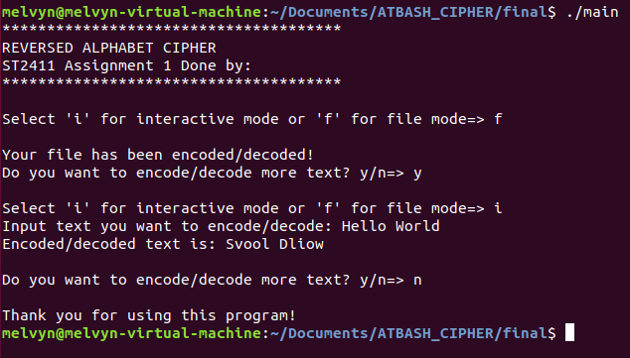

## **Interactive Mode**

Interactive Mode allows the user to enter a line of code and upon pressing the ENTER, the program automatically encodes every alphabetic texts in the line. Take note that the cipher will only be applied on alphabets (a to z, or A to Z). Numbers of other symbol (e.g. #,$,%,^,& are not applied).



## **File Mode**

When the user chooses to enter “f” for the mode of the program, File Mode is activated. The input file named “input.txt” is automatically read by the program, ciphering the texts line by line and prints the ciphered texts line by line too. All this happens in a while loop as illustrated below:

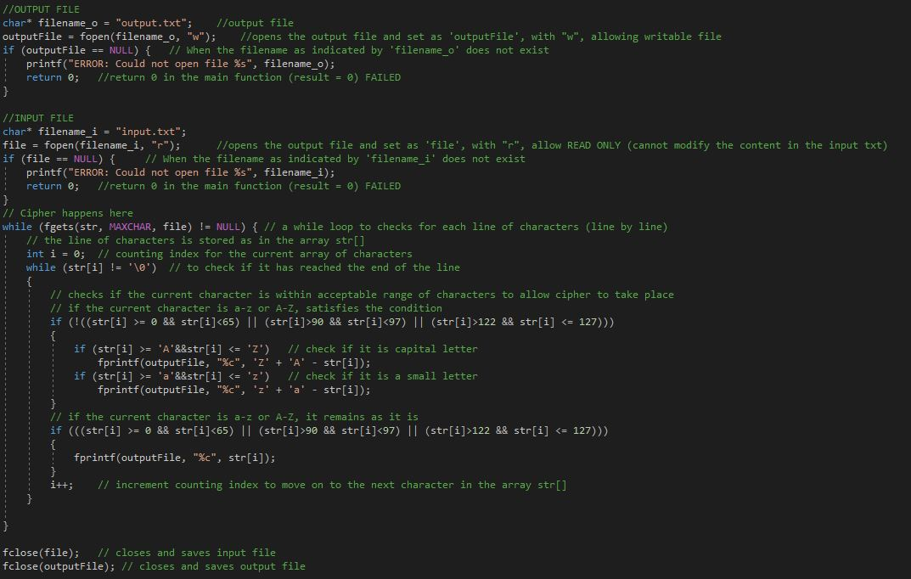

The input and the output text files are shown below. It can be seen that the formatting of the texts (spaces, inlining, capitalization) are preserved. Upper and lower casings are retained.

